HTML & CSS Web Development
Emily Stockdale - 1906962
BSC/HND Computing
Introduction to Web and Database Concepts
ACCA4023
Gareth Jones

Table of contents
Introduction 3
Requirements 3
Implementations
The website 4-6
Website validation 7
Evaluation 8-9
Website evaluation 9-10
Conclusion 10
References 11
Appendices 11 - 44

Introduction
This report is based on a hand coded website. Below is an introduction to the website including its purpose, subject matter, target audience and its relevance. The website has been created using HTML & CSS, during this report both the HTML code and the CSS code will be validated focusing on the home page only. Any occurring errors will be discussed and troubleshot. To conclude the website will be evaluated reviewing all aspects of usability, SEO (search engine optimisation) and accessibility. The use of website will also be discussed including how user friendly it is and if it meets the needs of the target audience with some recommendations for improvement.

Requirements
Introduction to the website
The website outlines the services of a social media marketing agency called ‘the social addict’. This website is made up of 5 pages:
- Home
- About
- Services
- Packages
- Contact
Each page is unique however all pages are consistent with the business branding.
The purpose of the website is to generate traffic and reach clients who may have limited or no access to social media.
The target audience for this website is business owners from all industries with a range of backgrounds.
The target audience ranges from those with little to no experience with social media platforms who need a digital marketing expert to support them, to those who understand and regularly use social media platforms but do not have the time and capacity in a working day to manage their business accounts.
This website outlines why business owners need a social media manager and what packages are available to support this.

Website Diagram
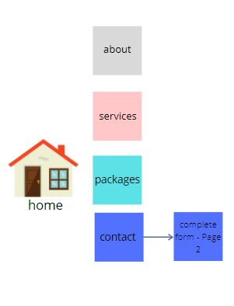
Implementation: The Website
Home Page:
The below page is the website Home page which as displayed below has the business logo. This page is the first page that users will see. This page includes a brief explanation of what the company is and what they do, this ensures immediately know what the company does and whether to continue exploring the website. As displayed below there is a clear simple navigation menu.
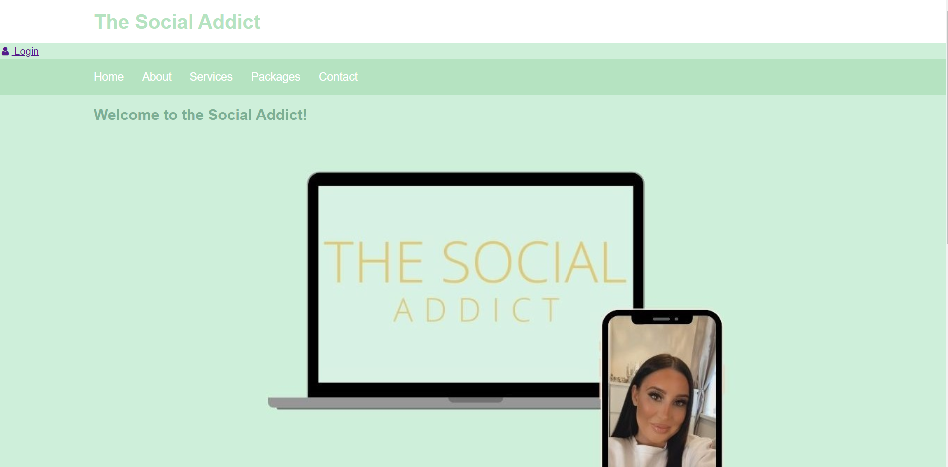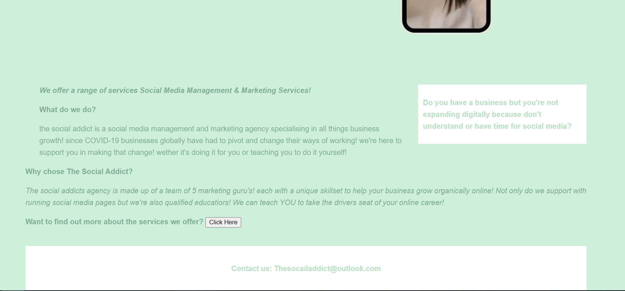
About:
The second page on the website menu is the about page. The about page has a brief description of the team and their skills. There is a YouTube video embedded in this page, the YouTube video chosen is a video explaining why the user needs a social media manager. The video is generic so that it applies to all.
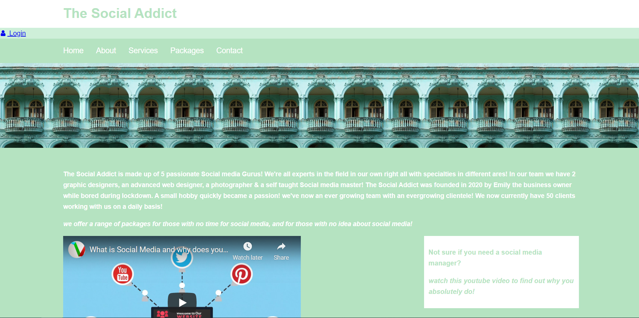
Services:
The page priovides a breif overview of the services offered by this business. This includes small descriptions including two photographs to break up the text and allow for an easier read.
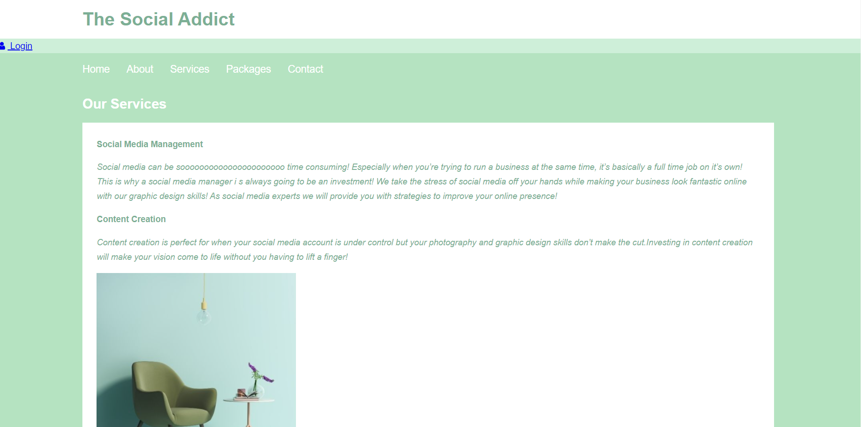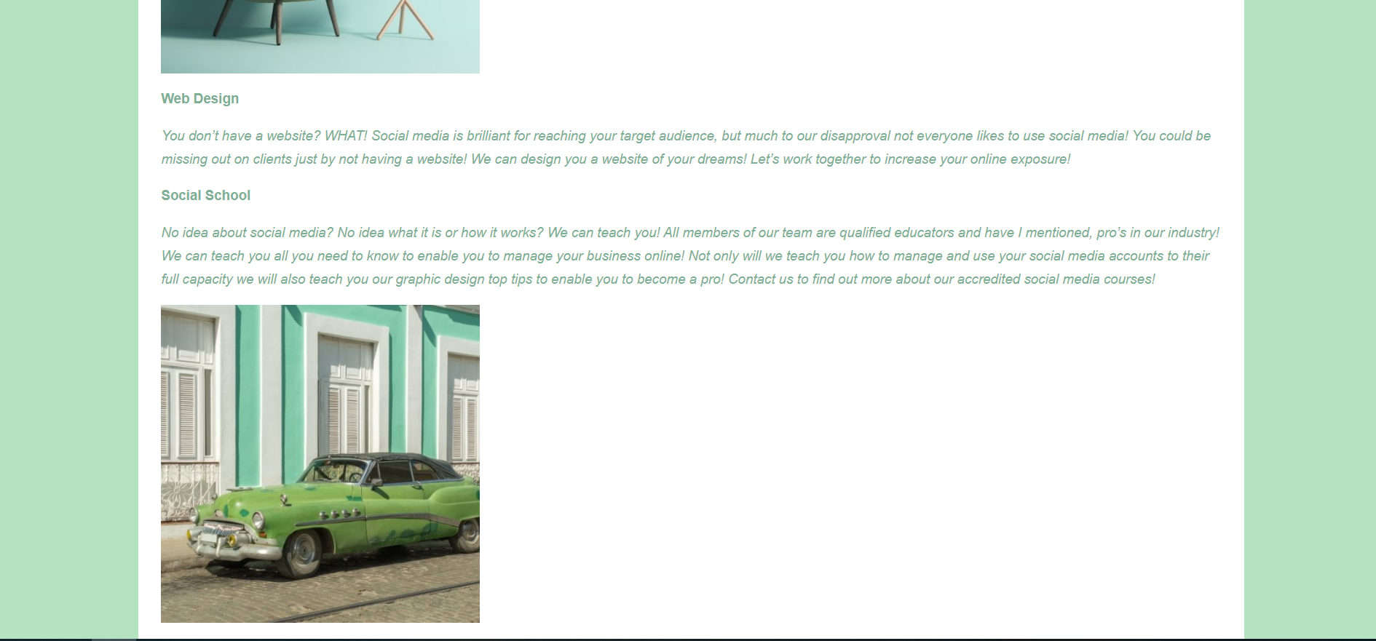
Packages:
This page breaks down the packages offered by the business with the use of columns, graphics & text within the main body of the website.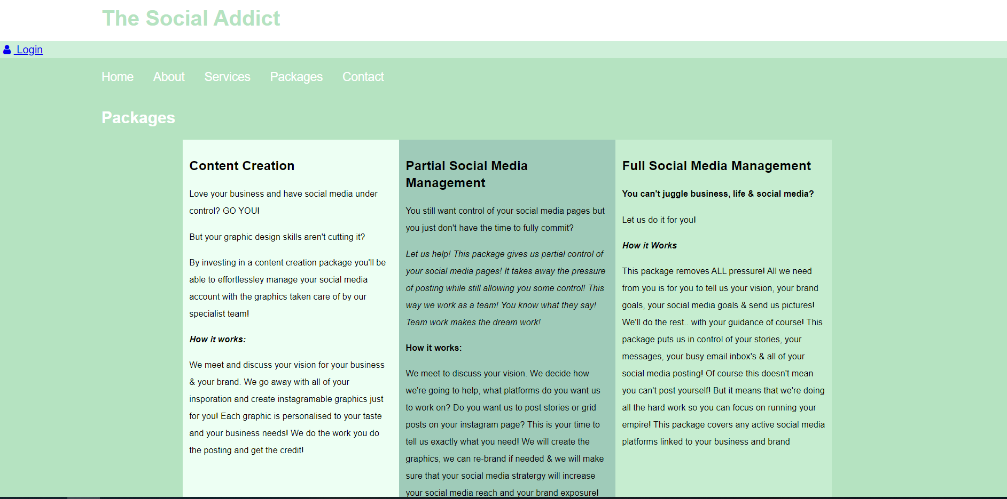 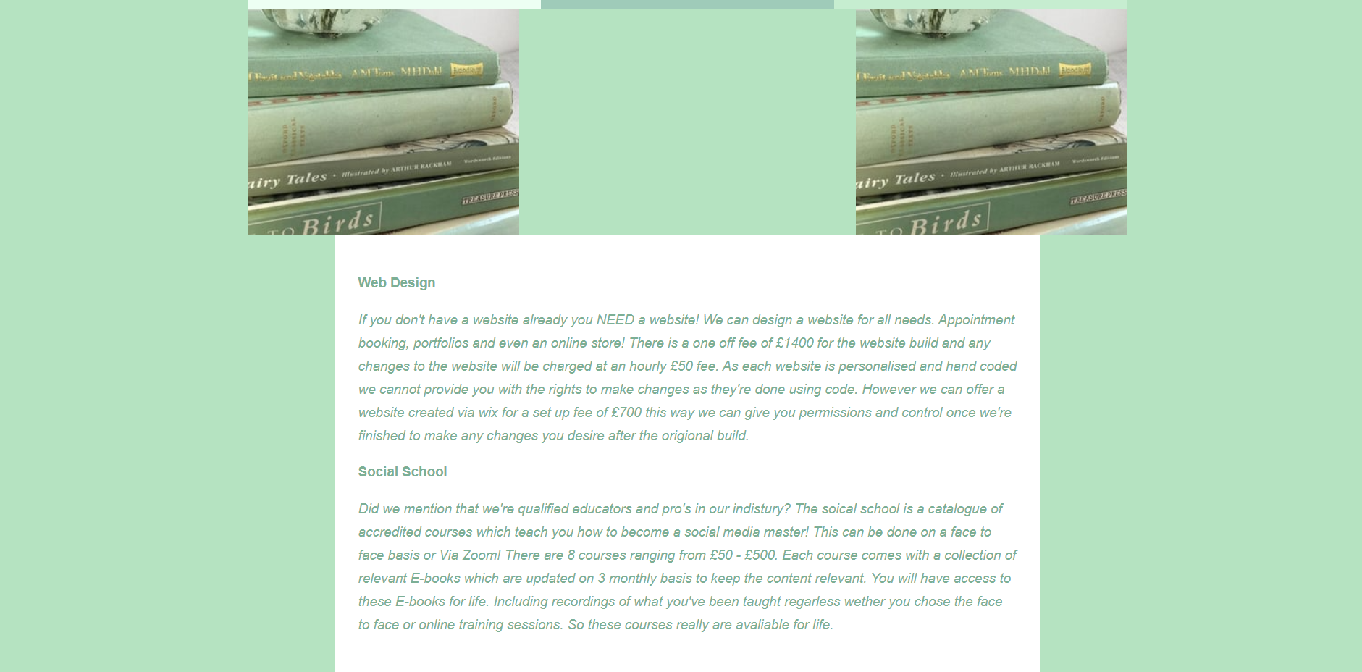 

Contact:
This page includes a contact form, this allows users to contact the company via the use of a direct form. This form asks for the users full name, email address, budget and for an overview of what they need. This is so that users can contact the company directly.
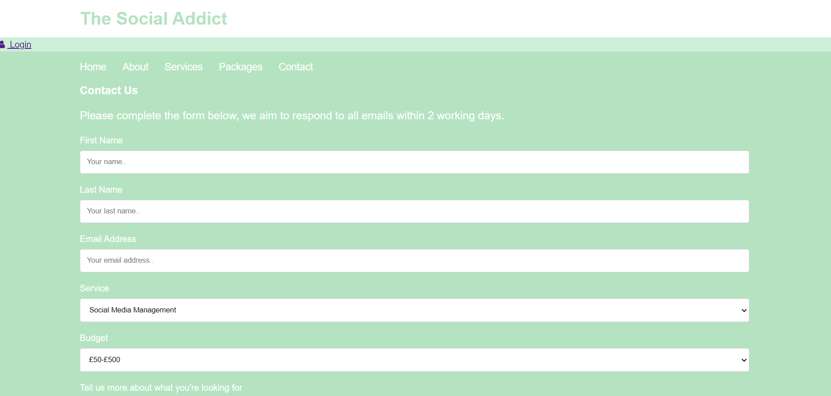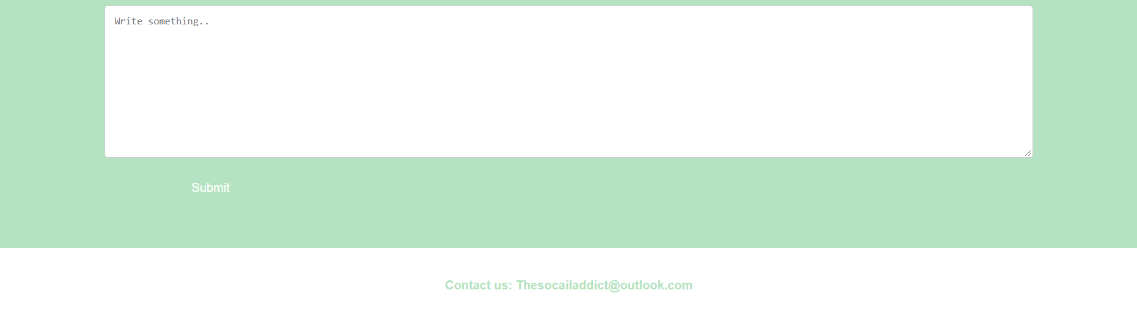

Implementation: The Validation

HTML Validation:
The below error is occurring due to a ‘stray end tag’ as stated below, this has happened as there hasn’t been an opening tag for this area <div>. This has not affected the usability or functionality of the website. This error can be easily rectified by removing the ‘stray end tag’ as it’s not needed within the code.
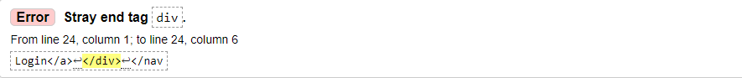
Below is an error caused by an incomplete attribute name <section id="main" there is a symbol missing to close the attribute name the symbol needed to rectify this is >. This hasn’t affected the functionality or usability of the website however this can be rectified by adding the symbol to complete the attribute name code. This will then allow the targeted text to become a heading.
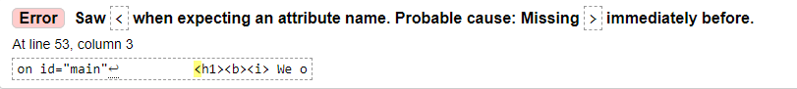
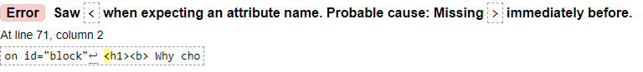
As displayed above both errors are of the same nature and can be rectified by closing the code and adding a > symbol.
The errors throughout the HTML code are of the same nature including stray end tags and missing symbols to finalise an attribute name.
Although the below error has shown that the section lacks heading this is due to the above error id=block not being complete, by adding the correct simple and completing the code correctly the text has now changed to a header although this hasn’t affected the functionality or usability of the website it may affect SEO rankings due to lack of organised headings..
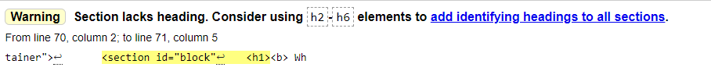

CSS Validation:
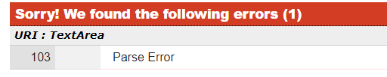
Upon validation of the CSS code for the home page of this website an error occurred. Upon further investigation this could be due to a spelling mistake or missing symbols. Upon review of the CSS code there were no missing symbols however there may be a spelling mistake which is unclear to the eye at first glance.

Evaluation
Website Usability
Website usability is an attribute that assesses how easy and user friendly user interfaces are to use [1]. When assessing and measuring website usability it should be assessed how easy is it to navigate around the website, how quickly can an individual get from one task or page to another, are there any common mistakes made by users, is the design aesthetically pleasing. Websites need to be relatively simple to navigate as the result of a difficult to use website is that people avoid them or they leave. A study conducted in 2007 found that ease of use when accessing a website is considered most important to users. [2] The findings of this study outline and indicate that web designers should prioritise ensuring that sites are easy to navigate and have clear navigation capabilities rather than prioritising personalisation and customisation [2].

Accessibility
Accessibility is ensuring that a website is developed and designed to be user friendly to those with disabilities.
Disabilities such as the below:
- Visual Disabilities
- Physical Disabilities
- Deafness and Hearing Loss
- Cognitive and Learning Disabilities
- Situationally induced impairments and disabilities
- Speech and Language
However accessibility is not limited to those with disabilities as it benefits those using technologies other than a PC to access a website. Websites which have been designed with accessibility in mind can be accessed by those who are blind or visually impaired, dyslexic and those with low vision [3]. Under the Equality Act 2010 service providers must consider ‘reasonable adjustments’ for those with disabilities [4]

Search Engine Optimisation (SEO)
Search engine optimisation otherwise known as SEO is the process of optimising your website to gain unpaid traffic from search engines such as google. SEO should be built into annual budgets and should be updated regularly [5]. SEO is a tool used to expand reach, in 2018 a study found that google was the largest traffic driver to websites. This is a larger impact than any social media channel [6].
There are two types of SEO on page SEO and off page SEO.
On page SEO:
- Internal links
- Alt text
- Key word optimisation
- Title tags
- Relevant content
- Meta description
- Title tags
When implementing on page SEO the content on the page needs to be discoverable, it should be paired with relevant search queries to be favoured by google. To optimise on page SEO a web designer/developer should start by understanding googles criteria and ensure to always use a key word in the first paragraph. Google similarly to social media has its own algorithm, in order to understand googles criteria start by understanding the algorithm. Google looks at things such as, how long is someone on a page? How often do people visit the site? Do people engage with the site when they’re on it? This tells google if the quality of the site content is of a high standard. Using title tags creates a hierarchy within your site which shows the algorithm that text is organised. Including internal links allows google and other search engines that a website is relates to other online content. The aim of On page SEO is to understand the algorithm of the search engine to enable a web designer/developer to maximise reach and gain organic traffic [7].

Off page SEO takes place outside of a website for example on social media. An increased reach on social media can cause an increased reach on a website especially when the link is available through the social media platform. Brand searches can also support off page SEO, when a brand is repeatedly searched it becomes more trust worthy [8]. More examples of off page SEO can be seen below.
Off page SEO:
- Link Building
- Social Media Reach
- Video Creation
- Guest Blogging
- Press Releases
- Blog commenting

Website Evaluation
Usefulness
The social addict website has been built using simple marketing principles. The website is simple and easy to navigate. The menu navigation bar has 5 titles: home, about, services, packages and contact. Each page is organised simple to navigate and all information can be found with ease. The contact page contains a contact form allowing users to contact the company directly with ease. The menu navigation is consistent across all pages meaning that the users can navigate from one area to another without having to go back to the home page or using a ‘back’ button.
Each page is uniquely designed however each page is consistent with the business branding. The use of minimal text and multiple graphics throughout makes the website aesthetically pleasing while ensuring the website is easy to navigate.
Recommendations to further improve this website would be to ensure that any buttons are of a consistent design as the button on the contact page and the button on the home page are different in design. For a more aesthetically pleasing look the menu bar could be moved to the right hand side of the page and the ‘log in’ button added to the top right to allow for a more visually pleasing appearance. Within the packages page there are 3 columns, if this website was to be improved or changed in the future it would be effective if each column included a graphic and the text was in a list format rather than a paragraphed format. Overall the web page is easy to navigate.

SEO
- You tube link embedded to the ‘about page’ – a well ranked you tube link has been added to the about page.
- Each page has included ‘H1’ & ‘H2’ tags throughout each page, this shows google that the content is organised.
- Keyword optimisation on home page – keyword optimisation has been used throughout the first page when welcoming users to the page.
Accessibility
The social addict website has been created in a ‘mint green’ colour, the colour of choice for both a combination of font and background colour supports those with dyslexia. Individuals with dyslexia can struggle to read documents on white backgrounds with dark fonts. However upon reflection the contrast of light colours could negatively affect those with vision impairment. This website does not include an option to change the colours neither is there an option for larger font however this website does have a zoom facility, allowing those who may need to increase font size can do so. Within this website there are no audio only or video only options, this is not user friendly to those who may be blind. It is recommended that this is changed at the earliest convenience including pre-recorded captions.

Conclusion
The website created is user friendly and simple to navigate however it is missing some key elements to support with accessibility. This can be improved by updating the code to reflect the relevant changes needed. There are multiple on page and off page SEO elements to be added to this website which can be changed throughout the code. Updating the errors flagged when validating the HTML and CSS code will also support with HTML optimisation to ensure that all headings and keywords are flagged. Further research into the google criteria and algorithm would support all improvements to this website. To conclude, the website is a user friendly website with minor updates to perfect the design and accessibility.

References

[1] | J. Nielsen, "Introduction to Usability," NN/G Neilsen Norman Group, 3 01 2012. [Online]. Available: https://www.nngroup.com/articles/usability-101-introduction-to-usability/. [Accessed 10 04 2021].
[2] | J. P. A. A. Pearson, "Detirming the improtance of Key Creiteria in Web Usability," 10 10 2007.
[3] | J. Craven, Web Accessability, London: Facet Bublishings, 2008.
[4] | C. D. a. D. Office, "Understanding accessibility requirements for public sector bodies," GOV, 09 05 2018. [Online]. Available: https://www.gov.uk/guidance/accessibility-requirements-for-public-sector-websites-and-apps. [Accessed 2021 04 10].
[5] | A. Kumar, "Search Engine Optimisation:Technical Analysis Concepts," International Journal of Emerging Technology and Advanced Engeneering, vol. 3, no. 3, p. 6, 2013.
[6] | K. Carney, "What are the Advantages and Disadvantages of SEO," Fire Starter, 09 10 2020. [Online]. Available: https://www.firestarterseo.com/what-are-the-advantages-and-disadvantages-of-seo/. [Accessed 10 04 2021].
[7] | C. Lahey, On page SEO:an in depth guide for 2021, 2020.
[8] | E. Varagouli, What is off-page SEO? a comprehensive guide, Semrush Blog, 2020.

Appendices
Appendix A
HTML Home page:
<html>
<head>
<meta charset="utf-8" \>
<title> The social Addict </title>
<link rel="stylesheet" type="text/css"
href="index.css">
</head>

<body>

<header id="main-header">
<div class="container">
<h1> The Social Addict</h1>
</div>
</header>

<nav>
<link rel="stylesheet" href="https://cdnjs.cloudflare.com/ajax/libs/font-awesome/4.7.0/css/font-awesome.min.css">

<a href="#"><i class="fa fa-fw fa-user"></i> Login</a>

</nav>

<nav id="navbar">
<div class="container">
<ul>
<a href="index.html">Home</a>
<a href="about.html">About</a>
<a href="services.html">Services</a>
<a href="ackages.html">Packages</a>
<a href="contact.html">Contact</a>
</ul>
</div>

</nav>

<section id="showcase">
<div class="container">

<h2> Welcome to the Social Addict!</h2>

</div>
</section>

<div class="container">
<section id="main"
<h1><b><i> We offer a range of services Social Media Management & Marketing Services! </h1></b></i>
<p><b> What do we do? </b></p>

<p> the social addict is a social media management and marketing
agency specialising in all things business growth! since COVID-19
businesses globally have had to pivot and change their ways of working!
we're here to support you in making that change! wether it's doing it for you
or teaching you to do it yourself!</p>

</section>

<aside id="sidebar">
<p><b>Do you have a business but you're not expanding digitally because don't understand or have time for social media?</p></b>
</aside>
</div>

<div class="container">
<section id="block">
<h1><b> Why chose The Social Addict? </b></h1>
<p><i> The social addicts agency is made up of a team of 5 marketing guru's!
each with a unique skillset to help your business grow organically online!
Not only do we support with running social media pages but we're also qualified
educatiors! We can teach YOU to take the drivers seat of your online career!</i></p>

<div class="button">
<section id="button"
<h4><b> Want to find out more about the services we offer?</h4></b>
<button class="GFG"
onclick="window.location.href = 'file:///C:/Users/em165295/Documents/Uni/services.html';">
Click Here
</button>

<footer id="main-footer">
<p><b> Contact us: Thesocailaddict@outlook.com </p></b>

</body>
</html>

CSS home page:
body{
background-color:#CEEFD9;
color:#7CAF95;
font-family:helvetica;
font-size:16px;
line-height:1.6em;
margin:0;
}

.container{
width:80%;
margin:auto;
overflow:hidden;
}

#main-header{
background-color:white;
color:#B5E3C1;
}

#navbar{
background-color:#B5E3C1;
color:white;
}

#navbar ul{
padding:0;
list-style:none;
}

#navbar li{
display:inline;
}

#navbar a{
color:white;
text-decoration:none;
font-size:18px;
font-family:helvetica;
padding-right:25px;
}

#navbar a:hover{
color:#D7F1E4;
}

#main-footer {
background:white;
color:#B5E3C1;
text-align:center;
padding:20px;
margin-top:40px;
}

#main{
float:left;
width:70%;
padding:0 30px;
box-sizing:border-box;
}

#sidebar{
float:right;
width: 30%;
background:white;
color:#B5E3C1;
padding:10px;
box-sizing:border-box;
}

#showcase{
background-image:url("glam11.jpg");
background-size:1200px;
opacity:1.0;
background-position:center;
/*height:300px;*/
min-height:800px;
margin-bottom:50px;

}

@media (max-width:600px) {
#main{
width:100%;
float:none;
display:inline;
}

#sidebar{
width:100%;
float:none;
}

body{
background-color:#CEEFD9;
color:#7CAF95;
font-family:helvetica;
font-size:16px;
line-height:1.6em;
margin:0;

Appendix B
HTML About Page:
<html>
<head>
<meta charset="utf-8">
<title>About</title>
<link rel="stylesheet" type="text/css"
href=about.css>
</head>

<body>
<header id="main-header">
<div class="container">
<h1> The Social Addict</h1>
</div>
</header>

<nav>
<link rel="stylesheet" href="https://cdnjs.cloudflare.com/ajax/libs/font-awesome/4.7.0/css/font-awesome.min.css">

<a href="#"><i class="fa fa-fw fa-user"></i> Login</a>
</div>

</nav>
<nav id="navbar">
<div class="container">
<ul>
<a href="index.html">Home</a>
<a href="about.html">About</a>
<a href="services.html">Services</a>
<a href="ackages.html">Packages</a>
<a href="contact.html">Contact</a>
</ul>
</div>

<section id="showcase">
<div class="container">

</div>
</section>
<div class="container">
<section id="main"

<p><b> The Social Addict is made up of 5 passionate Social media Gurus!
We're all experts in the field in our own right all with specialties in different ares!
In our team we have 2 graphic designers, an advanced web designer, a photographer &
a self taught Social media master! The Social Addict was founded in 2020 by Emily the
business owner while bored during lockdown. A small hobby quickly became a passion!
we've now an ever growing team with an evergrowing clientele! We now currently have
50 clients working with us on a daily basis!</p>

<p><i>we offer a range of packages for those with no time for social media,
and for those with no idea about social media! </i></p>

</section>

<section>

<iframe width="560" height="315" src="https://www.youtube.com/embed/yueGlUt2qMA" title="YouTube video player" frameborder="0" allow="accelerometer; autoplay; clipboard-write; encrypted-media; gyroscope; picture-in-picture" allowfullscreen></iframe>

<aside id="sidebar">
<p><b>Not sure if you need a social media manager?</p></b>
<p><i>watch this youtube video to find out why you absolutely do!<p></i>
</aside>
</div>
<footer id="main-footer">
<p><b> Contact us: Thesocailaddict@outlook.com </p></b>
</body>
</html>

CS About Page:
body{
background-color:#CEEFD9;
color:#7CAF95;
font-family:helvetica;
font-size:16px;
line-height:1.6em;
margin:0;
}

.container{
width:80%;
margin:auto;
overflow:hidden;
}

#navbar{
background-color:#B5E3C1;
color:white;
}

#navbar ul{
padding:0;
list-style:none;
}

#navbar li{
display:inline;
}

#navbar a{
color:white;
text-decoration:none;
font-size:18px;
font-family:helvetica;
padding-right:25px;
}

#navbar a:hover{
color:#D7F1E4;
}

#main-footer {
background:white;
color:#B5E3C1;
text-align:center;
padding:20px;
margin-top:40px;
}

#main-header{
background-color:white;
color:#B5E3C1;
}

#main {
font-size:15px;
}
#showcase{
background-image:url("aes.jpg");
background-size:200px;
opacity:1.0;
background-position:center;
/*height:300px;*/
min-height:200px;
margin-bottom:50px;
}

#sidebar{
float:right;
width: 30%;
background:white;
color:#B5E3C1;
padding:10px;
box-sizing:border-box;
}

body{
background-color:#CEEFD9;
color:#7CAF95;
font-family:helvetica;
font-size:16px;
line-height:1.6em;
margin:0;
}

Appendix C
HTML Services Page:
<html>
<head>
<meta charset="utf-8">
<title> Services</title>
<link rel="stylesheet" type="text/css"
href=services.css>
</head>

<body
<header id="main-header">
<div class="container">
<h1> The Social Addict</h1>
</div>
</header>

<nav id="navbarmain">
<link rel="stylesheet" href="https://cdnjs.cloudflare.com/ajax/libs/font-awesome/4.7.0/css/font-awesome.min.css">

<a href="#"><i class="fa fa-fw fa-user"></i> Login</a>
</div>
</nav>

<nav id="navbar">
<div class="container">
<ul>
<a href="index.html">Home</a>
<a href="about.html">About</a>
<a href="services.html">Services</a>
<a href="ackages.html">Packages</a>
<a href="contact.html">Contact</a>
</ul>
</div>

<section id="showcase">
<div class="container">

<h2> Our Services </h2>

</div>
</section>

<div class="container">
<section id="main"

<p><b>Social Media Management</b></p>
<p><i>Social media can be soooooooooooooooooooooo
time consuming! Especially when you’re trying to run a
business at the same time, it’s basically a full time
job on it’s own! This is why a social media manager i
s always going to be an investment! We take the stress of
social media off your hands while making your business
look fantastic online with our graphic design skills!
As social media experts we will provide you with strategies
to improve your online presence!</i></p>

<p><b>Content Creation</b></p>
<p><i>
Content creation is perfect for when your social media
account is under control but your photography and graphic design
skills don’t make the cut.Investing in content creation will make
your vision come to life without you having to lift a finger!
</i></p>

<img src="table.jpg" width="350" height=!"333">

<section>
<p><b>Web Design</b></p>
<p><i>You don’t have a website? WHAT! Social media is brilliant for reaching
your target audience, but much to our disapproval not everyone likes to use social
media! You could be missing out on clients just by not having a website!
We can design you a website of your dreams! Let’s work together to increase your online exposure!</i></b>

<p><b>Social School </p></b>
<p><i>No idea about social media? No idea what it is or how it works?
We can teach you! All members of our team are qualified educators and have
I mentioned, pro’s in our industry! We can teach you all you need to know to
enable you to manage your business online! Not only will we teach you how to
manage and use your social media accounts to their full capacity we will also
teach you our graphic design top tips to enable you to become a pro!
Contact us to find out more about our accredited social media courses!</i></p>
<img src="car.jpg" width="350" height=!"333">
</section>

</section>

</body>

<footer id="main-footer">
<p><b> Contact us: Thesocailaddict@outlook.com </p></b>

</html>

CSS Services Page:
body{
background-color:#white;
color:#7CAF95;
font-family:helvetica;
font-size:16px;
line-height:1.6em;
margin:0;
}

.container{
width:80%;
margin:auto;
overflow:hidden;
}

#navbar{
background-color:#B5E3C1;
color:white;
}

#navbar ul{
padding:0;
list-style:none;
}

#navbar li{
display:inline;
}

#navbar a{
color:white;
text-decoration:none;
font-size:18px;
font-family:helvetica;
padding-right:25px;
}

#navbar a:hover{
color:#D7F1E4;
}

#main-footer {
background:white;
color:#B5E3C1;
text-align:center;
padding:20px;
margin-top:40px;
}

#main {
float:left;
background:white;
color:#7CAF95;
font-size:15px;
padding:25px;
}

#navbarmain{
background-color:#CEEFD9;
}

Appendix D
HTML Packages Page:

<html>
<head>
<meta charset="utf-8">
<title> Packages</title>
<link rel="stylesheet" type="text/css"
href=packages.css>
<meta name="viewport" content="width=device-width, initial-scale=1">
</head>

<body
<header id="main-header">
<div class="container">
<h1> The Social Addict</h1>
</div>
</header>

<nav id=navbarmain>

<link rel="stylesheet" href="https://cdnjs.cloudflare.com/ajax/libs/font-awesome/4.7.0/css/font-awesome.min.css">

<a href="#"><i class="fa fa-fw fa-user"></i> Login</a>
</div>
</nav>

<nav id="navbar">
<div class="container">
<ul>
<a href="index.html">Home</a>
<a href="about.html">About</a>
<a href="services.html">Services</a>
<a href="ackages.html">Packages</a>
<a href="contact.html">Contact</a>
</ul>
</div>

<section id="showcase">
<div class="container">

<h2> Packages </h2>

<div class="container">
<section id="main1"

<div class="row">
<div class="column" style="background-color:#EDFFF3;">
<h2>Content Creation</h2>
<p>Love your business and have social media under control? GO YOU!</p>
<p> But your graphic design skills aren't cutting it?</p>
<p> By investing in a content creation package you'll be able to effortlessley
manage your social media account with the graphics taken care of by our specialist
team!</p>
<i><b><p> How it works:</i></b></p>
<p>We meet and discuss your vision for your business & your brand. We go away
with all of your insporation and create instagramable graphics just for you!
Each graphic is personalised to your taste and your business needs! We do the work
you do the posting and get the credit!</p>

</div>
<div class="column" style="background-color:#9FCBB9;">
<h2>Partial Social Media Management</h2>
<p>You still want control of your social media pages but you just don't have the time to fully commit?</p>
<p><i> Let us help! This package gives us partial control of your social media pages! It takes away the
pressure of posting while still allowing you some control! This way we work as a team! You know what they say!
Team work makes the dream work!</i></p>
<p><b> How it works:</b></p>
<p>We meet to discuss your vision. We decide how we're going to help, what platforms do you want us to work on?
Do you want us to post stories or grid posts on your instagram page? This is your time to tell us exactly what you need!
We will create the graphics, we can re-brand if needed & we will make sure that your social media stratergy will increase
your social media reach and your brand exposure!</p>
</div>
<div class="column" style="background-color:#C6EDD0;">
<h2>Full Social Media Management</h2>
<p><b>You can't juggle business, life & social media?</b></p>
<p>Let us do it for you!</p>
<p><i><b>How it Works</p></i></b>
<p> This package removes ALL pressure! All we need from you is for you to tell us your vision, your brand goals,
your social media goals & send us pictures! We'll do the rest.. with your guidance of course! This package puts
us in control of your stories, your messages, your busy email inbox's & all of your social media posting! Of course this
doesn't mean you can't post yourself! But it means that we're doing all the hard work so you can focus on running your empire!
This package covers any active social media platforms linked to your business and brand</p>
</div>

<img src="grb.png" alt="greenbook" width="300" height=!"333" align="right">

<img src="grb.png" alt="greenbook" width="300" height=!"333" align="left">

<div class="container">
<section id="main"

<section>
<p><b>Web Design</b></p>
<p><i>If you don't have a website already you NEED a website! We can design a website for all needs.
Appointment booking, portfolios and even an online store! There is a one off fee of £1400 for the website build
and any changes to the website will be charged at an hourly £50 fee. As each website is personalised and hand coded
we cannot provide you with the rights to make changes as they're done using code. However we can offer a website
created via wix for a set up fee of £700 this way we can give you permissions and control once we're finished to
make any changes you desire after the origional build.</i></b>

<p><b>Social School </p></b>
<p><i> Did we mention that we're qualified educators and pro's in our indistury? The soical school is a catalogue
of accredited courses which teach you how to become a social media master! This can be done on a face to face basis
or Via Zoom! There are 8 courses ranging from £50 - £500. Each course comes with a collection of relevant E-books
which are updated on 3 monthly basis to keep the content relevant. You will have access to these E-books for life.
Including recordings of what you've been taught regarless wether you chose the face to face or online training sessions.
So these courses really are avaliable for life.</i></p>

</div>

<footer id="main-footer">
<p><b> Contact us: Thesocailaddict@outlook.com </p></b>
</html>

CSS Packages Page:
body{
background-color:#white;
color:#7CAF95;
font-family:helvetica;
font-size:16px;
line-height:1.6em;
margin:0;
}

.container{
width:80%;
margin:auto;
overflow:hidden;
}

#navbar{
background-color:#B5E3C1;
color:white;
}

#navbar ul{
padding:0;
list-style:none;
}

#navbar li{
display:inline;
}

#navbar a{
color:white;
text-decoration:none;
font-size:18px;
font-family:helvetica;
padding-right:25px;
}

#navbar a:hover{
color:#D7F1E4;
}
{
box-sizing: border-box;
}

* {
box-sizing: border-box;
}

.column {
float: left;
width: 33.33%;
padding: 10px;
height: 600px;
}

.row:after {
content: "";
display: table;
clear: both;
}

#main-footer {
background:white;
color:#B5E3C1;
text-align:center;
padding:20px;
margin-top:40px;
}
.column {
color:black;
font-size:13;

}

#main {
float:left;
background:white;
color:#7CAF95;
font-size:15px;
padding:25px;
}

#main-header{
background-color:white;
color:#B5E3C1;
}

#navbarmain{
background-color:#CEEFD9;
}

Appendix E
HTML Contact Page:
<html>
<head>
<meta charset="utf-8">
<title> Contact</title>
<link rel="stylesheet" type="text/css"
href=contact.css>
</head>
<body>
<header id="main-header">
<div class="container">
<h1> The Social Addict</h1>
</div>
</header>

<nav>
<link rel="stylesheet" href="https://cdnjs.cloudflare.com/ajax/libs/font-awesome/4.7.0/css/font-awesome.min.css">

<a href="#"><i class="fa fa-fw fa-user"></i> Login</a>
</div>
</nav>
<nav id="navbar">
<div class="container">
<ul>
<a href="index.html">Home</a>
<a href="about.html">About</a>
<a href="services.html">Services</a>
<a href="ackages.html">Packages</a>
<a href="contact.html">Contact</a>
</ul>
</div>

<div class="container">
<section id="main"
<h1><b>Contact Us</h1></b>
<p> Please complete the form below, we aim to respond to all emails within 2 working days.</p>

</section>
</div>

<body>
<div>

<div class="container">
<form action="/action_page.php">
<label for="fname">First Name</label>
<input type="text" id="fname" name="firstname" placeholder="Your name..">

<label for="lname">Last Name</label>
<input type="text" id="lname" name="lastname" placeholder="Your last name..">

<label for="emails">Email Address</label>
<input type="text" id="lname" name="lastname" placeholder="Your email address..">

<label for="Service">Service</label>
<select id="Service" name="Service">
<option value="Social Media Management">Social Media Management</option>
<option value="Web Design">Web Design</option>
<option value="Social Media Training">Social Media Training</option>
</select>

<label for="Budget">Budget</label>
<select id="Service" name="Service">
<option value="Social Media Management">£50-£500</option>
<option value="Web Design">£600-£1000</option>
<option value="Social Media Training">£1400-£1700</option>
</select>

<label for="subject">Tell us more about what you're looking for</label>
<textarea id="subject" name="subject" placeholder="Write something.." style="height:200px"></textarea>

<input type="submit" value="Submit">
<button class="btn success">Submit</button>

</button>

</form>
</div>

<footer id="main-footer">
<p><b> Contact us: Thesocailaddict@outlook.com </p></b>

</body>
</html>

CSS Contact Page:
body {font-family: Arial, Helvetica, sans-serif;}
* {box-sizing: border-box;}

input[type=text], select, textarea {
width: 100%;
padding: 12px;
border: 1px solid #ccc;
border-radius: 4px;
box-sizing: border-box;
margin-top: 6px;
margin-bottom: 16px;
resize: vertical;
}

input[type=submit] {
background-color:#B5E3C1;
color:#B5E3C1;
padding:12px 20px;
border:none;
border-radius:4px;
cursor: pointer;
}

input[type=submit]:hover {
background-color:#B5E3C1;
}

.container {
border-radius: 5px;
background-color:#white;
padding: 0px;
}

#navbar{
background-color:#B5E3C1;
color:white;
}

#navbar ul{
padding:0;
list-style:none;
}

#navbar li{
display:inline;
}

#navbar a{
color:white;
text-decoration:none;
font-size:18px;
font-family:helvetica;
padding-right:25px;
}

#navbar a:hover{
color:#D7F1E4;
}

#main-footer {
background:white;
color:#B5E3C1;
text-align:center;
padding:20px;
margin-top:40px;
}

.container{
width:80%;
margin:auto;
overflow:hidden;
}
#main {
font-size:20px;
}
#main-header{
background-color:white;
color:#B5E3C1;
}
.btn {
border: none;
background-color: inherit;
padding: 14px 28px;
font-size: 16px;
cursor: pointer;
display: inline-block;
}

.btn:hover {background:#EDFFF3;}

.success {color: white;}

body{
background-color:#CEEFD9;
color:#7CAF95;
font-family:helvetica;
font-size:16px;
line-height:1.6em;
margin:0;
}

