Critical Incidents - Assessment 1 Rachel Walker 2004213 16th December 2022

Case study: Critical analysis of the response to a critical incident.

Analysing outdoor critical incidents can encourage reflective practice for both personal use and CPD, resulting in better safety awareness and the development of non-technical skills like perception and understanding (Hickman & Stokes, 2016). In critically analysing the response to an incident on Crib Goch that happened in March 2020, this essay aims to explore the actions taken and decisions made, offer suggestions for alternative courses of action and finally, apply what I have analysed to my own practice.

On the 7th of March 2020, Llanberis Mountain Rescue was called to an incident on Crib Goch to help a man who had fallen and slid 200m down a steep section of the Bwlch Coch (LMRT, 2020). The incident and events leading up to and after it were captured on camera and posted to YouTube (Brave Dave, 2020a) by the Leader who was with the Casualty and two others, and this video will be used to analyse the response. For the purposes of anonymity the people involved in the incident will be referred to as the Leader, Companion 1, Companion 2 and the Casualty. A brief description of the incident will give context for the following critical analysis of the response to it.

The Leader and Companion 1 were out on a recreational scramble of Crib Goch (while the Leader was a qualified Mountain Leader, this was a personal trip). The weather that day was very windy (30mph strengthening to 45-55mph on the higher areas of the Snowdon range), and somewhat drizzly with “Very extensive fog” (MWIS, 2020, p.1). The wind became too much to carry on so they decided to take an escape route down the South side of the Bwlch Coch and join up with the Pyg track below. They had met another party of two (Companion 2 and the Casualty) who were also planning to bail due to the conditions and they began making their way down the steep terrain together. It was at this point the Casualty slipped and fell down the slope and out of sight. The Leader and Companions 1 and 2 rushed down to get to him, often sliding a ways themselves. Mountain rescue was called part of the way down by Companion 2 and later they heard someone shout and were able to find the Casualty lying on the ground, still conscious. The Leader prioritised keeping the casualty warm and insulated with the equipment they had, given that the temperature was around 3°C with a wind chill of -11°C in direct wind (MWIS, 2020, p.1). The Leader made trips to the Pyg Track a few times in order to get more help from other hikers such as painkillers and more insulation. Mountain Rescue arrived approximately an hour an a half later (Brave Dave, 2020b) and the Casualty was stabilised and taken to hospital.

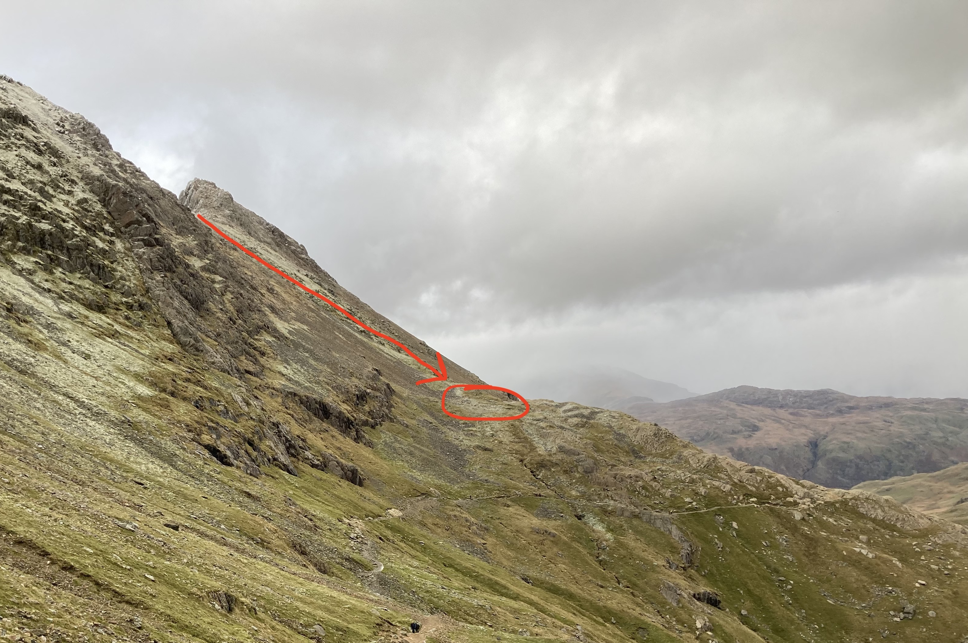
Figure 1: Estimated trajectory of the Casualty’s fall and where he landed. (Walker, 2022)

As soon as the party realised the Casualty had slipped and started sliding uncontrollably, they “instinctively started to rush down” (Brave Dave, 2020a, 03:37). The Leader's rushed approach of sliding down to find the Casualty and carry out first aid procedures could demonstrate a priority to deploy his technical skills to help the situation, which essentially put him and the other two walkers at risk of being casualties themselves. This could be a result of the emphasis on technical skills in NGB training and assessment, which can lead to practitioners favouring practical solutions (Hickman & Stokes, 2016). The skills checklist/syllabus for the Mountain leader qualification has only one section dedicated to non-technical skills; Leadership and Decision-making. The rest can be categorised as technical skills (Mountain Training, 2022). However, the fact that they started to rush down “instinctively” (Brave Dave, 2020a, 03:37) suggests that there was no considered leadership or decision making at all.

It could also be argued that this response was some version of “rescue altruism”. This phrase is generally used to describe when people impulsively attempt to rescue drowning victims (Pearn & Franklin, 2012) however in this scenario it could be used to explain why there was no decision making involved as to how to reach the casualty safely. Pearn and Franklin (2012) suggest that within the concept of rescue altruism there are three distinct themes that could contribute to such impulsive behaviour; duty, supererogation and altruism. Perhaps knowing that he was qualified as a Mountain Leader prompted some feeling of obligation and duty to act impulsively since he supposedly had the skills and knowledge to deal with such situations. As Long (2014, p.196) puts: “walkers owe a legal duty of care to other hill users who may be affected by their actions or failure to act.”

However the fact that the Leader was a qualified Mountain Leader would suggest that he would know that acting in such an instinctive way can be dangerous, especially on such steep terrain given that Mountain Training requires MLs to “Demonstrate the ability to manage a group and individuals and ensure safe travel on steep ground.” (2022, p.4). As a qualified Mountain Leader, it would be expected that he would “have a greater awareness of potential hazards than the rest of the group” (Long, 2014, p.196).

It is also worth mentioning that the shock of the incident may have contributed to acting impulsively and had an effect on the Leader’s ability to make considered decisions. Decision-making after a shock event is more likely to result in “a more intuitive” approach as a result of time pressured consequences (Bonn & Rundle-Thiele, 2007, p.619) and that this sense of urgency can contribute to acting without thinking (McKie & Richardson, 2003). This was also the first time the Leader had had to deal with an incident in the mountains (Brave Dave, 2020b) and effective leadership and decision making comes with experience (Long, 2014). Perhaps this urgency to act took over any training of how to respond to an emergency situation calmly due to a lack of experience of doing so.

In an ideal situation, if an accident happens, the first thing you should do is stay as calm as possible and take a moment to assess the situation and make a decision about what to do (BMC, 2010). The safety of yourself and others you are with is a top priority (BMC, 2010 & Mountain Training, 2022). In this scenario, the Leader could have taken a moment to make sure that themselves and Companions 1 & 2 could get into a stable position to decide what to do next (Carson, Davies and Collins, 2021). At that moment, perhaps it would have been best to call Mountain Rescue straight away given the severity of the fall, the fact that Mountain Rescue may take hours to arrive (BMC, 2010) and uncertainty as to whether they might have phone signal at all further down the slope.

Then, instead of sliding down to try and find the casualty, a more careful approach of kicking steps or edging their boots would have provided more stability (Glenmore Lodge, 2013) on steep ground. While this technique is commonly used in snowy terrain, given the slipperiness of the grass in this incident, edging would have been a good option. Furthermore, descending in a zigzag pattern would have been a safer way to descend. Having measured the South slope angle of the Bwlch Coch with a clinometer it is roughly 26-28° (given some margin of error). Downhill walking requires working hard to break due to acceleration (Llobera & Sluckin, 2007) even in dry conditions. Langmuir (1995, cited in Llobera & Sluckin, 2007) suggests that slopes with an angle of 25° should require zigzagging and so this slope in particular in the wet conditions should definitely have been approached in this way to avoid becoming casualties themselves.

When the party reached the Casualty, he was miraculously still alive and also conscious. Given that this was the case, everything that was said by the Leader and the two Companions would have had an effect on the Casualty’s levels of stress. While going about providing first aid and attempting to keep the Casualty warm, the Leader often vocalised his thoughts and fears through phrases such as “That’s the scariest thing I’ve ever seen, man” (Brave Dave, 2020a, 11:28) and “Okay, shit. The shock’s wearing off.” (17:40). An incident with someone so injured would understandably have this effect on the first responder however the emotional and mental wellbeing of the patient must also be taken into consideration and attended to (Carline, Lentz & Macdonald, 2004). Carline, Lentz and Macdonald (2004) even argue that Tender Loving Care (TLC) and attending to the casualty’s emotional needs is “one of the most effective remedies a first aider can provide.” (p.17). Given that this is the case, some words of calm reassurance could have been used to soothe any apprehension of the Casualty and some controlling of the Leader’s own emotions could have made the Casualty’s already stressful experience perhaps a bit less. However once again, the technical focus of NGB training does not cover these kinds of relational and intrapersonal skills such as emotional management (Hickman & Stokes, 2016), perhaps a reason why the Casualty’s emotional needs may not have been taken into consideration straight away.

The cold, wet and windy conditions of the day and the location of where the Casualty wound up meant that he was at serious risk of developing hypothermia. Given that the winds were Southwesterly that day (MWIS, 2020), and the party decided to escape down the South side of the Bwlch, they would have been hit fairly directly with all that 30mph wind. Hypothermia is a dangerous condition where the body’s core temperature drops below 35°C (NHS, 2020), can be caused by this kind of environmental exposure and increases the rate of mortality in severely injured patients (van Veelen & Maeder, 2021).

The Leader clearly prioritised insulating the Casualty as soon as he found him and it remained the main focus of his first aid response while they were waiting for Mountain Rescue. Spare fleeces were tucked around the Casualty in an attempt to insulate him from the ground. However it was difficult for them to be fully effective as his injuries prevented him from being able to move and get them underneath him. A two-person group shelter was also put over the Casualty as a vapour barrier which is a good method for treating hypothermia as it reduces heat loss by evaporation and keeps any insulation dry (Haverkamp, Giesbrecht & Tan, 2018). However, it is most effective when used in conjunction with an insulation layer underneath (Haverkamp, Giesbrecht & Tan, 2018) and so something like an insulating foil rescue blanket could have put on top of the Casualty to prevent any more cooling. Rescue blankets with reflective foil provide better insulation in comparison to other blankets due to their ability to compensate for the temperature already lost not just preventing further heat loss (Wallner et al, 2022).

Adding these kinds of layers is referred to as a passive method of dealing with hypothermia (van Veelen & Maeder, 2021). Active external rewarming is another method and can include using heat packs close to the chest and back (van Veelen & Maeder, 2021). Since the Leader and Companions did not have heat packs with them, they could have put down some bags (to insulate themselves from the ground) and Companion 1 (at this point Companion 2 was still on the phone to Mountain Rescue) could have lied down next to the Casualty under the group shelter in order to provide some extra heat and in doing so, Companion 1 would also be less at risk from hypothermia. This would also have contributed to the Leader’s effectiveness of keeping all of the group safe and also making better use of having another person available.

In this way, the equipment (and people) that were available could have been used more effectively to keep the Casualty warmer. It turns out that the Leader did have a foil blanket but “in the heat of the moment…I was like..just forgot it was there” (Brave Dave, 2020b,18:41). White (2019) links the reduction of the likelihood of human errors like forgetfulness with things like good diet and hydration as well as taking proper breaks. He writes of this in a workplace context but I believe it to still be relevant given Mountain Training’s requirements of “Manage self and group in a variety of different weather conditions including heat, cold, rain and high wind.” (2022, p.5 ). Taking the time to make sure that the Leader also took care of himself in this way could have led to him making better decisions and not forgetting where important kit was. Despite all of this critique, it should be noted that while the actions and decisions made could have been improved, they ultimately saved the Casualty’s life and therefore were effective.

To conclude, while some people who go out into the mountains may be qualified and skilled in the terrain, it still does not change the fact that mountaineering is an inherently dangerous activity, as highlighted in the BMC’s participation statement (2007). Nevertheless many people participate in such dangerous activities for a number of reasons including: getting away from the predictability of everyday life, wanting to be recognised for the skill that such activities require and connecting to the natural environment (Beames, Mackie & Atencio, 2019). With this in mind, it is very important that anyone who goes out into the mountains for whatever reason has a good understanding and relevant skills of how to deal with emergency situations.

I will be taking this understanding into my own practice for personal recreation and professional practice. In addition to getting qualified, I would like to get into the habit of regularly reflecting on experiences I have so that I can identify areas of improvement and overall develop my safety awareness skills (Hickman & Stokes, 2016). I also aim to put particular emphasis on developing my non-technical skills so that I may be able to manage emotions in an emergency situation. Visualising and practicing emergency procedures may also help to ensure that I can react in a safe and effective way. Knowing that the shock of an event could have an impact on my ability to make considered decisions (Bonn & Rundle-Thiele, 2007, p.619), having practiced emergency procedures will make them more likely to become second nature as opposed to impulsive reactions.

Elements of good practice demonstrated by those involved that I would like to take into my own practice include the priority of preventing the development of hypothermia. Since this is a very present threat anytime one participates in outdoor activities, it is an area of first aid that I would like to develop my proficiency in treating and preventing. An understanding of the different levels of effectiveness of insulation and rewarming strategies will help (Haverkamp, Giesbrecht & Tan, 2018), in addition to always being prepared with appropriate equipment and knowing exactly where it is when it is needed.

Word count: 2501

References

Beames, S., Mackie, C., and Atencio, M. (2019) Adventure and Society. Switzerland: Palgrave Macmillan.

Bonn, I., and Rundle-Thiele, S. (2007) Do or die - Strategic decision-making following a shock event. Tourism Management 28 (2007) 615–620

Brave Dave, (2020a) An Intense Day On Crib Goch (feat. Llanberis Mountain Rescue. [video] Available at: https://www.youtube.com/watch?v=CRf7CnhOzXY Accessed: 06/10/22
Brave Dave (2020b) Revisiting Ed’s Slope: A Follow Up To “An Intense Day On Crib Goch”. [video] Available at: https://www.youtube.com/watch?v=OmpWzwBTvXY Accessed on 29th November 2022

Carline, J.D., Lentz, M.J., and Macdonald, S.C. (2004) Mountaineering First Aid; A Guide to Accident Response and First Aid Care. (5th ed.) Great Britain: Cordee.

Carson, H.J., Davies, N., and Collins, L. (2021) The hills are alive with…Many different folk! Rationalising and operationalising a professional judgement and decision-making approach within mountain leadership. Journal of Adventure Education and Outdoor Learning, 21:4, 311-322, DOI: 10.1080/14729679.2020.1784768

Glenmore Lodge (2013) Kicking steps in snow. [video] Available at: https://www.youtube.com/watch?v=qa0MpRIcSFM Accessed on: 13th December 2022

Haverkamp, F.J.C., Giesbrecht, G.G., and Tan, E.C.T.H. (2018) The prehospital management of hypothermia — An up-to-date overview. Injury, Int. J. Care Injured 49 (2018) 149–164

Hickman, M. & Stokes, P. (2016) ‘Beyond learning by doing: an exploration of critical incidents in outdoor leadership education’, Journal of Adventure Education and Outdoor Learning, 16(1), pp. 63-77. DOI: 10.1080/14729679.2015.1051564

Llanberis Mountain Rescue Team. (2020) [Facebook] 8 March. Available at: https://www.facebook.com/watch/?v=2987899461231676 Accessed: 29th November 2022

Llobera, M. & Sluckin, T.J. (2007) Zigzagging: Theoretical insights on climbing strategies. Journal of Theoretical Biology 249 (2007) 206-217

Long, S. (2014) Hillwalking; The official handbook of the Mountain Training walking schemes. (3rd ed.) Mountain Training UK.

McKie, J., and Richardson, J. (2003) The Rule of Rescue. Social Science & Medicine 56 (2003) 2407–2419

Mountain Training, (2022) Mountain Leader skills checklist. Available at: https://www.mountain-training.org/qualifications/walking/mountain-leader Accessed: 06/10/22

Mountain Weather Information Service. (2020) Snowdonia national park General Summary for Saturday, 7 March 2020. Mountain Weather Information Service.

NHS (2020) Hypothermia. Available at: https://www.nhs.uk/conditions/hypothermia/ Accessed on: 14th December 2022

Pearn, J.H., and Franklin, R.C. (2012) “The Impulse to Rescue”: Rescue Altruism and the Challenge of Saving the Rescuer. International Journal of Aquatic Research and Education: Vol. 6: No. 4, Article 7.

The British Mountaineering Council (2010) Mountain incidents: what to do? Available at: https://www.thebmc.co.uk/mountain-incidents-what-to-do Accessed on: 13th December 2022

The British Mountaineering Council (2007) Risk and Safety. Available at: https://www.thebmc.co.uk/risk-and-safety Accessed on 14th December 2022

van Veelen, M.J., and Maeder, M.B. (2021) Hypothermia in Trauma. Int. J. Environ. Res. Public Health, 18, 8719. https://doi.org/10.3390/ ijerph18168719

Walker, R. (2022) Figure 1: Estimated trajectory of the Casualty’s fall and where he landed [photo]

Wallner, B., Salchner, H., Isser, M., Schachner, T., Wiedermann, F.J., and Lederer, W. (2022) Rescue blankets as multifunctional rescue equipment in alpine and wilderness emergencies: a commentary. Scand J Trauma Resusc Emerg Med (2022) 30:17 https://doi.org/10.1186/s13049-022-01005-5

White, J. (2019) Health and Safety Management; An Alternative Approach to Reducing Accidents, Injury and Illness at Work. Boca Raton: Taylor & Francis

