

Cover Page
BSc health and social care
Module- Changemakers: Building your Personal Brand for Sustainable Employment
Module code- BMHP5015
Student Name- Babita Masih
Student Number- 2409655
Assignment Title- Component 1: Online Portfolio of Set Exercises
Submission deadline- Sunday 5th July 2026
14:00 (2PM) - (Week 8)

Task 1 – Personal Brand
Write about your own person brand and how you could develop this to enable you to reach your employment goals (250 words- Minimum of 2 referenced sources)

My Personal Brand and How I Can Develop It to Reach My Employment Goals
People's perception of a person based on their skills, values, conduct, and professional image is known as their personal brand (Montoya and Vandehey, 2008). Being hard-working, trustworthy, flexible, and dedicated to lifelong learning are the cornerstones of my personal brand. These attributes, in my opinion, enable me to collaborate well with others and finish projects to a high standard. In both academic and professional settings, I value honesty, respect, and professionalism. I am also an effective communicator.
One of my key strengths is that I can speak multiple languages, including English, Punjabi, Hindi, and Urdu. Being multilingual allows me to communicate with people from different cultural backgrounds, build stronger relationships, and work effectively in diverse environments. This skill is particularly valuable in today's global and multicultural workplace, where employers often seek individuals who can communicate with a wide range of customers and colleagues.
Building my personal brand is crucial because it will enable me to reach my career objectives. Employers increasingly consider a candidate's reputation, online presence, and professional conduct alongside their qualifications (Shepherd, 2005). To strengthen my personal brand, I plan to continue improving my leadership, teamwork, and communication skills through education and work experience. I will also seek opportunities to participate in training programmes, volunteer work, and networking events to gain valuable experience and expand my professional network.
Additionally, I can develop my personal brand by creating and maintaining a professional online presence. Platforms such as LinkedIn allow individuals to showcase their achievements, skills, and experiences to potential employers. Maintaining a positive digital footprint and sharing relevant professional content can demonstrate expertise and commitment to professional growth (Montoya and Vandehey, 2008).
I can establish a positive personal brand that supports my long-term career goals by consistently demonstrating professionalism, learning new skills, and building strong relationships. A strong personal brand will help me stand out from other candidates, increase employment opportunities, and contribute to future career success.
References
Montoya, P. and Vandehey, T. (2008) The Brand Called You: Make Your Business Stand Out in a Crowded Marketplace. New York: McGraw-Hill.
Shepherd, I.D.H. (2005) 'From Cattle and Coke to Charlie: Meeting the Challenge of Self Marketing and Personal Branding', Journal of Marketing Management, 21(5–6), pp. 589–606.

Task 2 - Network Map and Rationale
Create a map of your own network considering career, support, social and community dimensions. Additionally you should provide a supporting rationale explaining and critically assessing this (250 words-Minimum of 2 referenced sources).

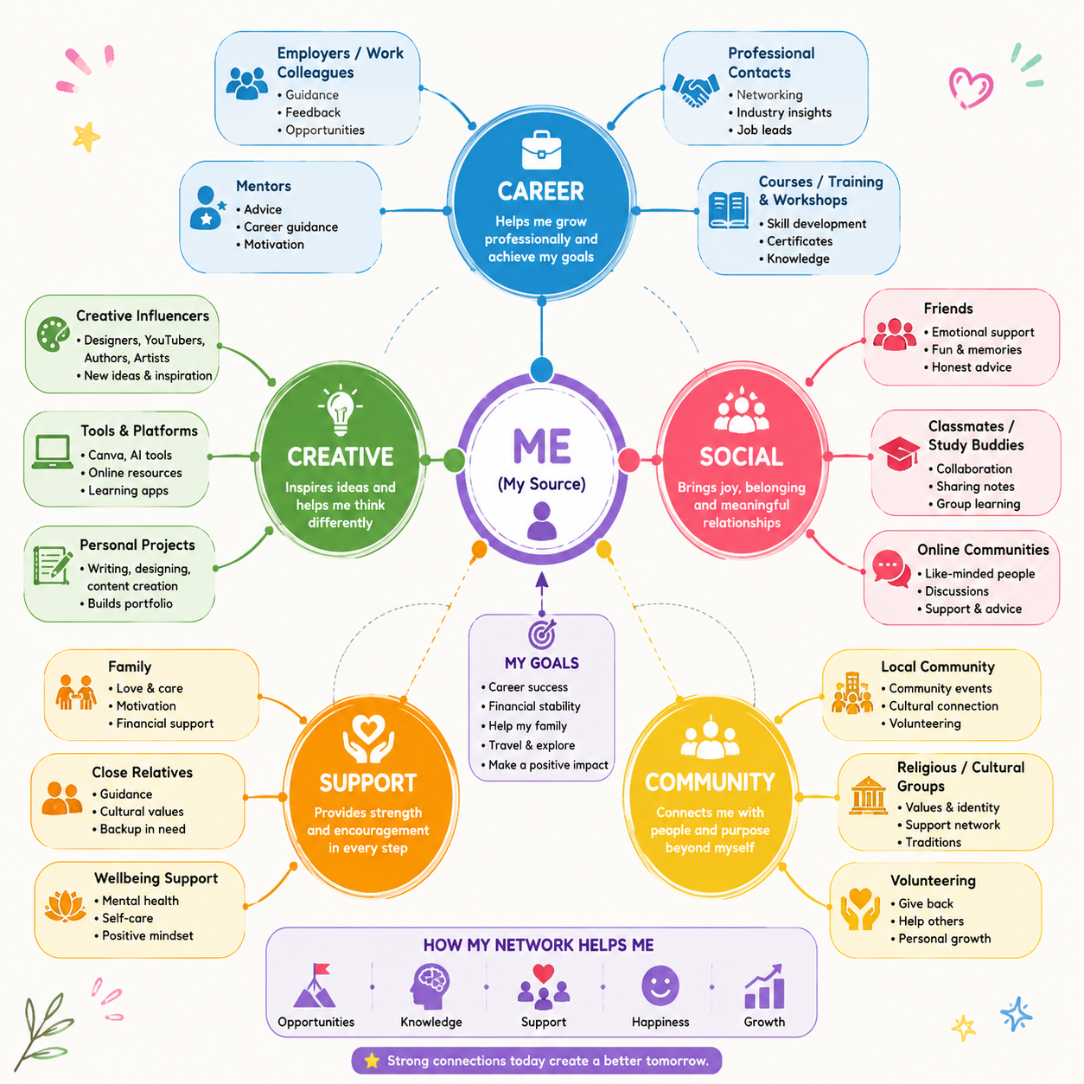
Task 2 – Network Map and Rationale
Figure 1 illustrates my personal network and the people who support my education, personal development, and future career goals. At the centre of the network map is me, surrounded by the different groups that influence my learning and personal growth.
I am currently studying Level 5 Health and Social Care and have successfully completed Level 1 and Level 4. As I have not yet started my professional career, my career network mainly includes my tutors, lecturers, classmates, and online learning resources. They help me develop the knowledge, confidence, and practical skills needed for future employment.
One of my strengths is being able to communicate in different languages. I can read, write, and speak English, Punjabi, and Hindi, and I can understand and speak Urdu. These language skills allow me to communicate with people from different backgrounds, which is valuable in health and social care. My support network includes my husband, children, family, and close friends. They encourage me to continue studying and motivate me to achieve my goals. Their support helps me balance my education with family responsibilities.
My social and community network includes classmates, neighbours, friends, and members of my local community. I enjoy helping people, especially children and older adults, which is one of the reasons I chose to study Health and Social Care. In the future, I hope to work with children and make a positive difference in their lives. I am also a quick learner who enjoys meeting new people and developing new skills.
Although my network provides strong personal support, I recognise the importance of expanding my professional network through volunteering, work placements, and networking opportunities. Granovetter (1973) suggests that wider networks can provide access to new opportunities, while Burt (2004) explains that diverse networks can support learning and career development. Therefore, continuing to build my network will improve my employability and help me achieve my future career goals.
References
Burt, R.S. (2004) ‘Structural Holes and Good Ideas’, American Journal of Sociology, 110(2), pp. 349–399.
Granovetter, M.S. (1973) ‘The Strength of Weak Ties’, American Journal of Sociology, 78(6), pp. 1360–1380.

Task 3- Blog
Write a blog exploring a current topic or issue of your choice within the health and social care sector in the UK. The purpose of this is to inform a specific target audience of your choosing (400 words) Referencing of your sources of information is not a compulsory requirement but could be beneficial.

The Impact of Social Media on Children's Mental Health in the UK
Target Audience: Parents and Carers
Children's daily life now heavily depends on social media. Young people can express themselves, learn new skills, and communicate with peers on platforms like YouTube, Instagram, Snapchat, and TikTok. However, even if social media has numerous advantages, if it is not used prudently and carefully, it may also have a negative impact on kids' mental health.
Many kids use social media for several hours every day. Sleep, focus, and mental health can all be impacted by too much screen usage. Children may develop low self-esteem, anxiety, and a negative body image because of comparing themselves to fake online photos. Another major problem is cyberbullying, which can have a long-lasting impact on a child's self-esteem and mental well-being.
Despite these disadvantages, social media also has many benefits. It allows children to stay connected with friends and family, access educational resources, and participate in supportive online communities. For some young people, social media provides a safe space to express their feelings, share their experiences, and seek advice about mental health. Rather than avoiding social media completely, the aim should be to encourage children to use it in a safe, balanced, and responsible way. Parents, carers, and schools can support this by promoting healthy online habits and helping children understand both the benefits and the risks of social media.
Supporting children is a primary responsibility of parents, carers, schools, and medical professionals. Adults should teach kids how to stay safe online, set reasonable screen-time limits, and promote open discussion about online experiences. The negative effects of social media can be decreased by creating a supportive home environment where kids feel at ease openly sharing their concerns.
This subject is significant to me as a student of health and social care because I intend to work with children in the future. Every child should, in my opinion, be raised in a safe and supportive setting where they may benefit from technology while safeguarding their mental health.
In conclusion, social media is neither entirely beneficial nor entirely harmful. It can promote education, communication, and personal growth when used appropriately. But in a shortage of direction and healthy balance, it can exacerbate mental health issues. Families, schools, and medical experts may work together to protect children's mental health and help them form good online habits.
References
NHS England (2024). Children and Young People's Mental Health Services (CAMHS).
YoungMinds (2024). Social Media and Young People's Mental Health.

Task 4- NHS Equality, Diversity and Inclusion Quiz (250 words equivalent)
- What is the primary goal of the NHS Equality, Diversity, and Inclusion Improvement Plan?
Improving equity, diversity, and inclusion within the NHS while building a deeper sense of community so that every employee feels appreciated, respected, and supported is the primary objective. Additionally, this enhances patient care and staff well-being

- How does the NHS EDI Improvement Plan propose to tackle the gender pay gap?
The proposal suggests looking at data on pay gaps, identifying disparities, and creating plans to close pay gaps related to gender, ethnicity, and disability through flexible work schedules and fair compensation.

- What is meant by the term ‘intersectionality’ as used in the NHS EDI Improvement Plan?
When a person has multiple protected characteristics, such as age, gender, race, or disability, they may encounter different forms of discrimination or disadvantage. This is known as intersectionality. The NHS EDI Improvement Plan acknowledges this to guarantee that inclusion and equality meet the needs of every employee.

- Why is it important for the NHS to create a psychologically safe work environment?
A psychologically safe workplace promotes employee welfare, teamwork, and patient safety by enabling employees to voice concerns, ask questions, and speak up without fear.

- How does the NHS EDI Improvement Plan suggest improving the experience of internationally recruited staff?
To make international employees feel included and appreciated, the strategy suggests offering thorough induction, cultural support, equitable access to training, and professional growth opportunities.

- What role does leadership play in advancing EDI objectives according to the NHS Improvement Plan?
Establishing quantifiable EDI goals, tracking advancement, and fostering an inclusive workplace where equality is a top priority are all expected of leaders.

- Identify one way the NHS EDI Improvement Plan aims to reduce health inequalities within the workforce.
Data collection aids in measuring progress, identifying differences, and ensuring that policies are just and supported by facts.

- Why does the NHS EDI Improvement Plan emphasise the importance of collecting and analysing data on protected characteristics?
Data collection aids in measuring progress, identifying disparities, and ensuring that policies are just and supported by facts.

- Explain how flexible working policies can contribute to equality and inclusion in the NHS workforce?
Employee retention, work-life balance, and equal access to professional prospects are all enhanced by flexible working arrangements.

- What is one strategy mentioned in the NHS EDI Improvement Plan to combat bullying and harassment in the workplace?
Establishing an inclusive culture where employees feel comfortable reporting bullying while leaders take steps to stop discrimination and foster respect is one tactic.

Task 5- A Letter to Yourself
Think of a time in the past when you may have been experiencing issues or difficulties, and after considering what you have learned in this module about emotional intelligence and resilience write a letter to your younger self explaining how these attributes were important at that time and perhaps how developing these areas could have been useful (300 words)
A Letter to Myself
Dear Younger me
I am aware that life has not always been simple and that there have been moments when you have questioned your own abilities and your capacity to reach your objectives. You didn't always believe in your own ability and usually prioritised the demands of others over your own. But I want you to know that every obstacle you experienced made you stronger.
You were born in India and later moved to the United Kingdom after getting married. Life changed quickly as you focused on your family and raising your children. At that time, you never imagined that one day you would return to education. You put your family's needs first and did not think you would have the opportunity to study again.
If I could give you one bit of advice, it would be to never stop learning and to have faith in yourself. Understanding your own emotions and identifying those of others are key components of emotional intelligence. You would have been better able to handle stress, communicate more clearly, and maintain composure in trying circumstances if you had acquired this ability sooner.
Another crucial trait that I wish you had recognised earlier is resilience. Challenges are a part of life, but they don't determine who you are. See challenges as chances to improve rather than as failures. Every challenge will strengthen you and get you ready for what lies ahead.
Today, I am studying Level 5 Health and Social Care after successfully completing Level 1 and Level 4. Completing my Level 4 qualification and graduating was one of the proudest moments of my life. I never imagined that I would wear a graduation gown or achieve a qualification after so many years away from education. Looking back, I feel incredibly proud of myself because this achievement has shown me that hard work, determination, and perseverance can make dreams come true. It has given me the confidence to continue my education and believe in my abilities
My family has supported me throughout this journey, and their encouragement has helped me stay focused and motivated. I have also realised that my ability to speak English, Punjabi, Hindi, and Urdu is one of my greatest strengths. It allows me to communicate with people from different backgrounds and will help me achieve my dream of working with children and making a positive difference in their lives.
Therefore, my advice to you is straightforward: have faith in yourself, never stop learning, and never assume that it is too late to fulfil your dreams. Your journey from India to the UK, becoming a wife and mother, and then going back to school demonstrates that you can do far more than you ever could have dreamed if you had hard work, determination, and family support.
With kindness,
Your Future Self

Task 6- GANTT Chart (200 words equivalent)
Compile a Gantt chart which illustrates the tasks you have to complete to achieve your future employment goals
Task 6 – Gantt Chart
Tasks | 2026 | 2027 | 2028
Complete Level 5 qualification | ███
Graduate from Level 5 | █
Update CV and LinkedIn profile | █
Gain voluntary/work placement experience | ███ | ██
Apply for Health & Social Care jobs |  | ███
Attend training and professional development |  | ███ | ██
Secure employment working with children |  | ███
Continue developing skills and qualifications |  | ██ |  | ███
Progress within Health & Social Care career |  |  | ███
Explanation
The main actions I intend to take to realise my long-term professional objective of working with children in the health and social care industry are shown in this Gantt chart. Getting my Level 5 qualification and graduating is my top priority. I intend to update my LinkedIn profile and CV after graduation to get ready for employment opportunities.
The next step is to gain real-world experience through volunteer work or job placements, which will boost my confidence and help me improve my professional abilities. After that, I'll apply for jobs in health and social care that include helping kids and teenagers.
I plan to keep going to training sessions and professional development programs after I have a job to advance my knowledge and abilities. To deliver high-quality care and advance in my job, I think lifelong learning is crucial. This plan will help me fulfil my goal of improving the lives of children and their families by giving me a defined schedule and achievable goals.

Task 7- Making Changes- Report
You are the manager of a care home and want to make changes your workplace. Identify one specific change that you want to implement and write a brief report on how this is going to be achieved considering the necessary skills needed and addressing possible barriers to success. Relevant change models can be highlighted (350 words Minimum of - 3 referenced sources).

Improving Communication Between Staff, Residents and Families
Introduction
To enhance information sharing between employees, residents, and their families, I would like to implement a new communication system as a care home manager. To provide safe, person-centred care and make sure that residents and their families feel informed and included in care decisions, effective communication is crucial. Effective communication and collaboration with service users and their families are key elements of person-centred care, according to the Care Quality Commission (CQC, 2023).
Implementing the Change
Before making this adjustment, I would meet with the staff to discuss the value of improved communication and how it will help the residents. I would offer instruction in record-keeping, attentive listening, efficient ways to communicate, and the use of digital or communication books. To get input and find any issues during the implementation phase, regular staff meetings would also be instituted. According to NHS England (2023), providing high-quality, person-centred care requires effective communication between staff, patients, and families.
Lewin's Change Management Model is what I would use to help with the procedure. The first phase, known as Unfreeze, would entail educating employees about the necessity of the change and getting them ready for it. Staff training and the introduction of the new communication protocols would be part of the second stage, Change. Lastly, constant monitoring and continuous assistance would help the new practices become integrated in daily routines during the Refreeze stage (Lewin, 1951).
Skills and Possible Barriers
Strong leadership, communication, teamwork, problem-solving, and organisational abilities are necessary for achievement of goals. To boost engagement and confidence, as a manager, I would encourage employees to discuss ideas and participate in decision-making.
Because they are comfortable with to their current habits or are concerned about learning new ones, some employees may be resistant to change. The implementation process may also be slowed by staff shortages and scheduling constraints. By offering suitable training, paying attention to staff concerns, providing ongoing support, and acknowledging minor victories during the transformation process, these obstacles can be lowered.
Conclusion
In addition to raising the standard of care, better communication will improve ties between staff, residents, and families. The care facility may successfully execute this transformation and establish a more positive and person-centred environment by utilising Lewin's transformation Management Model and promoting cooperation.
References
CQC (2023) Guidance for Providers on Person-Centred Care.
Lewin, K. (1951) Field Theory in Social Science. New York: Harper & Row.
NHS England (2023) Delivering High Qua

Reference List
- Burt, R.S. (2004) ‘Structural Holes and Good Ideas’, American Journal of Sociology, 110(2), pp. 349–399.
- Care Quality Commission (CQC) (2023) Guidance for Providers on Person-Centred Care.
- Granovetter, M.S. (1973) ‘The Strength of Weak Ties’, American Journal of Sociology, 78(6), pp. 1360–1380.
- Lewin, K. (1951) Field Theory in Social Science. New York: Harper & Row.
- Montoya, P. and Vandehey, T. (2008) The Brand Called You: Make Your Business Stand Out in a Crowded Marketplace. New York: McGraw-Hill.
- NHS England (2023) Delivering High-Quality, Person-Centred Care.
- NHS England (2024) Children and Young People's Mental Health Services (CAMHS).
- Shepherd, I.D.H. (2005) ‘From Cattle and Coke to Charlie: Meeting the Challenge of Self Marketing and Personal Branding’, Journal of Marketing Management, 21(5–6), pp. 589–606.
- YoungMinds (2024) Social Media and Young People's Mental Health.

