

Click to enter your name (e.g. First name(s) Family name)

Click here to enter the thesis title

Click here to enter your school
Click here and enter course title

Enter the award for which the thesis is submitted (eg MSc, PhD)
Academic Year: year - year

Supervisor: Enter the name of your supervisor
Associate Supervisor: Enter the name or delete if not applicable
Month Year

Click here to enter your school
Click here and enter course title

Enter the award for which the thesis is submitted (eg MSc, PhD)

Academic Year year - year

Click to enter your name (e.g. First name(s) Family name)

Click here and enter the thesis title

Supervisor: Enter the name of your supervisor
Associate Supervisor: Enter the name or delete if not applicable
Month Year

This thesis is submitted in partial fulfilment of the requirements for the degree of Enter degree
(NB. Remove if the degree award is based solely on examination of the thesis)

© UWTSD year. All rights reserved. No part of this publication may be reproduced without the written permission of the copyright owner.

Academic integrity declaration
I declare that:
- the thesis submitted has been written by me alone.
- the thesis submitted has not been previously submitted to this university or any other.
- that all content, including primary and/or secondary data, is true to the best of my knowledge.
- that all quotations and references have been duly acknowledged according to the requirements of academic research.
I understand that to knowingly submit work in violation of the above statement will be considered by examiners as academic misconduct.

Abstract
Click here to enter abstract text of not more than 300 words.

Keywords:
Click here to enter at least 6 keywords (not contained within the thesis title) – this makes the thesis searchable.

Acknowledgements
Click here to enter acknowledgement text.

Table of Contents
Academic integrity declaration i
Abstract ii
Acknowledgements iii
List of Figures vi
List of Tables vii
List of Equations viii
List of Abbreviations ix
1 Guidance (Chapter title (use heading 1)) 1
1.1 Section heading (use Heading 2) 1
1.1.1 Subsection heading (use Heading 3) 1
1.2 Section Breaks 1
1.3 The UWTSD logo and co-branding 2
1.3.1 Using UWTSD text in place of a logo 2
1.3.2 Adding a partner logo 2
1.4 Inserting captions in the main document 3
1.4.1 Referring to captions for figures, tables etc 4
1.5 Updating Tables of Contents, Lists of Figures and captions 4
1.6 Inserting landscape pages 4
2 Chapter title (use Heading 1) 6
2.1 Section heading (use Heading 2) 6
2.1.1 Subsection heading (use Heading 3) 6
3 Chapter title (use Heading 1) 7
3.1 Section heading (use Heading 2) 7
3.1.1 Subsection heading (use Heading 3) 7
4 Chapter title (use Heading 1) 8
4.1 Section heading (use Heading 2) 8
4.1.1 Subsection heading (use Heading 3) 8
5 Chapter title (use Heading 1) 9
5.1 Section heading (use Heading 2) 9
5.1.1 Subsection heading (use Heading 3) 9
6 Chapter title (use Heading 1) 10
6.1 Section heading (use Heading 2) 10
6.1.1 Subsection heading (use Heading 3) 10
7 Chapter title (use Heading 1) 11
7.1 Section heading (use Heading 2) 11
7.1.1 Subsection heading (use Heading 3) 11
8 Chapter title (use Heading 1) 12
8.1 Section heading (use Heading 2) 12
8.1.1 Subsection heading (use Heading 3) 12
9 Chapter title (use Heading 1) 13
9.1 Section heading (use Heading 2) 13
9.1.1 Subsection heading (use Heading 3) 13
References 14
Appendices 15
Appendix A Ethical approval letter 15
Appendix B Appendix guidance (Appendix title (use Heading 7)) 16
Appendix C Appendix title (use Heading 7) 18

List of Figures
Figure 1-1 A figure caption 2

List of Tables
Table 1-1 A table caption 2

List of Equations
(1-1) 2

List of Abbreviations
IT | Information Technology

Guidance (Chapter title (use heading 1))

Section heading (use Heading 2)

Subsection heading (use Heading 3)
Heading styles 1-6 should be applied to the headings throughout the main body of your thesis as they are the basis for the Table of Contents and caption numbering. Headings 7-9 have been modified specifically for use in the Appendices. The appearance of the headings can be changed by modifying the relevant Heading styles.
There is no need to leave blank lines between paragraphs as the Normal style (in addition to 1.5 line spacing) automatically incorporates spacing between paragraphs. The style Table Text can be applied to tables to reduce the line spacing.

Referring to Headings
To create a cross-reference to a heading:
- Click on the References tab on the Ribbon
- Select the Cross-reference command to open the Cross-reference window
- Under Reference Type choose Heading
- Under For which heading choose your heading
- Under Insert Reference To choose Heading Number and click Insert. Repeat to insert the Heading Text
- Click Close

Section Breaks
This document relies on section breaks to control page layout, page numbering and so on. It is recommended that you work with the non-printing characters visible at all times to minimise the risk of accidentally deleting the section breaks. The Show/Hide button is located in Paragraph group on the Home tab of the Ribbon.

The UWTSD logo and co-branding
It is preferred that the UWTSD logo is positioned at the top of the cover and title pages of the thesis document. However, if it is not appropriate to show the UWTSD logo, then it can be removed and replaced by the text as described below.
If you are working with a partner on the research included in this thesis document, you may, subject to their approval, also include their official logo as co-branding on the cover and title pages. Guidance is provided below.

Using UWTSD text in place of a logo
If appropriate you may remove the UWTSD logo from the cover and title pages of the thesis and in its place use the text “UWTSD”.
To remove the UWTSD logo:
- at the top of the cover/title page, delete the logo.
- at the same position, type the text UWTSD, ensuring it is centrally positioned and formatted as Arial 14pt.

Adding a partner logo
Before using a partner logo in this document you must:
- obtain permission from the partner to use their logo in this document.
- obtain a high-resolution logo from the organisation – do not take a screen-shot from the website.
To add the partner logo as co-branding:
- copy the table below.
- at the top of the cover and title page, delete the existing UWTSD logo.
- at the same position paste the table from above, ensuring that:
  - the logo UWTSD logo size is maintained as 4.4 cm x 4.4 cm, and
  - the centre column width is no less than 4.4 cm.
- In the right-hand column of the table, insert the high-resolution partner logo.

Inserting captions in the main document
Captions should be used whenever you insert a graphic, table or equation – to add a caption choose Insert Caption from the References tab on the Ribbon. Specify whether the label should be Figure, Table or Equation or create a new caption of your own.
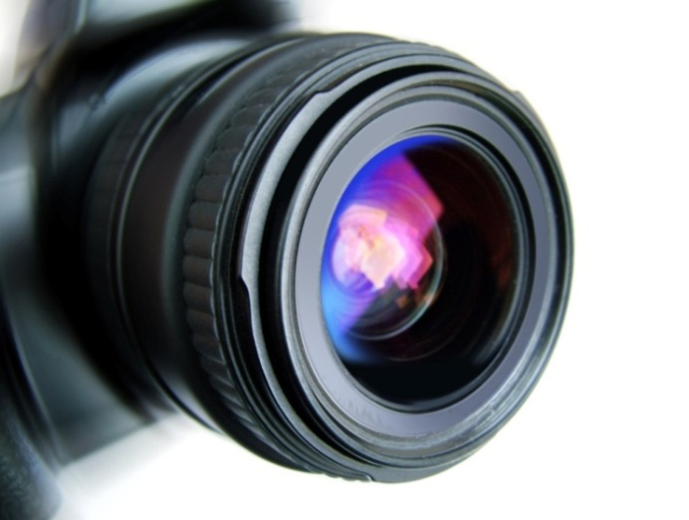
Figure 1-1 A figure caption
Table 1-1 A table caption
 | Heading | Heading
Label | Detail | Detail
Label | Detail | Detail
Equations and their captions can be placed ‘side-by-side’ by moving the equation and the caption into the cells of a borderless, 2 column x 1 row table as shown below. Simply copy and paste this table as many times as you need to for all subsequent equations, but remember to periodically highlight and update the equation captions by pressing the F9 key (or right-click and select Update Field from the shortcut menu).
$$a^{2}+b^{2}=c^{2}$$ | (1-1)
For information on inserting captions in appendices see Appendix A.

Referring to captions for figures, tables etc
Use a cross-reference when you want to insert text similar to ‘… as shown in Figure 5.1, below’
- Click on the References tab on the Ribbon
- Select the Cross-reference command to open the Cross-reference window
- In the Reference Type drop-down list choose the appropriate label
- Under For which heading choose your figure
- Under Insert Reference To choose Only label and number and click Insert. Repeat to insert either above/below or page number if required
- Click Close

Updating Tables of Contents, Lists of Figures and captions
Your table of contents, lists of figures and caption numbers will update automatically whenever you re-open the document, however you can ‘force’ an update at any time by highlighting the table or text and pressing the F9 key (or right-click and select Update Field from the shortcut menu). To update all fields in a document press Ctrl+A then F9.

Inserting landscape pages
It is often preferable to use a landscape page to display tables of data, charts or diagrams. Before changing an existing page from portrait to landscape it is necessary to enclose the page within a pair of next page section breaks. It may also be necessary to modify the page number format to ensure that page numbering continues from the previous section.
To insert a Next Page Section Break:
- Click to place the insertion point where you would like to switch from portrait to landscape page orientation.
- Go to the Page Layout tab on the Ribbon
- Select the Breaks command and choose Next Page from the drop down list
- Repeat steps 1-3 to insert a second Next Page Section Break at the point where you wish to switch back to portrait orientation
- Click somewhere between the 2 new section breaks and use the Orientation command on the Page Layout tab to change page orientation from portrait to landscape.

Chapter title (use Heading 1)

Section heading (use Heading 2)

Subsection heading (use Heading 3)

Chapter title (use Heading 1)

Section heading (use Heading 2)

Subsection heading (use Heading 3)

Chapter title (use Heading 1)

Section heading (use Heading 2)

Subsection heading (use Heading 3)

Chapter title (use Heading 1)

Section heading (use Heading 2)

Subsection heading (use Heading 3)

Chapter title (use Heading 1)

Section heading (use Heading 2)

Subsection heading (use Heading 3)

Chapter title (use Heading 1)

Section heading (use Heading 2)

Subsection heading (use Heading 3)

Chapter title (use Heading 1)

Section heading (use Heading 2)

Subsection heading (use Heading 3)

Chapter title (use Heading 1)

Section heading (use Heading 2)

Subsection heading (use Heading 3)

References
You must use the IEEE referencing standard
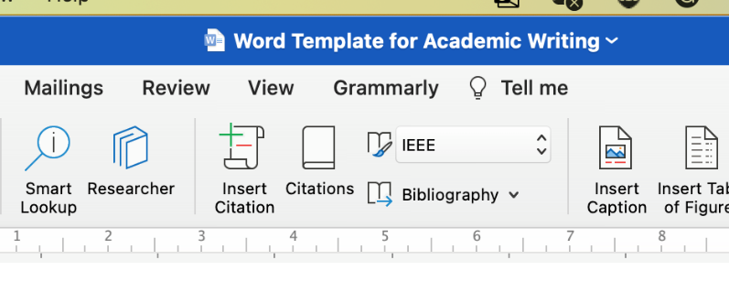
Click here to enter reference list.

Appendices
Whilst Heading 1 to Heading 6 can be used to number headings in the main body of the thesis, Heading styles 7–9 have been modified specifically for lettered appendix headings with Heading 7 having the ‘Appendix’ prefix as shown below.

Ethical approval letter
Click here to insert your ethical approval letter as the first appendix, i.e. Appendix A.

Appendix guidance (Appendix title (use Heading 7))

Appendix section (use Heading 8)

Appendix subsection (use Heading 9)

Creating captions in appendices
If you have chosen to include chapter numbers in your captions, then follow the instructions given here to apply the same format to the captions in your appendices. This section explains how to caption the figures and tables in your Appendices, assuming that Heading 7 is numbered “Appendix A” and that the Figures and Tables are going to be labelled ‘Figure A-1’, ‘Figure A-2’, ‘Table B-1’ etc.
You will have to create new, separate labels that look like the ‘Figure’ and ‘Table’ labels you used in the main body of your thesis.
- Select the References tab on the Ribbon then click on Insert Caption
- Click New Label. Type Figure_Apx then click OK
- You now have two labels for figures, called Figure and Figure_Apx
Repeat for table captions.
- In the Caption box, type your caption text
- Click Numbering. Tick Include chapter numbering and choose Heading 7 from the drop-down list of styles and click OK twice
- Your caption should look something like this:
Figure_Apx A-1 This is the caption text for a Figure in the Appendix
- Delete the extraneous ‘_Apx’ from the caption label so it reads:
Figure A-1 This is the caption text for a figure in the appendix.
TIP: Instead of deleting each ‘_Apx’ individually use Find & Replace to modify all the labels at once.

Creating Lists of Figures and Tables for Appendices
This template already includes a List of Figures and a List of Tables, however you will have to create two new lists for the ‘Figure_Apx’ and the ‘Table_Apx’ labels.
- Place the insertion point on a blank row after the existing List of Figures
- Select the Insert Table of Figures command on the References tab of the Ribbon
- Set the Caption Label box to ‘Figure_Apx’ and click OK
Note: Word will put a single blank line between the original list and the new list preventing it from appearing as one seamless list. However, if you select the blank paragraph between the tables you can hide it by opening the Font dialog box from the Home tab and selecting Hidden.
- Click after the List of Tables and repeat for the Caption Label ‘Table_Apx’.

Appendix title (use Heading 7)

Appendix section (use Heading 8)

Appendix subsection (use Heading 9)

