

“Case Study on Acquisition of ARM Holdings by Softbank Group”

Module: STRATEGIC CHANGE AND ORGANISATIONS

Module Code: LCDB7005

Assignment: 1

Prepared By:
Student Number: 1807120

Prepared For:
Dr. Gladius David Kulothungan

Date: 20/09/19

Table of Contents
1) Introduction: 3
2) Company Overview: 3
2.1) Softbank Group: 3
2.2) ARM Holdings: 4
3) Motives and Reasons Behind the Acquisition Decision: 5
3.1) Gain Market Competitiveness: 5
3.2) Opportunities to Gain Strong Position in Next Paradigm Shift: 6
3.3) Opportunities of Expansion through ARM Holdings: 7
3.4) ARM Holding’s Expertise in Developing Artificial Intelligence (AI): 8
3.5) Gaining Ownership of Internet of Things (IoT): 9
3.6) Gain Competitive Advantage by Acquiring an Already Established Business: 9
1) Threat of New Entry (Very Low): 10
2) Threat of Substitution (Very Low): 11
3) Bargaining Power of Buyers (Low): 11
4) Bargaining Power of Suppliers (High): 11
5) Competitive Rivalry (Very High): 12
4) Changes to Both Parties: 13
4.1) Shared Organizational Culture: 13
4.2) Changes in Management and Employee Base: 13
4.3) Changes in Trading Facilities and Share Scheme: 14
4.4) Changes in Source of Fund and Business Diversification: 14
5) Post-Acquisition Performance Measurement through KPI’s: 15
5.1) Revenues, Investments and Profits: 15
5.2) Market Share: 16
5.3) Market Value: 18
5.4) Royalty and Licencing: 19
5.5) Increased Job Opportunity: 20
6) Conclusion: 21
7) References: 22

Case Study on Acquisition of ARM Holdings by Softbank Group

Introduction:
New business ventures are emerging, and existing business organizations are rejuvenating themselves with the introduction of globalization. One of the best approaches implemented by the firms around the world to tackle business competition and re-establish the structure of business is known as Merger and Acquisition (M&A) approach (Korican et. al 2014). As per Soundarya et al. (2018), in merger, two or more firms form a new company by continuing the function of one firm in order to increase operational efficiency and to decrease competition. On the other hand, in acquisition, bigger sized organization purchases smaller sized organization to gain control of the ownership. According to Tamosiuniene and Duksaite (2009), organizations involve in M&A deals due to three key reasons. First reason is growth, second reason is synergy and third reason is accessibility to intangible assets. In the year 2016, one acquisition news became talked of topic in business world, which was the acquisition of ARM Holdings by Softbank Group. This study aims to understand the key motives and overall strategy of this acquisition, as well as analysing and evaluating the viewpoints of both ARM Holdings and Softbank Group for following the acquisition strategy.

Company Overview:
2.1) Softbank Group:
Softbank Group is widely known as internet-based innovator, which is one the largest public company in the world. It is a Japanese multinational conglomerate holding company which operates a wide range of sector leading businesses in information industry. During the late 20th century and early 21st century, Softbank focused on business expansion. Creating joint venture with Yahoo company and establishing Yahoo! Japan in late 90’s gave Softbank a strong position in internet industry as it turned out to be the most dominant internet side in Japan. Not only that, one of the most successful business strategies implemented by Softbank Group till date is the investment of $20 million in 2000 on Chinese venture Alibaba which turned into $60 billion in 2014 once Alibaba went public (Softbank Group, 2017). Questions were raised when Softbank Group signed the agreement to acquire Vodaphone as telecom industry was already in the maturity stage of the product life cycle. However, the ambition of Softbank was to grow as one of the most powerful company in the world (Financial Times, 2017). With 15 million subscribers and coverage offered to over 90% of the Japanese population, this decision of acquisition was already a success story in technology industry (Softbank Group, 2017).

2.2) ARM Holdings:
In 2016, Softbank Group again hit the headlines of business news around the world when the company announced its intention to buy Arm Holdings which was the market leader in chip designing. ARM Holdings is also known as the largest British technology company. Microchips of 95% world’s mobile devices are designed by Arm Holdings. Tech Giants such as Apple, Samsung, Huawei relies on Arm Holdings to design mobile processors (Arm Holdings, 2017). One of the crucial aspects to look into this acquisition is the timing of the decision for acquiring Arm Holdings. According to Forbes (2016), it was a good time for Softbank Group to bargain for Arm Holdings just prior the Brexit decision was made. On one hand, the Prime Minister at the time, Theresa May was more likely to push back the deal in order to protect British businesses from foreign ownership. However, with the likelihood of facing currency deficit due to post Brexit economic situation, the stakeholders were more interested in £17 a share in cash which was around $32 billion offered by Softbank Group to ARM Holdings. As it was 43% more than the closing share price of ARM Holdings, the board of directors of Arm Holdings were pleased to reach to an agreement with Softbank Group for the acquisition.

Motives and Reasons Behind the Acquisition Decision:
According to a report published on Forbes (2019), CEO of London based tech investment fund GP Bullhound believes that, the prime motive of this acquisition by Softbank Group was not to selling in to Europe but to bring talent and technology together. However, it can clearly be said that the decision of Softbank Group to acquire ARM Holdings was surrounded by number of business motives and operational goals. A discussion regarding those motives is shown in below:

3.1) Gain Market Competitiveness:
In order to stay competitive in the market, big cash leaders such as Google, Microsoft, Facebook, Apple are more incentivised to take over the potential tech-based start-ups. Mobile device market is significantly moving forward due to the crafted designs of low powered microchips by ARM Holdings. According to Business Insider (2019), ARM Holdings have done so well to design these low power microchips that it has almost got companies biggest rival ‘Intel’ out of this huge and lucrative market. As chips designed by ARM Holdings already powering the smartphones, tablets and smart watches in current market, Softbank Group’s target in 2016 was to get 25% market of the low power chips for computer servers by 2020. Which is only possible by acquiring ARM Holdings (Business Insider, 2016).

3.2) Opportunities to Gain Strong Position in Next Paradigm Shift:
Starting from the PC distribution, information technology has subsequently shifted to PC internet to PC broadband. Currently tech world is dominated by mobile internet which is largely dependent on the microchips designed by ARM Holdings. Softbank Group was quick to visualise the future of next paradigm shift which is IoT (Internet of Things) (ARM Holdings, 2019). As world is becoming increasingly connected and companies are focusing on digitalization to differentiate in order to remain competitive in the market. IoT enables data to be generated from billions of intelligent devices that generates massive volume of data, lowers down the cost, improves production quality, efficiency, responses on market demand and creates business opportunities. Softbank Group saw the future in ARM Holdings and grabbed the opportunity to have competitive edge over the competitors.
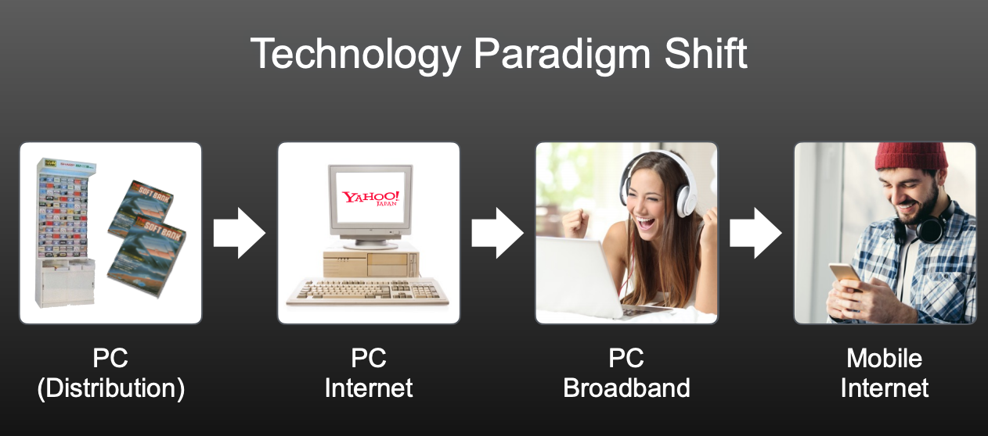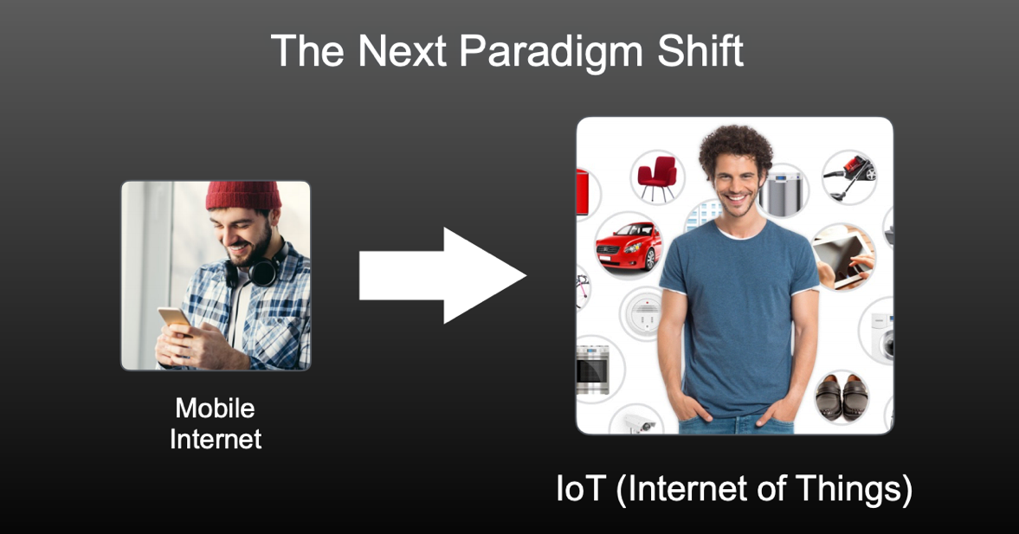
Figure 1: Paradigm Shift
Source: Softbank Group Strategic Agreement (2017)

3.3) Opportunities of Expansion through ARM Holdings:
By acquiring ARM Holdings, Softbank not only have got hold of the microchip industry but alongside, other industries as well. Industries such as automotive industry, consumer electronics industry and computer networking industry. According to the ARM Holding Q1 (2017) report, in 2016, ARM holdings market share in automotive was 10% and Total Available Market (TAM) was $11 billion. Whereas by 2015, expected TAM will be $17 billion. Similarly, market share in consumer electronics was 35% and TAM was $20 billion, which also expected to be increased to $25 billion by 2025. In networking infrastructure market share was 17% and TAM was $13 billion which is also expected to be increased to $18 by 2025. All these expected increase in Total Available Market, means growth opportunity for ARM Holdings, meaning overall growth opportunity for Softbank Group. Not only this, mobile application processors, servers and embedded intelligence are all likely to create bigger growth opportunity for Softbank.

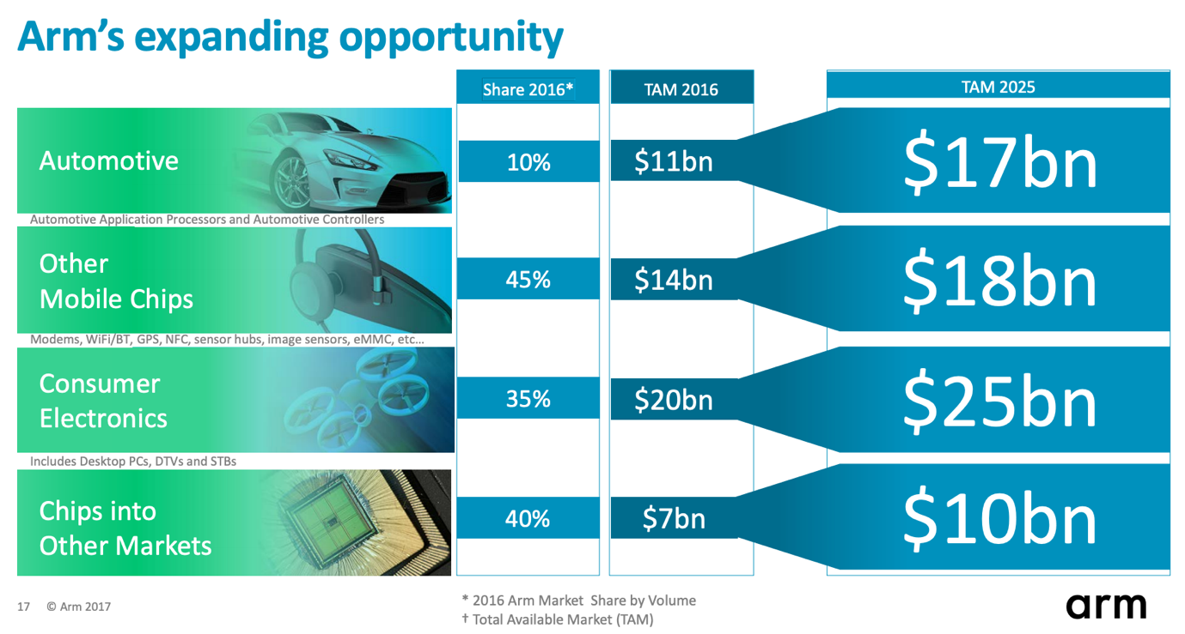
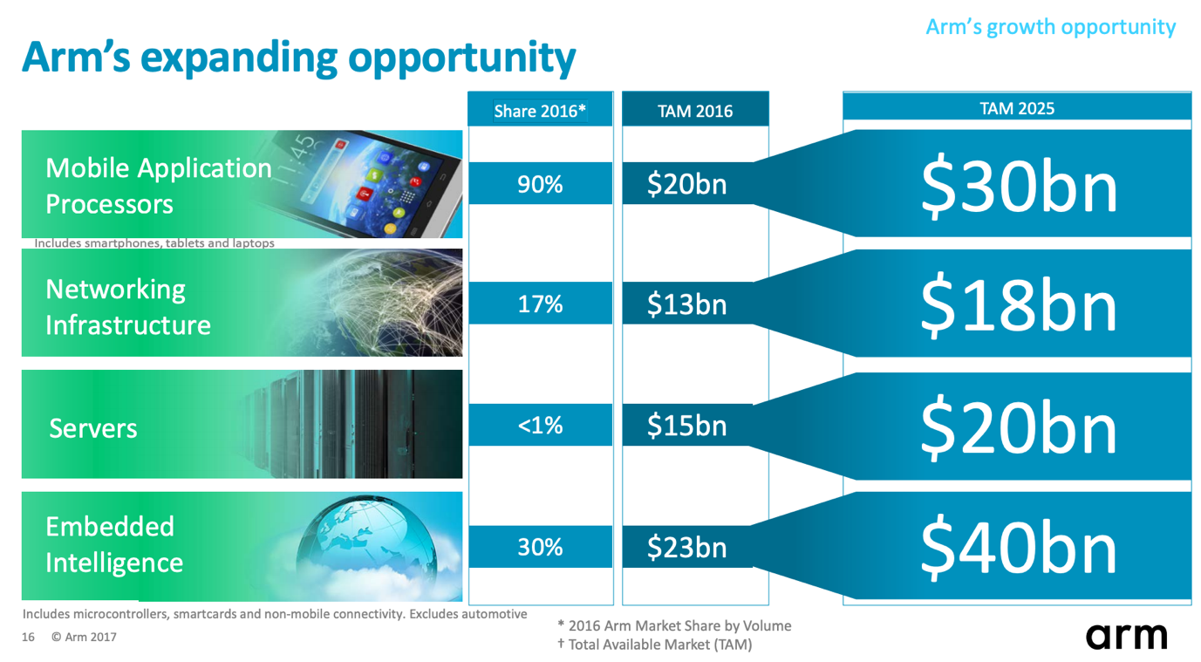

Figure 2: ARM’s Growth Opportunity
Source: ARM Holdings Q1 Roadshow (2017)

3.4) ARM Holding’s Expertise in Developing Artificial Intelligence (AI):
CEO of Softbank Masayoshi Son firmly believes that within this century, human will be overtaken by AI not only in terms of knowledge but also in terms of intelligence (Business Insider, 2019). ARM Holdings engineers are working on Artificial Intelligence (AI) and Machine Learning (ML) projects in order to design applications that will change the way human interacts with machines and devices (ARM Holdings, 2019). These modern machines and devices will be able to analyse large quantity of data and will have anonymous decision-making ability like humans. By adding Machine Learning (ML) capabilities in technologies and software’s, ARM Holding is combining Artificial Intelligence in trillions of edge devices which will result in smarter, more affordable and energy efficient software in future (ARM Holdings, 2019). As CEO of Softbank Group Masayoshi Son believes in singularity and Softbank have long been working in making robots that can read human emotions, therefore acquiring ARM Holdings will provide Softbank Group the opportunity to adopt intellectual property of ARM Holdings and will benefit Softbank Group to use the AI embedded software’s to use in the robots that the company makes. It will open the door of all opportunities for Softbank Group in future (Business Insider, 2016).

3.5) Gaining Ownership of Internet of Things (IoT):
World is progressing towards connectivity. IoT is a giant network that connects things. ARM Holdings already have proven track record of innovation and proven capabilities of shaping IoT. According to Forbes (2018), one of the primary reasons for Softbank Group to acquire ARM Holdings was to get ownership of IoT. Deep industry expertise, global relationships network and investment strategy of Softbank Group will help to sustain long-term growth of ARM Holdings. Not only that, ARM Holdings have been working on layering the security for upcoming one trillion devices. As cyber security is one of the prime concerns across all sectors of businesses, educations, governments, industries and so on. Therefore, ARM Holdings operations on providing secured devices in future was a great business opportunity for Softbank Group. The portfolio of ARM’s security is built up on Platform Security Architecture (PSA) framework, that allows quick identification of threats in a system. This platform also recommends and describes the finest measures to counter any problems (Softbank, 2019). It is considered as the future of cyber security which aims to increase ARM Holding designed devices to be in trillion devices by 2035. This was a huge opportunity for Softbank Group.

3.6) Gain Competitive Advantage by Acquiring an Already Established Business:
By the time Softbank Group decided to acquire ARM Holdings, it had already established itself as the market leader in microchip industry. Tech giants such Apple, Samsung, Huawei are already fixed clients of ARM Holdings. The business structure of ARM Holdings sets itself as a growing company in the market. With this acquisition, Softbank Group have also become successful in extending its global reach. This acquisition is considered as the biggest investment by an Asian organization in the United Kingdom (Financial Times, 2018). With this acquisition, Softbank have been successful in expanding its business network as current business partners and clients of ARM Holdings are now also related with Softbank Group. Not only that, Softbank committed the board of directors that the head office of ARM Holdings will remain in Cambridge, UK as it is well positioned and will be helpful to accelerate the long-term growth for ARM Holdings (Softbank Group, 2016). By taking this decision, Softbank is not only gaining the advantage of boosting, accelerating and delivering ARM Holding’s strategic goals but also it is helping Softbank to manage economic sustainability.

From the above discussion, conclusion can be drawn that the main motive of Softbank Group to acquire ARM Holdings was to gain competitive advantage from the deep pool of technology-based talent. It can also clearly be said that Softbank Group have done a sound risk assessment prior deciding to acquire the world’s number one chip designer and manufacturer ARM Holdings. Being a Japanese technology vendor, it was not an easy task to purchase an already established British multinational semiconductor and software designing company. There was always government pressure to take down this acquisition proposal. However, Softbank Group proposed a lucrative deal of $32 billion with $17 a share that the board of directors of ARM Holdings could not refuse. This was a well-planned strategic decision taken by Softbank Group as proposal was made just within the three weeks of the referendum decision of Brexit (Fortune, 2016).

Analysis of the Porter’s Five Forces in light of this acquisition decision is shown in below:

- Threat of New Entry (Very Low):
Technology is booming and will continue to grow in future as not only social world, but business world is highly dependent on technology. Semiconductor industry has a complex business structure and requires high level of expertise and massive capital. The requirement of continuous innovation and huge capital expenditure for start-up, makes it a strong barrier for new entrants (Rahman, 2014). ARM Holdings is currently the microchips provider of over 90% of the mobile devices which includes giant clients such as Apple, Samsung and Huawei. Unless a new entrant comes up with a new business strategy based on innovation and have a huge cash backup, the threat of new entrants is considerably very low for ARM Holdings/ Softbank Group.

- Threat of Substitution (Very Low):
There are two things that can make threat of substitution high. One is the performance of the substitute and other is the cost of change. In both cases, ARM Holdings/ Softbank Group are in a safe position. ARM Holding is known for manufacturing low cost, high performance mobile processors that has taken the biggest rival Intel almost out the mobile device market. Therefore, there is hardly any similar quality substitute available in the market. As there is hardly any substitute in the market, cost of change is almost out of the equation. This makes threat of substitution very low for ARM Holdings/ Softbank Group. Investments by Softbank Group is allowing ARM Holdings to focus on innovation and making the ARM products non-replaceable. However, due to continuous innovation process, the nature of this industry can change very quickly.

- Bargaining Power of Buyers (Low):
ARM Holdings is a strong player in the semiconductor industry. Number of buyers within this industry is endless and buyers are very price sensitive. Biggest challenge for ARM Holdings is that Intel is still market leader in manufacturing sector. Intel continuously lowers the price to push the demand of their product. However, apart from Intel, there is hardly any strong competition for ARM Holdings/Softbank Group in this industry. Acquisition by Softbank has also provided ARM Holdings solid foundation for finance to carry out research and development. Strong position of both Intel and ARM Holdings as well as lack of substitution have made buyers bargaining power very low.

- Bargaining Power of Suppliers (High):
The biggest advantage in the semiconductor industry is that there are thousands of suppliers in the market. However, due to the nature of the business process, the bargaining power of suppliers in this industry is relatively high. As the industry is dependent on innovation and requires specialized equipment’s, most of the semi-conductor companies like ARM Holdings depend on specific suppliers, making the suppliers bargaining power high. However, as ARM Holding is now part of one of the largest diversified organization known as Softbank Group. It increases the chance for ARM Holdings to network with new and promising suppliers to run the operation smoothly.

- Competitive Rivalry (Very High):
ARM Holdings operates in a highly competitive industry where competition takes place among rivals to manufacture products that are smaller in size, cheaper in price and powerful in performance. As technology changes rapidly, therefore the industry transforms quickly. As a result, competition tends to very high among competitors to innovate new product and get the biggest bite of the market. For example: If Intel manufactures a microchip to be used for HP laptops, ARM Holdings will try to bring up something unique for Samsung laptops to get hold of the laptop market. ARM Holdings already gained competitive advantage with mobile chip technology, where as Intel is considered as the best manufacturer of laptop microprocessors. Due to the emergence of cutting-edge technology, competitive rivalry is very high in this industry.

Changes to Both Parties:
4.1) Shared Organizational Culture:
Softbank Group CEO Masayoshi Son believes that even though both organizations have differences in organizational culture due to their origin and geographical setup, it will hardly make difference to the business process of ARM Holdings (Softbank Press Release, 2016). Southbank Group is of Asian origin, a Japanese internet to telecom conglomerate and ARM Holdings is a British originated microchip manufacturer. However, this acquisition will not stop both organizations to follow the same technology-oriented culture (Business Insider, 2016). Both organizations will continue to focus on innovating, committing to attract, developing and retaining top talents. These are considered as common and shared values for both Softbank Group and ARM Holdings, which will continue to contribute as the foundation of strong strategic partnership to capture future opportunities. As the head office of ARM Holdings remains in Cambridge, UK and the organization will continue to work as a separate entity, therefore organizational culture of both Softbank Group and ARM Holdings will stay protected in long-term (Softbank Group, 2019).

4.2) Changes in Management and Employee Base:

Even after the acquisition, Softbank Group promised to continue valuing the skills, knowledge and expertise of existing management and employees of ARM Holdings. According to the management of Softbank Group, regardless of the acquisition of ARM Holdings, the current ARM organization is intended to be preserved which includes the senior management, ARM brands, ARM business models and culture (ARM Rule 2 Announcement, 2016). Softbank ensured ARM Holdings will continue to contribute in success with its existing personnel’s. Not only that, decision have also been made to continue operating ARM businesses in the existing ARM headquarter as it comprises the key corporate functions of Legal, IT, HR and Finance resources (ARM Rule 2 Announcement, 2016). Softbank is positive to keep it like this for at least five years’ time from the effective date of the acquisition. No intensions of any major restructuring or changes in locations of ARM operations have been shown by Softbank Group management. Neither any intention to redeploy ARM Holdings fixed assets.

4.3) Changes in Trading Facilities and Share Scheme:

It was intended that; ARM Holdings shares will be ceased for trading in the London Stock exchange market only for the listed securities. This cease was also suggested to be listed in the official list shortly after the effective date of the acquisition. ARM shares certificates will also be ceased and will be held within the Crest system which will be disabled and removed soon thereafter as Softbank Group will hold all the rights of ARM Holdings share schemes (ARM Rule 2 Announcement, 2016). Not only the ARM shares that came under the cancellation list of Softbank Group. ARM developer suite ADS programme was also intended to be terminated from NASDAQ. As Softbank will own ARM Holdings after the acquisition process is completed, therefore ARM’s registration with SEC was also intended to be terminated (ARM Rule 2 Announcement, 2016).

4.4) Changes in Source of Fund and Business Diversification:

This acquisition has provided a strong change in source of capital to ARM Holdings for extending further research and development capabilities. Making it even more difficult for new entrants to enter in this industry. Prior acquisition, ARM Holdings had to rely on shares, royalty and net profit for fund to use (Softbank Annual Report, 2017). This change in ownership has created a strong platform for ARM Holdings. From Softbank Group’s point of view, this acquisition has enabled the organization to put a step forward in global presence and create a business diversification. It has given Softbank Group a strong position in the microchip industry.

Post-Acquisition Performance Measurement through KPI’s:
2016 was a vital year for both the organizations as Softbank Group had successfully completed the acquisition deal with ARM Holdings. It was also a successful year to end for ARM Holdings as the organization managed to manufacture nearly 18 billion chips and touched total 100 billion mark of manufacturing ARM based chips. Being a part of Softbank Group have helped ARM Holdings to grow faster as Softbank Group continuously invested in new technologies to meet the needs of rapidly changing markets. One of the prime reasons for ARM Holdings to become a part of Softbank Group was its big investment capability. This acquisition has proved to be a successful decision from both organizations as it increased revenues and formed a sustainable business fit for long-term. Based on related KPI’s, a discussion of post-acquisition performance is shown in below:

5.1) Revenues, Investments and Profits:

As mentioned earlier, acquisition took place in 2016 and in the late 2016, ARM Holdings became part of Softbank Group. According to graph 1 attached below, it is clearly visible that, since 2016 the investment has gone up by a significant margin as Softbank Group have been continuously making investment for technological development. Revenue has also increased since the acquisition. Even though there were not much difference in total revenue in 2017 and 2018. It is a positive indication that ARM Holding is performing well under the umbrella of Softbank Group. However, there is one concerning aspect to look into from Softbank Group’s point of view that the adjusted EBITDA has been decreasing, ever since the acquisition. That means, either Softbank Group management needs to focus on minimizing costs or needs to focus on increasing the revenue to bring the EBITDA level up as expected.

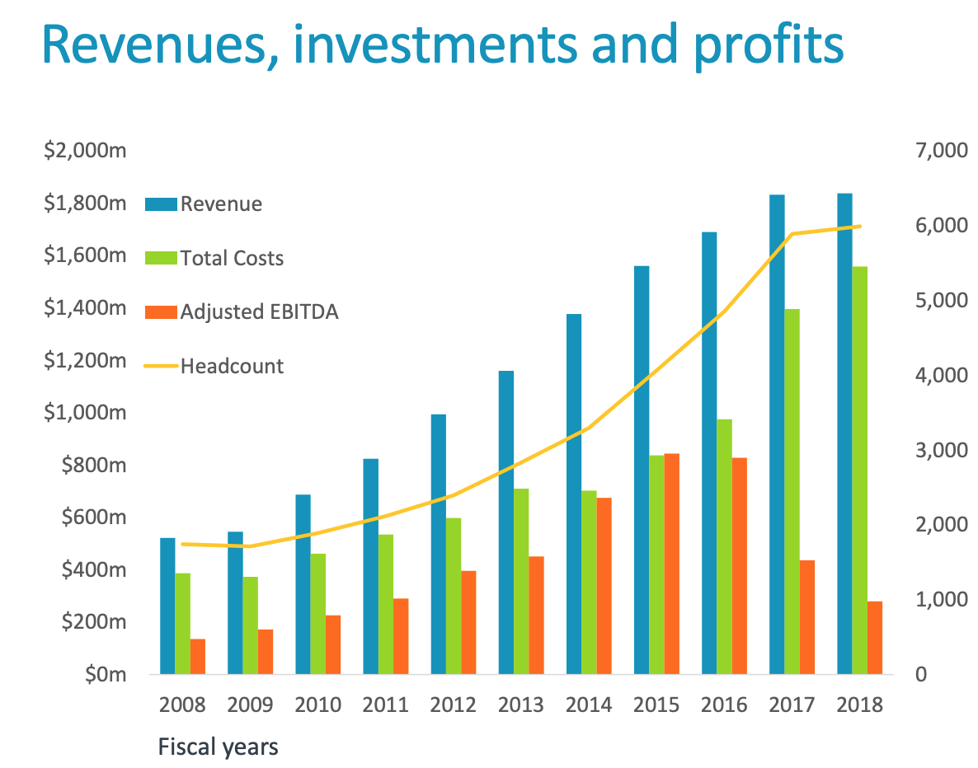
Graph 1: Revenues, Investments and Profits of ARM Holdings
Source: ARM Limited Q1 Roadshow (2019)

5.2) Market Share:

Previously discussed that, in the year 2016 ARM Holdings had already completed manufacturing and shipping over 100 billion ARM-based chips. Over the next couple of years since the acquisition, ARM Holdings have crossed the 150 billion mark. The investment of Softbank Group has allowed ARM Holdings to increase the volume of production. It reflects in the market share graph attached below that before the acquisition, ARM Holdings had market share of 25% which was around 16 billion net sales during that time. However, by the year 2018, market share of ARM Holdings raised to 33% and with a net sale of 22.9 billion. This shows ARM Holdings is growing rapidly under the umbrella of Softbank Group.

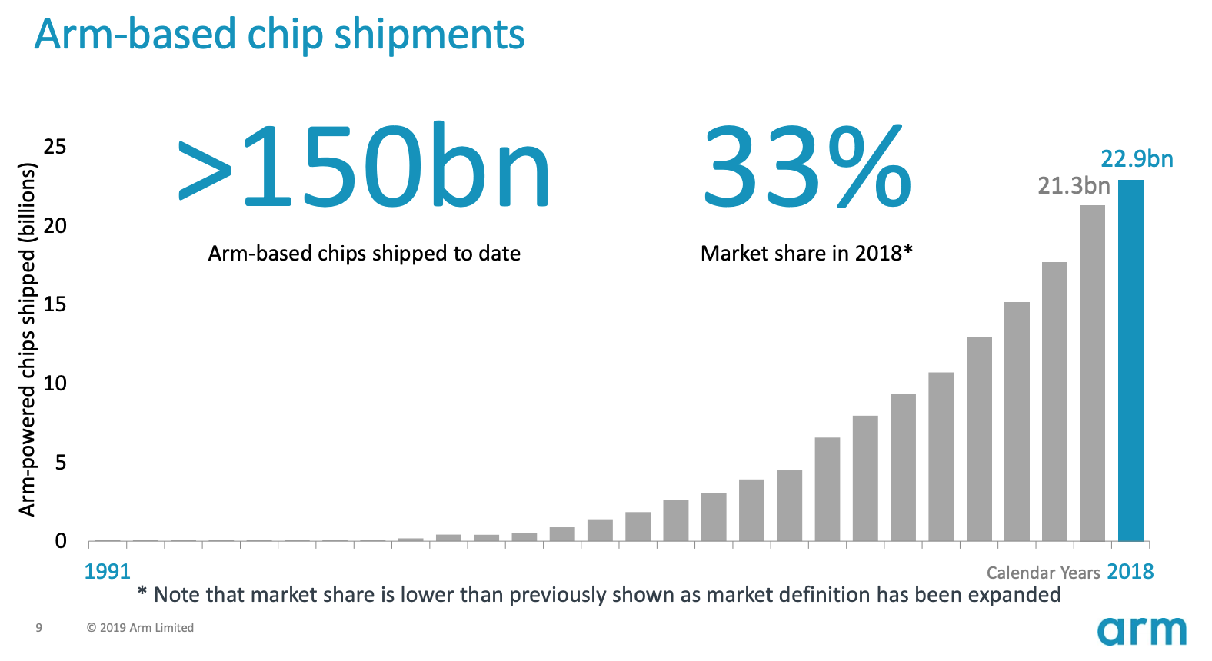

Graph 1: Market Share
Source: ARM Limited Q1 Roadshow (2019)

If we compare the market share of before acquisition and after acquisition for ARM Holdings in terms of the markets it serves, it is clearly visible as per table and table 1 shown below that, there is a significant increase in market share in all the markets ARM Holdings serves. Mobile application processor of ARM Holdings were dominating the market before the acquisition in 2016 with 90% of the market share, which has remained same after the acquisition in 2018. For Networking Infrastructure, market share was 17% in 2016 which has increased to 30% in 2018 after the acquisition. One notable aspect is that the market growth in Automotive market which had only 10% market share in 2016 and it has experienced a significant increase in two years’ time with 75% of the market share. Softbank Group is clearly focusing on in this market to grow even further by 2028. In terms of Embedded Intelligence, Southbank Group have experienced a staggering increase in market share from 30% to 90% after the acquisition. All these numbers suggest that the acquisition has been a successful one for both the companies.

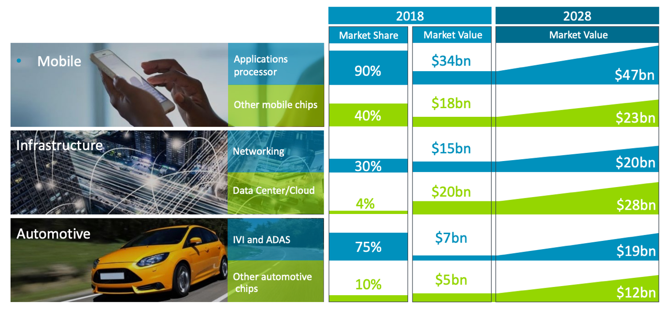

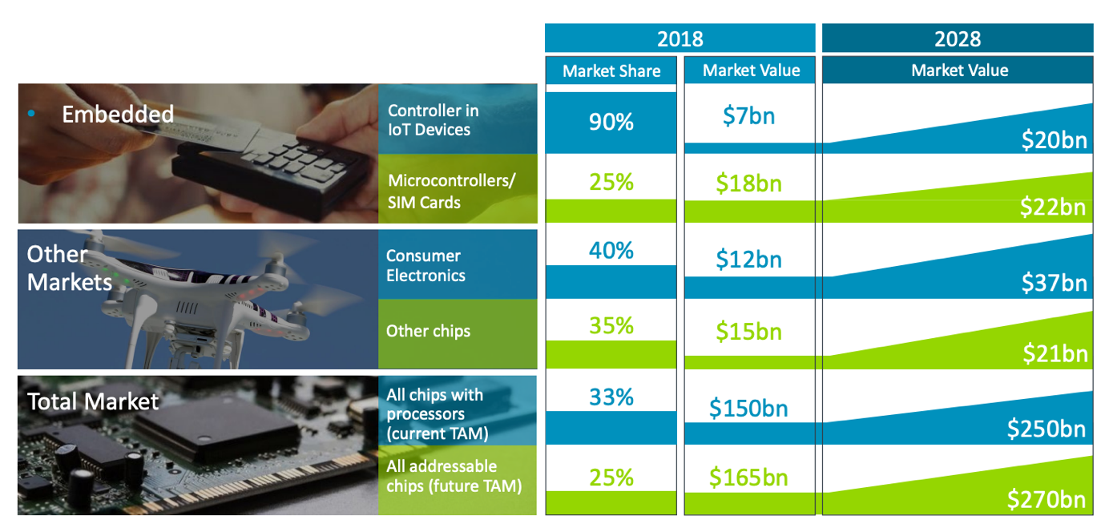

Table 1: Market Share and Market Value of All Sectors
Source: ARM Limited Q1 Roadshow (2019)

5.3) Market Value:
On the other hand, if we look in to graph 1, the change in market value since the acquisition, market value of mobile application processors was $20 billion in 2016, which has increased to $34 billion in 2018. It is expected to grow $47 billion by the end of 2028. For networking infrastructure, market value was $13 billion in 2016. It has increased to $15 billion in 2018 and expected to increase to $20 billion by 2028. However, there has been a drop-in market value of automotive since the acquisition. In 2016, market value of automotive was $11 billion which has reduced to $7 billion in 2018. As the market share is increasing, therefore it can be expected that automotive market value will rise to $19 billion by the end of 2028. All these performances indicate that this acquisition has been a successful business strategy from Softbank Group.

5.4) Royalty and Licencing: According to graph 2 shown in below, year by year ARM Holdings have managed to increase the number of licensing and also added up royalties under the organizations name. ARM Holdings have managed to sign 600 more licences since the Q1 of 2015. However, the graph suggests that the number of licensing have significantly increased since the acquisition and helped the company generate more cash flow than any time before.

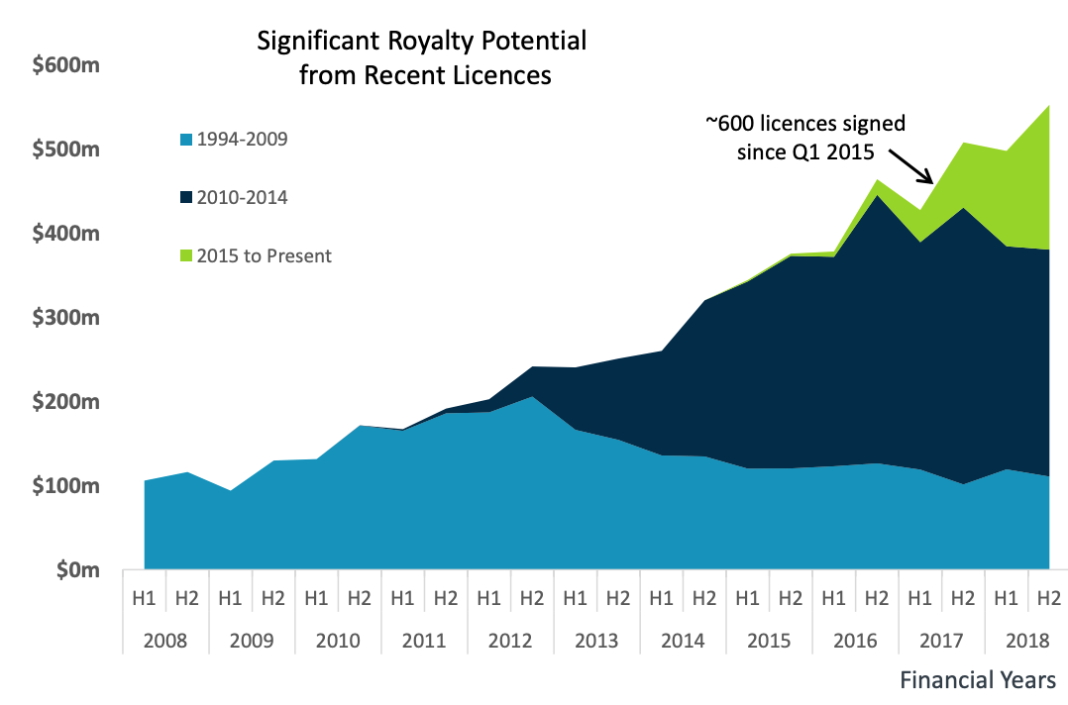

Graph 2: ARM Royalties and Licencing
Source: ARM Limited Q1 Roadshow (2019)

5.5) Increased Job Opportunity:

One of the integral parts of this acquisition was that, Softbank Group committed to invest in ARM Holdings in order support the management team and accelerate business strategies. Management of Softbank group had also promised to double the numbers of employees in five years’ time. According to the annual report of Softbank Group (2017), there has already been a huge increase in the total number of employees employed by ARM Holdings since the acquisition. Over one thousand new employees have been recruited since the acquisition which includes both technical staff and non-technical staffs. This is a positive sign of the expansion of businesses for ARM Holdings and Softbank Group as a whole.
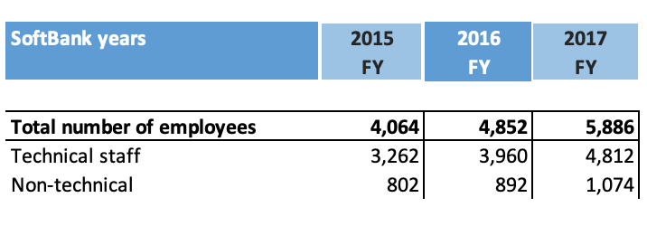

Figure 3: ARM’s Total Number of Employees by Years
Source: ARM Limited Q1 Roadshow (2019)

Conclusion:
When a big company acquires a small company, it tends to make the acquired company follow the business processes and organizational culture. However, Softbank Group management believes in individualism as it allowed ARM Holdings to continue follow its own organizational culture and business process. As mentioned earlier, Softbank Group encourages ARM Holdings to operate as a separate entity. The main idea of Softbank Group is to help ARM Holdings grow through continuous innovation. This acquisition can be considered as a win-win situation for both this companies as it helped to meet knowledge, innovation and talent with power of capital, business network and business experience.

References:
- ARM Holdings (2017), ARM Products. [Online] Available from: https://www.arm.com/ [Accessed 08 September 2019]

- ARM Holdings Q1 Roadshow (2017), ARM Holdings a Subsidiary of Soft Bank. [Online] Available from: https://www.google.com/search?biw=1280&bih=672&ei=zhRnXde6Beqk1fAPzOuJiAI&q=KPI%27s+for+arm+holdings+and+softbank+acquisition+pdf&oq=KPI%27s+for+arm+holdings+and+softbank+acquisition+pdf&gs_l=psy-ab.12...20575.37049..38596...2.0..1.672.4746.4j12j6j1j0j1......0....1..gws-wiz.......33i160._fLO8UUlvss&ved=0ahUKEwjX2dap4qbkAhVqUhUIHcx1AiE4ChDh1QMICg [Accessed 08 September, 2019]

- ARM Limited Q1 Roadshow (2019), ARM Ltd is a subsidiary of Softbank Group. [Online] Available from: https://www.google.com/search?sxsrf=ACYBGNQ0djyEJQibQxu8Fk-XOiDbLPrWaw%3A1568241928437&ei=CHl5XdevGtiEhbIPqaSQ6Ac&q=arm+holding+annual+report&oq=arm+holding+annual+report&gs_l=psy-ab.3..35i39j0i22i30l3.2337888.2347424..2348389...2.0..0.132.1934.25j2......0....1..gws-wiz.......0i131j0i67j0i131i67j0i10i67j0i20i263j0j35i304i39j0i13j0i13i30.tcBWxd8pnd4&ved=0ahUKEwjX08O47MnkAhVYQkEAHSkSBH0Q4dUDCAs&uact=5 [Accessed 10 September, 2019]

- ARM Rule 2 Announcement, (2016), RECOMMENDED ACQUISITION OF ARM HOLDINGS PLC BY SOFTBANK GROUP CORP. [Online] Available from: https://www.google.com/search?q=arm+acquition+rule+annoucement&oq=arm+acquition+rule+annoucement&aqs=chrome..69i57j33.10536j0j9&sourceid=chrome&ie=UTF-8 [Accessed 10 September, 2019]

- Business Insider (2019), There could be a wild, sci-fi reason that Softbank is spending $32 billion to buy mobile chip designer ARM Holdings. [Online] Available from: https://www.businessinsider.com/a-sci-fi-reason-why-softbank-bought-arm-2016-7?r=US&IR=T [Accessed 07 September, 2019]
- Financial Times (2017), Vodafone links with Softbank for Japanese enterprise customers. [Online] Available from: https://www.ft.com/content/20c7409a-89c0-3193-a182-df9c4b5ce40e [Accessed 07 September, 2019]
- Financial Times (2018), Softbank Flags Eventual Relisting of ARM Holdings. [Online] Available from: https://www.ft.com/content/29a28ad8-2b3e-11e8-9b4b-bc4b9f08f381 [Accessed 09 September, 2019]

- Forbes (2016), Brexit Made ARM Holdings A Bargain for Softbank. [Online] Available from: https://www.forbes.com/sites/parmyolson/2016/07/18/arm-softbank-bargain-britain/#1f40f6f63bc1 [Accessed 07 September, 2019]
- Forbes (2018), Softbank flags eventual relisting of ARM Holdings. [Online] Available from: https://www.ft.com/content/29a28ad8-2b3e-11e8-9b4b-bc4b9f08f381 [Accessed 08 September, 2019]

- Fortune (2016), Why Softbank is Spending $32 Billion in ARM. [Online] Available from: https://fortune.com/2016/07/18/softbank-arm-iot/ [Accessed 09 September, 2019]

- Korican, M. Barac, J. and Jelavic. I. (2014), Impact of Related Acquisition Strategy on Bidding Company Performance. Journal of Economic and Social Studies. Vol: 4, No:2.
- Rahman, A. (2014), A Review on Semiconductors Including Applications and Temperature Effects in Semiconductors. Vol: 2, No. 1.

- Softbank (2018), Investor Briefing. [Online] Available from: https://cdn.group.softbank/en/corp/set/data/irinfo/presentations/analyst/pdf/2017/investor_20180511_01.pdf [Accessed 08 September, 2019]

- Softbank Annual Report (2017), Financial Section. [Online] Available from: https://group.softbank/en/corp/set/data/irinfo/financials/annual_reports/pdf/2017/softbank_annual_report_2017_006.pdf [Accessed 10 September, 2019]

- Softbank Group (2016), Press Release 2016. [Online] Available from: https://group.softbank/en/corp/news/press/sb/2016/20160905_01/ [Accessed 09 September, 2019]

- Softbank Group (2017), History of Softbank Group. [Online] Available from: https://group.softbank/en/corp/about/history/ [Accessed 07 September, 2019]
- Softbank Group (2017), Strategic Agreement. [Online] Available from: https://cdn.group.softbank/en/corp/set/data/irinfo/presentations/vod/2016/pdf/press_20160718_01.pdf [Accessed 08 September, 2019]

- Tamosiuniene, R. and Duksaite, E. (2009), The Importance of Mergers and Acquisitions in Today’s Economy. Journal of Corporate Finance. Vol: 4, No: 3.

