
LEVEL 7 ASSESSMENT SPECIFICATION
Student name: Pogula Bharath Student ID number: 2512745
Programme: MSc Public Health and Social Care in Practice
Module: Health Care System, Organisation and Leadership
Module code: LCHS7002
Assignment Title: CASE STUDY ANALYSIS REPORT

Comparative Report on COVID-19 Leadership Responses: Spain, South Korea, and Canada

Executive Summary
This report explores how Spain, Canada and South Korea managed the pandemic through the health system settings and leadership approaches, thus providing some comparative information on effective crisis leadership and resilience in the system. The analysis evaluates the health governance structure, leadership style and centrality of every nation and health response to COVID-19.
Canada, which had a decentralised healthcare structure, used collaborative and consultative leadership, which emphasised transparency, equity and provincial autonomy. This plan enhanced community trust and made responses adaptive, but in some instances, it slowed down the quick decision-making process because of the intergovernmental coordination needs. South Korea, on the other hand, adopted a directive style of leadership and a centralised system of governance, which allowed the country to implement mass testing, digital contact tracing, and quarantine enforcement in the quickest possible way. This was the best way to promote quick containment and minimise initial mortality rates, but it raised concerns about privacy and civil rights. Nevertheless, after experiencing initial difficulties, the case of Spain became one of the most successful vaccination efforts in Europe due to the national planning that was complemented by regional execution and high adoption rates. The pandemic course in Spain exhibits that, following a decentralised governance approach, there is a temporary shift to the central command, followed by the realisation of the crisis and the relapse to the coordinated decentralisation due to system evolution based on feedback mechanisms.
As this discussion has shown, effective crisis management is not limited to any specific leadership style but to adaptive leadership, which is able to operate in the face of uncertainty, synthesise scientific evidence, and mobilise multisectoral collaboration. Some of the fundamental suggestions on strengthening future resilience to pandemics include the improvement of digital surveillance and data systems, investment in the leadership training of the public-health workforce, creation of fair emergency resource models, and institutionalisation of transparent communication to maintain trust among the population. The research finds that the combination of adaptive leadership and effective health-system design is an integral component of effective pandemic preparedness and response.

Table of Contents
Comparative Report on COVID-19 Leadership Responses: Spain, South Korea, and Canada 1
1. Introduction 5
1.1 Background of COVID-19 and its Global Impact 5
1.2 Importance of Leadership in Health Care Responses during a Pandemic 7
1.3 Overview of the Report Structure 7
2. Health Care System Organisations in the selected jurisdiction 8
2.1 Decentralised Healthcare Structure and Federalism of Approaches in Spain during COVID-19 8
2.1.1 Overview of the Healthcare System in Spain 8
2.1.2 Decentralisation of the Healthcare System in Spain 8
2.1.3 Response Measures Taken during the Pandemic in Spain 11
2.2 Centralised Healthcare Structure and Approaches in South Korea during COVID-19 12
2.2.1 Overview of the Healthcare System in South Korea 12
2.2.2 Centralisation of the Healthcare System in South Korea 12
2.2.3 Response Measures Taken during the Pandemic in South Korea 14
2.3 Hybrid Healthcare Structure and Federalism in Approaches in Canada during COVID-19 14
2.3.1 Overview of the Healthcare System in Canada 14
2.3.2 Universal and Hybrid Structure of the Healthcare System in Canada 15
2.3.3 Response Measures Taken during the Pandemic in Canada 17
2.4 Comparative Analysis of Health Care Systems 17
2.4.1 Critical Analysis of Centralisation vs. Decentralisation in Health Systems in Canada, South Korea and Spain 17
2.4.2 Impact of Different Healthcare Systems and Healthcare Organisations on Pandemic Response 18
3. Critical Analysis of Leadership Responses in the Context of COVID-19 in Spain, South Korea and Canada 19
3.1 Democratic Leadership Style in Spain: Minister of Health, Salvador Illa 19
3.1.1 Early Government Response and Criticism 19
3.1.2 Advantages and Challenges in Democratic Leadership 21
3.2 Authoritative Leadership Style in South Korea: Prime Minister Chung Sye-kyun 22
3.2.1 Government-Led Response and Successes 23
3.2.2 Advantages and Challenges in Authoritative Leadership 23
3.3 Transformational Leadership Style in Canada: Prime Minister Justin Trudeau 24
3.3.1 Decentralised Response Structure and Challenges 25
3.3.2 Advantages and Challenges in Crisis and Transformational Leadership: Key Characteristics and Strategies 25
3.4 Comparative Analysis of Leadership Styles in Canada, South Korea and Spain 26
3.4.1 Critical Analysis of Transformational, Democratic and Authoritative Leadership Styles 26
3.4.2 Effectiveness of the Leadership Styles and Decision-Making Processes 28
3.5 Impact of Leadership on Health Outcomes 28
3.5.1 Assessment of COVID-19 Outcomes in Each Jurisdiction 28
3.5.2 Influence of Leadership Quality on Health System Performance 30
3.5.3 Lessons Learned from Each Country's Approach 30
4. Discussion 30
4.1 Synthesis of Key Findings from the Health System, Organisational Leadership Analysis 30
4.2 Reflection on the Importance of Adaptive Leadership in Health Crisis 31
4.3 Recommendations for Improving Health System Resilience for Future Pandemics 34
5. Conclusion 34
References 36

1. Introduction

1.1 Background of COVID-19 and its Global Impact
The COVID-19 pandemic developed at the end of 2019, as a new coronavirus, SARS-CoV-2, was identified in Wuhan, China, and quickly transformed a local outbreak into a worldwide health disaster. In March 2020, the World Health Organisation declared COVID-19 a pandemic, highlighting the necessity of a global response (Chang, 2020). The pandemic has had unparalleled death and disability, claiming the lives of millions of people and leaving behind profound long-term health repercussions among those who survived in all parts of the world (Wagner et al., 2022). The WHO estimates at least 3,000,000 reported deaths in.(see fig-1)
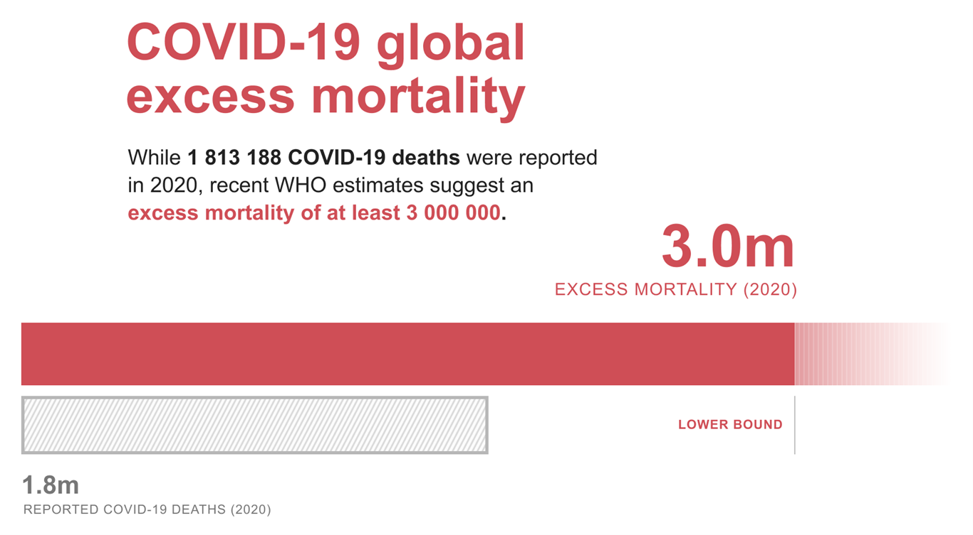
Figure 1: COVID-19 mortality rate
(Source: WHO, 2025)
In addition to direct health outcomes, COVID-19 caused significant social and economic impacts that triggered lockdowns, travel bans, and an economic recession that affected the entire world (Haldane et al., 2021). According to world health Federation, The health systems of all countries of the world were overstretched, with shortages of workforce, intensive care capacity, protective equipment, and surveillance infrastructure (Legido-Quigley et al., 2020)(see fig-2). The pandemic was an unprecedented national health crisis that required strong, dynamic, and integrated governmental leadership on various levels (Witter et al., 2023).
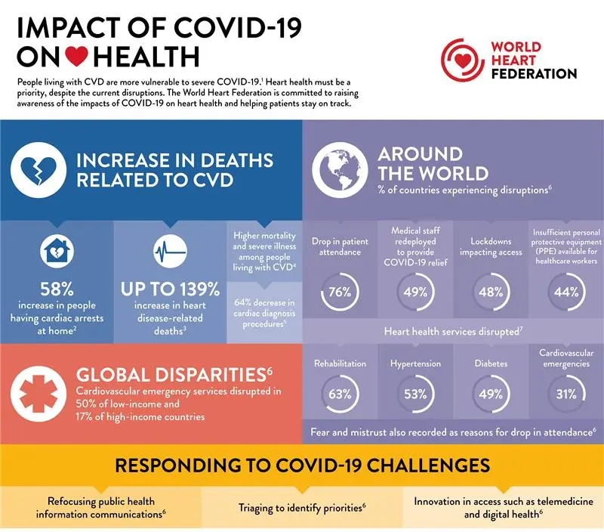
Figure 2: Impact of Covid-19
(Source: WHF, 2025)
However, the approaches and results of different countries were quite different, which represents the difference in the organisation of the system of governance, the structure of health systems, and the preparedness to pandemics (Oh et al., 2020). These international differences provided a rich set of comparative learning and analysis of the resilience of the system and leadership of the population in terms of health (Akinyemi et al., 2021).

1.2 Importance of Leadership in Health Care Responses during a Pandemic
The pandemic response is strongly impacted by the leadership, as it defines the areas of decision-making, communication, and policy actions in case of the crisis (Kaul et al., 2020). The leadership during a crisis dictates how governments develop and implement emergency policies, how they distribute scarce resources and how they mobilise health systems effectively (Sott and Bender, 2025).
The ability of leaders to communicate openly and establish trust with the population became a key factor that predetermined the population's behaviours and adherence to the public health procedures in the COVID-19 context (Wang et al., 2020). Leadership also has a key role to play in coordination among the federal, regional, and local organisations, especially in the complex health systems that are typified by the shared authority (Abimbola et al., 2019).
The theoretical literature confirms that the adaptive kind of leadership makes quick learning, flexibility, and innovation possible in the case of health emergencies (Crippen, 2023). In the meantime, it has been shown that transformational leadership improves systemic collective motivation and cooperation (Kwan, 2020). In turn, the study of leadership performance in the pandemic is important in terms of the desire to comprehend the differences in national results.

1.3 Overview of the Report Structure
This report can be characterised as a comparative case-study analysis of three high-income countries with well-developed health systems (Spain, South Korea, and Canada) that have different governance and leadership frameworks. The section below examines the structure of the healthcare system in each country and the extent of decentralisation of the response to the pandemic. The next measures leadership strategies, using crisis, adaptive, and transformational theories of leadership. Moreover, the report will summarise the findings to find the key lessons for future health crises. Policy and leadership implications are the end of the report. This comparative interest allows the critical analysis of the way various organisational systems and leadership styles influenced the outcomes of the pandemic in nations (You, 2020).

2. Health Care System Organisations in the selected jurisdiction

2.1 Decentralised Healthcare Structure and Federalism of Approaches in Spain during COVID-19

2.1.1 Overview of the Healthcare System in Spain
Spain has a universal, tax-financed national health system, the Sistema Nacional de Salud (SNS), which ensures access to universal healthcare services to every resident (Lopez-Casasnovas and Pifarre i Arolas, 2021). The system is mainly covered by means of public financing and service delivery with the help of a strong primary care network and the extensive network of public hospitals (WHO, 2023).
The organisational structure of Spain consists of 17 autonomous communities, where each is charged with the responsibility of administering and providing health services in line with reforms on decentralisation between the years 1981 and 2002 (Legido-Quigley et al., 2020). In this constitutional convention, a national government is still in charge of strategic coordination, legislation, and international health cooperation, whereas the regional governments manage healthcare planning, staffing, financing, and delivery (Martin et al., 2018).
Before the pandemic, the SNS was viewed as very fair, featuring good care in the community and universal access; however, the systemic problems were the unevenness of regional capabilities, austerity-induced workforce shortage, and lack of critical-care surge capacity (Haldane et al., 2021).

2.1.2 Decentralisation of the Healthcare System in Spain
The reason why Spain is known to be among the most decentralised systems of health in Europe is the post-Franco democratisation and codified in Article 43 of the 1978 Constitution, granting citizens the right to health protection and devolving health competences to regions (Abimbola et al., 2019). This model allows regions to have substantial freedom in budgets, public health services models, human resources and more (Reay et al., 2021). The Rich picture(see fig-3) illustrate the organizational complexity of Spain health system during COVID-19 pandemic, highlighting the balance between state, regional ministries, fragmentation of governance, varied, local and central demands and the impact on public health responses and decision-making speed.(Abimbola et al., 2019; Reay et al., 2021; García-Basteiro et al., 2020; Rusoi et al., 2018).
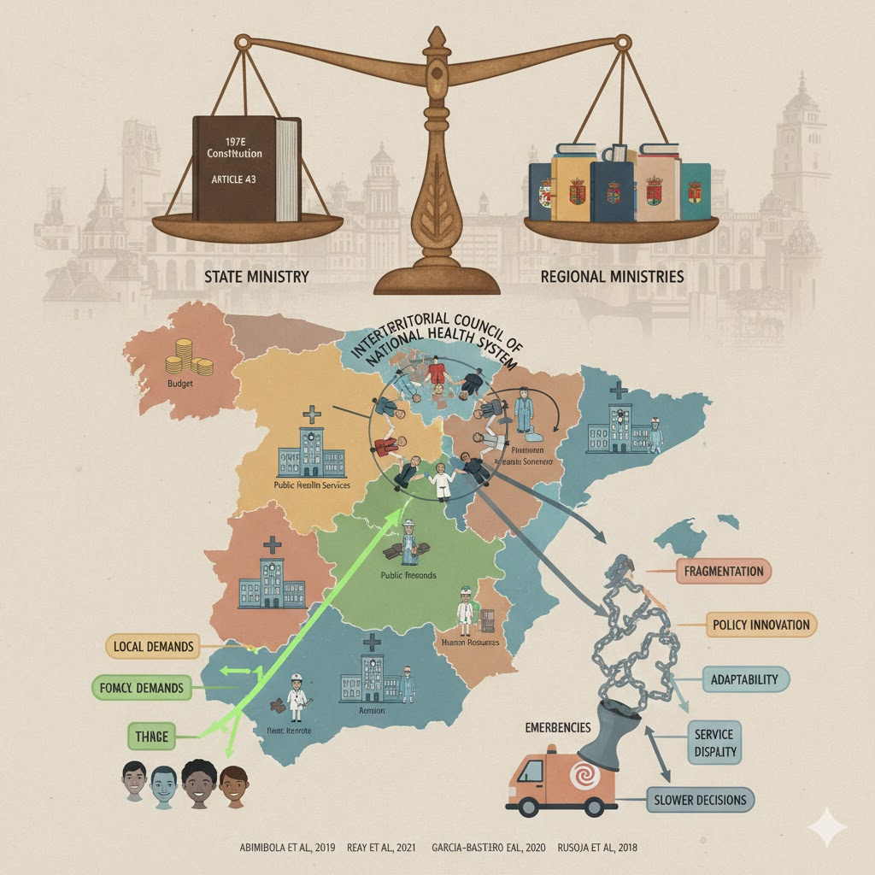
Figure 3: Healthcare system in Spain
(Source: Author)
The coordination mechanisms involve the Interterritorial Council of the National Health System, which was instituted to balance inter-regional decision-making between the state and regional ministries (Garcia‑Basteiro et al., 2020). Although decentralisation helps to be more responsive to local demands and implement policy innovation, it is also faced with several issues, including fragmentation, disparity in service quality, and slower, uncoordinated decisions in emergencies (Shishkin et al., 2025). The literature on systems-thinking shows that multi-level governance, which is complex and multi-level, is capable of promoting adaptability but also increases interdependency and coordination requirements, especially during crises (Rusoja et al., 2018).

2.1.3 Response Measures Taken during the Pandemic in Spain
First, the Spanish disintegrated system led to a faster lack of action rather than unity, as regional reactions varied and coordination systems were lacking to coordinate the strategies quickly (Gao and Yu, 2020). The initial governmental messages undermined the threat, and some observers were of the opinion that Spain seemed to be asleep at the wheel in early March 2020, spain saw a rapid increase in covid-19 cases from 114 at the beginning of the month to 999 by the 9th march(see fig-9) (National Atlas,2020)(Garcia-Basteiro et al., 2020).
As infections continued to rise, the national government announced a State of Alarm on 14 March 2020 under Article 116, which temporarily centralised the health authority and put in place a stringent nationwide lockdown (Legido-Quigley et al., 2020). Some of the emergency measures were rapid capacity expansion, the establishment of temporary testing centres like the IFEMA field hospital in Madrid, manpower mobilisation, and changing testing measures (Haldane et al., 2021).
Nevertheless, after experiencing initial difficulties, the case of Spain became one of the most successful vaccination efforts in Europe due to the national planning that was complemented by regional execution and high adoption rates (Wagner et al., 2022). The pandemic course in Spain exhibits that, following a decentralised governance approach, there is a temporary shift to the central command, followed by the realisation of the crisis and the relapse to the coordinated decentralisation due to system evolution based on feedback mechanisms (Khalil and Lakhani, 2022).

2.2 Centralised Healthcare Structure and Approaches in South Korea during COVID-19

2.2.1 Overview of the Healthcare System in South Korea
South Korea has an extensive National Health Insurance (NHI) fund, which covers the entire population with a single-payer system which offers widespread financial coverage and fair access (Oh et al., 2020). The healthcare sector is also very privatised, with close to 90 per cent of hospitals under private ownership, but the government controls prices and quality to ensure that the industry remains efficient and cost-effective (Yoon et al., 2024).
The system is hierarchical, and the patients are transferred between the primary clinics to the general and tertiary hospitals, with the support of high medical technology adoption and powerful digital systems. Although there is an abundant use of services, the system of charges per use and co-payments promotes high usage, which makes South Korea one of the most commonly used healthcare systems in the world (Witter et al., 2023).

2.2.2 Centralisation of the Healthcare System in South Korea
The Ministry of Health and Welfare is the central authority of the healthcare system, which allows making decisions quickly, unifying protocols, and coordinating responses in crises (Shishkin et al., 2025). The revised Infectious Disease Control and Prevention Act, which received legal validation after the MERS outbreak, gives broad-scale surveillance, testing, and isolation legislative powers. The rich picture (see fig-4) demonstrate South Korea, strong administrative capacity and crisis, agility, supported by unified public health systems and rapid testing infrastructure during COVID-19 pandemic.
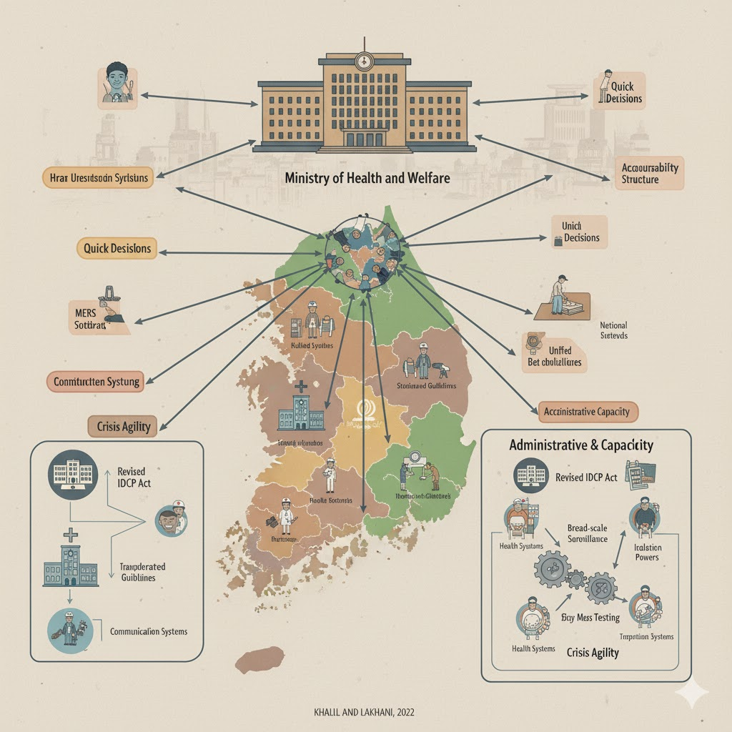
Figure 4: Healthcare system in South Korea
(Source: Author)
The benefits of centralisation have been standardisation of guidelines, mobilisation of resources in the whole country and an accountability structure which has shown great administrative capacity. Adaptive learning and systems thinking have been developed through the integration of health, technology, transportation, and communication systems and enhanced crisis agility (Khalil and Lakhani, 2022).

2.2.3 Response Measures Taken during the Pandemic in South Korea
Since January 2020, South Korea has taken a proactive position and did not impose complete lockdowns but focused on a Test Treat Trace model that was supported by the latest digital tools (You, 2020). Innovations, such as drive-through and walk-through testing, quick approval of diagnostic kits, and free testing of symptomatic people, took place. Contact tracing was based on mobile GPS, credit-card data, and CCTV, which was backed by the legal system and open communication (Littlecott et al., 2023).
The mild cases were treated in the community treatment centres, offloading the hospitals, and daily briefings by KDCA instilled public trust and adherence (Wang et al., 2020). Despite the privacy controversies and cluster epidemics, South Korea had low mortality with only 950 deaths in 2020 (see fig-10) and low economic activity, which is indicative of successful adaptive crisis leadership and systems coordination (Sott, 2025).

2.3 Hybrid Healthcare Structure and Federalism in Approaches in Canada during COVID-19

2.3.1 Overview of the Healthcare System in Canada
Canada has a publicly funded universal healthcare system that is known as Medicare and that is based on the principles of universality, comprehensiveness, accessibility, portability, and administration by the government as enshrined in the Canada Health Act (Marchildon et al., 2021).
Despite universal health coverage, the service delivery is largely provincial in nature, and thirteen provincial or territorial insurance plans govern the service delivery (Martin et al., 2018). The system is funded by the federal government via the Canada Health Transfer and directly provides services to specific groups, such as Indigenous communities, military members, and refugees (GOC, 2025).
Most hospitals are non-profit, privately based and primary care is mostly provided by privately practising physicians who are paid publicly, which indicates a mixed mode of service delivery (Martin et al., 2018). There is an inter-provincial difference in how health services are structured, access to care and the infrastructure capacity that is as a result of the common jurisdictional roles.

2.3.2 Universal and Hybrid Structure of the Healthcare System in Canada
The institutional structure of Canada is a blend of centrally operated funding and standard-setting and provincial discretion that, hence, creates a hybrid federal system designed to facilitate national uniformity and local variation (Gluck and Huberfeld, 2018). Governance needs to be cooperative through governmental levels through Federal-Provincial-Territorial systems and pan-Canadian organisations like the Public Health Agency of Canada (Cote et al., 2020). Figure-5 highlights the complex cities and challenges faced by the Canada’s multilevel health system, including policy duplication, and Inter Authority tension during the pandemic.
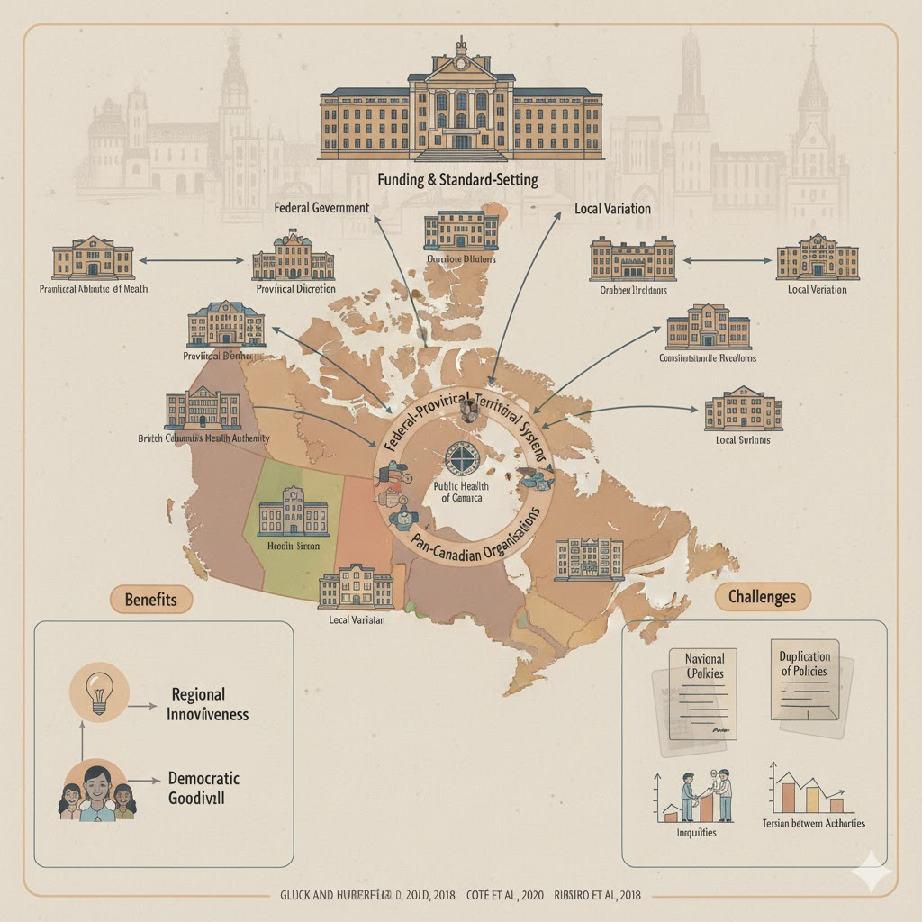
Figure 5: Healthcare system in Canada
(Source: Author)
However, fragmentation creates coordination problems, inequities, and data inconsistencies, which hinder fast crisis responses (Abimbola et al., 2019). Although the system promotes regional innovativeness and democratic goodwill, this kind of overlapping may create elements of duplication of policies and tension between intergovernmental authorities (Ribeiro et al., 2018).

2.3.3 Response Measures Taken during the Pandemic in Canada
The reaction of Canada to the COVID-19 pandemic started with border restrictions, federal directions, and emergency benefits, including the Canada Emergency Response Benefit, aimed at protecting incomes (Detsky and Bogoch, 2020). The disparities between the provinces were reflected in the lockdowns, school policies, and testing strategies, leading to unequal results of the containment process (Witter et al., 2023).
Although the acquisition of vaccines was centralised on the federal level, the process was divided by the provinces, with early delays but high vaccination coverage eventually (Wagner et al., 2022). There were major failures in long-term care institutions, which revealed inequities in the system and gaps in preparedness (Dosa et al., 2020). The lack of coordination of data and intergovernmental differences hindered surveillance fragmentation; however, community resilience and flexibility of the healthcare workforce supported the outcome of recovery (Haldane et al., 2021). Kenda has moderate mortality rate with only 1000 to 1200 deaths in 2020 (See Fig-11)

2.4 Comparative Analysis of Health Care Systems

2.4.1 Critical Analysis of Centralisation vs. Decentralisation in Health Systems in Canada, South Korea and Spain
The centrally managed command structure in South Korea allowed making decisions fast, having a set of standard protocols, and testing and tracing systems, which helped to strengthen the response to outbreaks (You, 2020). The regional model of Spain was very decentralised, but it ended up being fragmented and had inconsistent actions across the regions until the national emergency powers momentarily centralised control (Legido-Quigley et al., 2020). The hybrid system practised in Canada is equalising between federal direction and provincial freedom, but despite this, no obligatory integration has facilitated policy disparity and procrastination in harmonisation (Abimbola et al., 2019).
Centralised systems are efficient, have uniform messages and can be mobilised swiftly, whereas decentralised systems allow local customisation and invention (Shishkin et al., 2025). Spain and Canada encountered coordination issues and tension between the governments, which highlights that the structure of governance is not the only determinant of pandemic success that the capacity to lead and legal power to dictate outcomes are crucial (Patapan, 2022).

2.4.2 Impact of Different Healthcare Systems and Healthcare Organisations on Pandemic Response
The South Korean success in the lower mortality(0.3) and more rapid containment was due to the integrated systems of data and the rapid scaling of testing (Littlecott et al., 2023). The province of Canada ultimately achieved high levels of vaccination but faced a long-term care crisis and provincial disproportionate performance (Detsky and Bogoch, 2020). The pressure on the system was higher, and deaths in Spain were more frequent (30,000 deaths were reported by setember 2020), being worsened by previously existing conditions in several regions and the variations (Legido-Quigley et al., 2020).
Designs had an impact on the speed of response, yet the level of trust of the people, cultural adherence, and experience of the outbreak also had a role in performance (Gao and Yu, 2020). Finally, dynamic coordination and strong intergovernmental procedures were more decisive than just centralisation or decentralisation (Witter et al., 2023).

3. Critical Analysis of Leadership Responses in the Context of COVID-19 in Spain, South Korea and Canada

3.1 Democratic Leadership Style in Spain: Minister of Health, Salvador Illa

3.1.1 Early Government Response and Criticism
 Figure-6 (Spain’s Health Minister: Salvador Illa)
(Source: Instagram)
The first response of Spain under the leadership of Health Minister Salvador Illa he is recognized for champion, scientific guidance and for string, collaborative trust leader leadership during COVID-19 crisis and demonstrated a democratic and collaborative leadership style, but fell badly out of favour with harsh criticism because of a lack of timely action. This is a person centred leadership approach, prioritizing inclusion, collaboration, and the development of trust among the individuals. Early on, the government was more focused on consultation with both the regional authorities and scientific councils, which is a democratic principle of mutual decision-making (Legido-Quigley et al., 2020). Nevertheless, this type of style of consensus hampered decisive action and resulted in a lack of timely lockdowns and persistent mass meetings, including that on 8 March, which led to an increased spread (Garcia-Basteiro et al., 2020). This management approach is reflective of McGregor’s Theory Y, which assumes that people are self-motivated value trust and participation and prefer working in Team towards shared goals, such participate, leadership, posters, transparency and engagement, but I have seen in Spain.may slowdown urgent making in fast moving crisis.
The communication displayed by Illa focused on transparency but created confusion among the population due to mixed messages and decentralised implementation (Wang et al., 2020). Centralisation of emergency powers also happened in Spain, but only after the hospital was overloaded, which demonstrates that democratic consultation can hinder quick responses to the crisis (WHO, 2023). Regardless of the criticism, Illa encouraged a scientific direction and a more intergovernmental discussion, which is in line with the models of equity-oriented crisis leadership that emphasise trust and responsibility (Virella, 2023).

3.1.2 Advantages and Challenges in Democratic Leadership
Democratic leadership promotes involvement, mutual legitimacy, and popular trust or qualities that cannot be replaced during a period of disaster, where collaboration is critical in the field of public health (Sott and Bender, 2025). The style of Illa promoted cross-regional learning and transparency, which aligns with the principles of adaptive leadership that focus on collaboration and an iterative approach to the problem (Crippen, 2023).
However, democratic leadership is also less effective during crises that are urgent and at high speed since it takes time to reach consensus on a decision (Bhat and Saba, 2025). The Spanish experience showed that the flexible situational leadership requires the leaders to change the democratic consultation towards direct action when the situation is under the strain of an emergency (Francisco‬ and ‬Nuqui,‬2020). Illa was also more centralised in the implementation of the vaccination campaign, and it is an example of adaptive evolution, i.e., the transition to participatory decision-making to command-coordination when the situation imposed urgency on it (Aslam et al., 2022).
An example of antecedents of the Participative Leadership Theory and the Situational Leadership Theory was that of Spain in the Minister of Health, Salvador Illa. His democratic approach to decision-making encouraged cooperation in the region and allowed for adjusting strategies to changes in the waves of infection. However, in the slowness of reaction to his early interventions, the persuasive risks of consensus leadership became more pronounced in situations where the decisive actions were to be taken proactively and centrally in the face of the escalation of the crisis.

3.2 Authoritative Leadership Style in South Korea: Prime Minister Chung Sye-kyun.
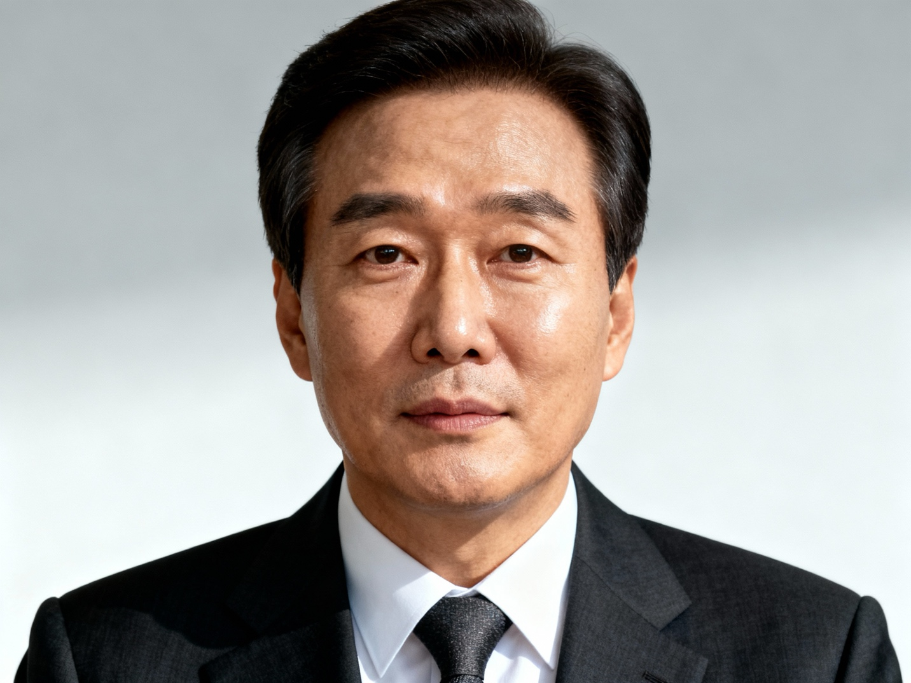 Figure-7 (South Korea’s, Prime Minister: Chung Sye-kyun) (source: Wikipedia)

South Korea provided an example of a largely authoritative type of leadership in the context of the COVID-19 pandemic, led by Prime Minister Chung-Sye-kyun, who emphasises rapid reaction to decisions, the centralisation of the authority system, and unquestioning obedience of people. This approach is characterized as job centred whereby the main focus is on rapid task, completion, efficiency, and compliance with directives and strongly aligned with McGregor’s Theory X. The given strategy allowed the government to respond quickly and effectively organise national health efforts, which is consistent with empirical data that the directive leadership style is effective during health crises with high levels of uncertainty (Stewart, 2023).

3.2.1 Government-Led Response and Successes
The Korean government quickly organised testing, digital contact-tracing, and institutional quarantine systems, and thus, reduced its transmission without implementing complete lockdowns of the country. Prime Minister Chung held briefings on the emergency every day and coordinated inter-ministerial work to ensure system readiness (Oh et al., 2020). The introduction of drive-through testing centres and real-time reporting of public data strengthened containment efforts, which led to significantly fewer deaths in the first waves of the pandemic (You,2020). The preparedness and surveillance systems in the case of Korea are also identified in international reports as a world standard in controlling epidemics (WBG, 2025). Openness and technology use led to long-term belief in the population and adherence, which is consistent with the official public health communication principles that focus on real-time data to influence behaviour (Wang, 2020).

3.2.2 Advantages and Challenges in Authoritative Leadership
Authority leadership brought such benefits as speed, consistent policy and efficient allocation of resources in crises (Patapan, 2022). It also facilitated uniformity in public communication and adherence, and thus reduced delays related to distributed decision-making (Gao, 2020). However, the obstacles were also present, such as the issues of surveillance, privacy, and the possibility of leaving citizen contribution to decision-making processes to the periphery (Duan et al., 2018). The situation in South Korea highlights the need to maintain authority while being ethically led and civil liberties to maintain legitimacy and trust in times of prolonged crisis (Virella, 2023).
The attitude of Prime Minister Chung-Sye-kyun was consistent with the Theory of Transactional Leadership and some traces of the Contingency Theory. His focus on enforcing rules, on building up testing facilities, and on strict quarantine measures actualised a reward-punishment relationship which effectively induced compliance and increased the effectiveness of operational efficiency. Therefore, this authoritative and performance-based approach was effective in taming the virus by increasing accountability and faster coordination of the government.

3.3 Transformational Leadership Style in Canada: Prime Minister Justin Trudeau
Figure-8 (Canada’s Prime Minister: Justin Trudeau)

(Source: Wikipedia)
The governmental response to the COVID-19 pandemic by Canada took the shape of a transformational and participatory paradigm, with Prime Minister Justin Trudeau attempting to use persuasion, empathy, and collective mobilisation instead of coercive power. This approach strongly alliance with McGregor’s Theory Y, which high trust empowerment and the belief that people are motivated to work towards shared goals, when provided with support and collaboration.This style is consistent with the focus of transformational leadership on vision-building, motivation, and joint accountability in a context of uncertainty (Kwan, 2020). The leadership style during pandemic also reflects a person centred orientation, focusing on empowering individuals and supporting personal development.
Trudeau projected compassion, social solidarity, and reassurance to the people in general, thus making people willingly comply and have civic responsibility (Detsky and Bogoch, 2020). This strategy aimed to give strength to provinces and communities, which is in line with the research that ties transformational leadership to an increased level of engagement and crisis resilience (Yucel, 2021).

3.3.1 Decentralised Response Structure and Challenges
The decentralised system of governance in Canada, however, limited the ability to act in unison by creating dissimilar provincial reactions and ineffective communication (Marchildon et al., 2021). Transformational leadership assumes a strong organisational alignment, which was compromised by the idea of political independence of the provinces (Abimbola et al., 2019). Sluggish expansion of testing, uneven distribution of vaccines, and lack of sufficient provision of long-term care revealed flaws in the structure of crisis management (GOC,⁫ 2025).

3.3.2 Advantages and Challenges in Crisis and Transformational Leadership: Key Characteristics and Strategies
Regardless of barriers in coordination, transformational leadership instilled the confidence of the population, openness, and adaptive learning at various stages of the pandemic (Sott 2025). However, the empirical evidence indicates that in the case of acute emergencies, transformational leaders might face some issues regarding the necessity to make quick, command-style decisions (Stewart et al., 2023).
The experience of Canada suggests that though transformational leadership encourages motivation and social solidarity, the effective management of any crisis requires the incorporation of decisive authority, adaptive coordination, and adaptable situational leadership mechanisms (Francisco and Nuqui, 2020).
The actions of Prime Minister Justin Trudeau can be seen in line with the Great Man Theory whereby his personal charisma, moral conviction, and empathic nature would have earned the trust of people during the time of the crisis. He instilled hope and solidarity among the provinces by using commanding communication, providing funds to cover vaccination throughout the country, and providing financial aid packages, thus demonstrating the concepts of transformational leadership.

3.4 Comparative Analysis of Leadership Styles in Canada, South Korea and Spain

3.4.1 Critical Analysis of Transformational, Democratic and Authoritative Leadership Styles
Canada was more transformational and democratic, focusing on empathy, communication, and inter-provincial cooperation, thus developing trust and social cohesion (Kwan, 2020). South Korea followed a strict form of authoritative and technocratic governance, which is characterised by central coordination based on expert-driven governance and quick implementation abilities (You, 2020).
The first leadership approach adopted by Spain was based on democracy and decentralisation, but had challenges of poor coordination and lack of political unity in response to crises, thereby weakening agility (Legido‑Quigley et al., 2020). Transformational leadership in Canada increased the motivation of the citizens, but the provincial autonomy delayed the decision-making (Yucel, 2021). The authoritative style of South Korea enhanced compliance and implementation but threatened civil liberties (Patapan, 2022). The example of decentralisation in Spain and late mobilisation demonstrated democratic handicaps with extreme uncertainty (Garcia-Basteiro et al., 2020).

Dimension | Spain - Illa (Democratic) | South Korea - Chung (Authoritative) | Canada - Trudeau (Transformational)
Decision-making | Consultative, consensus-seeking | Decisive, expert-driven | Collaborative, vision-driven
Communication | Transparent (evolved), formal | Clear, directive, data-focused | Empathetic, inspirational, and frequent
Stakeholder engagement | High (17 regions, parties) | Moderate (government-led, public-private) | High (provinces, communities)
Speed of action | Slow initially, improved | Rapid throughout | Moderate, constrained
Consistency | Variable (regional differences) | High (national uniformity) | Low (provincial variation)
Public trust | Eroded then rebuilt | High, sustained | Generally maintained
Innovation | Regional experimentation | Government-driven innovation | Provincial experimentation
Accountability | Diffused then centralised | Clear, centralised | Diffused across levels
Adaptability | High (learned from failures) | Moderate (refined approach) | High (encouraged flexibility)
Table 1: Comparative Analysis
(Source: Author)
The transformational leadership under Trudeau in Canada focused on emotional intelligence and motivation as compared to the democratic and authoritative type in Spain. His sympathetic national speeches and acts of relief contributed to the morale of the people, and this was a leadership characteristic of Transformational and Great Man leadership, which is based on the ability to inspire and set a personal example, as well as on the principle of building trust in the face of crisis reaction.

3.4.2 Effectiveness of the Leadership Styles and Decision-Making Processes
The adaptive authoritarian-technocratic model of South Korea had a strong effect on ensuring good public health due to fast testing and tracing infrastructure (Littlecott et al., 2023). Canada managed to build trust at the national level but was faced by the lack of coordination between the provinces and the sluggish logistics of vaccines (Detsky and Bogoch, 2020).
The late centralisation of the command in Spain caused acute pressure on the health system and unnecessary mortality (Lopez-Casasnovas ︊and ︊Pifarre i ︊Arolas, 2021). It has been proven that the role of leadership can be optimised in cases where crisis governance incorporates authority and adaptive collaboration (Sott 2025). The combination of decisional leadership, the flexibility of decentralisation, and the trust of the population is relevant to the new normal situational leadership paradigm (Francisco & Nuqui, 2020).
To address future pandemics, the leaders must consider striking a balance between speed of directive decision-making and transparency and adaptability of the health system (Haldane et al., 2021).

3.5 Impact of Leadership on Health Outcomes

3.5.1 Assessment of COVID-19 Outcomes in Each Jurisdiction
The results on vaccination uptake in Canada were heterogeneous across provinces, where the early response was high but varied, which can be explained by decentralised leadership dynamics (Detsky and Bogoch, 2020). South Korea regained success through centralised command and technological surveillance apparatuses, which resulted in a rapid containment, a high-volume testing and reduced mortality (You, 2020).
Initial heavy mortality and strain on the health system took place in Spain, but eventually the situation became better due to the introduction of more coordinated national measures (Legido-Quigley et al., 2020).
Outcome | Spain | South Korea | Canada
Cases per capita (2020-21) | High  (15,400 per 100k) | Low  (3,490 per 100k) | Moderate  (10,000 per 100k)
Deaths per capita | High  (192 per 100k) | Very Low  (6 per 100k) | Moderate  (110 per 100k)
Healthcare system strain | Severe initially | Minimal | Variable
Economic impact | Severe  (-11.3%) | Mild  (-0.9%) | Moderate  (-5.2%)
Vaccination success | High  (84%) | Moderate initially  62% (mid-2021) (80% end) | High eventually  70%(mid2021) (78% end)
Social cohesion | Challenged then strengthened | Strong | Fragmented
Table 2: Comparative Analysis (Source: Author)

3.5.2 Influence of Leadership Quality on Health System Performance
Adaptive and transformational leadership increased community engagement, compliance, and resilience across systems (Sott and Bender, 2025). The democratic and collaborative government made the trust better but occasionally hindered the action in the complicated federated organisation (Crippen, 2023). The authoritative and directive leadership increased the pace of decisive implementation but posed a threat to less transparency and equity (Patapan, 2022).

3.5.3 Lessons Learned from Each Country's Approach
Crisis governance requires dynamic leadership that swings to the extreme, either democratic participation or decisive action based on the demands of the situation at hand (Rachmad, 2022). The balancing of the leaders between the public communication, scientific guidance, and quick policy action is beneficial to improve the pandemic performance (Ma and Yang, 2020). The future readiness will rely on institutional learning, integrated data systems, as well as equity-based decision-making models (Virella, 2023).

4. Discussion

4.1 Synthesis of Key Findings from the Health System, Organisational Leadership Analysis
The comparative study conducted on Canada and South Korea has found that both countries had strong health system structures, but at the same time used different leadership styles. Canada has been relying on the idea of decentralised healthcare delivery and focusing on collaborative decisions made by all provincial jurisdictions, which enhanced equity and promoted community involvement (Martin et al., 2018). Conversely, South Korea enjoyed a well-organised and centralised response to the pandemic, which is supported by swift testing and electronic tracking systems (Oh et al., 2020).
In both cases, leadership played a crucial role; the collaborative leadership in Canada gave a chance to involve stakeholders and communicate openly (Detsky and Bogoch, 2020), but in South Korea, the directive leadership allowed immediate implementation and compliance among the population members (You, 2020).

4.2 Reflection on the Importance of Adaptive Leadership in Health Crisis
Adaptive leadership is becoming an important requirement to address the complexity and uncertainty of health emergencies. It previews adaptation, collaborative decision-making, and empowerment of frontline practitioners to be quicker in responding to any changes in threats (Sott and Bender, 2025). Adaptive leadership proved itself to have the ability to combine scientific knowledge, react promptly to arising threats, and enlist multi-sector cooperation during the COVID-19 pandemic (Crippen, 2023).
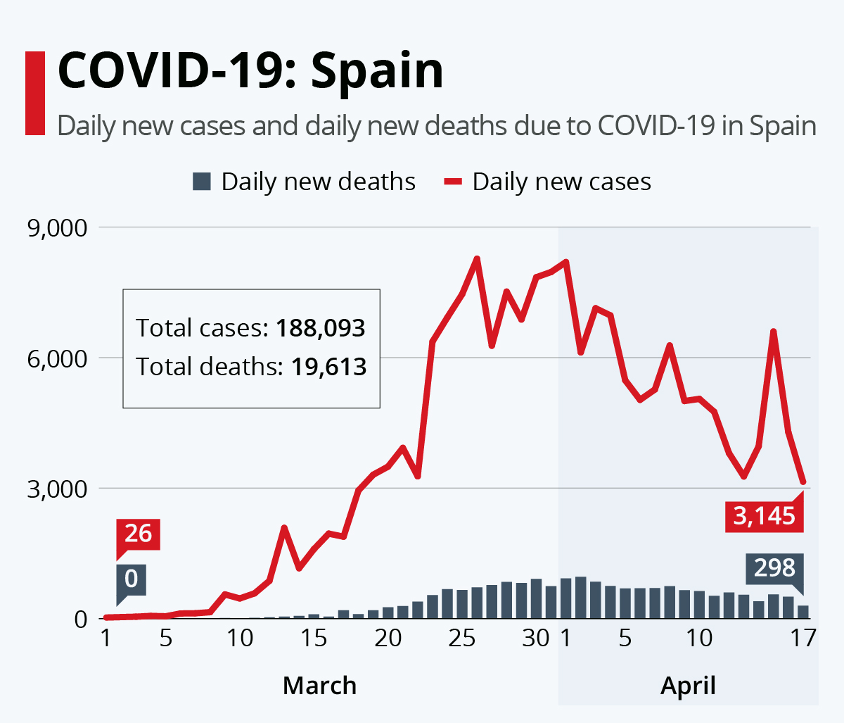
Figure-9: Spain Covid-19 Stats
(Source: WHO,2025)
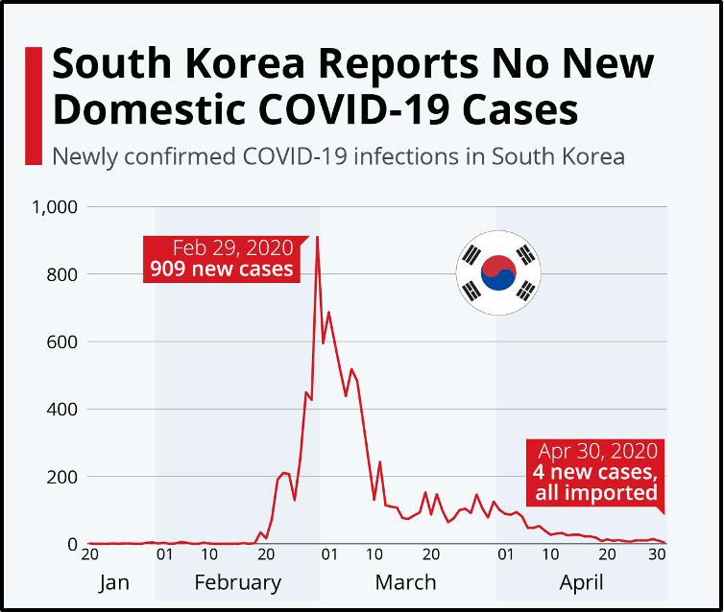
Figure-10: South Korea Covid-19 Stats
(Source: WHO,2025)
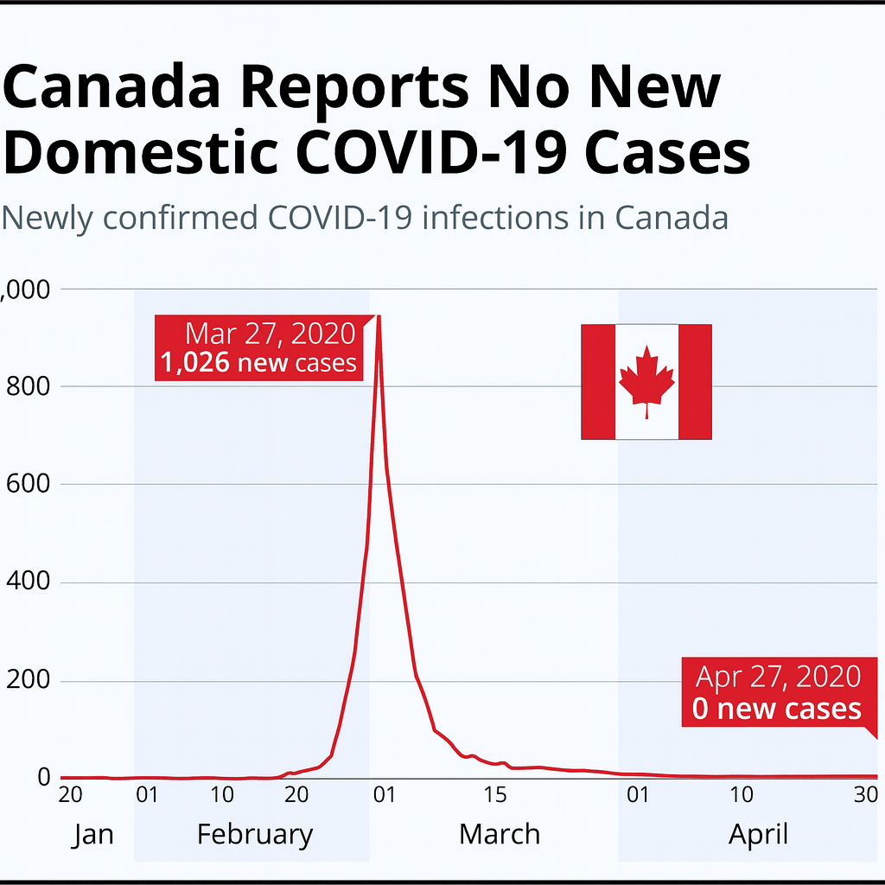
Figure 11: Covid-19 stats
(Source: WHO, 2025)
In addition, adaptive capacity will enable leaders to rescale strategies as additional treatments, technologies, and public health information are gathered (Rachmad, 2022). The discussion shows that successful crisis leadership is not limited to the presence of authoritarian and democratic leadership, but is found in the capacity to utilise situational judgment and adjust behaviour according to circumstances, resources and population requirements (Francisco and Nuqui, 2020).

4.3 Recommendations for Improving Health System Resilience for Future Pandemics
The increase of resilience also requires the creation of systems with the ability to predict, absorb, and react to the shock. It is important to have both decentralised and coordinated governance structures by governments that promote quick communication and mobilisation of resources (Abimbola et al., 2019). The growth of technology-based and data-based surveillance networks is suggested to enhance the ability to detect and respond quickly (Decoteau and Garrett, 2022). The training programs regarding crisis leadership will make sure that the health managers are capable of implementing adaptive principles in order to act effectively in case of an emergency (Bhat and Saba, 2025).
The need to prioritise the trust of people via open communication and policy development based on equity is important (Virella, 2023). Finally, the development of resilient system infrastructure together with adaptive, learning-based leadership will determine the preparedness to the pandemic in the future and will allow responding to the uncertainty (Aslam et al., 2022).

5. Conclusion
This paper is a critical assessment of the leadership modalities and health system capacities in Canada and South Korea during the COVID-19 pandemic, which showed how leadership typologies and government configurations guided the national responses. The decentralised, collaborative architecture of Canada created equity-based decision-making and engagement with stakeholders, whereas the centralised and directive system of South Korea enabled testing, tracing of contacts and containment of COVID-19 to be deployed quickly. In Canada, the initiatives of the Prime Minister Justin Trudeau, including the programs of financial support, coordination between provinces and their open communication, reinforced the trust of people and cooperation. His leadership was a blend of Transformational and Great Man qualities with empathy and resilience, which served to moderate federal-provincial reactions as well as to achieve successful results of dealing with the pandemic.
Despite the divergence, the two contexts were strong in terms of their political and cultural milieu. The facts show that there is no single leadership paradigm that guarantees success; sensible crisis management is based on adaptive and context-responsive leadership, which is supported by a solid institutional capacity and open communication.
The future readiness to pandemics depends on the capability of leaders to process scientific data, take decisive action, and mobilise the communities. Through the absorption of foreign diverse experiences, states can be more ready for subsequent global outbreaks of health conditions.

References
- Abimbola, S., Baatiema, L. and Bigdeli, M., 2019. The impacts of decentralization on health system equity, efficiency and resilience: a realist synthesis of the evidence. Health policy and planning, 34(8), pp.605-617.
- Akinyemi, O.O., Popoola, O.A., Fowotade, A., Adekanmbi, O., Cadmus, E.O. and Adebayo, A., 2021. Qualitative exploration of health system response to COVID-19 pandemic applying the WHO health systems framework: Case study of a Nigerian state. Scientific African, 13, p.e00945.
- Aslam, S., Saleem, A., Kumar, T. and Parveen, K., 2022. New normal: Emergence of situational leadership during COVID-19 and its impact on work motivation and job satisfaction. Frontiers in Psychology, 13, p.919941.
- Bhat, Z.H. and Saba, N., 2025. Navigating turbulence: leadership evolution in crisis management through response–recovery frameworks. International Journal of Organizational Analysis.
- Chang, A.E., 2020. WHO’s Response to the COVID-19 Pandemic: Assessment and Recommendations. National council for science and the environment.
- Côté, A., Beogo, I., Abasse, K.S., Laberge, M., Dogba, M.J. and Dallaire, C., 2020. The clinical microsystems approach: Does it really work? A systematic review of organizational theories of health care practices. Journal of the American Pharmacists Association, 60(6), pp.e388-e410.
- Crippen, S.A., 2023. Adaptive leadership and crisis management.
- Decoteau, C.L. and Garrett, C.L., 2022. Disease surveillance infrastructure and the economisation of public health. Sociology of Health & Illness, 44(8), pp.1251-1269.
- Detsky, A.S. and Bogoch, I.I., 2020. COVID-19 in Canada: experience and response. Jama, 324(8), pp.743-744.
- Detsky, A.S. and Bogoch, I.I., 2020. COVID-19 in Canada: experience and response. Jama, 324(8), pp.743-744.
- Dosa, D., Jump, R.L., LaPlante, K. and Gravenstein, S., 2020. Long-term care facilities and the coronavirus epidemic: practical guidelines for a population at highest risk. Journal of the American Medical Directors Association, 21(5), pp.569-571.
- Duan, J., Bao, C., Huang, C. and Brinsfield, C.T., 2018. Authoritarian leadership and employee silence in China. Journal of Management & Organization, 24(1), pp.62-80.
- Francisco, C.D. and Nuqui, A.V., 2020. Emergence of a Situational Leadership during COVID-19 Pandemic Called New Normal Leadership. Online Submission, 4(10), pp.15-19.
- Gao, X. and Yu, J., 2020. Public governance mechanism in the prevention and control of the COVID-19: information, decision-making and execution. Journal of Chinese Governance, 5(2), pp.178-197.
- García-Basteiro, A., Alvarez-Dardet, C., Arenas, A., Bengoa, R., Borrell, C., Del Val, M., Franco, M., Gea-Sánchez, M., Otero, J.J.G., Valcárcel, B.G.L. and Hernández, I., 2020. The need for an independent evaluation of the COVID-19 response in Spain. The Lancet, 396(10250), pp.529-530.
- Gluck, A.R. and Huberfeld, N., 2018. What is federalism in healthcare for?. Stan. L. Rev., 70, p.1689.
- GOC, (2025). COVID-19: Canada’s response. Available at: https://www.canada.ca/en/public-health/services/diseases/2019-novel-coronavirus-infection/canadas-reponse.html. [Accessed on: 02.11.2025].
- Haldane, V., De Foo, C., Abdalla, S.M., Jung, A.S., Tan, M., Wu, S., Chua, A., Verma, M., Shrestha, P., Singh, S. and Perez, T., 2021. Health systems resilience in managing the COVID-19 pandemic: lessons from 28 countries. Nature medicine, 27(6), pp.964-980.
- Kaul, V., Shah, V.H. and El-Serag, H., 2020. Leadership during crisis: lessons and applications from the COVID-19 pandemic. Gastroenterology, 159(3), p.809.
- Khalil, H. and Lakhani, A., 2022. Using systems thinking methodologies to address health care complexities and evidence implementation. JBI evidence implementation, 20(1), pp.3-9.
- Kwan, P., 2020. Is transformational leadership theory passé? Revisiting the integrative effect of instructional leadership and transformational leadership on student outcomes. Educational administration quarterly, 56(2), pp.321-349.
- Legido-Quigley, H., Mateos-García, J.T., Campos, V.R., Gea-Sánchez, M., Muntaner, C. and McKee, M., 2020. The resilience of the Spanish health system against the COVID-19 pandemic. The lancet public health, 5(5), pp.e251-e252.
- Littlecott, H., Herd, C., O'Rourke, J., Chaparro, L.T., Keeling, M., James Rubin, G. and Fearon, E., 2023. Effectiveness of testing, contact tracing and isolation interventions among the general population on reducing transmission of SARS-CoV-2: a systematic review. Philosophical Transactions of the Royal Society A, 381(2257), p.20230131.
- López-Casasnovas, G. and Pifarré i Arolas, H., 2021. The Spanish health-care system. The Sustainability of Health Care Systems in Europe, pp.189-207.
- Ma, M.H. and Yang, Q.S., 2020. How does transformational leadership work on COVID-19? An empirical evidence from China. Journal of Innovative Studies, 1(2).
- Marchildon, G.P., Allin, S. and Merkur, S., 2021. Health systems in transition third edition. University of Toronto Press.
- Martin, D., Miller, A.P., Quesnel-Vallée, A., Caron, N.R., Vissandjée, B. and Marchildon, G.P., 2018. Canada's universal health-care system: achieving its potential. The Lancet, 391(10131), pp.1718-1735.
- Oh, J., Lee, J.K., Schwarz, D., Ratcliffe, H.L., Markuns, J.F. and Hirschhorn, L.R., 2020. National response to COVID-19 in the Republic of Korea and lessons learned for other countries. Health Systems & Reform, 6(1), p.e1753464.
- Patapan, H., 2022. The modern manual of authoritarian leadership. Democratization, 29(5), pp.958-973.
- Rachmad, Y.E., 2022. Adaptive Leadership Theory. Albacete Cuchillo Publicaciones Internacionales, Edición Especial 2022.
- Reay, T., Goodrick, E. and D'Aunno, T., 2021. Health care research and organization theory. Cambridge University Press.
- Ribeiro, J.M., Moreira, M.R., Ouverney, A.M., Pinto, L.F. and Silva, C.M.F.P.D., 2018. Federalism and health policy in Brazil: institutional features and regional inequalities. Ciencia & saude coletiva, 23, pp.1777-1789.
- Rusoja, E., Haynie, D., Sievers, J., Mustafee, N., Nelson, F., Reynolds, M., Sarriot, E., Swanson, R.C. and Williams, B., 2018. Thinking about complexity in health: a systematic review of the key systems thinking and complexity ideas in health. Journal of evaluation in clinical practice, 24(3), pp.600-606.
- Shishkin, S., Sheiman, I., Potapchik, E., Vlassov, V. and Sazhina, S., 2025. The impact of centralization on structural changes in healthcare: when it works. Frontiers in Health Services, 5, p.1484225.
- Sott, M.K. and Bender, M.S., 2025. The role of adaptive leadership in times of crisis: A systematic review and conceptual framework. Merits, 5(1), p.2.
- Stewart, J.S., Woodley, H. and Hoersting, R., 2023. Leadership During a Pandemic–Comparing the Effectiveness of Empowering and Directive Leadership During Times of Crisis and Uncertainty.
- Virella, P.M., 2023. Introducing the pillars of equity-oriented crisis leadership: a conceptual framework. School Leadership & Management, 43(4), pp.390-410.
- Wagner, C.E., Saad-Roy, C.M. and Grenfell, B.T., 2022. Modelling vaccination strategies for COVID-19. Nature Reviews Immunology, 22(3), pp.139-141.
- Wang, H., Cleary, P.D., Little, J. and Auffray, C., 2020. Communicating in a public health crisis. The Lancet. Digital Health, 2(10), p.e503.
- WBG, (2025). WORLD BANK GROUP KOREA OFFICE INNOVATION AND TECHNOLOGY NOTE SERIES. Available at: https://documents1.worldbank.org/curated/en/534981606291035033/pdf/Republic-of-Korea-s-COVID-19-Preparedness-and-Response.pdf. [Accessed on: 02.11.2025].
- WHF, (2025). Impact of COVID-19 on Heart Health. Available at: https://world-heart-federation.org/resource/impact-of-covid-19-on-heart-health/. [Accessed on: 02.11.2025].
- WHO, (2023). Spain and WHO: longtime partners in the quest for a healthier world. Available at: https://www.who.int/about/funding/contributors/spain. [Accessed on: 02.11.2025].
- Witter, S., Thomas, S., Topp, S.M., Barasa, E., Chopra, M., Cobos, D., Blanchet, K., Teddy, G., Atun, R. and Ager, A., 2023. Health system resilience: a critical review and reconceptualisation. The Lancet Global Health, 11(9), pp.e1454-e1458.
- Yoon, J.H., Kwon, I.H. and Park, H.W., 2024. The South Korean health-care system in crisis. The Lancet, 403(10444), p.2589.
- You, J., 2020. Lessons from South Korea’s Covid-19 policy response. The American Review of Public Administration, 50(6-7), pp.801-808.
- Yücel, I., 2021. Transformational leadership and turnover intentions: the mediating role of employee performance during the COVID-19 pandemic. Administrative Sciences, 11(3), p.81.

