Executive Summary
AI declaration
I confirm that I have not used any Al tools in the research and creation of this assignment. I confirm that I have not presented any Al-generated materials as my own work. I confirm that I have copies of my drafts, notes, and other resources I used, which I may be asked to provide in evidence.
Module: Management& Organisational Behaviour
Module: BMIH5004
Lecturer: Ben Chong
Student: Eugen Gherasim
Student ID: 2242387

Wordcount: 2125
Report: An Organisational Analysis of Marriott International
This report provides a comprehensive organisational analysis of Marriott International, a global leader in the hospitality industry. It examines the company’s structure, culture, strategic change initiatives, and long-term direction.
Marriott employs a hybrid organisational structure, combining matrix and functional elements to balance global consistency with local adaptability. Regional leaders oversee market-specific strategies, while general managers ensure operational efficiency and brand compliance. Its corporate culture is founded on the Put People First philosophy, promoting employee well-being, leadership development, and diversity. Recognition initiatives like the J. Willard Marriott Award of Excellence and internal career growth opportunities contribute to high employee retention.
Recent strategic initiatives focus on digital transformation, customer loyalty, and sustainability. The 2019 launch of Marriott Bonvoy unified multiple rewards programmes, driving customer engagement. AI-driven innovations, mobile check-in, and keyless entry have enhanced guest experiences. Sustainability efforts under the Serve 360 programme aim to reduce carbon emissions and waste while promoting eco-friendly operations.
Marriott’s long-term strategy prioritises global expansion, acquisitions, digitalisation, and sustainability. The company continues to penetrate high-growth markets like Saudi Arabia and Vietnam while leveraging technological advancements to improve customer satisfaction. Competitive advantages include a diverse brand portfolio, a strong loyalty programme with over 200 million members, and commitment to environmental responsibility.
To maintain its leadership, Marriott should strengthen leadership development, cultural adaptability, and change management processes. Implementing structured change frameworks, expanding leadership training, and enhancing employee engagement will ensure continued innovation and long-term success.

Table of Contents
1. Introduction 3
2. Organisation Structure, Culture and Goals 3
2.1 Organisational Structure 3
2.2 Corporate Culture and Organisational Goals 3
3. Recent Change Initiatives 6
3.1 Strategic Change Initiatives and Their Implementation 6
3.2 Impact and Management of Change 7
4. Strategic Direction 9
4.1 Long-Term Strategies 9
4.2 Competitive Positioning 10
4.3 Key Success Factors 12
5. Conclusion 12
6. Recommendations 13
7. References 14
8. Appendices 18
Appendix A 18

1. Introduction
This report aims to critically analyse Marriott International’s organisational structure, corporate culture, recent change initiatives, and long-term strategic direction. Founded in 1927, Marriott International is a leading hospitality company, operating 8,785 properties worldwide as of 2023 (Horozhankina et al, 2024). Its portfolio includes 30 brands, such as Ritz-Carlton, Sheraton, and St. Regis, catering to diverse market segments. Understanding these key dimensions is crucial in the hospitality industry, where employee behaviour, leadership, and operational efficiency significantly impact customer satisfaction and overall business performance (Secchi et al, 2019). This report will also assess Marriott’s focus on innovation, sustainability, and employee development.

2. Organisation Structure, Culture and Goals

2.1 Organisational Structure
Marriott International employs a hybrid organisational structure, blending matrix and functional elements to balance global consistency with local adaptability. Its Bethesda, Maryland headquarters centralises key functions like branding, finance, and global strategy (Marriott International, 2025). A 2023 restructuring enhanced agility by streamlining leadership and decision-making (Marriott International, 2023). Daily management is delegated to regional leaders and general managers, ensuring corporate oversight while allowing local autonomy. Regional managers set market-specific strategies, while general managers oversee staffing, guest satisfaction, and cost control. Following Mintzberg’s Divisionalised Form, Marriott brands operate semi-autonomously within corporate guidelines. Luxury brands like The Ritz-Carlton enforce strict service models, whereas select-service brands like Courtyard offer greater flexibility. Hotels maintain uniform housekeeping standards but adapt to local preferences, such as enhanced concierge services in Asia-Pacific and sustainability initiatives in Europe (Dudovskiy, 2023). This structure preserves Marriott’s global identity while allowing market responsiveness.

2.2 Corporate Culture and Organisational Goals
Marriott International’s corporate culture is built on its Put People First philosophy, prioritising employee well-being, guest satisfaction, and service excellence (Marriott International, 2024). Initiatives like the TakeCare Wellbeing Program provide mental health support, leadership development, and diversity programmes to foster employee growth (Marriott International, 2023). Employee recognition is central to Marriott’s culture, with the J. Willard Marriott Award of Excellence honouring outstanding dedication, service, and integrity (Marriott International, 2024). Career development is also a key focus, with many leadership roles filled internally. A significant number of general managers have advanced from entry-level positions, reflecting Marriott’s investment in long-term growth (Wesley et al, 2024). These efforts contribute to high retention rates and reinforce Marriott’s reputation as a company that values both employees and guest experience.
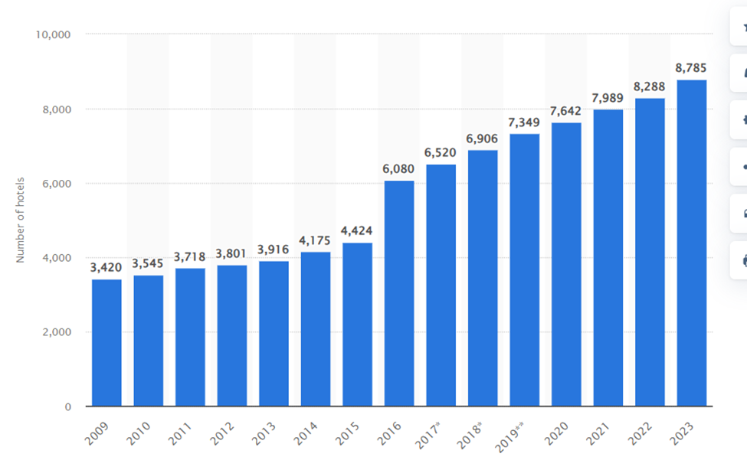
Figure 1: Number of Marriott International hotels worldwide 2009-2023
Source: (Statista, 2024)
(Figure 1) illustrates the growth of Marriott International’s hotel portfolio from 2009 to 2023, highlighting significant expansion, including the 2016 Starwood acquisition, and reflecting Marriott’s strategic global market penetration. Mintzberg's Organisational Structure Model categorises organisations based on structural design, highlighting key elements that shape their effectiveness. Artifacts include employee reward schemes and customer-centric policies, demonstrating a commitment to employee recognition and service excellence (Mintzberg, 2024). Espoused values reflect principles such as diversity, sustainability, and service excellence, guiding decision-making and fostering an inclusive, high-performance culture (Croitoru et al, 2022). Underlying assumptions support the belief that engaged employees drive business success, with research showing a strong link between employee engagement, performance, and organisational commitment (Zhenjing et al, 2022). Marriott International exemplifies a low power distance culture defined by Hofstede's Cultural Dimensions, empowering frontline employees to make service-related decisions. This empowerment is evident through initiatives that encourage associates to take leadership roles, regardless of their position, fostering a sense of ownership and responsibility. For instance, Marriott's leadership framework emphasises that leadership is not confined to titles or roles but is about leading by example, enabling associates at all levels to act autonomously in addressing guest needs (Great Place To Work, 2024).
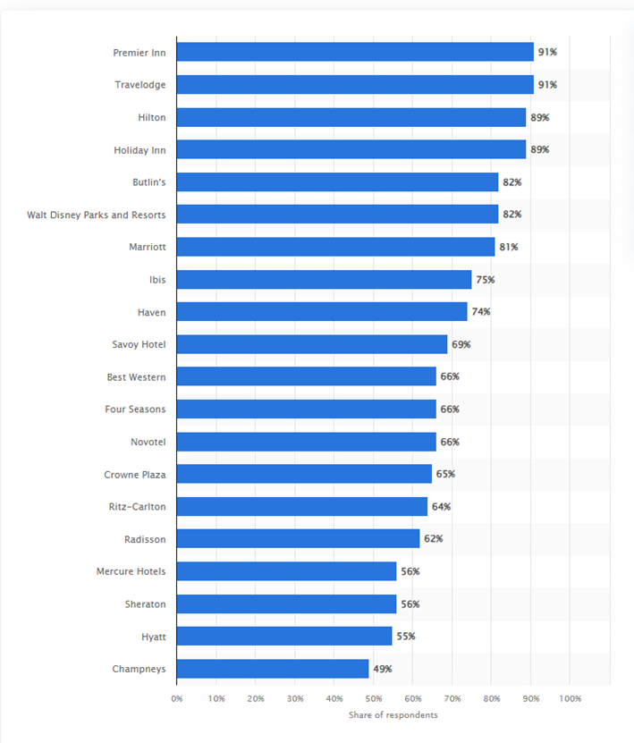
Figure 2: Most well-known hotel brands in the UK 2023
Source: (Statista, 2023)
(Figure 2) highlights the “most well-known hotel brands in the UK in 2023”, showcasing Marriott’s market position relative to competitors and reflecting brand recognition, customer loyalty, and industry influence. Marriott International fosters a culture of collectivism through incentive-based programmes such as the J. Willard Marriott Awards of Excellence, which recognise outstanding associate achievements and promote a unified organisational ethos (Marriott International, 2024a). Additionally, Marriott's Serve 360 sustainability initiative “aims to reduce carbon emissions by 30% and food waste by 50% by 2025” while incorporating environmentally friendly hotel designs (Marriott International, 2024b). The company is also expanding into high-growth markets like Saudi Arabia and Vietnam, with individual hotels focusing on guest satisfaction and revenue maximisation to ensure long-term success in the hospitality sector (Marriott International, 2024b).

3. Recent Change Initiatives

3.1 Strategic Change Initiatives and Their Implementation
Marriott International has adopted strategic initiatives to maintain its competitive edge in the hospitality industry. In 2019, it launched Marriott Bonvoy, merging Marriott Rewards, The Ritz-Carlton Rewards, and SPG to enhance customer engagement through seamless rewards and mobile integration (Marriott International, 2019; Harris et al, 2022). The company has also invested in technology-driven service upgrades, including mobile check-in, keyless entry, and AI-powered customer interactions to improve efficiency and guest experience (Harris et al, 2022). Sustainability is a key focus under its Serve 360 initiative, with targets “to reduce carbon intensity by 30% and water intensity by 15% by 2025’’. Marriott aims to achieve this through minimising single-use plastics, cutting food waste, and implementing energy-efficient technologies (Marriott International, 2024b).
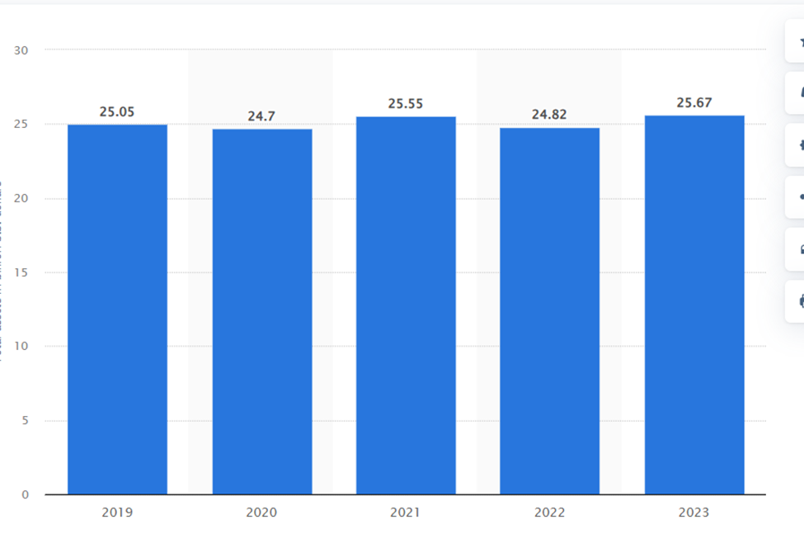
Figure 3: Marriott International total assets 2019-2023
Source: (Statista, 2023)
Figure 3 illustrates Marriott International's total assets from 2019 to 2023, highlighting financial growth, asset expansion, and the influence of economic conditions, acquisitions, and strategic investments on the company’s balance sheet. Implementing these initiatives required significant changes to corporate policies, technological systems, and staff training. For example, the integration of Marriott Bonvoy necessitated modernising IT systems, launching customer awareness campaigns, and adjusting operations across more than 8,500 properties worldwide. At the same time, Marriott’s sustainability efforts involved upgrading buildings with smart energy solutions, training staff in sustainable practices, and ensuring suppliers align with the company’s environmental initiatives (Wesley et al, 2024). These strategic transitions indicate Marriott's emphasis on boosting customer loyalty, operational effectiveness, and long-term sustainability.

3.2 Impact and Management of Change
Marriott International's strategic initiatives have significantly influenced its staff, operations, and customer experience.
Marriott Bonvoy Integration: The 2019 launch of Marriott Bonvoy, which unified Marriott Rewards, The Ritz-Carlton Rewards, and Starwood Preferred Guest, initially led to customer confusion and IT system issues. Users reported problems with point transfers, reward availability, and programme usability (Steinberg, 2019). To address these concerns, Marriott enhanced customer support, optimised digital interfaces, and offered bonus rewards to smooth the transition (Marriott International, 2019).
Staff Training: Front desk and reservations personnel underwent extensive training to manage programme-related inquiries and resolve guest issues, ensuring a consistent and positive customer experience (Arrivia, 2024).
Operational Enhancements: Marriott implemented technology-driven improvements, including mobile check-in and keyless room entry, to streamline processes, reduce wait times, and enhance operational efficiency (Arrivia, 2024). However, reliance on digital solutions introduced challenges such as cybersecurity risks and technical glitches, necessitating robust IT support and contingency planning (Arrivia, 2024).
Sustainability Initiatives: Marriott’s "Serve 360" programme integrates eco-friendly practices into hotel operations and supply chain management. Efforts include upgrading buildings with smart energy solutions, training staff on sustainable practices, and ensuring supplier alignment with the company’s environmental goals (Marriott International, 2024b). Employees are required to adapt to waste reduction programmes, water conservation measures, and new supplier agreements (Marriott International, 2024b).
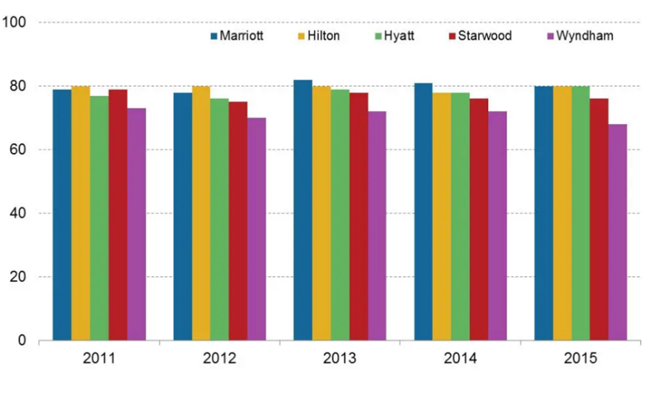
Figure 4: Marriott International in the Eyes of Customers
Source: (Matthews, 2016)
(Figure 4) reflects customer perceptions of Marriott International, highlighting key factors such as brand reputation, service quality, guest satisfaction, and loyalty, providing insights into Marriott’s market positioning and consumer trust. With the guidance of Kotter’s 8-Step Change Model, Marriott implemented a three-phase change process: Unfreezing, Changing, and Refreezing. This approach facilitated a structured transition, ensuring that changes were effectively introduced and sustained. Kotter’s model helped drive successful transformation by creating a sense of urgency, empowering key stakeholders, and embedding new practices within the organisation. While these changes improved guest satisfaction, operational efficiency, and Marriott's corporate image, they also presented challenges such as technical issues, employee adaptation, and cost concerns, which required proactive management. Ultimately, Marriott’s strong leadership, structured change strategy, and commitment to continuous improvement enabled the successful execution of these strategic initiatives (Eschenbrenner et al, 2023).

4. Strategic Direction

4.1 Long-Term Strategies
Table 1: Long-term strategies
Strategy Area | Description | Strategic Model Link
Expansion | Marriott is expanding globally, focusing on high-growth markets such as Saudi Arabia, Vietnam, and Africa. New properties under brands like JW Marriott and Courtyard are being introduced to increase market presence and revenue potential. | In SWOT, the opportunities expanding into emerging markets strengthen Marriott’s brand and create new revenue streams.
Acquisitions | The $13 billion acquisition of Starwood Hotels in 2016 added 11 brands to Marriott’s portfolio, reinforcing its position in the luxury segment. Future acquisitions will help consolidate market share and reduce competition. | In Porter’s Five Forces, the competitive rivalry purchase allows Marriott to dominate the market by reducing competition.
Digitalisation | Marriott has invested in AI-driven guest experiences, mobile check-ins, keyless entry, and enhancements to the Bonvoy app. These innovations improve efficiency and enhance customer satisfaction. | In a SWOT analysis, digital transformation is a key strength that enhances Marriott’s brand and strengthens customer loyalty.
Sustainability | The Serve 360 strategy aims to reduce carbon emissions by 30% by 2025, cut food waste by 50%, and introduce eco-friendly hotel designs to align with global sustainability goals. | In Porter’s Five Forces, the threat of new entrants highlights the importance of strong sustainability initiatives, which can enhance Marriott’s reputation and help meet regulatory requirements.

Source: (Author)

4.2 Competitive Positioning
Marriott International leads the global hospitality industry, operating “over 9,300 properties across 144 countries and territories” (Marriott International, 2024c). This portfolio surpasses competitors like Hilton and IHG. Using Porter’s Differentiation Strategy, Marriott offers 30+ brands, from luxury options like The Ritz-Carlton to budget-friendly Fairfield Inn (Marriott International, 2025).
Marriott leverages digital innovation to enhance guest experiences and efficiency through AI-driven customer service, personalised loyalty programmes, and mobile check-in. Marriott Bonvoy surpasses 200 million members, boosting retention and direct bookings (O’Neill, 2024).
Strategic acquisitions, including Starwood Hotels in 2016, expanded Marriott’s reach in corporate and leisure travel. Its sustainability efforts appeal to eco-conscious travellers. Combining brand diversity, technology, and strong customer engagement, Marriott sustains its industry leadership.
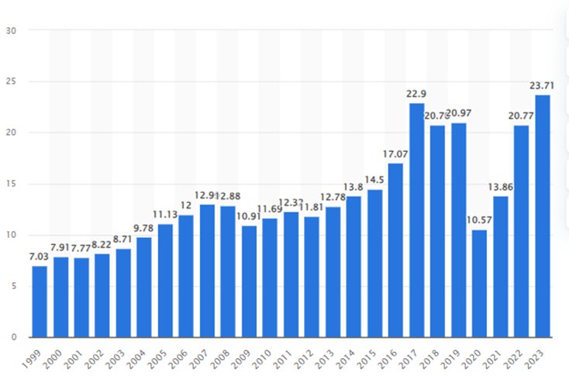
Figure 5: Marriott revenue 1999-2023
Source: (Statista, 2023)

Marriott International's Marriott Bonvoy loyalty programme “has surpassed 200 million members”, maintaining its position as the world's largest hotel loyalty programme (O'Neill, 2024). In comparison, Hilton Honors has approximately 173 million members (O’Neill, 2023). Notably, in both 2019 and 2020, Marriott Bonvoy members accounted for approximately 50% of the company's room nights booked (Marriott International, 2020).

4.3 Key Success Factors
Marriott International's success is driven by digital innovation, brand loyalty, and employee engagement, ensuring strong customer retention and growth. The Marriott Bonvoy loyalty programme, with 228 million members, contributes to 50% of total bookings, with members spending more and booking directly through Marriott’s channels (Marriott International, 2024d). Technological advancements, including AI-powered chatbots, smart room technologies, and automated guest preferences, have boosted operational efficiency and increased mobile bookings by 22% in 2023 (Marriott International, 2024e). Employee engagement initiatives, such as the TakeCare Wellbeing Programme, have also strengthened workplace satisfaction and retention (Catalyst, 2024). Through the Serve 360 initiative, Marriott has reinforced sustainability efforts, focusing on water conservation and carbon footprint reduction, aligning with global environmental targets and appealing to eco-conscious travellers (Marriott International, 2024e). With a presence in 9,300 properties across 144 countries, Marriott’s global reach, dynamic pricing strategies, and personalised guest experiences enhance its market dominance and profitability (Marriott International, 2024e). Its franchise partnerships and cost management strategies further support long-term resilience, ensuring continued leadership in the hospitality industry.

5. Conclusion
Marriott International remains a global leader in hospitality through strategic structure, innovation, and strong corporate culture. Its hybrid model ensures brand consistency while adapting to local markets. Initiatives like TakeCare Wellbeing and Serve 360 enhance employee engagement and sustainability.
Despite initial challenges, recent digital advancements, and Marriott Bonvoy’s integration have strengthened customer loyalty. With continued expansion into high-growth markets, investment in AI, and sustainability efforts, Marriott is well-positioned to maintain its competitive edge and long-term success in an evolving industry.

6. Recommendations
To enhance its organisational effectiveness, Marriott International should focus on leadership development, corporate culture, and change management (see Appendix A Implementation Plan) Expanding programmes like the Voyage Global Leadership Development Program, an initiative designed to prepare recent graduates for leadership roles, can equip employees with essential skills and foster diverse, innovative leadership (Marriott International, 2024f). Enhancing cultural competency training and tailored employee engagement initiatives will help Marriott maintain its "Put People First" philosophy while adapting to local markets. Implementing Kotter’s 8-Step Change Model, which provides a structured approach to organisational transformation, along with establishing a Change Leadership Taskforce, will ensure smooth transitions during digitalisation, acquisitions, and operational changes, driving long-term success (Kotter Inc, 2024).

7. References

Arrivia (2024). Most Common Loyalty Program Problems. Available at: https://www.arrivia.com/insights/loyalty-program-problems-solutions/ (Accessed 27 Feb. 2025).
Catalyst (2024). Frontline Employee Retention at Marriott. Available at: https://www.catalyst.org/about/stories/2024/frontline-employee-retention-marriott (Accessed 28 Feb. 2025).
Croitoru, G., Florea, N.V., Ionescu, C.A., Robescu, V.O., Paschia, L., Uzlau, M.C. and Manea, M.D. (2022). Diversity in the Workplace for Sustainable Company Development. Sustainability, 14(11), p.6728. Available at: doi:https://doi.org/10.3390/su14116728 (Accessed 26 Feb. 2025).
Dudovskiy, J. (2023). Marriott Organisational Structure Overview. Available at: https://research-methodology.net/marriott-organizational-structure-overview/ (Accessed 25 Feb. 2025).
Eschenbrenner, B., Zlatic, A., Bechtel, M., Collins, B., Straley, C., and Gubbels, G. (2023). Marriott International: A Managerial Strategic Audit, Undergraduate Honors Thesis, University of Nebraska-Lincoln. Available at: https://digitalcommons.unl.edu/honorstheses/632/ (Accessed 27 Feb. 2025).
Great Place To Work (2024). Empowering the Frontlines. Available at: https://pubfiles.greatplacetowork.com/root/com/GPTW_Marriott_Frontlines_08_Download.pdf (Accessed 26 Feb. 2025).
Harris, J.D., Snell, S.A., and Harrison, K. (2022). Marriott International: Hospitality's Uncertain Future, SSRN Electronic Journal. Available at: doi:https://doi.org/10.2139/ssrn.4248262 (Accessed 26 Feb. 2025).
Horozhankina, N., Korneyev, M. and Farzullaev, R. (2024). Marriott International’s place in international hotel chains, Scientific Opinion: Economics and Management, 4(88). Available at: doi:https://doi.org/10.32782/2521-666x/2024-88-4 (Accessed 25 Feb. 2025).
Kotter Inc. (2024). The 8-Step Process for Leading Change. Available at: https://www.kotterinc.com/methodology/8-steps/ (Accessed 28 Feb. 2025).
Marriott International (2019). Marriott International Announces Marriott Bonvoy – The New Brand Name of Its Loyalty Program. Available at: https://news.marriott.com/news/2019/01/16/marriott-international-announces-marriott-bonvoy-the-new-brand-name-of-its-loyalty-program (Accessed 26 Feb. 2025).
Marriott International (2020). Marriott 2020 Annual Report. Available at: https://media.corporate-ir.net/media_files/IROL/10/108017/marriott20AR/10k-item1-p3.html (Accessed 28 Feb. 2025).
Marriott International (2023). Marriott International Announces Organizational Structure and Executive Appointments. Available at: https://news.marriott.com/news/2023/02/24/marriott-international-announces-organizational-structure-and-executive-appointments (Accessed 25 Feb. 2025).
Marriott International (2023). TakeCare Wellbeing Programme. Available at: https://life.marriott.com/blog/marriott-benefits/ (Accessed 26 Feb. 2025).
Marriott International (2024). Core Values and Heritage | Marriott International Corporate Values. Marriott.com. Available at: https://www.marriott.com/culture-and-values/core-values.mi (Accessed 26 Feb. 2025).
Marriott International (2024a). J. Willard Marriott Awards of Excellence. Available at: https://www.marriott.com/culture-and-values/awards-of-excellence.mi (Accessed 26 Feb. 2025).
Marriott International (2024b). 2024 Serve 360 Report: Environmental, Social & Governance Progress. Available at: https://serve360.marriott.com/wp-content/uploads/2024/07/2024ESGProgress.pdf (Accessed 26 Feb. 2025).
Marriott International (2024c). Marriott International Celebrates Outstanding Development Year with 6.8% Net Rooms Growth and Record Number of Gross Openings in 2024. Available at: https://marriott.gcs-web.com/news-releases/news-release-details/marriott-international-celebrates-outstanding-development-year (Accessed 26 Feb. 2025).
Marriott International (2024d). The Power of Marriott. Available at: https://www.hotel-development.marriott.com/power-of-marriott (Accessed 28 Feb. 2025).
Marriott International (2024e). Marriott International 2024 ESG Report. Available at: https://marriott.gcs-web.com/static-files/b82978a6-9d28-4e38-9855-fc4ae2cebe11 (Accessed 28 Feb. 2025).
Marriott International (2024f). Voyage Global Leadership Development Program. Available at: https://careers.marriott.com/career-journeys/early-careers/ (Accessed 1 March 2025).
Marriott International (2025). About Marriott International | Corporate Information. Available at: https://www.marriott.com/marriott/aboutmarriott.mi (Accessed 25 Feb. 2025).
Matthews, S. (2016). Marriott International in the Eyes of Customers: Outside Looking In. Market Realist. Available at: https://marketrealist.com/2016/01/marriott-international-eyes-customers-outside-looking/ (Accessed 27 Feb. 2025).
Mintzberg, H. (2024). Four Forms That Fit Most Organizations, California Management Review, 66(1), pp. 29–47. Available at: https://journals.sagepub.com/doi/full/10.1177/00081256231214816 (Accessed 26 Feb. 2025).
O’Neill, S. (2023). Hotel Loyalty Race: Hilton Gains on Marriott. Skift. Available at: https://skift.com/2023/12/31/hotel-loyalty-race-hilton-gains-on-marriott/ (Accessed 28 Feb. 2025).
O’Neill, S. (2024). Marriott Bonvoy Adds 200 Millionth Member as Hotel Loyalty Race Heats Up, Skift. Available at: https://skift.com/2024/02/26/marriott-bonvoy-adds-200-millionth-member-as-hotel-loyalty-race-heats-up/ (Accessed 26 Feb. 2025).
Secchi, E., Roth, A., & Verma, R. (2019). The Impact of Service Improvisation Competence on Customer Satisfaction: Evidence from the Hospitality Industry. Production and Operations Management, 28(6), 1329–1346. Available at: doi:https://doi.org/10.1111/poms.12969 (Accessed 25 Feb. 2025).
Statista (2023). Hotels brand awareness KPI ranking UK 2023 | Statista. Available at: https://www.statista.com/statistics/1343521/most-well-known-hotel-brands-in-the-uk/ (Accessed 26 Feb. 2025).
Statista (2023). Marriott International total assets 2023 | Statista. Available at: https://www.statista.com/statistics/1529244/marriott-international-total-assets (Accessed 28 Feb. 2025).
Statista (2023). Marriott International total equity 2023 | Statista. Available at: https://www.statista.com/statistics/1529390/marriott-international-total-equity/ (Accessed 26 Feb. 2025).
Statista (2024). Marriott hotels worldwide 2023 | Statista. Available at: https://www.statista.com/statistics/247285/number-of-marriott-international-hotels-worldwide/ (Accessed 26 Feb. 2025).
Steinberg, E. (2019). Top 10 Marriott Complaints and How They Can Be Resolved in 2019 - The Points Guy. The Points Guy. Available at: https://thepointsguy.com/hotel/top-marriott-complaints-to-resolve-2019/ (Accessed 27 Feb. 2025).
Wesley, S., Jackson, K.N., Ramos, D.M., Vanbeber, S. and Mujtaba, B.G. (2024). Marriott Hotel’s Practices in Mitigating Discrimination Through Inclusionary Employee Resource Groups, Journal of Business Diversity, 24(1), pp. 41–56. Available at: doi:https://doi.org/10.33423/jbd.v24i1.6897 (Accessed 26 Feb. 2025).
Zhenjing, G., Chupradit, S., Ku, K.Y., Nassani, A.A. and Haffar, M. (2022). Impact of employees’ workplace environment on employees’ performance: A multi-mediation model. Frontiers in Public Health, 10, p. 890400. Available at: doi:https://doi.org/10.3389/fpubh.2022.890400 (Accessed 26 Feb. 2025).

8. Appendices

Appendix A: Implementation Plan
Recommendation | Who | When | Where | Why | How
Leadership Development Enhancement | HR and Training Teams | 6 to 12 months | Global | Strengthen internal talent pipeline | Strengthen the internal talent pipeline by expanding digital learning platforms and mentorship programs to support employee development and career growth.
Strengthening Corporate Culture | Regional Managers and HR | Ongoing | Culturally diverse markets | Ensure Marriott values align with local expectations | It ensures Marriott’s values align with local expectations by conducting cultural training and implementing local engagement initiatives.
Improving Change Management | Change Leadership Taskforce | 12 months | Across all properties | Enhance adaptability & efficiency | Implement Kotter’s 8-Step Model for structured change execution
Source: (Author)

