Kai Probert - 2200897

NOS – Network operating systems and services (accA5023)

Contents
Network Operating Systems and Services 1
Hypervisors 1
IP addressing 2
Network Testing 3
Proof Of Connectivity 4
References 6

Network Operating Systems and Services

Hypervisors
There are two main types of Hypervisors. These are defined as type 1 and type 2. They work slightly differently in the implementation while both providing the same result. Type 1 hypervisors are “Bare-Metal” meaning that they do not run off the host system OS. They can directly access any machine resources and implement custom resource allocation; this allows them to run far faster and be more efficient. Type 2 on the other hand, runs off the host OS. Meaning that they require splitting resources with the host OS, making them slower and less efficient. Advantages of a type 2 system are that it is far easier to install and manage the system. As type 2 run above the host os, it allows for any hardware, assuming that the hypervisor is compatible with it. Its also installed like any typical program, making it far easier to understand and setup for beginners.
Advantages of a type 1 system are their ability to directly use system resources, making them faster and more efficient that a type 2 system. They are also capable of being far more secure, as the system does not run off a host os, the attack vectors for a type 1 implementation are far fewer and considerably harder to undergo. There are also far more stable, as they do not have to compete with the host os and worry about incompatibilities. Advantages of a type 2 system are their ability to run on most hardware, they are easier to install and manage for the end user and also since they run off of the host os, it means that users can still access the host machine without requiring a different system.
Disadvantages of a type 2 system is their lower overall performance outlook compared to a type 1 system, due to their requirements of resource sharing with the host os and applications. A lack of stability and security means that they are far more likely to fail in situations of crashes and cyber-attacks. A Type 2 crash could also affect the host OS, making it also crash. The disadvantages of a type 1 system are their complexity, hardware requirements, difficulty to manage and lack of scalability. Their complexity is sometimes an advantage, as it allows far more implementations and changes, while also being harder to manage and deploy, meaning that the person implementing would need far more experience with type 1 systems, than what would be required for a type 2 infrastructure. Some type 1 systems require specific implementations of hardware to allow them to work.^{[1]} Some hardware for these systems is incompatible and will not work in some situations. Making them costly for a business to implement also. They are also not scalable, so if a business wanted multiple hypervisor implementations it could be advantageous for them to implement a type 2 design instead.
Examples of type 1 hypervisor implementations are : ESXi, created by VMware (not to be confused with VMware Workstation), and Hyper-V, a VM that can both run on windows, or fully bare-metal. While still having full access to the system hardware. Examples of type 2 hypervisors are Oracles VirtualBox and VMware Workstation. Both of these type 2 hypervisors can run on both many versions of Linux and windows. While VirtualBox also works on MacOS systems.
For my hypervisor of choice, I have decided to go with VMware Workstation. I have previous experience using Workstation, so I feel more comfortable using it. It is more user intuitive and friendly. I believe it has far more options that VirtualBox, which I also have limited experience using. I find the nature of Workstation far easier to work with, especially with how it manages the Virtual Machines running in multiple instances.

IP addressing
Transferring information over the internet requires IP addressing and its many quirks and requirements to work. IPs are a 32bit number divided into 4 octets of numbers. Without these, we would not be able to access the internet.^{[2]} They are a requirement in using the internet. Messages over the internet originate from your system at full size, but before they can travel to their end destination they need to be split into “packets”, packets are byte sized chunks of your data, this is done as sending entire pieces of information through the internet at once, means that anyone also using that connection would have to wait until the data is received. The internet today uses “packet switching,” it allows networks to independently understand what data is for them and what isn’t. Allowing for many systems to use the same network and send data at once. It also allows packets to transfer using different routes, while still arriving in the order that they were sent.^{[3]} Networks use TCP/IP protocols (Transmission Control Protocol) to send data across networks. This is extremely important as TCP is a set of rules that is required to allow systems to communicate with each-other. Without these rules, these connections would not be possible. This model is used almost everywhere, email, major web applications etc. An alternative to this is the UDP model. 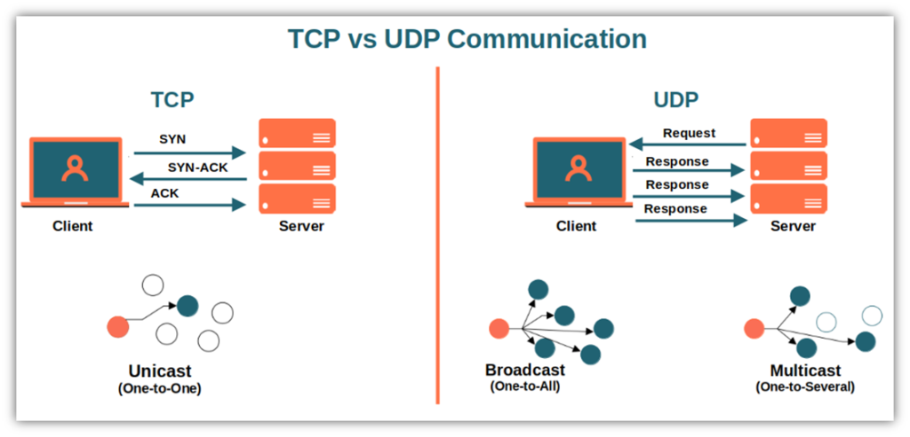
Figure 1 - TCP vs UDP ^{[4]}
UDP (User Datagram Protocol) is a faster, but less reliable network protocol. Typically, UDP is supported when an application or system requires quick, efficient transmission of data, which does not necessarily require a 100% success rate. TCP does not allow for packet loss, (although it does happen, it is not intended by the protocol) while UDP does allow for this, assuming that the data arrives in its majority. You will find UDP implemented in VoIP (Voice Over IP) and video streaming, as packet loss here is less important. These packets will not always arrive in order, too, meaning its able to be faster than the TCP model. Where TCP is a connected model, meaning it has a defined origin (similar to cabled connection) Whereas UDP is connectionless open signal, allowing it to send the data faster, as it does not require to do things like error checking.^{[5]}
Switches and Routers are vital to making sure networks work. Both switches and routers are physical devices that allow for network connectivity to take place. A switch works at layer 2 of the OSI model (sometimes also layer 3, for routing and support with VLANs). A switch is a device that essentially takes in packets, and forwards them to their expected destination. A switch uses the packets header to identify its end location, it can then forward these packets to that destination. A router operates at level 3 of the OSI model. A router differs from a switch as a router allows for networks to be connected to other networks. Although a switch can route, its not its main purpose and cannot supply true connectivity like a router can.

Network Testing
The most basic examples of network testing in windows would be the “ping” and “traceroute” commands. Although basic, they are a sanity check for network administrators to see if the network is functioning properly, one way. This test can be conducted on other machines to the host machine to identify if there is a active connection for all systems in the network. The traceroute command is used as a form of ping command, but instead of just returning a yes/no answer, traceroute shows you where the packets are traveling through the network. This is especially useful if your network is suffering from high amounts of packet loss, traceroute can show you the route of the packets and you can from there identify where the packet loss is originating. Traceroutes can be successful even with packet loss, as the packets can recover and reach the end destination, but you can still identify what hops are causing problems in the network. Checking firewall configurations is important when encountering issues in the network. Firewall misconfigurations are typical problems that would cause a network connection to fail. Verifying this, using programs like Wireshark can help look for blocked packets, you can find the problem in the network. During security tests, you can use programs like Nmap to identify open ports on a network. This is of upmost importance as open ports can lead to very easy targets from threat actors. Systematic diagnosis of network issues is vital to a successful patch. Identifying the symptoms, isolating the issue, and eliminating any reasonably likely causes are steps you should take to defining the networks integrity. You can then implement any solutions you find to the issues you identified earlier, retesting the network often can help in identifying these problems.^{[6]}

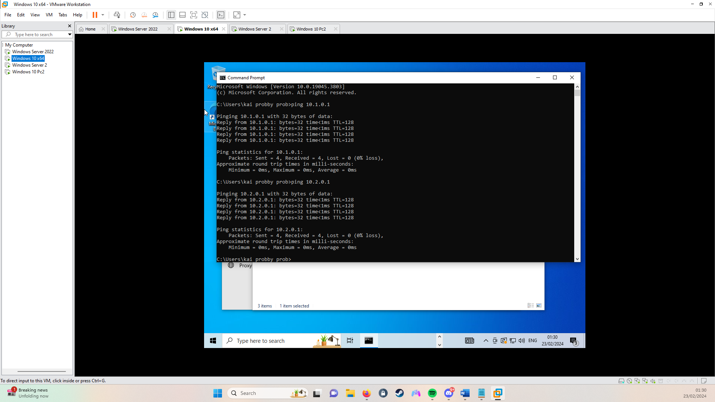
Proof Of Connectivity

Ping from SW-PC to LD-DC
Ping from SW-PC to SW-DC

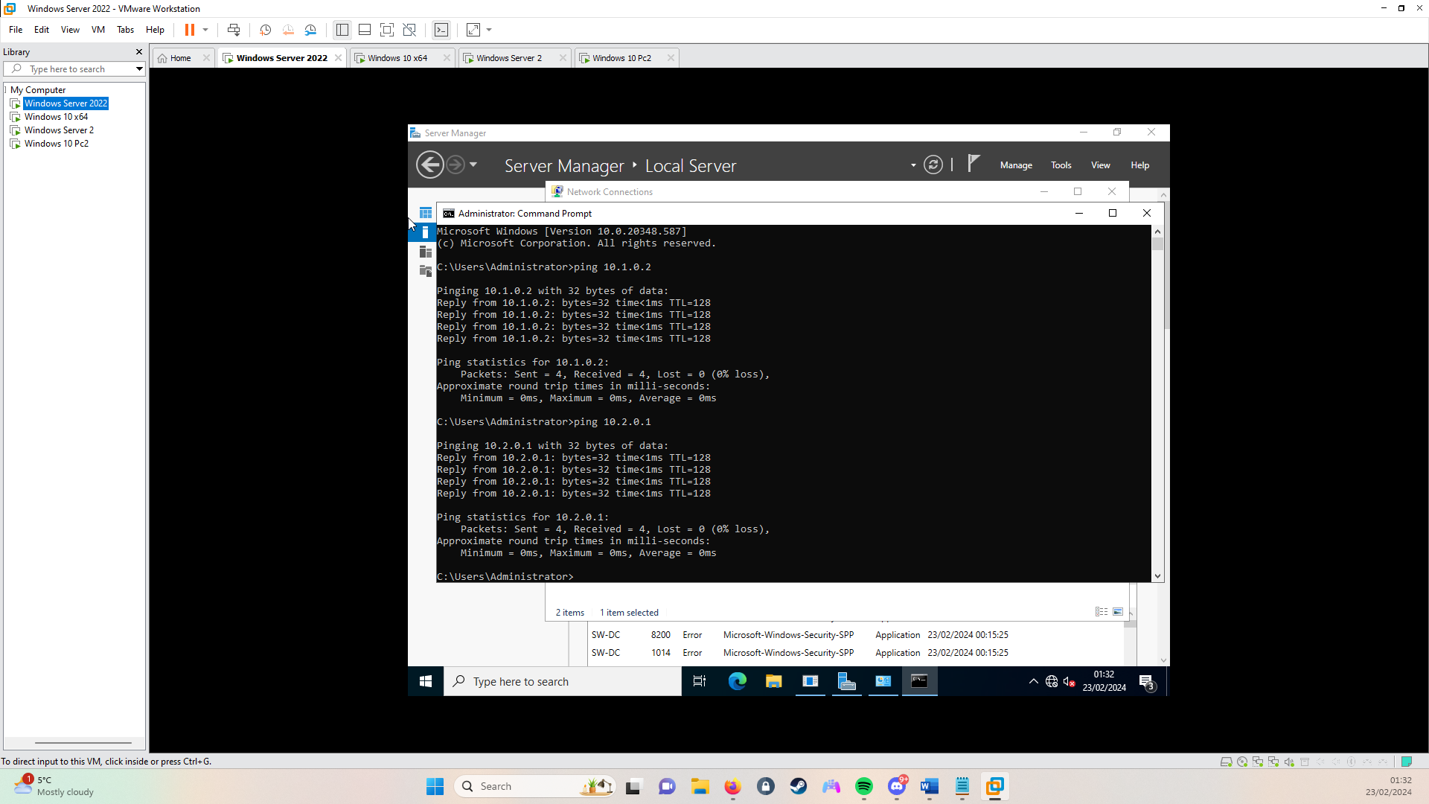
Ping from SW-DC to SW-PC
Ping from SW-DC to LD-DC

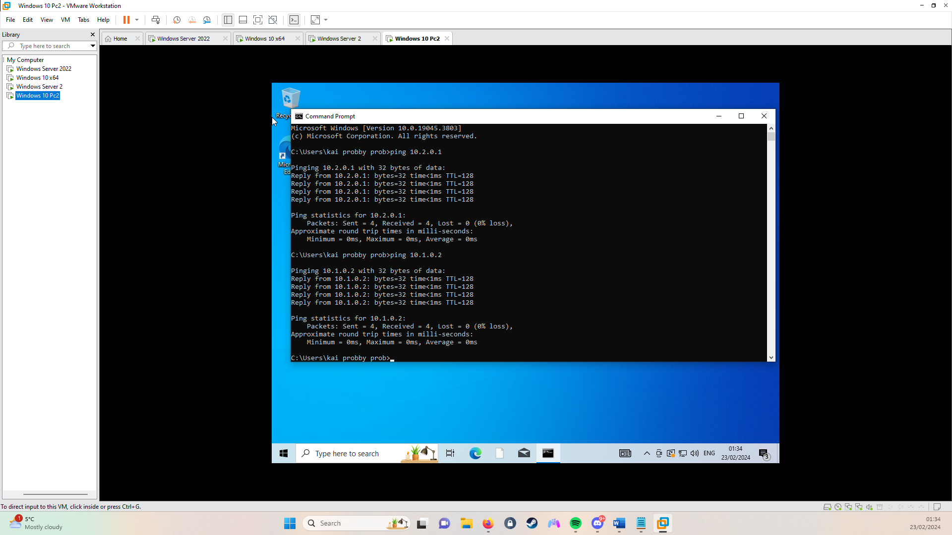
Ping from LD-PC to LD-DC

Ping from LD-PC to SW-PC

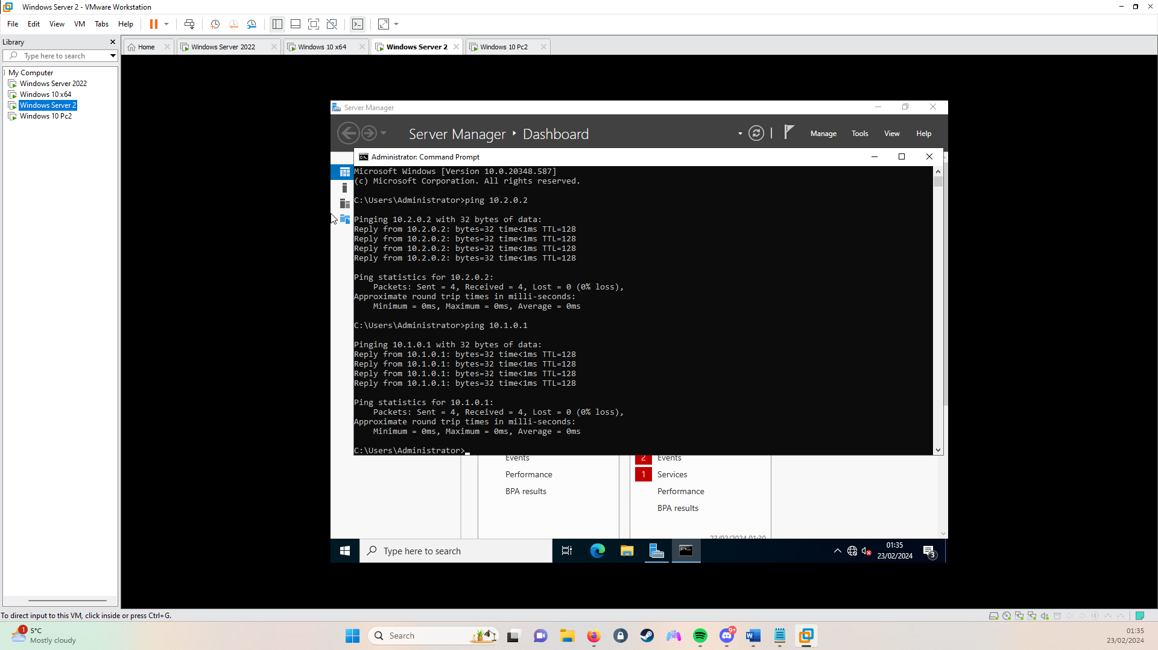

Ping From LD-DC to SW-DC
Ping from LD-DC to LD-PC

References
[1]
“type 1 vs type 2 hypervisors,” 2022. https://www.starwindsoftware.com/blog/type-1-vs-type-2-hypervisor-what-is-the-difference (accessed 21/02/24).
[2]
HP, “how does the internet work<br>,” 2023. https://www.hp.com/us-en/shop/tech-takes/how-does-the-internet-work (accessed 21/02/24).
[3]
Cloudflare, “What is a packet<br>,” 2020. https://www.cloudflare.com/en-gb/learning/network-layer/what-is-a-packet/ (accessed 21/02/24).
[4]
medium, “differences in network communication<br>,” 2022. https://medium.com/@debopamdeycse19/tcp-vs-udp-exploring-the-differences-in-network-communication-a1543f2e70f3 (accessed 22/02/24).
[5]
“avinetworks.” https://avinetworks.com/glossary/connectionless-protocol/ (accessed 22/02/24).

[6]
Venkatasubramanian, Venkat, R. Rengaswamy, and S. N. Kavuri, “A review of process fault detection and diagnosis: Part II: Qualitative models and search strategies." Computers & chemical engineering,” 2003.

