Organisational Culture Individual Report - Component 1
Organisational Culture Report on Walmart
Student name: Florin Marian Bariz
Student ID: 2221353
Module: LCLM 5005 Organisational Culture
Lecturer: David Oyebisi

Executive Summary
Walmart's culture is built on providing low prices and superior customer service. The hierarchical nature of the organisation also strengthens this culture and ensures uniformity of all the retail outlets. The company's profitability, operational efficiency, and competitiveness are based on this culture driven by technological innovation. The firm has revenues of 648 billion dollars. However, some of its employees have low salaries and are dissatisfied. Walmart should increase the remuneration and benefits of its employees so as to increase their satisfaction and better the level of customer service. The company should also prevent excessive costs, ensure customer requirements, and ensure product quality at an acceptable cost and fair price. Walmart can sustain its resiliency and ensure long-term success by paying attention to its employees, addressing them in an impartial way, and reinforcing ethical behaviours.
Table of Contents
Introduction 4
Culture Shaping Structure and Decision-Making 4
Cultural Frameworks Analysis 7
Culture and External Environment Adaptation 10
Culture as Barrier or Enabler 11
Impact on Performance and Recommendations 12
Conclusion 13
References 14

Introduction
The organisational culture consists of values, beliefs, and practices that are applicable in the running of a company. It affects the decision-making, structures, and behaviour of employees. The existence of a strong culture improves corporate performance, customer satisfaction, and attracts a workforce. This report entails the analysis of Walmart, the largest retailing company in the world, with 2.3 million employees in 10,500 stores distributed worldwide (Walmart, 2025). Low prices and customer service culture have been the pillars on which Walmart has been successful for a long time. Three models are employed in the analysis, including Schein, Hofstede, and Handy. The report expounds further on how culture shapes the structure, decision-making, external adaptation, and performance of the business, and ends with suggestions for improvement.

Culture Shaping Structure and Decision-Making
How Walmart's Culture Shapes Its Company Structure
The cost-efficiency and customer-focused culture of Walmart is the direct influence that shapes the organisation of the company. The structure of the company is hierarchical. This implies that the CEO will be in the topmost position and the decision will be made downwards, through regional managers, district managers, store managers, and finally to the store employees. This high authority is typical of Walmart and its value: control and consistency. All the stores should be subject to the policies and practices due to the culture of Walmart that requires uniformity among all locations. Walmart employs this structure since the cultural value of the company is to keep costs low (Walmart, 2025). A centralised system enables corporate leaders to make huge decisions within a short period of time, and simultaneously apply the decisions everywhere (Gade, 2021). Take the example of when Walmart chooses to reduce the prices on products that are offered; the news can be relayed in the hierarchy to all its 10,500 stores worldwide in a matter of days.
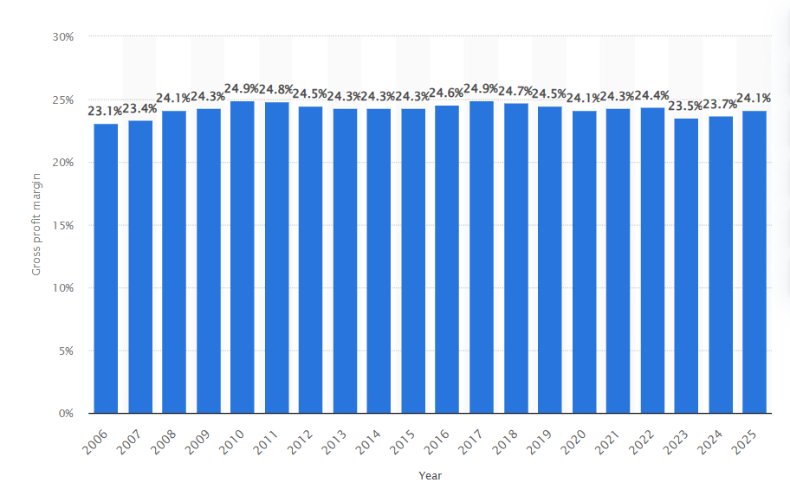
Figure 1: Walmart: gross profit margin worldwide FY2006-FY2025
(Source: Statista, 2025)
Since 2006, Walmart has had a stable gross profit margin. In fiscal year 2025, the retailer's global profit margin amounted to 24.1%. This organisation is appropriate for a retail giant that has to operate with more than 2.3 million employees. Nevertheless, this is not the only rigid structure in Walmart (Walmart, 2025). There are also functional groups in the company that are within the stores, such as marketing, human resources, and customer service. The groups are grouped according to what they do and not by the way they sit. This combined solution (hierarchy and functional) provides some flexibility as well as control to Walmart.
How Culture Influences Decision-Making at Walmart
The culture of Walmart focuses on four values, which include customer service, respect for people, pursuit of excellence, and integrity. These values form the basis of the decision-making at all levels. The CEO and executives are at the highest level and make all the strategic decisions on the basis of the customer-first mentality. As an illustration, Walmart makes its decisions on what new markets to go to and what to invest in technology with the aim of offering low prices and improved service. These are decisions of the top-down organisation; a small number of individuals make decisions on behalf of the masses. The managers at the middle level and the store level make decisions grounded in the culture of the company, which is with respect for the individual and service to the customers (Wiechmann et al., 2022). Store managers have the authority to determine how their store should be staffed, how to position products, as well as how to resolve customer complaints. Although they adhere to corporate rules, they are somewhat free to adjust to the local demands.
Among the cultural factors that may have contributed to this is the fact that Walmart has relied on an authoritarian culture in the past. This implies that leaders have high power and authority, and decisions made at the leadership level are passed downwards. Employees are supposed to be submissive to the guidelines and rules of the company. This decision-making style endorses the hierarchical style of organising the company; the flow of commands is apparent, and the decisions take too little time (Sulich et al., 2021). However, Walmart is changing. An open-door policy has currently been promoted in the company. It refers to the fact that employees are able to come to the managers with their thoughts or issues. It demonstrates that the culture in Walmart is changing through increased collaboration and input of employees in decision-making. The organisational structure also displays this culture change. The company has now decentralised teams with a certain degree of freedom to make decisions on the local scale, with overall standards being set by corporate offices.
Evidence from Walmart
The case of Walmart and its cost-saving approach is a definite one. The culture of the company places emphasis on low prices. It resulted in a top-down organisation where decisions in terms of prices and policies are made at the centre and implemented everywhere. In 1997, when Walmart ventured into Germany, it made an attempt to bring with it the American culture and structure. German workers and customers, however, expected better-structured and formal decisions (Walmart, 2025). The informal, top-down strategy exercised by Walmart was not working, and the company exited Germany in 2006. This is a confirmation that the culture and structure of Walmart are closely related.
The other case is the case of Walmart, which invested in technology and e-commerce. Innovation and adaptation are appreciated in the culture of the company. This caused alterations in the structure of the organisation, and new digital and technology divisions were added. The level of autonomy that these groups enjoy in terms of experimental and rapid decision-making is also the case, since innovation demands flexibility.

Cultural Frameworks Analysis
Schein's Model: Understanding Walmart's Layers
Edgar Schein has developed the model of three levels to comprehend the organisational culture. The first level is Artefacts. They are tangible items that are observable. At Walmart, the examples of artefacts are blue uniforms employed by the staff, store structure where the greeters are present at the entrance, low-cost products being visible at the front, and salespeople's scripts, which are friendly (Rickard, 2024). These prominent aspects reflect to customers and employees what Walmart values: customer service and value.
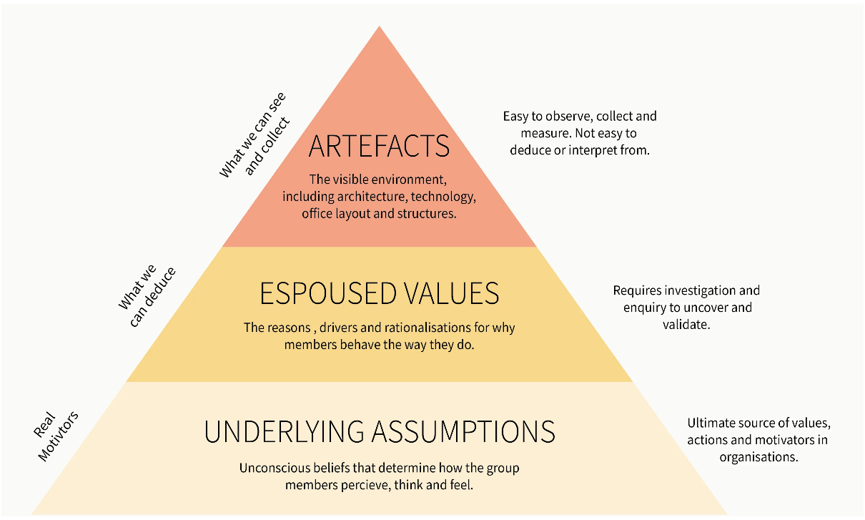
Figure 2: Edgar Schein's Culture Model
(Source: Dominick et al., 2021)
The second one is Espoused Values. These are the values that the organisation claims to take pride in. Walmart is quite frank in declaring its four core values: service to customers, respect for individuals, excellence, and integrity (Dominick et al., 2021). The company publishes these on its webpage, training documents, and handbooks for its employees. These are values that need to be determined in the way the employees ought to act.
Underlying Beliefs is the third level. Such are the implicit, unconscious assumptions. The philosophy at Walmart is that prices leading to customer loyalty and profits are due to low prices. Consistency is another of the beliefs held that centralised control should be in place (Seitz, 2022). They are not written, and this is because they are governed by these beliefs, which make all decisions. Indicatively, when managers assume that they will reduce costs, customers will spend more and therefore strive to reduce costs.
Hofstede's Cultural Dimensions: Walmart across the World
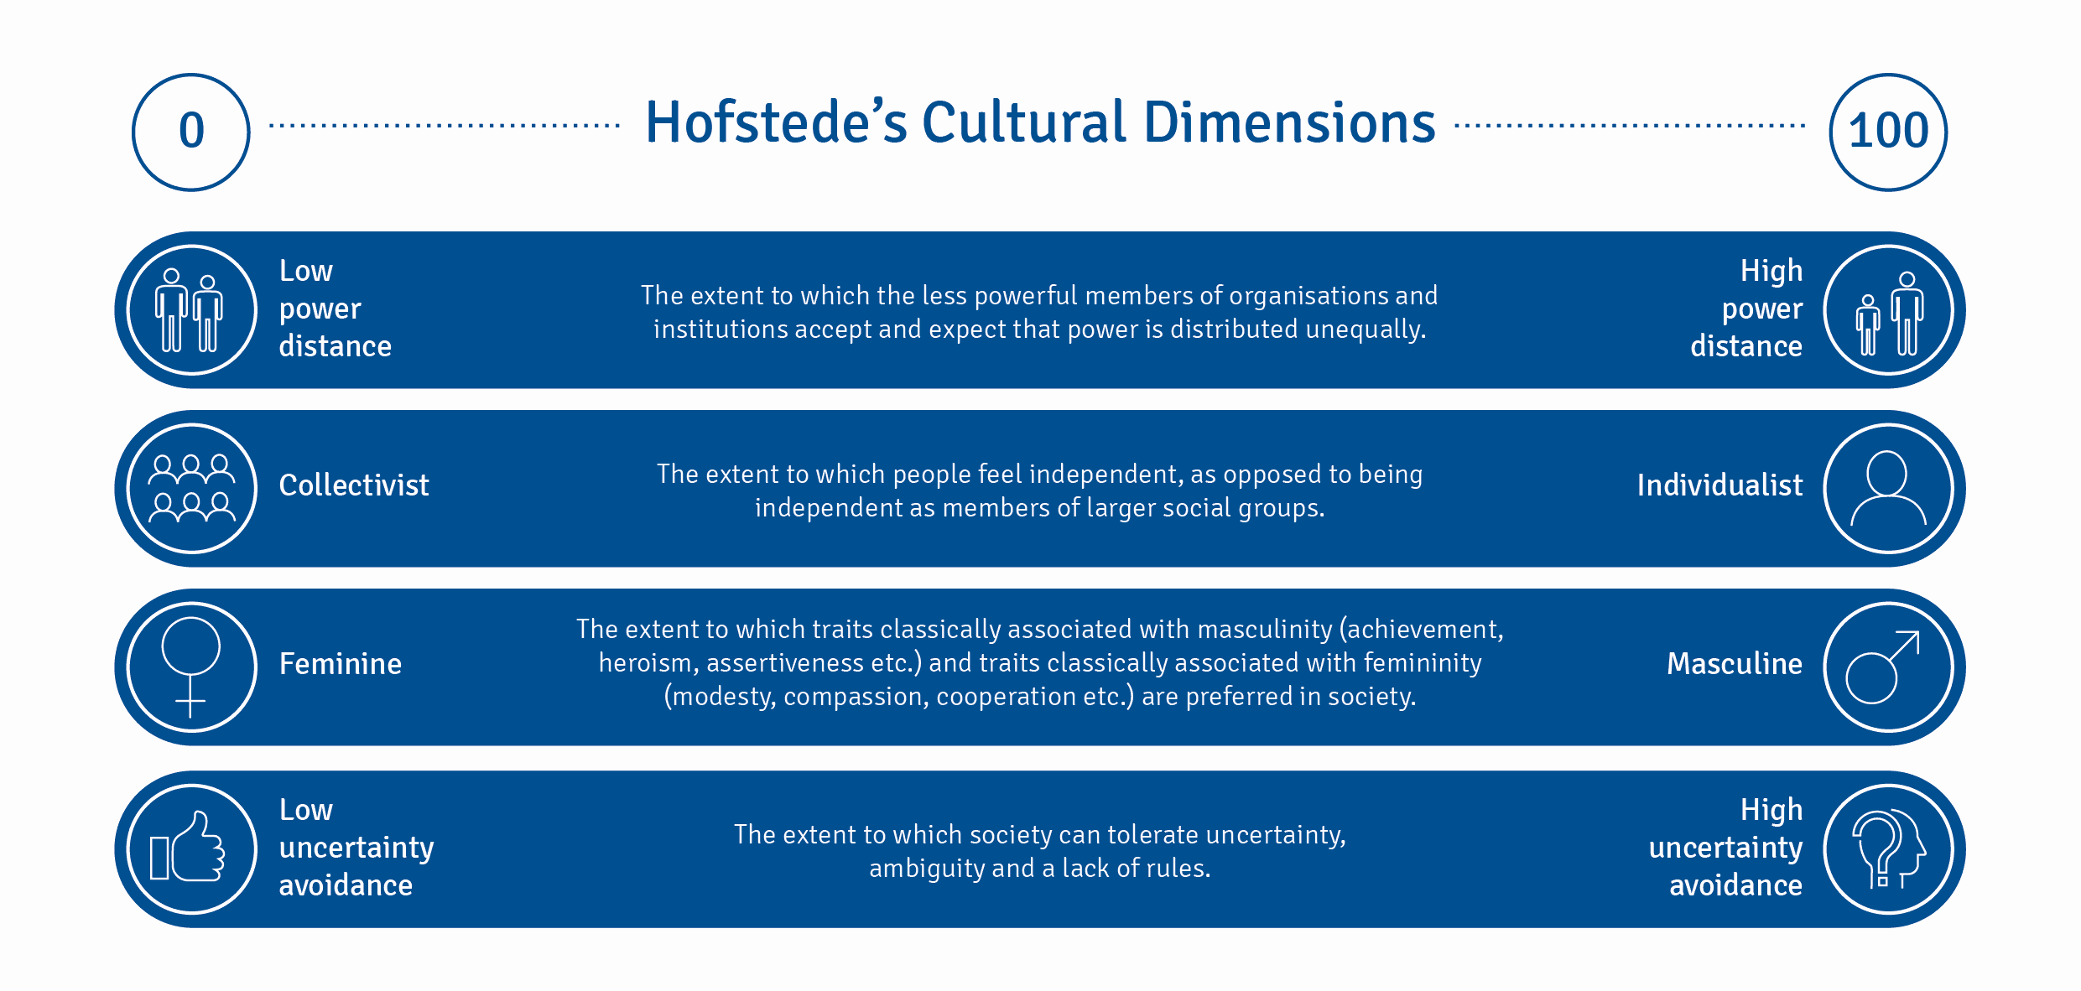
Figure 3: Hofstede's Cultural Dimensions
(Source: Lim, 2025)
Power Distance: Walmart is not characterised by high power distance. The organisation encourages the idea of an open-door policy and minimises the distance between the bosses and the employees. The staff members will not fear speaking to managers directly (Lim, 2025). Walmart promotes horizontal and vertical communication, which is not the case in authoritarian companies.
Individualism: Walmart is highly rated in terms of individualism, which is characteristic of Americans. The company appreciates individual performance, performance-related rewards, and promotes independent thought. The staff members are encouraged to perform at an individual level and achieve recognition (Imran et al., 2025).
Masculinity: Walmart has masculine values. It is an achievement-oriented, competitive culture. They have an employee competition that results in success being celebrated. The corporation emphasises achievement and drive over teamwork.
Uncertainty Avoidance: Walmart is a company with low uncertainty avoidance. The firm is open to discovering and exploring new things. The company embraces experimentation amongst the employees and is not afraid of change.
Long-Term Orientation: Walmart is balanced in the short and long term. The company can make fast decisions to get short-term outcomes, but its long-term investments are geared towards long-term expansion and sustainability.
Indulgence: Walmart is hedonistic. Among the benefits provided to the employees by the company are flexible working schedules, remote work, a gym, day care, and paid leave. The following benefits demonstrate that Walmart is committed to the well-being of its employees.
Handy's Cultural Types: Walmart as a Task Culture
Charles Handy came up with four types of cultures. Walmart is mainly a Task Culture. Work in a task culture is based on accomplishing projects and tackling issues. Teams are created to achieve functions and dissolved when this task is completed (Lim, 2025). At Walmart, workers operate in groups in order to meet the sales goals, enhance inventory, or introduce new store formats. There is a cherishing of the team spirit, and the objective is quantified by accomplishment. Role Culture (inflexible, by the book) and Power Culture (centralised leadership) are also avoided by the company. Rather, Walmart focuses on flexibility and teamwork.
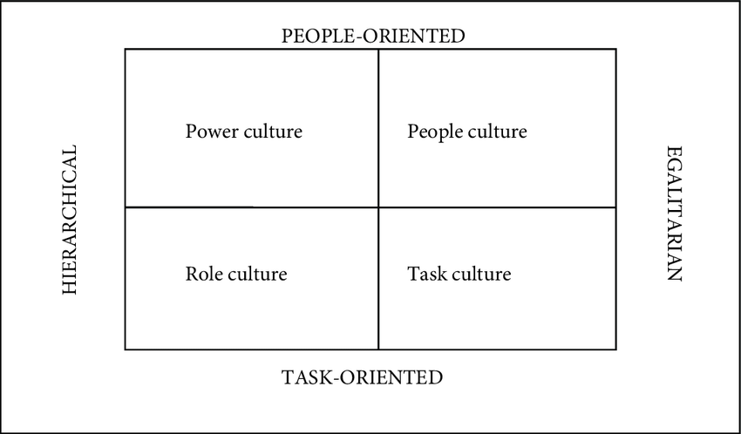
Figure 4: Handy's Cultural Types
(Source: Lim, 2025)
Comparison of Frameworks
All three models affirm the fact that Walmart has a customer-oriented flexing culture driven by innovation. The model developed by Schein describes it using the artefacts of customer service. The model created by Hofstede brings it under low power distance and low uncertainty avoidance. The model proposed by Handy can illustrate it with the help of task-focused teamwork. All these structures depict Walmart as a firm that places a high premium on efficiencies, advancements, and cooperation among staff and still exercises utter authority in the strategy.

Culture and External Environment Adaptation
How Walmart's Culture Helps It Adapt to Changes
The culture of cost-efficiency and nonstop innovation of Walmart leads to the possibility of rapid response to the external change that occurs. The world is changing rapidly, customers can order from their shop online, rivals like Amazon are very strong, and technology has improved. The culture of Walmart drives change in the company (Ponce Gea and Serrano Pastor, 2022).
Technology and E-commerce Changes
The biggest change in external impact is the emergence of online shopping. In the past decade, the majority of customers used to shop offline; nowadays, buying through the Internet is becoming more and more widespread (Espinoza et al., 2021). Walmart's culture that believes in innovation and change caused the firm to spend billions of dollars on digital transformation. It produced Walmart.com, mobile apps, and pick-up services, as well as applied the philosophy of the company of low prices and customer service to online services. Another show of acquisition of technology companies into the firm was the purchase of Jet.com, which hastened the process of gaining digital abilities.
Market Competition
The online retailers, including Amazon, pose stiff competition. The culture developed at Walmart taught the firm to be competitive in price and speed (Waller, 2025). Walmart invested in artificial intelligence, automated warehouses, and expedited delivery systems to be a competitive company. These investments were guided by the culture of efficiency of the company. The AI chatbots are currently used at Walmart to negotiate with the suppliers, which saves 1.5% of costs, a direct consequence of the cost-cutting culture that the business has been successful with over the decades.
Global Market Adaptation
The external environments in different countries are different. The culture of Walmart is flexible. In beginning to operate in India, Walmart did not open new stores, but instead acquired local business Flipkart, which portrays a show of adaptation to the culture. Walmart has small urban stores, rather than large ones, in China, with respect to the local shopping habits. The central philosophy of the company, as one should know, serves customers, and that makes it flexible to various markets (Purnomo, 2023).
Technology Partnerships
Walmart also has partnerships with technology companies like Microsoft and OpenAI in order to keep up with the emerging technology. This depicts that the culture of Walmart is open to external support and cooperation. The company understands that it is not able to do it all alone, so it is versatile through collaboration with experts. This has allowed openness to partnerships, which has enabled Walmart to remain in touch with the fast-changing external environment.

Culture as Barrier or Enabler
Is Walmart's Culture a Help or a Problem?
The culture adopted by Walmart has its advantages as well as disadvantages. In total, it is rather an enabler than a prohibitor, but the company is also facing real difficulties connected with the cultural values.
Culture as an Enabler: Positive Aspects
The cost-oriented culture has helped Walmart to be the largest retailer in the world. This culture motivates efficiency, which forms low prices that serve millions of customers across the globe. The hierarchical structure and strict rules allow the company to have all its 10,500 stores working in the same way and make the scale and coordination unmatched by other companies. Rapid decisions it make are also made through the Walmart culture. At the moment when the company decided to invest in e-commerce and AI massively, it could introduce these initiatives at the organisation level as quickly as possible (AlSaied and McLaughlin, 2024). Walmart is able to compete properly with Amazon because of its culture of innovation and adoption of technology. In 2024, the rate of employee turnover declined by 37% as a result of enhanced pay, benefits, and job security, which indicates that the corporate culture within the organisation is changing to provide a better employee experience.
Culture as a Barrier: Negative Aspects
There are actual barriers to Walmart, however. There is a culture that is cost-oriented; this translates into the low wages of employees and their minimal benefits. Research shows that Walmart employees still experience economic struggles despite the changes; thus, the employee turnover is high, with low employee morale. The top-down culture results in the suppression of creativity amongst the bottom (Misra et al., 2021). Store managers have a small degree of freedom in making local choices and become less responsive to the needs of the community. International trouble has also been caused by the rigorous hierarchical culture of Walmart. Informal and top-down American style by Walmart in Germany did not synchronise with the expectations of Germans of ruling with rules, leading to the exit of Walmart in 2006.
The culture of cost-reduction helped in discrimination and work conflicts. Low wages, inability to suppress union activities, racial- and gender-based discrimination, and undermining the presence of unions, Walmart was brought into the arguments about becoming more satisfied with her job and its mark on the corporate reputation. The culture at Walmart is a key facilitator of retailing success and profitability, as it allows the company to distribute its products to billions of customers without high expenses. However, it creates obstacles to workers' health, local adaptation, and ethical conduct of business (Böhm et al., 2022). Although the culture helps in the development of business, there is a lack of morality and social responsibility.

Impact on Performance and Recommendations
The cultural influence on the performance of Walmart
The culture of Walmart has a direct influence on the financial performance, operational performance, and employee performance of the company.
Financial Performance
The financial performance of Walmart is strong due to the culture of cost focus. The company had a revenue of $648.1 billion and a profit of $14.8 billion in 2024, which is a 9% increase over profits. Hierarchical and efficient culture has helped the company to maintain a low cost to increase profitability (Bhadu et al., 2022). The development of e-commerce increased by 16% in 2024 on an international scale due to the cultural significance of innovation and adjustment. The culture of low price, high service serving to customers is one that appeals to clients and generates sales.
Operational Performance
The Walmart organisation operates efficiently and with technology due to its culture of efficiency and technology. Walmart's supply chain is considered one of the best in the world. Inventory optimisation and waste minimisation are achieved with the help of artificial intelligence, robotics, and data analytics deployed by the company (Arvind et al., 2025). By 2026, warehouse automation is expected to be 65% of stores. This operational superiority is a result of a culture that appreciates cost-cutting and innovation. Having perfect inventory embedded would mean that the products are always ready and at very low waste rates.
Employee Satisfaction Impact
The satisfaction of employees is also ambivalent. In 2024, turnover declined by 37% as Walmart increased wages and benefits. However, the morale of employees remains below the standards of the competitors due to the low payments and a repressive culture. This is a cause of service quality failures as overworked staff become less accommodating to the customers.
Recommendations for Improvement
- Increase Employee Involvement: Bring more store decisions to the store managers. This contributes to adaptation and increased ownership of employees.
- Strengthen Benefits Further: Keep increasing the rate of health insurance coverage, paid leaves, and mental health so that employees can provide customer satisfaction.
- Blend Low Price and Quality and Ethics: Low pricing is a present priority of Walmart. It would also do well by focusing more on the quality of products and carrying out business ethically. This strategy would promote the image of the company and help find talented people who consider ethics to be important (Wan and Bharti, 2025).
- Fix Equal Pay and Workforce Diversity: Walmart needs to make efforts in response to the mistreatment of its employees and cases of discrimination. The conformity to fair labour laws protects the company against litigation as well as improves its corporate image.

Conclusion
Walmart supports its cost-focused culture and ensures that the operations are the same in all its stores. The dominant culture is attributed to the financial success of the company, the effectiveness of operations, and allowing the company to have a competitive advantage due to innovation and the implementation of new technology. Walmart's culture is, therefore, simply proven to be of the success of its business. However, it is also restrictive, especially to the well-being of the employees and local autonomy. However, although this healthy culture has provided a revenue of 648 billion and a growth rate of 9% in profits, the satisfaction of the employees is not unanimous. To maintain success at a later stage, Walmart needs to strike a balance between cost-cutting and moral practices, employee cultivation, and making decisions on a local level. This will make the culture more inclusive, which will improve performance and reputation in the long term.

References
AlSaied, M. and McLaughlin, P., 2024. Organisational Culture enabler and inhibitor factors for ambidextrous innovation. Administrative Sciences, 14(9), p.207.
Arvind, V.R., Shrinidhi, R.M., Deepa, T. and Maheedhar, M., 2025. Intelligent Warehousing: A Machine Learning and IoT Framework for Precision Inventory Optimisation. IEEE Access.
Available at: https://www.statista.com/statistics/269414/gross-profit-margin-of-walmart-worldwide-since-2006/ [Accessed on: 13.11.2025]
Bhadu, J., Kumar, P., Bhamu, J. and Singh, D., 2022. Lean production performance indicators for medium and small manufacturing enterprises: modelling through analytical hierarchy process. International Journal of System Assurance Engineering and Management, 13(2), pp.978-997.
Böhm, S., Carrington, M., Cornelius, N., de Bruin, B., Greenwood, M., Hassan, L., Jain, T., Karam, C., Kourula, A., Romani, L. and Riaz, S., 2022. Ethics at the centre of global and local challenges: Thoughts on the future of business ethics. Journal of Business Ethics, 180(3), pp.835-861.
Dominick, P.G., Iordanoglou, D., Prastacos, G. and Reilly, R.R., 2021. Espoused values of the “Fortune 100 best companies to work for”: Essential themes and implementation practices. Journal of Business Ethics, 173(1), pp.69-88.
Espinoza, M.C., Ganatra, V., Prasanth, K., Sinha, R., Montañez, C.E.O., Sunil, K.M. and Kaakandikar, R., 2021. Consumer behaviour analysis on online and offline shopping during the pandemic situation. International Journal of Accounting & Finance in Asia Pacific, 4(3), pp.75-87.
Gade, K.R., 2021. Data-driven decision making in a complex world. Journal of Computational Innovation, 1(1).
Imran, U.D., Ghazwan, M.F. and Firmansyah, F., 2025. The effect of recognition and appreciation on employee motivation and performance. Economics and Digital Business Review, 6(1), pp.1-18.
Lim, Q., 2025. The Dynamic Integration of National Culture in Organisational Structure for Entrepreneurial Success.
Lim, Q., 2025. The Dynamic Integration of National Culture in Organisational Structure for Entrepreneurial Success.
Misra, S., Jackson, V.W., Chong, J., Choe, K., Tay, C., Wong, J. and Yang, L.H., 2021. Systematic review of cultural aspects of stigma and mental illness among racial and ethnic minority groups in the United States: Implications for interventions. American journal of community psychology, 68(3-4), pp.486-512.
Ponce Gea, A.I. and Serrano Pastor, F.J., 2022. The Cultural Element in the Adaptation of a Test: Proposals and Reflections on Internal and External Influences. Education Sciences, 12(5), p.291.
Purnomo, Y.J., 2023. Digital marketing strategy to increase sales conversion on e-commerce platforms. Journal of Contemporary Administration and Management (ADMAN), 1(2), pp.54-62.
Rickard, B., 2024. Large-scale organisational change leadership: The emergence, impact, and evolution of Walmart.
Seitz, R.J., 2022. Believing and beliefs—neurophysiological underpinnings. Frontiers in Behavioural Neuroscience, 16, p.880504.
Statista (2025). WALMART: GROSS PROFIT MARGIN WORLDWIDE FY2006-FY2025.
Sulich, A., Sołoducho-Pelc, L. and Ferasso, M., 2021. Management styles and decision-making: Pro-ecological strategy approach. Sustainability, 13(4), p.1604.
Waller, S.G., 2025. Customer and Employee Centricity: Insights from a Walmart Merchandising Internship.
Walmart (2025). ABOUT US. Available at: https://corporate.walmart.com/about [Accessed on: 13.11.2025]
Wan, J. and Bharti, M., 2025. From Price to Quantity: Redefining How Consumers Pay the Ethical Premium. Journal of Business Ethics, pp.1-14.
Wiechmann, D.M., Reichstein, C., Härting, R.C., Bueechl, J. and Pressl, M., 2022. Agile management to secure competitiveness in times of digital transformation in medium-sized businesses. Procedia computer science, 207, pp.2353-2363.

