Task one – Written answers (recruitment and selection)
Q1. Create a diagram that shows stages in the employee lifecycle. After reading all the tasks in the assessment brief, annotate each stage to explain how people professionals at Jemijo could contribute to the stages in your diagram. (AC 1.1)

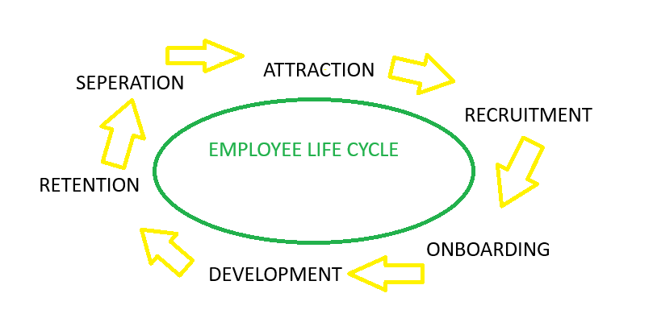

Attraction – During the attraction stage of recruitment, people professionals will help to promote Jemijo as desirable employer of choice by developing a strong employee brand. Due to Jemijo offering a range of hybrid, remote and office-based roles, they will strategically tailor their job adverts accordingly, to attract a variety of candidates. People professionals will gain attraction by ensuring their job adverts provide a clear and detailed job description alongside any employee benefits.
Recruitment – During the recruitment and selection process, people professionals ensure that the hiring process is fair and effective, providing support to hiring managers and ensuring they are using appropriate recruitment methods. They will support hiring managers in making objective decisions, ensuring the right people with the right skills are appointed.
Onboarding – People professionals will ensure transparent and details communication with employees being onboarded prior to their induction day. They will ensure that employees understand their roles and what is required of them, providing effective communication prior to their first day and that they have designed a structured induction.
Development – People professionals support the ongoing training, performance management and career progression. This is particularly important at Jemijo, where employees may progress into specialist role and management positions. They will ensure management have the tools available to them to manage performance and personal development.
Retention – People professionals at Jemijo will focus on employee engagement, wellbeing programmes and recognition for high performance. They will also review and analyse employee feedback and support management team to address issues early and ensure that employees feel valued and listened to.
Separation – People professionals at Jemijo will ensure that the offboarding process is done in a fair and respectful manner. Whether the employee leaves voluntarily or not, they will protect the legal and compliance of Jemijo’ s reputation.

Q2. Explain how job analysis can help to create an accurate job description and person specification, for the role of a claim’s handler, at Jemijo’ s call centre (AC 1.2)

Job analysis is the process of gathering detailed information about a role to ensure the job description and person specification are accurate, relevant, and aligned with organisational needs. For a claims handler at Jemijo’ s call centre, this is essential due to the fast-paced, customer-focused nature of the role.
It identifies key duties such as handling incoming calls, assessing insurance claims, supporting customers in stressful situations, and maintaining accurate records. This forms the basis of a clear job description, including responsibilities, reporting lines, and working conditions such as shift patterns.
Job analysis also defines the skills, knowledge, and behaviours required, informing the person specification. For a claim’s handler, this includes communication skills, attention to detail, IT ability, and emotional resilience, as well as desirable experience in call centres or insurance.
Importantly, it ensures recruitment is based on current role requirements rather than outdated information, supporting fair and objective decision-making. People professionals use this to design suitable selection methods, such as competency-based interviews or scenario-based assessments, while ensuring reasonable adjustments are in place to make the process accessible.
Overall, job analysis helps Jemijo recruit the right candidates, improving performance, engagement, and retention while reducing the risk of poor hiring decisions.

Q3. Jemijo advertise vacancies though their website and on commercial jobs boards. Explain each of these recruitment methods and explain why these methods are appropriate for advertising call centre vacancies. (AC 1.3)

Jemijo’ s company website is a platform where they advertise current vacancies directly to potential applicants through a dedicated careers page. This includes job descriptions, company values and employee benefits. Advertising via the company website is effective as it attracts candidates who are already interested in working specifically for Jemijo, meaning they are more likely to align with the organisation’s culture. It also allows Jemijo to promote its employer brand and clearly communicate expectations of the role, such as working hours and the nature of call centre work, including handling customer queries and claims.
Commercial job boards, such as Indeed, are online platforms where employers advertise vacancies to a wider audience. These platforms allow candidates to filter roles based on location, salary and job type, making them accessible to a large pool of applicants. This is particularly useful for call centre roles, which are often entry-level and require high-volume recruitment. Job boards can also attract both active job seekers and those open to new opportunities.
As Jemijo employs a large workforce, recruitment is ongoing, and job boards support this by enabling quick and efficient hiring at scale. Using both methods together increases the reach of vacancies, attracting both candidates specifically interested in Jemijo and those actively seeking customer service roles.

Q4. Explain why the content of the copy used in the job adverts on Jemijo’ s website could vary compared to the content of copy on commercial jobs boards. (AC 1.4)

Candidates using Jemijo’s careers website are likely already familiar with the organisation or specifically interested in working there. Because of this, adverts can focus more on role details such as responsibilities, working patterns, and progression opportunities, rather than introducing the company. The website also allows Jemijo to include additional information about company values, culture, and employee benefits through links and detailed pages.
In contrast, job boards such as Indeed target a much wider audience, including candidates who may not know about Jemijo. Therefore, adverts need to be more attention-grabbing and informative, clearly outlining the company’s reputation, services, salary, benefits, and career opportunities to compete with other employers advertising similar roles.
Job boards may also limit the amount of content included in adverts, meaning information needs to be shorter and more structured. Jemijo’s own website provides greater flexibility over content, layout, and detail.
Overall, the content varies to suit the platform and audience, helping Jemijo attract suitable candidates effectively.

Q5. Explain why structured interviews and assessment centres are appropriate selection methods for call centre roles at Jemijo. (AC 2.1)

Having structured interviews and assessment centres are appropriate selection methods for call centre roles Jemijo because they provide fairness, consistency and the accuracy of hiring decisions.
A structured interview allows you to score against a clear marking criteria, asking each candidate the same questions and using the quality of their responses against the scoring marker. This approach allows consistency and reduces bias. In a structured interview you can also assess the candidate’s skills and competencies such as communication skills, problem solving abilities, resilience and empathy in a personal and formal setting.
An assessment centre allows Jemijo to evaluate candidates through practical exercises that simulate real job tasks, this could include some role-play scenarios such as dealing with difficult conflicting customer service scenarios which is an important skill to have in a high pressures environment. These activities give a more realistic view on how candidates are likely to perform in the role, rather than relying on interview question responses.
Both interview methods are appropriate as it allows Jemijo to assess candidates against the same clear criteria making the selection decision more transparent and allows you to be more defensible should there be an appeal.
Both interview methods must always be accessible and fair, with reasonable adjustments made where needed to ensure candidates have equal opportunities to demonstrate their skills, supportive inclusive and legally compliant recruitment practices.

Q6. Explain what records from the structured interviews and assessment centres at Jemijo should be retained. (AC 2.4)

To ensure legal compliance and fairness, records from structured interviews and assessment centres at Jemijo should be securely retained for around six months after the recruitment process. These records provide evidence that hiring decisions were fair and consistent and can support the organisation in the event of complaints or discrimination claims.
For structured interviews, Jemijo should keep interview notes from all panel members, including candidate responses, scoring against set criteria, and comments explaining decisions. This shows all candidates were assessed consistently using the same process.
For assessment centres, records should include scoring sheets from role plays, group exercises, and scenario-based tasks, alongside observers’ notes and overall assessment summaries. These help evidence how candidates demonstrated key skills such as communication, teamwork, resilience, and problem-solving.
Jemijo should also retain feedback records for both successful and unsuccessful candidates, as applicants may request feedback following the process.
All records must be stored securely and managed in line with UK GDPR and data protection legislation, ensuring information is only kept for as long as necessary.

Q7. Using an AI tool of your choice, create templates for a letter of appointment and a letter of non-appointment for the call centre customer service role. Once you have created the templates, critically review each template, and explain which elements you would keep and why, and which elements you would remove or change and why. (AC 2.5)

I utilised ChatGPT for my letters of appointment and non-appointment, my instructions were. “I work as a people professional for an insurance firm called Jemijo. We have recently been conducting interviews in both assessment centres and through structured interview panels. The role we are recruiting for is a customer service claims handler, they will be responsibly for handling phone calls and processing claims. The job offer will be for home, office and hybrid working. Using this information and skills required for a role such as this, please can you draft me a letter of appointment and a letter of non-appointment”
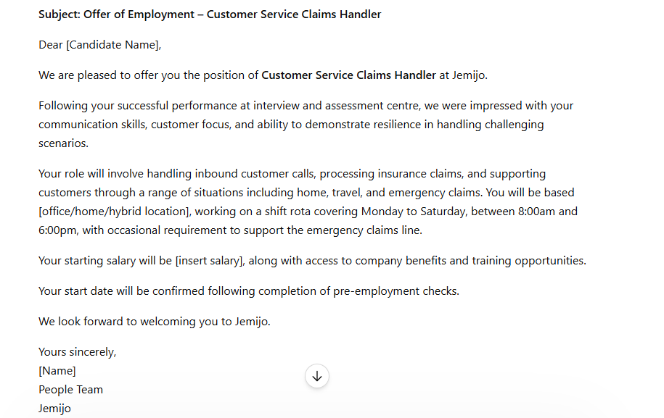
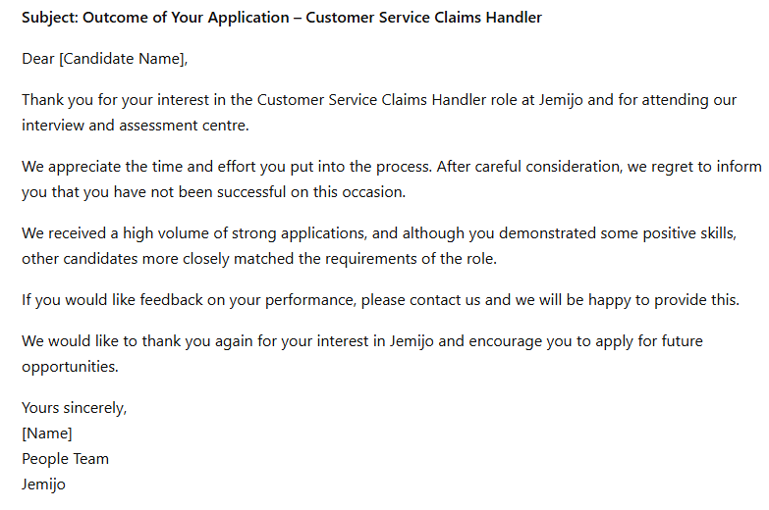

Overall, I think the appointment letter is strong, well-structured, and includes most key information. However, compared to the reccomended(ACAS) template, I would add the date issued, a “Private and Confidential” heading, salary payment frequency, and whether the role is permanent, fixed-term, or temporary.
ChatGPT performed well in creating a warm and supportive tone by congratulating the successful candidate, helping create a positive candidate experience. I also think it was sensible not to include a confirmed start date, as candidates may need to work notice periods. I like that the letter focuses on offering the role rather than including excessive contractual detail, as full documentation can follow after acceptance.
I would make very few changes to the non-appointment letter, as it is professional, respectful, and sensitive in communicating the outcome. It thanks the candidate for their time, explains that other applicants more closely matched the role requirements, and offers feedback if requested. Ending the letter by encouraging future applications also supports a positive candidate experience and protects Jemijo’s employer brand. Compared to an ACAS template, I feel this version is more personal while still remaining professional.

