Name: Marcus Carr
Student number: 2114457
Course: BA Graphic Design
Word count: 2733
Research in Context : ADAD5003/C
Lecturer’s name: Donna Williams
Question : Why is Information Design important? Explore how Information Design helps to shape the world around us as well as our understanding of it. (Gavin Kirby)

In this world of constant raw data being provided in abundance can be useless without that information being formatted to the user for the ease of understanding. As people are bombarded with high levels of information ranging from bank statements, airplane tickets or even the underground trainline maps. So does the underlining use of that information and how its perceived be it good or bad by design can it affect the individual or to the masses on a much larger scale.
As new information is pouring threw different channels it’s up to the design to break through these challenges and provide a simple, yet effect means of interpretation. Given the lack of trust with misinterpretation of information the design may have to give a more basic yet complex insight to what the challenge being discussed that of political, entertainment or business data. In view of current world being designed to be minimal that information and understanding shouldn’t as this is they can be a cause to more confusion. Also, what classes as information and does it only apply to humans.
The idea of information being utilised in designs must be asked of the question, why is Information Design important? The broad sense of importance comes down to the values to progression and understanding, so to follow the different utilisations of information designed for science to the classics of history. Also, the use of information for public transportation of road and the trainline. To then see the following of how information designed can be misleading in news media, then onto that information designed for the workplace and the use of interactive ways for a more personalised experience. Lastly how information can focus on the cognitive mind and mental disability, to then the new upcoming era of information designed of motion and interactive digital media.
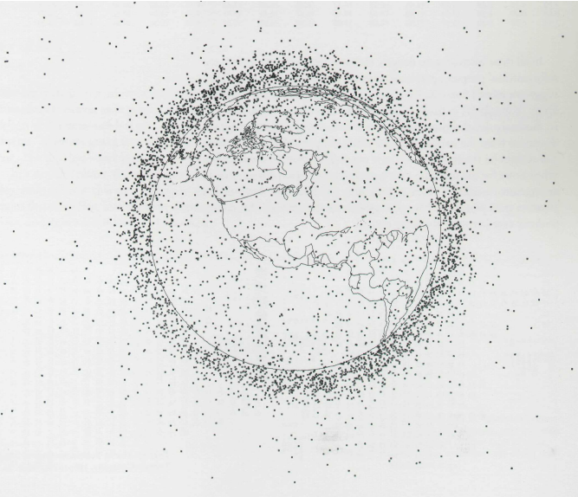
Figure 1. Orbital pollution: debris circling the earth. (Johnson, 1991)
The best way to understand the visualisation of data is to see its conceptualise design. The demonstration of debris in orbit as a simple design diagram to an understanding, even when it is not using the correct scale but using dots can still help to understand the visual data of importance of the future of space travel. The information of debris in orbit from earth to determine the risk of damaging collision. but must be updated to represent the current debris every 5 years as the debris in space can double in that time shown in Figure 1 so it must be change or updated to fit the current data as to use this image can be a misconception of what the current/future data is.
“Visual displays rich with data are not only an appropriate and proper complement to human capabilities, but also such designs are frequently optimal.” (Tutfe, 1990, pg. 50) This statement that the human ability of processing information can be limited by the human body on how we can perceive and collect or even process data, our visual stimuli is the most common factor in creating informational designs from diagrams to statistical analysis but some information when trying to create can be beyond human physical capabilities. Even the vast amount of spooling information a person must have a greater memory beyond the average human mind to comprehend massive amounts of data. So, to compile that data into a design that is perceived to be simple to understand can be a challenge. That information design is a human element of our creation and one of the greatest abilities.
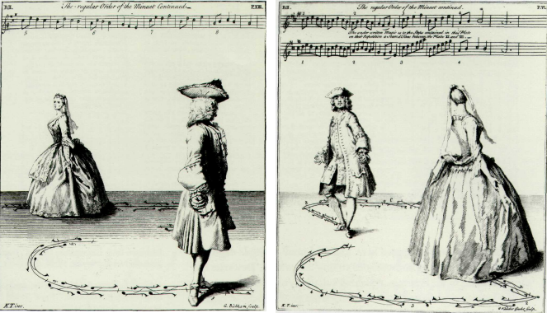
Figure 2. The Art of Dancing, Explained by Reading and Figures (Tomlinson, 1735)
The use of information in many art forms can help the participant to follow and learn the fundamentals of that art that being shown in Figure 2 the art of dancing. Without the aid of this information, one may never know how the use of movement with the aid of sound can help visualise a joy of that art.
The process of information does not always give simple understanding. As can be demonstrated in sheet music, without the knowing what notes of a key are the visual of sheet music will look cryptic to the viewer and will not have meaning without the knowledge of music. 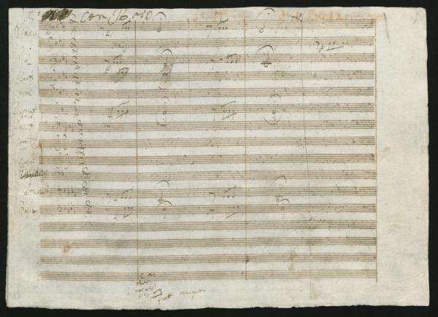
Figure 3. Beethoven, (1807) Sinfonien; orch; c-Moll; op.67
Furthermore, the use of sheet music being to know how to form a musical symphony of sound and the creation of an industry of today. Using a good example is Beethoven’s sheet music for Allegro con brio as shown in Figure 3, without conceptualising the design of information of sound Beethoven may never had a way of placing that information of music to be one of the most recognizable artists.
Information is being used not only by humans but also machines, as by that the use of barcodes can also be thought as the design of information. That being how does a machine know of information being presented to it to understand as there are many forms of this data to be categorized in use of many products and information. Even though humans have made simple understanding formats of information that ranging from iconography and short instructions to help with guidance of understanding. Machines have their own language to process that information. The creator of the barcode Norman J Woodland and Bernard Silver at Drexel university after four years later they patented the creation of what we have today but from a simplistic standpoint. “Barcodes fill vital roles in capturing, indexing, tracking, integrating, and document storage-and-retrieval.” (Gordon, Barcodes and Document Management Hoke, 2005 pg. 32) The very idea that machines storing information that needed to be identified by humans for a large process of an ever-changing world needed a simpler function that a machine can use to aid society. By function of that data to store an index of information in a simple format that a n average person may take a very long time trying to decipher. So, the design of the barcode was not intended for people to understand as much for the machine to scan and identify threw the array of black and white line to find and understand what to do and where to go to then be presented to a person. The evolution of that information of data being used but not even fully understood by the common public that information is stored in such a way that we never appreciate how the simplest idea of creating a design that helps categorize and index every information from the standard bar code or even the Widley use web barcode the QR code. This design has greatly improved performance and efficiency to the users as for not only to index and categorise but to server as a quicker way within a symbiotic relation with computer technology.
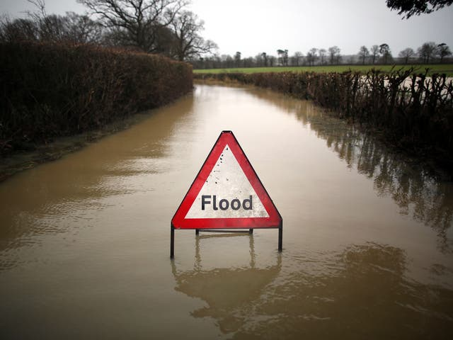
Information in the visual aspect from something that is recognisable, road signs seen in everyday travels. As for the use of signs which there is a pleather used for different scenarios and conditions on the public roads as shown in Figure 4. demonstrates the effectiveness of it information with clear understanding and communicate a cognitive efficiency by highlighting a contrast to the user with a previous knowledge index from which to learn the individual meanings.
Figure 4. The bold typeface ( Macdiarmid, 2015)
“We define multimedia learning as learning from words and pictures, and we define multimedia instruction as presenting words and pictures that are intended to foster learning.” (Mayer and Moreno, Educational Psychologist, , 2003) this is ever present in the design of traffic signs as the information that needs to be provided are show on a given bases of the scenarios in which a sign is designed to inform the public drivers of different meanings that signs have been giving orders, warning, direction, information and road work. So, the importance for traffic users is to have a visible and clear understanding of what to do in scenarios where these signs are placed.
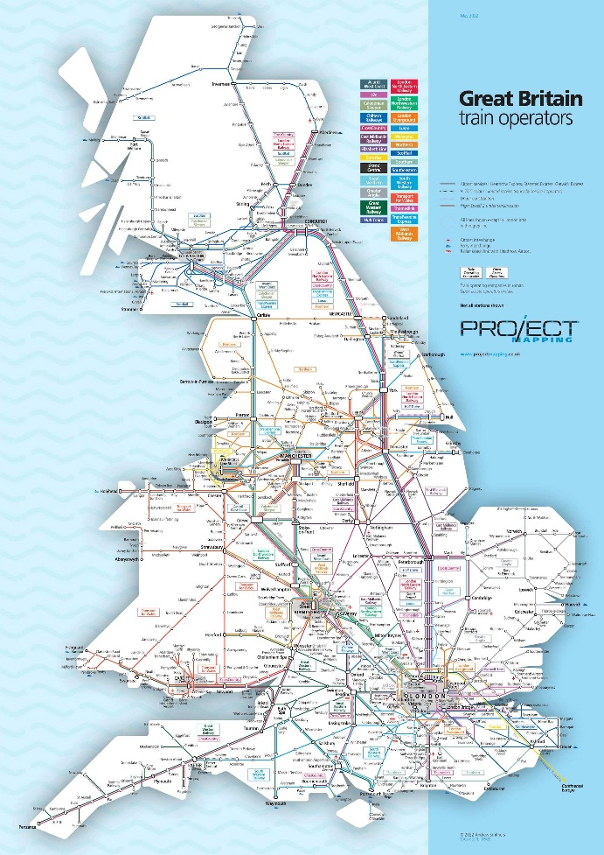
Figure 5. Project Mapping (Smithers, 2022)
The usefulness of maps to help the public must be simple to understand and must have a clear understanding of what it is showing as in Figure 5. The use of simplification and identification using a key colour coding to help user. In light of recent trends to oversimplify current systems it can be even more confusing with an overload of information or even to minimal to understand without an in depth look and concentration from the user.
In addition to what can be bad infographics set out to help there is a plethora of bad designed infographics that can be more problematic to the audience and the populus as show in Figure 6.
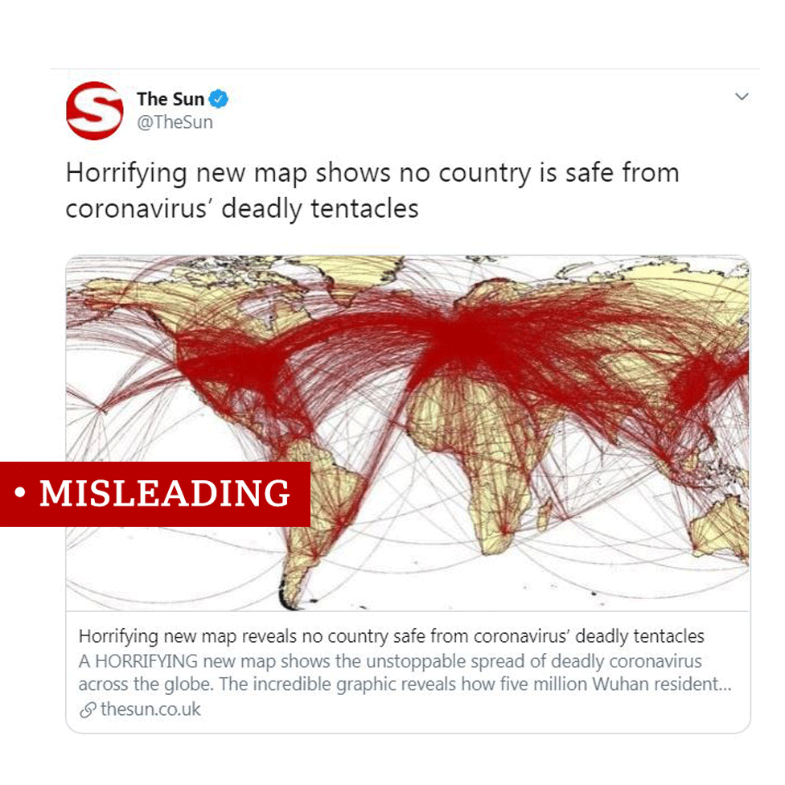
Figure 6. Misleading data (BBC News, 2020)
The example show has been reported by several news station in Australia as from the BBC article stating “the five million figure comes from an entirely separate source. The mayor of Wuhan gave this number when talking about the total leaving the city ahead of the Lunar New Year holiday, most of whom would have stayed within China.” (BBC News, 2020) This can be attributed to not fact checking the data and compiling unreliable sources that can cause more mass hysteria to the general public. Information needs to be handled with more care on pressing matters that can be of the publics general health. This can be said for all contents of marketing to an audience to some may say it misleading to lead a bias agenda to the public.
Bad infographics that are designed for different purposes have common factors to them that being choosing the wrong colour to emphasize important for example red being danger or emergency then calm and peaceful. Secondly overcrowded with too many details can lose the viewers understanding of what they are looking at and lastly the overwhelming or unreadable font styles.
The use of infographics seen in medical centres like the NHS help not only for the patient, but the workers as shown in Figure 7.
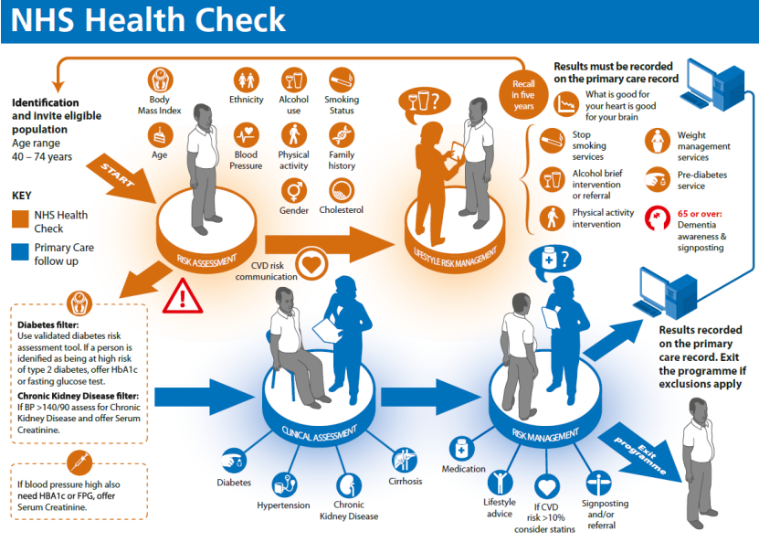
Figure 7. Health Check risk assessment and management (NHS, 2017)
The use of information designed to help workers with the use of stages shown in a diagram threw assessments of those workers to formulate a coherent understanding. From the use of text base language and minimal use of detailed imagery and colour, the application for a simplistic style that is easy to follow from a non-health carer. As Tomoko Ichikawa an Associate Teaching Professor at the Institute of Design “ Something that's specifically for you that you can reference again and again” (Ichikawa, Nov 17, 2020) this being the use of information design with an interactive ability to communicate to others using a design that helps.
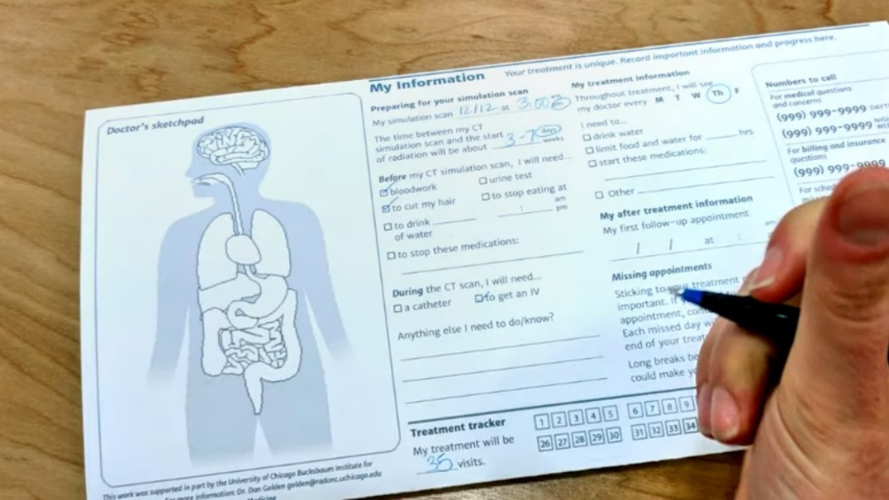
Figure 8. (Information designing, TEDxChicagoSalon, 2020)
This way of a more personal to the patient in this situation to have a repeatable information that can be show to others to help with a better understanding. Information designed doesn’t have to be static in use with a visual element of motion and/or an interactive element which is becoming more popular with in the cyberspace.
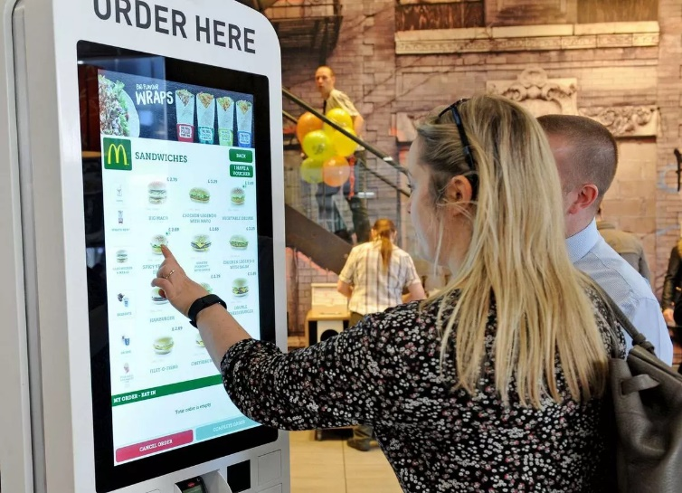
The very idea that an interactive information design can have more benefits in user ability and appearances to be more of an eye grab then an eye sore. More and more information being created to fit into motion graphics from weather apps using icon movement to represent rain or cloud movement, to the news using motion to keep the audience engaged with what information is presented Rather than overlooked.
Figure 9. Wright, J. (2016) McDonalds Restaurants in Liverpools Lord Street has a new way of working.
The best-case use for this can be seen in fast food restaurants with the new digital age of technology and touchscreen the display for picking out food and drink has become more of a simplistic but enjoyable task in an easy-to-understand form factor as show in Figure 9.
The usability of how the public will view information can be different of cases of disability and how to create something that not only can be shown to everyone for accessibility. To understand this for one part is the cognitive load the audience can bear this is to find a balance in the design that does not over stimulate the audience.
The psychology of designing something that uses information can be a struggle for some individuals with a physical or mental disability. To combat this research on cognitive function on images and the connections individuals place on those images creating mental pathways of different outcomes of understanding. “People with dyslexia also experience greater cognitive load when processing images. ” (James, Morrison and Valerie, 2022)) To this the design of which information will be place may not be well with people with dyslexia if the image realizes of typography and text. As the cognitive load can create more confusion within the information that is relaying to that individual. By understanding the problems that can cause for the minority of the audience in which if a design is to inform that particular audience the information must be tailored in a way to fit with in the boundaries of cognitive process. To a wider scope of importance of designing information to the public must have common relations with pre understood ideas. That being of which not only to understand what is being created but the effects it can bring to a demographic audience as the bearer to see information that can’t be understood could be more beneficial in the designing process as to design for that audience can help with the wider audience.
Lastly to look at the new age of how information being designed and utilised in the cyberspace for it is now commonplace for the creative branch of new formats to be place as more can be fitted into a more compact display with motions and intractability as an example that can be seen in Figure 10. 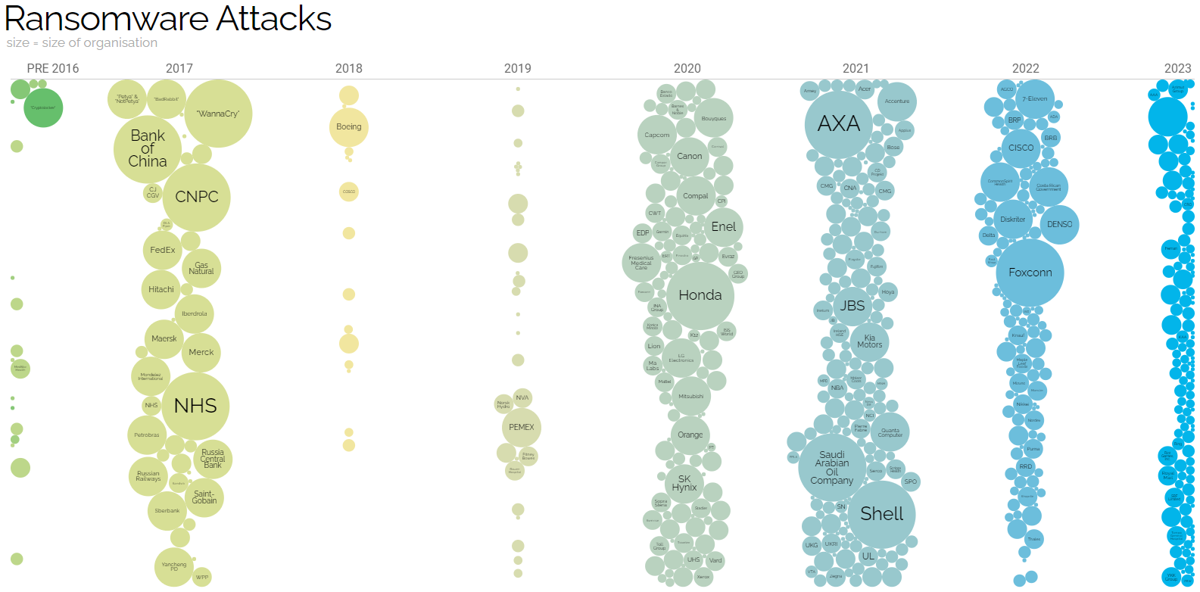
Figure 10 Information is Beautiful (McCandless, Evans 2023)
The many uses and designs have begun to grow abundance in different ways on the internet. This has begun a spark of creating new ways to show the public informative data. Most common designs are exploring outside the boundaries of what is most commonplace of digesting information.
As well as the portability of how data can now be traced and utilised in the business marketplace which is growing concerns of privacy in the publics information being sold. It raises problems of how data is being monitor for some infographics. As there is no concrete evidence as to see if data is being stolen and all is speculation. The more we need to keep data protected and to know how it is utilised for designs that demonstrate the information provided. “Under the Data Protection Act 2018, you have the right to find out what information the government and other organisations store about you.” [Data protection Act], (2018). Knowing this going forward that information should be taken lightly as for how the sources of that information was collected.

To conclude, the information design stands as a crucial part of the human experience of how we understand the world as from the question is it important? with absolute that it is the function of the world and how the utilisation should be handled with care. Its impact of the way people thinks and show different viewpoint that not all may know. Moreover, the complex world of information data is forever changing and for the public to understand the changes set of that data the design designation of that information is crucial to the development and safety for all participants. The use of new mediums must know of the facts to not mislead as the dangers if used incorrectly can give a drastic change of situations that may not have fruition if the presentation of the information was properly handled, also to include everyone if possible that design should include everyone. Information design is very important from the early stages of civilization to the future not just to simplify knowledge but to put it into perspectives for future generations to understand the importance of what data has been collected. The design flexibility is also important to information design as its ability to evolve from traditional standards but keep a coherent but versatile design and adopt new methods and media.
Lastly, for the next stages moving on with information being designed for different formats they must follow rules and regulations as that is one if not the major aspect when designing something with information to be seen and learnt to a wide range audience.

BILBLOGRAPHY
Reference Listed:
BBC News (2020) Coronavirus: How a misleading map went global. (Available at: https://www.bbc.co.uk/news/world-51504512) (Accessed : November 11th, 2023)
Gordon E J (2005) Barcodes and Document Management Hoke. Doc Magazine. Available at: https://www.proquest.com/docview/216584930?accountid=130472&parentSessionId=Q3XqB92R%2FEtwIvf8JCVWZUJU6rNwZwE7%2FqdN%2FyuviII%3D&pq-origsite=primo (Accessed : November 6th 2023)
Ichikawa, T. (2020) TEDxChicagoSalon: Information designing. (Available at: https://www.youtube.com/watch?v=_3Z9ACsyzkE) (3:16) (Accessed : November 13th, 2023) James, K. , Morrison, B. S. (2022) Creating Accessible Infographics: Describing Scientific Data in Ways Everyone Can Understand Monroe, Assistive Technology Outcomes & Benefits, Vol. 16, Iss. 2, Chicago. Available at: https://www.proquest.com/docview/2712291822?accountid=130472&parentSessionId=2uxfV%2B0wl8zhvua8nj59PBa3byJeIxWv48PB70qZSH4%3D&pq-origsite=primo (Accessed : November 13th, 2023)
Mayer, R. E., & Moreno, R. (2003). Nine Ways to Reduce Cognitive Load in Multimedia Learning. Educational Psychologist. Available at: https://www.uky.edu/~gmswan3/544/9_ways_to_reduce_CL.pdf (Accessed : November 6th, 2023)
Tutfe R. E (1991) Envisioning Information. Cheshire, Graphics press. Available at: http://okhaos.com/tufte.pdf (Accessed : November 4th, 2023)
UK Government (2018) Data protection Act 2018. Available at: https://www.gov.uk/data-protection (Accessed : November 20th, 2023)
Photos/Images
Figure 1. Johnson, L. N ( ) Orbital pollution: debris circling the earth. Colorado Springs, Teledyne Brown Engineering, Cited by Tufte, R. E , 1991, pg. 48) (Available at: http://okhaos.com/tufte.pdf) (Accessed : November 4th, 2023)
Figure 2. Tomlinson, k. (1735) The Art of Dancing, Explained by Reading and Figures, London. Available at: http://www.lisaroberts.com.au/content/studies/ImagingData/ImagingData.php (Accessed : November 12th, 2023)
Figure 3. Beethoven, V. L.( 1807) Sinfonien; Allegro con brio (Available at: https://digital.staatsbibliothek-berlin.de/werkansicht?PPN=PPN664344127&PHYSID=PHYS_0001&DMDID=DMDLOG_0001)
Figure 4. Macdiarmid, P. (2015) The bold typeface , Getty Images, The Independent. Available at: https://www.independent.co.uk/news/uk/home-news/road-signs-why-britain-s-designs-rule-10466510.html (Accessed : November 13th, 2023)
Figure 5. Project Mapping, The Trainline, 2022 Andrew Smithers Available at: https://www.thetrainline.com/train-companies/national-rail/national-rail-map (Accessed : November 16th, 2023
Figure 6. Misleading Map , BBC News 2020, the sun twitter (Available at: https://www.bbc.co.uk/news/world-51504512) (Accessed : November 19th, 2023)
Figure 7. NHS (2017) Health Check risk assessment and management, pg. 8. Available at: https://www.google.com/url?sa=i&url=https%3A%2F%2Fwww.healthcheck.nhs.uk%2Fseecmsfile%2F%3Fid%3D551&psig=AOvVaw3_x5gpRKc7MHrjP-jfy0ja&ust=1701325704296000&source=images&cd=vfe&opi=89978449&ved=0CBIQjRxqFwoTCPCUwdbm6YIDFQAAAAAdAAAAABAE (Accessed : November 14th, 2023
Figure 8. TEDxChicagoSalon (2023) Information designing, Ichikawa, T. Available at: https://www.youtube.com/watch?v=_3Z9ACsyzkE (3:08) (Accessed : November 13th, 2023)
Figure 9. Wright, J. (2016) McDonalds Restaurants in Liverpools Lord Street has a new way of working. The Mirror. Available at: https://www.mirror.co.uk/news/uk-news/inside-britains-first-modern-mcdonalds-6668333 (Accessed : November 15th, 2023)
Figure 10.McCandless, D. , Maslekar, S. and Evans, T. (2023) Ransomware Attacks, Information is Beautiful. Available at: https://informationisbeautiful.net/visualizations/ransomware-attacks/ (Accessed : November 21st, 2023)

References not listed:
Few, S. (2010) Our Irresistible Fascination with All Things Circular, Visual Business Intelligence Newsletter. Available at: http://www.perceptualedge.com/articles/visual_business_intelligence/our_fascination_with_all_things_circular.pdf (Accessed: November 15th, 2023)
Jones, J. (2015) Information Graphics and Intuition Heuristics as a Techne for Visualization, SAGE Publication. Available at: https://journals-sagepub-com.ezproxy.uwtsd.ac.uk/doi/epub/10.1177/1050651915573943 (Accessed: November 23th, 2023)
Otten, J. J , Cheng, K and Drewnowski, A. (2015) Infographics And Public Policy: Using Data Visualization To Convey Complex Information, Health Affairs (Available at: https://www.proquest.com/docview/1731754928?accountid=130472&parentSessionId=NrcKLKeLWS3ggc8IOw56vF1Q%2FJHxJ8nnLMVYpBM6J88%3D&pq-origsite=primo (Accessed: November 12th, 2023)
Puttipakorn, P. and Upala, P. (2018) Comparative Analysis of Environmental Graphic Design for Wayfinding on the Exit Patterns of Mass Transit Stations, Open Transportation Journal, Vol 12. Available at: https://www.proquest.com/docview/2669576847?accountid=130472&parentSessionId=HQJl1BhdsaQXP5pvMbVl8yv3%2B9tYPxcwbZ7IQAFxr%2Bw%3D&pq-origsite=primo (Accessed: November 14th, 2023)
Spence, I (1990) Visual Psychophysics of Simple Graphical Elements, University of Toronto, Canada. Available at: https://classes.engineering.wustl.edu/cse557/readings/spence1990.pdf (Accessed: November 10th, 2023)
Stones, C (2021) Public Health Infographic Design for the public – the evidence base, European Journal of public health, Vol 31. Available at: https://academic.oup.com/eurpub/article/31/Supplement_3/ckab164.283/6405115?login=true (Accessed: November 16th, 2023)

