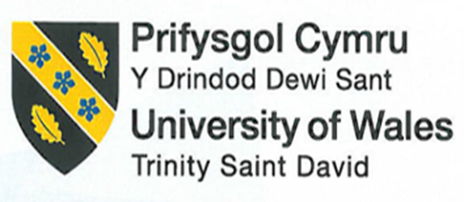
Student No: 2246329
Module Title: Personnel Resourcing & Development
Module Code: BMIH5005
Lecturer: Scott James

Discuss how the evolution of Human Resources Management (HRM) facilitates the strategic development of an international hotel brand through workforce planning, recruitment, and selection.

Introduction
Human resource management has a significant role in the development and growth of any business organisation. The evolution of human resource management can facilitate the effective growth of international brands. With the proper planning, recruitment and selection process, human resource management helps in the growth and development of a hotel brand. The main purpose of this essay is to discuss the evolution of human resource management and how it simulates the growth of Marriott, an international hotel brand. In this essay, there is a brief discussion of the hotel brand and the evolution of human resource management.
The essay has highlighted the strategic roles of the human resource department in the growth of this hotel. The essay will also analyse the recruitment and selection process of the human resource department to hire the right candidate for the company.
Discussion
Marriott is the largest hotel brand operating in the entire world. It is a USA-based international hotel company. Marriott licenses operates and franchises different lodging brands in the world. The company owns more than 30 hotels and brands in more than 8000 locations in around 138 countries (Marriott International, 2024). The headquarters of the company is in Bethesda, Maryland USA. Marriott acquired around 23.7 billion dollars in revenue collection in 2023. Currently, 411,000 employees work in different hotels of Marriott (Marriott International, 2024). The development and growth of this process largely depend on the effective planning and execution process that brings success to this company. The evolution of the human resource department of the hotel brand follows some crucial steps that are impacted by globalization, changing demographics of the workforce, technology, and organisational strategies (Coron, 2022).

Human resource management is focused on performing different administrative tasks for example staffing and payroll (Coron, 2022). With the increased competition in the market and more focus on customer-centric Hotel services, the human resource department has also shifted the strategic planning considering the business goals and objectives. With the increased impact of globalization on hotel companies in the world, human resource management has put immense focus on talent sourcing and retaining (de Silva et al., 2022). The human resource managers of Marriott highest employees from different cultural and social backgrounds. More focus has also been shifted to the recruitment strategies. HR recruit’s employees from global talent pools, online portals, and social media platforms to get skilled employees.

The demands of the people in the hotel industry continuously change. To deal with these rapid changes, human resource management focuses on the training and development process for the employees (de Silva et al., 2022). The department organises cross-cultural training, language training, skill developmental programs, and leadership development to enhance employee ability and skill. The purpose of human resource management is to help employees adapt to the different needs and requirements of customers and deal with the changing trends of the industry (Shamaileh et al., 2022). Leveraging technological solutions is another aspect of the human resource department. The managers of the human resource department in international hotels like Marriott integrate different technical systems and devices to improve the recruitment, selection, training and performance evaluation process (Shamaileh et al., 2022). They leverage an online feedback system and engagement of employees to mobile apps. All these processes can enhance the communication system in the workplace. It also streamlines the decision-making process of the management.

Marriott's human resource management also plays an important role in the well-being of employees. They take care of the safety, security, and mental and physical health of the workers (Shamaileh et al., 2022). They have integrated diversity and inclusion in the recruitment and selection process. Performance management also highlights the evolution of human resource management and the development of Marriott. The HR department now estimates the performance of the employees by continuously checking their performance and collecting feedback (de Silva et al., 2022). By incorporating feedback mechanisms and performance metrics they can understand whether the performance of employees is aligned with the objectives of the company.
The human resource department of Marriott has some strategic roles to operate its functions in such a way that the organisation achieves its goals. They create proper planning to develop an efficient and skilled workforce. Human resource management engages in planning for the workforce and ensures that the work has enough skilled and efficient workers (Asamani et al., 2021). It is also the role of the human resource department to ensure that the organisation has enough talented workers for now and in the future. They try to access the existing and future needs of talent and figure out the skill gaps. Based on these needs and gaps, they develop proper strategies to meet the demand (Francois Koukpaki et al., 2020). They plan for the training and development of the existing workers to fill the skill gap.

The human resource department has another important role to manage employee relations and engage them with the company. Human resource management manages the relations of employees and tries to promote a united and collaborative workplace (Rossidis et al., 2021). They handle the conflict and employee disagreements. They foster effective employee engagement policies by organising feedback mechanisms and employee training and development. They also provide opportunities for the employees of Marriott to ensure their personal and professional growth and development (He et al., 2021). These activities help them to engage employees with the company for a long time.

HR of Marriott develops a recruitment and selection process to ensure that the right candidate is recruited and selected for the company. They adopt diversity and inclusion policies in which they can hire candidates from different cultural backgrounds (Al-Dmour, 2020). Maintaining a fair and transparent recruitment process is another strategic role of the human resource department. The human resource department of the hotel brand makes strategic planning with the help of analysis of the previous data and forecasting. The managers of the human resource department estimate the labour demand and supply using historical data, the goals of the company and the trends of the industry (Al-Dmour, 2020). They check the employee turnover rate, projected business growth rate and employee retirement rates (Kumar, 2020). Based on this analysis, they figure out the future needs of the workforce which helps them in making plans for hiring or retaining workers. They also figure out the areas where the talents of employees lack the organisational goals of Marriott. They make strategies to find the right candidates to fill these gaps (Kumar, 2020). Based on this need and skill demands, they conduct the recruitment processes to find the right candidate. In this way, the human resource management plan is to meet the labour demand and supply at Marriott.
Goal setting and strategic planning of Marriott are made by the human resource department by aligning the objectives of the organisation and team. The HR collaborates with the leaders to define the strategic direction of the company (Chakraborty and Biswas, 2020). By doing so they also identify the primary priority for the organisation and thereby make strategic plans. Identifying the needs and requirements of the organisation, they set the goals and align the goals of the company with the actions of the employees. After that, they collaborate with employees and other managers to align the goals with the entire organisational process. The strategic planning of the human resource department also depends on the performance evaluation process (Falletta and Combs, 2020). They estimate employees' performance to determine whether they have met the targeted goals. When they see that the goals are not met or that employees' performance is not aligned with the company's goals, they have to make other strategy planning and decision-making decisions.
The human resource managers of Marriott used data-driven insights to make informed decisions. By using the data, they foster collaboration with the employees, other managers and departments (Falletta and Combs, 2020). They conduct feedback and review processes to understand the effectiveness of the strategic plans and actions. In case any adjustments are required, the human resource managers implement new plans and strategies. They implement different programs, such as employee training and skill development programs, and estimate their performance (Zhang and Cheng, 2023). By checking performance or using review and feedback systems, they determine whether the programs are aligned with the desired goals. The recruitment and selection process of Marriott depends on certain stages. The Marriott human resource department first identifies and analyzes the vacant position in the company. They understand the requirements and responsibilities of specific roles (Abbasi et al., 2022). Based on this information, they develop job specifications and descriptions. The human resource department tries to source candidates using multiple channels. They use job boards, online job portals, recruitment agencies, employee referrals, and social media platforms (Ibrahim et al., 2022).
After that, they review different applications and resumes of the candidates to screen them against the requirements of the job (Abbasi et al., 2022). The shortlisted candidates are called for further evaluation and selection process. The human resource department interviews the selected candidates to assess their behaviours and attitudes and check their skills and efficiencies (Abdalla Hamza et al., 2021). They also check whether the candidates can meet the organisation's requirements. The most efficient and suitable candidates are selected by the interview process at Marriott. The salary, joining date, roles and other perks are discussed with the candidates (Abdalla Hamza et al., 2021). After the selection process, the human resource department starts the onboarding process. They integrate the new hires into the organisation, complete the paperwork, and share the organisational policies and practices with them (Ibrahim et al., 2022).

Conclusion
The strategic role of the human resource department helps the company to find the right candidate for the organisation and set the actions of the employees according to the goals and objectives of the company. The functions of the human resource department can improve employee performance by providing the necessary changing and developmental opportunities. Effective planning of the human resource department helps the company to go in the right direction so the desired objective can be achieved. The discussion of the recruitment and selection process has helped me understand how the human resource department sources the right candidate understanding the requirements of the company. They also plan to develop an efficient workforce in which the right candidate can give the best efforts aligning with the objectives of the company. In this way, the human resource department helps a company achieve the maximum growth rate to operate in the international market.

References

Abbasi, S.G., Tahir, M.S., Abbas, M. and Shabbir, M.S., (2022). Examining the relationship between recruitment & selection practices and business growth: An exploratory study. Journal of Public Affairs, 22(2), p.e2438.
Abdalla Hamza, P., Jabbar Othman, B., Gardi, B., Sorguli, S., Mahmood Aziz, H., Ali Ahmed, S., Sabir, B.Y., Burhan Ismael, N., Ali, B.J. and Anwar, G., (2021). Recruitment and selection: The relationship between recruitment and selection with organizational performance. P.1-13.
Al-Dmour, R.H., (2020). The influence of HRIS usage on employee performance and mediating effects of employee engagement in five stars hotels in Jordan. International Journal of Information Systems in the Service Sector (IJISSS), 12(3), pp.1-18.
Asamani, J.A., Christmals, C.D. and Reitsma, G.M., (2021). The needs-based health workforce planning method: a systematic scoping review of analytical applications. Health Policy and Planning, 36(8), pp.1325-1343.
Chakraborty, D. and Biswas, W., (2020). Articulating the value of human resource planning (HRP) activities in augmenting organizational performance toward a sustained competitive firm. Journal of Asia Business Studies, 14(1), pp.62-90.
Coron, C., (2022). Quantifying human resource management: a literature review. Personnel Review, 51(4), pp.1386-1409
da Silva, L.B.P., Soltovski, R., Pontes, J., Treinta, F.T., Leitão, P., Mosconi, E., de Resende, L.M.M. and Yoshino, R.T., (2022). Human resources management 4.0: Literature review and trends. Computers & Industrial Engineering, 168, p.108111.
Falletta, S.V. and Combs, W.L., (2020). The HR analytics cycle: a seven-step process for building evidence-based and ethical HR analytics capabilities. Journal of Work-Applied Management, 13(1), pp.51-68.
Francois Koukpaki, A.S., Adams, K. and Oyedijo, A., (2020). The contribution of human resource development managers to organisational branding in the hotel industry in India and South East Asia (ISEA): a dynamic capabilities perspective. Employee Relations: The International Journal, 43(1), pp.131-153.
He, J., Morrison, A.M. and Zhang, H., (2021). How high-performance HR practices and LMX affect employee engagement and creativity in hospitality. Journal of Hospitality & Tourism Research, 45(8), pp.1360-1382.
HRM practice (2023). Recruitment and Selection Process | Human Resource Management. [online] hrmpractice.com. Available at: https://hrmpractice.com/recruitment-and-selection-process/.
Ibrahim, U.S.G., Yusof, R.B. and Ibrahim, H.I.B., (2022). The role of employee onboarding training program in mitigating deviant workplace behavior: Job satisfaction as a mediator. Global Business and Management Research, 14(3s), pp.983-1007.
Kumar, S., (2022). The impact of talent management practices on employee turnover and retention intentions. Global Business and Organizational Excellence, 41(2), pp.21-34.
Marriott International (2024). About Marriott International | Corporate Information. [online] Marriott.com. Available at: https://www.marriott.com/marriott/aboutmarriott.mi.
Neupane, R. and Khanal, T.R., (2022). Evaluation of The Impacts of Training on Employee Performance in The UK Hotel Industry: An Analysis of Employees’ Perspectives at Marriott International. International Journal of Research-GRANTHAALAYAH, 10(3), pp.57-85.
OpenHRM (2023). Top 11 Key Functions of an Human Resources Management (HRM) in 2023. [online] OpenHRMS. Available at: https://www.openhrms.com/blog/top-11-key-functions-of-an-human-resources-management-hrm-in-2023/ [Accessed 7 Sep. 2023].
Rossidis, I., Belias, D. and Vasiliadis, L., (2021), June. Strategic human resource management in the international hospitality industry. An extensive literature review. In Culture and Tourism in a Smart, Globalized, and Sustainable World: 7th International Conference of IACuDiT, Hydra, Greece, 2020 (pp. 337-346). Cham: Springer International Publishing.
Shamaileh, N., AlHamad, A., Al-Qudah, M., Mohammad, A., Alhalalmeh, M., Al-Azzam, M. and Alshurideh, M., (2022). The effect of e-HRM on organizational performance and talent management: A strategic evolution perspective. International Journal of Data and Network Science, 6(4), pp.1043-1048.
Stahl, G.K., Brewster, C.J., Collings, D.G. and Hajro, A., (2020). Enhancing the role of human resource management in corporate sustainability and social responsibility: A multi-stakeholder, multidimensional approach to HRM. Human Resource Management Review, 30(3), p.100708.
Zhang, J. and Chen, Z., (2023). Exploring human resource management digital transformation in the digital age. Journal of the Knowledge Economy, pp.1-17.

Appendix
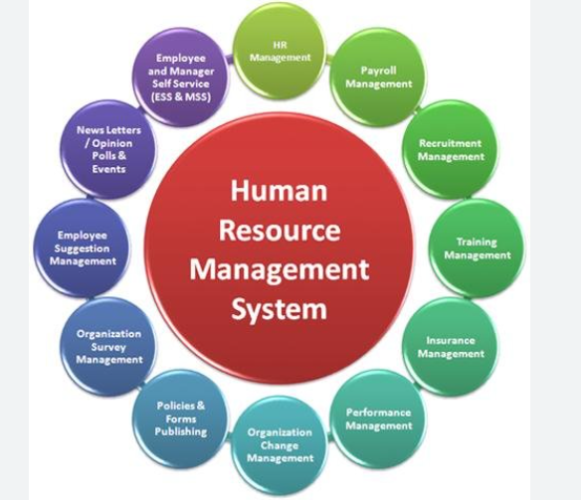
Figure 1: Functions of Human Resource Management
(Source: OpenHRM, 2023)

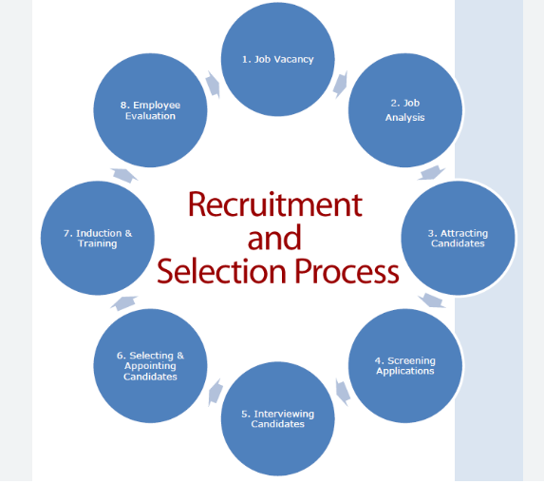
Figure 2: Recruitment and selection process
(Source: HRM practice, 2

