DS 1 Template

My Screenshots/Photos
- Please add 4–6 screenshots or photos of your digital life.
- You can use your phone or laptop.
- For each screenshot, write one or two sentences explaining what it shows.

Screenshot/Photo 1
Outlook Calendar
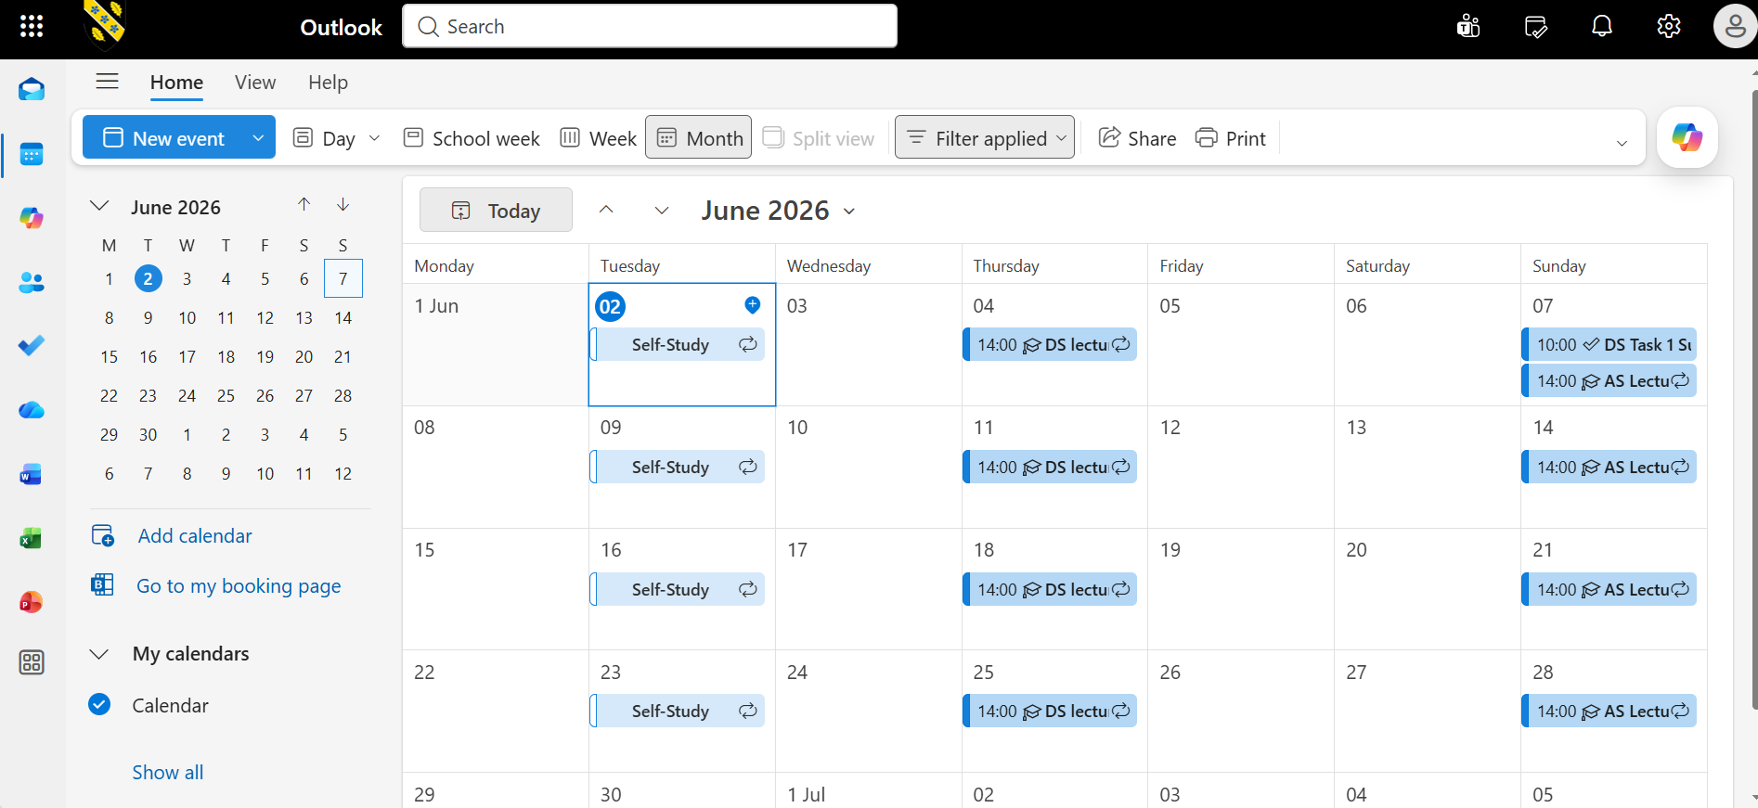
This is Microsoft outlook calendar. I use this digital tool to plan my schedules. This shows my monthly activities, scheduled lectures and deadlines. It helps me to be organised.

Screenshot/Photo 2
Google map
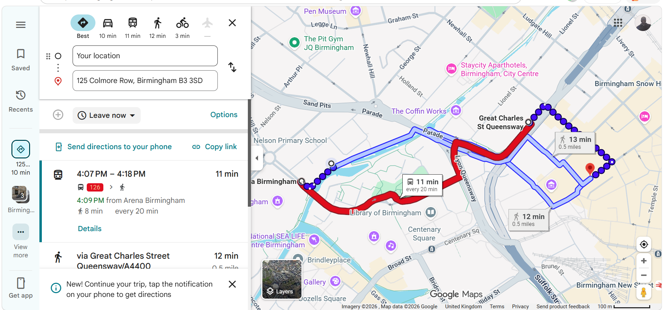
This is Google map. I use this digital tool as a navigational application. Useful for finding directions.

Screenshot/Photo 3
BBC iplayer App
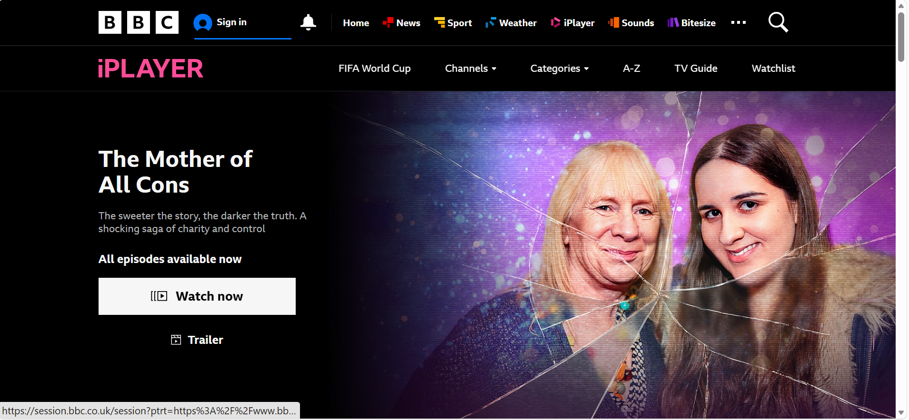
This is BBC iplayer. I use this digital tool to know what’s going on around the wrold

Screenshot/Photo 4
Intergram]
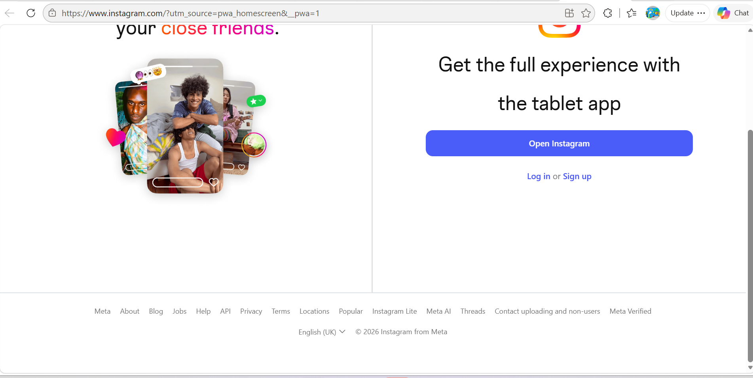
This is Instagram a social media platform. I use this digital tool to communicate with friends and for general entertainment.

Screenshot/Photo 5
School hub
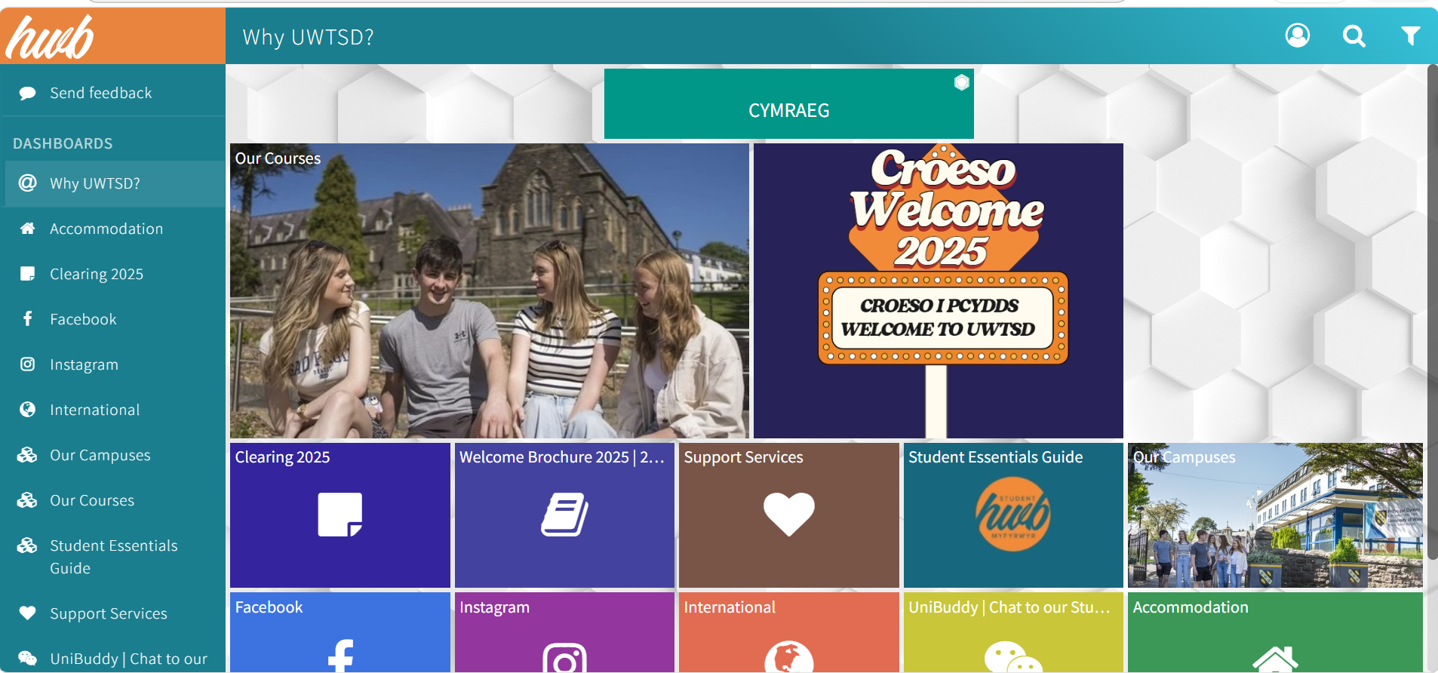
I use my school hub to sort my school activities and to help arrange all other day to day programs.

Screenshot/Photo 6
[School email
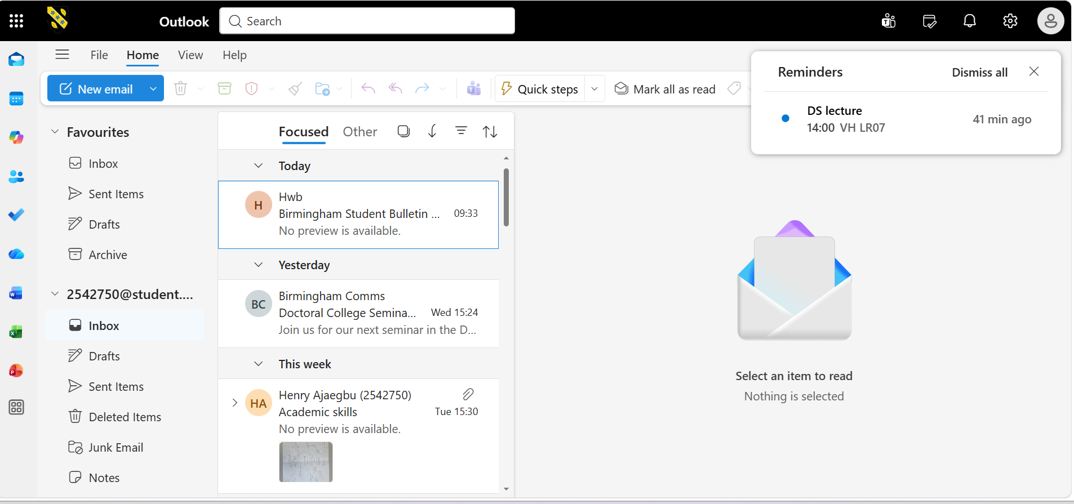
[My school email helps me to be up to date and to know what is happening in the university.

My Short Reflection
- Write 5–8 simple sentences about your digital life.
- You can use the sentence starters below if helpful.
I use digital tool in my everyday activity.
I feel confident whenever am using it because it makes life easier. Digital tool helps me to connect with friends that I lost contact with.
I often use digital tool to transact business, which I find simpler.
I hope this module improves my skills in my business life.

Sentence starters
- I use digital tools to …
- I feel confident when I …
- I want to improve …
- I often use these tools: …
- I sometimes feel nervous about …
- I hope this module will help me …
- Digital skills are important for me because …
You can write more if you want.

Submission Checklist
Before you submit, please check:
​​​ ☒ I added 4–6 screenshots
☒ I wrote short sentences for each screenshot
☒ I wrote my short reflection
☒ My work is my own
☒ My file opens correctly
​​☒ My file opens correctly

