Group Presentation

Assessment 2

International Business Communications

LCBB6001

Husam Alharahsheh

Elena Blagoeva 1913400

Lyuben Eftimov 1913402

Nadya Vasileva 1908838

Valentina Vasileva 1909485

BA Business Management

Level 6 Term 1
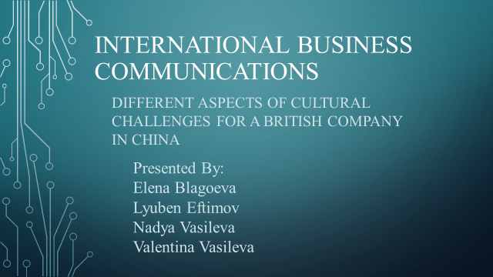

Table of Contents
Different Aspects of Cultural Challenges for a British Company in China 3
Nadya Vasileva 1908838 3
Introduction 3
Introduction to Chinese culture 4
Elena Blagoeva (1913400) 6
Success and failure factors of joint ventures 6
Cultural sensitivity in China / The differences from the UK 8
Valentina Vasileva 1909485 9
Hofstede cultural Dimensions: UK and China 9
Lyuben Eftimov (1913402) 13
Recommendations 13
Conclusion 15
Referencing List 16

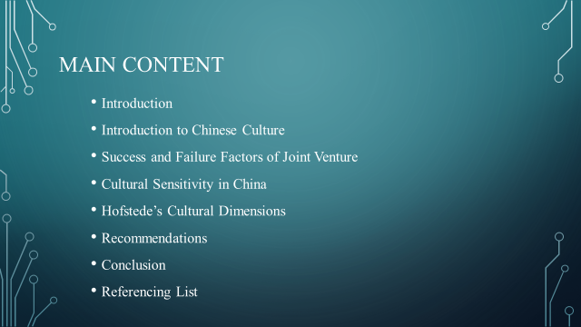

Different Aspects of Cultural Challenges for a British Company in China

Nadya Vasileva 1908838

Introduction

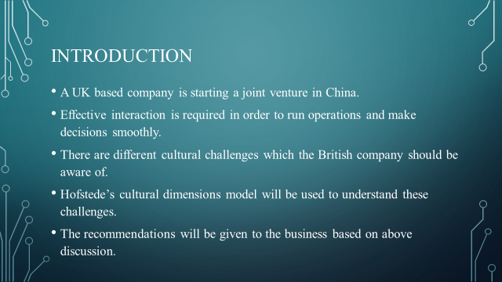

The presentation is about a UK company which is going to start a joint venture with a Chinese company based in China. One of the biggest challenge for the UK Company is that effective interaction has to take place in order for the venture to run smoothly and the decision making can be done effectively. At the same time, the British culture is quite different from the culture of China (Lihua, 2018). The UK Company has to make sure they understand the different aspect of Chinese culture to better communicate with them. Also, the cultural sensitivity of the Chinese should be understood to avoid any misconception. The Hofstede’s cultural dimension model will be used to understand the differences between UK and China culture. The recommendations will be given to the UK business to better formulate their communication with other businesses.

Introduction to Chinese culture

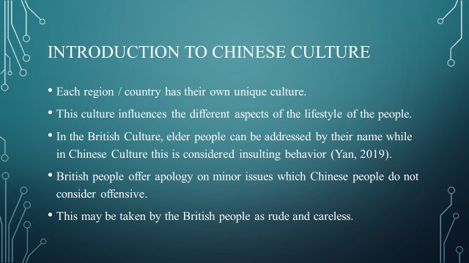

The first thing which the UK based company should understand is the different aspects of the Chinese culture. If the cultural differences are not understood, this may lead to communication problems which can negatively impact the joint venture. The values, beliefs, family system, thought process and lifestyle of the people are different from each other. For example, in the British Culture the elderly people can be called by their names and this is acceptable. On the other hand, the Chinese culture is traditional in this regard. They are offended if a senior person is addressed by their name only especially by a younger person (Yan, 2019). British people also have the cultural habit of apologizing for small things such as when two people accidently bump with each other. Such things are not present in Chinese culture and such behavior may be considered rude by the British.

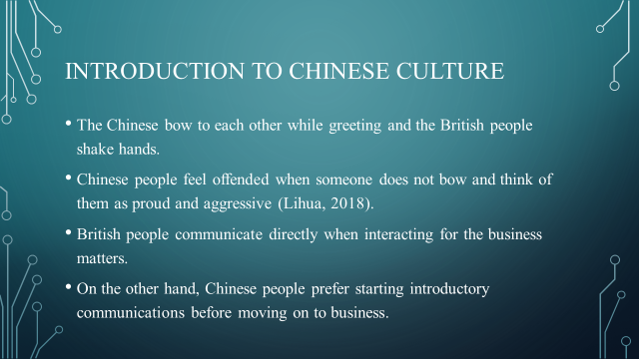

The greeting style of the Chinese is also quite different from British. The Chinese people take a small bow when they interact while the British tend to only shake hands with each other. Although, the culture adaptations are being made by Chinese but someone not greeting in their way may be considered offensive. Another difference is the way business communication is initiated. The British do not indulge in personal interaction and jump straight to the point. On the other hand, Chinse engaged in personal interaction and the direct communication of business matters may be considered mean (Lihua, 2018).

Elena Blagoeva (1913400)

Success and failure factors of joint ventures

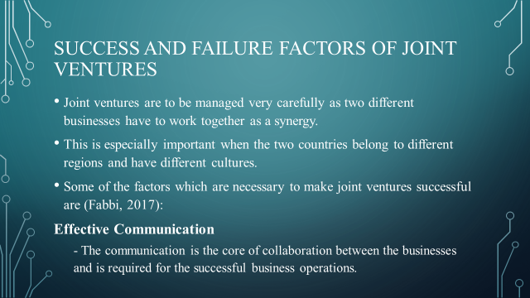

The joint ventures are started as the collaboration of two different businesses and it is important that the different factors which can have an impact on their success should be clearly understood. This is of higher importance when the businesses starting a joint venture belong to different countries. As the culture of different nations are unique, the joint ventures have to be managed in a much better manner. Effective communication is one of the most important factor in this regard. The language differences as well as cultural differences should be accommodated in the communication to make sure it takes place in an effective manner (Fabbi, 2017)

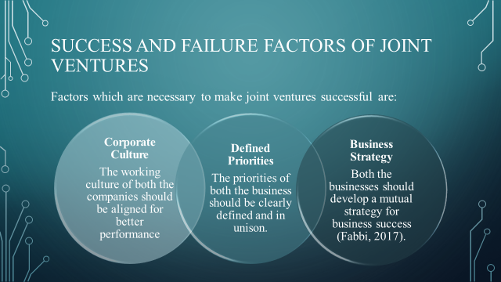

Another factor which is of great importance in the success of a joint venture is the corporate culture. The both organizations have to ensure that their business culture has similarities in relation to their work ethics and efforts. If the difference in corporate culture is huge, this may result in challenge for the venture. The priorities of the ventures should be clearly defined by both the businesses in order to avoid any conflict of interest at any stage (Fabbi, 2017). This will result in better business operations. Lastly, the business strategy is of extreme importance for joint venture success. If a unified strategy is not developed and implemented, the venture may not be able to perform effectively and fail.

Cultural sensitivity in China / The differences from the UK

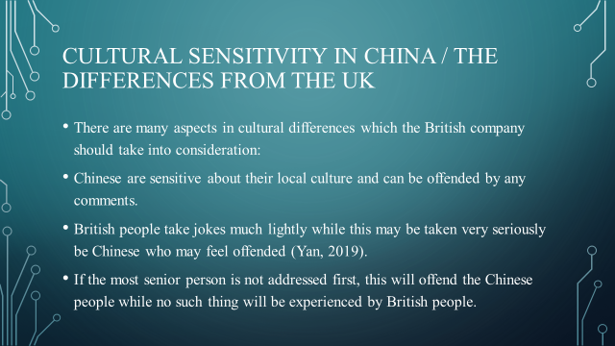

The UK company should be aware of the difference in their and Chinese culture. This is extremely important as there are many things which the Chinese people are sensitive about and should be avoided in order to maintain good relationships. The Chinese are proud people and show great sensitivity about their culture. Any light remark about them may be taken as an offense and should be avoided (Yan, 2019). The British people make jokes at each other and the tolerance level of such jokes is very high. Chinese are not very comfortable with this behavior and jokes should be avoided in communication with them. Also, the Chinese norm is to address the most senior person in the room first while the British interact with anyone without any regard with this matter. This can also create problems as Chinese are very concerned with their cultural values.

Valentina Vasileva 1909485

Hofstede cultural Dimensions: UK and China

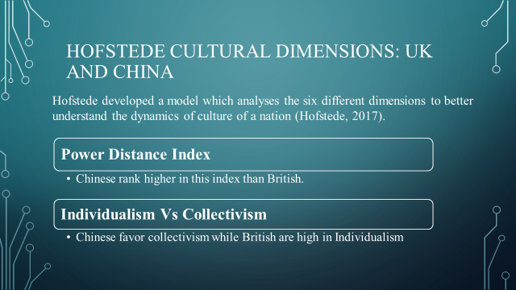

This model was developed by Hofstede as a means of understanding the culture of different nations based on six dimensions. These dimensions represent the different aspects of the society .A better understanding of these factors is essential for company success.

Power Distance Index
This represents the difference in people authorities based on the power they have in the society (Hofstede, 2017). The western cultures have lower power index as also in UK. This means that the power is spread among different levels. While in China, the power distance Index is high representing greater difference based on position of authority.
At a score 80, China is among the top PDI scores, indicating a society that accepts inequities among individuals. (Hofstede Insights, 2022)

Individualism Vs Collectivism
The society may have a tendency of individuals favoring their personal benefits more over the collective (Hofstede, 2017). This is the case in UK where the individual interests are more commonly in focus. The collectivism is shown in societies such as China which represent the tendency of people to avoid their individual goals for the greater good of the country or society.

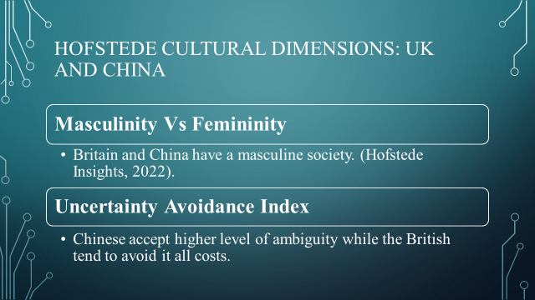

Masculinity Vs Femininity
This is represented by the tendency of the society to follow masculine identified behaviors such as success driven and goal oriented. While the feminine oriented behaviors are caring and relationships. Britain and China are masculine societies.
Britains are competitive and determined. People in the UK live in order to work and have a defined performance goal.
The drive to achieve success is reflected by the fact that many Chinese would put work ahead of family and pleasure. (Hofstede Insights, 2022).

Uncertainty Avoidance Index
This represents the acceptability of ambiguity by the people. For example, Chinese have lower uncertainty index number, which means that their subordinates will be comfortable with a few instructions and lesser clarity. The Chinese language is full of unclear connotation that Western people may find difficult to comprehend. Chinese people are adaptive and inventive.
British on the other hand avoid uncertainty and demand more clarity (Hofstede Insights, 2022).

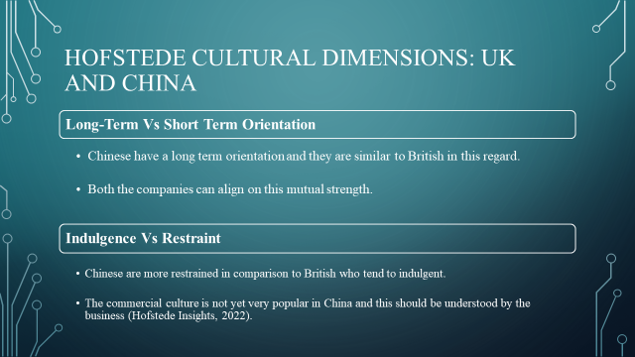

Long-Term Vs Short Term Orientation
This is another important cultural dimension which is to be understood from the company point of view. Some cultures have a long term orientation and are looking for future successes. Such cultures accept necessary changes for development. The short term oriented cultures are more traditional and do not accept the developmental changes. Both China and UK have a long term orientation and the business can benefit greatly from that (Hofstede Insights, 2022).

Indulgence Vs Restraint
This dimension is described as the degree to which people try to manage their desires and impulses, as a result of their upbringing.
This cultural dimension is related to the spending habits of the people. Some societies are more indulgent and they spend highly on fulfilling their impulsive desires. While other cultures show restraint and manage their finances more efficiently .The Chinese rank high on restraint and interaction with them should be managed while keeping in mind this tendency (Hofstede Insights, 2022).

Lyuben Eftimov (1913402)

Recommendations

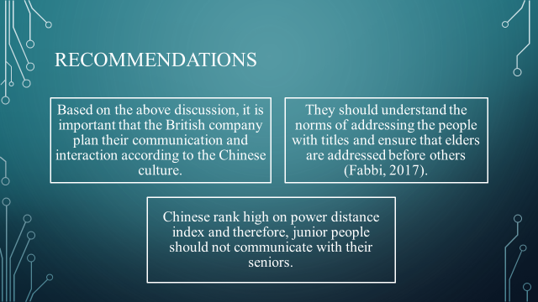

The understanding of the cultural differences is very important and based on the above discussion there are some recommendations for the UK Company. First of all, they should understand that their communication strategy has to be aligned with the Chinese culture for the venture to be successful. They should understand that when interacting the seniors are addressed first and also the titles of the people are used to show respect to there. The power distance index is high in China and no junior employee or UK Company should interact with Chinese seniors to avoid issues.

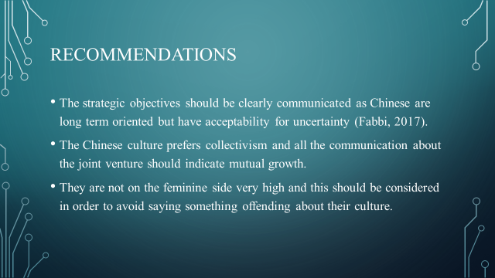

Both Chinese and British have long term orientation which means that the strategic objectives should be defined clearly. The communication should ensure that the joint venture represents the success of both companies for success of everyone. They rank high on masculinity which is different from Western culture, so any remark in this matte should be avoided.

Conclusion

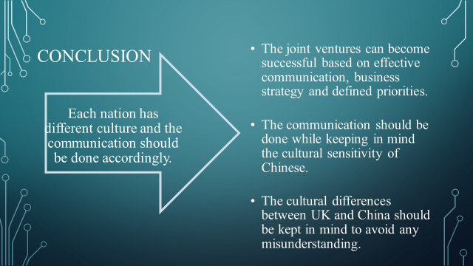

Every company must do a research of the country where the business will extended. Where the cultural difference exist as an example between UK and Chine a little gesture or words even an outfit can be offensive to the other side. This can lead to unsuccessful business deal and complicated business relationship in the future.
Each nation has different culture and the communication should be done accordingly.
The joint ventures can become successful based on effective communication, business strategy and defined priorities.
The cultural differences between UK and China should be kept in mind to avoid any misunderstanding.
The communication should be done while keeping in mind the cultural sensitivity of Chinese.

Referencing List

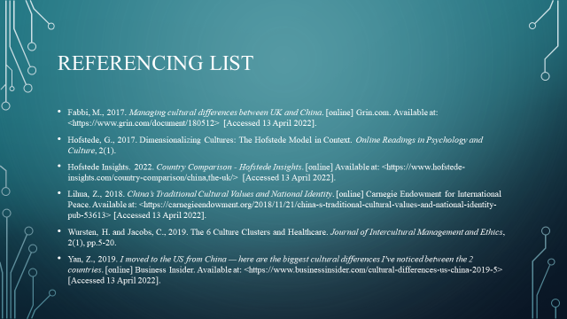

Fabbi, M., 2017. Managing cultural differences between UK and China. [online] Grin.com. Available at: <https://www.grin.com/document/180512> [Accessed 13 April 2022].
Hofstede, G., 2017. Dimensionalizing Cultures: The Hofstede Model in Context. Online Readings in Psychology and Culture, 2(1).
Hofstede Insights. 2022. Country Comparison - Hofstede Insights. [online] Available at: <https://www.hofstede-insights.com/country-comparison/china,the-uk/> [Accessed 13 April 2022].
Lihua, Z., 2018. China’s Traditional Cultural Values and National Identity. [online] Carnegie Endowment for International Peace. Available at: <https://carnegieendowment.org/2018/11/21/china-s-traditional-cultural-values-and-national-identity-pub-53613> [Accessed 13 April 2022].
Wursten, H. and Jacobs, C., 2019. The 6 Culture Clusters and Healthcare. Journal of Intercultural Management and Ethics, 2(1), pp.5-20.
Yan, Z., 2019. I moved to the US from China — here are the biggest cultural differences I've noticed between the 2 countries. [online] Business Insider. Available at: <https://www.businessinsider.com/cultural-differences-us-china-2019-5> [Accessed 13 April 2022].


