Student name: Iulian Vasile Purice

Student id nr: 1919243
Module code: LCBB6001
Lecturer: Husam Helmi

International Business Communication

Assignment 1

Table of Contents
Introduction 1
An introduction of the selected developing country 2
Cultural differences 3
Cultural sensitivity 5
Communication barrier and challenges (UK vs. India) 6
Communication strategies and recommendations 8
Conclusion 9
References 10

Introduction
The onset of globalisation has resulted in the expansion of business operations in an overseas land. It has helped organisations to build connections with foreign countries and develop cross-cultural communication. Therefore, the trading of goods, services, capital and technology across the border in an overseas land is known as international business. As Hamilton, and Webster, (2018) have pointed out, globalisation helps in the creation of interconnection and linkages between the nations that result in acculturation. The growth of the international business has given rise to the need of developing international communication skills. Communication is the basis of all relations a reason the need for developing international communication skills has become utterly important for career development so that individuals can communicate with people of other cultures.
The skill of communicating with the people of the overseas country has been termed a cross-cultural communication skill which is an essential skill in the present day (Llopis-Lorente et al., 2017). However, despite cross-cultural communication skills, there are certain challenges which a company faces when it expands its operations in the international land with respect to cultural differences and cultural sensitivity which can only be addressed by gaining detailed knowledge about the behaviour, language, and attitudes of the people. The purpose of this study is to discuss the challenges of setting up international business in regard to a chosen company of the UK named Waitrose w supermarket Company in developing nation, India.

An introduction to the selected developing country
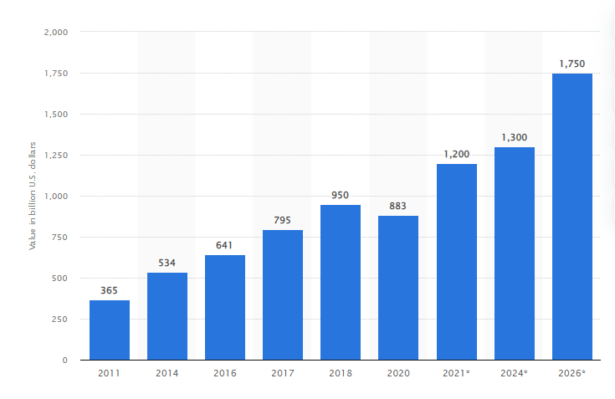
Figure: The positive growth of the retail industry in India
Source: (Statista Research Department, 2022)
The Waitrose Company is a British supermarket company that has planned to shift its production to the developing nation of India. India is the seventh-largest country with the highest population in the world which opens up a huge market opportunity for companies enabling them to serve a huge customer base. As per reports, (Statista Research Department, 2022), the retail market of India is valued at $883 billion which is estimated to show positive growth in the near future by $1.7 trillion. This makes it evident that choosing to move the production of the Waitrose Company to the developing country of India could be a big opportunity for the company. The company can also enjoy the additional benefits of cheap and skilled labour. However, India is impacted by political issues like corruption which poses threats to companies. As per the reports, of The World Bank, (2021), the estimated GDP of the country is $3.18 trillion, and it is predicted to grow in the near future which makes India an attractive country for international market expansion.

Cultural differences

Adamczyk, (2017), has put forward his opinion that cultural differences can affect businesses in the international context. As businesses expand their operations overseas land one of the prime challenges, they face is the cultural differences that exist between the countries. The behaviour, attitude, and language of the people differ from one country to another and that is what gives rise to cultural differences and makes it difficult for the company to operate in the international country. Therefore, before deciding on expanding business operations in Overseas land it is crucial to gain knowledge about the cultural preferences of the other country. Hofstede's framework of the Cultural dimension is popularly identified as a framework that points out the cultural differences that exist when countries in terms of power distance, individuality, uncertainty, masculinity, long term, and indulgence. These dimensions give a clear idea about the cultural preferences of a country that further helps in understanding the taste of the people. This can help a manager to plan their move to an overseas land. In this context, Hofstede's framework of cultural dimensions will be used in the study to analyse the cultural differences between the UK and India.
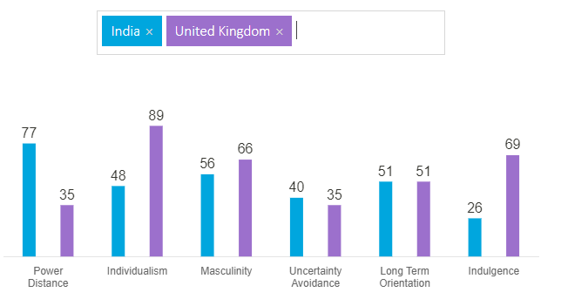
Figure: The cultural differences between the UK and India
Source:
Power distance: In reference to the figure above the power distance score of the UK is 35 which signifies that people of the UK prioritise minimising inequalities between the people. However, India with a higher score of 77 in the power distance dimension India can be assumed to be the believer in the opposite which means the Indian society supports inequality where they prefer the top-down structure in the organisation and the society.
Individualism: In terms of individualism the UK with a score of 89 signify that the people in the UK are highly individualistic and they prefer being on their own. In such kind of a society, people give high preference to personal fulfilment. On the other hand, India with a score of 48 in this dimension signifies that India has a collectivist society where people like to work in groups and society prioritises strong relationships (Hofstede's Insights, 2022). Therefore, the dimension of individualism shows that there is a huge cultural difference between the UK and India.
Masculinity: The masculinity score of 66 in the UK indicates that the UK society is masculine and is driven by success, achievement, and competition. In contradiction to the UK India with a score of 56 is also a masculine society where the society is more success-oriented with a higher priority on material gains (Hofstede's Insights, 2022). This signifies that in terms of masculinity the UK and India are also masculine societies which can act as an opportunity for the Waitrose Company.
Uncertainty avoidance: Uncertainty avoidance is a dimension that helps to understand how the members of society react in case of unknown or ambiguous situations. The UK with a score of 35 signifies that the society is comfortable handling ambiguous situations while India with a score of 40 somewhat has similar characteristics which means the people of the Indian society are comfortable with ambiguous situations (Hofstede's Insights, 2022).
Long-term orientation: Long-term orientation shows how a society maintains links with the past while tackling the contradictions of the present as well as the future. The UK with a score of 51 which signifies that give a pragmatic approach. India with a similar score of 51 signifies that they have a high preference for religious views. A high score on pragmatism means that the people of such a society are less punctual (Hofstede's Insights, 2022).
Indulgence: The dimension of indulgence defines the way society controls its impulses and desires. The UK with a higher score of 69 is a highly indulgent country that indulges itself in mirth and enjoyment and is highly optimistic and places higher importance on leisure time, whereas India with an extremely low score of 26 is comparatively less indulgent and is pessimistic (Hofstede's Insights, 2022).

Cultural sensitivity
Cultural sensitivity is defined as the awareness of the cultural similarities and differences that exist between people without assigning value to them. Setting up business operations in the international land requires awareness of the cultural differences that exist between the tastes and preferences of the people. To carry on business operations without any kind of hindrances it is important to attack the cultures of another country. The idea of cultural sensitivity within the workplace is highly recognised as businesses are gradually expanding their operations and they must deal with varieties of customers.
On conducting a comparative study between the cultures of the UK and India with the application of Hofstede's cultural dimensions framework it has been assessed that the UK and India are similar on certain terms like masculinity, uncertainty avoidance, and long-term orientation. The differences between the societies lie in the fact that the UK society is more individualistic while people of the Indian society are collectivist nature. In addition to that, the people of Indian society prefer inequality in society whereas the people of the UK in the opposite way. Therefore, as the UK-based company Waitrose has planned to shift its productions to the developing country of India it must be aware of the cultural differences that exist in Indian society. As Voldnes and Kvalvik, (2017) discussed in their study that cultural sensitivity is the awareness of the exporter and the adaption of the importer to the business practices of the domestic market. Therefore, to overcome the cultural differences the company has to be culturally sensitive. In the Indian market, the manager of the Waitrose Company must hold a collectivist approach and try to build good relationships with the individuals so that they can attract more employees from the Indian market. As Khalid and Ali, (2017) hold the view that cultural sensitivity can help in creating an inclusive workplace. This can be beneficial for the company in the Indian market.
When a company expands its operations into the international market the primary priority of the company should be to build its network in the new market so that it can attract more talents to the company. Building connections in the retail factor will also help the company to remain apprised of the opportunities and present chances for collaboration with other companies. language is a medium through which a connection can be built with the people of the other culture. People in India speak different languages, but Hindi and English are the common languages spoken in all parts of India. Therefore, using these languages can help in building a connection with the Indian people that can help the company to reach out to its target customers.

Communication barrier and challenges (UK vs. India)
Communication becomes a prime challenge when a business enterprise enters the global business. As the Waitrose retail Company has planned to move its production to the country of India it must hire employees who are competent in cross-cultural communication. However, some of the key communication barriers that the UK may face in India are:
Ethnocentrism: Ethnocentrism is the belief that one own way of doing things is correct which leads to the negative judgement of behaviour and gives rise to more differences (Stahl et al., 2020).
Stereotyping: Stereotyping is holding a few preconceived notions about a culture that does not exist in reality. Therefore, giving a place to search stereotypes while communicating with Indian people can give rise to more challenges.
Body language: Body language includes communication and nonverbal channels. This refers to the way one greets others, the gestures and the facial expressions, voice tone as well as eye movements (Maude, 2017). If the body language appears friendly to the people of the Indian culture then it becomes easy to establish communication with the people of the other culture. Indians are very expressive people and they observe the gestures of the people very minutely. Joining hands and doing Namaste is a common way of greeting people in India while people in the UK prefer to shake hands for greeting people.
The language barrier: The language barrier is a common problem faced by employees in a global market. Being unaware of the language of the Indians can lead to barriers in communication and setting up business operations.

Communication strategies and recommendations
The role of communication is undeniable in international business. Communication is the code of business operations in the international land. The issues in the organisations are managed, led, and created through communication that plays a primary role in exchanging knowledge and health in the maintenance and development of relationships and deal negotiation. The increased level of business internationalisation has escalated the requirement of understanding the various communication processes. To carry on business operations swiftly it is necessary to overcome the communication barriers written at the beginning so that the company can operate without any hindrances.
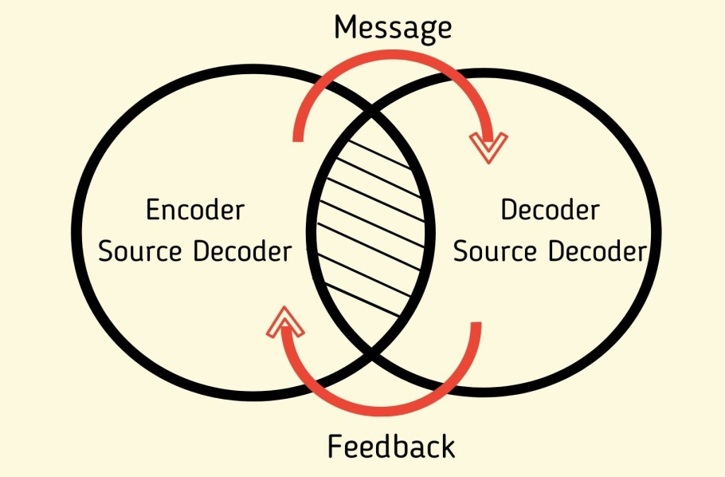
Figure: The interactive model of communication
Source: (Bhasin, 2021)
Considering the Interactive model of communication can be an effective communication strategy through which the managers of the Waitrose Company can try to make the communication more interactive. The implementation of this communication model can help to ensure that message is received by the individuals of the other culture and also provides a chance for the receiver of the message to provide feedback. The interactive model takes psychological and physical contexts are taken into account. In the physical context, the environmental factors of communication are taken into consideration. On the other hand, in the psychological context, the emotional and mental factors in communications are encountered. Anxiety, stress, and emotions are some of the psychological factors taken into consideration in the interactive model of communication. As per reports, by Szkudlarek et al., (2020) people in India are very expressive. Therefore, some of the strategies that can be used for communicating with the people in India are trying to understand the communication differences, creating a common culture in the organisation and hiring multilingual people in the company who are capable of communicating with people who speak different languages (Szkudlarek et al., 2020). Intercultural communication competence is extremely necessary for businesses with international operations. Hiring people with cross-cultural communication competence can help to communicate with people of different cultures and overcome the barriers that can help the business to thrive in the international market.

Globalisation has led to the expansion of business operations in the international market which has resulted in acculturation which gave rise to cross-cultural communication. The importance of cross-cultural communication has increased over the years as more and more businesses have started operating in the international market. In this study, the role of communication in the international business context has been discussed. The Waitrose retail company has considered moving its production to the country of India. The application of Hofstede's model of cultural insights has helped to find out the cultural differences that exist between the UK and India. Furthermore, the study also analyzes the importance of cultural sensitivity and the communication barriers faced by companies in the international market. However, for overcoming the communication barriers the interactive model of communication has been included in the study that can help in making the communication more effective between the centre and the receiver which can help to overcome all communication gaps. The additional focus must also be made on hiring people with cross-cultural communication competence and individuals who are multilingual these are some of the effective communication strategies for operating in the international market.

References
Adamczyk, M., 2017. The importance of cultural differences in international business. The Central European Review of Economics and Management (CEREM), 1(2), pp.151-170.
Bhasin, H., 2021. Interactive Model of Communication. [online] Marketing91. Available at: <https://www.marketing91.com/interactive-model-of-communication/> [Accessed 25 July 2022].
Hamilton, L. and Webster, P., 2018. The international business environment. Oxford University Press.
Hofstede's Insights, 2022. Country Comparison - Hofstede Insights. [online] Hofstede Insights. Available at: <https://www.hofstede-insights.com/country-comparison/india,the-uk/> [Accessed 25 July 2022].
Khalid, S. and Ali, T., 2017. An integrated perspective of social exchange theory and transaction cost approach on the antecedents of trust in international joint ventures. International Business Review, 26(3), pp.491-501.
Llopis-Lorente, A., Díez, P., Sánchez, A., Marcos, M.D., Sancenón, F., Martínez-Ruiz, P., Villalonga, R. and Martínez-Máñez, R., 2017. Interactive models of communication at the nanoscale using nanoparticles that talk to one another. Nature communications, 8(1), pp.1-7.
Maude, B., 2017. Managing cross-cultural communication: Principles and practice. Bloomsbury Publishing.
Stahl, G.K., Miska, C., Lee, H.J. and De Luque, M.S., 2017. The upside of cultural differences: Towards a more balanced treatment of culture in cross-cultural management research. Cross Cultural & Strategic Management.
Statista Research Department, 2022. India: retail market size 2020 | Statista. [online] Statista. Available at: <https://www.statista.com/statistics/935872/india-retail-market-size/#:~:text=The%20retail%20market%20size%20in,estimated%20to%20recover%20in%202021.> [Accessed 25 July 2022].
Szkudlarek, B., Osland, J.S., Nardon, L. and Zander, L., 2020. Communication and culture in international business–Moving the field forward. Journal of World Business, 55(6), p.101126.
The World Bank, 2022. GDP (current US$) - India | Data. [online] Data.worldbank.org. Available at: <https://data.worldbank.org/indicator/NY.GDP.MKTP.CD?locations=IN> [Accessed 25 July 2022].
Voldnes, G. and Kvalvik, I., 2017. Interfirm relationships in emerging markets: The importance of relationships and cultural sensitivity. Journal of East-West Business, 23(2), pp.194-214.

