Ffion Richardson

1505031

Surface Pattern Design

words: 1,524

Julia Lockheart

Gwenllian Beynon

Mewn byd sy'n cael ei reoli gan gyfrifiaduron a thechnoleg rydym yn aml yn anghofio sut i siarad â'n gilydd. Mae’r holl dechnoleg newydd yn ein rhwystro rhag canolbwyntio ar yr hyn sydd yn bwysig. Mae defnyddio gwefannau cymdeithasol fel Facebook, Twitter ac Instagram wedi datblygu mewn i ddefod ddyddiol i ran fwyaf o bobl y byd a dyma’r ffordd fodern o gyfathrebu. Dinistrir hwn yr allu i ryngweithio gydag eraill yn ogystal â datgysylltu ein hunain o’r byd o’n cwmpas. Dywed Lefebvre (1991, p.77) yn ei lyfr bod gofod cymdeithasol yn cynnwys amrywiaeth fawr o wrthrychau, “both natural and social, including the networks and pathways which facilitate the exchange of material things and information. Such ‘objects’ are thus not only things but also relations.”. Yn yr achos hwn, nid pethau materol sy’n bwysig ond y cysylltiadau rhwng bodau dynol wrth geisio osgoi defnyddio ‘social media’ ar ein ffonau bob dydd. Mae’r rhwydweithiau ar-lein wedi strwythuro'r ffordd mae ein cymdeithas yn meddwl heddiw. Er enghraifft, mae llawer ohonom ni yn troi at gyfryngau cymdeithasol er mwyn mynegi barn a phryderon gwleidyddol sy’n achosi ni i ddadansoddi'r cydberthnasau rhyngddynt. Yn ogystal â hyn, rydym yn cynnig diffiniad gweithredol o gyfryngau cymdeithasol ond nid yw datblygiadau technolegol bellach yn frawychus oherwydd disgwylir iddynt gael eu cyflawni. Gellir ystyried bod y datblygiadau technolegol cyson sy'n helpu i gysylltu'r byd yn fuddiol neu'n niweidiol i gydberthnasau dynol. Mae'r newidiadau mewn perthnasoedd yn eithriadol o bresennol mewn pobl ifanc yn eu harddegau sy'n defnyddio ‘instant text messages’ yn lle sgwrs wyneb yn wyneb â ffrindiau a theulu.

This exhibition (see figure 1) inspects what we as human beings feel deep within, restrict ourselves from checking our phones for just a few minutes and to physically engage with real people. Too much time is wasted without us even realising, most of that time being virtually connected elsewhere when there is so much more in front of you.
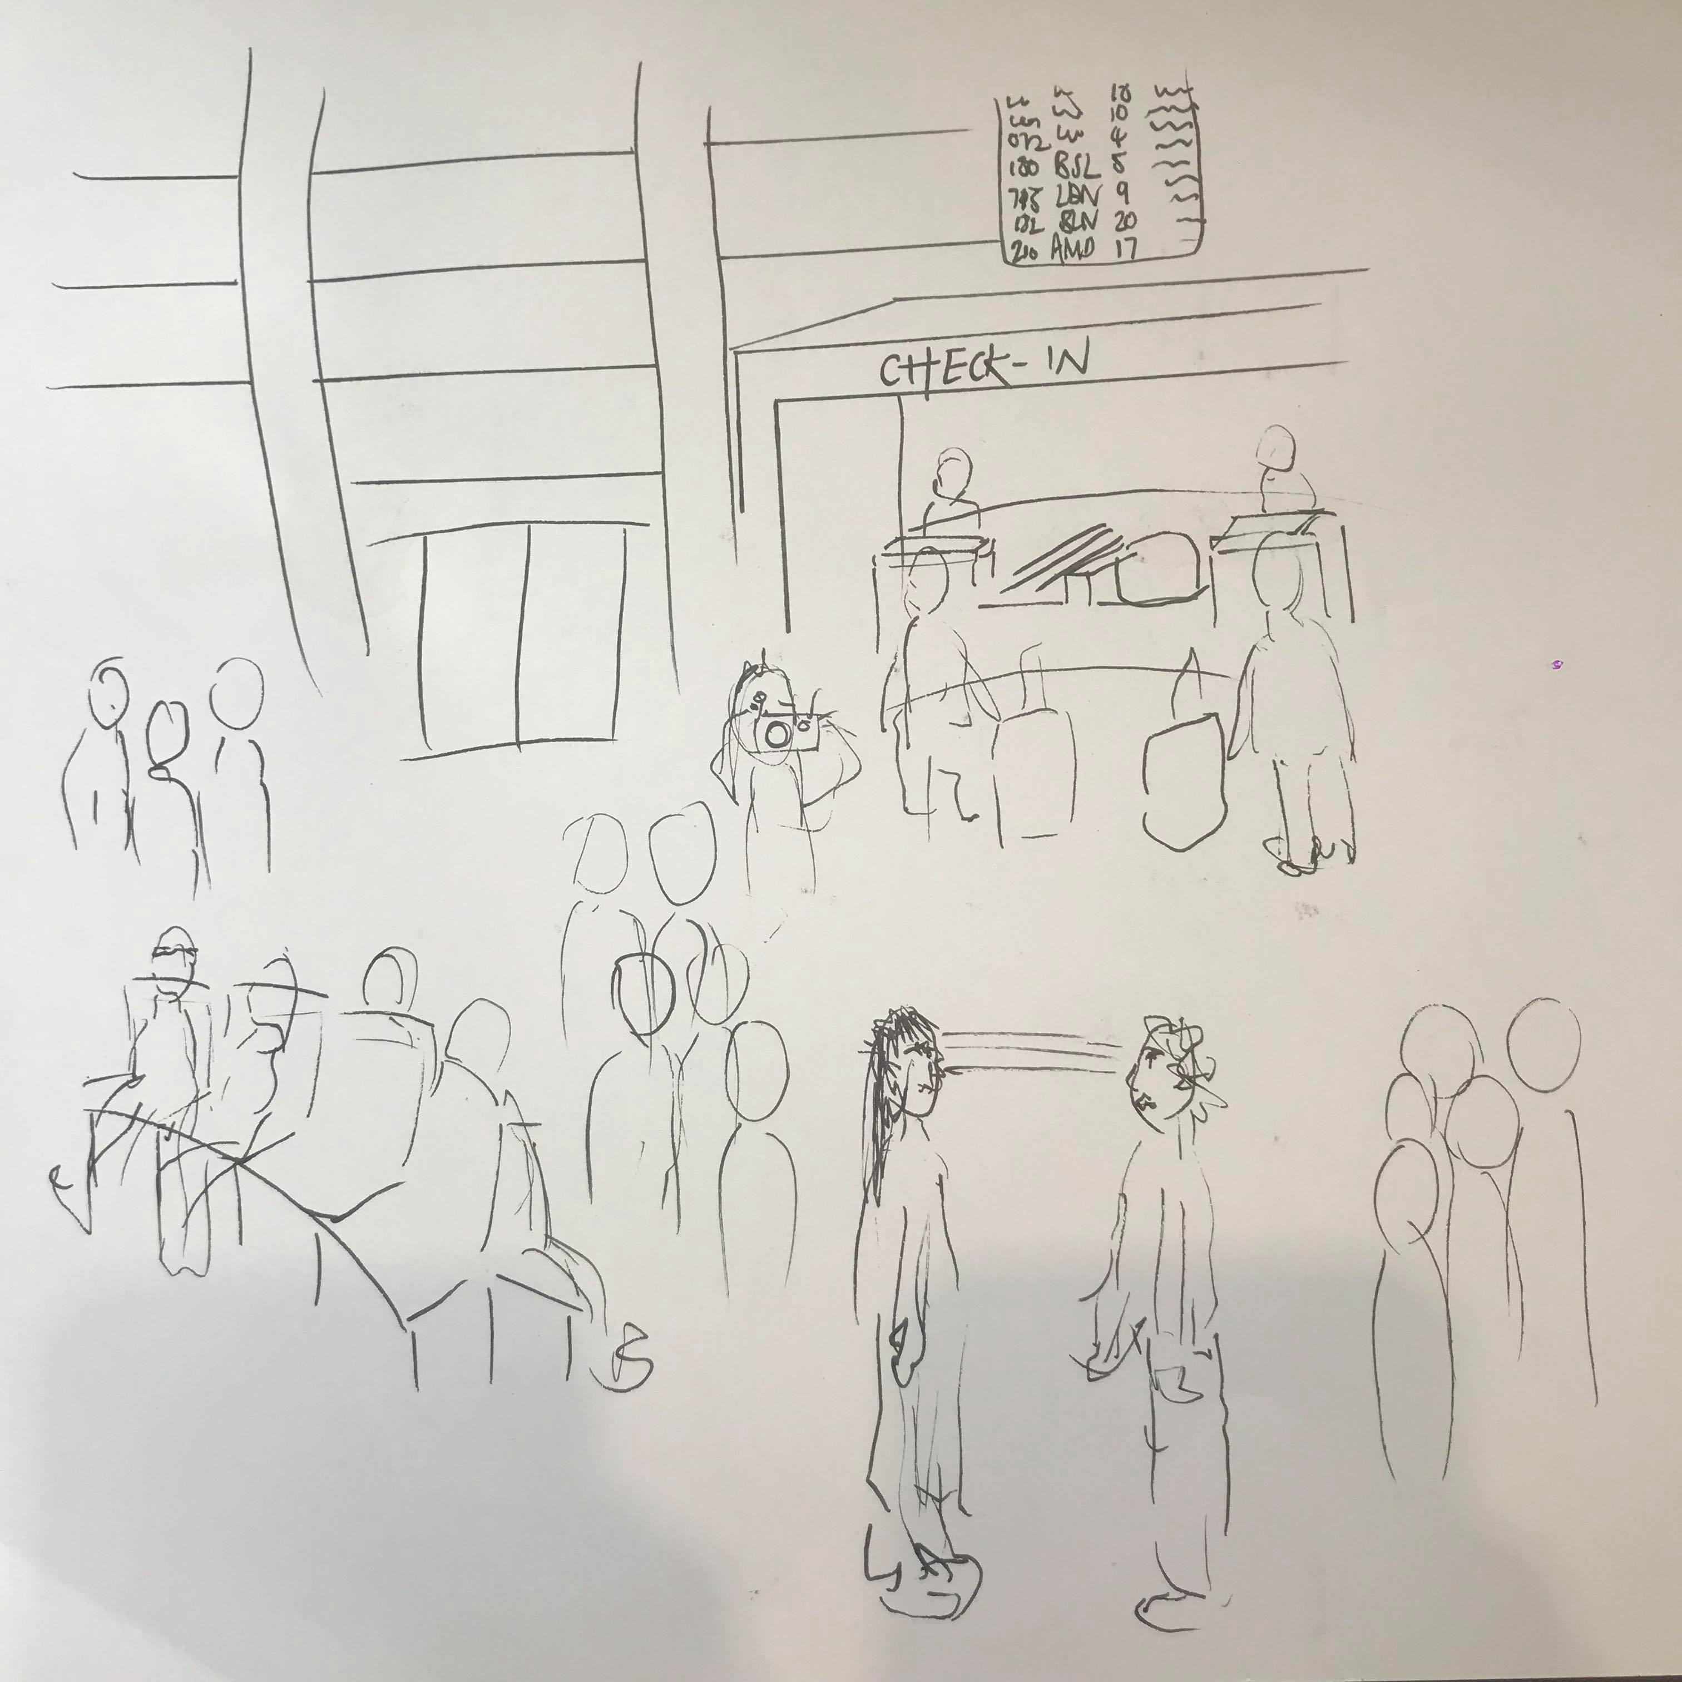

Figure 1 (Richardson, Ff.E. 2018)

People simply do not spend enough time in the time that is present. Scenes such as the streets create a space, one that examines a particular vibrancy that emanates from the interactions taking place between occupants of the world. Streets not only connect roads but they connect people and it’s where we act out our lives as social beings and communities.
Another vibrant space is the airport, this is where the exhibition will be situated. A place that constantly holds thousands of people from all kinds of places and backgrounds. The only difference is that the airport does not usually connect people the same way as streets, instead they connect people to a destination, for instance a holiday. The airport constantly highlights a sense of continuity with the ebb and flow of humans; planes; suitcases; experiences, all things that captivate stories. However time at the airport can be either short or painfully long for instance waiting to board planes, without forgetting to check-in on Facebook and updating your status at every announcement. Philosopher Augé argues that the airport is a ‘non-place’ quoted in his book ‘Non-places: Introduction to an Anthropology of Supermodernity’ (Augé, 1995) as an anthropological and temporary space where human beings are quite frankly nameless, as those spaces do not withhold adequate significance in order to be considered as ‘places’.

Bydd y ‘di-le’ hwn yn cynnwys gosodiad arferol y maes awyr gydag amrywiaeth o bobl o bob cwr o’r byd. Fe fydd dau berson ar y tro yn sefyll gyferbyn â’i gilydd ac edrych i mewn i’w lygaid am bum munud. Gobeithio yn ystod y bum munud hyn fe fydd emosiwn yn sbarcio ac yn fwrw’r galon yn drwm. Er mwyn cofnodi hyn, bydd ffotograffydd yn dal yr eiliad cyntaf dengys emosiwn yn eu hwynebau. Ar ôl hwn, bydd y ddau berson yn cyfnewid stori personol neu rhywbeth o’u deithiau.

Watching two people from completely different societies gaze into each other’s eyes echoes Edward Said’s ‘Othering’ theory (Said, 1978) where he believes that one group that embodies the norm and whose identity is valued and another that is defined by its faults, devalued and vulnerable to discrimination. The construction of geographical otherness is based on a hierarchy of civilisations and requires the use of a universal criterion that allows their comparison. Language and political systems fulfilled this role until the emergence of Christianity and Islam, and then religion replaced them to oppose believes and non-believers.

Mae’r term ‘Othering’ yn fframwaith cysyniadol sy’n cynnwys mynegiadau o ragfarn ac ymddygiadau. Yn yr un modd, mae’r term “Belonging” yn condemnio rhywbeth sylfaenol ynglŷn â sut mae grwpiau wedi’u rhoi o fewn cymdeithas, yn ogystal â sut maent yn cael eu hystyried. Adlewyrchir hefyd safbwynt gwrthrychol o bŵer ac adnoddau yn ogystal â natur hunaniaethau. Mewn byd sydd angen galwad am berthyn a chynhwysiant fel yr unig ateb cynaliadwy i ‘Othering’. Wrth i ddigwyddiadau byd-eang ymddangos, mae dynoliaeth wedi gwneud cynnydd aruthrol tuag at oddefgarwch, cynhwysiant a chydraddoldeb. Rydym yn byw mewn cyfnod o newid cymdeithasol dramatig mewn hanes dynol.
Figure 2
The Artist is Present by Performance Artist (Abramovic, 2012)

The exhibition is inspired by Marina Abramovic’s ‘The Artist is Present’ (2012) which features herself; someone from the audience and an elongated stare between the two. Abramovic sat for the entire performance which was seven hours a day for three months. The response to this exhibition was surprising due to the fact that the silent stare overwhelmed the audience and even made some cry. This confirms that an effortless activity is capable of producing a strong emotional response. Comparably to this, there will be an audience in the airport which will create an atmosphere and tension as the two strangers will be watched. The human interaction considers the attempt of the performers and audiences’ shared empathy for one another, almost as if the only thing shared between them is their heartbeat which creates a sense of vulnerability. Some might argue that the heartbeat is the main characteristic of human nature especially during this kind of emotional labyrinth. The time spent staring into each others eyes is almost like a silent examination combined with the observer’s vulnerability which emotionally affects the audience. Additionally the only thing that stands between the performers and the audience is a sense of an unspoken empathy. The act is so simple that the audience has the time to inspect its simplicity and accept the fact that they are all there at that moment in time, they’re all human and they simply share that with each other. Lefebvre (1991, pp. 70) alludes to space as a ‘nature’ that “creates and does not produce; it provides resources for a creative and productive activity on the part of social humanity” which in this case is the intimate contact between two strangers. In addition to this, the fact that there won’t be anything between the two people heightens the notion of vulnerability once again because hiding behind anything is simply impossible including anything emotional.

We live in a world where humans choose to avoid eye contact which is why this exhibition is based around it and by elongating the eye contact it causes vulnerability between two complete strangers. As a result of maintaining the lengthened stare, people often become overwhelmed by their own feelings expressing them in various ways. Similarly staring into the eyes of a loved one, some might feel overwhelmed by the love they have for them and might even shed a tear. By standing opposite one another and gazing into each others eyes perhaps allows one to identify and understand another person’s emotions or pain. Many people are afraid to express how they feel in the world we live in, filled with prejudice and societal taboos when genuinely we’re all human and are allowed to have emotions.
Lefebvre (1991, pp. 70-71) quotes that nature is indeed “drawing away from us” as human beings are becoming impossible to escape the notion of nature being replaced by “anti-nature” thus “by abstraction, by signs and images, by discourse, as also by labour and its products”. This signifies the absence of humanity and not enough time spent in the Present moment as previously mentioned. Too much time is spent on social media where society make up certain “signs and images” which they eventually live by because of the addictive effect it has on our generation, slowly disconnecting from things that matter most.
In conclusion to this, it’s evident that online social networking is growing rapidly but we shall not disconnect ourselves from each other - we are still human and must remember that. Throughout his book, Lefebvre (1991, pp.82-83) plays with the idea of ‘space’ as a “floating medium” or a “simple abstraction” which in regards to the exhibition is inapt due to its powerful content - exhibiting depth rather than a ‘floating element’. The two strangers and the audience share their humanity which is a heartbeat and roots the entire performance. The aim is to touch the hearts of many and hopefully give a sense of realisation by slowing time down and signify the importance of human interaction.

Bibliography

- Lefebvre, H. (1991) The Production of Space. Great Britain: Blackwell Publishing.
- Powell, J.A. and Menendian, S. (2017) The Problem of Othering: Towards Inclusiveness and Belonging. Available at: http://www.otheringandbelonging.org/the-problem-of-othering/
- Moosavinia, S.R. et al. (2011) Edward Said’s Orientalism and the Study of the Self and the Other in Orwell’s Burmese Days. Available at: https://pdfs.semanticscholar.org/05de/122dafdc37fefc7ccb46b4599e018b14a11d.pdf
- Augé, M. (1995) Non-places: introduction to an Anthropology of Supermodernity. pp.75-115, London: Verso.
- Rose, H. (2018) Locking Eyes With Marina Abramovic in ‘The Artist Is Present’ Inspired This Author to Write a Novel—Read an Excerpt Here. Available at: https://news.artnet.com/art-world/marina-abramovic-inspired-novel-1425469
- Richardson, Ff.E. (2018) Figure 1
- Abramovic, M. (2012) The Artist is Present. Figure 2

