Investigation into the replacement of the cylinder expansion test with the disc acceleration experiment.
Research Proposal
Jennifer Mungham

Contents
Contents 2
Figures 3
Tables 3
1. Introduction 4
2. Background to the Proposed Research 5
Explosive Theory 5
3. Aims & Objectives 7
3.1 Aim 7
3.2 Objectives 7
4. Experimental Design 8
4.1 Outline of Experimental Procedure 8
Cylinder Expansion Tests 8
Disc Acceleration Tests 8
4.2 Data Collection 10
4.3 Data Evaluation 11
4.4 Risks & Limitations 12
Risks 12
Limitations 12
4.5 Ethical Issues 12
6. Resources & Planning 13
6.1 Resources Required 13
6.1.1 Physical Resources 13
6.1.2 Human Resources 13
6.1.3 Other Resources 13
6.2 Gantt Chart 14
7. References 15

Figures
Figure 1 Pressures in a Detonation 5
Figure 2 Cylex Test Set Up 8
Figure 3 DAX Experimental Set-Up 9
Figure 4 Heterodyne Velocimetry Trace for DAX 11

Tables
Table 1 Examples of Explosive material parameters 6

Equations
Equation 1 JWL Equation of State 6
Equation 2 Apparent velocity of a moving object measured using het-v 10
Equation 3 Equation for calculating CJ Pressure using Chaos' Effective Mass Method [8] 11
Equation 4 Equation for calculation of CJ pressure in a Cylex test [11] 11

1. Introduction
To model and understand energetic materials for their use if industry and military applications, the materials need to studied in experiments. These are expensive and time consuming experiments done using the Cylinder expansion (CYLEX) Test method. Alternatives to the Cylex are regularly mooted in the energetics community, the latest of which is the Disc Acceleration Experiment (DAX) designed by Lorenz [1].
This new test would provide a cheaper and quicker alternative to the Cylex test allowing for more tests to be undertaken to improve the statistical quality of the results obtained. As well, it would allow tests to determine energetic materials characteristics to be undertaken as part of the rapid prototyping in small scale manufacturing.
To determine if the DAX is a suitable alternative to the Cylex test, a series of experiments will be undertaken with both test methods, using the same batch of an energetic composition.

2. Background to the Proposed Research

Explosive Theory
Explosive materials are used around the world for a variety of work, including mining, military use and scientific research. Each use requires different characteristics from the material such as different levels of static peak overpressure, positive impulse and sensitivity.
The static peak overpressure is caused by the gases created in the reaction zone of a detonation, just behind the shockwave, rapidly expanding outwards. The gas formed from a solid or liquid material requires a greater volume at the same temperature and so starts to expand. This expansion produces a pressure on the surrounding medium, which for these experiments was a light plastic or PMMA case. With enough pressure, this can cause the fracture of the casing and shockwaves in the medium beyond i.e. air. The static peak overpressure created by the gases, depends on several factors, including the rate of formation, the amount of gas produced per unit mass of the products, ambient temperature, and case strength.
The positive impulse is the area under the positive part of the overpressure curve (see Figure 1) and is directly related to the brisance, the pushing force of the explosive material. A higher static peak overpressure doesn’t necessarily mean a higher impulse. A lower static peak overpressure but high positive impulse can occur when the gaseous expansion happens over a longer time period, such as in Ammonium-Nitrate Fuel Oil (ANFO), or when the return to ambient pressure occurs more slowly.
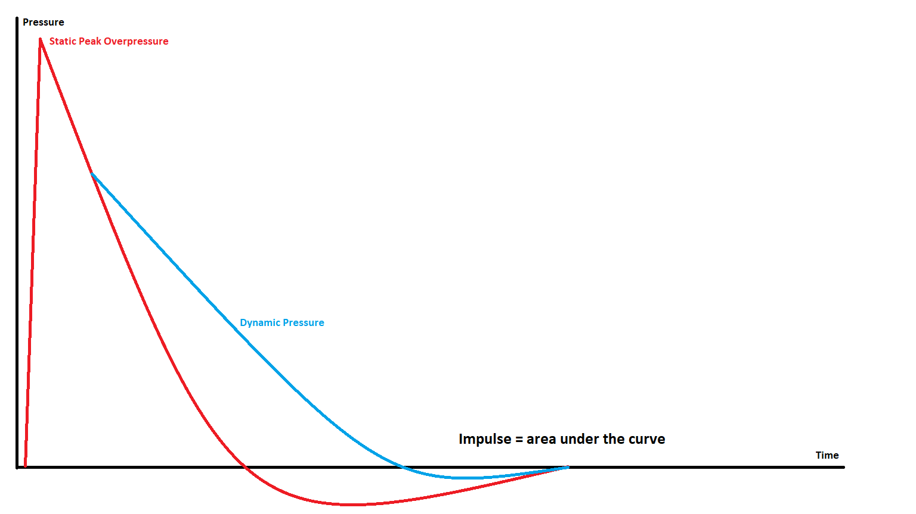
Figure 1 Pressures in a Detonation
The positive impulse of an explosive can also be increased with the addition of secondary burning, to create a dynamic pressure, which occurs after the initial detonation reaction and produces more gas products. For example, Tritonal, is a mixture of TNT and aluminium, the aluminium reacts after the initial detonation to increase the total gas volume produced without increasing the static peak overpressure. As in Figure 1, with the addition of dynamic pressure, the area under the positive part of the curve is increased, corresponding to a larger positive impulse.
To be able to model an explosive in a computer program, certain parameters, such as velocity of detonation (VoD) and Chapman-Jouguet Pressure (P_{CJ}), are needed to build an Equation of State (EOS). Each explosive has a single value for its VoD and CJ pressure, some examples of which are in Table 1.

Material | Density ρ₀ (g/cm³) | VoD (m/s) | CJ Pressure (GPa)
TNT [2] | 1.63 | 6930 | 21.0
C4 [3] | 1.59 | 8040 | 16.0
PE4 [4] | 1.60 | 8193 | 28
RDX [5] | 1.78 | 8700 | 30.0
Table 1 Examples of Explosive material parameters
An equation of state describes how a material will react in certain conditions, such as with the same pressure but varying temperature. The most commonly used equation of state for energetic materials is the Jones-Wilkins-Lee (JWL) which describes the expansion of the products, during a detonation, in the pressure-volume domain.
$$p=A\left(1-\frac{ω}{R_{1}V}\right)e^{-R_{1}V}+B\left(1-\frac{ω}{R_{2}V}\right)e^{-R_{2}V}+\frac{ωe_{0}}{V}$$
Equation 1 JWL Equation of State
The VoD is the velocity at which the reaction zone, immediately behind the shock wave, passes through a material and it is always supersonic for a detonation. The P_{CJ} is the gas pressure of the reactants at the point they start to expand behind the reaction zone. A material’s VoD and P_{CJ} can only be found from experimentally recorded measurements.
The Cylinder Expansion (Cylex) Test, developed in the 1970’s, is a well-established method of finding these parameters and a common precursor to modelling explosives. It has undergone several changes, especially in the instrumentation used, over the years. Los Alamos National Laboratory (LANL), USA published an updated Cylinder test Specification in 1999 [6]. The rate of expansion of the metal outwards is dependent on the rate at which the reactant gases expand which is driven by the P_{CJ}.
For explosives with large critical diameters, filling a tube with a length to diameter ratio of 12 can lead to a substantial amount of explosive material being needed for each experiment. This can be both hazardous for the people working with the explosives, and expensive. The annealed copper tubes are also expensive costing upwards of £600 for the relatively small, 200mm long, tube that it is planned to use in these experiments.

3. Aims & Objectives
Is the Disc Acceleration Experiment a suitable alternative to the cylinder expansion test for Dstl work

3.1 Aim
To determine whether the DAX makes a suitable alternative to the cylex test for determining the parameters required for the computational modelling of explosives.

3.2 Objectives
- Identify a suitable, well defined energetic material
- Undertake a series of Cylex tests with the identified material
- Undertake a series of DAX tests with the identified material
- Compare the results for Chapman-Jouguet Pressure and Velocity of Detonation from the two different tests to each other and the accepted standard

4. Experimental Design
The experimental procedures will follow Dstl protocol for energetics work and the standard set ups described in published papers for DAX by Chaos [7] and Lorenz [1] and for Cylex by Lindsay et al [8] and Maines et al [9].

4.1 Outline of Experimental Procedure

Cylinder Expansion Tests
A Cylex test consists of an annealed C101 Half hard copper tube with a wall thickness 1/10 of the tube diameter and a length of about 12 times the diameter filled with an explosive material. The diameter of the tube is determined by the critical diameter of the explosives.
When the explosive material fill is detonated, the copper tube begins to expand in a cone-like shape, with the widening section at the detonator end, as can be seen in Figure 2.

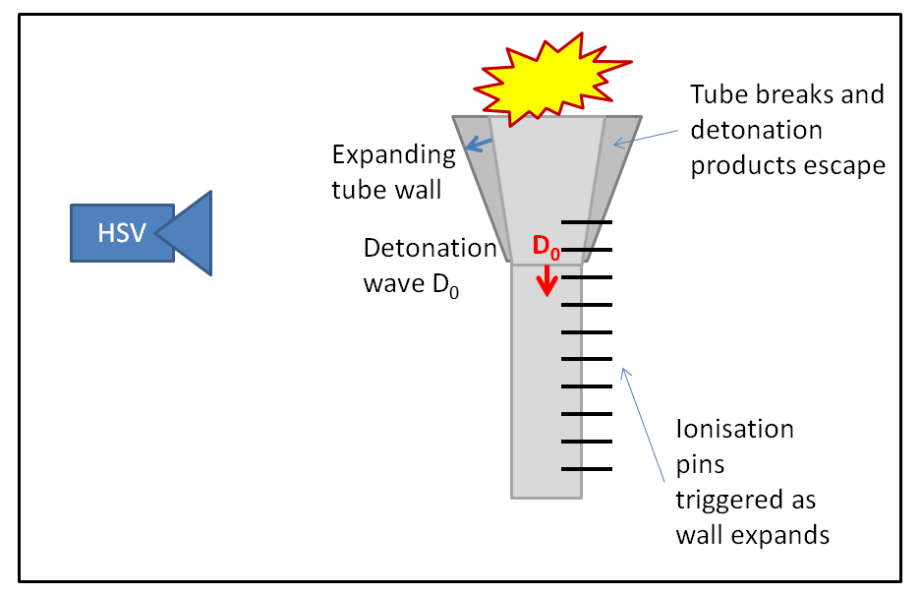
Figure 2 Cylex Test Set Up
The copper tube is filled with approximately 200g of the explosives to be tested and is measured using several instrumentation techniques. Heterodyne velocimetry (het-V) is used to measure the wall expansion. Two probes are placed on opposite sides of the tube about 150mm and 200mm from the detonating end of the tube. The ionisation pins measure the velocity of detonation and are spaced evenly between 100mm and 250mm from the detonating end of the tube and1mm from the surface of the tube. High speed cameras can also be used to derive the VoD and wall expansion, but at a lower precision. The tube sits upon a Perspex block which contains a manganin stress and a train gauge.

Disc Acceleration Tests
Lorenz, Lee and Chambers at Lawrence Livermore National Laboratories (LLNL), USA, developed a new test [1], the Disc Acceleration Experiment (DAX) to find the VoD and P_{CJ} of an explosive which was significantly cheaper per experiment than the Cylex test but with equally precise and accurate data.
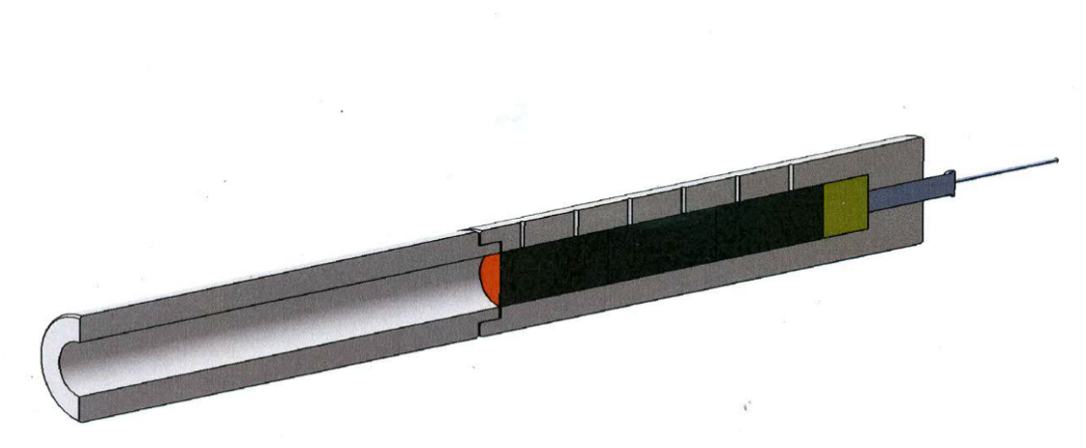
RP80 EBW Detonator
Optional HE Booster
Test charge
Piezoelectric timing pins
Witness foil/disc
HetV Probe
Figure 3 DAX Experimental Set-Up
The DAX test uses a PMMA tube to contain approximately 20g of explosive material, with 6 piezoelectric pins down the side, 12.5mm apart, for calculating the VoD and a copper metal flyer plate on the end whose velocity is measured using het-v to calculate the P_{CJ} A simple set up can be seen in Figure 3.
Lorenz’s paper [1] outlines the dimensions of the tube, the specifications for the metal flyer plate and the instrumentation to be used in the DAX.
“These witness discs are either 425 μm thick aluminum (1100 series alloy) or 250 μm thick copper (CDA 110, soft). The acrylic (PMMA) sleeve that surrounds the explosive pellets holds the PDV probe on the geometric axis at a position 10 cm from the thin metal witness disc. These tubes are precision machined from rod stock,”

4.2 Data Collection
A minimum of three sets of results of each experiment will be needed to be collected before data analysis can be undertaken to compare the two tests.
Both tests utilise heterodyne velocimetry (het-v), an instrumentation technique developed in the early 2000’s [10] which directly measures the velocity of a reflective surface. It uses telecommunication technology and is based upon the 1550nm wavelength for the laser.
A laser light is shone at a reflective surface and mixed with a reference laser, creating an interference pattern. In generation zero and one systems, the reference and source laser are the same and split using an optical splitter. If the surface is moving, this affects the frequency of the reflected laser light and this frequency shift (f) can be directly related to the velocity (v) of the moving surface using the formula below.
$$v=\frac{λ_{0}}{2}f$$
Equation 2 Apparent velocity of a moving object measured using het-v
The voltage output of the photodetector is recorded using a high sample rate, high bandwidth oscilloscope.
The piezo and electric pins and strain/stress gauges produce voltage outputs which are recorded by a high sample rate analogue to digital data recorder; Genesis 7t, at 100MS/s.
High speed cameras are used as a back-up method of capturing the wall expansion in the Cylex test and velocity of detonation in both experiments. Phantom v2512 high speed cameras with a resolution of 128x16 pixels at a sample rate of 1Mfps will be used alongside a SIM16 framing camera at a sample rate of 2Mfps.

4.3 Data Evaluation
In 2018 Chaos [7] submitted a paper that described a way to calculate the CJ Pressure from the “coast” velocity of the DAX plate after the initial acceleration using Equation 3.
$$P_{CJ}=\frac{ρ_{0}D^{2}}{γ+1}$$
Equation 3 Equation for calculating CJ Pressure using Chaos' Effective Mass Method [8]
Where PCJ is the Chapman Jouguet Pressure, Po is the initial density of the explosive, D is the VoD and γ is a factor based on the ratio of container density to explosives density which can be calculated separately.
The Lorenz method, uses the angle of the initial plate push to calculate het-v and so this early part of the trace where large accelerations are occurring need to be captured. The Chaos method requires the coast section of the het-v trace which occurs over a longer time span, with near zero acceleration and is therefore easier to capture with het-v and high speed imagery.
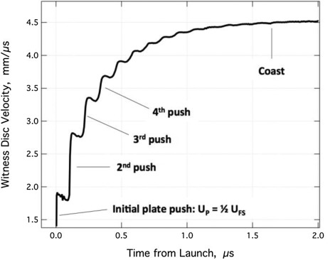
Figure 4 Heterodyne Velocimetry Trace for DAX
The pins time of activation and their displacement from the initial pin will be plotted on a scattergraph to determine the velocity of detonation. The manganin gauge in the Cylex test should provide the CJ pressure, but as a back-up the following equation from the Book Explosives Engineering by Cooper [11] can be used.
$$P_{CJ}=ρ_{0}D^{2}(1-0.7125{ρ_{0}}^{0.04})$$
Equation 4 Equation for calculation of CJ pressure in a Cylex test [11]
Once CJ pressures and velocities of detonation have been found for multiple runs of each experiment, they can be compared using the Unpaired T-test and box plots to confirm if they are statistically significantly different. If so, then the DAX test is not a suitable replacement for the Cylex test.

4.4 Risks & Limitations

Risks
- Risk to investigators/personnel in the conduction of experiments
- Risk to reputation of individuals and institutions if incorrect/unsubstantiated findings are published
- Risk to environment of contamination of energetic materials
- Risk of sensitive data being accidentally released to the public.

Limitations
- Tests only to be run with one energetic material
- Limited number of repeats of each test due to time and cost

4.5 Ethical Issues
- Study of energetic materials has ethical concerns when used for defence/military applications
- No study participants will be used
- No personal data will be collected.

6. Resources & Planning
Range slots for the undertaking of energetic experiments are booked months in advance and usually cannot be changed. Paperwork must be completed in time for reviews and sign-off in advance of the experiment to allow permits to be produced for the work and so advanced planning is essential to ensure no time on the range is wasted.

6.1 Resources Required
These Experiments will require the following resources.

6.1.1 Physical Resources
- A secure test site with suitable facilities will be required including:
  - Concrete pad upon which work can be performed
  - Secure room for storage of instrumentation equipment
  - Secure day locker for the energetic materials,
  - Welfare facilities for the staff (toilets, kettle, fridge, heated room, etc),
  - Suitable power for the running of recording equipment,
  - Secure control room protected from fragmentation.
- Energetic material
- High voltage detonators
- C101 copper tubes (length 300mm, diameter 25mm, wall thickness 2.5mm)
- Perspex tubes as per design
- Instrumentation Equipment:
  - Ionisation pins
  - Piezoelectric pins
  - 1550nm collimators
  - Phantom v2512 high speed cameras
  - SIM16D framing camera
  - Agilent 33GHz oscilloscope
  - Heterodyne Velocimetry laser system
  - Genesis 7t Data Acquisition system
  - Dynasen pin mixer
- Encrypted laptops
- Encrypted USB hard drive
- Range table to hold tubes

6.1.2 Human Resources
- A Trials Conducting office (TCO) licenced for energetics work
- A Range safety link
- A Trials Manager (TM) licenced for energetics work
- Two Instrumentation Engineers to capture data
- SHEF representative to review and approve paperwork
- Group Leader to review and approve paperwork
- Lead Technical Reviewer to review and approve paperwork

6.1.3 Other Resources
- Software
  - Perception
  - Famos
  - MatLab
  - Phantom Camera Control
  - SIM Control
- Modelling Hydrocodes
  - CHEETAH

6.2 Gantt Chart

7. References

[1] | L. C. R. Lorenz, “A Simple & Rapid Evaluation of Explsoive Performance - The Disc Acceleration eXperiment,” Propellant, Explosives, Pyrotechnics, vol. 40, no. 1, pp. 96-108, 11 Septmeber 2015.
[2] | Wikipedia, “TNT,” Wikipedia, 7 January 2020. [Online]. Available: https://en.wikipedia.org/wiki/TNT. [Accessed January 2020].
[3] | Ribbands Explosives, C4 Plastic Explosive, Ribbands Explosives, 2020.
[4] | M. C. Chick and L. A. Learmonth, “Determination of shock initiation and detoantion characteristics of PE4 in proof test geometries,” Department of Defence, Melbourne, 1985.
[5] | Wikipedia, “RDX,” Wikipedia, 5 November 2019. [Online]. Available: https://en.wikipedia.org/wiki/RDX. [Accessed January 2020].
[6] | R. Catanach, L. Hill, H. Harry, E. Aragon and D. Murk, “Cylinder Test Specification, Loas Alamos National Laboratory Technical Report LA13643-MS,” Los Alamos National Laboratory, New Mexico, 1999.
[7] | M. Chaos, E. L. Lee and K. T. Lorenz, “Experimental Determination of Chapman-Jouguet Pressure using Disc Acceleration eXperiment (DAX) Data,” in 16th International Detonation Symposium, Cambridge, maryland, 2018.
[8] | W. Maines, D. Kittell and M. Hobbs, “Combined Mini-Cylex & Disc Acceleration Tests in Type K Copper,” Propellants, Explsoives, Pyrotechnics, vol. 43, no. 5, 2018.
[9] | C. Lindsay, G. Butler, C. Rumchik, B. Schulze, R. Gustafson and W. Maines, “Increasing the Utility of the Copper Cylinder Expansion Test,” Propellants Explsoives Pyrotechnics, vol. 25, no. 5, pp. 433-439, 2010.
[10] | O. Strand, D. Goosman, C. Martinez and T. Whitworth, “Compact System for high-speed velocimetry using heterodyne techniques,” Review of Scientific Instruments, vol. 77, no. 8, 206.
[11] | P. W. Cooper, Explosives Engineering, New York: Wiley-VCH, 1996.

