Build and Deploy a Type 2 Hypervisor platform based Virtualised Network
Network OPERATING SYSTEMS AND SERVICES
Peter Siow (2104217)

Introduction 2
Type 1 Hypervisor 2
Type 2 Hypervisor 2
Features of Type 1 Hypervisor 2
Features of Type 2 Hypervisor 2
Advantages of a Type 1 Hypervisor 3
Advantages of a Type 2 Hypervisor 3
Different types of hypervisors on the market 3
Hypervisor of Choice – VMWare Station 3
IP Addressing 4
IPv4 4
IPv6 4
Subnetting 4

Introduction
I have been hired as an IT professional by a company called NOSS which are a multinational corporation. The company operates in two different locations which are Swansea and London. Based on the topology which has been assigned I have to build, deploy, configure and manage a virtualised network.
A hypervisor is known as a VMM, and this is a software which allows a user to create and run a virtual machine. The purpose of a hypervisor is to allow a host machine to support several guests VM by allow them all to have access to its resources such as memory.

Type 1 Hypervisor
A type 1 Hypervisor is also known as a bare-metal hypervisor and this hypervisor is a layer of software installed directly on top of the physical server and the underlying hardware. A type 1 hypervisor is focuses on performance and stability since the operating system used for type hypervisors are focused to solely run virtual machines. A disadvantage of the type 1 hypervisor is that they’re usually used in enterprise environments meaning they’re impractical for users working outside of an enterprise or have the purpose using a type 1 hypervisor for educational purposes.

Type 2 Hypervisor
A type 2 hypervisor runs on the physical host machine’s operating system. The difference between a type 1 and type 2 hypervisor is that the type 2 hypervisor has one software layer in between. Type 2 hypervisors are usually used in environments which serve a small number of servers. An advantage of a type 2 hypervisor is that they’re very convenient and this is because they don't need a management console to setup and manage virtual machines.

Features of Type 1 Hypervisor
High Performance - A feature which a type 1 hypervisor has is that the performance is severely better than a type 2 hypervisor. This is due because a type 1 hypervisor is directly run on the hardware of that system unlike a type 2 hypervisor which is run from an additional operating system. [1]
Bare-Metal – This feature can handle many virtual machines running at the same time and due to the operating system used for type 1 hypervisors is dedicated for the use of virtual machines and like again has better performance than a type 2 hypervisor
Deployment Flexibility – A type 1 hypervisor has many different environments which they can deploy in as usually enterprise data centres, cloud infrastructures and IoT devices use type 1 hypervisors as the focus of type 1 hypervisors are to have high performance and security.

Features of Type 2 Hypervisor
Resource Sharing – Due to a type 2 hypervisor being used on an existing operating system it allows the uses resources from the original machine, for example the type 2 hypervisor can use cores from CPU, memory and storage from the machine for the virtual machine. [4]
Ease of management – A feature of ease of management and this creates a user-friendly environment due to the interface this makes creating, configuring and managing virtual machines simply and easier due to the simplicity of the interface. [3]
Desktop Virtualization – As a type 2 hypervisor is used on a host operating this allows users to create multiple virtual machines and run them at the same time and due to this it creates a testing environment for them.

Advantages of a Type 1 Hypervisor
Security – The security in type 1 hypervisor is extremely strong due to the architectural design as the type 1 hypervisor runs directly on the hardware on the host system and it doesn’t interfere with the operating system as well each virtual machine which is created all of the virtual machines operate in their own isolated environment which restricts access to resources and do not have communication with any other virtual machines or the kernel in the hypervisor. As well as type 1 hypervisors usually offer security features which are far more advanced than a type 2 hypervisor, examples of the features are secure boot mechanisms and hypervisor-level encryption. [6]
Scalability – A type 1 hypervisor can provide immense support up to large numbers of virtual machines across many physicals' hosts, which also provides control and centralised management and due to large numbers it can support it ensures that virtualised workloads are still accessible and responsive if any problems occur which can either be hardware failures or even when maintenance is happening. [2]
Optimised resource utilization – As a type 1 hypervisor uses the hardware resources more efficiently than a type 2 hypervisor this is due to a type 1 hypervisor being able to have direct control of the existing hardware of a system without another layer interfering like a type 2 hypervisor relies on the host of the operating system.

Advantages of a Type 2 Hypervisor
Ease of Installation – The installation setup for a type 2 hypervisor is far easier to install and configure than a type 1 hypervisor due to the interface for a type 2 being user friendly and a type 1 hypervisor to solely run on an existing operating system. [5]
Platform independence – Type 2 hypervisors can run different types of operating systems such as Windows, MacOS and Linux etc. This provides a user flexibility of which type of operating system they’d want to choose to use, and this can also provide a user training or practice with other operating systems, and it does display that type 2 hypervisors are compatible due to being able to access certain applications on the virtual machines which would not be available on the host operating system. [8]
Cost efficient – A type 2 hypervisor are significantly cheaper than a type 1 hypervisor, as one of the reasons for this is because a type 2 hypervisor runs on top of existing operating system which means that the hypervisor is available without needing to purchase specialised hardware and a user is able to run multiple of virtual machines without the need of additional hardware
Security – Security for a type 2 hypervisor is dependent on the host and the security measures which were put in place as if the host of the operating system doesn’t update their operating system regularly it be a vulnerability to the host and then if the attacker has achieved to infiltrate they’re able to gain access to the virtual machines which have been created by the host. [14]

Different types of hypervisors on the market
There are many hypervisors which serve their own purpose and benefits depending on the reason for using a hypervisor. The hypervisor’s which I have mentioned already type 1 and type 2, but there are many other hypervisors that are available such as Nested hypervisor, Cloud hypervisor and Container hypervisor

Hypervisor of Choice – VMWare Station
The Hypervisor which I will be using for this assignment is the type 2 hypervisor because stated in the scenario it was addressed that it was a virtualised network and according to the topology there would need to be 2 server and 2 client PC’s which I would need to run simultaneously which a type 2 hypervisor provides. Also another reason why I will be using a type 2 hypervisor is because I am creating the topology there is a lot of room for mistakes, so a lot of testing will be required to ensure the network is running properly and a type 2 hypervisor allows a user to create, configure and test quickly if the network is working, additionally the feature of snapshotting on a type 2 allows a user to lookback on parts which either went wrong or even document the process for the network. The hypervisor software which I will be using is VMWare Station for deploying the network

IP Addressing
The process of data getting retrieved to a computer on the internet is also known as packet switching and this process occurs when data is being transferred over the internet and then which is broken into smaller pieces which is called packets, the packets are responsible for holding the data being transmitted, but packets are also responsible for holding information such as destination IP addresses and other details related. The whole process in order goes from packetization, routing, transmission and then finally reassembly which resolve all the packets sent into the original data which was sent from the host. [9]
Routers and switches have important roles when it comes to the flow of the data between different networks. Firstly, routers have the purpose of forwarding packets to different networks based upon the IP address of the destination. The routers also find the most optimal path for each packet to travel, and it depends on the factors of the topology of the network, traffic load and the link quality etc. The routers can do this as they use routing tables and algorithms to achieve the result. [10]
Switches have the purpose of forwarding packets within the same network but is dependent on the destination of the MAC address, as for this the switches are operated at the data link which is layer 2 in the OSI model. The switches also utilise MAC address tables to affiliate mac addresses to the specific ports which only send packets to the port which the device is connected to depending on the destination where the data is getting sent to. [10]

IPv4
The structure of IPv4 is that the addresses which are set they all consist of 32 bits which are then split into four octets. From there every octet is represented in a decimal format, an example of an IPv4 address would be 192.168.1.10. [11]
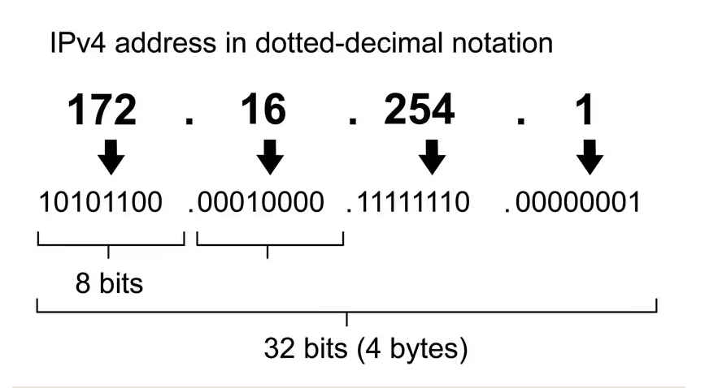

IPv6
The structure of IPv6 addresses also holds bits like IPv4 but the difference is that IPv6 addresses are 128bits long and are represented in a hexadecimal format. The 128-bit addresses get split into 8 groups which each group contains 16 bits consisting of 4 hexadecimal numbers and colons to separate from each other. An example of an IPv6 address would be 2001:0db8:3c4d:0015:0000:0000:8a2e:0370:7334 [15]
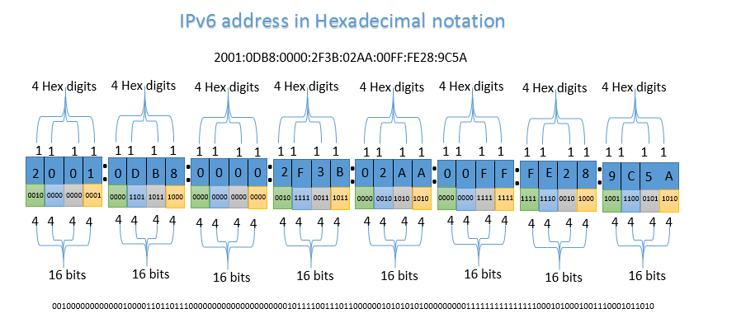
[12]

Subnetting
The purpose of subnetting for IP addresses to be utilised efficiently and improve the performance, management and security of a network it is important as subnetting allows large networks to be split into smaller subnetworks which are then called subnets. [16]

Testing
A testing technique which can be used to test connectivity is by using the command line interface and using the command “ping” and follow up with an IP address, as this allows a user to test if a reply is available or if the destination is unreachable and using this technique can either tell you if the connection works or not.
To test the bandwidth a user can go online and find any speed test and when a user runs a speed test, and running these speed tests also provide details about their network including bandwidth. Another technique which can be used to test the bandwidth is throughput testing and this is when a certain amount of data is being transferred between two points on the network and then is measured to record how much time it takes to complete the transfer of the data.
To test if packets are lost when being sent you can do this by going into the command line interface and using the command “ping -t” and this command will allow a user to monitor the packet loss over time, if the packet loss is happening consistently this can indicate a congestion within the network or even issues with the hardware. [13]
To test if the security on a network is secure a user is able to do a technique called port scanning, as there are many tools available which are capable of port scanning such as using the command “nmap” and basically this command views ports which are open and this technique is majorly useful for a security as it reviews the potential vulnerabilities which are known in the network.
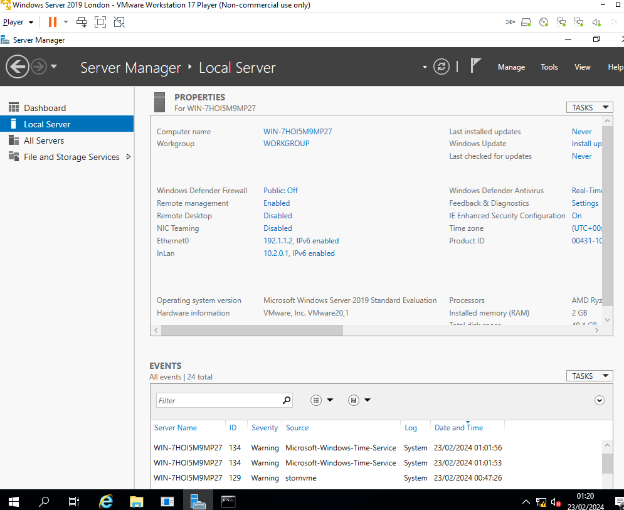
The IP addresses which I configured for the London server which contain configured IP addresses and suitable subnet masks

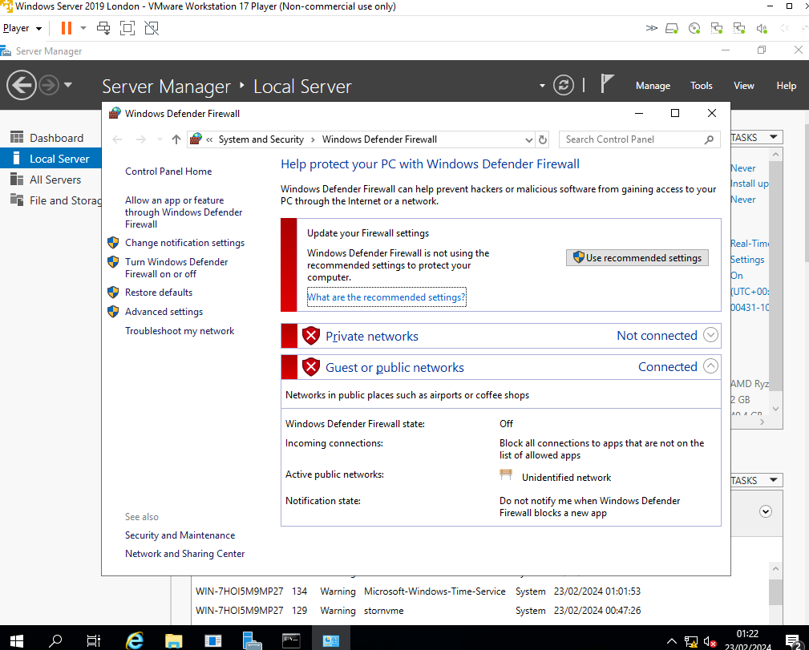
This screenshot shows the firewalls turned off as it ensures that the server can connect to the PC’s as one problem faced when testing connectivity was that the firewall was preventing me to ping the devices together.
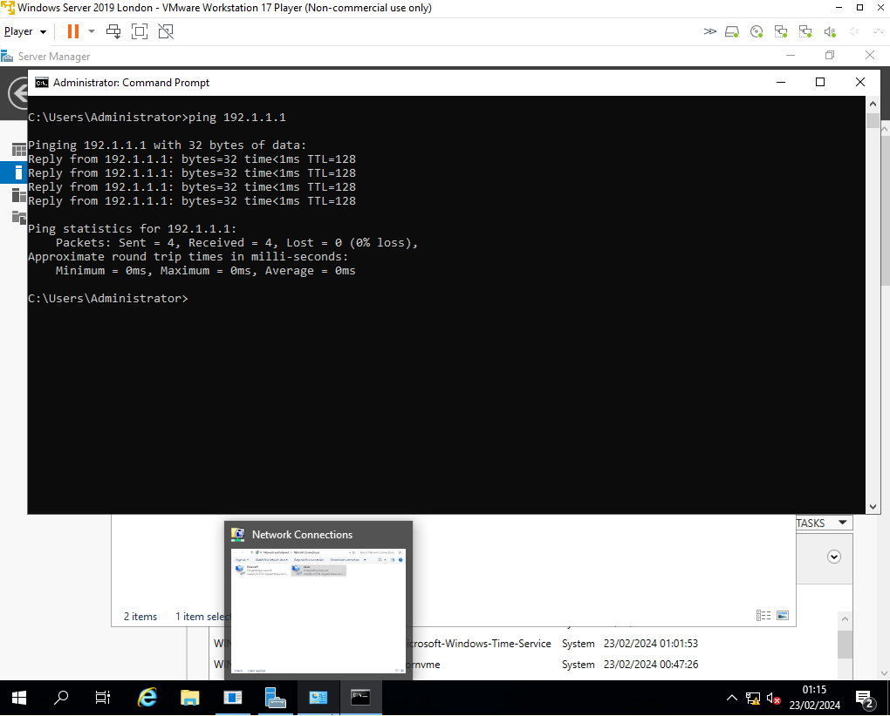
This screenshot shows that the London server can ping to the Swansea Server and receives replies from Swansea
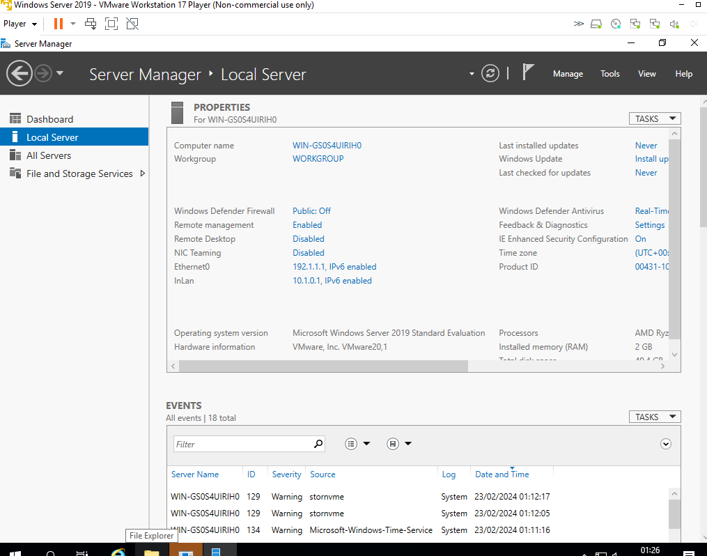This the Swansea Server which the IP addresses and subnets masks have been configured to ensure connectivity to the PC’s and servers.

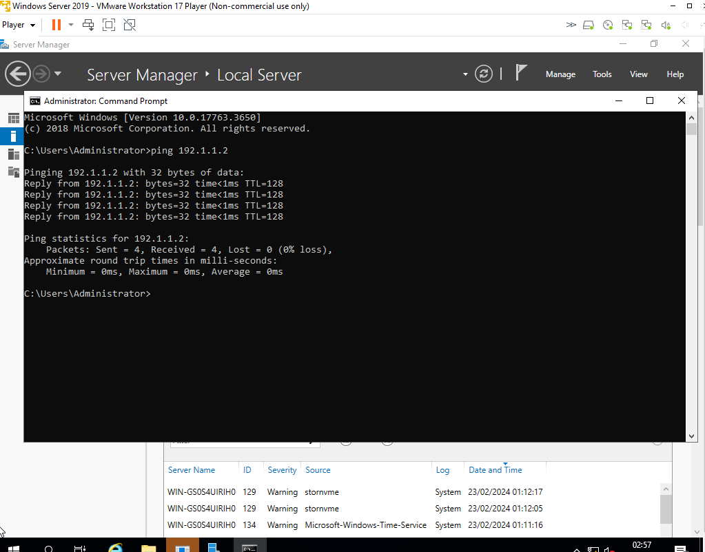This screenshot shows that the Swansea server can ping to the London server meaning London can ping to Swansea and Swansea can ping to the London server.

Conclusion
Overall, with this report I have learnt how to build and deploy a Type 2 Hypervisor platform, as well troubleshooting problems which I’ve faced when configuring the IP addresses and subnet masks. I have now gained more knowledge about this and feel more confident in moving forward. Also, now a deeper knowledge on Type 1 and Type 2 hypervisors.

References

[1] Microsoft. Hyper-V Architecture. (2022) https://learn.microsoft.com/en-us/virtualization/hyper-v-on-windows/reference/hyper-v-architecture
[2] A Performance Comparison of Hypervisors, 2022 https://www.vmware.com/pdf/hypervisor_performance.pdf
[3] What is a Hypervisor and What are its benefits? Vissarion Yfantis. April 2020 https://www.parallels.com/blogs/ras/hypervisor/

[4] What is a Hypervisor? April 2020. https://www.vmware.com/topics/glossary/content/hypervisor.html
[5] Type 1 Hypervisor vs Type 2: What is the difference? Crystal. March 2023 https://www.ubackup.com/enterprise-backup/type-1-hypervisor-vs-type-2.html
[6] National Institute of Standards and Technology (NIST). (2017). Guide to Security for Full Virtualization Technologies. https://csrc.nist.gov/publications/detail/sp/800-125B/final
[7] Red Hat. (2022). Scaling with Red Hat Virtualization. https://www.redhat.com/en/resources/scaling-red-hat-virtualization
[8] The Difference between Type 1 and Type 2 Hypervisors, August 2020 https://aws.amazon.com/compare/the-difference-between-type-1-and-type-2-hypervisors/
[9] Introduction of Classful IP addressing. October 2022. https://www.geeksforgeeks.org/introduction-of-classful-ip-addressing/
[10] How data flows through the internet. Sudan. April 2022 https://ssudan16.medium.com/how-data-flows-through-the-internet-91790a4d9092
[11] https://computer.howstuffworks.com/internet/basics/what-is-an-ip-address.htm
[12] https://www.computernetworkingnotes.com/networking-tutorials/ipv6-address-types-notation-and-structure-explained.html
[13]Requirements for Internet Hosts – Communication Layers. R Braiden. October 1989 https://www.rfc-editor.org/rfc/rfc1122.html
[14] Reference: Stallings, W. (2017). Network security essentials: Applications and standards. Pearson.
[15] IP Verison 6 Addressing Archictechture. Dr Steve E. Deering, Bob Hinden. 02, 2006 https://datatracker.ietf.org/doc/rfc4291/

