

MARKETING ENVIRONMENT ANALYSIS
Rio Tinto and the lower-carbon transition
Programme: | Master of Business Administration
Module: | Marketing Management (LCMB7024)
Assessment | Assessment Component 1: Marketing Environment Analysis
Student | Tchewebe Alain Hoola
Student ID | 2520485
Lecturer | Taonga Kaonga Sobere-Snithers
Submission date | 22 October 2026
Final word count | 2,723 words

Table of Contents
MARKETING ENVIRONMENT ANALYSIS 1
List of Abbreviations 3
1 Introduction 4
2 Task 1 Marketing Environment Analysis 4
2.1 Environmental Actor 4
2.2 Political Actor 6
2.3 Technological Actor 7
2.4 Customer Behaviour, Brand and Competitor Implications 7
2.5 Porter’s Five Forces and Competitive Pressure 8
3 Task 2 Strategic Growth and Competitive Positioning 8
3.1 Ansoff Matrix Applied to Rio Tinto 8
3.2 Recommended Growth Approach 9
3.3 Competitive Positioning and Implementation 10
4 Task 3 Managerial and Professional Reflection 11
5 Conclusion 13
6 Reference List 13
7 Appendices 15
Appendix A Evidence and decision summary 15
Appendix B Submission checks 15

List of Abbreviations
Abbreviation | Meaning
AI | Artificial intelligence
BHP | BHP Group, a global resources company
CBAM | Carbon Border Adjustment Mechanism
CO₂e | Carbon dioxide equivalent
IEA | International Energy Agency
IPCC | Intergovernmental Panel on Climate Change
LCMB7024 | Marketing Management module code
MBA | Master of Business Administration
Mt | Million tonnes
MW | Megawatt
MWh | Megawatt-hour
OECD | Organisation for Economic Co-operation and Development
PESTLE | Political, economic, social, technological, legal and environmental analysis
SWOT | Strengths, weaknesses, opportunities and threats analysis
UNEP | United Nations Environment Programme
UWTSD | University of Wales Trinity Saint David

1 Introduction
Rio Tinto’s iron ore, aluminium, copper and lithium businesses operate in a marketing environment increasingly shaped by climate policy, environmental expectations, technology and industrial-customer requirements. Because external forces affect its ability to build customer relationships, the company must monitor and adapt to them (Kotler et al., 2020).
This report analyses three connected forces in Rio Tinto’s lower-carbon transition: environmental, political and technological. Environmental pressures receive greatest attention because they affect both mining’s legitimacy and demand for transition-critical materials. PESTLE and SWOT analysis, customer buying behaviour, branding, competitor analysis, Porter’s Five Forces and the Ansoff Matrix inform a recommendation for product development with selective market development.
The scale of the challenge is clear. Rio Tinto reports 2025 adjusted gross Scope 1 and 2 emissions of 31.5 Mt CO₂e, 14% below its 2018 baseline, while Scope 3 emissions were 575.7 Mt CO₂e (Rio Tinto, 2026a). Scope 3 is therefore around eighteen times larger than operational Scope 1 and 2 emissions. Rio Tinto’s lower-carbon transition is not only an operational matter: it is also a customer-value, brand-trust and market-positioning issue.
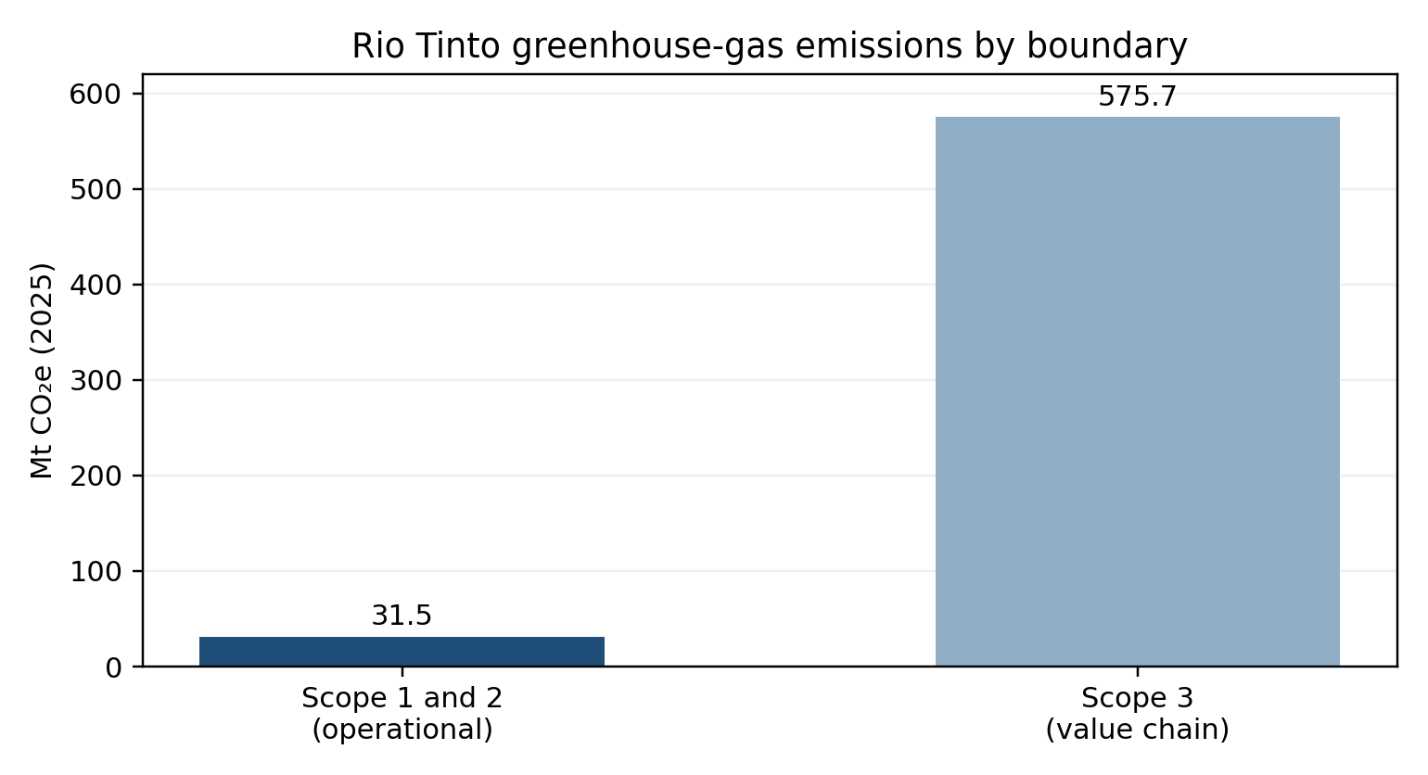
Figure 1: Rio Tinto greenhouse-gas emissions by boundary, 2025 (Mt CO₂e). Source: Rio Tinto (2026a).

2 Task 1 Marketing Environment Analysis

2.1 Environmental Actor
Environmental forces shape resource access, emissions, biodiversity and water impacts (Kotler et al., 2020). The central tension is that the energy transition needs more minerals, while extraction can intensify climate and community pressures. Growth is an opportunity only when supply is responsible and credible.
Demand for electrification minerals, particularly copper, is expected to grow (IEA, 2024). Rio Tinto’s portfolio offers exposure, but responsible growth is essential. Its 2030 target is a 50% Scope 1 and 2 reduction from 2018, with operational net zero by 2050 (Rio Tinto, 2026b). These targets do not address the much larger emissions from customers processing iron ore, bauxite and alumina.
Most of Rio Tinto’s Scope 3 emissions arise when customers process iron ore and bauxite/alumina (Rio Tinto, 2026a). Customer partnerships, product-level carbon data and process innovation can influence these emissions. Customers are therefore partners whose targets can shape specifications, supplier choice and contracts.
Higher-grade iron ore can support lower-emissions steelmaking when paired with suitable downstream technology; Rio Tinto’s first Simandou shipment left Guinea in December 2025 (Rio Tinto, 2025a). Copper and aluminium also serve electrification and renewable infrastructure (IEA, 2024). However, growth can increase land, water, waste and social pressures, so climate gains must be assessed alongside wider impacts (Negrete et al., 2024).
“Lower carbon” is a value proposition only when comparable measurement and credible boundaries show a meaningful difference customers value. Environmental due diligence affects trust among customers, investors, regulators and communities (OECD, 2023). It raises operating costs but can reward suppliers that substantiate lower-impact performance.
Table 1: Environmental actor diagnosis using a marketing SWOT lens.
Environmental pressure | Opportunity for Rio Tinto | Threat or constraint | Marketing implication
Demand for copper, lithium and aluminium in electrification | Grow transition-linked commodities and partnerships | Demand growth can increase ecological and social impacts | Make responsible supply part of the customer proposition
Large downstream emissions from customer processing | Co-develop lower-carbon value chains | Rio Tinto cannot control all Scope 3 emissions | Sell evidence, collaboration and transparency rather than a simple “green” claim
Climate and biodiversity scrutiny | Differentiate through verified performance | Greenwashing concerns and community opposition | Use independent assurance, clear claims and stakeholder engagement
Resource scarcity and energy volatility | Invest in efficient and renewable-powered operations | High capital cost and technology uncertainty | Stage investment and link projects to measurable customer value
Source: Author’s analysis, based on IEA (2024), OECD (2023), Rio Tinto (2026a) and UNEP (2024).
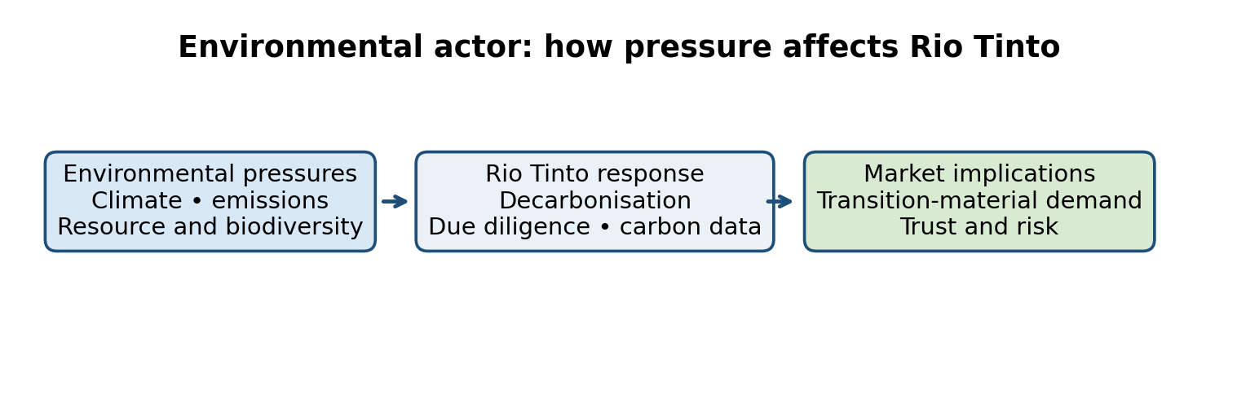
Figure 2: Environmental actor: how pressure affects Rio Tinto. Source: Author’s diagram based on IEA (2024), OECD (2023), Rio Tinto (2026a) and UNEP (2024).

2.2 Political Actor
Political forces shape Rio Tinto through regulation, trade policy, permits, energy policy and political stability (Kotler et al., 2020). Because Rio Tinto operates in several countries, changes in government policy can affect project costs, approvals and customer requirements.
The European Union Carbon Border Adjustment Mechanism (CBAM) illustrates the direction of travel. Its definitive regime applies from 1 January 2026 and includes iron and steel and aluminium among the covered sectors (European Commission, 2026). CBAM increases the importance of reliable embedded-emissions information across traded value chains. For Rio Tinto, this creates a potential advantage for transparent carbon data, but it also creates reporting, verification and customer-support costs. This may reward suppliers able to document embedded emissions, but the administrative burden falls across producers and importers and can disadvantage smaller suppliers. It is not a guarantee of premium pricing: buyers may choose compliant supply on cost, and CBAM covers only specified goods. The policy thus creates a market signal while leaving demand and margin uncertain.
Political risk also affects Rio Tinto’s social licence to operate. Major projects require government approval, infrastructure agreements and constructive relationships with communities and public-interest groups. Environmental due diligence and sound resource governance support sustainable mining (OECD, 2023; Jin, 2023). Rio Tinto should therefore treat governments and publics as active stakeholders. Its corporate brand must be supported by responsible operations, transparent reporting and local engagement.
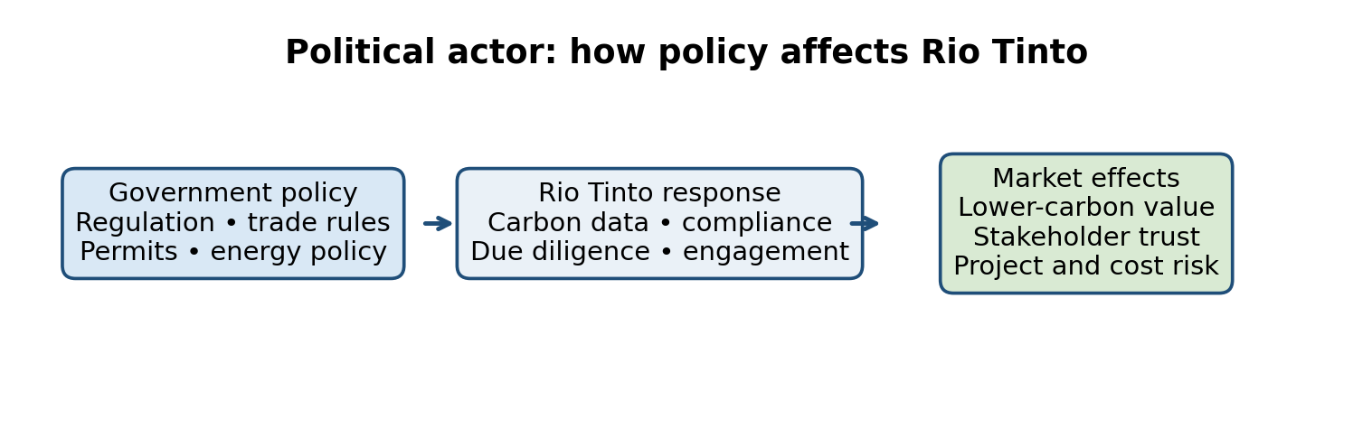
Figure 3: Political actor: how policy affects Rio Tinto. Source: Author-created diagram based on Kotler et al. (2020), European Commission (2026), OECD (2023) and Jin (2023).

2.3 Technological Actor
Technology affects Rio Tinto’s costs, productivity and ability to offer lower-carbon products. Automation, data, electrification, renewable power and process innovation can change how mining companies compete (Kotler et al., 2020).
In 2025, Rio Tinto agreed to buy 90% of the power and storage from two planned solar and battery projects for its Gladstone operations. The projects are expected to provide 600 MW of solar power and 600 MW/2,400 MWh of battery storage for 20 years (Rio Tinto, 2025b). This could improve energy security and support lower-carbon aluminium, although it depends on partners, infrastructure and long-term contracts.
Technology also involves risk. Its value depends on cost, maturity, reliability and scale. Research links innovation with better mining energy efficiency, but results depend on the organisation’s capabilities (Ma et al., 2024). Rio Tinto should therefore link technology to clear customer benefits, such as reliable supply, lower emissions and improved regulatory readiness, rather than treating new technology as valuable by itself. Benefits may accrue to customers through cleaner inputs and to Rio Tinto through energy security, while capital and reliability risks remain with the producer and its partners. If storage costs, grid constraints or process performance disappoint, the projected carbon benefit and the customer proposition weaken together.
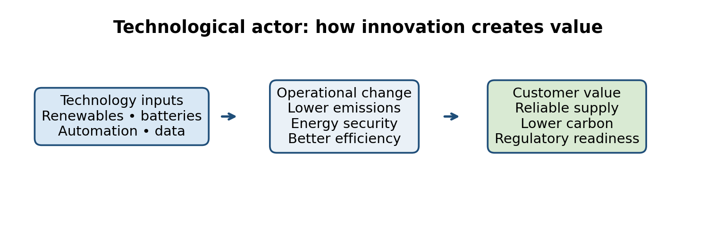
Figure 4: Technological actor: how innovation creates value. Source: Author’s own image based on Rio Tinto (2025b) and Ma et al. (2024).

2.4 Customer Behaviour, Brand and Competitor Implications
Industrial customers still move through a buying process: need recognition, information search, evaluation of alternatives, purchase decision and post-purchase behaviour (Kotler, Keller and Chernev, 2021). The process is likely to be high-involvement because metals contracts affect cost, quality, supply continuity and regulatory exposure. Customer evaluation can be represented as a weighted-attribute decision: price, quality, reliability, carbon intensity, traceability and technical support each receive an importance weight, and suppliers are compared against those criteria. This helps explain why a lower-carbon claim alone will not win business if delivery performance or price is unacceptable.
Branding matters because the Rio Tinto name is an intangible asset that must be created, maintained and protected over time (Kotler et al., 2020). The relevant positioning should operate at three levels: product attributes such as grade and verified carbon data; benefits such as efficiency, compliance and supply confidence; and beliefs and values such as responsible production (Kotler et al., 2020). A corporate brand can differentiate Rio Tinto from direct competitors, reinforce reputation and support customer loyalty, but only if internal training, customer experience, brand audits and public reporting are aligned with the promise.
Competitor analysis should distinguish direct competitors, indirect alternatives and sources of advantage (Kotler et al., 2020). BHP is trialling hydrogen-based ironmaking with POSCO using Pilbara ore, while Vale is developing briquettes and customer partnerships to decarbonise steelmaking; Fortescue is pursuing green iron and argues that standards, low-cost renewables and procurement demand are needed to scale it (BHP, 2025; Vale, n.d.; Fortescue, n.d.). These initiatives show that lower-carbon offers are becoming a competitive arena rather than a unique Rio Tinto claim. Recycling and substitution add indirect pressure. Rio Tinto must combine ore quality, delivery, credible measurement and customer co-development in ways competitors cannot easily match. Customers may benefit from lower process emissions and compliance readiness; Rio Tinto bears investment and execution risk, while communities may bear local environmental costs if expansion is poorly governed.

2.5 Porter’s Five Forces and Competitive Pressure
Porter’s Five Forces shows how competition affects Rio Tinto’s profitability (Porter, 2008). Rio Tinto faces strong rivalry from BHP and Vale, while high costs and permit requirements limit new entrants (Rio Tinto, 2026a; OECD, 2023). Large customers can negotiate on price and emissions data, and recycled metals can reduce demand for mined materials (IEA, 2024). Rio Tinto should protect its position through reliable supply, quality and verified emissions information.

3 Task 2 Strategic Growth and Competitive Positioning

3.1 Ansoff Matrix Applied to Rio Tinto
The Ansoff Matrix compares products and markets to identify four growth routes: market penetration, market development, product development and diversification (Ansoff, 1957). It is useful here because the lower-carbon transition is not simply a technology programme; it is a question of what Rio Tinto offers, to whom, and with what level of risk.

Table 2: Ansoff Matrix applied to Rio Tinto.
 | Existing markets | New markets
Existing products | Market penetration: increase share with existing iron ore, aluminium, copper and lithium customers through stronger reliability, traceability and lower-carbon evidence. | Market development: take existing commodities to new geographic or industrial customer segments whose procurement is shaped by the energy transition.
New or differentiated products | Product development: develop lower-carbon product propositions, verified carbon information, customer solutions and co-designed transition contracts around existing commodities. | Diversification: enter unrelated products or markets requiring capabilities substantially outside Rio Tinto’s current mining and metals base.
Source: Adapted from Ansoff (1957) and Hooley et al. (2020).
Market penetration is the lowest-risk route and can protect existing volume, but it does little by itself to reduce customer-processing emissions or create a distinct offer. Market development can reach buyers in clean-infrastructure markets, yet exposes Rio Tinto to unfamiliar regulation, logistics and political conditions. Diversification offers new growth but combines product and market uncertainty and may divert capital from mining capabilities (Hooley et al., 2020). Product development is the strongest fit because it adds customer-valued services and evidence to established commodities, although its advantage remains conditional on adoption and viable margins.

3.2 Recommended Growth Approach
The recommended approach is product development supported by selective market development. Rio Tinto should develop differentiated lower-carbon commodity propositions, backed by product-level carbon data, renewable-energy sourcing, process innovation and customer partnerships. This uses capabilities the company already has while responding to the natural, regulatory and technological pressures identified above. It is more coherent than broad unrelated diversification and more transformative than simply promoting existing products more heavily.
The customer case is promising but uncertain. Around 54% of Rio Tinto’s steel-producing customers by direct iron ore sales volume had public net-zero or carbon-neutral targets in 2025 (Rio Tinto, 2026a), signalling strategic alignment but not a purchase commitment. Buyers may pay for lower-carbon inputs when these help meet regulation, product standards or customer requirements; they may still reject a premium if it cannot be passed downstream. Lower-carbon production will not create a durable advantage unless customers value it enough to accept a possible price premium and longer-term contract conditions. Market evidence also points to the importance of common definitions and procurement rules (Fastmarkets, 2023). Rio Tinto should test both premium and non-premium offers through pilots and compare realised margins, conversion and contract duration before scaling.
Selective market development can follow where customer demand and enabling infrastructure are clear. For example, renewable-powered aluminium in India could connect industrial growth with decarbonisation needs (Rio Tinto, 2025c). The proposal is selective because geographic expansion can expose Rio Tinto to political, energy, logistics and execution risk. The priority should be markets where Rio Tinto can show a real advantage in resource quality, low-carbon power, customer access or regulatory readiness.

3.3 Competitive Positioning and Implementation
Porter’s Generic Strategies identify cost leadership, differentiation, cost focus and differentiation focus (Johnson et al., 2017). Rio Tinto should use focused differentiation for customers with demanding carbon, traceability and supply-security requirements. Cost leadership is an attractive alternative because metals are price-sensitive and scale can defend margins; however, a cost-only position leaves limited room to capture value from verified emissions performance and may invite direct price competition. Differentiation better matches customer needs where carbon evidence reduces regulatory or product risk, and it can build longer-term relationships. Its weakness is that rivals are investing in similar propositions and customers may refuse to pay more. Rio Tinto should therefore retain cost discipline as a condition of differentiation, not assume a green premium.
The proposed differentiation should rest on evidence rather than advertising: verified carbon performance, product quality, reliable delivery, customer co-development and transparent reporting. Corporate branding can reinforce the position by making the company’s values and capabilities consistent across investor, customer, employee and community touchpoints. Co-branding or joint communication with trusted technology and energy partners could add credibility, but it should be used carefully because Rio Tinto remains accountable for the final claim (Kotler et al., 2021).
Implementation should be staged. First, identify customers with explicit carbon-reduction procurement criteria. Second, agree a common product boundary and verification method. Third, run pilots for selected iron ore, aluminium or copper flows. Fourth, compare customer response, cost, emissions reduction and contract retention before scaling. Measures should include verified emissions reduction, pilot conversion, customer retention, delivery reliability, incremental margin, capital employed and progress against the 2030 target. This approach also protects the brand from over-extension: a new “green” label that is not clearly different from the corporate promise could confuse customers and dilute meaning, a recognized brand-development risk (Kotler et al., 2020).
Table 3: Strategic options and decision criteria.
Option | Customer value | Capability fit | Main risk | Decision
Market penetration | Improves retention and share with current customers | High | May not address value-chain emissions | Supporting action
Market development | Accesses new transition-led demand | Medium | Political, infrastructure and execution risk | Selective only
Product development | Creates differentiated, evidence-based offers | High | Customer willingness to pay is uncertain | Recommended core
Diversification | Could create new growth platforms | Low to medium | Highest capital and capability risk | Defer
Source: Author’s analysis based on Ansoff (1957), Hooley et al. (2020), Johnson et al. (2017) and Rio Tinto (2026a).

4 Task 3 Managerial and Professional Reflection
I selected Rio Tinto because its position contains a difficult tension: its products support electrification, while extraction and downstream processing create substantial environmental impacts. I initially viewed lower-carbon production mainly as an environmental issue. The analysis showed me that it is also a customer-value, regulatory and competitive issue. A technically lower-emissions product has limited marketing value unless customers can verify the difference and connect it to their own commercial or compliance needs.
I chose environmental, political and technological actors because they interact: environmental pressure creates the challenge, policy translates some expectations into rules, and technology affects the cost and feasibility of a response. Treating these forces together helped me move beyond listing trends to ask who gains, who carries risk and where Rio Tinto has control. I learned that a product proposition depends not only on the producer’s emissions but also on customer processes, shared measurement boundaries and credible assurance.
I recommend product development supported by selective market development because it builds on Rio Tinto’s resources, customer relationships and decarbonisation investments. I consider it stronger than market penetration, which may preserve volume without changing the value proposition; stronger than broad market development, which adds geographic risk; and safer than diversification, which would demand unfamiliar capabilities and capital. Differentiation is also preferable to pure cost leadership when verified carbon data, quality and supply reliability help customers meet requirements, although cost discipline remains essential. The recommendation is conditional: if customers do not convert pilots into contracts or accept workable terms, Rio Tinto should not scale a premium offer merely to support its brand narrative.
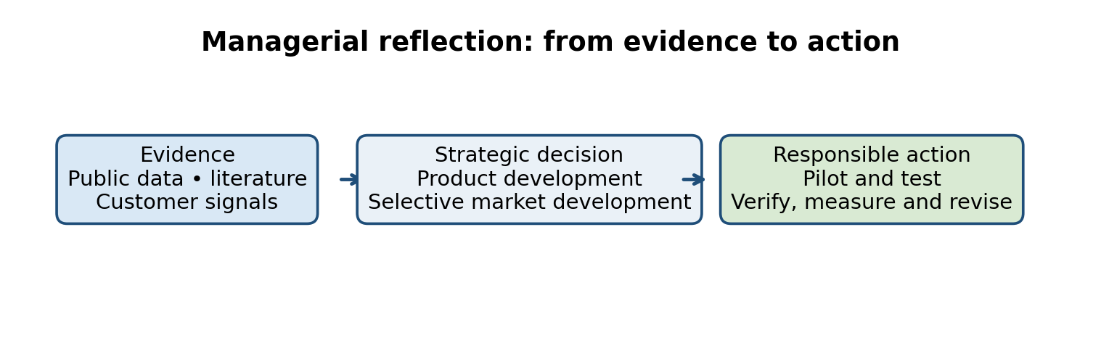
Figure 5: Managerial reflection: from evidence to action. Source: Author-created diagram based on the managerial and professional reflection.
The analysis relies on public information, including company disclosures. Competitors may use different emissions boundaries, and I could not confirm willingness to pay, future carbon prices, technology economics or the full local effects of expansion. With more time and access to data, I would interview procurement teams and affected communities, compare independently verified product footprints, and test customer price and contract responses against project-level costs. I would also stress-test the recommendation against delayed technology, lower demand and stricter regulation. If demand weakened or the technology failed to reach reliable, cost-effective scale, I would prioritise operational efficiency and customer retention, defer capital-intensive product launches and revisit pilots when evidence improved. If regulation or buyer standards accelerated, I would bring forward verified product data and partnerships, while still using stage gates.
For senior leadership, I would present a concise decision paper and a short verbal briefing: the strategic choice, evidence for customer value, alternatives rejected, downside scenarios, staged investment gates and a small set of measures covering verified emissions, pilot conversion, margin, retention and delivery reliability. I would state clearly which evidence is observed and which is an assumption. My professional judgement developed from favouring an appealing strategic narrative to requiring proof of customer value, implementation capability and acceptable risk. I would make the recommendation revisable rather than treating it as a fixed forecast.
5 Conclusion
Environmental pressures, regulation, technology, customers and competitors shape Rio Tinto’s transition. Commercial value depends on reliable delivery, measurable performance and social legitimacy.
Rio Tinto should develop differentiated propositions supported by verified carbon data and customer partnerships, scaling only when pilots show demand and viable margins. Cost discipline and transparent evidence protect trust.

6 Reference List
Adomako, S. and Tran, M.D. (2022) ‘Sustainable environmental strategy, firm competitiveness, and financial performance: Evidence from the mining industry’, Resources Policy, 75, 102515. doi: 10.1016/j.resourpol.2021.102515.
Ansoff, H.I. (1957) ‘Strategies for diversification’, Harvard Business Review, 35(5), pp. 113–124.
BHP (2025) ‘BHP and POSCO partner to advance hydrogen-based ironmaking technology’, 30 October. Available at: https://www.bhp.com/news/media-centre/releases/2025/10/bhp-and-posco-partner-to-advance-hydrogen-based-ironmaking-technology (Accessed: 21 October 2026).
European Commission (2026) Carbon Border Adjustment Mechanism: definitive regime. Available at: https://taxation-customs.ec.europa.eu/carbon-border-adjustment-mechanism/cbam-definitive-regime_en (Accessed: 14 October 2026).
Fastmarkets (2023) ‘Value of green steel comes down to ability to price it’. Available at: https://www.fastmarkets.com/insights/value-of-green-steel-comes-down-to-ability-to-price-it/ (Accessed: 14 October 2026).
Fortescue (n.d.) Green metals vision. Available at: https://www.fortescue.com/en/real-zero/green-metals-vision (Accessed: 21 October 2026).
Hague, P. (2019) The Business Models Handbook: Templates, Theory and Case Studies. London: Kogan Page.
Hooley, G., Nicoulaud, B., Rudd, J.M. and Lee, N. (2020) Marketing Strategy and Competitive Positioning. 7th edn. Harlow: Pearson.
IEA (2024) Global Critical Minerals Outlook 2024. Paris: International Energy Agency. Available at: https://www.iea.org/reports/global-critical-minerals-outlook-2024 (Accessed: 14 October 2026).
IPCC (2023) Climate Change 2023: Synthesis Report. Geneva: Intergovernmental Panel on Climate Change. Available at: https://www.ipcc.ch/report/ar6/syr/ (Accessed: 14 October 2026).
Jin, H. (2023) ‘Analyzing factors and resource policymaking options for sustainable resource management and carbon neutrality in mining industry’, Resources Policy, 86, 104185. doi: 10.1016/j.resourpol.2023.104185.
Johnson, G., Whittington, R., Scholes, K., Angwin, D. and Regnér, P. (2017) Exploring Strategy: Text and Cases. 11th edn. Harlow: Pearson.
Kotler, P., Armstrong, G., Harris, L.C. and Piercy, N. (2020) Principles of Marketing. 8th European edn. Harlow: Pearson.
Kotler, P., Keller, K.L. and Chernev, A. (2021) Marketing Management. 16th edn. Harlow: Pearson.
Ma, X., Xu, X., Wang, Z., Zhao, X., Lee, H. and Truskolaski, T. (2024) ‘Technological innovation, industrial structure upgrading and mining energy efficiency’, Resources Policy, 98, 105339. doi: 10.1016/j.resourpol.2024.105339.
Negrete, M., Fuentes, M., Kraslawski, A., Irarrazaval, F. and Herrera-León, S. et al. (2024) ‘Socio-environmental implications of the decarbonization of copper and lithium mining and mineral processing’, Resources Policy, 95, 105135. doi: 10.1016/j.resourpol.2024.105135.
OECD (2023) Handbook on Environmental Due Diligence in Mineral Supply Chains. Paris: OECD Publishing. doi: 10.1787/cef843bf-en.
Porter, M.E. (2008) ‘The five competitive forces that shape strategy’, Harvard Business Review, 86(1), pp. 78–93.
Rio Tinto (2025a) Simandou. Available at: https://www.riotinto.com/operations/africa/simandou (Accessed: 14 October 2026).
Rio Tinto (2025b) ‘Rio Tinto and Edify Energy sign landmark solar and battery agreement for Rio Tinto’s Gladstone operations’, 13 March. Available at: https://www.riotinto.com/news/releases/2025/rio-tinto-and-edify-energy-sign-landmark-solar-and-battery-agreement-for-rio-tintos-gladstone-operations (Accessed: 14 October 2026).
Rio Tinto (2025c) ‘Rio Tinto and AMG Metals & Materials to assess low-carbon aluminium project in India’, 17 April. Available at: https://www.riotinto.com/news/releases/2025/rio-tinto-and-amg-metals--materials-to-assess-low-carbon-aluminium-project-in-india (Accessed: 14 October 2026).
Rio Tinto (2026a) Climate reporting and sustainability reporting: 2025 performance. Available at: https://www.riotinto.com/invest/reports/climate-reporting and https://www.riotinto.com/invest/reports/sustainability-report (Accessed: 14 October 2026).
Rio Tinto (2026b) Climate change. Available at: https://www.riotinto.com/sustainability/climate-change (Accessed: 14 October 2026).
UNEP (2024) Global Resources Outlook 2024. Nairobi: United Nations Environment Programme. Available at: https://www.unep.org/resources/Global-Resource-Outlook-2024 (Accessed: 14 October 2026).
Vale (n.d.) ‘Vale and SHS sign MoU to develop decarbonization solutions in steelmaking’. Available at: https://www.vale.com/w/vale-and-shs-sign-mou-to-develop-decarbonization-solutions-in-steelmaking (Accessed: 21 October 2026).
Whittington, R., Regnér, P., Angwin, D., Johnson, G. and Scholes, K. (2023) Exploring Strategy: Text and Cases. 13th edn. Harlow: Pearson.

7 Appendices

Appendix A Evidence and decision summary
Decision | Evidence used | Remaining question
Prioritise the natural actor | Mineral demand is rising while mining faces emissions, resource and legitimacy pressures (IEA, 2024; UNEP, 2024). | Can Rio Tinto expand supply without transferring environmental costs to communities and ecosystems?
Recommend product development | Existing assets and decarbonisation projects can support differentiated offers (Rio Tinto, 2025b; Rio Tinto, 2026a). | Will customers pay, contract or change procurement criteria for lower-carbon material?
Use focused differentiation | Reliable quality, carbon evidence and partnerships can create value for high-involvement industrial buyers (Kotler, Keller and Chernev, 2021; Johnson et al., 2017). | Which capabilities are genuinely difficult for BHP, Vale, Fortescue and others to imitate?

Appendix B Submission checks
- Main report is within the 2,250–2,750 word tolerance once Word fields and references are excluded.
- All major claims are supported by in-text citations and a matching reference-list entry.
- Tables and figures use consistent captions and source notes.
- The contents field can be updated in Microsoft Word before submission.

