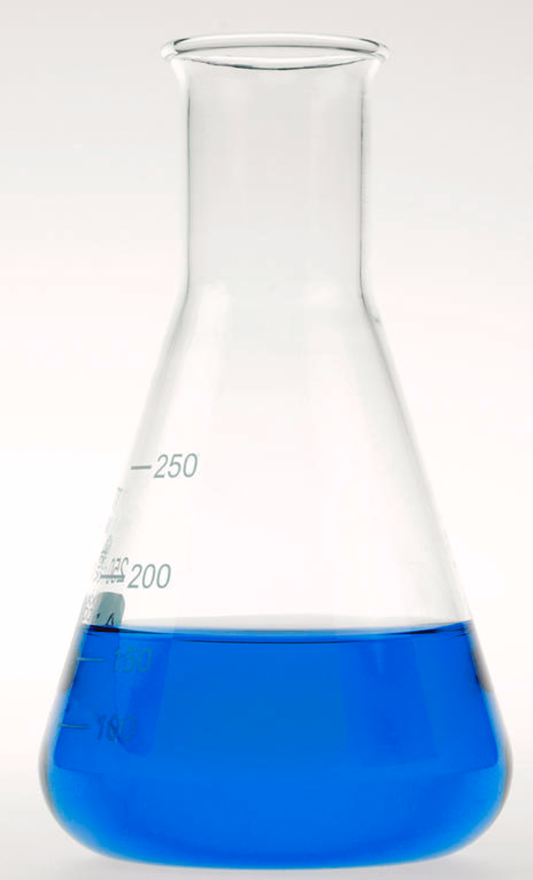  Figure 1 Conical flask [13]  Lab Report 2  Rate of Reaction | Abstract  The aim of this activity was to determine the rate law for the formation of iodine in the reaction between hydrogen peroxide and iodide ions in an aqueous solution, using vitamin C as a reducing agent and starch as an indicator.  Rebecca Dingwall (2217521)  ACDA6020

Table of Contents
1. Introduction 2
1.1 Aim 2
1.2 Hypothesis 2
1.3 Variables 2
2. Theory 2
2. Materials & Method 3
3. Observations 3
4. Results 4
5. Discussion 5
6. Conclusion 5
Bibliography 6
Appendix 1. 7
Materials & Method. 7

1. Introduction
This lab report was required to gain a better practical understanding of kinetics and REDOX reactions employing the ‘clock’ method. The clock method, known by its dramatic change from colourless -to-blue is often employed in chemistry to explore reaction rate [1]. Traditionally the rate of reaction is found by measuring how the concentration of the reactant changes with time. With this experiment the gradual formation of iodine cannot be easily measured due to the immediate reduction of vitamin C until it is fully consumed.

Aim
The aim of this activity was to determine the rate law for the formation of iodine in the reaction between hydrogen peroxide and iodide ions in an aqueous solution, using vitamin C as a reducing agent and starch as an indicator.
H₂O₂ + 2I⁻+2H⁺→I₂ + 2H₂O.
Vitamin C (ascorbic acid) instantly reduces iodine back to iodide.
C₆H₈O₆ + I₂ → C₆H₆O₆ + 2I⁻ + 2H⁺

1.2 Hypothesis
Based on previous experience and knowledge the assumption is that the rate law for both reactions is going to be either first order or second order. Not likely to be zero order due to the absence of a catalyst [2].

1.3 Variables
Trial 1: Order of reaction in H₂O₂
The dependant variable is the time taken for a colour change.
The independent variable is concentration of hydrogen peroxide.
The controls are potassium iodide, vitamin C (ascorbic acid), starch and water.

Trial 2: Order of reaction in I⁻
The dependant variable is the time taken for a colour change.
The independent variable is concentration of potassium iodide
The controls are hydrogen peroxide, vitamin C (ascorbic acid), starch and water.

2. Theory
As previously mentioned in the introduction the basic principles of the iodine clock reaction are to give a better understanding of kinetics and REDOX reactions. Specifically, within the explosives industry chemical kinetics influences safety, stability and performance of explosives.
Safety & Stability : recent studies have shown the use of a kinetic model can be used to predict impact sensitivity [3] but most chemical kinetics surrounding safety is used around the shelf life and storage of the explosives [4] [5] [6] [7].
Performance: Most performance based kinetics are around activation energies for energetic materials, how and why they are influenced and how they could be improved [8] [9] [10].

2. Materials & Method
The materials and method used can be found in Appendix 1.

3. Observations
Data given and collected are as follows:
 | KI | Vitamin C | Starch | Water | H₂O₂
Molarity | 0.20 | 0.010 | 1% | - | (3%) 0.891
mL used in Trial 1: | 3 | 1.5 | 1 | 18.5 | 1
mL used in Trial 1: | 3 | 1.5 | 1 | 17.5 | 2
mL used in Trial 1: | 3 | 1.5 | 1 | 16.5 | 3
mL used in Trial 1: | 3 | 1.5 | 1 | 15.5 | 4
mL used in Trial 2: | 1 | 1.5 | 1 | 18.5 | 3
mL used in Trial 2: | 2 | 1.5 | 1 | 17.5 | 3
mL used in Trial 2: | 3 | 1.5 | 1 | 16.5 | 3
mL used in Trial 2: | 4 | 1.5 | 1 | 15.5 | 3
Table 1: Data given and collected for the experiment.
Molarity of H₂O₂:

Vol= $\frac{Mass}{Density}$ $\frac{100}{1.01}=99.01ml$

Mole= $\frac{Mass}{Mr}$ $\frac{3g}{34g {mol}^{-1}}=0.0882 mole$

Molarity= $\frac{Moles ofH_{2}O_{2} }{Volume of solution \left(L\right)}$ $\frac{0.0882}{0.09901}=0.891M$

To find the final molarity of the solution the following calculations were performed:
M_{Final} (mol/L) = $\frac{L of H_{2}O_{2}}{{0.025}_{Total reaction solution L }}×0.891 (M)$

M_{Final} (mol/L) = $\frac{L of KI}{{0.025}_{Total reaction solution L }}×0.20 (M)$
[I⁻]₀ | t | Log ([I⁻]₀) | 1/t
0.008 | 175 | -2.243038049 | 0.005714
0.016 | 108 | -2.033423755 | 0.009259
0.024 | 69 | -1.838849091 | 0.014493
0.032 | 36 | -1.556302501 | 0.027778

Table 3 Values for Trial 2: [I⁻]₀, Time, Log ([I⁻]₀) and 1/t.
[H₂O₂]₀ | t | Log ([H₂O₂]₀) | 1/t
0.036 | 200 | -1.443697499 | 0.005
0.071 | 100 | -1.148741651 | 0.01
0.11 | 80 | -0.958607315 | 0.0125
0.14 | 66 | -0.853871964 | 0.015151
Table 2 Values for Trial 1: [H₂O₂]₀, Time, Log ([H₂O₂]₀) and 1/t.
Rate constant equation:
$$k=\frac{1/t}{[H_{2}O_{2}]^{m}[I^{-}]^{n}}$$

$Trial 1 k: \frac{0.005}{[0.036]^{1}×[0.20]^{2}}=3.47$

4. Results

Figure 2: Graph depicting 1/t vs Log [H₂O₂]₀

Figure 3: Graph depicting 1/t vs [I⁻]₀

5. Discussion
For trial 1, table 2 shows that between experiments 1 and 2, doubling the concentration roughly doubles the initial reaction rate shown in 1/t, this initially would reflect that the reaction rate is proportional , however when comparing experiments 1 and 4, quadrupling the concentration shows a discrepancy of 0.31 this could be down to a variety of factors, more than likely due to accumulated rounding errors that stem from slight discrepancies in volume added due to any remaining liquid clinging to the initial vessel and not being added to the final solution. This reaction rate proportionality is characteristic of a first order reaction [11] this is also shown in the graph in figure 2, due to this the rate constant can be calculated using any row in the table resulting in K=3.47 for trial 1.
For trial 2, table 3 shows that between experiments 1 and 2, doubling the concentration roughly doubles the initial reaction rate shown in 1/t, this again would reflect that the reaction rate is proportional [11] there is a discrepancy again of 0.002169 and because as mentioned before due to rounding errors moving forwards, however this proportionality is again characteristic of a first order reaction, however when used in conjunction for the whole experiment would put the overall order at second order [12]. This second order can be seen in the graph data from figure 3, the slope of the curve is more characteristic of a second order reaction.

6. Conclusion
This experiment proved the initial point, but moving forwards there should have been more experiments per concentration to get an average time. Next time the addition of rerunning the experiment again at an increased temperature. It would be expected that the reaction time should decrease with increased temperature and due to this faster reaction rate, a higher rate constant would be observed. The rate is dependent on activation energy, using both sets of measurements at Temp₁ and Temp₂ could then subsequently be used to calculate activation energy as per the Arrhenius equation [13].

Bibliography

[1] | BellevueCollege, “Reaction Kinetics: The Iodine Clock Reaction,” BellevueCollege |Chemistry162LabManual , [Online]. Available: https://www.bellevuecollege.edu/wp-content/uploads/sites/140/2014/06/Kinetics_Iodine_Clock_Rxn_Reportsheets.pdf. [Accessed 26 10 2025].
[2] | B. Bahr, “Zero-Order Reaction – Intro to Chemistry,” Fiveable, 2024. [Online]. Available: https://fiveable.me/key-terms/intro-chem/zero-order-reaction. [Accessed 28 10 2025].
[3] | K. D. S. M. J. C. &. V. W. M. Nicholas Lease, “Synthesis and investigation into explosive sensitivity for a series of new picramide explosives,” Journal of Energetic Materials , 28 12 2024. [Online]. Available: https://www.tandfonline.com/doi/full/10.1080/07370652.2024.2446882?af=R#abstract. [Accessed 30 10 2025].
[4] | W. P. C. d. K. &. R. E. K. E. L. M. Krabbendam-LaHaye, “The kinetic behaviour and thermal stability of commercially available explosives,” Journal of Thermal Analysis and Calorimetry, 1 5 2005. [Online]. Available: https://link.springer.com/article/10.1007/s10973-005-0683-9. [Accessed 30 10 2025].
[5] | R. D. S. V. Sanchirico, “redicting the Shelf Life of Energetic Materials via Kinetic Analysis of Decomposition Data Gathered by Using Thermal Analysis Techniques,” The Italian Association of Chemical Engineering, 15 10 2024. [Online]. Available: https://www.cetjournal.it/index.php/cet/article/view/CET24111062. [Accessed 30 10 2025].
[6] | M. R. b. ,. A. F. a. ,. H. E. M. a. ,. S. E. Ashraf M.A. Elghafour a, “Novel approach to quantify the chemical stability and shelf life of modified double-base propellants,” Defence Technology, 12 2018. [Online]. Available: https://www.sciencedirect.com/science/article/pii/S2214914718301132. [Accessed 30 10 2025].
[7] | T. C. S. a. ,. M. K. a. J. K. N. a. ,. P. K. a. ,. A. S. b. Arjun Singh a b, “Thermal decomposition and kinetics of plastic bonded explosives based on mixture of HMX and TATB with polymer matrices,” Defence Technology, 02 2017. [Online]. Available: https://www.sciencedirect.com/science/article/pii/S2214914716301568#:~:text=Thermogravimetric%20analysis%20(TGA)%20indicated%20that,in%20the%20first%20step%20decomposition.. [Accessed 30 10 2025].
[8] | *. J. D. 1. N. L. 1. F. W. M. 1. A. B. 1. S. F. 1. V. W. M. 1. Marc J Cawkwell 1, “Understanding Explosive Sensitivity with Effective Trigger Linkage Kinetics,” ACS Phys Chem , 22 06 2022. [Online]. Available: https://pmc.ncbi.nlm.nih.gov/articles/PMC9955191/. [Accessed 30 10 2025].
[9] | V. W. M. J. C. D. S. G. T. W. R. A. T. D. M. C. C. D. Aslam, “An Integrated Experimental and Modeling Approach for Assessing High-Temperature Decomposition Kinetics of Explosives,” Journal of the American Chemical Society, 11 09 2024. [Online]. Available: https://pubs.acs.org/doi/10.1021/jacs.4c08424#. [Accessed 30 10 2025].
[10] | D. N. P. V. T. D. H. N. N. Trung Toan Nguyen, “Kinetic Analysis of the Thermal Decomposition of Polymer-Bonded Explosive Based on PETN: Model-Fitting Method and Isoconversional Method,” Advances in material science and engineering , 11 07 2020. [Online]. Available: https://onlinelibrary.wiley.com/doi/10.1155/2020/9260818. [Accessed 30 10 2025].
[11] | Libre Texts Chemistry , “1.6: Integrated Rate Laws (Zeroth, First, and second order reactions),” Libre Texts Chemistry , [Online]. Available: https://chem.libretexts.org/Courses/Prince_Georges_Community_College/CHEM_1020%3A_General_Chemistry_II_(S.N._Yasapala)/01%3A_Chemical_Kinetics/1.06%3A_Integrated_Rate_Laws_(Zeroth_First_and_second_order_reactions). [Accessed 28 10 2025].
[12] | J. R. a. L. Edwards-Stuart, “Topic 1 – Kinetics Revision Notes,” Physics and Maths Tutor , [Online]. Available: https://pmt.physicsandmathstutor.com/download/Chemistry/A-level/Notes/AQA-Old/Unit-4/Set-B/1%20Kinetics.pdf. [Accessed 28 10 2025].
[13] | Science Photo Library , “Conical Flask Holding Blue Liquid,” Science Photo Gallery , [Online]. Available: https://sciencephotogallery.com/featured/conical-flask-holding-blue-liquid-natural-history-museum-london.html. [Accessed 24 10 2025].

Appendix 1.

Materials & Method.
ACDA 6020 LAB SESSION #2

RATE OF REACTION (Advanced)

AIM OF THE EXPERIMENT: To determine the rate law for the formation of iodine in the reaction between hydrogen peroxide and iodide ions in aqueous solution, using vitamin C (ascorbic acid) as a reducing agent and starch as an indicator.
INTRODUCTION
In acidic solution, hydrogen peroxide oxidises iodide ions to iodine:
H₂O₂ + 2I⁻ + 2H⁺ → I₂ + 2H₂O
Vitamin C instantly reduces iodine back to iodide:
C₆H₈O₆ + I₂ → C₆H₆O₆ + 2I⁻ + 2H⁺
As long as vitamin C is present, no blue colour appears. When it is consumed, iodine accumulates and forms a blue starch–iodine complex. The time until this colour appears is the clock time (t), which reflects the rate of iodine formation.
In Part 1 you will determine the order of the reaction in [H₂O₂] and in Part 2 – order of reaction in [I⁻].
Why we use the “clock” method
In most kinetics experiments, the rate of reaction is found by measuring how the concentration of a reactant or product changes continuously with time.
In this iodine clock experiment, however, we cannot easily monitor the gradual formation of iodine because it is immediately reduced by vitamin C until that reagent is fully consumed.
To overcome this, we use a clock approach: the moment the blue starch–iodine colour appears corresponds to the instant when all vitamin C has been used up and a small, fixed amount of iodine suddenly accumulates.
That fixed iodine amount is the same in every trial, so the time taken to reach it (the clock time, t) depends only on how fast iodine is being produced.
If iodine forms quickly, the blue colour appears sooner (small t); if formation is slower, the colour takes longer (large t).
This means the average rate of the reaction is inversely proportional to the measured clock time:
Rate ∝ 1/t
By varying one reactant concentration at a time and comparing the reciprocal of the times, we can determine how the rate depends on each concentration and hence deduce the rate law for the reaction.

PROCEDURE
Put on the lab coat, safety goggles, and gloves. Make sure that long hair is tied.
IMPORTANT: Record all your observation sin the data sheets at the end of this script.
Lab tools and supplies:
- 50 mL conical flasks x4
- Glass pipettes x2 (pipette 1 used for KI and ascorbic acid; pipette 2 – H₂O₂) and pipette filler
- Graduated cylinder or small beaker and test tube
- Stopwatch
- Glass stirring rod
Chemicals:
Solution A (in conical flask):
- 0.20 M KI solution
- 0.010 – 0.025 M ascorbic acid (Vitamin C) solution
- 1 % starch indicator
- Distilled water
Solution B (in test tube):
- 3% H₂O₂ solution
Procedure:
- Order of the reaction in [H₂O₂]
- In four conical flasks prepare solution A according to the table. Use one glass pipette to measure the required volumes of KI and Vit C solutions. Add ~1 mL of starch solution.
- With the second glass pipette measure the required volume of H₂O₂ (solution B) and transfer it in the test tube.
- Pour quickly solution B from the test tube to solution A in the conical flask, stir and start the timer as soon as the solutions are mixed.
- Record the time until the first permanent blue colour appears.

Trial | A: KI 0.20 M (mL) | A: Vit C 0.010 M (mL) | A: Starch 1% (mL) | A: Water (mL) | B: H₂O₂ 3% (mL)
I.1 | 3.0 | 1.5 | 1.0 | 18.5 | 1.0
I.2 | 3.0 | 1.5 | 1.0 | 17.5 | 2.0
I.3 | 3.0 | 1.5 | 1.0 | 16.5 | 3.0
I.4 | 3.0 | 1.5 | 1.0 | 15.5 | 4.0

- Order of the reaction in [I⁻]
- In four conical flasks prepare solution A according to the table. Use one glass pipette to measure the required volumes of KI and Vit C solutions. Add ~1 mL of starch solution.
- With the second glass pipette measure the required volume of H₂O₂ (solution B) and transfer it in the test tube.
- Pour quickly solution B from the test tube to solution A in conical flask, stir and start the timer as soon as the solutions are mixed.
- Record the time until the first permanent blue colour appears.

Trial | A: KI 0.20 M (mL) | A: Vit C 0.010 M (mL) | A: Starch 1% (mL) | A: Water (mL) | B: H₂O₂ 3% (mL)
II.1 | 1.0 | 1.5 | 1.0 | 18.5 | 3.0
II.2 | 2.0 | 1.5 | 1.0 | 17.5 | 3.0
II.3 | 3.0 | 1.5 | 1.0 | 16.5 | 3.0
II.4 | 4.0 | 1.5 | 1.0 | 15.5 | 3.0

