  Report – Case study: The City Hotel | Student No: | 2240761
 | Module Title: | Financial Management for the Hotel Industry
 | Module Code: | BMIH5007
 | Lecturer: | Tristan Hawkins
 | Words: | 2124

Acknowledgement
I acknowledge the use of Grammarly (https://www.grammarly.com/) on 09 November 2024 to check my work using the prompt:
- “Can you please check the below text to check grammatical mistakes and syntax issues properly?”
I confirm that I have not presented any AI-generated text as my work. I confirm I have copies of my drafts, notes, and other resources I used before, and after using AI tools which I may be asked to provide in evidence.

Contents
Introduction 1
Financial Performance Analysis of The City Hotel (2021-2023) 2
Revenue and Expenses 2
Gross Profit and Operating Profit Margin 2
Key Financial Ratios 2
Key Reasons Behind the Decline in Profitability 3
Market Conditions and Economic Factors 3
Supply and Demand Dynamics 4
Cost Management Challenges 4
Market Positioning using Bowman’s Clock 5
Turnaround Strategies 6
Revenue Enhancement Strategies 6
Cost Optimisation 6
Customer Experience Enhancement 6
Ongoing Monitoring and Evaluation 7
Conclusion 8
Reference 9
Appendices 11
Appendix 1: Raw data 11
Appendix 2: Bowman’s Strategy Clock Model 12
Appendix 3: Supply and Demand Dynamic 13

Introduction
City Hotel, located in the city environment with restaurant, bar and event commercial spaces, faced several issues within the last years, namely low revenues, occupancy rates and customer satisfaction. The report will assess profitability, liquidity and solvency over the last three years to understand the major factors that contributed to the decline. Furthermore, it aims to provide ideas for comprehensive turnaround strategies which can bring the hotel to the state when it would significantly improve financial status and occupancy rates.

Financial Performance Analysis of The City Hotel (2021-2023)

Revenue and Expenses
For the past three years, The City Hotel has disappointed on the revenue side although experienced a change in its expenses. In 2021, the revenue was £5.25 million, and it has remained almost level into 2022 at £5.31 million. However, by 2023 the revenue declined to £2.33 million which is a very blunt sign of contraction of business activities. Meanwhile, expenses showed a varied pattern; while costs of goods sold and employee costs followed a downward trend, other operating expenses, including external and depreciation costs, remained substantial. Despite some cost reductions, these expenses exceeded revenue in 2023, leading to an operating loss of £1.22 million. This trend highlights a pressing need for restructuring and targeted cost-management strategies to stabilise the hotel’s financial position (Catan, et al. 2023).

Gross Profit and Operating Profit Margin
There is evidence of a steady gross profit margin figure of almost 90% for the past three years, showing a firm ability to generate revenues with minimal cost of goods sold. However, a different picture of the operating profit margin is observed which has continuously deteriorated with time. The operating profit margin was slightly positive in 2021 but very small compared to the gross operating margin. By 2022, it has reduced even more, and operating by 2023 turned to a considerable negative number around -50% which implies deep underlying operating loss. This shows increasing operating expenses which surpassed the revenues to deeper operational loss notwithstanding a relatively strong gross profit margin.

Key Financial Ratios
In the course of the last three years, there was a negative trend of profitability and solvency and a moderately negative trend of liquidity in the total assets of The City Hotel. Measuring liquidity ratio, the current ratio and Quick Ratio were declining from 96.66% and 94.86% in the first year to 63.83% and 62.37% in the last year. This points to a decrease in the capacity to meet its near-term maturities, pointing to liquidity woes that have deteriorated over time (Adrian, et al. 2017). Total debt to total equity was also affected moving from 4.74 to 10.10 showing the company has been relying more on debts to fund its operations. This increasing debt level is a threat to the financial structure as the hotel is climbing the debt ladder and is exposed to credit pressure which may lead to insolvency. Company profitability as will be illustrated by Return on Assets (ROA) and Return on Equity (ROE) also declined. ROA reduced from 5.13% to -7.79% which means that assets are not generating profits but rather profiting from the company’s losses. Likewise, ROE initiated from 30.85% and declined sharply to -91.34% which means losses are inflicting shareholders’ equity. Such a deterioration of margins coupled with growth in debt implies that the company lacks proper resource management and has deteriorating operations (Seal, 2019). Both of these ratios are). These trends signify that these firms require restructuring to enhance liquidity, management of debt, as well as the restoration of their profitability (Yin and Yang, 2022).

Year | Current Ratio | Quick Ratio | Debt to Equity Ratio | ROA | ROE
2021 | 96.66% | 94.86% | 4.74 | 5.13% | 30.85%
2022 | 93.24% | 91.52% | 5.16 | 4.24% | 27.29%
2023 | 63.83% | 62.37% | 10.1 | -7.79% | -91.34%
Table 1 The City Hotel - Key Financial Ratios (Author)

Key Reasons Behind the Decline in Profitability

Market Conditions and Economic Factors
An increase in the hospitality industry’s vulnerability was also noted because of the recent changes in the global context (Song, et al. 2018). Looking at the revenues of The City Hotel we can consider the following distribution, where the overall drop in income is evident — from £5.25 million in 2021 to £2.33 million in 2023, The City Hotel’s revenue can be affected by various factors in the external economy. COVID-19 affected the travel and tourism industry placing numerous restrictions on travel, limiting international travel significantly, and creating uncertainty among consumers in booking accommodations (Volgger, et al. 2021). While GDP growth was gradually regaining in developed countries and the rest of the world, inflation put pressure on costs, eradicating potential customers’ luxury to afford leisure travel. Similarly, factors such as political turmoil like the war between Russia and Ukraine have culminated in a higher cost of energy thus exerting a lot of pressure on households and companies (Akbarlı, et al. 2022). All these factors lead to lower occupancy levels and eroded consumer power negatively affecting The City Hotel’s revenues.

Supply and Demand Dynamics
The study shows that supply and demand factors are central to analysing occupancy levels and average daily rates in the hospitality industry. Just as shown in the supply and demand diagram, the point of equilibrium can also be defined where the price equals the quantity demanded, pointed out as P*. However, if competition rises, for example, due to the appearance of new hotel chains or services like Airbnb, the demand curve shifts to the left (Tao, 2019). Such a shift implies a lower quantity demanded at the previous prices hence resulting in a lower equilibrium price and quantity. For The City Hotel, this has compromised occupancy levels and the bank’s inability to sustain standard average room rates. The context of today’s emerging post-pandemic market reality has directly impacted customer needs, especially with travellers becoming more price-sensitive while focusing on the flexibility, safety, and cost of the accommodation offerings (Gambini, 2023). These shifts have put pressure on traditional hotels, making it difficult to attract customers without adjusting pricing or enhancing offerings. Furthermore, economic turbulence, including the inflation rate and resulting skyrocketing energy costs due to geopolitical factors, has limited people’s impulse to travel for leisure (Menegaki and Poutakidou, 2023). This environment has put it a lot of pressure to maintain its revenue levels as customers look for cheaper or other alternatives such as house rent. Collectively, such factors explain why The City Hotel has been operating under a demand-supply gap concerning existing room capacities and reduced consumer bookings thereby resulting in revenues per available room and overall profitability. To overcome these challenges managerial implication calls for strategic positioning and service differentiation to access new positions in the new market environment.

Cost Management Challenges
Even operations costs have continued to increase thus compounding the profitability problem. Establishment expenses, which in the past were the largest cost factor in hotels, have escalated because of wage inflation occasioned by the scarcity of labour in the recovery stage after the pandemic (Jones, et al. 2014). This has been evident universally as organisations in the hospitality industry face the challenge of retaining and attracting a competent workforce (Walker, 2021). This challenge is well illustrated by the fact that even though the total expenditure of the City Hotel in 2022 was low at £ 2.3 million, employee costs accounted for £ 1.77 million and in 2023 a comparatively tiny £ 1.23 million drop to £ 1.23 million shows. Besides wages, maintenance has become more expensive, because infrastructure ages, while inflation energises the price of supplies and services. There is a significant elevation in the energy cost implications from a disrupted global supply chain, and higher fuel costs attributed to political instability (Cui, et al. 2023). These persistent high costs, without corresponding revenue recovery, have pushed The City Hotel deeper into operating losses, as evidenced by a negative operating profit margin of around -50% in 2023.

Market Positioning using Bowman’s Clock
Using Bowman’s Strategy Clock, The City Hotel's market positioning appears misaligned with current industry trends and consumer expectations. Bowman’s framework outlines that businesses should aim for either differentiation (position 4) or a hybrid strategy (position 3) to offer unique value and competitive pricing. However, The City Hotel's financial struggles indicate that it may have fallen into a risk-prone position, such as position 6 (risky high margins) or position 8 (low added value and price), which can lead to a loss of market share (Cakir, 2022). This misalignment could stem from outdated service models that do not align with the demand for more personalised and experience-oriented travel that has become popular post-pandemic. Currently, travellers are seeking accommodations that offer both safety and value. Competitors that have adapted by incorporating health-focused amenities, contactless services, and flexible booking policies have fared better (Tussyadiah and Pesonen, 2016). Some of these distortions may have rendered the City Hotel unable to adapt to the above preferences shifts that could have compounded its market positioning woes. To restore competitiveness, The City Hotel should change its focus from product-related factors toward more customer-oriented factors such as value, service quality, innovation, and price.

Turnaround Strategies

Revenue Enhancement Strategies
Due to changes in occupancy status and competition positioning, The City Hotel should adopt a flexible price strategy. This involves changing rates of rooms with special regard made to occupancy demand, seasons and even the competitors’ rates. Applying the revenue management software to these changes may enhance the possibility of charging reasonable but adequate prices. Further, the adoption of wider strategies at the property level, such as offering tiered pricing for qualitative and new services and packages could appeal to customers of different classes and improve the revenue by room (Canina & Enz, 2008). On the other hand, the occupancy and customer retention levels in the business require increased marketing efforts that focus on differentiated strategies and environment. Especially when it comes to using social media and e-mail marketing it is easier to expand the coverage (Ortega, 2016).

Cost Optimisation
In line with increasing operational costs, The City Hotel should employ an operational cost-cutting audit that will reveal the possible avenues of optimisation. Consequently, the primary supply category that results from business-to-business negotiations involves better pricing from vendors after the contracts have been renegotiated (Drury, 2021). Also, the usage of energy-saving measures and technologies including the likes of; LED bulbs, and smart thermostats leads to a decrease in energy expenditure. I would like to fill staff rotas to match periods of high and low occupancy based on the findings to reduce labour costs without compromising the quality of service delivered to guests (Petricek, et al. 2021). On the other hand, outsourcing and automating work coupled with staff training may increase organisational performance and decrease expenses (Arbelo, et al. 2017).

Customer Experience Enhancement
Customer experience investments are pivotal to driving satisfaction and its sustainment. The respondents also understood that it is possible to alter their perceptions through a range of additions and improvements to the current services; free high-speed Internet, as well as superior in-room technology and wellness services, were cited as the attributes most likely to give a positive boost to perceptions. When it comes to providing customer feedback systems that seek to actively collect and address guests’ posted reviews, customers will also appreciate the efforts by The City Hotel towards quality and flexibility. Other complementary offerings including customised welcome gifts or rewards for loyalty also a major plus to re-peat business clients (Alnawas and Hemsley-Brown, 2019).

Ongoing Monitoring and Evaluation
If the business is to achieve its long-term goals a schedule for the review of financial and operational performance targets must be formed. With KPIs like RevPAR (Revenue per Available Room), GOPPAR (Gross Operating Profit per Available Room), and CSat (Customer satisfaction) one will be able to see how far the objectives have been achieved (Singh, et al. 2022). It is proposed that this set of indicators will be reviewed at least once per quarter to assess strategy and operations changes and adjustments based on competitors' and customers' feedback. Employees and managers can use BI tools to make the right decisions that would make the hotel functional and sensitive to market conditions and performance results.

Conclusion
The financial management of The City Hotel has several problems: revenues are declining, the company is increasingly using debt, the operating profit margin is negative, and the company’s liquidity ratios are worsening. Some of the causes attributed to problems such as these include fluctuations in the economy, increasing competitiveness in the market and increasing overhead costs. Nevertheless, strategies such as dynamic pricing, targeted marketing, cost optimisation, customer experience differentiation and diversification of revenues present a clear way for the organisation’s revival. Depending on the success undertaken and the development of these projects, there is a possibility of bringing the financial position of the hotel to order, increasing profitability and regaining confidence.

Reference
Adrian, T., Fleming, M., Shachar, O. and Vogt, E., 2017. Market liquidity after the financial crisis. Annual Review of Financial Economics, [online] 9(1), pp.43-83. doi: https://doi.org/10.1146/annurev-financial-110716-032325.
Akbarlı, A., Öndeş, E.B., Gezer, D. and Açıkel, B. (2022). The Impact of the Ukraine-Russia Conflict on the Aviation Sector: February-May 2022. Journal of Aviation, [online] 6(3), pp.346-354. doi:https://doi.org/10.30518/jav.1125560 (Accessed on 5 Nov.2024).
Alnawas, I. and Hemsley-Brown, J. (2019). Examining the key dimensions of customer experience quality in the hotel industry. Journal of Hospitality Marketing & Management, [online] 28(7), pp.833-861. doi:https://doi.org/10.1080/19368623.2019.1568339.
Arbelo, A., Perez-Gomez, P. and Arbelo-Perez, M. (2017). Cost efficiency and its determinants in the hotel industry. Tourism Economics, [online] 23(5), pp.1056-1068. doi:https://doi.org/10.1177/1354816616656419.
Cakir, T. (2022). Bowman’s Strategy Clock Framework. [online] www.linkedin.com. Available at: https://www.linkedin.com/pulse/bowmans-strategy-clock-framework-tim-cakir (Accessed 1 Nov. 2024).
Canina, L. and Enz, C.A. (2008). Pricing for revenue enhancement in Asian and Pacific region hotels: A study of relative pricing strategies. [online] 8(3). Available at: https://ecommons.cornell.edu/bitstream/handle/1813/71027/Canina_202008_20Pricing_20the_20revenue.pdf?sequence=1.(Accessed 1 Nov. 2024).
Catan, P., Lîsîi, A., Scutari, A.S., Frumusachi, L. and Melnic, G. (2023). The impact of financial management tools on tourism companies in the post-COVID environment. GeoJournal of Tourism and Geosites, [online] pp.1645-1654. Available at: https://ibn.idsi.md/vizualizare_articol/194560. (Accessed 31 Oct. 2024).
Cui, L., Yue, S., Nghiem, X.H. and Duan, M. (2023). Exploring the risk and economic vulnerability of global energy supply chain interruption in the context of the Russo-Ukrainian war. Resources Policy, [online] 81, p.103373.doi:https://doi.org/10.1016/j.resourpol.2023.103373.
Drury, C. (2021) (11th Ed) Management and Cost Accounting, London, Prentice Hall. [online] doi:https://doi.org/978-1-4737-7361-5.
Gambini, A. (2023). Understanding Generation Z travellers, an Australian perspective and a worldwide tool.dspace.unive.it. [online] Available at: http://dspace.unive.it/handle/10579/23372. (Accessed 3 Nov. 2024).
Jones, P., Hillier, D. and Comfort, D. (2014). Sustainability in the global hotel industry. International Journal of Contemporary Hospitality Management, [online] 26(1), pp.5-17. https://doi.org/10.1108/IJCHM-10-2012-0180 (Accessed on 9 Nov. 2024).
Menegaki, A.N. and Poutakidou, G. (2023). Risks in the Tourism Sector from the Increase in Energy Prices [online]. Available at: https://www.preprints.org/manuscript/202305.0030 (Accessed on 6 Nov. 2024).
Ortega, B. (2016). Revenue management systems and hotel performance in the economic downturn. International Journal of Contemporary Hospitality Management, [online] 28(4), pp.658-680. doi:https://doi.org/10.1108/IJCHM-07-2014-0324.
Petricek, M., Chalupa, S. and Melas, D. (2021). Model of price optimization as a part of hotel revenue management—stochastic approach. Mathematics, [online] 9(13), p.1552. doi:https://doi.org/10.3390/math9131552.
Product Mindset (2022). Bowman’s Strategy Clock. [online] productmindset.substack.com. Available at: https://productmindset.substack.com/p/bowmans-strategy-clock (Accessed 9 Oct. 2024).
Seal, W. (2019) (6th Ed) Management Accounting, London, McGraw Hil. [online] research.cbs.dk. Available at: https://research.cbs.dk/en/publications/management-accounting-2 (Accessed on 1 Nov. 2024).
Singh, R., Charan, P. and Chattopadhyay, M. (2022). Evaluating the hotel industry performance using efficiency and effectiveness measures. International Journal of Hospitality & Tourism Administration, [online] 23(2), pp.408-431. Available at: https://www.tandfonline.com/doi/abs/10.1080/15256480.2020.1769521 (Accessed on 10 Nov. 2024).
Song, H., Li, G. and Cao, Z. (2018). Tourism and economic Globalization: An emerging research agenda. Journal of Travel Research, [online] 57(8), pp.999-1011.Available at: https://journals.sagepub.com/doi/abs/10.1177/0047287517734943 (Accessed on 5 Nov. 2024).
Tao, T. (2019). The Problem of Supply and Demand. [online] Medium. Available at: https://medium.com/@tonytao_32486/the-problem-of-supply-and-demand-5c7f191f1669 (Accessed 9 Nov. 2024).
Tussyadiah, I.P. and Pesonen, J. (2016). Impacts of peer-to-peer accommodation use on travel patterns. Journal of travel Research, [online] 55(8), pp.1022-1040. Available at: https://journals.sagepub.com/doi/abs/10.1177/0047287515608505 (Accessed 11 Nov. 2024).
Volgger, M., Taplin, R. and Aebli, A. (2021). Recovery of domestic tourism during the COVID-19 pandemic: An experimental comparison of interventions. Journal of Hospitality and Tourism Management, [online] 48, pp.428-440. Available at: https://www.sciencedirect.com/science/article/pii/S1447677021001194 (Accessed on 5 Nov. 2024).
Walker, J. (2021) Introduction to Hospitality, Harlow, Pearson [online]. Available at: https://librarysearch.uwtsd.ac.uk/permalink/44WHELF_UWTSD/tj3s4p/alma99100345960202421 (Accessed on 11 Nov. 2024)
Yin, L. and Yang, Z. (2022). The profitability effect: Insight from a dynamic perspective. International Review of Financial Analysis, [online] 80, p.102059. doi:https://doi.org/10.1016/j.irfa.2022.102059 (Accessed on 1 Nov. 2024).

Appendices

Appendix 1: Income Statement (in GBP)
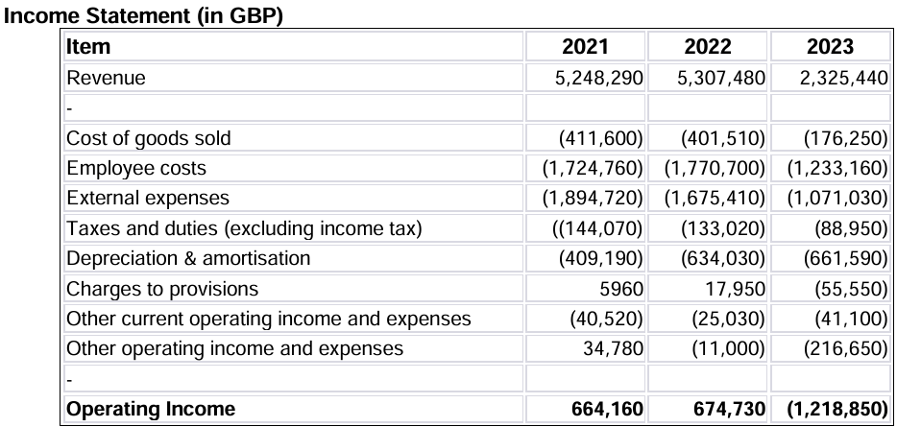
(Module Handbook)

Appendix 2: Balance Sheet (in GBP)

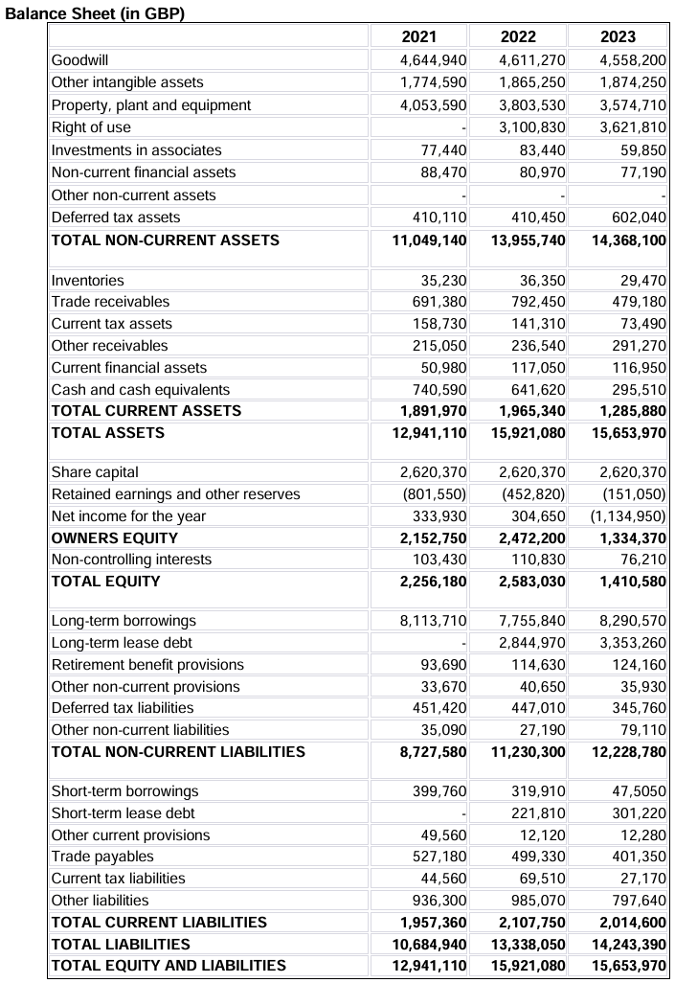
(Module Handbook)

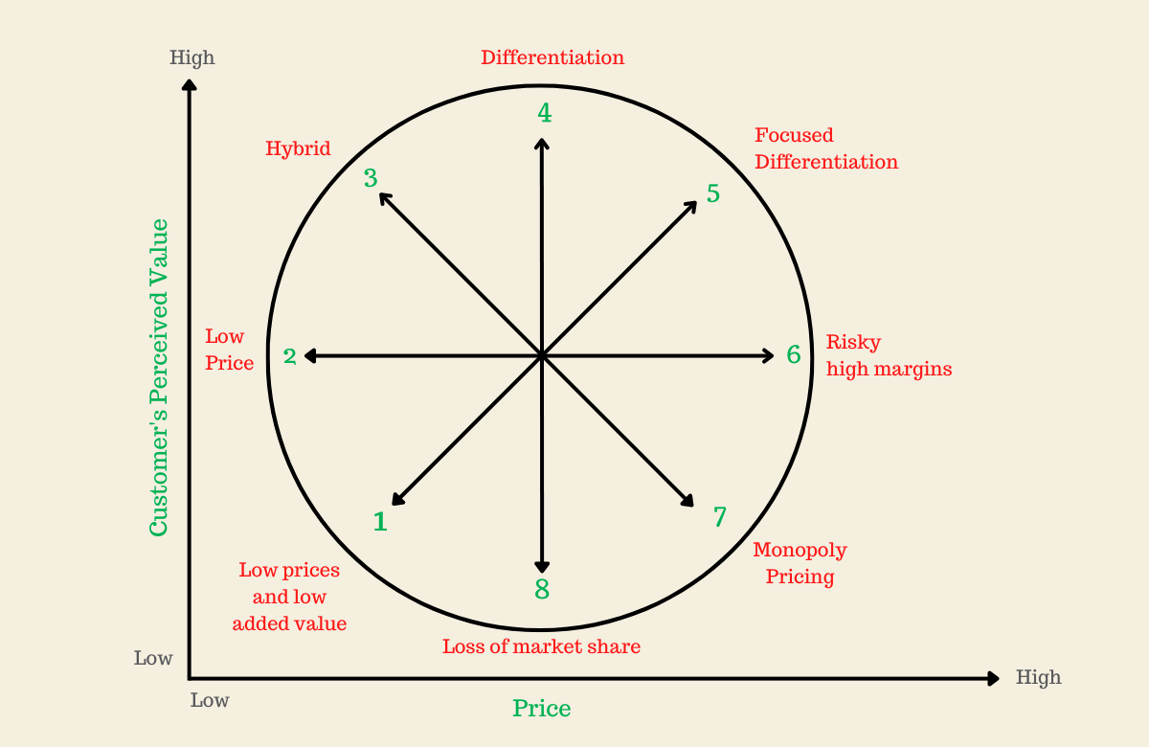
Appendix 3: Bowman’s Strategy Clock Model

Bowman’s Strategy Clock (Product Mindset, 2022)

Appendix 4: Supply and Demand Dynamic
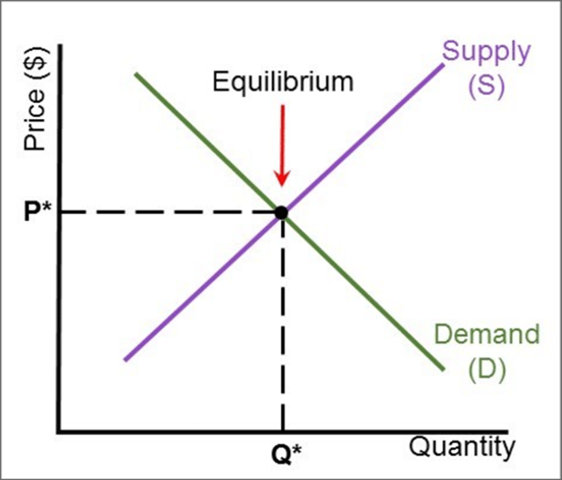
Supply and Demand Dynamic (Tao, 2019)

