University of Wales Trinity Saint David

Ordnance, Munitions and Explosives



Advanced Chemistry of OME - ACDA6020

Laboratory Report – Fourier Transform Infrared Analysis of Organic Compounds

Natalie Coplin - 2113351

Date – 10/2025

Lecturer: Ewa Kazimierska

Contents
List of Figures 3
List of Tables 3
1. Introduction 4
1.1. Hypothesis 4
1.2. Predicted Outcome 4
1.3. Key Variables 5
1.4. FTIR 6
1.5. Importance of FTIR in Energetics 7
2. Methodology 8
2.1. Equipment and Personal Protective Equipment (PPE) 8
2.2. Procedure 8
3. Results 14
4. Observations 18
5. Discussion 19
6. Conclusion 20
7. References 21
8. Appendix 1 24
9. Appendix 2 – Library search results 25

List of Figures
Figure 1 Chemical structure of Guanidine [1] 4
Figure 2 Acetaminophen structure [2] 5
Figure 3 Structure of ascorbic acid [3] 5
Figure 4 Chemical structure of methyl 3-nitrobenzoate [4] 5
Figure 5 FTIR spectrometer features [9] 6
Figure 6 FTIR Spectrometer 8
Figure 7 Anvil options 9
Figure 8 Anvil fitted to arm 9
Figure 9 Plate and crystal 10
Figure 10 Number of sample scans (accumulations) 11
Figure 11 Absorbance spectrum button 12
Figure 12 Search function in software 12
Figure 13 Library search results for acetaminophen 13
Figure 14 FTIR spectrum for sample A 14
Figure 15 FTIR spectrum for sample B 15
Figure 16 FTIR spectrum for sample C 16
Figure 17 FTIR spectrum for sample D 17
Figure 18 Sample A - ascorbic acid 25
Figure 19 Sample B - guanidine nitrate 26
Figure 20 Methyl 3-nitrobenzoate 27
Figure 21 Acetaminophen 28

List of Tables
Table 1 Key peaks identified from FTIR spectra 19
Table 2 ATR-FTIR Troubleshooting Guide 25
Table 3 Table 3 Quick reference guide to Perkin Elmer Spectrum II settings 25

Introduction
The purpose of this experiment is to confirm key functional groups of four unlabelled samples, each corresponding to one of the following: guanidine, acetaminophen, ascorbic acid and methyl 3-nitrobenzoate. Each of these compounds are often used in the design, manufacture or disposal of energetic compounds. Confirmation of their identity will enable safe disposal by preventing incorrect mixing of chemicals and reducing the risk of any unplanned reactions. Analysis will be performed using Attenuated Total Reflectance - Fourier Transform Infrared Spectroscopy (ATR-FTIR) and obtaining spectra for each of the samples.

Hypothesis
Four samples have been provided: guanidine, acetaminophen, ascorbic acid and methyl 3-nitrobenzoate. By determining and comparing the specific functional groups of each compound, each Fourier Transform Infrared Spectroscopy (FTIR) spectra will correspond to one of these samples.

Predicted Outcome
The samples are expected to exhibit distinct functional groups on each spectrum, enabling identification.
Figure 1, shows the structure of guanidine. It is expected to display bands for -NH₂ (amino) and C=N groups.
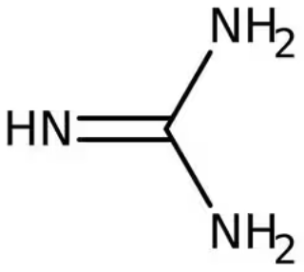
Figure 1 Chemical structure of Guanidine [1]
Acetaminophen is expected to exhibit a band for a phenol group (-OH), an aromatic ring and an amide group with both C=O carbonyl group and a N-H bond, these groups can be seen in Figure 2.
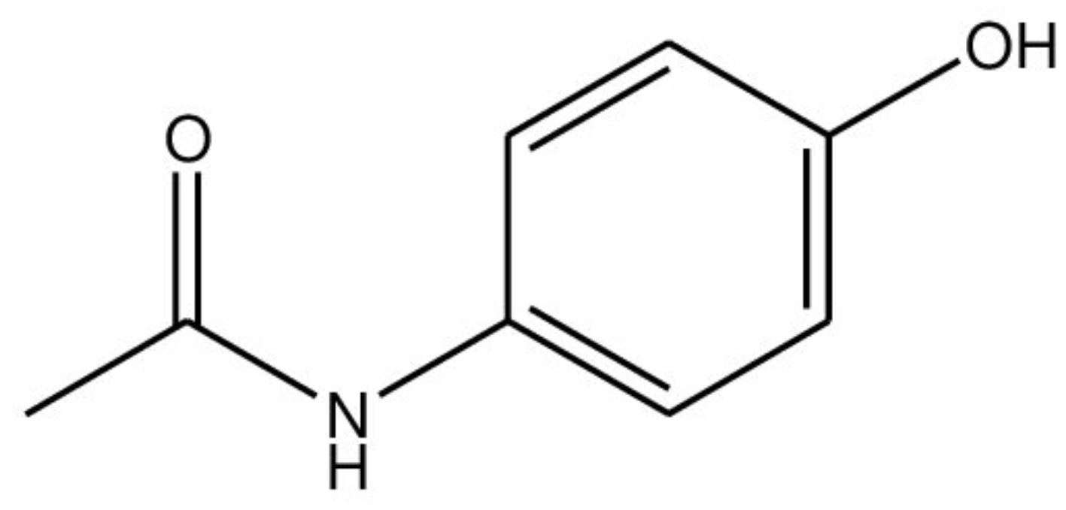
Figure 2 Acetaminophen structure [2]
Ascorbic acid, shown in Figure 3, is expected to exhibit a broad O-H stretching band due to four hydroxyl groups, and a C=O band characteristic of a lactone ring.
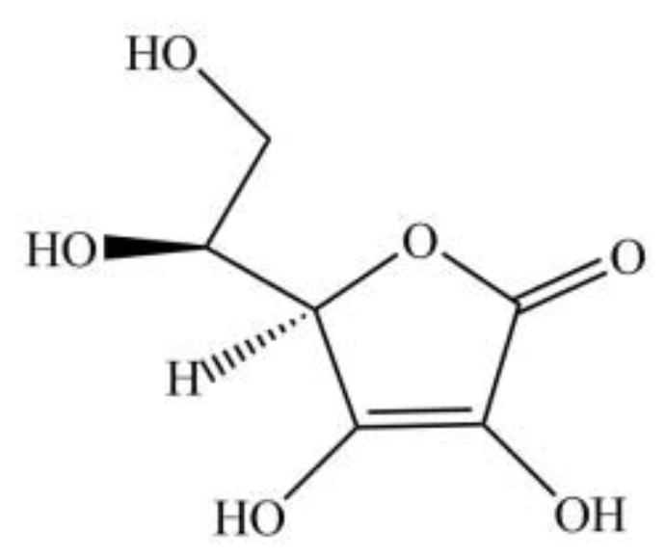
Figure 3 Structure of ascorbic acid [3]
Methyl 3-nitrobenzoate is expected to exhibit an ester group (-COOCH₃) and a nitro-group (NO₂) attached to an aromatic ring, as shown in Figure 4.
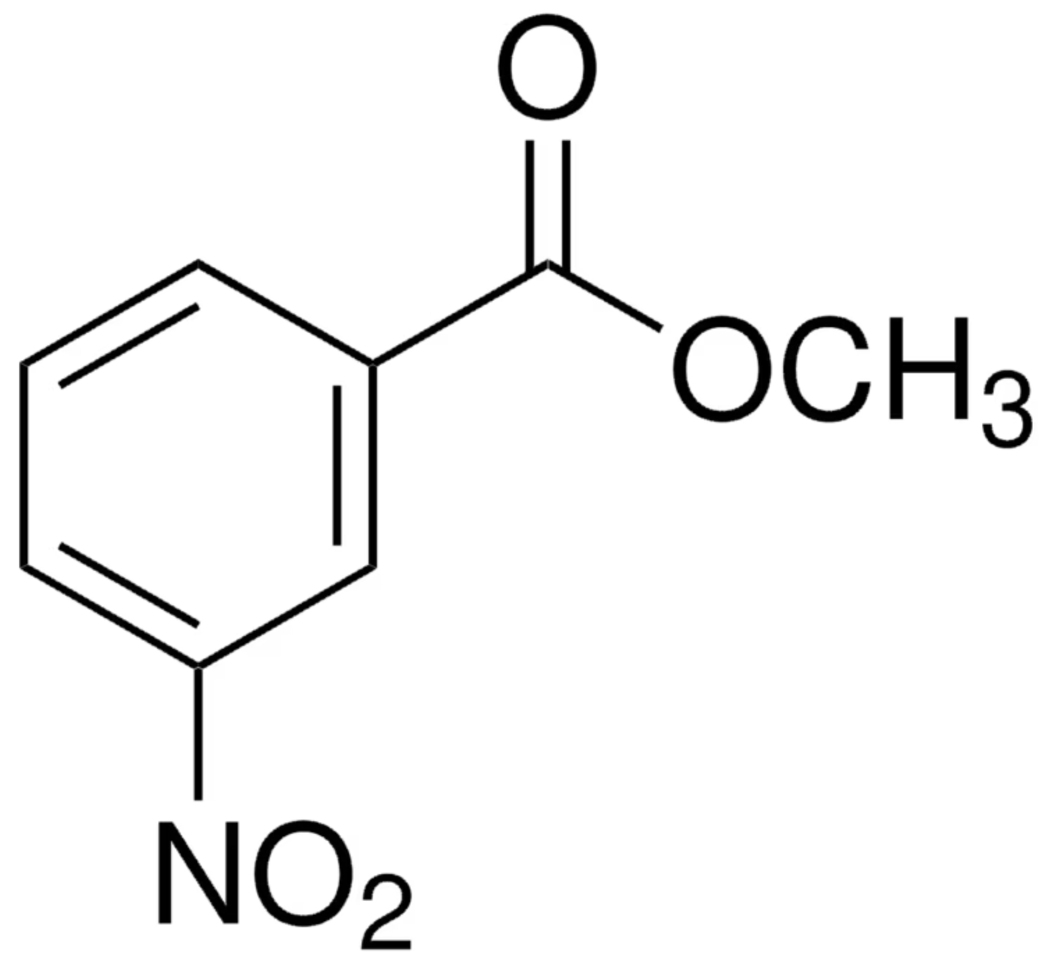
Figure 4 Chemical structure of methyl 3-nitrobenzoate [4]

Key Variables
For this experiment the variables are:
Independent – samples under test
Dependent – resulting ATR-FTIR spectra
Control – crystal type, instrument settings, cleaning method, sample contact pressure.

FTIR
FTIR is a widely used largely non-destructive method for the identification of compounds based on the vibrations of functional groups when light is passed through the sample. The frequency at which a sample absorbs radiation and the intensity of the absorption is measured to produce a spectrum [5]. To do this, infrared radiation of a known wavelength range is directed at the sample through a beam splitter. The light is reflected by two mirrors, one of which is fixed while the other can move. The reflected light recombines at the beam splitter and it them directed to the sample. some of which will transmit through, while some is absorbed [6]. The transmitted light is measured and a Fourier Transform applied to convert raw data into a readable spectrum of either transmittance or absorbance [7] [8]. The vibrations of the functional groups vary depending upon the bonds in the compound, with each bond absorbing a different amount of energy and producing a corresponding peak on the spectrum.
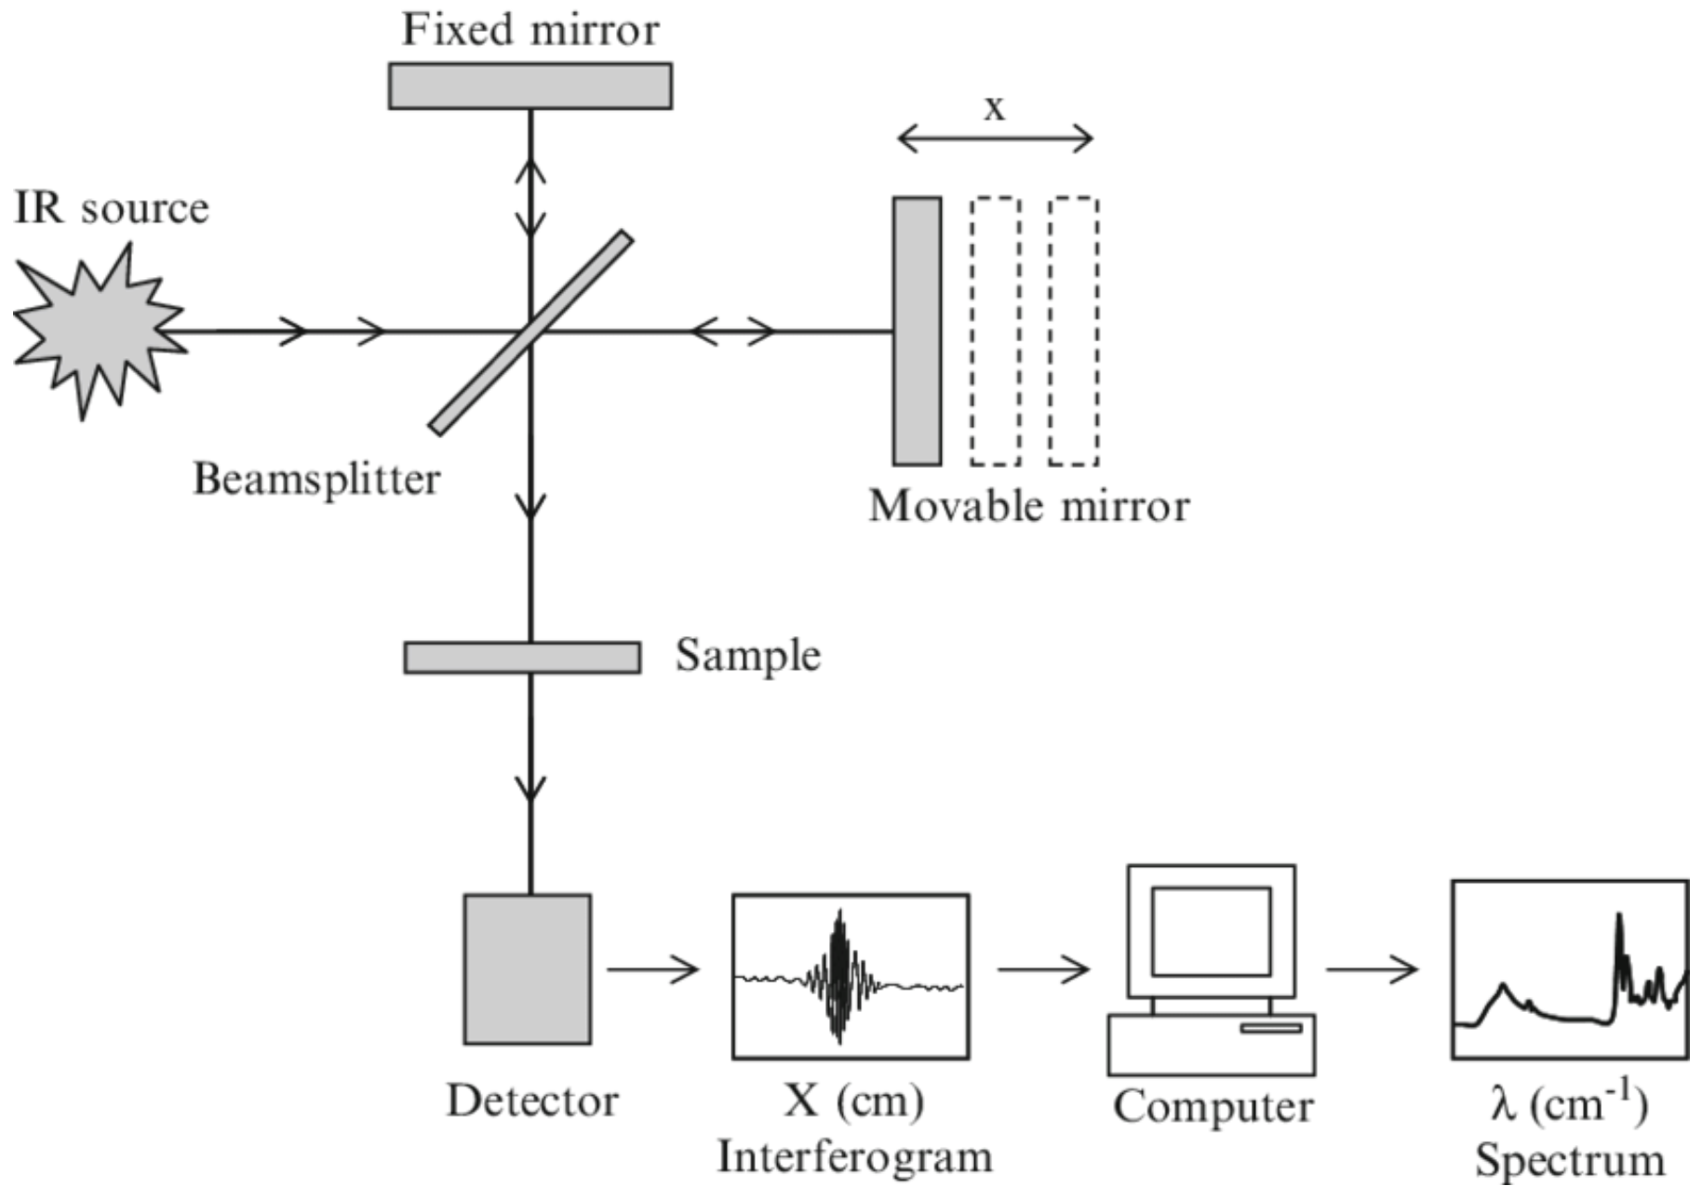
Figure 5 FTIR spectrometer features [9]
ATR-FTIR relies on total internal reflection of the beam, with the crystal having a higher refractive index than the sample. When the beam strikes the internal surface of the crystal, at an angle above the critical angle, it undergoes total internal reflection, producing an evanescent wave which interacts with only the first few microns of the sample. Due to this, sample preparation is minimal. [10], [11].

Importance of FTIR in Energetics
FTIR is commonly used in laboratories and in the field for the identification of explosive compounds [12]. In field tests allow samples to be analysed without the need for transportation and the potential increase in risk of an unplanned reaction or explosion. As FTIR is non-destructive, it is valuable where there is limited quantity of sample available for test. FTIR can be used in manufacture and through-life monitoring of samples, due to the formation or loss of functional groups. Additionally, it can detect contamination in samples, revealing impurities which may impact the stability or reactivity of a compound [13]. This helps ensure the expected stability, performance and reliability can be maintained.

Methodology

Equipment and Personal Protective Equipment (PPE)
- Samples for analysis.
- FTIR spectrometer and computer.
- Laboratory coat.
- Safety glasses.
- Nitrile gloves.
- Blue roll.
- Isopropyl alcohol.
- Bin for waste disposal.

Procedure
- Before starting the experiment put on the required PPE. This experiment is considered low risk; however, standard laboratory PPE should be worn.
Ensure the computer and Perkin Elmer Spectrum Two FTIR spectrometer are switched on, with the Spectrum IR software running. If either of these are not ready to use, seek assistance from the technician. The spectrometer will be in the configuration shown in Figure 6. Background scans will have already been run therefore there is no need for the student to conduct these.
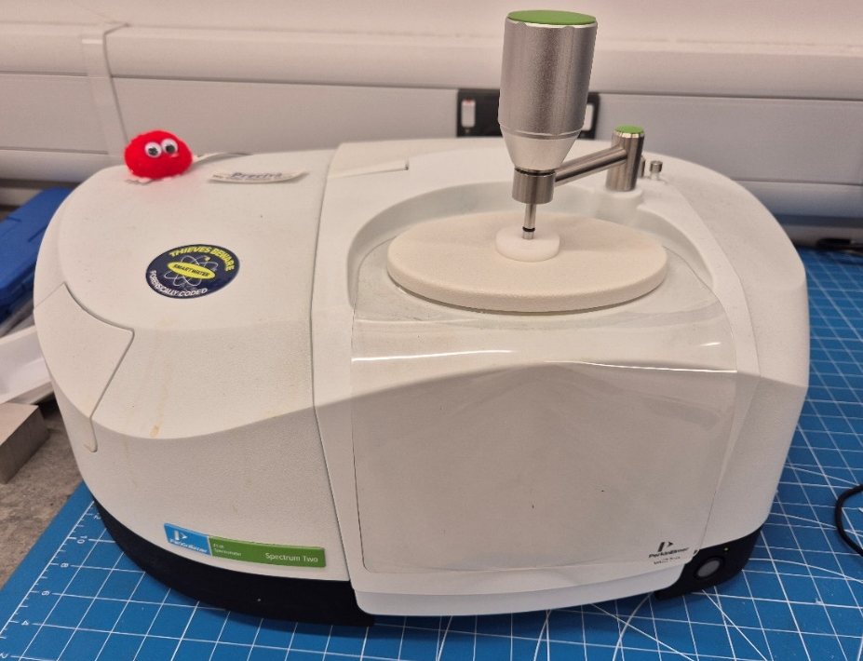
Figure 6 FTIR Spectrometer
- Select the correct anvil for the type of sample, referring to Figure 7 for guidance. These are located at the back right on the machine behind the arm. Attach the anvil onto the base of the arm, as shown in Figure 8, by firmly pushing.

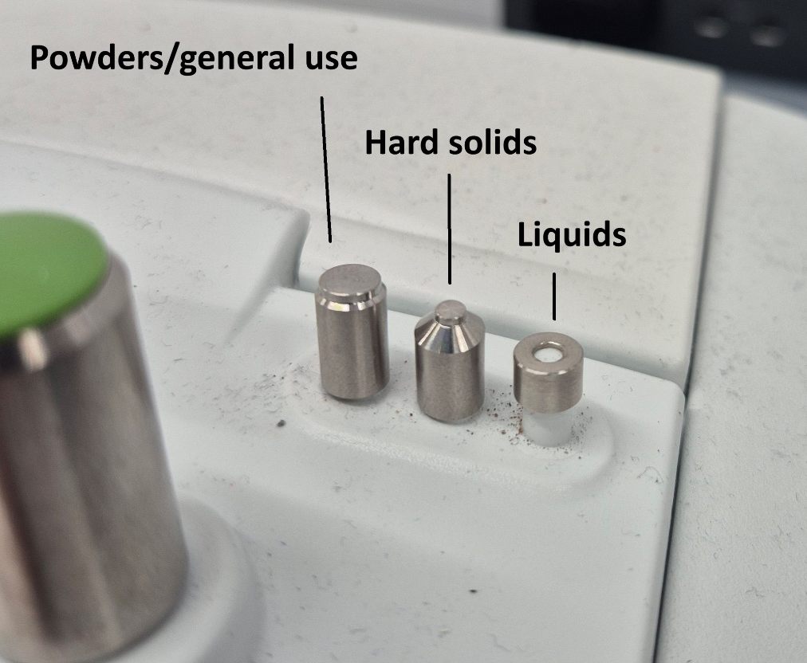
Figure 7 Anvil options
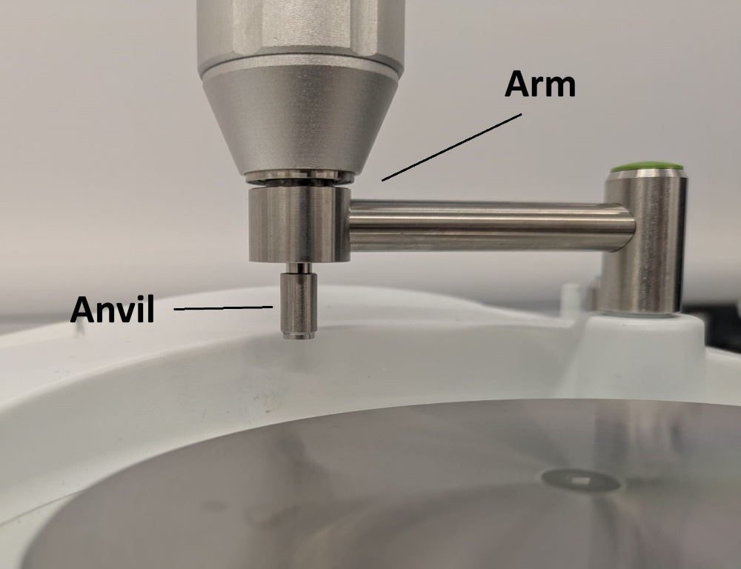
Figure 8 Anvil fitted to arm
- With a lint free tissue and isopropyl alcohol, clean the plate, crystal and anvil. Dry with a clean tissue.
- Using a spatula place enough sample on the crystal to completely cover it. The crystal is shown in Figure 9.

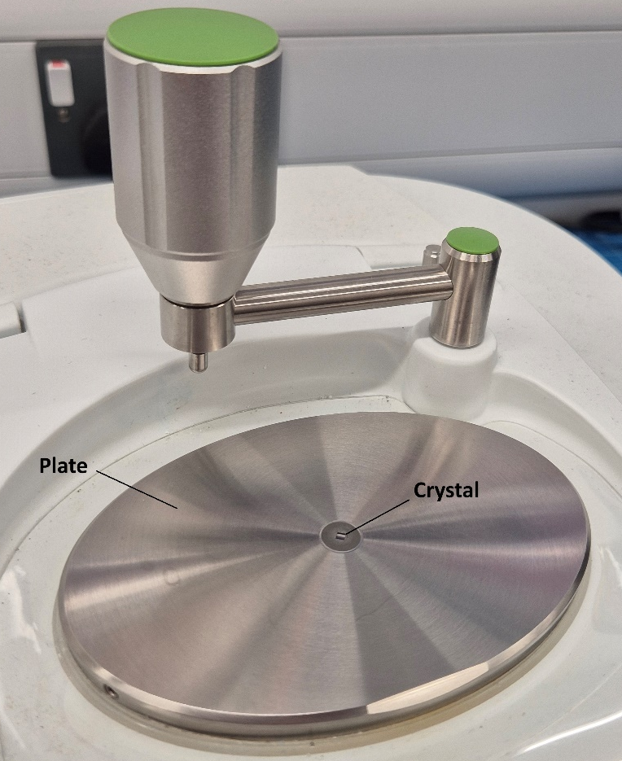
Figure 9 Plate and crystal

- Rotate the arm anticlockwise until it is over the sample. Turn the green knob clockwise until the ratchet clicks over at the preset tension, indicating sufficient pressure and contact with the sample.
- In the Spectrum Two software check the number of scans is set to 15, under ‘accumulations’ – shown in Figure 10.
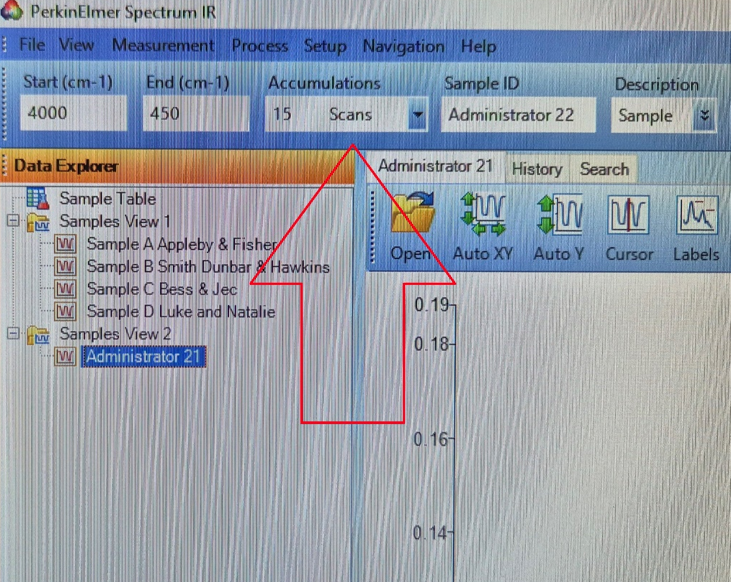
Figure 10 Number of sample scans (accumulations)

- Click ‘preview scan’. This provides a quick overview of the sample showing if it is clean and useable. If the preview returns a poor spectrum, refer to Appendix 1 for guidance.
- With an acceptable preview scan, click ‘scan’ again to run a full scan. This will perform 15 individual scans in the spectral range of 4000 cm⁻¹ to 450 cm⁻¹ and negates the need for manual repeat tests.
- A high-quality spectrum should be produced, if this is not the case refer to Appendix 1. The software automatically produces a transmittance spectrum; this is easily changed to absorbance by clicking ‘absorbance’ – highlighted in Figure 11.
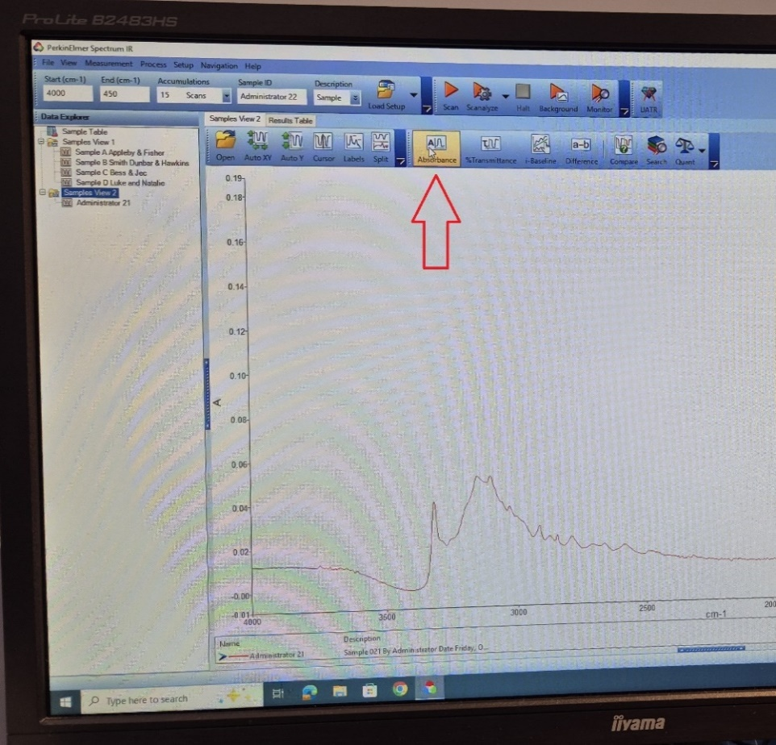
Figure 11 Absorbance spectrum button
- Compare the spectrum to the library by clicking ‘search’ – shown in Figure 12. This has been configured to search all 14466 samples held in the library. A search score will be shown alongside potential material matches, indicating the confidence limit for the sample to that material. A 95% match or higher is considered acceptable.

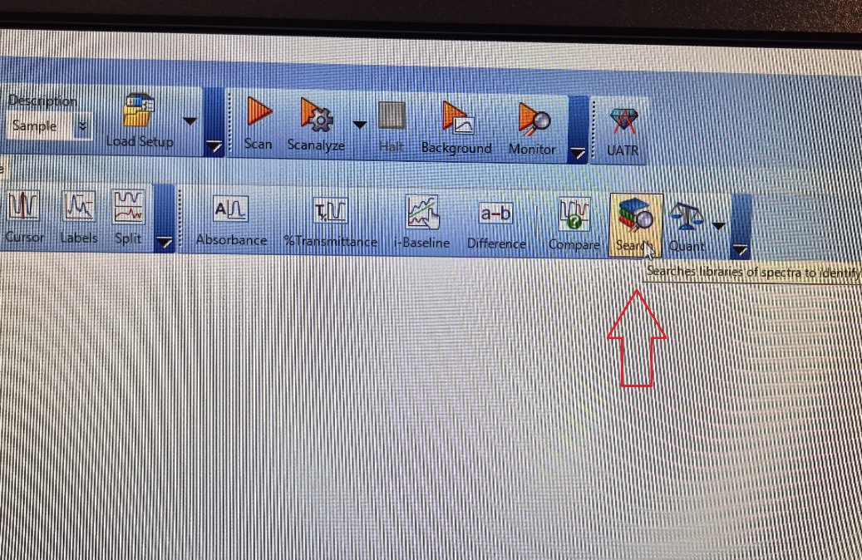
Figure 12 Search function in software
Search results and search score (percentage match) are shown in Figure 12.
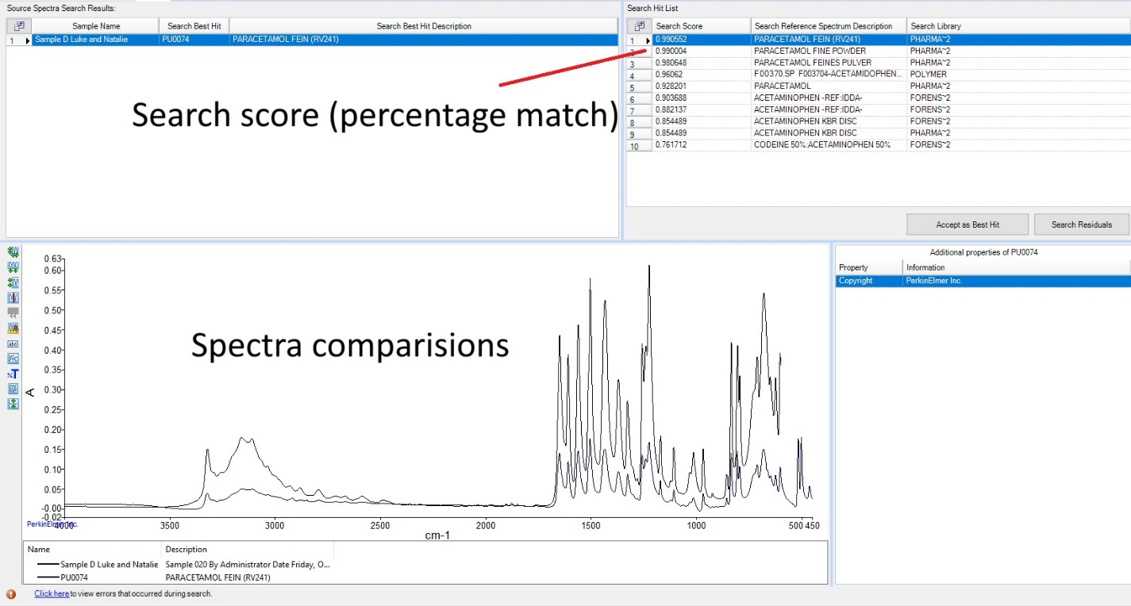
Figure 13 Library search results for acetaminophen
- When finished with the sample, twist the green knob on the arm anti-clockwise to lift the foot. Rotate the green arm clockwise to expose the crystal. Clean the plate, foot and crystal with IPA and lint free tissue, ensuring all waste is disposed of through appropriate routes. The FTIR and computer can be left running. Remove the anvil and place back on the holder, cover the crystal with the arm (or alternative cover if provided).
A quick reference guide for the Perkin Elmer Spectrum II can be found in Appendix 1.

Results
Figure 14 to Figure 17 show the spectra obtained from the scans for each of the four samples with each peak wave number labelled.
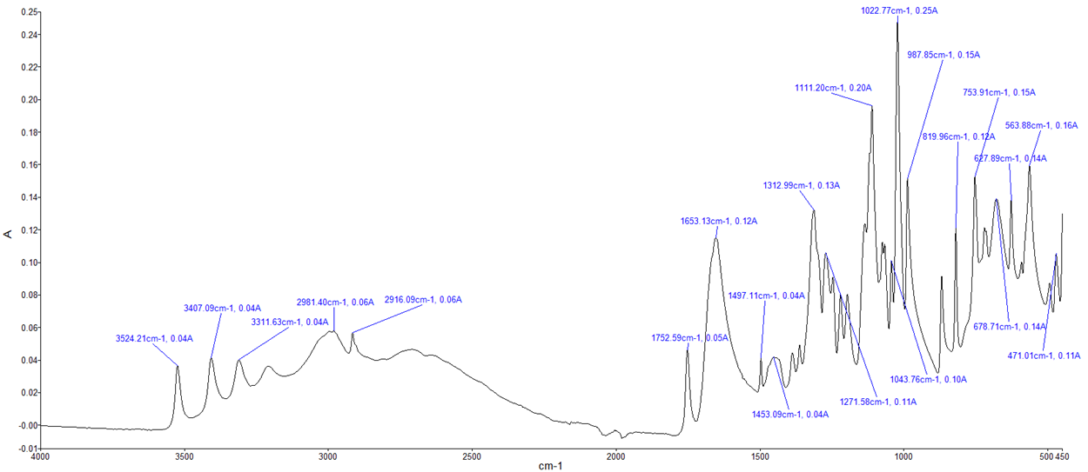
Figure 14 FTIR spectrum for sample A

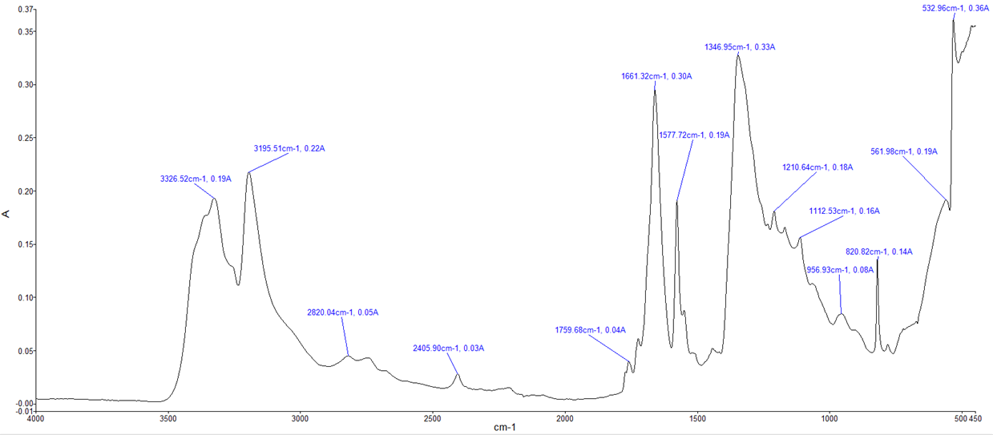
Figure 15 FTIR spectrum for sample B

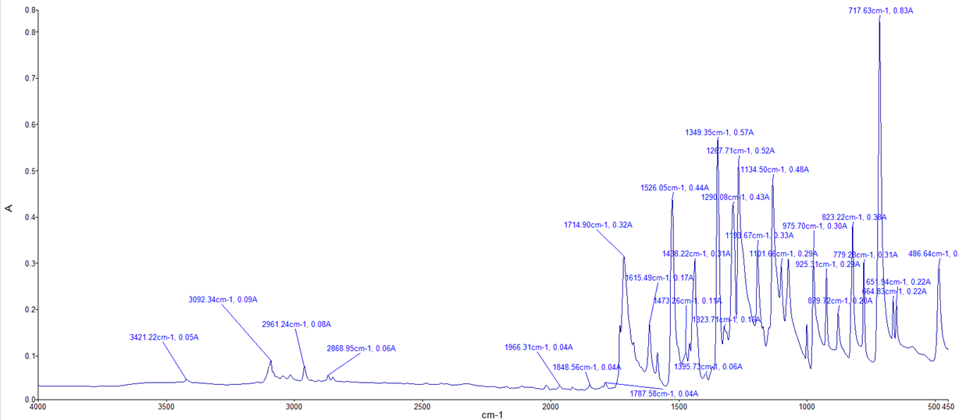
Figure 16 FTIR spectrum for sample C

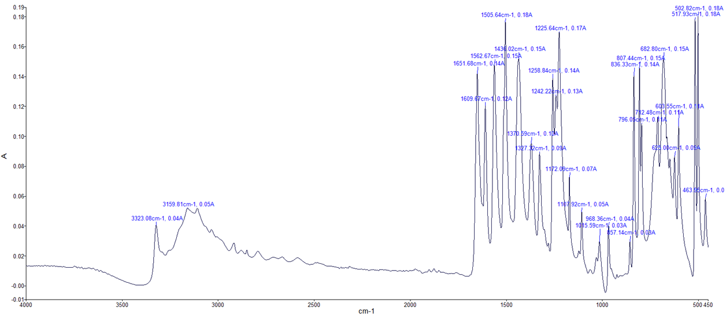
Figure 17 FTIR spectrum for sample D

Observations
Using information provided in the brief and literature, key general and fingerprint peaks were identified in each spectrum from the four compounds analysed [14], [15], [16], [17], [18], [19], [20] [21]. This information is summarised in Table 1 showing the peak and the wave number – noting that overlap and shifting of peaks may have introduced some error.
Table 1 Key peaks identified from FTIR spectra
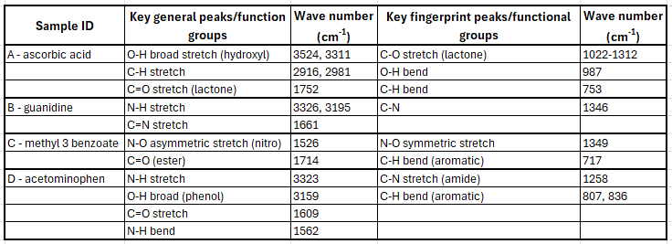
By identifying key peaks in both the general and the fingerprint region [22], it was possible to determine which spectra likely corresponded to each sample. For example, methyl 3-nitrobenzoate is the only compound in the tests to contain N-O bonds, while ascorbic acid is the only compound that features a lactone ring. Guanidine and acetaminophen both contain N-H bonds; however, guanidine lacks a benzene ring whereas acetaminophen contains one. The peaks noted in Table 1 support the predicted outcomes from 1.2 Predicted Outcome.
By way of confirmation the library search results have been included in Appendix 2. The percentage match from the library search is as follows:
- Ascorbic acid – 99.4%
- Guanidine – 99.5% (to guanidine nitrate)
- Methyl 3-nitrobenzoate – 52.6%
- Acetaminophen – 99.1%
Methyl 3-nitrobenzoate has a lower percentage match with compounds in the library than ideal. It was noted during testing the library does not contain a reference spectrum for methyl 3-nitrobenzoate, so a good match will not be possible. In this case it is possible to state this compound is likely to be methyl 3-nitrobenzoate due to a partial match from the library, identification of key functional groups from the spectrum and through a process of elimination with the other samples, given the information in the brief states that one sample is methyl 3-nitrobenzoate.

Discussion
Each of the identified compounds have applications to the energetic world.
Ascorbic acid has been used as a fuel substitute in black powder mixtures. It acts as a reducing agent, reacting with potassium nitrate to produce gas and heat, burning cleaner than conventional black powder [23] [24].
Guanidine (nitrate) is an explosive precursor that can be nitrated into nitroguanidine using sulphuric acid [25], [26]. It is used extensively in the energetic field from triple-base gun propellants to shock insensitive high explosives [27].
Cranfield University has been studying the use of acetaminophen as an inert substitute for High Melting Explosive (HMX), due to similar crystal properties [28]. This approach helps to establish good research methods before applying the techniques to energetic materials.
Methyl 3-nitrobenzoate is used in the manufacture of explosives. Since the compound is a nitro aromatic, it can be used as a precursor to a more energetic material [29] [30].

Conclusion
By examining FTIR spectra it was possible to determine the four unlabelled compounds, which was confirmed through comparison of a spectral library search. Sample A was identified as ascorbic acid, sample B as guanidine, sample C as methyl 3-nitrobenzoate and sample D as acetaminophen.
These results highlight the effectiveness of FTIR in identifying unknown compounds, by determination of key functional groups. The minimal sample preparation and rapid analysis is particularly valuable in the detection of explosive compounds both in the laboratory and in the field.
Future work could consider validation of the samples through a complementary technique such as Raman spectroscopy or gas chromatography - mass spectrometry which would provide additional structural information. This would provide additional confidence in any results obtained.

References

[1] | American Chemical Society, “Guanidine,” ACS, 20 07 2020. [Online]. Available: https://www.acs.org/molecule-of-the-week/archive/g/guanidine.html. [Accessed 2025 10 22].
[2] | M. Srabovic, M. Huremovic, B. Catovic, S. Kulic and A. Taletovic, “Design synthesis and crystallization of acetaminophen,” Journal of Chemical, Biological and Physical Sciences, vol. 7, no. 1, pp. 218-230, 2017.
[3] | EFSA Panel on Additives and Products or Substances used in Animal Feed, “Scientific Opinion on the safety and efficacy of vitamin C (ascorbic acid, sodium ascorbate, calcium ascorbate, ascorbyl palmitate, sodium calcium ascorbyl phosphate and sodium ascorbyl phosphate) as a feed additive for all animal species based on a dossi,” European Food Safety Authority, vol. 11, no. 2, 2013.
[4] | Sigma Aldrich, “Methyl 3-nitrobenzoate,” Merck, 2025. [Online]. Available: https://www.sigmaaldrich.com/GB/en/product/aldrich/155977?srsltid=AfmBOorXSo8izxyiqRqvufU_IxvMZaJg9m8HeCbqAgHkyZfL7xKcL96y. [Accessed 22 10 2025].
[5] | Y. Gong, X. Chen and W. Wu, “Application of fourier transform infrared (FTIR) spectroscopy in sample preparation: Material characterization and mechanism investigation,” Advances in Sample Preparation, vol. 11, 2024.
[6] | Thermo Fisher Scientific, Introduction to Fourier Transform Infrared Spectroscopy, Thermo Fisher Scientific.
[7] | X. Hou, S. Lv, Z. Chen and F. Xiao, “Applications of Fourier transform infrared spectroscopy technologies on asphalt materials,” Measurement, vol. 121, pp. 304-316, 2018.
[8] | K. Mattsson, S. Jocic, J. Aristeia de Lima and L.-A. Hansson, “Nanoplastics in aquatic environments—Sources, sampling techniques, and identification methods,” in Microplastic Contamination in Aquatic Environments, Elsevier, 2024, pp. 381-397.
[9] | J. Ojeda and M. Dittrich, “Fourier Transform Infrared Spectroscopy for MolecularAnalysis of Microbial Cells,” in Methods in Molecular Biology, Clifton, New Jersey, 2021, pp. 187-211.
[10] | M. Al-Kelani and N. Buthelezi, “Advancements in medical research: Exploring Fourier Transform Infrared (FTIR) spectroscopy for tissue, cell, and hair sample analysis,” Skin Research and Technology, vol. 30, no. 6, 2014.
[11] | S. G. Kazarian and K. L. A. Chan, “Applications of ATR-FTIR spectroscopic imaging to biomedical samples,” Biochimica et Biophysica Acta, vol. 1758, no. 7, pp. 858-867, 2006.
[12] | A. Banas, K. Banas, M. Banhou, H. O. Moser, L. Wen, P. Yang, Z. J. Li, M. Cholewa, S. K. Lim and C. H. Lim, “Post-blast detection of traces of explosives by means of Fourier transform infrared spectroscopy,” Vibrational Spectroscopy, vol. 51, pp. 168-176, 2009.
[13] | J. Wojtas and M. Szala, “Thermally enhanced FTIR spectroscopy applied to study of explosives stability,” Measurement, vol. 184, 2021.
[14] | A. Umer, S. Naveed, R. Naveed, M. S. Rafique and M. Imran, “A green method for the synthesis of Copper Nanoparticles using L-ascorbic acid,” RevistaMateria, pp. 197-203, 2014.
[15] | Y. C. Panicker, H. T. Varghese and D. Philip, “FT-IR, FT-Raman and SERS spectra of Vitamin C,” Spectrochimica Acta Part A: Molecular and Biomolecular Spectroscopy, vol. 65, no. 3-4, pp. 802-804, 2006.
[16] | A. A. Ebnalwaled, A. H. Said, M. M. Mahmoud and Y. M. Alsedfy, “XRD and FTIR of Ascorbic Acid and Monosodium Glutamate Food Additives,” International Journal of Research Publication and Reviews, vol. 3, no. 9, pp. 2155-2159, 2022.
[17] | C. Cao, K. Wu, W. Yuan, Y. Zhang and H. Wang, “Synthesis of non-water soluble polymeric guanidine derivatives and application in preparation of antimicrobial regenerated cellulose,” Fibers and Polymers, vol. 18, no. 6, pp. 1040-1047, 2017.
[18] | U. D. Thangaraj, M. Rajaganthan, K. Govindarajulu and J. P. Arulsamy, “Synthesis, Crystal Structure and Vibrational Spectral Analysis of Guanidinium Hydrogen L-aspartate Single Crystal,” Journal of Physical Science, vol. 28, no. 1, pp. 27-47, 2017.
[19] | C. E. Răducanu, T. Dobre, E. D. Mihăiescu, A. Morosan, R. Jidveian, D. R. C. Tîrpan, A. D. Vasiliu, C. I. Gogosa, O. C. Pârvulescu and B. Trică, “Synthesis of Guanidine and Its Deposition on Bacterial Cellulose as Green Heterogeneous Catalyst for Transesterification to Methyl Esters,” Energies, vol. 17, 2024.
[20] | P. Baspha, K. Bijudas, A. M. Tom, P. K. Archana, K. P. Murshida, K. Noufala Banu, K. R. Amritha and K. Vimisha, “Polymorphism of paracetamol: A comparative study on commercial paracetamol samples,” nternational Journal of Chemical Studies, vol. 1, no. 6, pp. 25-29, 2014.
[21] | F. Zapata, A. López-Fernández, F. Ortega-Ojeda, G. Quintanilla, C. García-Ruiz and G. Montalvo, “Introducing ATR-FTIR Spectroscopy through Analysis of Acetaminophen Drugs: Practical Lessons for Interdisciplinary and Progressive Learning for Undergraduate Students,” Journal of Chemical Education, vol. 98, no. 8, pp. 2676-2686, 2021.
[22] | M. Danilczuk, S. Schlick, S. Hamrock and M. Schaberg, “Understanding the fingerprint region in the infra-red spectra of perfluorinated ionomer membranes and corresponding model compounds: Experiments and theoretical calculations,” Journal of Power Sources, vol. 196, no. 20, pp. 8216-8224, 2011.
[23] | F. R. B. a. Medicine, D. Njus, P. M. Kelley, Y.-J. Tu and B. Schlegal, “Ascorbic acid: The chemistry underlying its antioxidant properties,” Free Radical Biology and Medicine, vol. 159, no. 1, pp. 37-43, 2020.
[24] | G.-h. L. Lang and K. Boyle, “Identification of Ascorbic Acid and Its Degradation Products in Black Powder Substitutes,” Journal of Forensic Science, vol. 54, no. 6, pp. 1315-1322, 2009.
[25] | M. Warman, S. Semel, J. Leccacorvi, R. Motto and R. Hutchinson, “Conversion of guanidine nitrate to nitroguanidine with recycle of spent acid,” Feltman Research Laboratory, New Jersey, 2018.
[26] | R. J. J. Simkins and G. Williams, “The nitration of guanidine in sulphuric acid. Part I. The reversible conversion of guanidine nitrate into nitroguanidine,” Journal of the Chemical Society, 1952.
[27] | S. W. Lewis, K. M. Agg, S. J. Gutowski and P. Ross, “Forensic Sciences | Gunshot Residues,” in Encyclopedia of Analytical Science (Second Edition), Elsevier, 2005, pp. 430-436.
[28] | A. Mintoff, C. Stennett and R. Vreclj, “The growth and shock testing of large single crystal energetics and analogues,” in Next Generation Energetics: 2nd International Explosives Conference, Royal Society of Chemistry, 2025, pp. 10-18.
[29] | M. J. Ledo, H. Flores, F. Ramos, V. L. S. Freitas and M. D. M. C. Ribeiro da Silva, “Thermochemical study to assess the energetical and structural effects of nitro substituents in methyl benzoate isomers,” The Journal of Chemical Thermodynamics, vol. 173, 2022.
[30] | S. I. Mulla, T. P. Manjunatha, R. S. Hoskeri, P. N. Tallur and H. Z. Ninnekar, “Biodegradation of 3-Nitrobenzoate by Bacillus flexus strain XJU-4,” World J Microbiol Biotechnol, vol. 27, no. 7, pp. 1582-1592, 2011.

Appendix 1
Table 2 provides an overview of some common problems associated with ATR-FTIR and how they might be resolved. In each case, seek guidance from the technician where further clarity or assistance is needed.
Table 2 ATR-FTIR Troubleshooting Guide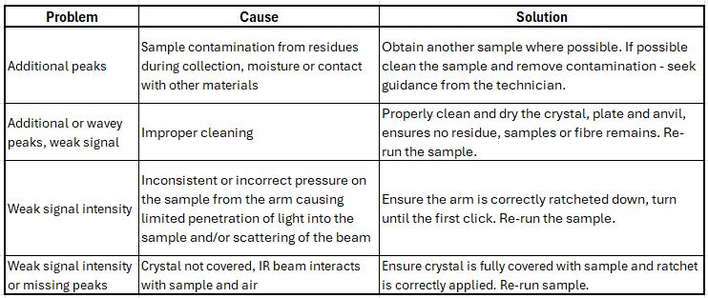
Table 3 provides a quick reference guide to the key parameters for the Perkin Elmer Spectrum II. These should not need to be changed. Guidance from the technician should be sought if there is a need for alternative settings or for help troubleshooting.
Table 3 Table 3 Quick reference guide to Perkin Elmer Spectrum II settings
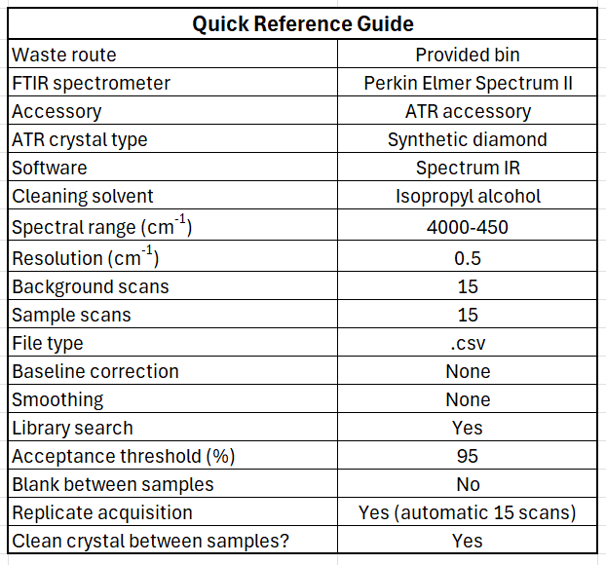

Appendix 2 – Library search results
Spectra from the analysed samples and library matched spectra are shown in Figure 18 to Figure 21. They show the percentage match of the library entry to that of the unknown sample, providing level of confidence (or not) in the composition of the sample.
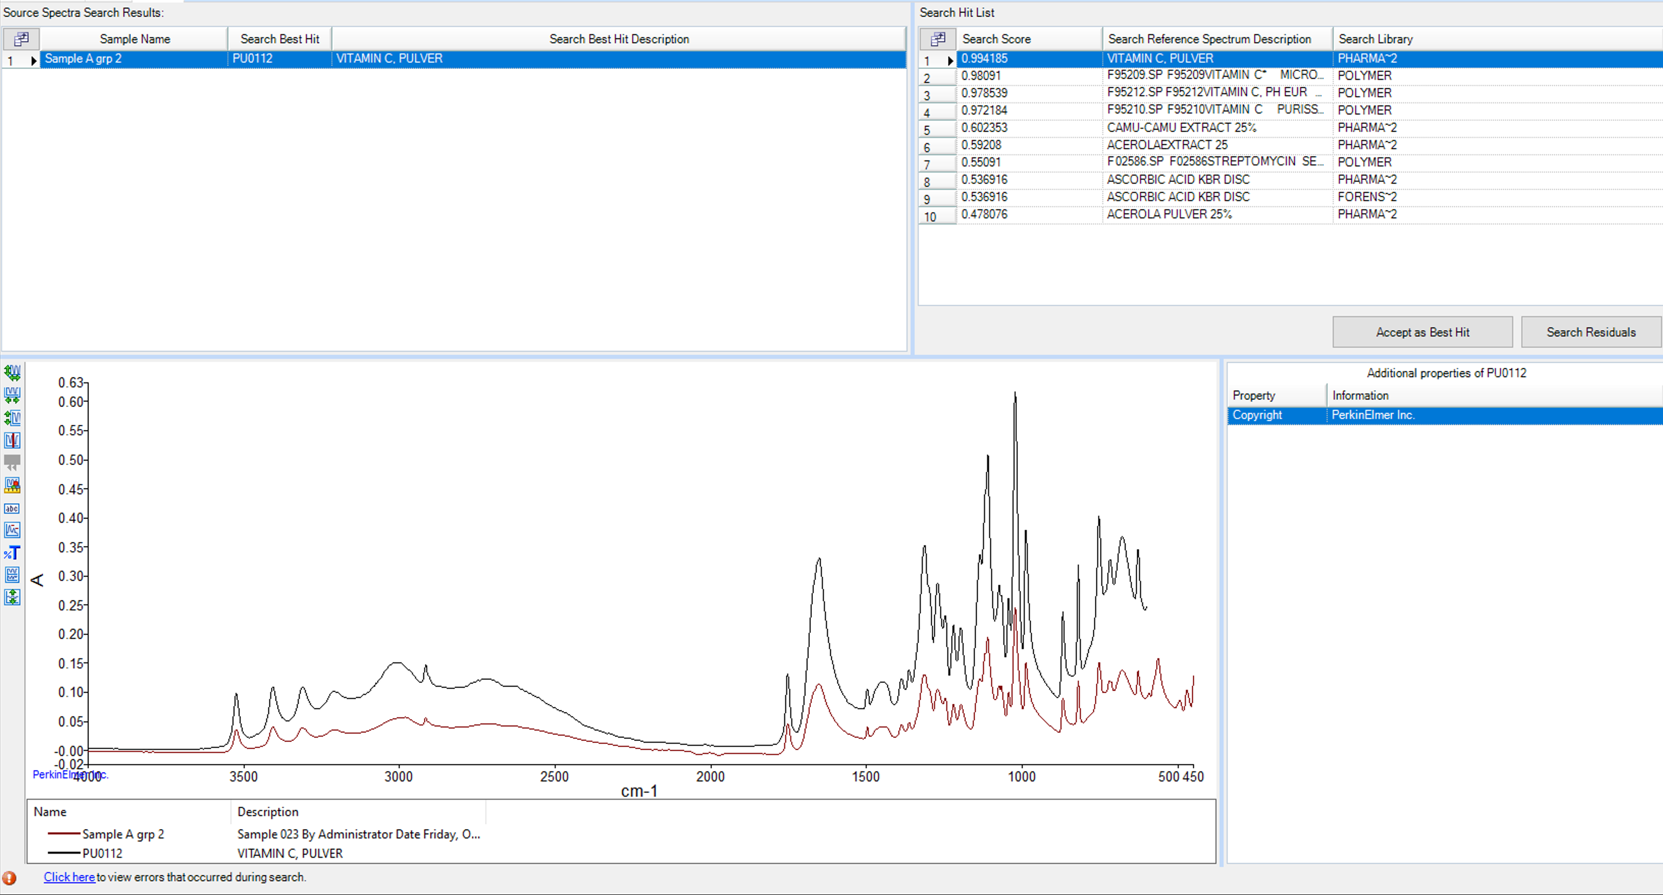
Figure 18 Sample A - ascorbic acid
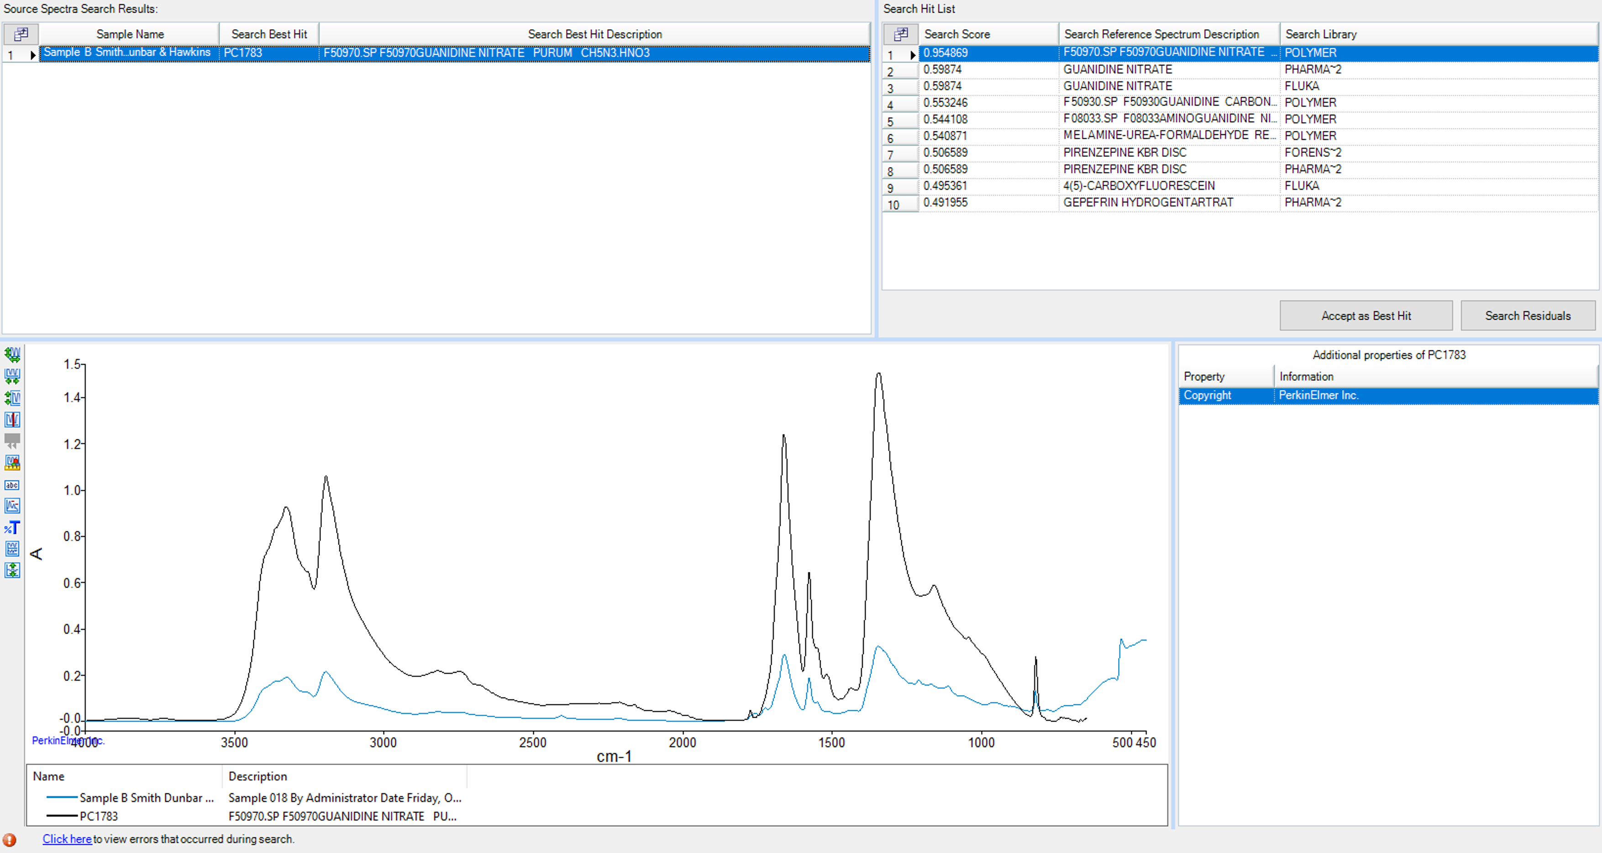
Figure 19 Sample B - guanidine nitrate
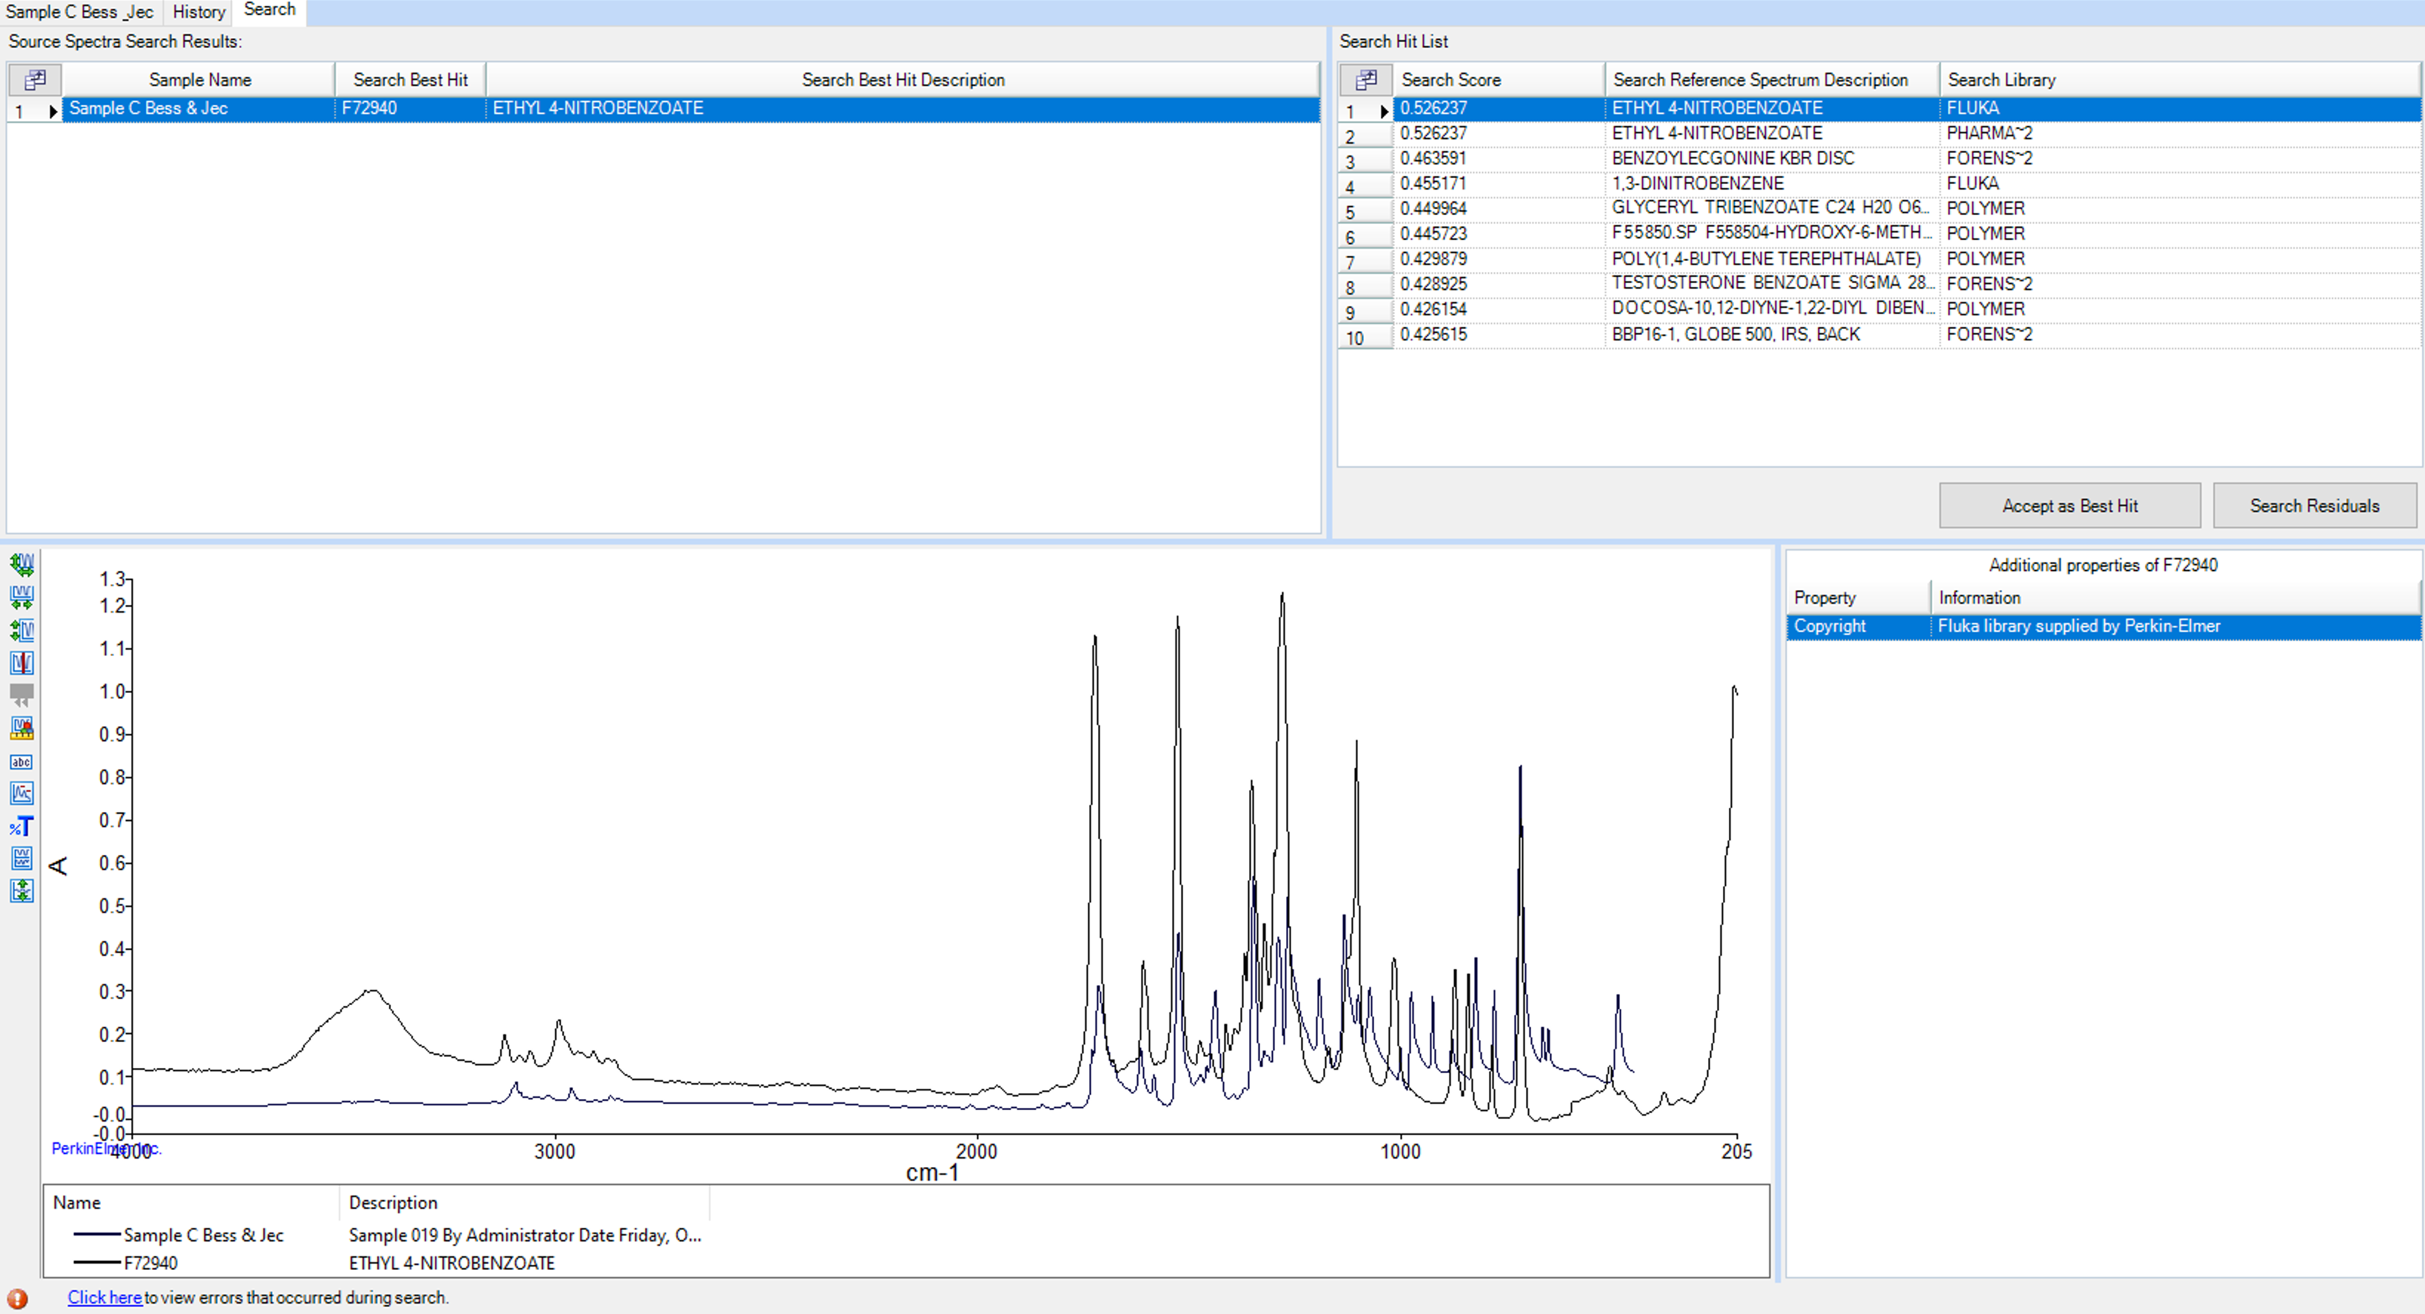
Figure 20 Methyl 3-nitrobenzoate
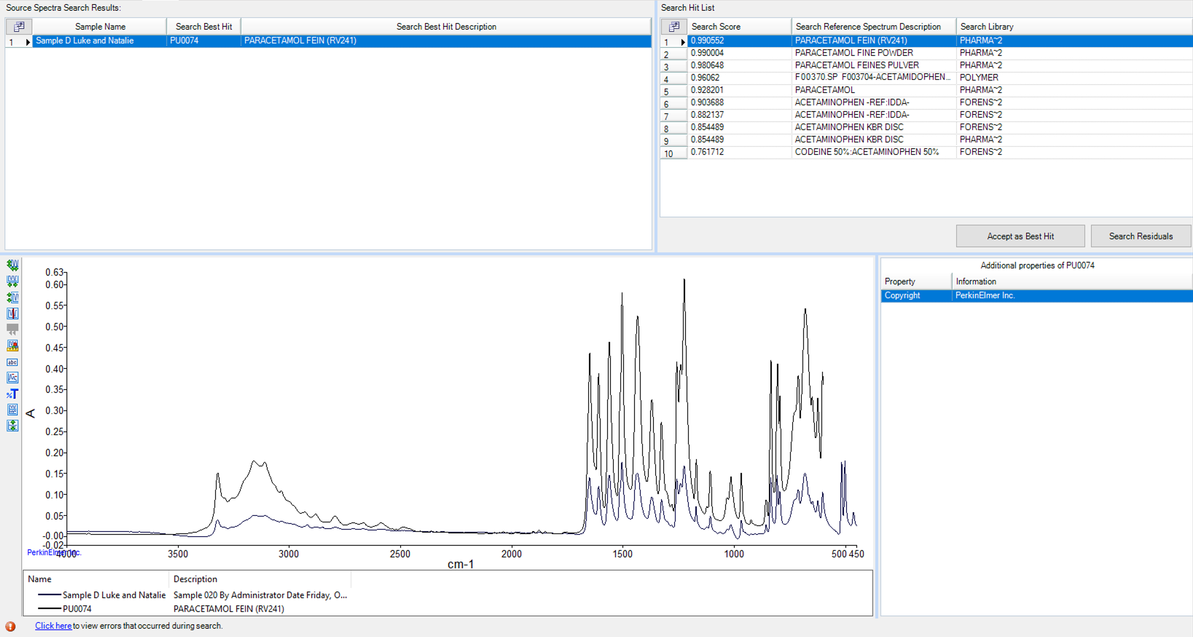
Figure 21 Acetaminophen

