Analysis chapter:
4.1 Introduction:
According to the National Institute of Health (2016), analysis is a detailed examination of research to deepen the readers understanding of the research topic and the true nature of the subject. In this chapter links between the secondary research conducted in the literature review will be compared against the data gathered through thematic analysis from the survey that asks both open and closed questions. This chapter will guide the researcher through the process of interpreting, presenting, and validating the data (Horn, 2009). The research will code the data into the following 3 objectives:

- To define the term domestic abuse and identify its prevalence within the UK.
- To explore the explanations of why domestic abuse is predominantly a female centred form of victimisation.
- To evaluate public perception on why they believe women are targeted more often, in comparison to men.

4.2: Findings: Description of analysis and results: Objective 1
Whilst the survey conducted had an estimated number of 100 responses, the survey had 35 responses overall. The first question in the survey that was presented to the participants was the age range of the participants. Anyone who was under the age of 18 was automatically kicked off the survey because of ethical considerations that must be complied with whilst conducting the research.
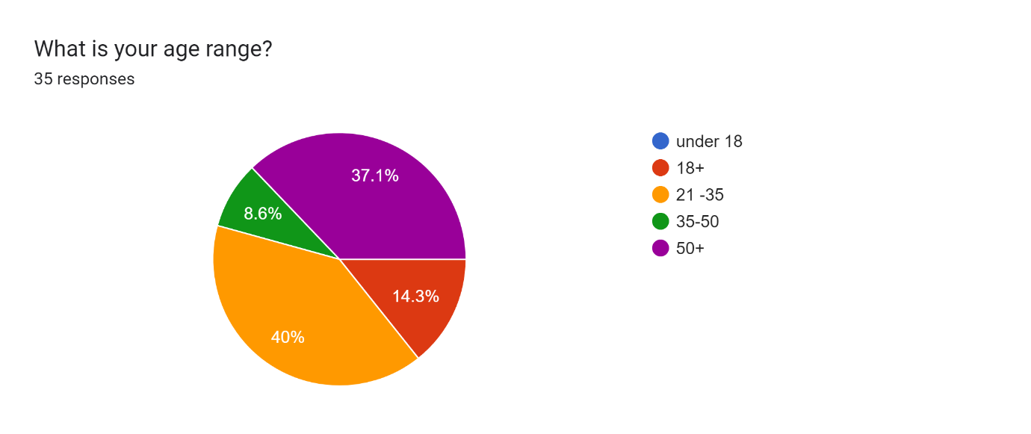
Q.1.
The pie chart displays that 14.3% of the participants are 18 or just over 18. With the lowest percentage (8.6%) of participants being aged 35-50. The majority (40%) of the participants were between the ages 21-35 and 37.1% of participants being over the age of 50. The survey being conducted in line with the literature review reveals how each age demographic views domestic abuse. The varying age demographics are due to the survey having been distributed on the researcher’s social media accounts.
Q.2.
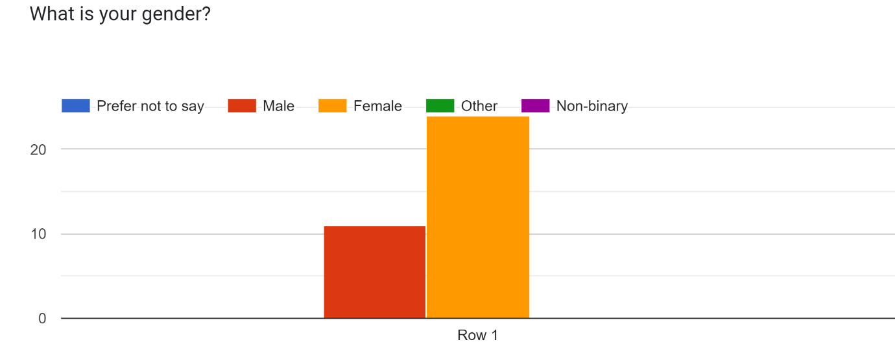
The graph above displays the number of total responses, the large majority being female participants. Participants who identified as male total 11 (31%) compared to 24 (69%) participants that identified as female. In context of the literature conducted for the study, the researcher aims to identify the difference between male and female perceptions on domestic abuse. The hypothesis states that women as a demographic group, are disproportionately affected by domestic abuse compared to males.

Q3. “What do you think domestic abuse is?”
For this question, participants communicated a thorough description of the term domestic abuse. Most participants described domestic abuse by providing examples of actions that are conducted by a perpetrator of domestic abuse. For example, a few participants stated that the use of “violence and control” against another were the actions that best describe an act of domestic abuse. The participants understanding of domestic abuse is similar to the research conducted in the literature review, where academics such as Bishop (2022) state that domestic abuse involves coercion and control. A few other responses from participants included the concept that domestic abuse is often psychical or emotional abuse conducted by someone ‘in their household’. The response regarding perpetrators being someone close to the victim reflects the revisions made to the definition of the domestic abuse by the Domestic Abuse Act 2021 that emphasises that domestic abuse is: “An abhorrent crime perpetrated on victims and their families by those who should love and care for them”. Overall, the participants had a good understanding of what domestic abuse encompasses.

Q4.
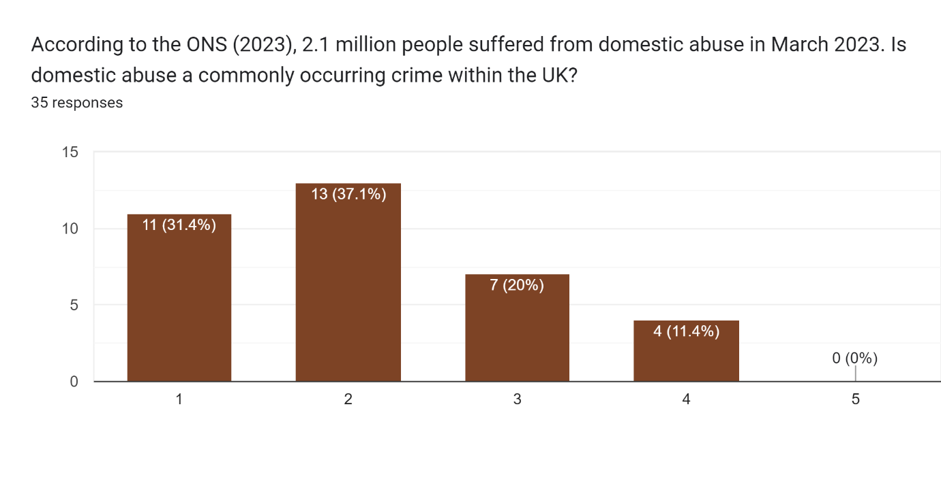
The prevalence of domestic abuse in the UK was tested against participants understanding and perception of how common domestic abuse cases are within the UK. According to the literature conducted, the ONS (2021), police records state that 1,453 867 abuse related incidents were recorded in March 2021. However, in the year 2023 more people suffered from domestic abuse: 2.1 million people suffered from domestic abuse in March (ONS, 2023). Participants were asked to select from a scale of 1-5. One being the more common and five being the least common. The bar graph displays that 68.5% of the respondents selected between 1-2 on the scale and 32.4 % of respondents selected between 3-4 on the scale for domestic abuse being a less common crime. However, not a single respondent thought that domestic abuse was uncommon as scale 5 was not selected by any participants. This reflects the idea that domestic abuse is a common crime within the UK.

Q.5 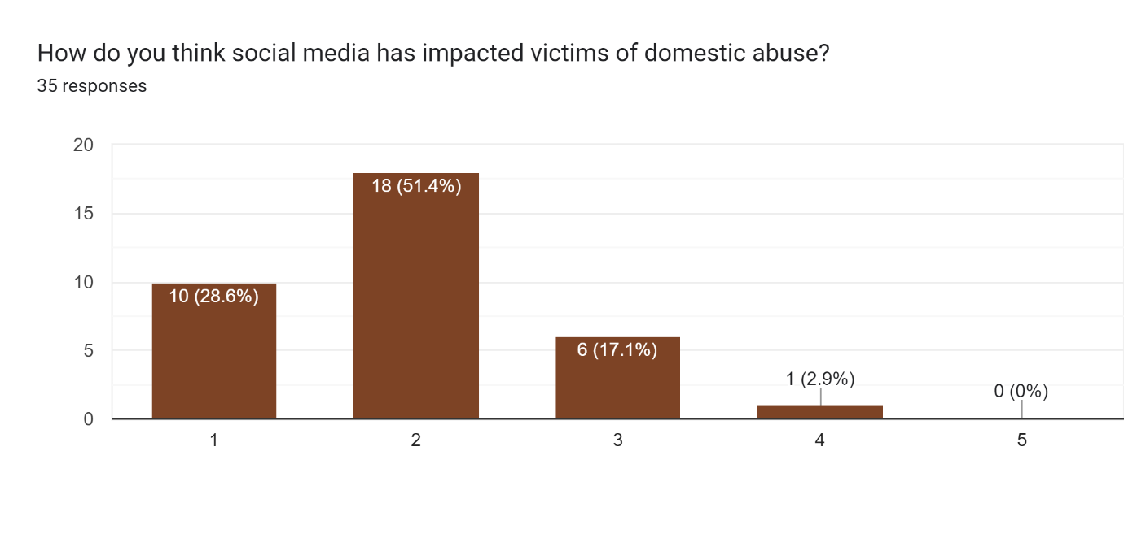
The question used a scale of 1-5 to identify participants viewpoint on factors that catalyse the prevalence of domestic abuse within the UK. The factor that was in the question of the survey was social media. 1 on the scale being that social media has largely impacted victims and 5 being hardly impacting victims. According to the data, 10 respondents believe that social media has largely impacted victims of domestic abuse and 18 respondents had the viewpoint that social media largely impacted victims of domestic abuse. All together 80% of respondents believe that social media has a significant impact on domestic abuse victims. Correspondingly the literature presents that technology facilitates coercive control by making it easier for perpetrators to keep track of their victims and gather information on their victim (Parliament, 2020). 17.1 % (6 respondents), selected 3 on the scale that infers that the respondents were unsure of the role that social media plays. 1 respondent answered 4 on the scale that suggests they believe that social media has hardly any impact on the victim and the difference in statistics displays a difference in public perception on the role of social media on victims of domestic abuse. This could largely be due to more mature age groups having a lack of understanding of what constitutes social media.
Q.6. “How do you think public health emergencies such as coronavirus impacted domestic abuse?”
Most participants stated that they did think that the coronavirus significantly impacted the number of domestic abuse cases regarding an increase in the number of cases. With reference to the literature review, in June 2020 there was a 7% increase in domestic abuse cases (Office for National Statistics, 2020). Participants further communicated that they believed the pandemic to have made it easier for perpetrators to hide the abuse. Demonstrated in the literature by the academic scholar Halford et al., (2020) communicates that in relation to domestic abuse, the mobility theory of crime suggests that victims were more susceptible to domestic abuse as regulations during that time obliged victims to spend more time with the perpetrator. Respondents stated that many victims of domestic abuse failed to report the abuse, particularly during covid. In correspondence with the literature, Hodgkinson (2023) states that police intervention and access to third party sectors made it more difficult for victims to ask and implement the means of support during social distancing restrictions.
4.3. The following responses are relevant to both Objective 2 and 3 of this research:
Objective 2: To explore the explanations of why domestic abuse is predominantly a female centred form of victimisation.
Objective 3: To evaluate public perception on why they believe women are targeted more often, in comparison to men.

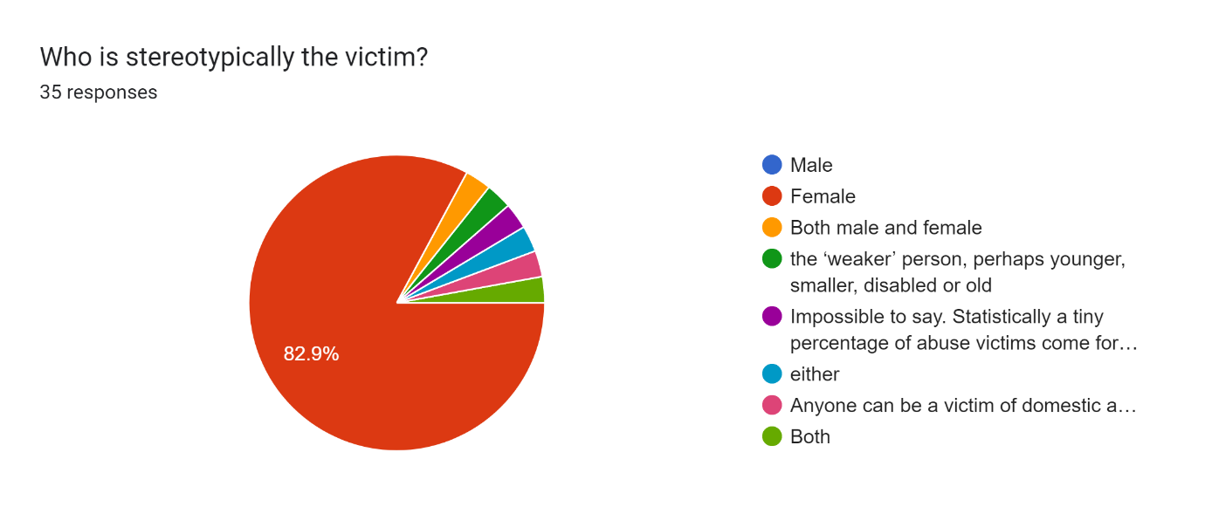
Q.7: Findings: description of analysis and results:
Common themes identified in Question 7 that is displayed is that out of 35 participants, 29 (82.9%) of the respondents had the viewpoint that females are stereotypically the victim of domestic abuse. 2 (5.8%) participants selected that both males and females can be victims of domestic abuse. Interestingly, 2 participants gave factors contributing to someone being a victim of domestic abuse, such as having lived in care homes or being the weaker individual. The respondents, however, did not select the option for ‘males’ to be victims of domestic abuse. Highlights research in the literature as the researcher provides evidence that women are predominately victims of domestic abuse. Morrison and Houghton (2023) explain that women are portrayed as the victims of domestic abuse and never the perpetrator that feeds the narrative that men are perceived to be perpetrators rather than victims.

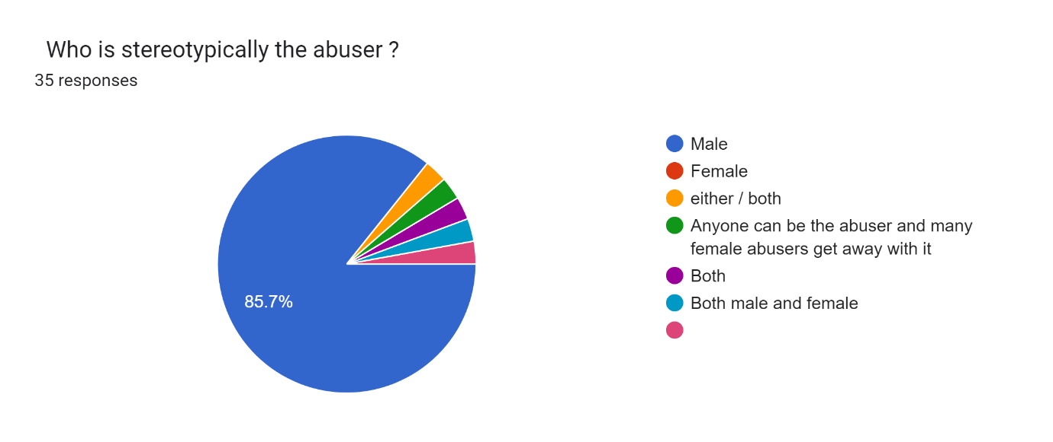
Q.8.
The pie chart presents statistics that reveal that 85.7% (30) respondants have the perception that men are stereotypically the abusers. As presented in the literature, Nnawulezi and Hacskaylo (2022), explain that conventional ideas of male dominance and female submission feeds into the concept of power disparities. 1 (2.9%) participant selected that females and another respondent 3 (8.7%) selected that both genders can be the abuser. Bhatia et al., (2021) presents a counter argument that states that male offenders are only responsible for being perpetrators. A respondent (2.9%) highlights the idea that women are perpetrators of domestic abuse but can hide the abuse more easily. According to the literature, Morrison and Houghton (2023), explain that women are exclusively portrayed as victims and not as willing participants in gender-based violence.
Q.9.
For the following question, the researcher asked the respondents to elaborate on question 7 by explaining why they felt that women are more likely to be victims of domestic abuse through asking the question:
“Give an example of a factor that could make women more susceptible to domestic abuse”.

A common theme identified through participants responses were that women were more likely to be victims of domestic abuse if they were isolated in some way. Responses indicated these themes as key words identified in the responses were: ‘Experiencing adverse childhood experiences’, ‘having ill mental health’ and ‘lack of contact with family and friends’. In accordance with the literature, scholars, Perrin et al., (2019) and Hogan et al., (2022) suggest that domestic abuse perpetrated by men is due to women’s unequal place in society and is a larger systemic issue of male violence against women. In relation to the responses, factors such as a lack of physical strength and women being afraid to speak up further supports the argument put forth. Other respondents gave factors such as drugs, and traditional views, according to statistics from a report by Reis (2019), women who face financial difficulties are 3.5 times more likely to be a victim of domestic abuse. Karlsson et al., (2022) note that the perception that women are stereotypically the victim comes from historical, cultural, and systemic factors that have shaped societal views on gender roles and power dynamics. For example, in cultures where women are encouraged to take on gender roles such as being a housewife.

Q.10
“Men can be victims of domestic abuse too. According to the Mankind Initiative (2020), men are 3 times less likely to report domestic abuse. Why do you think they fail to report the abuse?”

The responses were as follows:
- “The social pressure to appear like a “manly man” as well as a lack of information on what domestic violence really is.”
- “Because of the stereotype that forms around men to be “big strong man” and “men don’t cry”. So, I think they would feel if they reported abuse from there partner, they would get laughed at or not taken seriously because of their gender.”
- “They are afraid of the sigma that may come with being abused.”
- “It’s a macho thing!”

The researcher asked the participants why they thought that men were less likely to report domestic abuse. According to the data collected, the majority of respondents relayed that gender stereotypes, such as being “the big strong man”, play a major role in men’s lives and create conflict in their minds when it comes to reporting abuse that makes them feel as though their ego has been deflated. According to Wilson et al., (2021) indicate that underreporting and a shortage of resources for male victims could be due to society’s failure to view men as victims due to harmful social norms.

Q.11. “How could society and public services help male victims of domestic abuse come forward?”
The researcher identified common themes in the responses that was relevant to men failing to come forward and report domestic abuse. Respondents mainly stated that the stereotypes that men have imposed on them by society is a major factor. For instance, key words identified in the responses included: ‘Make it known that it is a genderless crime’. In accordance respondents stated that ‘awareness of male influences who have been victims’, ‘increased awareness and education, ‘more helplines’ to encourage men to come forward and discourage underreporting. For example, further steps can be taken to encourage male victims to seek help and come forward. For example, public services educating their workers on the stigma, prevention techniques (register for domestic abuse offenders) and the need for more male based charities.

4.4 Summary:
This chapter has highlighted key themes in the research that suggest that domestic abuse is a prevalent crime within the UK. Highlighted in question 4, not a single respondent selected that domestic abuse was ‘uncommon’. Factors that increased the prevalence of domestic abuse were the corona virus and technology that facilitated perpetrators actions. In accordance with objective 2 and 3, common themes were relevant to stereotypes encouraged by society, including men as the perpetrators and women as the victim and concluded that men fail to report domestic abuse due to these power disparities influenced by society. In the next chapter of the research the key themes will be discussed in further detail to validate the research conducted.

References:
Ali, Z. and Bhaskar, S.B., (2016) Basic statistical tools in research and data analysis, Indian journal of anaesthesia. Available at: https://www.ncbi.nlm.nih.gov/pmc/articles/PMC5037948/ (Accessed: 21 March 2024).
Bhatia, A., Fabbri, C., Cerna-Turoff, I., Turner, E., Lokot, M., Warria, A., Tuladhar, S., Tanton, C., Knight, L., Lees, S. and Cislaghi, B., (2021) ‘Violence against children during the COVID-19 pandemic’, Bulletin of the World Health Organisation, 99(10), p.730.
Bishop, C., (2022) ‘The impact of proposed intimate image abuse offences on domestic violence and abuse’, Northern Ireland Legal Quarterly, 73(AD2), pp.125-153.
Hodgkinson, S., Dixon, A., Halford, E. et al., (2023) Domestic abuse in the Covid-19 pandemic: measures designed to overcome common limitations of trend measurement. Crime Sci 12, 12. https://doi.org/10.1186/s40163-023-00190-7
Hylton, P., (2022) ‘Raising awareness of domestic abuse’, BDJ Team, 9(7), pp.8-10.
Karlsson, M., Wemrell, M., Merlo, J., & Ivert, A. K., (2022) ‘Intimate partner violence against women in the EU: a multilevel analysis of the contextual and individual impact on public perceptions’, Women & Criminal Justice, 32(5), 417-430.
Morrison, F. and Houghton, C., (2023) ‘Children’s human rights in the contexts of domestic abuse and COVID-19’
Nnawulezi, N. and Hacskaylo, M., (2022) ‘Identifying and responding to the complex needs of domestic violence housing practitioners at the onset of the COVID-19 pandemic’, Journal of Family Violence, 37(6), pp.915-925.
Office for National Statistics (2021). Domestic abuse prevalence and trends, England and Wales - Office for National Statistics. [online] www.ons.gov.uk. Available at: <// https://www.ons.gov.uk/peoplepopulationandcommunity/crimeandjustice/articles/domesticabuseprevalenceandtrendsenglandandwales/yearendingmarch2023#:~:text=%5Bnote%201%5D.- //> [Accessed 8 Dec. 2023].
Parliament., (2020) ‘Update following cyber security incident’ . Available at: <// https://www.parliament.uk/mps-lords-and-offices/offices/commons/media-relations-group/news/update-following-cyber-attack/ > (Accessed: 21 March 2024).
Reis, S., (2019). Domestic abuse is an economic issue – for its victims and for society. [online] CPAG. <//Available at: https://cpag.org.uk/news-blogs/news-listings/domestic-abuse-economic-issue-%E2%80%93-its-victims-and-society#:~:text=Women%20in%20households%20with%20low// > [Accessed 7 Dec. 2023].
Wilson, J.M. and Goodman, L.A., (2021) ‘"A community of survivors": a grounded theory of organisational support for survivor-advocates in domestic violence agencies’, Violence Against Women, 27(14), pp.2664-2686.

