6/16/2023
Isabela Golofca (2230764)
EFFECTIVE TEAM-WORKING AND COMMUNICATION
COMMUNICATION
WRITTEN REPORT
Word count: 1138

CONTENTS:
1. TERM OF REFERENCE 2
2. PROCEDURE 3
3. INTRODUCTION 4
4. MAIN FINDINGS 5
4.1. Effective communication in the workplace 5
4.2. Diverse types of communication 7
4.3. Communication issues in the workplace 11
5. CONCLUSION 13
6. REFERENCE LIST 15
7. APPENDICES 17

TERM OF REFERENCE

The report was requested by my lecturer, Melanie Squire and is one thousand words written report about Communication and should be finished by 16th of June 2023.

PROCEDURE

The sources that were used to compile this report are academic books, electronic journal, articles and books, web sites, own personal notes from my lecturer and YouTube video.

INTRODUCTION

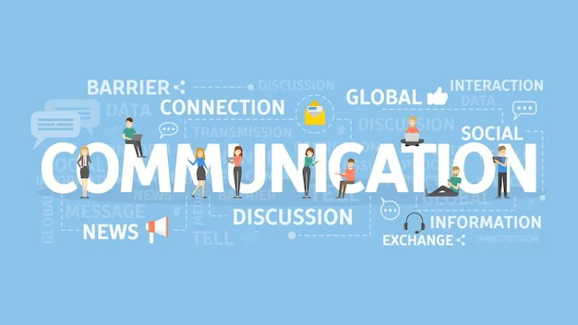
Image by Freepik.com

Communication refers to the process of exchanging information, messages, thoughts, or ideas between individuals or groups being a fundamental aspect of human interaction and having a crucial role in conveying thoughts, expressing emotions, sharing knowledge, and coordinating actions (Hasson, 2012).
On the other side, like were discus in class on 22nd of May (see Appendix 4), the most important that makes effective communication in the workplace is “leadership in action” (Maund, Schriek and Tinkler, 2017, p.17). A leader who gives clear goals, clear directions, and an exciting vision, will made the employee to be a part of it, giving feedback, loyalty, being professional and motivated, including face-to-face conversations, written correspondence, telephone calls, emails, text messages, video calls, social media platforms, and more.

MAIN FINDINGS

Effective communication in the workplace

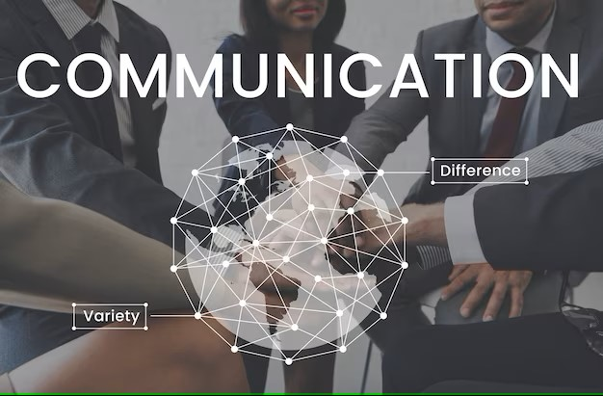
Image by Freepik.com

Effective communication is the ability to convey messages accurately and clearly to achieve the intended purpose. It involves both verbal (Pumble Blog, n.d.) and nonverbal (www.youtube.com, n.d.) elements and requires active listening and understanding. Key principles of effective communication include clarity, brevity, relevance, empathy, and feedback. By employing these principles, individuals can minimize misunderstandings, build rapport, and foster collaboration.
Effective communication involves the transmission and understanding of information in a clear and concise manner (www.mindtools.com, n.d.).
Effective communication in the workplace is essential for fostering collaboration, managing conflicts, and maintaining a positive and productive environment. Various key themes contribute to successful communication within a professional setting, including active listening, open and transparent communication, collaboration (Maund, Schriek and Tinkler, 2017, pp.45-101), and consideration for colleagues working remotely or in a hybrid setup (GilLab, n.d.).
In conclusion, effective workplace communication encompasses various themes that contribute to a harmonious and productive work environment. Active listening, open and transparent communication, collaboration, conflict management, and consideration for hybrid/home working colleagues all play pivotal roles in fostering effective communication (see Appendix 5). By embracing these principles, organizations can enhance teamwork, creativity, and overall success (GilLab, n.d.).
Effective communication is the foundation of successful interpersonal interactions, relationships, and organizational functioning. To understand and enhance communication processes, various communication models have been developed (Kashyap, 2021).

Diverse types of communication


Image by Freepik.com

This report provides an overview of effective communication and explores three prominent communication models: Berlo's model, Shannon-Weaver model, and Schramm's model, helping individuals and organizations optimize their communication practices.

- Developed by David K. Berlo in 1960, Berlo's model of communication highlight the role of the sender, receiver, message, channel, and feedback. According to this model, communication is a dynamic process influenced by numerous factors. The sender encodes the message, selecting symbols or words to convey the intended meaning. The message can be transmitted through a chosen channel, such as face-to-face interaction, phone call, or written communication. The receiver decodes the message, interpreting its meaning based on their understanding and context. Feedback is crucial in Berlo's model as it allows for the verification and clarification of the message (E-Learning Hub, 2020).



See Appendix 1

- Developed by Claude Shannon and Warren Weaver in 1949, the Shannon-Weaver model is widely recognized in the field of information theory. It views communication as a linear process comprising the sender, message, channel, receiver, and noise. The sender begins the communication by encoding the message and transmitting it through a channel. The receiver then decodes the message, attempting to extract the sender's intended meaning. However, noise, which can be external or internal, interferes with the communication process and may result in distortion or misinterpretation of the message (Shannon, 1948).



See Appendix 2

- Developed by Wilbur Schramm in 1954, Schramm's model emphasizes the role of shared meanings and feedback in communication. It views communication as a reciprocal process between the sender and receiver, with both parties actively encoding and decoding messages. According to this model, effective communication is achieved when shared meanings are created through a mutually understandable message. The model highlights the importance of feedback in assessing the effectiveness of communication and making necessary adjustments to ensure shared understanding. Schramm's model also acknowledges that communication is influenced by factors such as cultural background, individual experiences, and social context (Lee and Schramm, 1956).

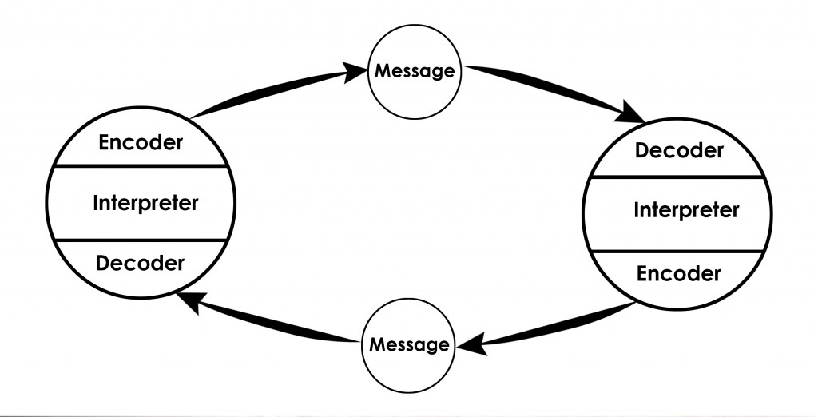

See Appendix 3

Communication issues in the workplace


Image by Freepik.com

Effective communication plays a vital role in promoting productivity and fostering a harmonious work environment. However, despite its importance, communication issues can arise in the workplace, hindering collaboration and hindering progress. In this report, the creator will discuss a specific communication issue encountered in the workplace, outline how the creator overcame it, and reflect on the lessons learned from the experience.
The communication issue encountered was related to misinterpretation and lack of clarity in written communication (LISBDNETWORK, 2014). In creator team, they heavily relied on emails and instant messaging platforms to exchange information and coordinate tasks.

Image by Freepik.com

However, due to the brevity and informality of these mediums, messages often lacked necessary context and were prone to misinterpretation. This led to confusion, delays, and occasional misunderstandings among team members.
Recognizing the negative impact of miscommunication, the creator took various steps to address and overcome this issue, beginning by practicing active listening, seeking clarification, and put in practice face-to-face discussions. The creator started utilizing diagrams, and flowcharts to supplement the written messages. These aids helped convey complex ideas more effectively and reduced the chances of misinterpretation.

CONCLUSION


Image by Freepik.com

Effective communication is crucial for individuals and organizations to achieve their goals. Understanding and applying these communication models can enhance interpersonal and organizational communication, leading to better understanding, collaboration, and overall success.
According to Fuller et al., each of the three communication models offers valuable insights into understanding the communication process. While Berlo's Model focuses on interpersonal communication, Shannon-Weaver's Model is more suitable for technical communication, and Schramm's Model finds application in mass communication contexts.
However, all three models have limitations in capturing the complexities of communication, such as cultural influences, power dynamics, and interactive nature (Fuller et al., 2023).
To fully comprehend communication dynamics, it is essential to consider a combination of these models along with other relevant frameworks that address the broader contextual factors and societal dynamics at play.

REFERENCE LIST

E-Learning Hub (2020). Berlo’s Model of Communication/SMCR Model of Communication [video]. Available at: https://www.youtube.com/watch?v=wYiSBT0gNv8 [Accessed 18 May 2023].

Fuller et al., (2023). Empathy Competencies and Behaviors in Professional Communication Interactions: Self Versus Client Assessments. Business and Professional Communication Quarterly, p.232949062211375 [online]
Available at: https://doi.org/10.1177/23294906221137569. [Accessed 20 May 2023].

GilLab. (n. d.). Hybrid-Remote: understanding nuances and pitfalls [Online]. Available at: https://about.gitlab.com/company/culture/all-remote/hybrid-remote/ [Accessed 4 June 2023].

‌Goman, C.K. (n.d.). How Culture Controls Communication. [online] Forbes. Available at: https://www.forbes.com/sites/carolkinseygoman/2011/11/28/how-culture-controls-communication/?sh=3922eef5263b [Accessed 18 May 2023].

‌Hasson, G. (2012). Brilliant Communication Skills: What the best communicators know, do and say. [online] Google Books. Pearson UK. Available at: https://www.google.co.uk/books/edition/Brilliant_Communication_Skills/U4zFAusntjsC?hl=en&gbpv=0 [Accessed 19 May 2023].

‌Kashyap, V. (2021). Effective Communication in the Workplace: How and Why? Spiceworks [online]. Available at: https://www.spiceworks.com/hr/engagement-retention/guest-article/effective-communication-in-the-workplace-how-and-why/. [Accessed 18 May 2023].

LISBDNETWORK (2014). What is communication? [online] Library & Information Science Education Network [online]. Available at: https://www.lisedunetwork.com/communication-meaning-definition/. [Accessed 20 May 2023]

Maund A., Schriek M., and Tinkler P. K. (2017). Certificate in Higher Education: Skills for the Workplace Student Yearbook. London: Sage Publications Ltd, pp.45-101.
www.mindtools.com. (n.d.). MindTools | Home. [online] Available at: https://www.mindtools.com/a3y5cte/how-good-are-your-communication-skills. [Accessed 16 May 2023].

Pech, J. (2022). Nonverbal Communication in Leadership | Father Dr. Dr. Justinus Pech | [video] Available at: https://www.youtube.com/watch?v=q03U5Kfsxt0. [Accessed 01 Jun. 2023].

‌Pumble Blog. (n.d.). Verbal communication explained - Pumble. [online] Available at: https://pumble.com/blog/verbal-communication/#:~:text=Verbal%20communication%20is%20a%20type. [Accessed 01 Jun. 2023].

‌Lee, A.M. and Schramm, W. (1956). The Process and Effects of Mass Communication. American Sociological Review, 21(3), p.408 [online].
Available at: https://doi.org/10.2307/2089327. [Accessed 17 May 2023].

‌Shannon, C.E. (1948). A Mathematical Theory of Communication. Bell System Technical Journal, [online] 27(4), pp.623–656 [online].
Available at: https://doi.org/10.1002/j.1538-7305.1948.tb00917.x. [Accessed 17 May 2023]
‌

APPENDICES

Appendix 1: https://www.communicationtheory.org/berlos-smcr-model-of-communication/
Additionally, the model recognizes the influence of factors such as attitudes, knowledge, and social system on effective communication. Berlo's model is widely used in interpersonal communication research and training. However, it oversimplifies the complexity of communication by neglecting contextual and cultural factors, limiting its applicability in diverse settings (Goman, n.d.).

Appendix 2: https://www.communicationtheory.org/shannon-and-weaver-model-of-communication/
This model introduces the concept of noise, which can interfere with message transmission. The Shannon-Weaver Model has been influential in the field of technical communication and telecommunication systems. However, its limitation lies in its linear nature, overlooking the interactive and dynamic aspects of communication. It also lacks emphasis on the role of context and the social dimensions of communication (Shannon, 1948).

Appendix 3: https://www.communicationtheory.org/osgood-schramm-model-of-communication/
This model has been influential in the field of mass communication and media studies. However, it tends to oversimplify complex communication processes and does not address the power dynamics inherent in certain communication contexts (Lee and Schramm, 1956).

Appendix 4:

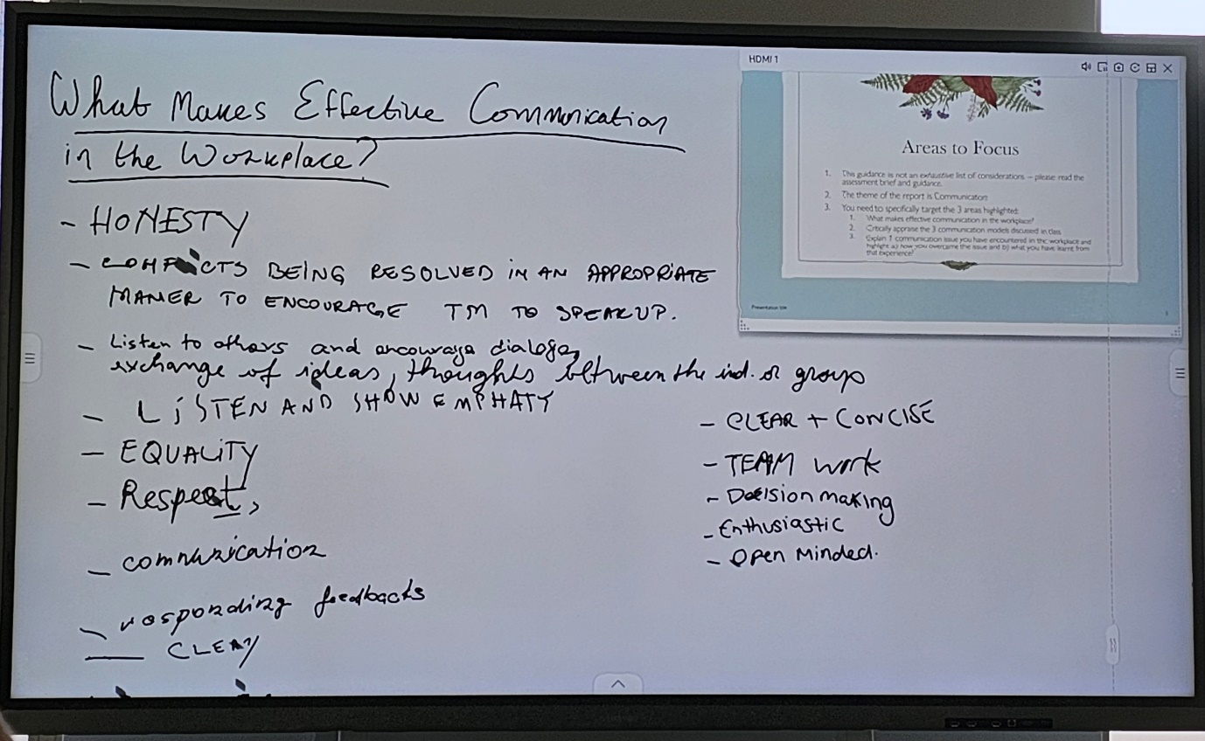
Work in class, 22nd of May 2023.

Appendix 5:
Active listening is a fundamental aspect of effective workplace communication. It involves fully concentrating on and understanding the message being conveyed by a colleague or team member. Active listening entails giving one's undivided attention, maintaining eye contact, and being attentive to both verbal and non-verbal cues. By actively listening, individuals can comprehend information accurately, demonstrate respect for others, and respond appropriately. This practice facilitates mutual understanding and promotes meaningful interactions among team members (Maund, Schriek and Tinkler, 2017, pp.52-54).

Open and transparent communication is another crucial element in the workplace. It involves sharing information, ideas, and feedback openly, honestly, and respectfully. Transparent communication cultivates trust, encourages open dialogue, and helps build stronger relationships within teams. It also ensures that everyone is well-informed, reducing misunderstandings, and promoting a sense of inclusion and belonging (Maund, Schriek and Tinkler, 2017, p.62).

Collaboration plays a significant role in effective workplace communication. It involves working together towards a common goal, pooling resources, and leveraging the diverse skills and perspectives of team members. Effective collaboration requires clear communication channels, defined roles and responsibilities, and an atmosphere of trust and respect. When individuals actively communicate and collaborate, they can generate innovative ideas, solve problems efficiently, and achieve collective success (GilLab, no date).

Conflict management is another critical aspect of effective workplace communication. Conflicts and disagreements are inevitable in any professional setting, but how they are managed can significantly impact the overall work environment. Effective communication skills, such as active listening, empathy, and assertiveness, help address conflicts constructively. It is important to encourage open discussions, seek common ground, and find mutually beneficial solutions. By managing conflicts effectively, teams can maintain positive relationships, foster a healthy work environment, and achieve optimal outcomes (GilLab, no date).

Considering the increasing prevalence of hybrid and remote work arrangements, it is vital to adapt communication practices to accommodate colleagues working from various locations. This may involve utilizing digital tools and platforms for seamless collaboration, ensuring regular and inclusive communication with remote team members, and being mindful of potential communication barriers. By embracing technology and adopting inclusive practices, teams can overcome geographical limitations and promote effective communication regardless of physical proximity (GilLab, no date).

