

Course Title: MBA - International Business
Term 1

Module Name: Marketing Management
Module Code: LCMB7024

Student Name: Hitarth Girishbhai Sorathiya
Student ID: 2506577

Lecturer’s Name: Dr. Laila Maazouz

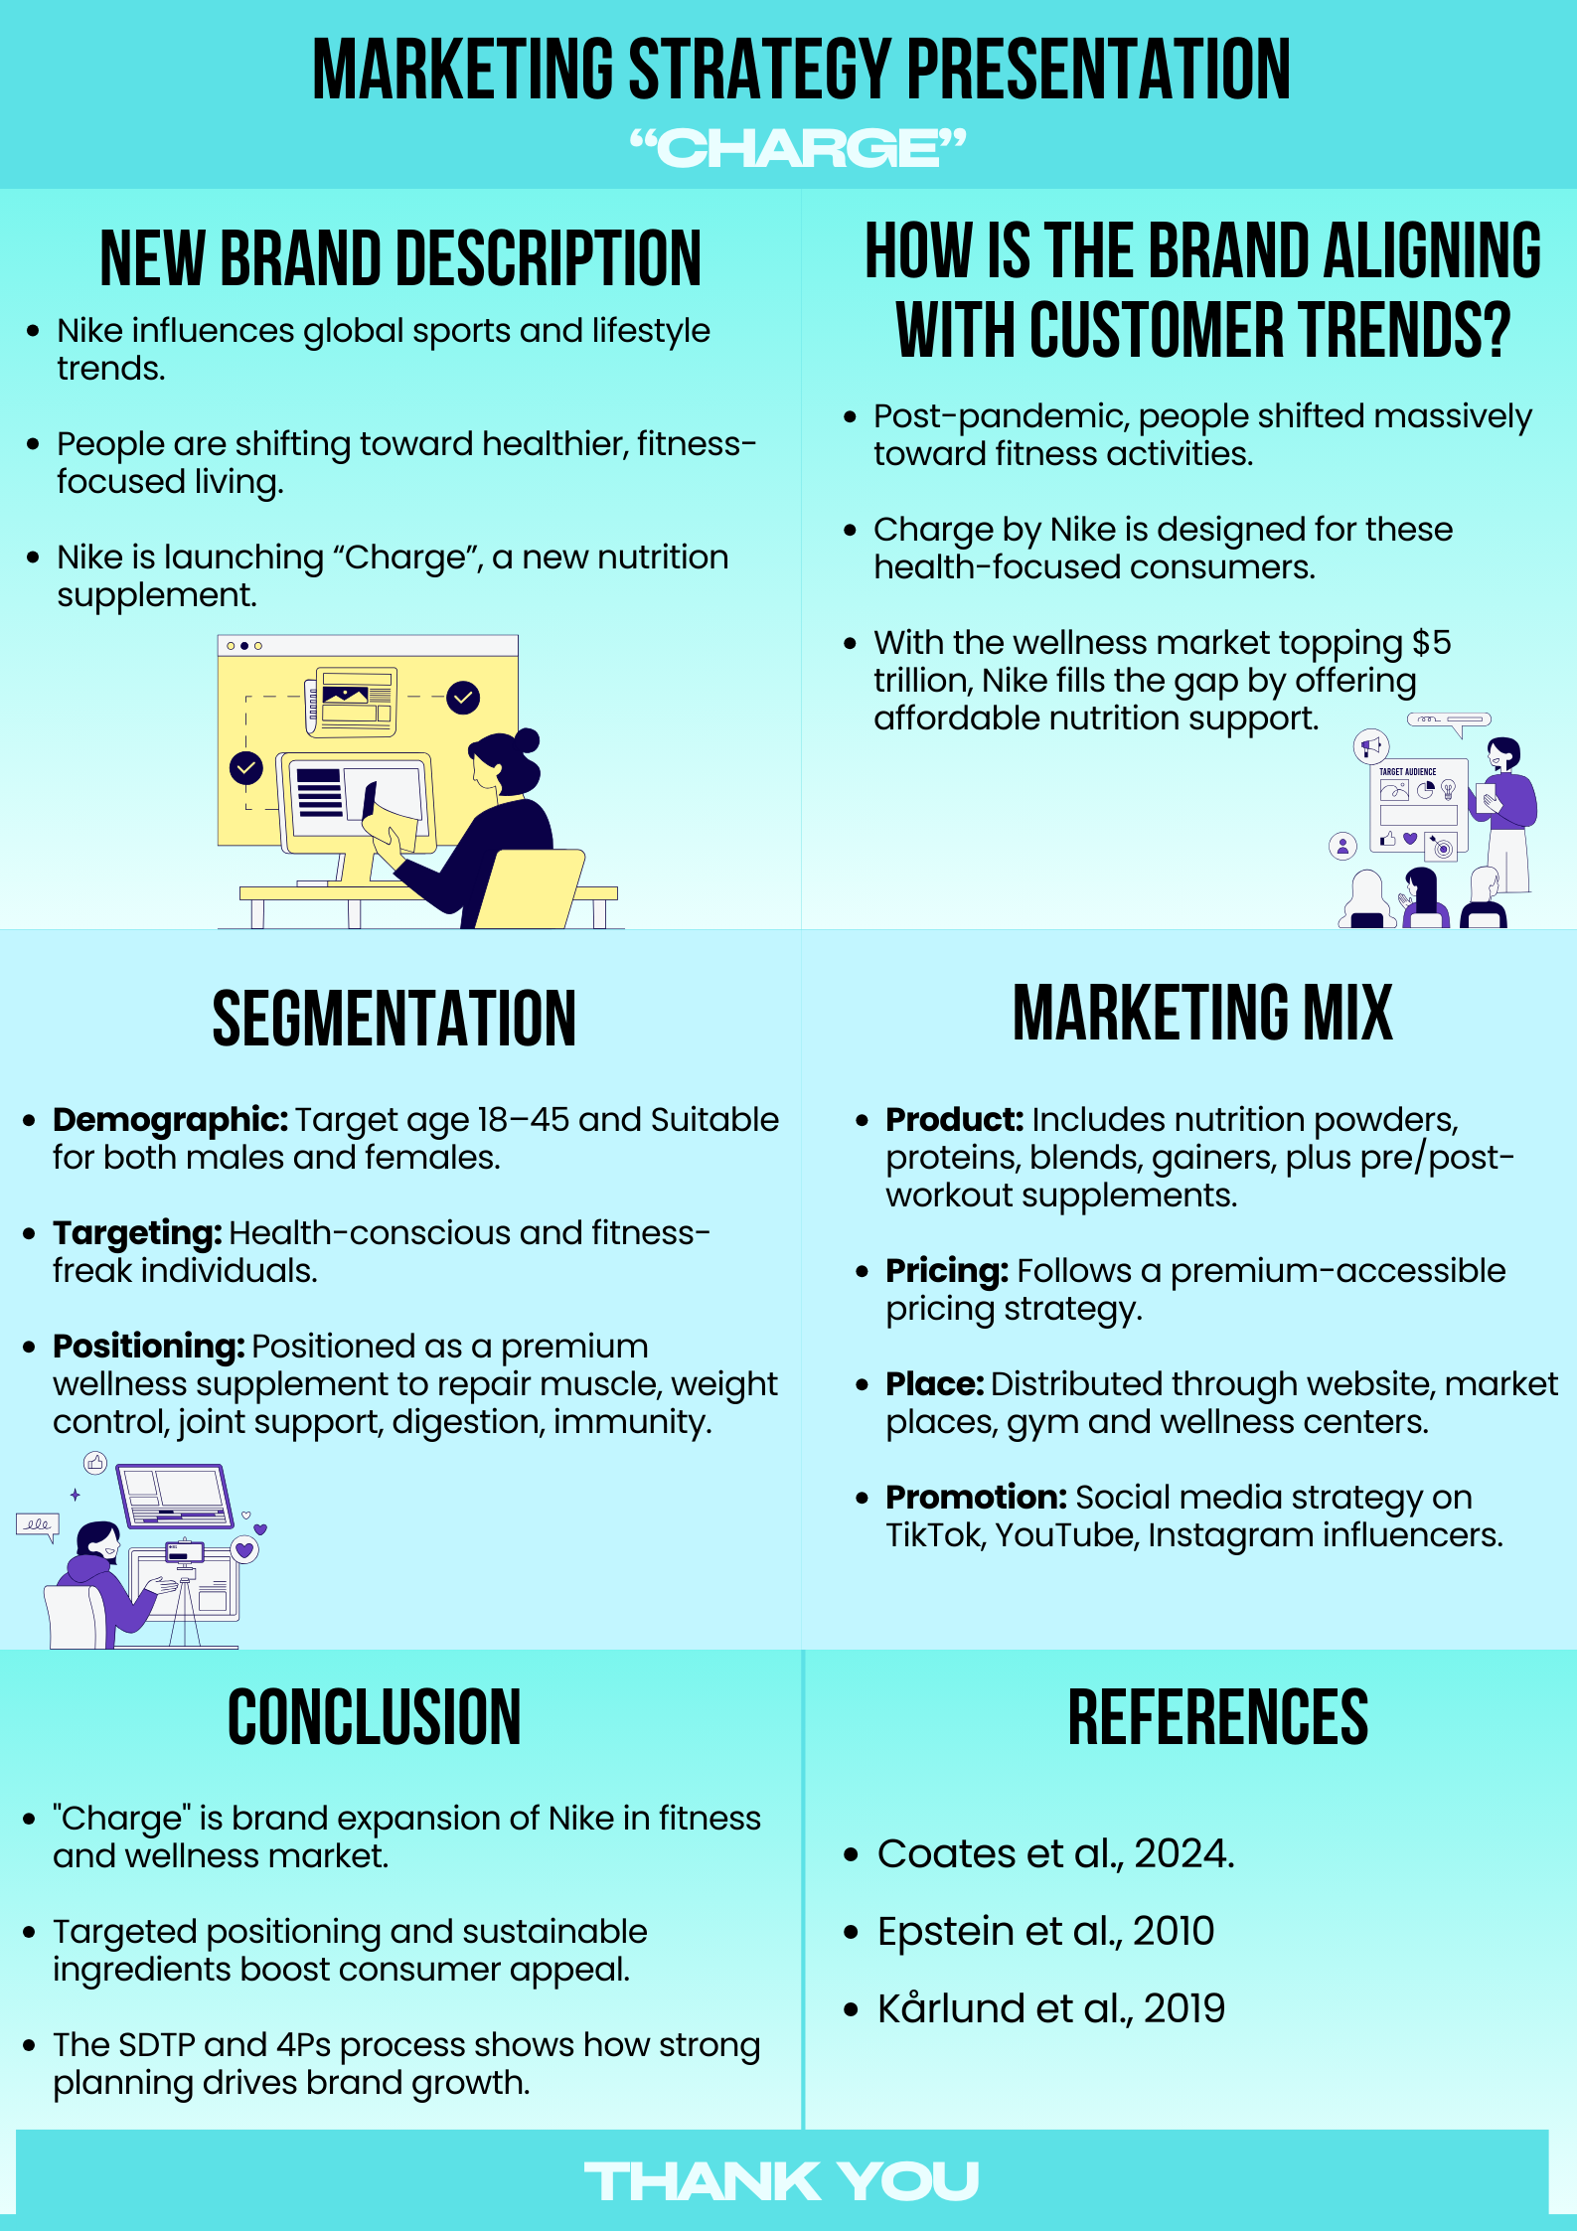

References
Coates, P. M., Bailey, R. L., Blumberg, J. B., El-Sohemy, A., Floyd, E., Goldenberg, J. Z., Shunney, A. G., Holscher, H. D., Nkrumah-Elie, Y., Rai, D., Ritz, B. W., & Weber, W. J. (2024). The evolution of science and regulation of Dietary Supplements: past, present, and future. Journal of Nutrition, 154(8), 2335–2345. https://doi.org/10.1016/j.tjnut.2024.06.017

Epstein, M. J., Buhovac, A. R., & Yuthas, K. (2010). Why Nike kicks butt in sustainability. Organizational Dynamics, 39(4), 353–356. https://doi.org/10.1016/j.orgdyn.2010.07.007

Kårlund, A., Gómez-Gallego, C., Turpeinen, A. M., Palo-Oja, O., El-Nezami, H., & Kolehmainen, M. (2019). Protein Supplements and Their Relation with Nutrition, Microbiota Composition and Health: Is More Protein Always Better for Sportspeople? Nutrients, 11(4), 829. https://doi.org/10.3390/nu11040829

