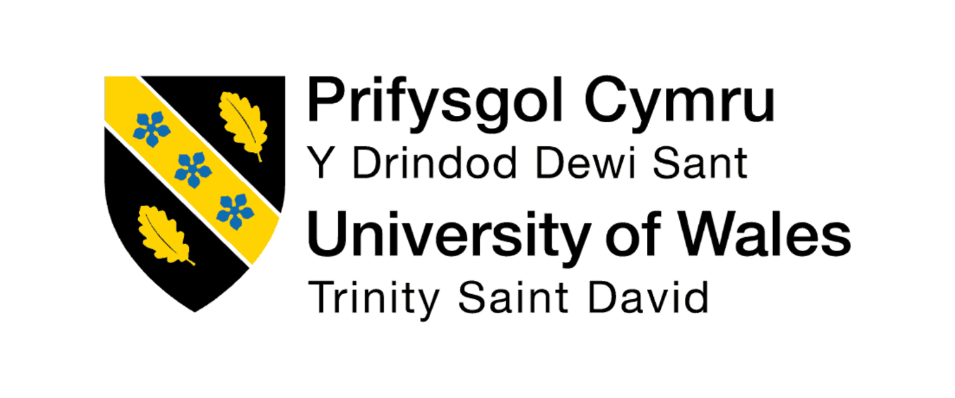
2516125@student.terrace.uk
My name is Allin Jalloh. I am currently studying business skills at the University of Wales Trinity Saint David. I have eight months of customer service experience working in busy shops. I enjoy meeting new people, working with a team, and I am excited to work as a club promoter.”
What Skills do you have for this role
I have excellent communication and customer service skills. I am friendly, confident, hardworking, and enjoy talking to people. I also have sales experience and work well in busy environments.

Why do you want this job
“I enjoy meeting people and working in lively environments. I like the idea of helping create exciting events and encouraging people to have a great night out. I also think this role will help me improve my communication and sales skills.”

Why should we hire you
“I’m friendly, reliable, confident speaking with people, and I already have experience in customer service and sales. I’m a quick learner, I enjoy working as part of a team, and I’m prepared to work hard to help make each event successful.”

What are your strengths and weaknesses
StrengthsI am friendly, reliable, and I work well with people.”
Weakness Sometimes I am quiet when I meet new people, but I become confident very quickly.”

Tell me about a problem you had at work.
“One day the shop was very busy and there were long queues. I stayed calm, helped customers quickly, and worked with my team. We managed to serve everyone, and the customers were happy.”
Thank you for your time today. I really appreciate the opportunity to interview with you. I’m excited about this role, and I hope to become part of your team.”

