Suraj Gull (2537885)
LONDON CAMPUS
Assignment 2
Learning in the Digital Era
Video Link:
https://uowtsd-my.sharepoint.com/:v:/r/personal/2537885_student_uwtsd_ac_uk/Documents/LDE/Digital%20Era%20Assessement%202%20.mp4?d=wc1ffa08e36ed42e4bb156dfedeca6ba7&csf=1&web=1&e=vVvcF5

Please be sure to give unrestricted access to your video presentation so that your work can be marked by the examiner.
Module Name: Learning in the Digital Era
Module Code: ACCA 4025

Student Name: Suraj Gull
Student ID: 2537885
Group: 2

Lecturer’s Name: Suneth Fernado

Table of Contents
Introduction 2
Main Body 2
Conclusion 9
References 9

Introduction
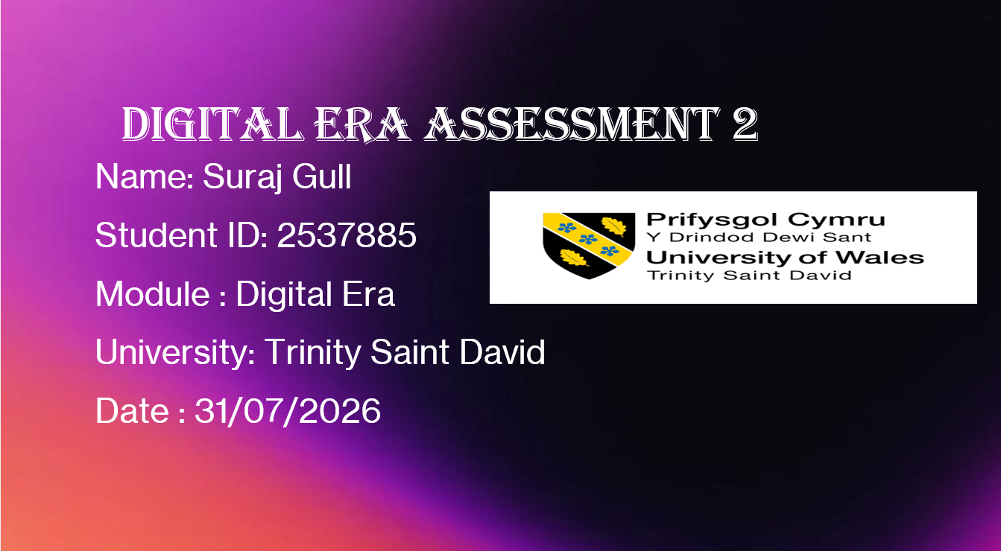

Video Link:
Slide 1 COVER PAGE
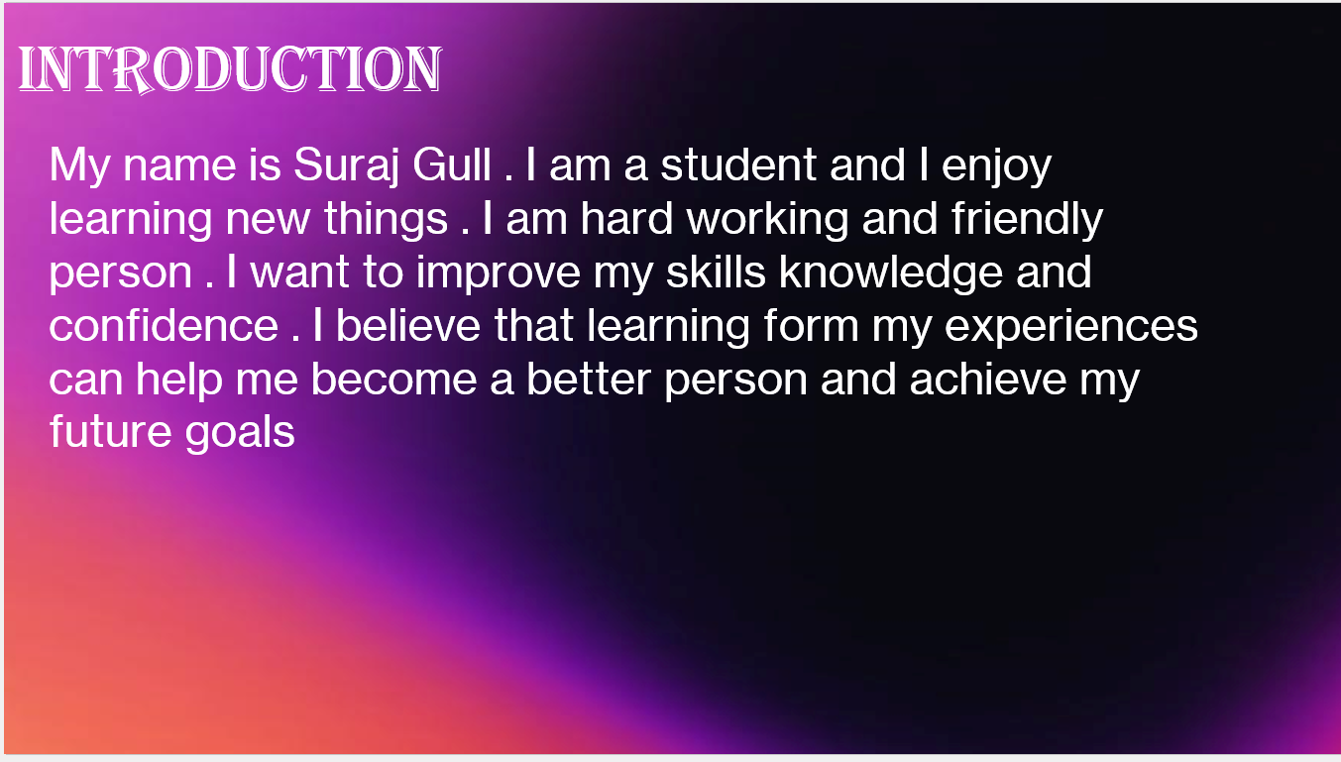

Slide 2 CONTENTS
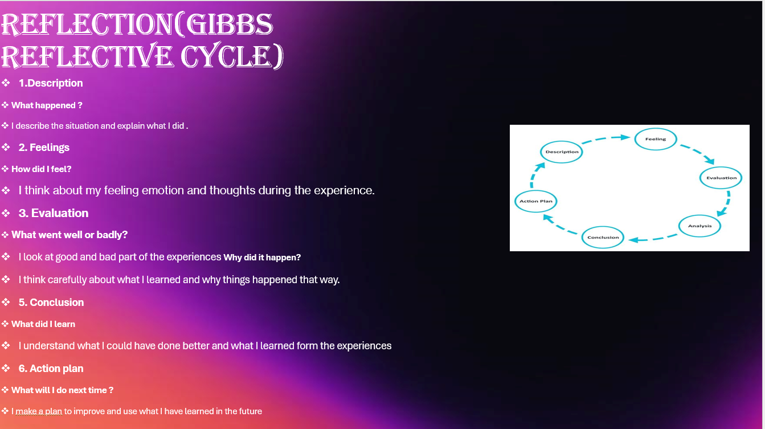

Slide 3
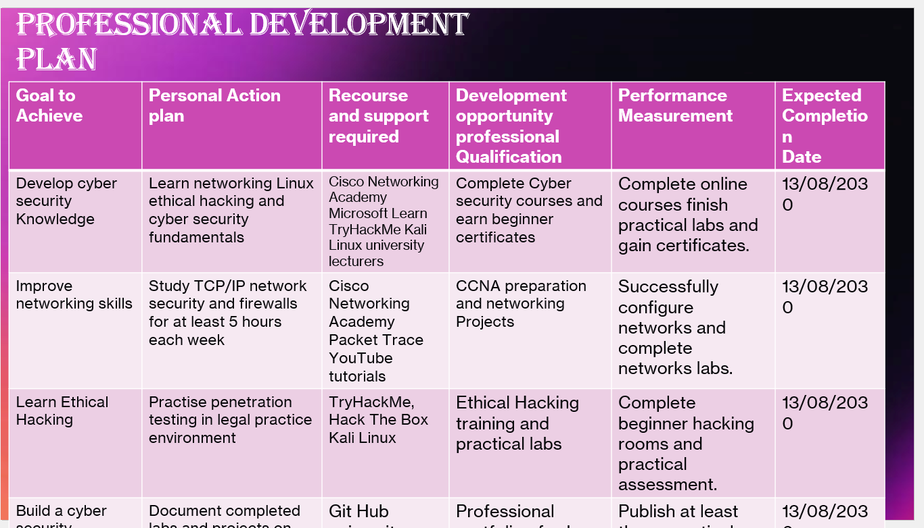

Slide 4
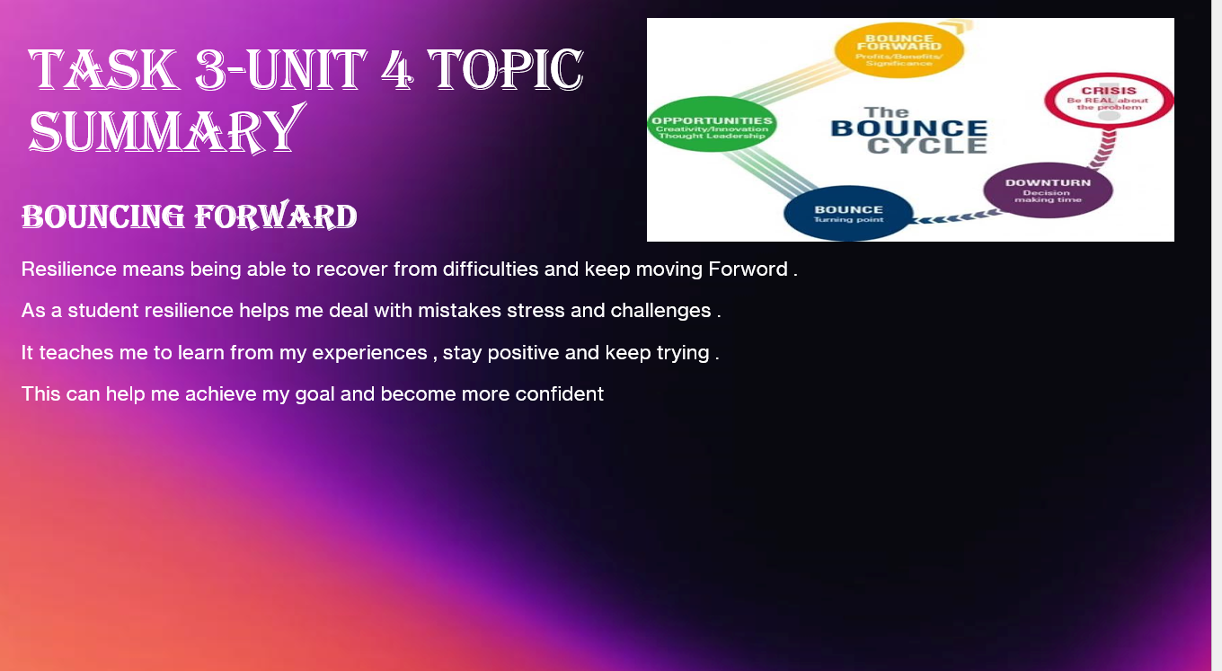

Slide 5 GIBB’s REFLECTIVE MODEL
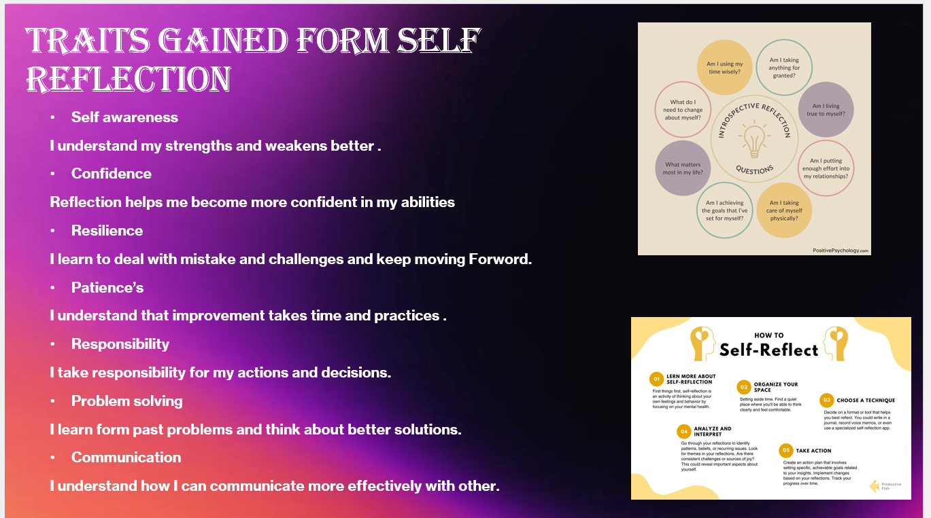

Brief explanation: Present a brief explanation on Gibb’s Model and how you are planning to apply this model in your Assignment 2.
Intext citations are required in this section along with the corresponding full citation at the end in the List of references.

Slide 6 TASK 1: SELF EVALUATION
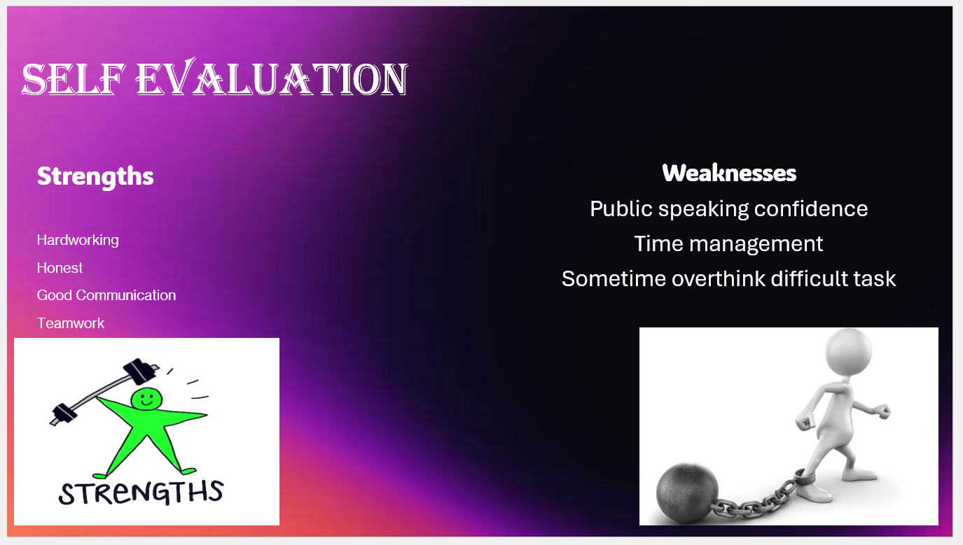
Brief explanation: Discuss your strengths and weaknesses based on your individual SWOT analysis. One Strength and one weakness are provided as example. Please feel free to remove them if that does not apply to you.
Slide 7 TRAITS GAINED FROM THE SELF EVALUATION
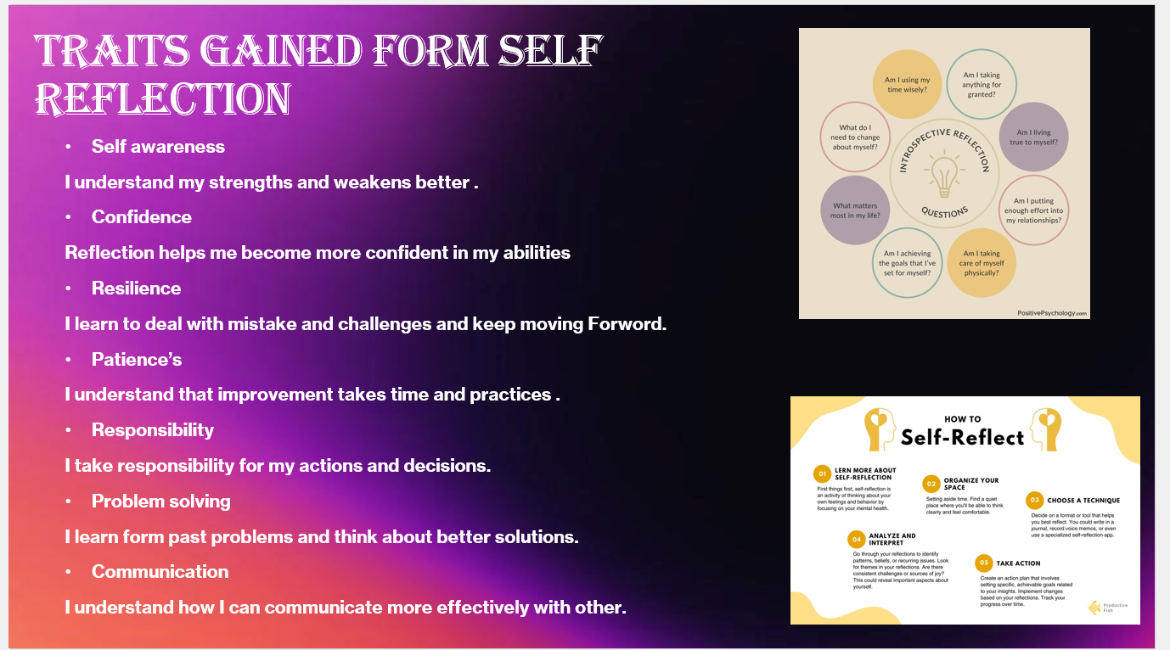

Slide 8
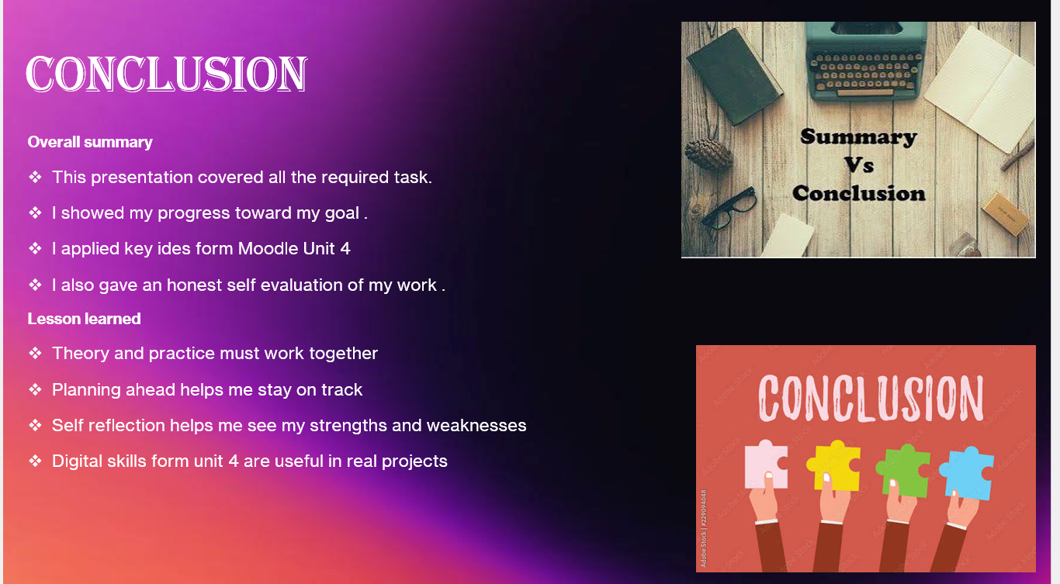

Slide 9
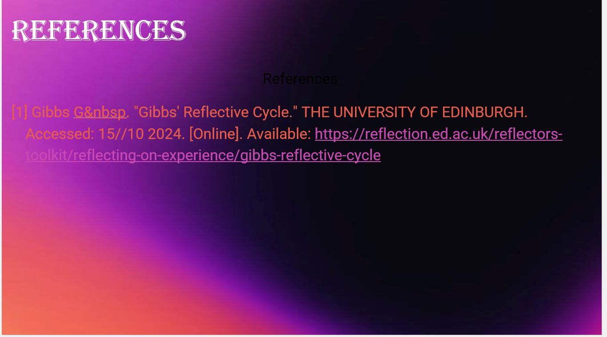

Slide 9 UNIT 4 TOPIC SUMMARY
Brief explanation: Choose one topic from the 3 topics given in Unit 4 and present a short summary of that topic.

Slide 10 CONCLUSION

Brief explanation:

Slide 11

Conclusion
A general conclusion for this word document (Briefly in a few sentences)

References

Copy and paste the sources from your reference slide.

IEEE referencing style must be followed.
In-text citations need to be used in the slide as well as in brief explanation section in this report.

