Rohan Dubrey (1905715)
Tutor: Dr Olu Adegbite
International Hotel Management BA Hons (UWTSD)
Cultural Awareness: Aide Memoir: HotelHandbook for intercultural competence.
Module: M5X01923

Contents

Introduction-------------------------------------------------------------------2
Cultural Intelligence--------------------------------------------------------2
Figure 1.1---------------------------------------------------------------------2
International Customs and Behaviours--------------------------------3
Table 1.1-----------------------------------------------------------------------3
Cultural Fragmentation-----------------------------------------------------3
Cultural Dimensions---------------------------------------------------------3
Cultural Theories-------------------------------------------------------------4
Figure 1.2----------------------------------------------------------------------5
Comparison of Main Guests----------------------------------------------5
Table 1.2-----------------------------------------------------------------------5
Figure 1.3----------------------------------------------------------------------5
Cultural Differences---------------------------------------------------------6
Cultural Competence-------------------------------------------------------7
Classification of Countries-------------------------------------------------8
Table 1.3-------------------------------------------------------------------8 -10
Enhancing Guest Service Experience---------------------------------10
Managerial Implementations---------------------------------------------11
Service Quality---------------------------------------------------------------11
Figure 1.3----------------------------------------------------------------------12
Figure 1.4----------------------------------------------------------------------12
Hotel Policy--------------------------------------------------------------------13
Figure 1.5----------------------------------------------------------------------13
References--------------------------------------------------------------------14

Introduction

Culture, while challenging to understand due to its seeming complexity, is quite simple (Steers et al. 2016). The complexity derived from the various dimensions within a culture is a result of the challenges faced when researching the topic (Reisenger, 2009). The concept of culture has brought about several interpretations in-relation to race, diversity within groups and the overall differences within communities worldwide.

Implicitly, the variations of culture have led to the diversification along cultural lines in the hospitality sector, enabling the implementation of strategic management practices. Dutch researcher Geert Hofstede defined culture as 'the collective programming of the mind, which distinguishes the members of one group or category of people from another' (Hofstede et al. 2010, p. 385). Therefore, the hospitality sector must gain a thorough understanding of cultural differences, as more brands seek to operate and attract guests from different regions (Armstrong et al. 2014). This aide memoir astute diversity within the management of the hotel, with strategies and practices implemented for efficient and effective cultural awareness.

Cultural intelligence

Acquiring proficient knowledge of culture enables employees to measure and pre-judge cultural practices and expectations effectively across cultures (Grove, 2005). Cultural intelligence is a crucial tool in communicating and understanding guests from different cultures.

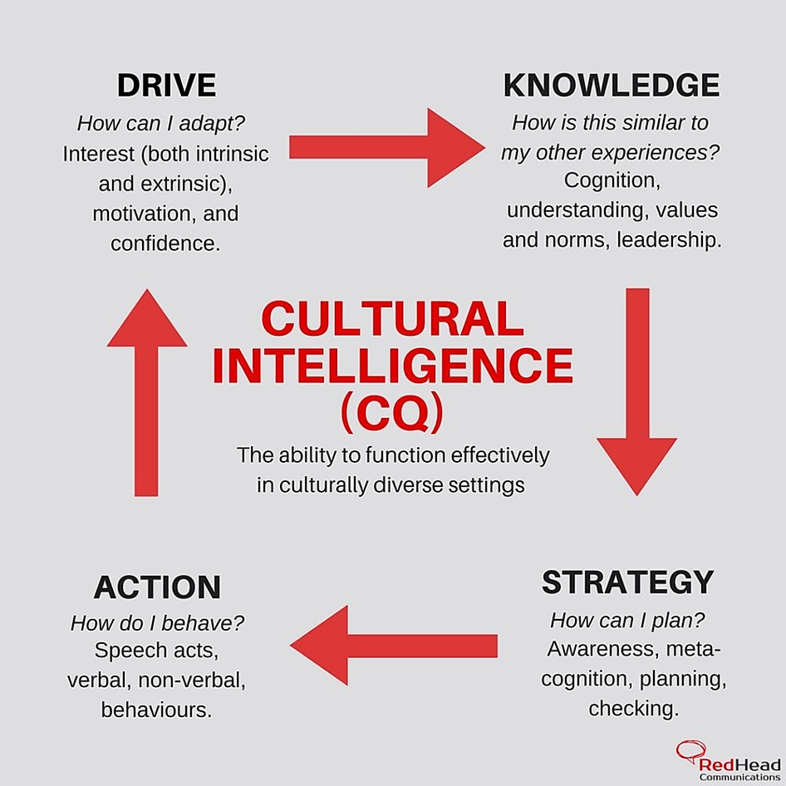
Figure 1.1 (Damaschin, 2020)
International customs and behaviours

Hotel staffs’ emotional intelligence is crucial in understanding the customs and behaviour of international guests. However, emotional intelligence is not enough if not combined with cultural intelligence (Steers et al., 2016). Cultural intelligence acts as an international merger respecting and providing for the needs of foreign guests. Understanding cultural intelligence enables acquisition with business partners globally (Harris and Moran, 1996). Obtaining cultural competence allows for more effective management of employees. In understanding international customs and behaviours, cultural competences should adopt the outline in table 1.1.

Intercultural competence | Act effectively
Specialist competence | Knowledge
Methodical competence | Attitude
Social competence | Behaviour
Table 1.1

Cultural Fragmentation

With globalisation playing a pivotal role in hospitality, the separations of cultural groups have been emerging, modernising and forming groups based on non-geographical specific ideologies (Gonclaves, 2014). The influence of consumer products is a contributing factor for groups spreading their own beliefs, comprising of local and global ideologies (Derrida, 1994). The beliefs have resulted in the differential benefits sought after by homogeneous groups in comparison to heterogeneous groups. However, this behaviour interconnects businesses globally using cultural intelligence.

Cultural dimension

While agreeing globally that culture within organisations exists and plays an essential part cultivating behaviours, the agreement to come up with a single or straightforward reasonable definition of culture has never been so remote (Watkins, 2013). Additionally, without a concrete definition, linking culture with the organisation's structure becomes difficult, prohibiting practical analysis and preservation of cultures (Watkins 2013).

Hofstede et al. (2010) counteracted the argument after conducting several pieces of research. The findings concluded that psychological environments contribute to the culture of an organisation.

Cultural Theories

Hofstede came up with six categories that help to define national cultures, known as cultural dimensions (figure 1.1), which is vital in identifying critical indicators amongst cultures. Trompenaars and Hampden-Turner, (1997) refined the model on the seven dimensions of culture, differentiating cultures based on preference. The idea was based on the previous study of Florence Kluckhohn and Fred Strodtbeck (Kluckhohn and Strodtbeck,1961) and Talcott Parsons and Edward Shils (Parsons and Shils,1951). In studying different cultural systems, Parson and Shils concluded that these systems should act as a network of values, symbols and norms, which regulate alternatives and stipulate interactions which may occur among people (Balan and Vreja, 2013).

In the multi-authored project Global Leadership and Organisational Behaviour Effectiveness (GLOBE); Edward Hall’s theory contextualising culture on proxemics defining high and low; Fons Trompenaars’ seven dimensions of culture differentiating values and personal relationship amongst cultures; and Geert Hofstede cultural indicators on how national cultures differ, gave contrasting conclusions. These authors, at times, adversely critique each other. Notably, their conclusions have much in common with only minor variants (Balan and Vreja, 2013).

However, the work of Samuel Huntington, relating to civilisation in culture, goes in-depth beyond any of the researchers previously mentioned (Huntington, 1993). Notably, Hofstede's dimension of culture has received full acceptance globally.

Conversely, Wood (1998) has explicitly criticised the problem of hegemony, emphasising culture adds to social life and calls for an account of cultural formation.

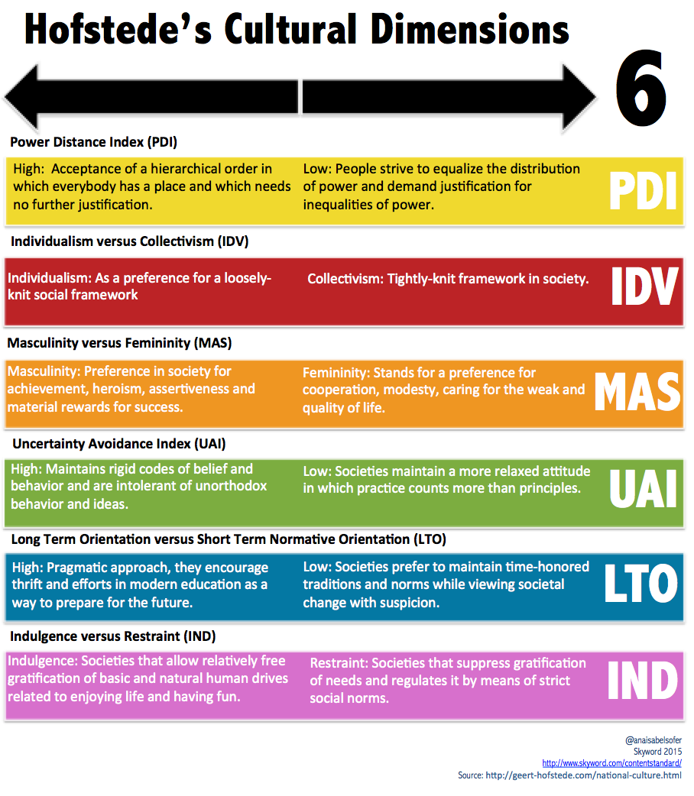
Figure 1.2 (Sky Word, 2015)

Comparison of Main Guests

Countries | Key Cultural Differences | Customs | Behaviour
South Korean | Lack of time management | Bowing | Polite
Germans | Strict time management | Handshake | Reserved
Table 1.2

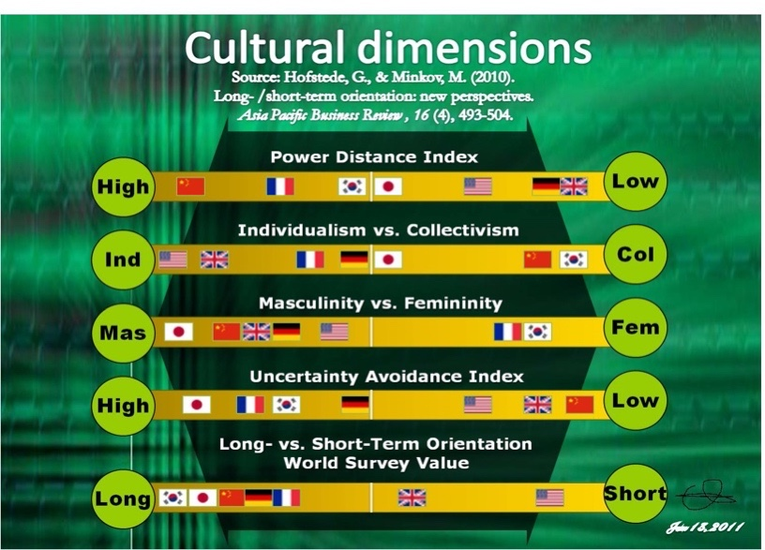
Figure 1.3 (Hofstede et al., 2010)
Cultural Differences

Providing excellent service requires the requisite skills and knowledge of the customs and behaviour of guests from these countries (Harris et al., 2007). The South Koreans and Germans make up a greater extent of this hotel’s occupancy, with crucial cultural differences which should be understood and upheld to enhance excellent customer service (table 1.2) and (figure 1.2).

Although strongly influenced by Confucianism and Buddhism, South Koreans’ ancient religion Shamanism is prevalent (Harris and Moran, 1996). Buddhism is the most extended religion, with Confucianism taking precedence over the newer combined religion of Chondogyo. Conversely, Germany is made up mainly of Christians.

Mood and inner feelings are influential factors for South Koreans referred to as kibun. When the kibun of individuals are in a good state, it allows for relaxation enabling the smooth running of activities. However, a lousy kibun emits sadness (Harris et al., 2007).

Germans are reserved. Militaristic approach prevents leaving any eventuality to be judged by feelings. South Koreans seldom regard equality, with the public at all times ranking above private as taught by Confucius. The Germans are private, making clear and robust distention between friends and acquaintances, only using the word friend [bekante] when truly meant (Harris and Moran, 1996). It is customary for Germans to be meticulous and not spontaneous. The Germans are amongst the highest-paid, appreciating luxury and high quality of service, being able to afford it (Mok and Armstrong, 1998).

Handshakes are customary for Germans. In the presence of a man, it is customary for the woman to extend her hand first unless the male holds a higher position. Germans avoid gesticulation during conversations, as seen as improper etiquette. Placing hands in pockets during conversations are seen as impolite and are also avoided.

Although South Koreans greet with handshakes in showing modernisation in society, this is often followed with bowing from the waist, saying names in a low voice and the exchanging of business cards as per tradition. The cards are used to teach the person’s title and name, refraining from asking to repeat (Harris et al., 2007). In Confucian philosophy, a name should be respected and honoured. Adversely, failure to follow social exchange is met with resentment showing minute concern for such person's ignorance, classed as "unperson." Additionally, German men also bow in greeting individuals but only slightly from the shoulders and neck (Mok and Armstrong, 1998).

More than half the population of South Koreans can be identified by surnames consisting of three letters, mainly being Lee and Kim, quickly recognising family tree connections (Harris and Moran, 1996). The Koreans believe that names are personal and should not be abused. Instead, persons are referred to by titles. Moreover, writing a name in Shamanism is alleged to call up spirits and classed as unlucky. The Germans, besides the South Koreans, like to be addressed by their titles.

South Koreans like the Germans are polite when adhering to rules on etiquettes. To joke causing embarrassment is highly resented, with no excuse of ignorance to culture by the South Koreans. Acting too familiar with persons slightly acquainted or putting one's arm around that individual is considered a severe breach that may cause a guest to abandon their stay or refuse to return to the hotel.

South Koreans are not concerned with timekeeping, being on time for an event or meeting. However, this custom is changing coming in-line with western cultures. Conversely, Germans adhere strictly to time, turning up for meetings and check-ins promptly (Mok and Armstrong, 1998).

Great emphasis and respect often time centres on Korean elders which influences the opinion of others, regardless of being considered right or wrong. Catering for elders is highly essential with special exotic foods provided at meals.

Germans and Koreans avoid discussing private life. Germans prefer discussions on politics and religion, avoiding American sports, as rarely understood. Additionally, self-bragging and personal finances are purposely avoided.

Cultural Competence

Cultural competencies enable the understanding of one’s host country and personal culture from another, in acceptance and behavioural characteristics (Luka et al. 2013). In acquiring cultural competence, the three main characteristics of knowledge; skills and attitude needs administering. However, intercultural competence cannot be gain over short periods with limited training.

Therefore, the use of Continuous Professional Development (CPD) training is recommended in gaining knowledge of different international customs. The aide memoir should continuously be revised, gaining useful insights into the customs, behaviour and norms of different cultural backgrounds (Friedman, 2013). In achieving competent knowledge, attitude and skills, good rapport is attained with different cultures (Taylor and MaCarthur 2009).

Classification of Countries

Nationalities | Do’s | Religion | Languages | Don’ts
Indians | Namaste greeting. Use appropriate titles. | Hinduism | Hindi | Whistle. Extend a hand first to be shaken by a woman. Do not ask personal questions.
Philippians | Work with conditions present. Pakiksama belief. Handshake greeting for men or a light pat on the back. Women may kiss on their cheeks. Rarely say no. | Christianity. Protestant. | Philipino, Tagalog and English. | Avoid confrontation and staring. Stand with hands-on hip [shows anger].
Japanese | Purchasing gifts[omiyage]. Use san [Mr. Or Mrs.] when addressing someone. Rarely say no. | Shinto and Buddhism. | Japanese | Tipping is insulting. Loud and obnoxious. Do not ask age. Do not maintain eye contact.
Asian | Maintain a high level of discipline. Recognise rank or status. | Sikhism, Islam, Buddhism, Hinduism. | Hindu, Punjabi, Mandarin, English. | Cough, sneeze or blow nose at the dinner table.
Malayaswk6L1 | Greet with both hands like a handshake [without grasp]. Greet with salaam. | Islam | Malay [Jawi]. | Gesture or pat a child's head.
Africans | Greet with a friendly smile and handshake. Appreciate friendship and trust before business, like to socialise. Hygiene is sensitive. | Islam | Swahili. Shona. Zulu. Oromo. Igbo. Yoruba. | Adhere to time. Engaging in conversations with hands in pockets is deemed impolite. Do not regard ostentatious clothing.
Chinese are | Group-oriented. Upheld trust and mutual respect. Adhere to what they say. Chinese negotiates through an intermediary. Appropriate to bow slightly with a brief handshake. Always mention family name first. | Buddhist | Mandarin, Cantonese. | Comment on Chinese political issues. Touch. Loud and boisterous behaviour.
French | Punctuality is essential. Individualistic. Friendly and sardonic. Great taste for fine food and wine. | Christianity  Catholic | French | Firm pumping handshakes uncultured. Snapping fingers.
Nigerians | Be formal and respectful. Deliver when and what is promised. Eat spicy food. | Africans have a mix of religions of Muslim, Protestant, African Christian, and Traditional African beliefs. | Pidgin English. | Do not try too hard to understand them. Do not be overly sensitive to criticism or advice.
Europeans | A desire for security. Customer service is key to success. Prefer published price list. | Christianity. Protestant. Muslims. | English. Spanish. Dutch. | Do not like change [money]. Over tipping.

Table 1.3

Enhancing Guest Service Experience

Enhancing and delivering guest service experience is enabled through knowledge of cultural intelligence. However, guest service and guest cultural expectation cannot be separated (Berry et al., 1988). CPD to communicate effectively in different languages is advantageous when interacting with guests from different cultures. Additionally, understanding international consumer behaviours enhances the guest service experience (Virginia et al., 2013).
Managerial Implementations

For staff to develop the requisite skills in intercultural communication and culture awareness, practical communication skills are necessary to communicating across the board with diverse groups of employees. Diversity should be promoted at every level within the hospitality industry, eliminating employees’ frustration (Shames and Glover, 1988). The lack of diversity amongst employees contributes to high turnover and affects service quality. Services need to be tailored explicitly to guests based on their culture (Armstrong et al., 2014).

Service Quality

In understanding the cultural expectation from international guests to effectively meet the service quality expectations, employees are required to attend educational workshops provided. Mok and Armstrong (1998) defined service quality as the flawless, accurate and dependable services provided, eliminating unreliability which is the hallmark of service excellence. Service quality, although arduous to assess due to heterogeneity, intangibility and the inseparability of consumption and production, should be of high quality in order to be successful (Berry et al.,1988).

Expectation and behaviour of guests fluctuate between reputation, location and response to staff, which are graded on cultural merits. However, they are exceptions [for example, guest choice of location] where expectations are widely the same, demonstrating positive and negative feelings, considered empirical hotel service attributes (Cadott and Turgeon 1988). They are different dimensions of service quality which should be applied in accordance with the cultural expectation of these guests shown in figure 1.4.

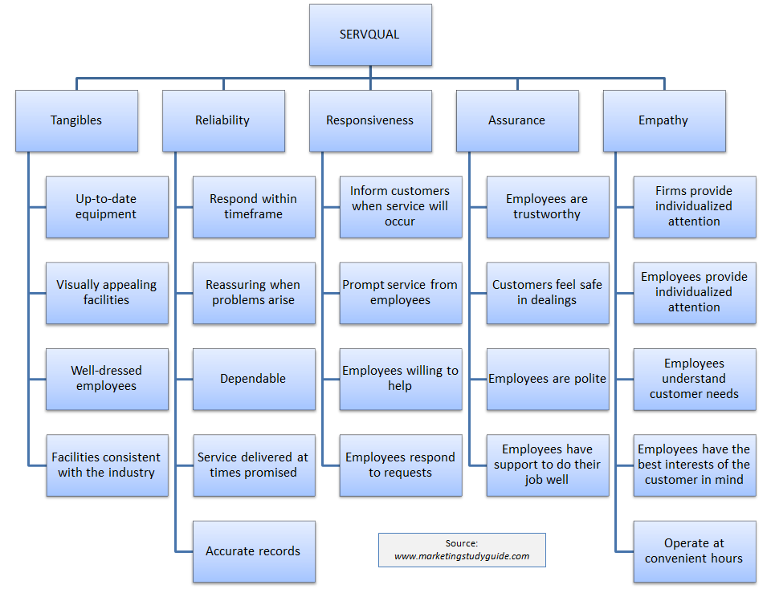

Figure 1.4 (MHA Study Guide, 2018)

Parasuraman et al. (1988) constructed the framework SERVQUAL, separating service quality into five distinct groups (figure 1.5). The determinants of Perceived Service Quality theory have been perceived differently throughout cultures.

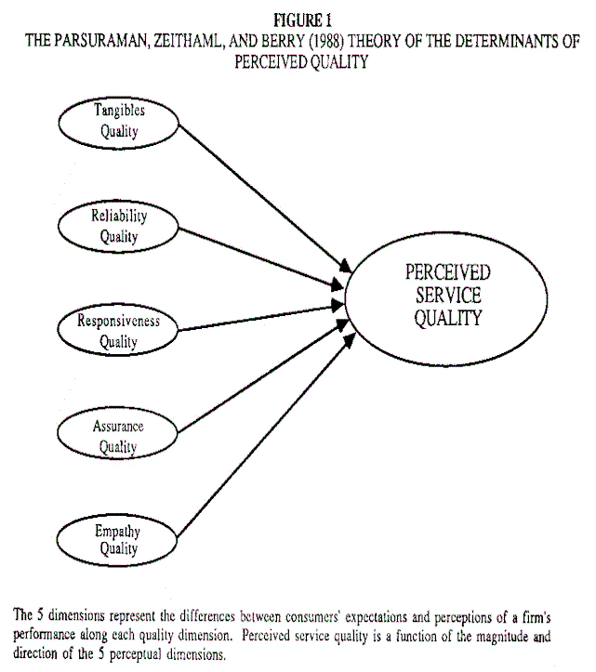

Figure 1.5 (Finn Jr, 1991)

Hotel Policy

The expectations of guests are measured using five dimensions (figure 1.6). The hotel’s policy enables employees to meet cultural expectations based on fulfilling the service quality. Employees effectiveness and consistency in quality services deployed utilises knowledge gained to instil confidence in guests, achieving competitive advantage for the hotel.

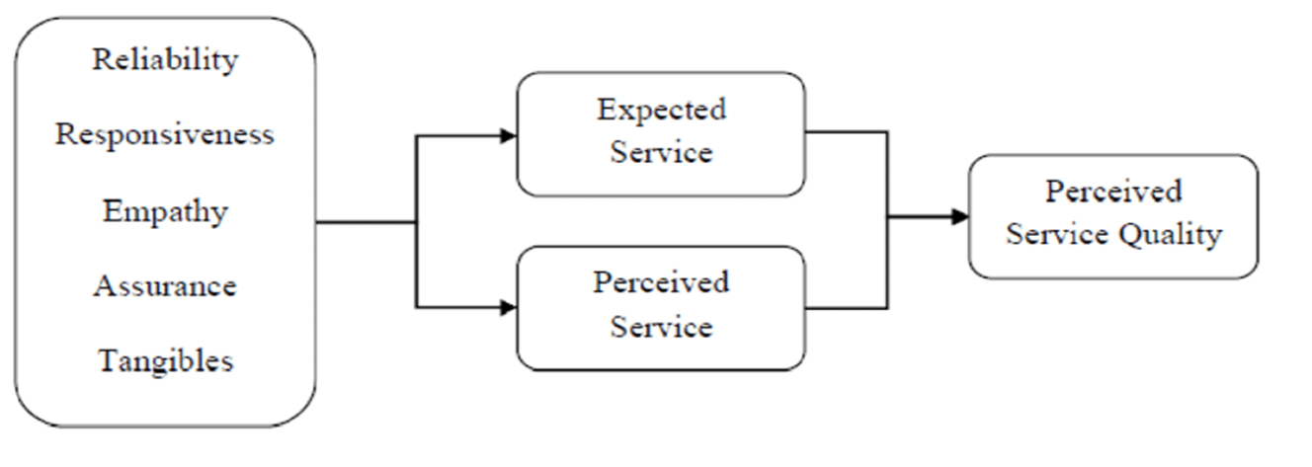
Figure 1.6 (Research Gate, 2009)

References
Armstrong, Moran and Abramson, 2014. Managing Cultural Differences. 9th ed. London: Routledge.
Balan, S. and Vreja, L., 2013. The Trompenaars’ Seven-Dimension Cultural Model and Cultural Orientations of Romanian Students in Management. Bucharest: Bucharest University of Economic Studies, pp.96,97,98.
Berry, L., Parasuraman, A. and Zeithaml, V., 1988. The service-quality puzzle. Business Horizons, 31(5), pp.35-43.
Cadotte, E. and Turgeon, N., 1988. Key Factors in Guest Satisfaction. Cornell Hotel and Restaurant Administration Quarterly, 28(4), pp.44-51.
Damaschin, 2020. Cultural Intelligence: The Tao To Intelligent Perspective In a Diverse Environment. [image] Available at: https://www.japancreativeenterprise.jp/single-post/2020/01/09/cultural-intelligence-the-tao-to-intellegent-perspective-in-a-diverse-environment [Accessed 12 August 2020].

Derrida, J., 1994. Specters Of Marx The State of The Debt, The Work of Mourning and The New International. London: Routledge.
Finn Jr, D., 1991. An Evaluation of The Servqual Scales in A Retailing Setting. [online] Acrwebsite.org. Available at: https://www.acrwebsite.org/volumes/7137/volumes/v18/NA%20-%2018 [Accessed 6 August 2020].
Finn, D. and Lamb, C., 1991. An Evaluation of the Servqual Scales in a Retailing Setting. Advances in Consumer Research, 18(1), pp.483-490.
Friedman, A., 2013. Continuing Professional Development. Hoboken: Taylor and Francis.
Gonclaves, A., 2014. The Journey not the Arrival Matters: Developing Intercultural Awareness and Communication Skills in Tourism Education1. Journal of Cultural Management and Policy, 4(1), pp.31-45.
Grove, C., 2005. Worldwide Differences in Business Values and Practices: Overview of GLOBE Research Findings. [online] Grovewell.com. Available at: https://www.grovewell.com/wp-content/uploads/pub-GLOBE-dimensions.pdf [Accessed 10 August 2020].
Hampden-Turner, C. and Trompenaars, F., 1997. Response to Geert Hofstede. International Journal of Intercultural Relations, 21(1), pp.149-159.
Harris, P. and Moran, R., 1996. Managing Cultural Differences: Leadership Strategies for A New World of Business. 4th ed. Houston, Tex.: Gulf Pub. Co.
Harris, P., Moran, R. and Moran, S., 2007. Managing Cultural Differences. 6th ed. London: Elsevier.
Hofstede, G., Hofstede, G. and Minkov, M., 2010. Cultures and Organizations. 3rd ed. London: McGraw-Hill Education.
Huntington, S., 1993. The Clash of Civilizations? Foreign Affairs, 72(3), p.22.
Huntington, S., 1997. The Clash of Civilizations and The Remaking of World Order. 1st ed. London: Simon & Schuster UK Ltd, pp.76,183,258.
Kluckhohn, F. and Strodtbeck, F., 1961. Variations in Value Orientations. 1st ed. Evanston, Ill: Row, Peterson.
Luka, I., Vaidesvarans, S. and Vinklere, D., 2013. Educating Tourism Students for Work in a Multicultural Environment. Journal of Teaching in Travel & Tourism, 13(1), pp.1-29.
MHA Study Guide, 2018. SERVQUAL. [image] Available at: https://mhastudyguide.wordpress.com/2018/01/09/servqual/ [Accessed 10 August 2020].
Mok, C. and Armstrong, R., 1998. Expectations for hotel service quality: Do they differ from culture to culture? Journal of Vacation Marketing, 4(4), pp.381-391.
Mullins, L., 2001. Hospitality Management and Organisational Behaviour. London: Pearson Education.
Parsons, T. and Shils, E., 1951. Toward A General Theory of Action: Theoretical Foundations for The Social Sciences. 1st ed. Cambridge: Harvard University Press, pp.47-69.
Reisenger, Y., 2009. International Tourism: Cultures and Behaviour. Oxford: Elsevier.
Research Gate, 2009. Measuring Service Quality Using SERVQUAL Model. [image] Available at: https://www.researchgate.net/figure/Measuring-service-quality-using-SERVQUAL_fig10_238193459 [Accessed 10 August 2020].
Shames, G. and Glover, G., 1988. Service management as if culture exists. International Journal of Hospitality Management, 7(1), pp.5-7.
Sky Word, 2015. Beyond Hofstede’s Cultural Dimensions Theory: Approaching A Multicultural Audience. [image] Available at: https://www.skyword.com/contentstandard/beyond-hofstedes-cultural-dimensions-theory-approaching-a-multicultural-audience/ [Accessed 10 August 2020].
Steers, R. and Osland, J., 2019. Management Across Cultures Challenges Strategies and Skills. 4th ed. Cambridge: Cambridge University Press.
Steers, R., Sanchez-Runde, C. and Nardon, L., 2016. Management Across Cultures: Challenges and Strategies. 3rd ed. Cambridge: Cambridge University Press.
Taylor, M. and McArthur, L., 2009. Cross-Cultural Knowledge, Attitudes and Experiences of Hospitality Management Students. Journal of Hospitality & Tourism Education, 21(4), pp.6-14.
Trompenaars, F. and Hampden-Turner, C., 1997. Riding The Waves Of Culture: Understanding Diversity In Global Business. 3rd ed. London: Nicholas Brealey.
Tsang, N., 2011. Dimensions of Chinese culture values in relation to service provision in hospitality and tourism industry. International Journal of Hospitality Management, 30(3), pp.670-679.
Virginia, Demitrescu and Mihaela, 2013. CULTURAL COMPETENCE, A CONDITION FOR SECOND-LANGUAGE PROFICIENCY. Professional Communication and Translation Studies, 5(6), pp.195-204.
Watkins, M., 2013. What Is Organizational Culture? And Why Should We Care? [online] Harvard Business Review. Available at: https://hbr.org/2013/05/what-is-organizational-culture [Accessed 29 July 2020].

