Name- Amaan Malik
Student ID- 2246841
Module code- LCBB4004
Module name- Marketing Fundamentals
Lecturer- Tushara Balendran

Market Segmentation and Marketing Mix of Sainsbury
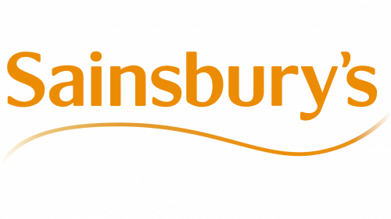

Abstract
The report elaborates on and discusses the market segmentation, targeting, and positioning strategies of J Sainsbury Plc. It provided about the 4 Ps of the marketing mix used by the company namely: Product, price, place, and promotion. This entailed the pricing strategies of various products, availability of a wide range of products, and places where it currently operates. In addition, it also laid down promotional strategies including advertisements, social media platforms, and various promotional campaigns to increase its sales and build a brand image.

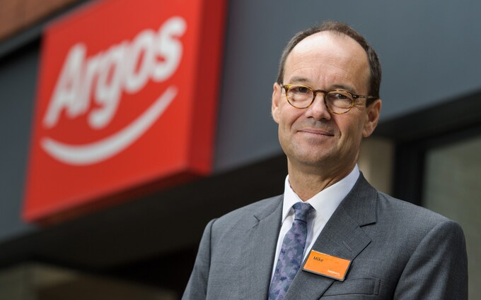

Background/history of the company
J Sainsbury PLC, founded in 1869, operates the largest chain of supermarkets in London, England, United Kingdom. It is the largest retailer in the United Kingdom that deals in groceries. It offers a variety of groceries, clothing products, and general merchandise and is a multi-channel retailer in the United Kingdom. Its retail outlets including convenience stores and supermarkets are operated under Sainsbury’s Argo’s banners and Habitat. Its slogan is “Helping everyone eat better”. Its shares are listed and traded on the London Stock Exchange and also form part of the FTSE 100 index (Sainsbury, 2023).
In 1869, it was established in the form of a partnership, whereby the founder John James Sainsbury along with his wife inaugurated their shop in London. He began s a retailer of fresh foods, however, entered and expanded his existing business into other groceries including tea and sugar. It incorporated itself as a private company in 1922. Further, it was realized that Sainsbury has a future of self-service supermarkets, which will be accompanied by car parking for convenience. In 1999, the corporate identity of Sainsbury was unveiled. The top-rated products include household essentials, air fresheners, household bigger packs, good bags, foils, party tableware, cleansing products, kitchen roll, toilet roll, and tissues.
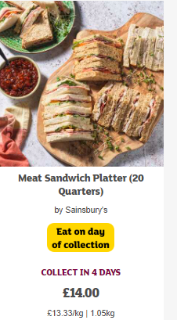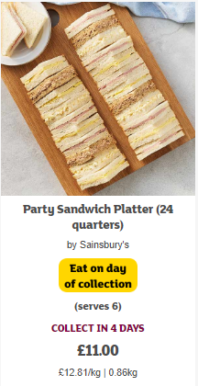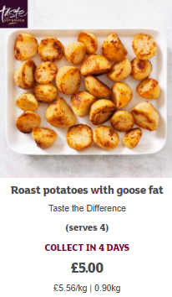

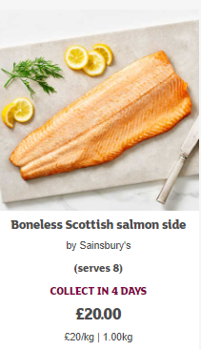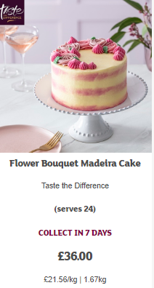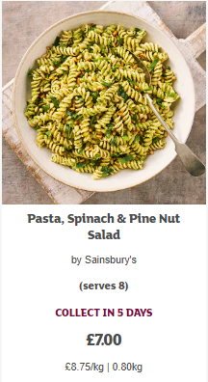
Source: (Sainsbury, 2023).
Vision: The vision of Sainsbury is to become the most trusted retailer, where people will work with full dedication and love to shop, thereby aiming to make the life of the customers easier by providing them with the best and great quality at affordable prices.
Mission: The mission of Sainsbury is to ensure that the customers prefer them to purchase f the food items and become their first choice.
Values: It offers the widest and highest range of welfare products by incorporating sustainable practices at the core of the business, thereby assuring rendering the highest quality products at reasonable and affordable prices. These values enable to develop of strong relationships with the stakeholders and leave a positive impact in the United Kingdom as well as globally.

Current Segmentation, Targeting, and Positioning strategies
Sainsbury has segmented the market into smaller segments having similar attributes, socio-economic background, etc to cater to the needs of its customers most effectively and efficiently (Xiao, et al., 2021). The segmentation has been done in demographic and geographic variables that include income, occupation, race, gender, sex, education, nationality, family size, and family life cycle The Company is operating and has stores in all the cities of the United Kingdom. The geographic dimension of Sainsbury is very efficient due to different preferences, cultures, and administrative systems. The marketing strategies used by Sainsbury include both ATL and BTL techniques (Wood & McCarthy, 2014). Further, it aims to attract its customers and build trust by ensuring “value for money”, which means that the customers are retained by providing them with the best quality of products and services. In addition, it takes into account competitive pricing rather than lowering its prices as price lowering ensures gains only in the short term (Czinkota, et al., 2021).
The name of the company has become familiar across all demographics, where female customers account for 56.9%, whereas male customers account for 43.1% in terms of affordable and best-quality grocery shopping.
Its current targeting strategies include targeting the audience aged between 15 to 80 years (IIDE, 2023). This chain of supermarkets takes into consideration that people prefer to buy all stuff having the best quality to buy under the same roof. The company makes use of segmentation which trickles into the targeting strategies.
The most effective positioning strategy of Sainsbury is the commitment of the company to omnichannel marketing to build the brand name of the company. This strategy aims to prioritize the cooperation between channels used by the company to cater to the needs of its customers (Li, et al., 2023). and integration Its Positioning strategies ensure that it accounts for a 16% share in the sector of supermarkets and is the second-largest grocery retailer in London, United Kingdom. It operates more than 700 convenience stores and 500 supermarkets (Hood, et al., 2016). Some of the stores operate 24x7 and some operate till midnight. In addition, orders can be placed on its website or mean by phone calls. It also offers home deliveries. It handles distribution to those who specialize in these areas like NFT, and DHL (Fahy & Jobber, 2019).
It possesses advantages including improving the service of customer standards, increase in sales and profits, optimum utilization of the resources in the chosen segments, ability to review the developments, and anticipation of changes. However, the disadvantage is that it is quite expensive to segment the markets as this involves developing strategies for every segment.
The Economic Theory of Segmentation: This theory entails the selling of homogenous products by a company or firm to maximize profits. Moreover, this theory depicts using of marginal response to price. This is considered to be an optimal or ideal approach. Although it is a simple concept, there are four problems including:
- Measuring response elasticities on a segment basis
- Defining mutually exclusive segments
- Constraints in reaching segments
Industry examples include carrying on the business of retail groceries and merchandise by TESCO in the United Kingdom. The segmentation is done into demographic, geographic, behavioral, and psychographic dimensions. Further, Segmentation, targeting, and positioning have been applied to Tesco in general and, its products.

4 P’s of Marketing mix of Sainsbury
The marketing mix includes 4 P’s namely: Product, Price, Place, and Promotion.

Product

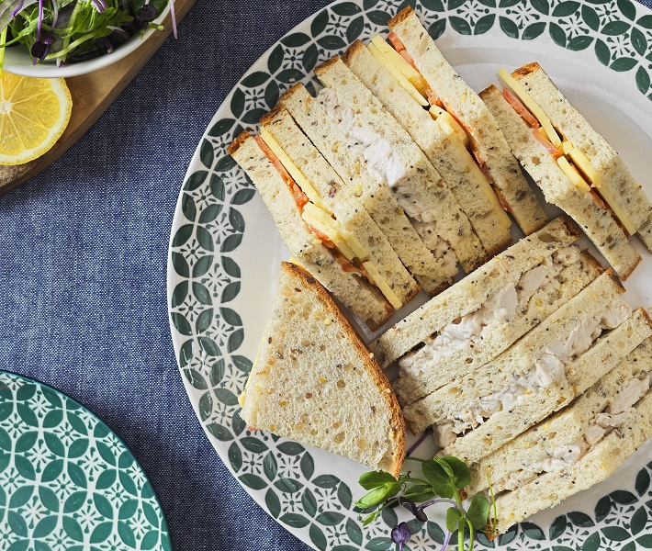
The products of the chosen company include a wide variety that includes but is not limited to low-fat content food items, bakery products, ready-to-eat meals, organic food products, gluten-free food items, clothing, TU range, kitchen products, a range of home collection products, kitchen furnishings. It also sells its organic fruits by using biodegradable trays (Sainsburry, 2023).
It produces a range of baking potatoes, carrots, jewel plum tomatoes, parsnips loose, British Swede, and many other items with the best quality, choice, and freshness (ScienceDirect, 2023). 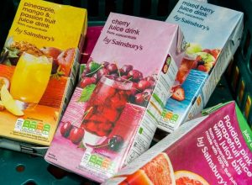 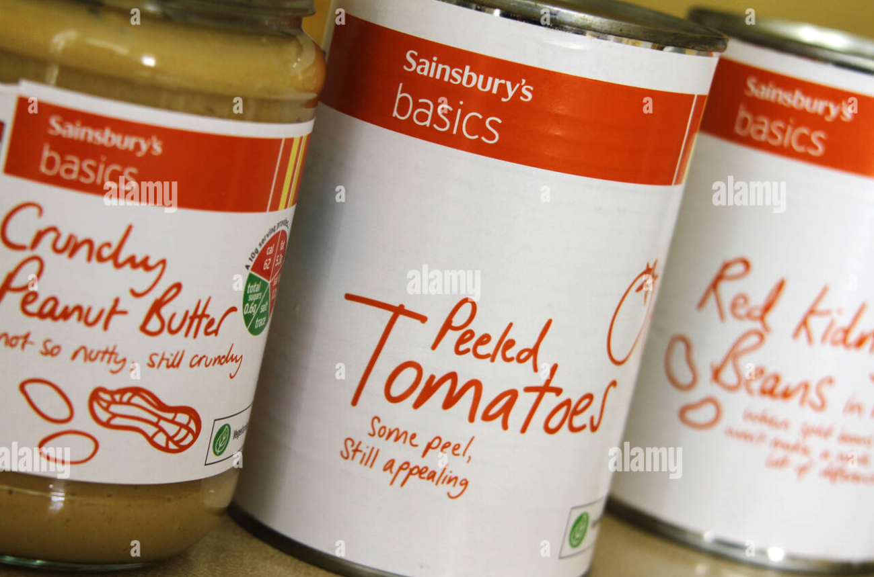
Its wide range of products is classified as under:
Fruits and vegetables-
- Fresh fruits, salad, and vegetables
- Frozen and organic vegetables and fruits
- Organic vegetables and fruits
- Prepared fruits, salad, and vegetables
Household
- Laundry
- household essentials
- cleaning products
Fish and meat
- Seafood and fish
- Chicken, bacon, sausages,
- Turkey, beef, mince, and lamb
- Cooked meats
- Duck, game, pork
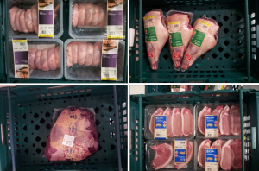
Dairy
- Custard and cream
- Desserts
- Dough
- Milk
- Cheese
- Eggs
- Yogurts
- Smoothies and fruit juices
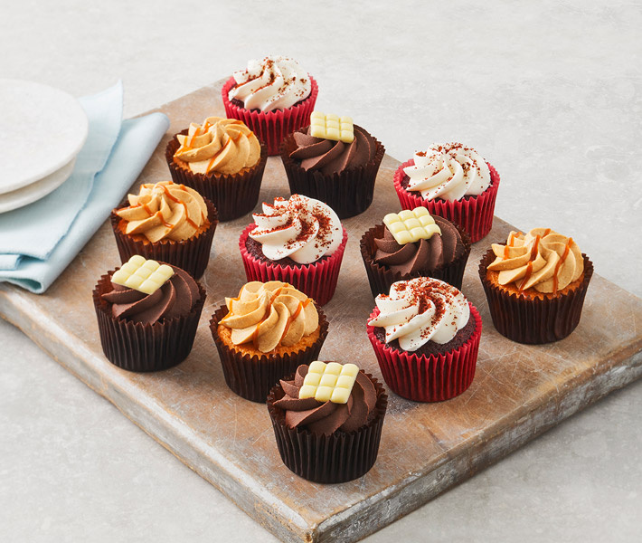
Health and Beauty
- Body care
- Haircare
- Oral care
- Make-up
Baby
- Wipes
- Toys
- Nappies
- Accessories
- Meals
Sainsbury has appointed an in-house design team as the packaging plays a crucial role in creating the rand. It endeavors to make the design catchier to attract more customers. It has rolled out its trayless packaging design for the whole chicken.
Source: (Logos-World, 2023).
The logo of Sainsbury is simple and clear and seems quite appealing to the customers who visit its website and stores in the United Kingdom. The meaning of logo implies cheerfulness and confidence.

Price
Pricing strategy for different products has been chosen keeping in view the different range of its products. It also considers the concept of value for money and believes in choosing a competitive pricing strategy, thereby varying its prices based on the prices of the products of its rivals. It does not believe in price-cutting strategies and rather prefers a price discrimination policy for the positioning of its products. The price of the basic products and kids products are relatively low than that of its competitors. Furthermore, the rates of fresh produce and groceries are quite affordable as these are bought from the local markets and also attract the consumer (Xia, 2023).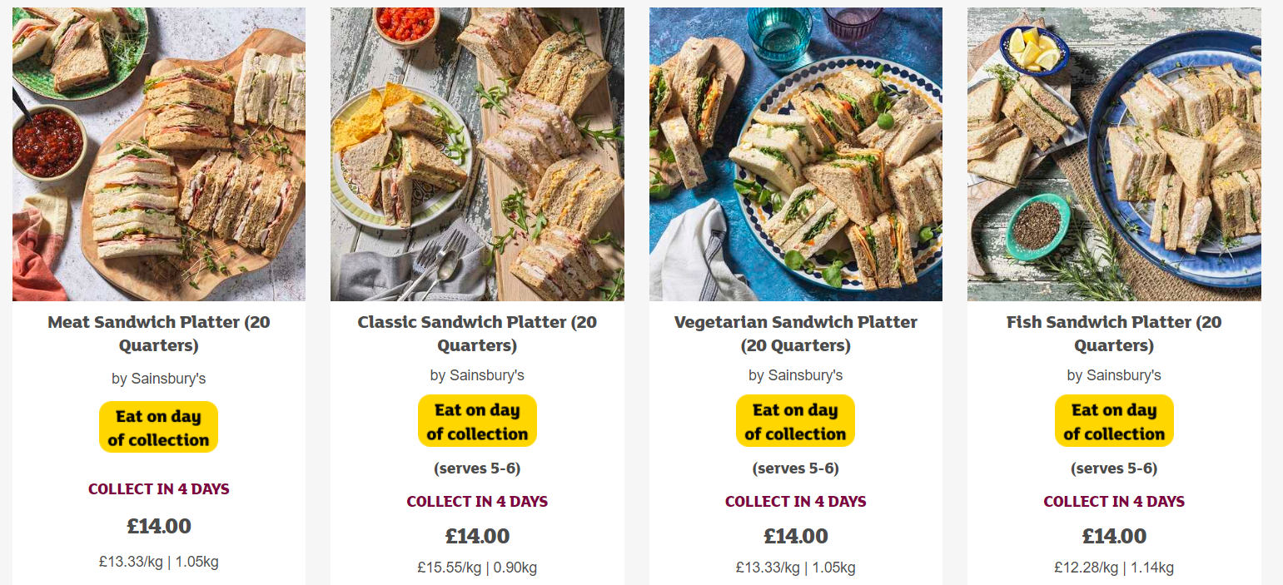

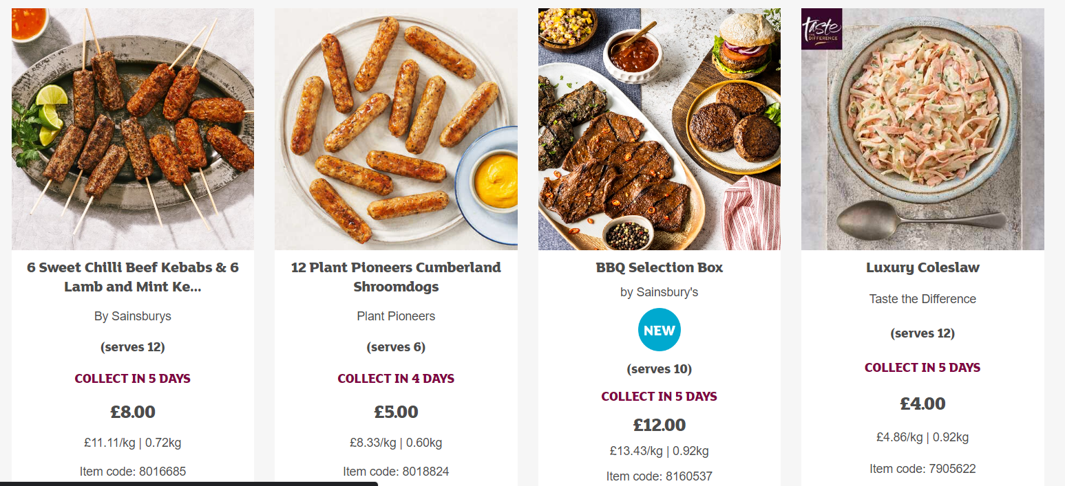

Place
Sainsbury has provided flexibility to enable its customers to shop the products by multi-channel proposition. Its products are also available at 2200 convenience stores, supermarkets, and Agro stores in the United Kingdom and Ireland. Moreover, customers can shop the product via mobile applications also. The company generates approximately 20% of its sales through online mode. Further, it makes available its products in the United Kingdom and Ireland. The products of Sainsbury are also made available at the website: https://www.sainsburys.co.uk/ 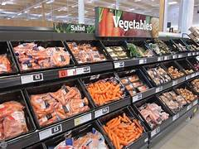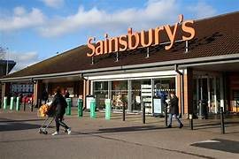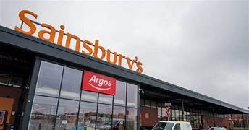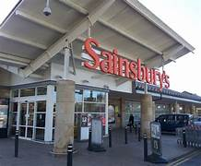

Promotion
Sainsbury promotes its products using database marketing and incentives. Further, its promotional strategies include above-the-line and below-the-line to build the brand name and attract customers. Moreover, it made use of advertisements to put focus on the London Paralympic Games. It uses a combination of data marketing, sales promotion, and packaging. For its promotional campaigns, it uses the slogan “Live well for less”. Moreover, it also made use of radios and television to communicate with the target market. Sainsbury is using its social media tools to communicate with its target market very successfully.
It updates regularly on its Instagram handle, the link of which is as follows: https://www.instagram.com/sainsburys/?hl=en
Moreover, it complies with environmental responsibilities and community service to develop its positive image in the eyes of its customers both current and potential (Matthew, 2019).

References
Czinkota, M.R., Kotabe, M., Vrontis, D., Shams, S.R., Czinkota, M.R., Kotabe, M., Vrontis, D. and Shams, S.R., 2021. Market segmentation, positioning, and branding. Marketing Management: Past, Present, and Future, pp.283-340 https://www.researchgate.net/profile/Demetris-Vrontis/publication/354108947_Market_Segmentation_Positioning_and_Branding/links/6252f016cf60536e23527168/Market-Segmentation-Positioning-and-Branding.pdf
Fahy, J. and Jobber, D., 2019. Ebook: Foundations of marketing, 6e. McGraw Hill https://d1wqtxts1xzle7.cloudfront.net/62060384/Marketing_Textbook20200210-17069-1cu2keb.pdf?1581398711=&response-content-disposition=inline%3B+filename%3DFOUNDATIONS_OF_MARKETING.pdf&Expires=1690192153&Signature=WscUVDiC8wasz4YxTxU1yZ4UaX~3kfyE3xQVk7TxokwxfDTfKqY~5~hl0AuQo6Ja~B6o58zTrWVSi9prnbYNCNT0intSWpYCCXgiIRDawPNkQjbouYWulXGL8~sYSi0Peqb8tKm~7pTAsHg3P7dHQtgMj1N2cnyqg4PJWvjLJ0xr3~zcdM~ySHMqP~kI7mDt9Sai6s8OrCiikAmnuAm48ORYLlwVLinEx5JjwTc94OCJOIcbDcSk0BIsZSDFNTzU63TkIk6HayaziaWeoGbn~EXzDvrvUVpxHbxDKdAicowlDxutL-TYGX99bPUreELTg9FGKzyt0iXiqkIw1JpdZw__&Key-Pair-Id=APKAJLOHF5GGSLRBV4ZA
Hood, N., Clarke, G. and Clarke, M., 2016. Segmenting the growing UK convenience store market for retail location planning. The International Review of Retail, Distribution and Consumer Research, 26(2), pp.113-136.https://sci-hub.hkvisa.net/10.1080/09593969.2015.1086403
IIDE., 2023. Segmentation, targeting, and positioning strategy of Sainsburry. [Online]. Available at: https://iide.co/case-studies/marketing-strategy-of-sainsburys/#:~:text=The%20target%20audience%20of%20Sainsbury's,the%20family%20unit%2C%20especially%20Mother. [Accessed on 25th July, 2023].
Li, L., Wang, Y. and Zhang, Y.Y., 2023. A critical examination of M&S's current strategic and marketing position, as well as potential sustainable competitive marketing strategies. International Journal of Science and Business, 18(1), pp.108-117. https://www.researchgate.net/profile/Le-Li-61/publication/367559196_A_critical_examination_of_MS's_current_strategic_and_marketing_position_as_well_as_potential_sustainable_competitive_marketing_strategies/links/63d899af62d2a24f92deffb2/A-critical-examination-of-M-Ss-current-strategic-and-marketing-position-as-well-as-potential-sustainable-competitive-marketing-strategies.pdf
Logos-World., 2023. Sainsbury’s Logo. [ONLINE]. Available at https://1000logos.net/sainsburys-logo/ [Accessed on 24th July 2023].
Matthew, A.G., 2019. RAIS RESEARCH. STUDIES https://rais.education/wp-content/uploads/2019/07/031AG.pdf
Sainsburry., 2023. Business strategy of Sainsburry. [Online]. Available at: https://www.about.sainsburys.co.uk/about-us/our-business-strategy [Accessed on 25th July, 2023].
Sainsbury, 2023. About Sainsbury. [ONLINE]. Available at https://www.sainsburys.co.uk/shop/gb/groceries [Accessed on 24th July 2023].
Sainsbury., 2023. About Sainsbury. [ONLINE]. Available at https://www.sainsburys.co.uk/ [Accessed on 24th July 2023].
ScienceDirect., 2023. Are UK retailers well placed to deliver ‘less and better’ meat and dairy to consumers? [ONLINE]. Available at https://www.sciencedirect.com/science/article/abs/pii/S235255092100110X [Accessed on 24th July 2023]
Wood, S. and McCarthy, D., 2014. The UK food retail ‘race for space’and market saturation: A contemporary review. The international review of retail, distribution and consumer research, 24(2), pp.121-144. https://sci-hub.hkvisa.net/10.1080/09593969.2013.839465
Xia, Y., 2023. The 4Ps of Marketing and Applications in Various Brands. Journal of Education, Humanities and Social Sciences, 16, pp.165-170. https://doi.org/10.54097/ehss.v16i.9601
Xiao, B., Chen, Q. and Yu, Z., 2021, April. Research on the Investment Value of Sainsbury’s. In 2021 6th International Conference on Social Sciences and Economic Development (ICSSED 2021) (pp. 108-115). Atlantis Press. https://doi.org/10.2991/assehr.k.210407.022

