

SONIMA POUDEL
Student Number: 1913137
Assignment Title: Marketing Management
Faculty: MBA in General Management
Lecturer: Tushara Balendran

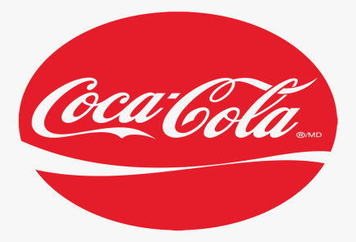

INTRODUCTION
The best marketing strategy can lead to the continuous growth and development of business. The strategies and policies should be implemented in such a way that the company will lead to achieve the organizational goal and objectives. It’s all depends upon tough decision that has to made by the administration of company/ organization. However, this report may help the companies of Coca-Cola to engage actively on the national as well as the international market.

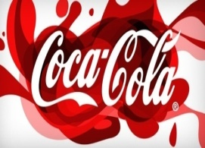
BRIEF HISTORY OF COCA COLA

The most popular drink was first introduces by John Pemberton and Asa Griggs Candler on 8th May, 1886 in the United States of America. Coca cola success formula has been bought in 1894 and yet its mystery has been unfolded what actually it was. Coca-Cola was first sold in bottle since 1894 for the first time. Likewise, Coca-Cola brings the Diet Coke in 1982 which became the most popular soft drinks in the world.
Recently, it manufactures many products which are distributed in more than 200 countries. Coca-Cola produces different soft drinks so; customers can get a complete choice of drinks in every festival by Coca-Cola companies. They made 97 percent of products in United Kingdom too in cans and bottles. Source: https://www.coca-colacompany.com/company.

ENVIRONMENTAL ANALYSIS
The environmental analysis is key factors that affect an increment or decrement in the abilities of work by the organization to achieve certain goals in the future. Environmental analysis consists of different factors that could help to attain the goal of an organization. There are many strategic tools that an organization can analyze to achieve their objectives properly. However, the most common tools of environment that are used by the companies are the PESTLE analysis in order to achieve their firm’s goals.
- P-Political:
Due to the increase value on Value Added Tax (VAT), Coca Cola has increasing their products price in the market. Likewise, due to the changes in government rule and regulation to reduce the amount of workers in an organization, Coca-Cola has also implemented these rules effectively. As a result, les numbers of people are purchasing the product. Different laws and regulations has been updated day by day about the company such as consumer protection and regulation legislation, health and security ,law of employees and customers, environmental and natural resources protection protocols and as well employment law, which directly influence the business environment as well as the market value of an organization.

- E-Economic

There is an economic breakdown in various countries around the globe. Due to this there has been an increase on interest rate. As a result consumers have to spend more on basic needs such as food material rather than drinks and other beverages. Thus, the factors are unfavorable because customers are spending more on other alternative healthy soft drinks rather than Coca-Cola.

- S-Social:

Nowadays, human beings are more concern with their health and physical condition, we monitor ourselves what we consuming in our busy day to day life. Somehow we also wanted to be fit, healthy and good-looking and this makes us to be more conscious about our health and safety. This factors in unfavorable because despite of bringing several low calorie products its sales has been decreasing due to soda and aerated drinks across the world.

- T-Technological:
Well, Coca-Cola had recently launched a smart technology/system where consumers can trace their bottle/ can of Coca-Cola about place and time of its manufacturing. Coca-cola factors are favorable because of the various smart tools and technological system that brands can use to helps customer to know the carbon track of the drink, the ingredients contain on the drink and what they use for the packaging too.
- E-Environmental
Since last few years, the governments have been emphasizing more about reducing carbon in our environment that are released from large industries and factories which are the main reason and cause for the problems like global warming as well as climate change in our planet, So Coca-Cola have embraced this idea. Ecological factors of Coca-cola brands are favorable because Coca-Cola Company is making their drinking bottles that can be totally recycled. This makes the environment clean and fresh.
- L-Legal
Every brands need to ensure that it meets up with certain rules and regulations wherever its products are sold. This factors is unfavorable because Coca-cola has also has to face this problems and in past it has to pay lawsuits in many countries. Likewise, Coca-Cola has been known as treating their employees in prejudice manners also pay fewer wage than the normal in some country.
Source: https://pestleanalysis.com/what-is-environmental-analysis/

PORTARS FIVE FORCES MODEL:

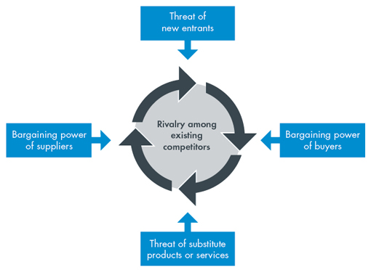

Source: https://www.cgma.org/resources/tools/essential-tools/porters-five-forces.html
The five forces are:
- Threats of New entrants:
Coca-cola is a globally recognized brand whose products are available in among 200 countries. Therefore, there is no any threat by small scale companies and new entry companies for the company .It has very strong market share and has large number of loyal customers. So, they cannot easily switch to new brand.

- Threat of substitute:

The main substitutes of Coca-Cola are the products produced by Pepsi, fruit juice, other soft drinks. People who like soft drinks, diet coke don’t want to switch by other brands. However, availability of other brand’s drinks may affect the market share as the consumers have the option to select other drinks apart from Coca-Cola.

- Bargaining power of buyers

As, Pepsi and coca-cola sell similar flavor’s drinks switching cost of customers are not high while buying brands. The bargaining power is not possible in coca-cola brands whether it’s individual buy or largest retailer because backward integration is not possible in coca-cola companies. Nevertheless, if a retailer purchase in larger volume they can acquire some power to bargain. The bargaining power of buyers is high as they can easily switch to other rivals or substitutes. However, brand loyalty can reduce their power.

- Bargaining power of suppliers

The bargaining power of suppliers of Coca-Cola is low because the switching cost is low although the numbers of suppliers are high in the market. It is not easily possible for any suppliers to switch to other brand easily which led them toward loss of their companies in the market.

- Competitive rivalry

Pepsi is the toughest competitors of Coca cola in current scenario. There are other some companies who produces soft drinks, bottled waters too but their market share is low and they cannot be competitors for Coca cola. Thus, other small companies do not have any potential to compete with coca-cola brands. It has high brand loyalty so it is not likely affected by customers easily.

Source: https://www.porteranalysis.com/porters-five-forces-of-coca-cola/

SWOT ANALYSIS OF COCA COLA

Strength

The brands have a powerful and reliable network in the market with strong brand equity. Its soft drinks are considered to be highest selling products in the world. Coca cola brands are distributed 500 new products globally and target their customers emotionally to purchase the products. The brand is highly associated with the customer’s happiness as they labels their customers name in their product. Likewise, Coca Cola Company distributes their products almost 250 countries globally. Thus, it has largest and well organized distribution network in the world. Source: https://bstrategyhub.com/swot-analysis-of-coca-cola-2019-coca-cola-swot-analysis/

Weaknesses:
The toughest competition with the Pepsi is the major weakness of Coca-Cola. Pepsi had launched many snacks items in market which makes the Coca-Cola fall behind.
Likewise, it has no any age specific group to be targeted. Mainly, company targets youngsters due to this most of the people they are not giving much attention towards the products. Similarly, there is a controversial issue for the company as most of the health experts have restricted the use of soft drinks.

Opportunities:
Large international markets: The size of international market for Coca-Cola Company is very enormous and opportunistic as compared to any other soft drink producers that are in competition with the Coca-Cola.
Introduce new products: Coca cola has launched different new products in the market like Diet coke, Zero coke, Coca cola life and many more. It has the opportunity to bring new products in different segments.

Threats:
Other soft drinks in the market that can be a threat for Coca cola companies as they are trying hard to remain at top in the market.
Strong competition: Coca-Cola is facing many problems with strong competitor in its market. Not only in Asian countries like Bangladesh and India was the product compete with Pepsi but also thumps up, dew, sprite, etc.
Packaging controversy: Due to its single use plastic bottles green peace has restricted coca cola in 2017 in its published report, Coca cola has been censured for its recycling and renewable source.

PESTLE ANALYSIS
Pestle analysis is the strategic tool used by the companies to identify key elements that affect the environment as well as performance of the organization. Some of the advantage and disadvantage of pestle analysis are:
Advantage:
- Easy to understand: Pestle analysis can be effectively implemented as it has easy framework to be understand.
- Make use of opportunities: Pestle analysis helps the organization in making the advantageous opportunities which rises time to time in organization through external factors.
- Alertness development: The realization of potential threats in an external environment in the organization can be easily identified by this model. It allows you to thoroughly study the changes happened in the market and to develop a plan which can lead to the profits in near future.

Disadvantage:

- Rapid change: It’s became very difficult to analyze the factors of Pestle as keep changing time to time.
- Data is not easily found: Unfortunately, lot of data about pestle analysis is difficult to obtain in online. It takes long hours to take information plus the informative may not be trustworthy always. Source: https://pestleanalysis.com/disadvantages-of-pestle-analysis/

- The investment is massive: More information is not easily available online plus some data may be inaccurate too plus it takes long hours to find out reliable data. Therefore, we need to invest more for manpower and research.

SEGMENTATION, TARGETING AND POSITIONING OF COCA COLA

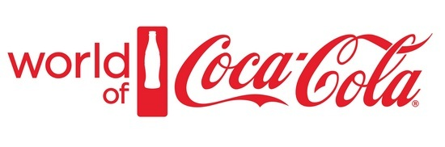
Source: https://www.marketing91.com/marketing-strategy-of-coca-cola/
Segmentation
The company has been segmented on the basic of following area:
Geographic segmentation: Coca-Cola Company targeted their customers on the basis of geographic areas. Coca-Cola mainly distributes its products in urban or cities areas as compared to rural areas.
Place of consumption: Coca-Cola Company targets its market according to the place of consumption .Coca-Cola can distribute their products in public places such as theater, petrol stations, restaurants and bars etc. while maximum of consumption is done by household peoples.

Demographics: Another segmentation of Coca-Cola Company is based on demographics. Coca cola targets their consumers based on their age groups mainly youngsters and teenagers.
Source: https://www.assignmentsbox.co.uk/wp-content/uploads/2011/10/The-Coca-Cola-Company-Marketing-Strategy.pdf

Targeting
Coca-Cola targets mainly youngsters and youth ones who want strong flavor in their taste. It mainly targets the people with busy lifestyles who nature is joyful, entertaining and enjoyable. Coca-Cola targets equally to both the consumers.
Positioning:
Coca-Cola are said to bring joy and happiness in peoples life by positioning their products by labeling the customer’s name on their products. Coca-Cola helps to make good time and create memorable events with their family by having it in every occasion. Every product of coca cola is highly qualitative and also consistent too.

Source: https://www.assignmentsbox.co.uk/wp-content/uploads/2011/10/The-Coca-Cola-Company-Marketing-Strategy.pdf

MARKETING MIX STRATEGIES OF COCA COLA
- Product Strategy:

Coca-Cola has the widest portfolio who manufactures more than 3300 products around 200 countries throughout the world. The logo is clearly made recognizable and unique to make it memorable and different from other products. The Coca-Cola Company also provides different and remarkable shapes pertaining to the brand. The brand mainly focuses on the individual their lives, and relationship they have with others, not on the organization .Thus, it emotionally persuades the consumers to buy the product. Likewise, the brand not one makes commercial ads but also create many stories for their products that leave their customers spellbound.

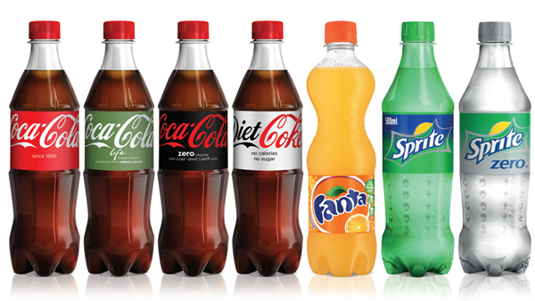

Source: https://coca-colahellenic.com/en/brands/the-brands-we-sell/brands-overview/
- Pricing Strategy:

The pricing strategy of Coca-Cola is done according to the geographic segments as there are wide ranges of products manufactured by coca cola. Pepsi is the tough competitor of Coke in the market. If coke price will rapidly increase in the market then customers might switch towards Pepsi. However, Coca-Cola gives discounts on large purchases by sometimes and even bundling the products.

- Coca Cola Place & Distribution Strategy:

Coca-Cola is the topmost multinational companies across the world. The products are available in bottles and cans in supermarkets and other stores throughout the world. They use different channels in order to distribute their products. They even use thousand of pop vending machines to make convenience for the customers to purchase the products.

The company’s bottling partners work closely with the customers including grocery stores, stations, restaurants and bars and many more.

- Coca Cola Promotion & Advertising Strategy:

Coca-Cola use different media in order to promote their brands. There are about many promotional videos on different social Medias like YouTube, Instragram to promote their products. The company has spent almost 5 dollar billion in 2018 in to advertise their products globally. There are more than 1,250 promotional videos of Coca-Cola products and brand on its official YouTube channel.

Where is Coca cola Available?
Coca cola runs its operation worldwide and distribute its products through various channels too. The company manufacture and sell through various bottles and cans in the market .However, it is also responsible for consumer brand marketing enterprise. The bottling partner’s produces packages and distribute its products in market and vending partners so that they could sell the products to many customers. Likewise, Coca cola sell its products in bottles and cans operations, salesperson, foundation, wholesalers and distribute them to retailers, stores, and supermarket, station and many more.

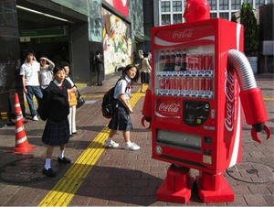
Source: https://mpk732.wordpress.com/2015/05/17/the-coca-cola-companys-distribution-strategy/

CONCLUSION:
This report discuss about the topmost and multinational business which is almost leading rapidly throughout the world. This reports discuss about different model that are use to identify the business structure. Besides this, Coca-Cola has been segmented in different areas and positioned to different age groups people and target mainly to youngsters and teenagers. Likewise, this report has discussed about 4Ps of Coca-Cola in Marketing with appropriate strategies and policies that Coca-Cola need to implement in near future.

- INCLUDE RECOMMENDATION FOR FUTURE:
Coca-Cola is the topmost multinational companies around the world. However, there are still some strategies and policies that Coca-Cola need to implement in order to remain at the top list throughout the world. Therefore, with the appropriate research result conducted, it can several recommendation that Coca-Cola Company need to carry out which are listed below:
- The company should provide different offers and discounts to the consumers according to the country traditional and festive seasons as well as holidays time so that the customers will be attracted towards the company products..
- The Coca-Cola Company should target its products for all age group rather than focusing only youngsters.
- The price rate given by Coca-Cola company need to be monitored by the head of the marketing faculties because of the challengers arise in market and more consumers tend to find any other products like soda, dew and other soft drink products that has best price value for them. So, the company needs to benchmark on challengers’ pricing strategy available in market.
- Coca-Cola must bring different flavors or taste in their brand in order to increase its market demand.

Besides this, Coca-Cola can also use different strategies explained by Ansoff Matrix in near future. Some of them are:
- Market development. Coca-Cola can adopt this strategy in near future to increase its market share and volume. It is all about selling company’s their existing products in the new market. Through this strategy, coca-cola can reach to their new customer segments or they can expand their targeted areas internationally. However, there are still two countries where Coca-Cola has not entered recently and they are Cuba and North Korea. However, it is not always the same as Coca-Cola first opened its bottling system in 1906 in Cuba but due to trade embargo it could not take place. Likewise, the only things that stopped in North Korea were due to World War II. Thus, Coca-Cola need to distribute their products across this both countries .They can distribute their products in remaining countries where they have not operated their business. Source: https://www.business-to-you.com/ansoff-matrix-grow-business/

- Diversification: Another strategy that Coca-Cola can adopt in near future is Diversification. Coca-Cola needs to enter the new market with new products that are either related or completely unrelated. Coca-Cola needs to introduce new product in foods and snacks products. It is the riskiest strategy because businesses are entering into new market with no any experience or little experience but Coca-Cola is the topmost companies throughout the world so they have necessary resources to enter into the new market. Source: https://learn.g2.com/ansoff-matrix.

BOOKS
- Author
Art Weinstein (2004) Handbook of Market segmentation: strategic targeting for business and technology firms. 3rd ed. New York : Haworth Press.
- Author
Brian Sheehan (2010) Marketing Management. Lausanne, Switzerland

- Author

Philip Kotler and Kevin Lane Keller (2018) Basics Marketing 03: Marketing Management, Lausanne Available online: https://www-bloomsburyappliedvisualarts-com.ezproxy.uwtsd.ac.uk/encyclopedia?docid=b-9781350057913

- Author

Beller, K., Weiss, S. & Patler, L. (2007) The Consistent Consumer, Sedona AZ, LTS Press.

- Author

Dibb, S., Simkin, L. M. and Ferrell, O. C. (2012) Marketing: Concepts and Strategies.6e. Cengage Learning EMEA

- Author

Michael John Baker; Susan J Hart (2008) The Marketing Book 6th ed. Oxford ; Boston : Butterworth-Heinemann Available on : https://www-dawsonera-com.ezproxy.uwtsd.ac.uk/abstract/9780080942544

Resources
Journal and magazines:
- Regassa, Hailu;Corradino, Laurie ‘Determining the value of coca-cola company-A case analysis’ Vol. 17, Iss. 8, (2011): 79-86.

- Charlotte Ellertson (1996) ‘History and Efficacy of Emergency Contraception: Beyond Coca-Cola
International Family Planning Perspectives
Vol. 22, No. 2 , pp. 52-56.

- BUEHLER, N. (2019) ‘ 5 Companies Owned By Coca Cola’ Published on April 1, 2019, Available at: https://www.investopedia.com/articles/markets/011216/top-5-companies-owned-coca-cola-ko.asp
- CBS News. (2015)’30 years ago today, Coca-Cola made its worst mistake’ Published on April 13, 2019, from CBS News: Available at: https://www.cbsnews.com/news/30-years-ago-today-cocacola-new-coke-failure/

- Lee, Don,(2003) ‘Segmentation and promotional strategies for selling CARB bearings in China, The Journal of Business & Industrial Marketing’, Vol.18(2/3), pp.258-267.Available at
https://search-proquest-com.ezproxy.uwtsd.ac.uk/docview/222024643?accountid=130472&rfr_id=info%3Axri%2Fsid%3Aprimo

- Ford, John, ‘What do you kno about segmentation and targeting?’ Journal of Advertising Research, Jun 1, 2019, Vol.59(2), p.131.[Available on : https://web-a-ebscohost-com.ezproxy.uwtsd.ac.uk/ehost/pdfviewer/pdfviewer?vid=1&sid=9ceecfcc-15a8-4609-8d29-03ac829b46b9%40sdc-v-sessmgr02

OTHER INTERNET SOURCES:

- https://www.coca-cola.com/
- https://www.cocacola.co.uk/en/home/
- https://www.coca-colacompany.com/company/coca-cola-system
- https://www.coca-colacompany.com/careers/who-we-are
- https://notesmatic.com/2017/03/coca-cola-marketing-mix/ [ Published on May14,2020]
- https://www.worldofcoca-cola.com/about-us/coca-cola-history/
- https://www.business-to-you.com/ansoff-matrix-grow-business/ [Published on: March 9,2017]
- https://pestleanalysis.com/swot-analysis-coca-cola/ [Published on : Nov 23,2016]
- https://www.investopedia.com/articles/markets/120915/analyzing-porters-5-forces-cocacola.asp [Published on: 2020]
- https://prezi.com/j6s00dbtmoso/strategy-recommendation-for/ [Published on :23 August 2015]
- https://www.coca-colacompany.com/press-releases/coca-cola-reports-strong-growth-in-fourth-quarter-and-full-year [Published on : 01/21/2020]

