Name: Estella May Chambers
Student number: 1800682
Course: Fine Art
Lecturer: Alex Duncan
Question 5: Choose a theme, movement, or selection of artists or designers that relate to your practice or interests, and construct a 2,500-word essay. Critically assess consider primary themes, key writers, and relevant practitioners.
Words: 2048
Tim Burton began his creative career working for Disney animation studios, creating many original characters and even pitching short films. Two of which, Vincent (1982) and Frankenweenie (1984) were made into feature films. However, Disney did not see his work as particularly investable and therefore dropped Burton after making his second short film. After leaving Disney he created The Nightmare Before Christmas which became the springboard for this career. The running gag with Burton films is that he is eternally trying to get his (ex) wife and best friend to be love interests. This casting choice leads to a reoccurring theme within his films. If Depp is involved with Bonham Carter, it is a Burton film.

Produced by Burton in 1993, The Nightmare Before Christmas actually came around due to a technicality over ownership. Given that Burton started writing/ playing around with the characters and story for The Nightmare Before Christmas while still working for Disney Animation Studios, when he finally came to making the film, having left Disney, the intellectual rights were Disney’s. However, due to the narrative premise of a skeleton who kidnaps Santa with the help of an “ambiguous swamp creature” (Bond, n.d), Disney did not want to be directly involved with the production of the film. In spite of that Disney still profits from the film to this day. The film took three years to make from start to finish, with over sixty characters moving twenty-four times per second. (The making of the nightmare before Christmas (1/3), 2009)

The director, Henry Selick wanted to light the over two hundred sets the same way you would for a live action film. (The making of the nightmare before Christmas (2/3), 2009) This was to create extra contrast within the sets and give the animation an edge that no other film had done before with so much care and attention. With up to fifteen animators working at one time the film has a particular smoothness, especially for its time. Selick suggests in the making-of documentary, that each person has to love what they do in order to turn up each day and “you can’t go into a project like this dreaming of the end of it” (The making of the nightmare before Christmas (3/3), 2009). The score being composed by Danny Elfman (which aids the narrative flow) begins a creative partnership. This “reverse Grinch” story still gets played every year, with new merchandise and ‘easter eggs’ being found each year. For example, the protagonist Jack Skellington can be seen portraying a pirate in 1996’s James and The Giant Peach (1996), also directed by Selick and produced by Burton. The minimal colour used in Halloween Town was deliberate, not just to create a spooky atmosphere but also to give a heightened contrast when Christmas Town is introduced, the viewer cant help but agree with Jack’s excitement at the bright lights.
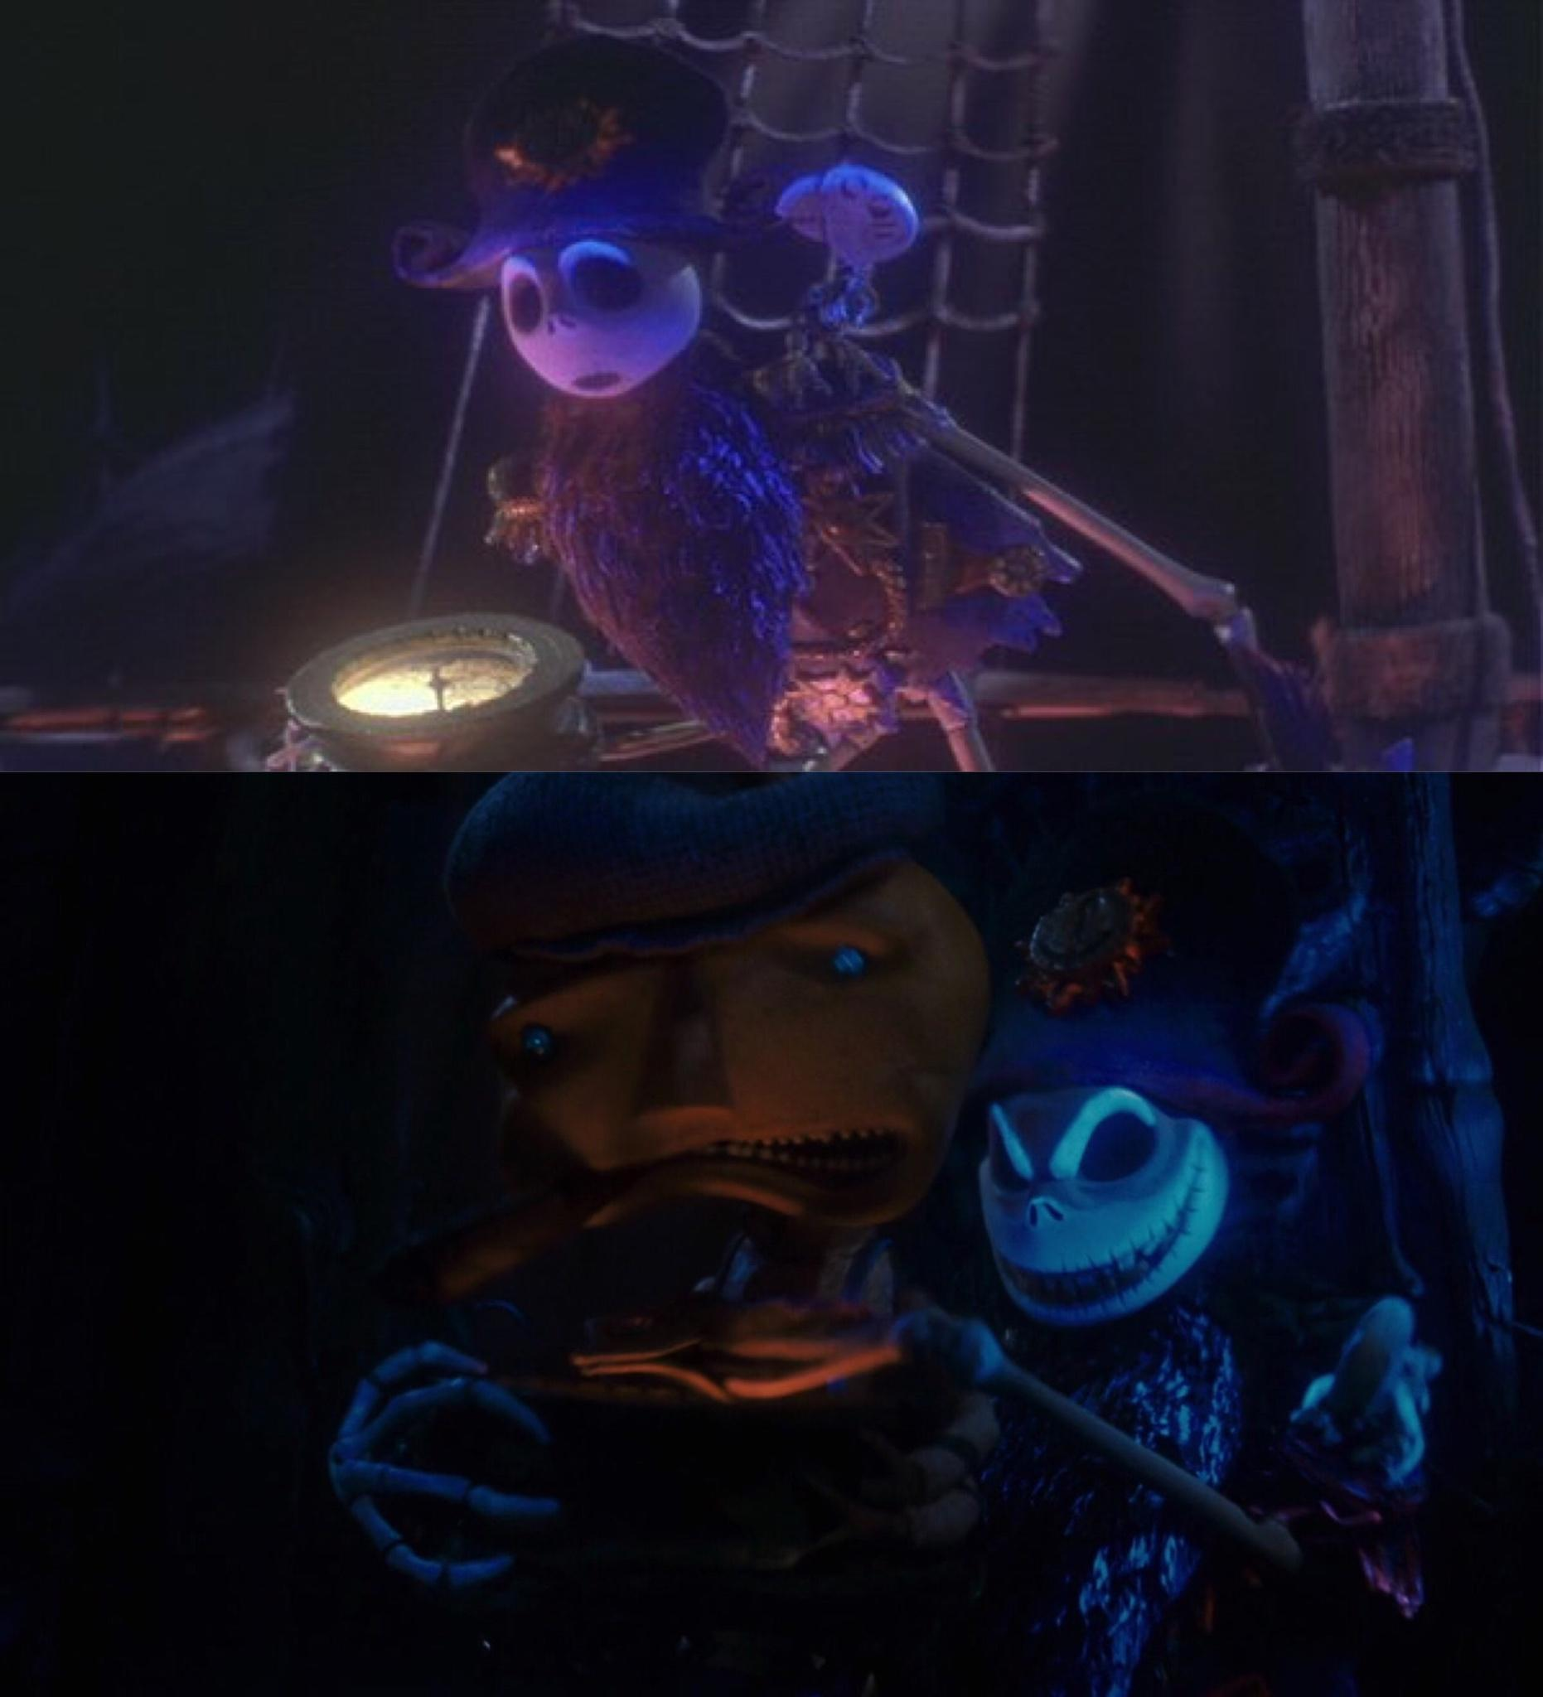
Figure 1 (Reddit, n.d.)

Ronald Searle and Edward Gorey are credited by the artists of the film as inspiration, for their detailed, scratchy, cross-hatched ink drawings. The Nightmare Before Christmas is, in my opinion, Burton’s most known and appreciated work. I say this because while Burton has created several films that stick out in people’s minds; Batman Begins, Beetlejuice, and Edward Scissorhands just to name a few, The Nightmare Before Christmas creates imagery and shows stop motion like no other film had before it.

Additionally, it is hard to argue the film wasn’t successful especially given that to this day it still gets played every Halloween and Christmas, new articles emerge, looking at creation and build of the set designs, alongside the designers’ experiences working on the film. New merchandise is being made almost 30 years on from its release that sells out, for example, this year (2020), one of the world’s top jewellery companies (About Pandora, n.d.), Pandora released a limited edition The Nightmare Before Christmas charm.


Figure 2 (Jewel Hut, 2020)

Elfman and Burton collaborate again in 2005’s Corpse Bride. This tale sees Victor (Depp), in an attempt to learn his wedding vowels, accidentally wed deceased Emily (Bonham Carter). Naturally chaos ensues. The two learn of Emily’s past and how it is currently affecting Victor’s living present. The production started over ten years after directing Burton’s first animated film The Nightmare Before Christmas (1993) and was Depp’s first animated speaking role. Many have questioned if Depp would have taken the part if it were not for his already successful friendship with Burton, and proof of their winning combination in Sleepy Hollow (1999). Additionally, Burton had displayed his unique take on animated films while helping to produce James and The Giant Peach (1996). Given that animation and original characters are Burton’s stylistic trademark, it makes sense for him to keep returning to stop-motion animation. Additionally, given the success of The Nightmare before Christmas seeing Burton make a second animated musical feels like an attempt to spark that existing fanbase.

It is impossible to talk about Burton’s film style without discussing German expressionism. As described by Movements in Film, “German expressionism reflects the inner conflict of the 1920s audience…by rejecting cinematic realism Expressionist films showcased dramatic revolutionary interpretations of the human condition” (n.d). One of the most influential artworks to consider when discussing German expressionism is actually a Norwegian artist Edvard Munch’s The Scream.

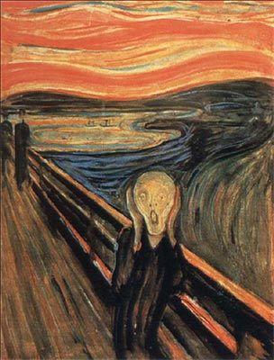
Figure 3 (The Art Story, n.d.)

Influenced by Munch's unfortunate childhood a large focus of his work depicts life and death scenes, terror and the feeling of loneliness (Edvard Munch - Paintings, Biography, Quotes of Edvard Munch, n.d.). A lot of this has been linked to the death of Munch’s mother in his early childhood. Consequently, his Father had to raise Edvard and his siblings, where we can only imagine how the loss of a parental figure took a toll on the family. This reflects Burton’s work as his first short film, Vincent, was about a lonely child and reflected upon Burton’s own childhood. German expressionism attempts to seek out our deeper feelings, exposing negative and darker emotions. Burton talks a lot about how he doesn’t feel that anybody likes him, or didn’t feel like anybody like him when he first started out his career.

“characters, stories and imagery have been drawn directly from his childhood. A childhood Burton claims Was unhappy and isolating. Making him feel like an outcast...” (Tim Burton: The Twisted Story of The Eccentric Filmmaker, 2019)

Could this be why his first big piece, the nightmare before Christmas, is about a confused, out of place character who is being told to fit into one specific box -the ‘cookie cutter’ Disney life- and actually wants to go off and explore something completely different? Personally, I think, yes. I attempt to use my own emotions in my work, and through my research I have discovered that other creatives are the same. It is a lot easier to put your heart and soul into something when you identify with the experience you are trying to portray.

Another iconic work to study when discussing German expressionism is The Cabinet of Dr. Caligari (1920). The black and white, silent film sees a murder, a murder attempt and an insane asylum all tie in to a story with a large plot twist. (The Cabinet of Dr. Caligari (1920) - IMDb, n.d.) The ending is not the only thing twisted about this film as the majority of the imagery is somewhat crooked. The heavy shadows and stark contrast give an almost charcoal drawing effect to the film. With that being said it is easy to make parallels between the sets for The Cabinet of Dr. Caligari and Burton’s own work. The slanted, wobbly designs of Halloween Town almost mimic some of the shots from the 1920’s film. The way the buildings feels as though they should not be standing and the creativity to have that contrast with the characters moving relatively normally is apparent in both pieces. Additionally, the heavy strong lighting of the ‘20’s can be seen in not only The Nightmare Before Christmas but also in many other Burton films, examples include; Corpes Bride, Sleepy Hollow and more recently Dark Shadows.

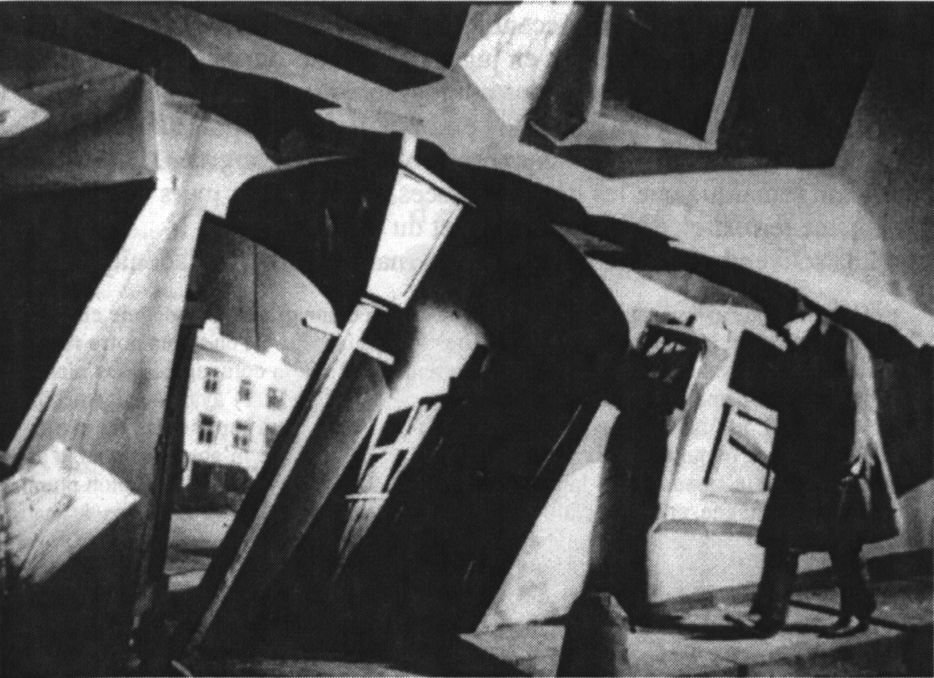
Figure 4 The Cabinet of Dr. Caligari (1920), Robert Wiene (Wordpress, n.d.)
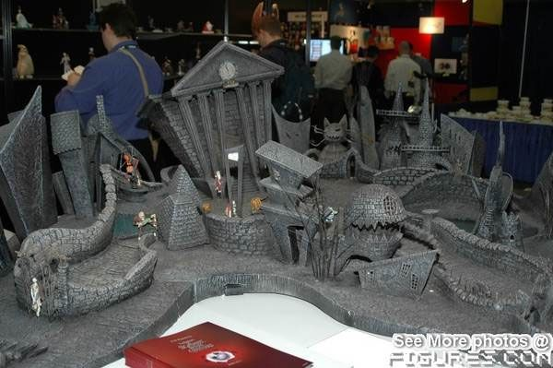
(Pinterest, n.d.)

Burton has recently come under scrutiny due to his lack of diversity within his cast. (day 24: #timburtonchallenge with an important message…, 2020) Most of Burton's films have a very white-washed cast. This has led to Burton having to defend himself in 2016 “things either call for things, or they don’t.” (Butler and Izadi, 2016) However, due to a recent TikTok trend people are once again debating if this lack of diversity is due to this art style or just simply down to racism.

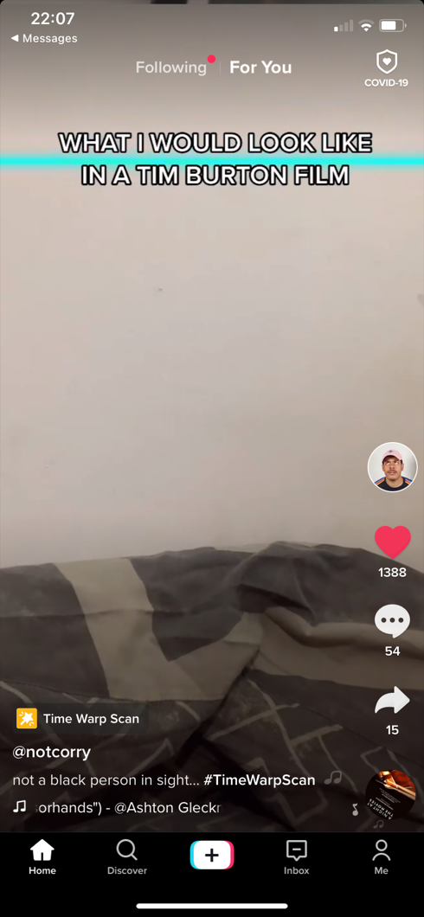
This came to my attention when Youtube creator Notcorry posted Not a black person in sight…#TimeWarpScan (2020) to TikTok. The video is of Corry demonstrating what he would look like in a Burton film, he then proceeds to go off-camera.
Figure 5 not a black person in sight…#TimeWarpScan, Notcorry (2020)
I found it shocking and a clear blind-sightedness -with the addition of a feeling of white privilege- on my side that I had never thought to consider the lack of people of black and ethnic minorities in a Burton film. Burton has claimed in the past it would be counterproductive to have a “token” diverse character (Todd,2016), but does this defense really stand when you have blue people, half your films are animated and a talking black widow spider? Additionally, ableism could be questioned due to the villain in The Nightmare Before Christmas being in a wheelchair and The Queen of Hearts having a defect. The first notable black actor to appear in a Burton film is Samual L. Jackson in Miss Peregrine’s Home for Peculiar Children – it is worth noting that he plays the antagonist.

It is essential to mention this because in more recent years it has become clearer that as a society we need to give more voices to minorities. This include, but is not limited to more equal casting opportunities. Holding people accountable, especially those who are in the media industry and are therefore responsible for creating the images people grow up around, could potentially change the world view for many.

This unrealistic, one sided world creation just does not portray real-world truth. Which, again I know is a fine like to walk when in the real world you cannot have talking skeletons etc. but it is important that everyone feel represented. What message is Burton displaying if his first and only canon character of colour is a villain? Even if it is subconsciously. Now that I’m aware of this lack of diversity I really hope that in future projects this is rectified.

We have witnessed the recent views of J.K Rowling around Trans-identity (Shennan, 2020) and how public opinion has been divided about her comments and her creations; with most accepting that when they introduce their children to Harry Potter it will have to come with caveats about the author. I would really hate to see this happen to one of my favorite creators, it would be amazing to talking about the positive change this criticism pushed Burton towards. Only time will tell.

Ultimately, Burton has managed to turn his doodles, and bizarre creations into a career and if that is not every creatives’ life goal then I do not know what is? The fact that he started out working for a company that were not really appreciating him so he founded a studio that would support his dreams and employ multiple people is very inspiring. Not to mention that Burton clearly struggles, or did originally struggle, with anxiety and isolation in early life, but used that to fuel his projects is why I find him so important in my own work. While flawed at times, needing improve the diversity of characters in his output, to follow changing world view and become more inclusive- Burton’s footsteps are definitely some I would like to walk in. Taking that rage and annoyance at the world and making work with it is, and probably always will be, the heart and soul of many creatives’ work. If Burton could use his own emotions to make a creative empire, then what is stopping me?

Bibliography
Websites
Bond, A., n.d. SKELETONS, RAG DOLLS, AND AMBIGUOUS SWAMP CREATURES: GENDER IN TIM BURTON’S THE NIGHTMARE BEFORE CHRISTMAS. [online] Wp.rutgers.edu. Available at: http://wp.rutgers.edu/attachments/article/515/a_bond.pdf [Accessed 29 November 2020].

Burger, A., 2017. A Critical Companion To Tim Burton. [online] Google Books. Available at: https://books.google.co.uk/books?hl=en&lr=&id=cbI3DwAAQBAJ&oi=fnd&pg=PA107&dq=nightmare+before+christmas&ots=6yTadcCEoC&sig=JBSVNawUEKZi_PMTk6oYJiJFgvQ&redir_esc=y#v=onepage&q=nightmare%20before%20christmas&f=false [Accessed 8 December 2020].

Butler, B. and Izade, E., 2016. Tim Burton Explains Why His Movies Are Full Of White People. [online] Washington Post. Available at: https://www.washingtonpost.com/news/arts-and-entertainment/wp/2016/09/29/tim-burton/ [Accessed 5 December 2020].

Crazy Nate. n.d. What Do Easter Eggs Mean In Movies?. [online] Available at: https://crazynate.com/what-do-easter-eggs-mean-in-movies/ [Accessed 8 December 2020].
TikTok. 2020.

Day 24: #Timburtonchallenge With An Important Message. Please Share! #31Daysofhalloween #Poc #Altblack #Goth #Scene #Timburtonmakeup #Corpsebride #Alt. [online] Available at: <https://vm.tiktok.com/ZSsQWe6c/> [Accessed 9 December 2020].

Edvardmunch.org. n.d. Edvard Munch - Paintings,Biography,Quotes Of Edvard Munch. [online] Available at: https://www.edvardmunch.org/ [Accessed 4 December 2020].

IMDb. n.d. Corpse Bride (2005) - Imdb. [online] Available at: https://www.imdb.com/title/tt0121164/ [Accessed 2 December 2020].

IMDb. n.d. Sleepy Hollow (1999) - Imdb. [online] Available at: https://www.imdb.com/title/tt0162661/ [Accessed 2 December 2020].

IMDb. n.d. Tim Burton - Imdb. [online] Available at: https://www.imdb.com/name/nm0000318/ [Accessed 5 December 2020].

IMDb. n.d. The Cabinet Of Dr. Caligari (1920) - Imdb. [online] Available at: https://www.imdb.com/title/tt0010323/plotsummary?ref_=tt_stry_pl [Accessed 7 December 2020].

Interiors. n.d. The Cabinet Of Dr. Caligari (1920) — Interiors : An Online Publication About Architecture And Film. [online] Available at: https://www.intjournal.com/0813/the-cabinet-of-dr-caligari [Accessed 7 December 2020].

Movements in Film. n.d. GERMAN EXPRESSIONISM GERMANY (EST. 1919 - 1931). [online] Available at: https://www.movementsinfilm.com/german-expressionism [Accessed 4 December 2020].

Pandora.net. n.d. About Pandora. [online] Available at: https://us.pandora.net/en/explore-the-brand/about-pandora.html [Accessed 7 December 2020].

Roth, J., 2017. The Nightmare Before Christmas: Tim Burton’S Self-Adaptation. [online] Marshall Digital Scholar. Available at: https://mds.marshall.edu/colaconf/2017/day2/19/ [Accessed 29 November 2020].

Shennan, R., 2020. JK Rowling on Twitter: why the Harry Potter author has been accused of transphobia on social media platforms. [online] The Scotsman. Available at: https://www.scotsman.com/arts-and-culture/books/jk-rowling-twitter-why-harry-potter-author-has-been-accused-transphobia-social-media-platforms-2877977 [Accessed 9 December 2020]

YouTube. 2019. JOHNNY DEPP: Behind The Scenes On “Corpse Bride”. [online] Available at: https://youtu.be/hbfxyojuxnE [Accessed 2 December 2020].

YouTube. 2019. Tim Burton: The Twisted Story Of The Eccentric Filmmaker. [online] Available at: https://youtu.be/BsdYCREsCco [Accessed 2 December 2020].

Youtube. 2009. The Making Of The Nightmare Before Christmas (1/3). [online] Available at: https://youtu.be/M-LXKoNOMj0 [Accessed 26 November 2020]

Youtube. 2009. The Making Of The Nightmare Before Christmas (2/3). [online] Available at: https://youtu.be/rAATOXkd5pU [Accessed 26 November 2020].

Youtube. 2009. The Making Of The Nightmare Before Christmas (3/3). [online] Available at: https://youtu.be/YLVMvvFQ0yo [Accessed 26 November 2020].

Tate. n.d. German Expressionism – Art Term | Tate. [online] Available at: https://www.tate.org.uk/art/art-terms/g/german-expressionism [Accessed 4 December 2020].

TikTok. 2020. Not A Black Person In Sight... #Timewarpscan. [online] Available at: https://vm.tiktok.com/ZSsQpm5x/ [Accessed 23 November 2020].

The Art Story. n.d. Edvard Munch Artworks & Famous Paintings. [online] Available at: https://www.theartstory.org/artist/munch-edvard/artworks/ [Accessed 4 December 2020].

Todd, C., 2016. What Tim Burton Gets Wrong About Race In Hollywood. [online] Refinery29.com. Available at: https://www.refinery29.com/en-gb/2016/09/124945/tim-burton-wrong-about-race-in-hollywood [Accessed 26 November 2020].

Images

Jewel Hut, 2020. Nightmare Before Christmas Pandora. [image] Available at: https://www.thejewelhut.co.uk/pandora-disney-nightmare-before-christmas-dangle-charm-799148c01 [Accessed 7 December 2020].

Pinterest, n.d. Nightmare Before Christmas Set. [image] Available at: https://pin.it/3hh6QcJ [Accessed 8 December 2020].

The Art Story, n.d. The Scream. [image] Available at: https://www.theartstory.org/artist/munch-edvard/artworks/ [Accessed 3 December 2020].

TikTok. 2020. Not A Black Person In Sight... #Timewarpscan. [online] Available at: https://vm.tiktok.com/ZSsQpm5x/ [Accessed 23 November 2020].

Reddit, n.d. James And The Giant Peach Jack. [image] Available at: https://www.reddit.com/r/MovieDetails/comments/agehn0/in_james_and_the_giant_peach_1996_jack/ [Accessed 4 December 2020].

Wordpress, n.d. The Cabinet Of Dr. Caligari. [image] Available at: https://ameliagauci.wordpress.com/2015/03/24/the-cabinet-of-dr-caligari/the-cabinet-of-dr-caligari-5/ [Accessed 7 December 2020].

