

‘A Study on how Technological Advancements have affected the usage of Pixel Art within Video Games’

by
Luke Rees (2100874)

Supervisor: Adam Head

Project submitted as part of the requirements for the award of
BA Computer Games Design

April 2024

Declaration

I, Luke Paul Kenneth Rees declare that I am the sole author of this Project; that all references cited have been consulted; that I have conducted all work of which this is a record, and that the finished work lies within the prescribed word limits.

This work has not previously been accepted as part of any other degree submission.

Date: 24th April 2024

Form Of Consent

I, Luke Paul Kenneth Rees hereby consent that my Project, submitted in candidature for the BA Computer Games Design degree, if successful, may be made available for inter-library loan or photocopying (subject to the law of copyright), and that the title and abstract may be made available to outside organisations.

Date: 24th April 2024

Contents
Declaration 2
Form Of Consent 2
Introduction 4
Early Games 4
Post Industry Crash 6
The Start of 3D 9
The Modern Day 12
Other Media 14
Practical 15
Conclusion 17
Figures 18
References 19
Bibliography 21

Introduction
Throughout the history of video games pixel art has been an incredibly prevalent art form. It has seen major use across a variety of titles and genres and for a significant period of time, it represented the main art style used across all video games no matter the genre or system.
In recent years, however, pixel art has seen a large dip in usage due to the drastic change in the technology available to developers within the industry in comparison to the technology used by developers in the 1970s and 1980s. This shift in technology is best represented in the graphical advancements made most significant of which being the widespread use and ease of access too realistic 3D graphics in the modern day.
Despite this change in technology available to developers, pixel art does still see continued usage in games today. However, the reasons for its continued usage have had to change with the technology around it. Additionally, a few examples within other forms of media make use of pixel art but these usages are due to reasons specific to those forms of media in comparison to video games.
This dissertation will go over a brief history of games, with a focus on those making use of pixel art and to define the main reasons for why these games use pixel art throughout different eras of video game history, starting from the very beginning in the 1950s all the way to modern day in the 2020s.
The research from this dissertation will then be applied to a practical element. The research will be used in that practical element by taking techniques used through all eras covered in the research. This will be done to better understand the processes covered, as well as, to create a more effective final product within the practical element by using the techniques and styles from different eras of pixel art.

Early Games
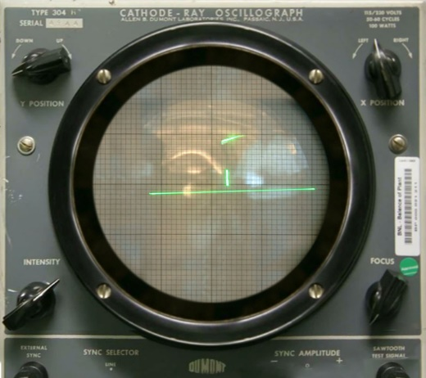
Figure 1 Tennis for Two [1]
To start with, one of the earliest examples of a video game came in the form of Tennis for Two [1], this game was made in 1958 for a computer used within Brookhaven National Laboratory [2] as a way to showcase a computers ability to simulate physics. The visuals of the game consist of a simple graphic interpretation of a tennis game which was all the computer was able to visualise at the time. While this doesn’t fall under the definition of pixel art it does showcase the main principles used in creating pixel art that would come with the next generations of games, these being, making efficient use of what the technology is capable of by creating an effective and concise view of the actions and characters being displayed on screen, in this example, a simple tennis game. This style wasn’t able to develop significantly for the next couple of decades however, since the technology wouldn’t become readily available to the public for some time. This technology was limited to labs and universities for the first few decades of game history while it developed and improved.
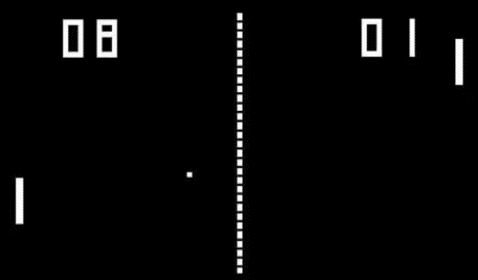
Figure 2 Pong [4]
Computer Space [3] and Pong [4] would follow on from Tennis for Two [1] in the early 1970s, marking the beginning of true pixel art in comparison to older games which used the equivalent of a military radar. By this point technology has advanced enough to allow for games to be released in arcades on arcade cabinets and, following a few years later, on dedicated video game consoles. Graphically, the depictions shown consist of a very early and limited pixel art style, being limited by the number of pixels able to be displayed as well as a lack of colour outside of the default colour of the monitor. Some games from this era made use of screen overlays to enhance the visuals. These overlays would be put over the screen to add extra details outside of the graphics displayed on the screen. This was done in an effort to assist the very limited pixel art of the time and to add some more colour to the game being played.
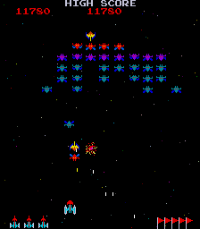
Figure 3 Galaxian [9]
Asteroids [5], Pac-Man [6] and Donkey Kong [7] are some examples of the next steps taken graphically by video games. By this point, pixel art could now include even more detail on screen due to graphical advancements, this led to an increase in recognizable characters during this era despite the limitations presented by their sprites. This was further assisted by full colour able to be shown on screen as well. Colour for video games started with Wimbledon [8] in 1974 which was able to portray sprites with a single colour but Galaxian [9] in 1979 was the first game to include full colour sprites meaning that by this era sprites could include multiple colours within them so long as the system could store the colours needed for the sprite. The general techniques have not shifted much during this time period though as artists are still required to follow the early principles of pixel art due to the fact that the technology still hasn’t advanced enough to allow for more detail, however, colour now allows for the sprites created to be easier to recognize despite the simplicity required.
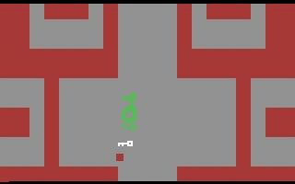
Figure 4 Adventure [10]
The early 1980s saw Atari as the most notable developer at the time. This era saw a very unique style in comparison to other eras. Atari games used a pixel art style that made use of sprites composed of more rectangular shapes as opposed to the basic squares traditionally used in other pixel art styles. This was seemingly done to take advantage of the CRT televisions of the time as the stretched pixels would display better on those monitors as opposed to modern TVs. Similarly, Atari employed other techniques that would only work on a CRT or an emulated CRT monitor such as with Pac-Man [11] the ghosts would flicker to create a see-through effect that was only noticeable on the CRT TVs of the time. Colour was also seeing more frequent use with coloured backgrounds becoming increasingly common during this era.

Post Industry Crash
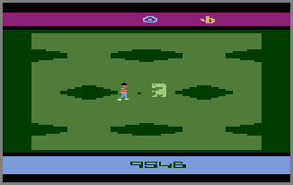
Figure 5 E.T [12]
By the start of the 1980s, the video game industry had truly taken off. This time period saw widespread success for the industry, showcased in the number of recognisable companies, consoles and games from this era. Many people were trying to break into the video game industry at this time to try and take advantage of the rampant success it saw, unfortunately this led to a dip in general quality as many games were made in a rush or with very little polish to try and make a quick profit, one of the most famous examples of this is E.T [12]. E.T [12] was made in 1982 over a period of 5 weeks as an attempt to make more money off of the success of the movie and to meet the Christmas season of that year. This short development time ultimately led to a very poorly made game that many people at the time criticised. This game and many games like it were met with disappointment from the public which led to a general distrust in the quality of video games as a result of the sheer number of games released of this quality. This would lead to the video game crash in 1983 that saw many companies either heavily effected or bankrupted by the middle of the decade.
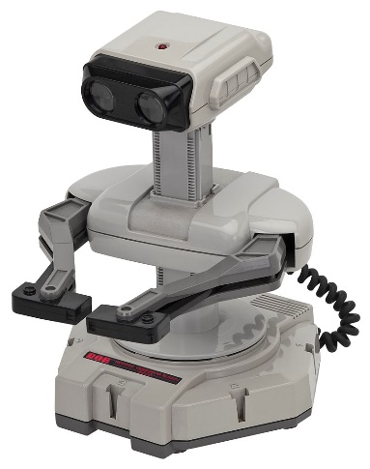
Figure 6 R.O.B [13]
To recover from the crash, many games had to differentiate themselves from previous releases to avoid the bad public perception around games at this time. This resulted in greater care being taken in their creation. For example, when Nintendo released the NES in 1984, they imposed a ‘seal of approval’ on third party games to ensure their quality to the general public. Games also shifted to a younger audience and started to make an effort to appear more like toys in their advertising. This is most notably shown in Nintendo’s releases at the time which included peripherals such as R.O.B [13] a toy robot and the Zapper [14] a toy gun, which both acted as a less traditional way of controlling the games on screen by allowing for a more immersive experience. The Zapper [14], for example, was used in games like Duck Hunt [15] and Hogan’s Alley [16] where it would emulate the feeling of using a gun within the game.
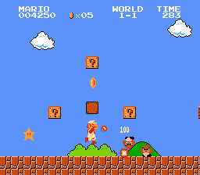
Figure 7 Super Mario Bros [17]
The art style on screen was still making use of pixel art for these games. This would remain the same for the next decade. Games such as Super Mario Bros [17], The Legend of Zelda [18] and Metroid [19] are good showcases of the art style used during the latter half of the 1980s. The graphics were still limited by the 8-bit graphics cards used for the consoles which led to 8-bit becoming the term used to describe this art style due to consoles from this point forward advertising themselves based on the bits they can display. Due to limited space on video game cartridges, techniques were developed to get around this limit and save space. One example is the reuse and recolouring of sprites to use in other locations on screen such as in Super Mario Bros [17] where the bush and the cloud are the same sprite but in different colours, or enemies in games like The Legend of Zelda [18] and Metroid [19] being different colours of the same sprite which would signify to the player how strong the enemy was.
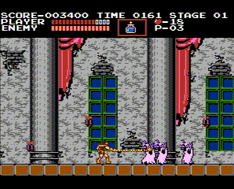
Figure 8 Castlevania [20]
Despite these limitations, this time period saw many new genres and many old ones developed further than before. Adventure games started out with very plain interpretations of an environment, with examples like Adventure [10] in the 1980s. By this era, however, games can now include more detail, so the environments are now easier to recognise, and it has become easier to create a larger variety of environments for the player to travel through, such as in The Legend of Zelda [18]. With the graphical improvements new genres are able to be developed as well. One example is the Metroidvania style of games, which started with Metroid [19] and Castlevania [20] from which the genre gets its name.
Over the next decade, the graphical advancement would be found in the increase in detail and colour able to be displayed on screen by the technology provided as well as the size limit on cartridges no longer being an issue as storage space improved allowing for more sprites to be created for a game and therefore more detailed and varied environments.
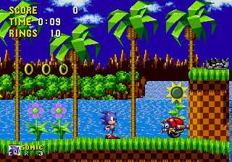
Figure 9 Sonic the Hedgehog [21]
16-bit games and consoles would follow on from 8-bit with examples like Sonic the Hedgehog [21] which was released in 1991 for the Sega Genesis [22] and showcased a further increase in detail for both the number of pixels on screen as well as colours. This further increase in detail also meant that games could now include a wider variety of styles as the available detail and colour could now support that. So, while games like Sonic the Hedgehog [21] and Super Mario World [23] were bright and vibrant, showcasing a cartoony style, other games like Mortal Kombat [24] were able to go for a grittier and more serious look with an emphasis on muted colours and realistic character proportions.
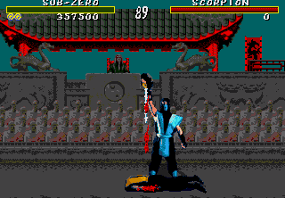
Figure 10 Mortal Kombat [24]
Due to the further increase in detail found in the graphics, in game content could now be depicted in higher detail. This did lead to a growing concern from some people though, as games like Mortal Kombat [24] could depict graphic violence in much higher detail than games from previous generations. This led to rating systems being developed for games that would inform the buyer of the games content before they purchased the game. It also meant that minors could no longer purchase games with content not suitable for them.
All these graphical advancements and technological improvements would reach a breaking point for pixel art however, as once 32-bit and then a few years later 64-bit consoles appeared, 3D graphics began taking over as the mainstream art style for all games due to a drastic decrease in the amount of effort required to get 3D graphics working at a commercial scale.

The Start of 3D
During the 1990s and 2000s, 3D graphics became increasingly easier to create and sell due to advancements in graphics technology, as such, the number of games making use of 3D graphics increased dramatically during this era. This resulted in a drastic decline in games making use of pixel art as the industry shifted more and more towards creating realistic 3D games.
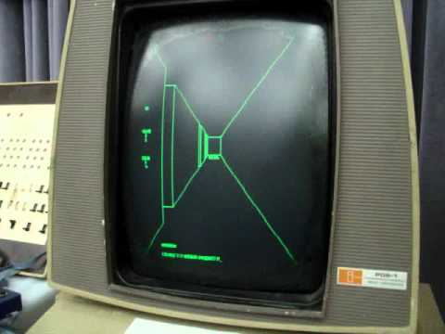
Figure 11 Maze War [25]
The early 1990s was not the true start of 3D, however, as Maze War [25], Spasim [26] and Battlezone [27] are all examples of 3D games created much earlier, around the early 1970s, a long time before later games such as Super Mario 64 [28] or Quake [29]. The main difference between these eras is in the way this 3D was produced. Since previous games consoles were not capable of displaying 3D models within a 3D space, these games had to make use of perspective tricks or illusions to give the player the effect of 3D while constrained to a 2D art style which was further limited by requiring this all to be done within the confines of pixel art, such as with Maze War [25]. Meaning that, while the spaces were simulated in a 3D manner, the graphics used within them were not at the same complexity that would be seen in the 1990s.
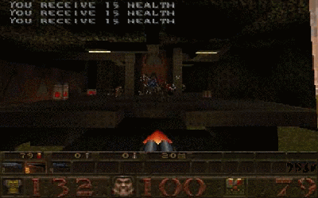
Figure 12 Quake [29]
By the 1990s, technology has now advanced to the point where creating a true 3D space is not only possible but easy to mass produce at a much lower cost for both the producer as well as the consumer with examples like Super Mario 64 [28] or Quake [29]. This meant that pixel art was no longer a necessity for video games as the art style could now make use of 3D models and environments.
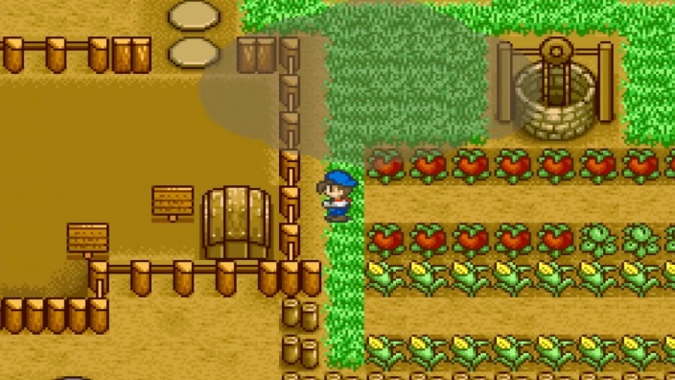
Figure 13 Harvest Moon [32]
Pixel art did still see some usage throughout this decade as many games were still released with a 2D pixel art style during this time as pixel art was still arguably easier to create for most developers in comparison to 3D. Some notable examples include Earthbound [30], Chrono Trigger [31] and Harvest Moon [32]. By this point, however, there were no longer limits on what pixel art could do on home consoles as the 3D technology made 2D graphics incredibly easy to produce at high detail.
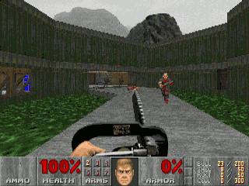
Figure 14 Doom [33]
Pixel art’s usage also extended into 3D games as well with examples like Doom [33] and Wolfenstein 3D [34]. These games made use of pixel art sprites within a 3D space displayed as flat images and for the characters, items and even the textures for the 3D models. This was done as it required less processing power compared to multiple full 3D models and detailed textures. This would allow games like Doom [33] to be run on a wide variety of PCs at that time regardless of processing power which increased their popularity among consumers dramatically.
At this time handheld consoles started achieving commercial success too with the likes of the Gameboy [35]. Due to their size handheld consoles began with the same limitations of earlier home consoles. This meant that the issues of graphics and cartridge size came back and as such pixel art was a requirement for handheld consoles too until 3D technology could be shrunk down to a handheld size without risk of running the consoles battery down quickly.
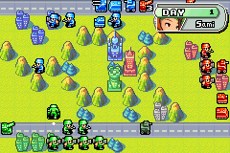
Figure 15 Advanced Wars [37]
Handheld consoles, essentially saw the same advancement that home consoles saw. Starting with the Gameboy [35], graphics were limited in colour and pixel size. Showcased in games like Pokémon Red and Blue [36] where it had to use a monochrome colour palette and used sprites with very low pixel count. But like home consoles, this would continue to improve as handhelds developed, with games like Advanced Wars [37] including higher quality graphics and colours. The main difference in handheld advancement in comparison to home consoles is how quickly the advancements came about, home consoles took decades to advance enough for 3D graphics, spanning a time period from the 1950s all the way to the 1990s. Handhelds on the other hand, took only a couple of decades to reach a better point than home consoles as by the 2000s handhelds could display graphics matching that of the current generation of home consoles.
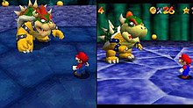
Figure 16 Super Mario 64 DS [38] and Super Mario 64 [28]
This advancement continued like home consoles until eventually even handhelds would end up the same as home consoles by the mid-2000s, allowing for widespread usage of 3D showcased with games like Super Mario 64 DS [38] and Grand Theft Auto Vice City Stories [39]. Super Mario 64 DS [38] acts as a great showcase of this advancement as it is a remake of the Nintendo 64 version Super Mario 64 [28]. The DS version showcases more detailed and smooth models compared to it’s to the original. As such the advancement of handhelds has clearly happened much faster in comparison to home consoles as it took handhelds a decade to reach the level that home consoles took nearly half a century to achieve.
All this means is that by the end of the 2000s every platform was capable enough to display 3D graphics at a decent quality or better and led to pixel art no longer being the required art style of video games.
Despite this, the art style never truly disappeared. Pixel art would still see usage later on, mainly on handhelds like the 3DS [40] or the Steam Deck [41], alongside 3D games, even leading to a new style of 2.5D graphics that started with the likes of Doom [33] where 3D environments were mixed with 2D sprites.

The Modern Day
Modern day advancements have now reached the point where creating a high quality, realistic 3D game now requires minimal investment and processing power. This has led to most games produced being of a realistic 3D art style. Despite this, pixel art still sees widespread usage, the main difference now is the reasons certain games use pixel art.
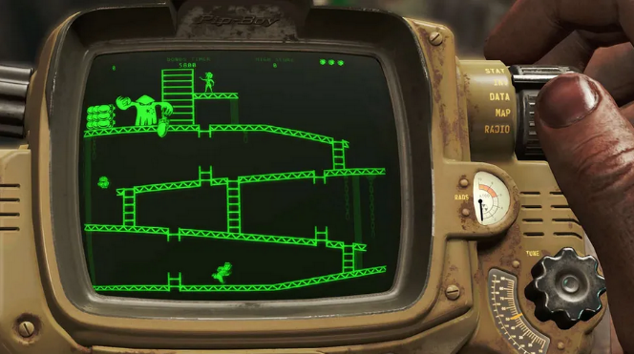
Figure 17 Fallout 4 [44]
Games produced by major publishers don’t see that much usage of pixel art anymore since 3D became easy to produce. Most pixel art usage in these games is used purely to reference the past of a franchise, such as 2D pixelated segments in Mario Odyssey [42] that recreate the art style of Super Mario Bros [17] or box sprites in Pokémon Sword and Shield [43] still being pixelated despite the franchise’s jump to 3D during the previous console. Other games may use pixel art for smaller side games with a game such as with Fallout 4 [44] where there are small minigames you can play on the device that you use throughout the game; these emulate games from the 1970s such as Space Invaders [45] or Donkey Kong [7]
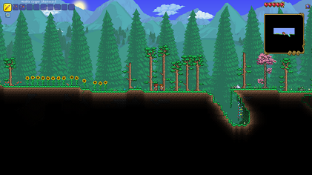
Figure 18 Terraria [46]
The main place where pixel art is used within the modern day is with indie games. Indie games are games made by smaller studios or teams and they now make up the majority of games with pixel art as their art style. This is due to a few different reasons, the main reason being that pixel art is easier to create at a large scale compared to 3D, this is helpful for small indie teams who are working with limited resources. Some examples of this include Terraria [46], Stardew Valley [47] and Undertale [49]. They can also more easily use some older techniques to create pixel art at a more efficient pace, for example, the recolouring and reuse of sprites can help create pixel art at a faster rate.

Figure 19 Stardew Valley [47]
Alternatively, pixel art has also been used to try and recreate the feeling or style of an older game or franchise. This could be done as a spiritual successor where the game is created by taking a lot of inspiration from an older game, franchise, or genre. This is showcased in cases such as Shovel Knight [50] being inspired by Duck Tales [51] or Stardew Valley [47] being made off of inspiration from the Harvest Moon [48] franchise. This also extends into reviving an older genre such as with Celeste [52] or Octopath Traveller [53]. These spiritual successors make use of the gameplay and style of older games while making effective use of modern technologies. For example, Octopath Traveller [53] is a spiritual successor to RPG games, such as Chrono Trigger [31], so it makes use of the old RPG game play as well as the detailed sprites from that era of RPG while also making use of modern technologies by incorporating a 2.5D look to its art style. This allows for a similar feeling within the gameplay and style while also improving upon them by taking effective advantage of the technologies provided.
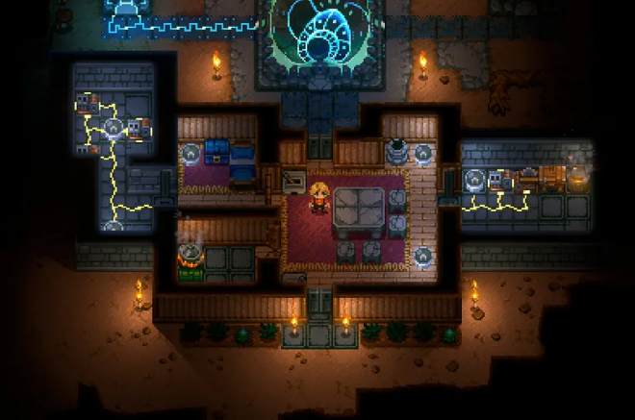
Figure 20 Core Keeper [54]
While technological advancements no longer effect the usage of pixel art within games, that doesn’t mean these advancements haven’t affected the styles and techniques used by pixel artists in these games’ creation. These advancements are no longer about the technology improving; they are now about artists discovering new techniques in the creation of a pixelated world by using creative tricks and taking advantage of modern technologies to provide a more dynamic and interesting experience. One example is how dynamic lighting can be made easier by creating the game within a 3D space. This doesn’t lose out on the 2D pixel art style as the camera can be locked into one position for these games to keep the camera angle found in similar titles, but it does save on having to animate lighting in a 2D space by using a 3D environment to simulate it instead. One example of this is Core Keeper [54] which is built in an entirely 3D environment, but the camera is placed in a way that the game appears to be 2D. This trick can also be applied to overlapping elements, the main example of this being foreground and background elements. This technique can create a sense of depth to the environment without having to accurately shade and position elements. It also makes a scrolling background incredibly easy to accomplish as the background will scroll by itself due to the perspective used.
Creating a 2D game in a 3D environment also has some other benefits. For example, Enter the Gungeon [55] has an item that is rendered with a 3D model, this creates an effect where the item seems strange and otherworldly to the player. A mix of 3D models and sprites can also create a very interesting style for the environment depending on how it is used. Pokémon Black and White [56], for example, creates its buildings and terrain in 3D while keeping the characters as 2D sprites, this results in a very interesting 2.5D Style. Minecraft [57] on the other hand is made entirely within a 3D world but all the textures, characters and items are made with pixel art sprites in an effort to align with the blocky world.

Other Media
Pixel art sees very limited usage in other forms of media. This is because films, tv, books, etc. have never been limited by how many pixels they can show on a screen. This means that most uses of pixel art in other media come about due to stylistic reasons rather than necessity.
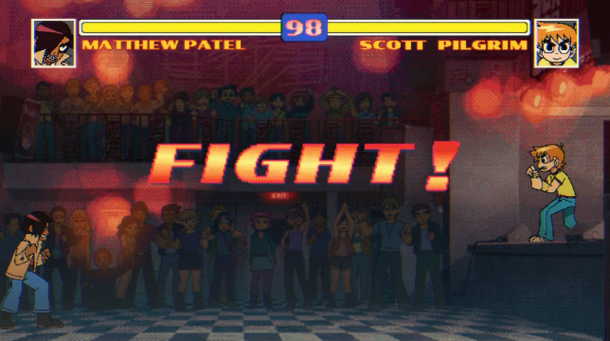
Figure 21 Scott Pilgrim Takes Off [61]
The graphic novel Scott Pilgrim: Scott Pilgrim’s Precious Little Life [58] makes use of pixel art to reference fighting games such as Street Fighter 2 [59] or Mortal Kombat [24]. This is carried over to other media that takes place in that world such as the film Scott Pilgrim vs the World [60] and the animated series Scott Pilgrim Takes Off [61] which shows that it is an intentional stylistic decision for the franchise. Scott Pilgrim vs. The World: The Game [62] was a game based on this franchise; it makes use of a pixel art style that takes the artwork from the graphic novel and converts it into pixel art sprites. This further cements the fact that the usage of pixel art within this franchise is an intended stylistic choice.
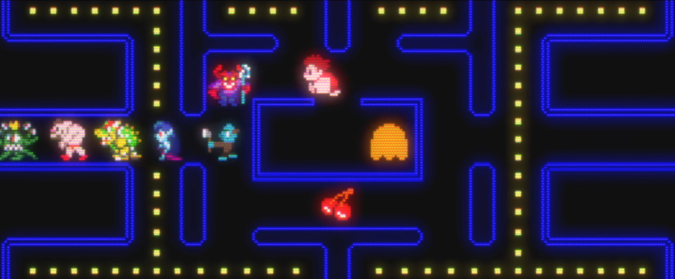
Figure 22 Wreck-It Ralph [63]
The film Wreck-It Ralph [63] and its sequel Ralph Breaks the Internet [64] takes place within an arcade as well as the internet and as such is required to use pixel art to accurately showcase some of the worlds they go to within the story. This isn’t the main style of the film, however, as most of the film is in 3D. The art style only shifts when the world is viewed from the perspective of one of the human characters, such as, looking through an arcade machine. The film did create a fake game for the main characters of the film in the style of old arcade games such as Donkey Kong [7] to further sell it’s setting without requiring the use of an old franchise. One segment of the film showcases a selection of characters in the style of Pac-Man [6] to showcase the characters hopping between games and how that is viewed from the outside world.
The film Pixels [65] is filmed in live action and CGI used for the fantastical elements of the film. It doesn’t make use of pixel art, but it does make use of old pixel art sprites by turning them into 3D CGI cuboid models. Ready Player One [66] uses pixel art in a similar vein, aside from the main character playing Adventure [10] at the end of the film, no true pixel art is found within. This is due to all the characters being translated into CGI models such as the characters from Battletoads [67] being depicted with full 3D models without any pixel art.
All these examples make use of pixel art for stylistic reasons and showcases that if pixel art wasn’t a necessity to run old games, then it might not have ever existed in the first place.

Practical
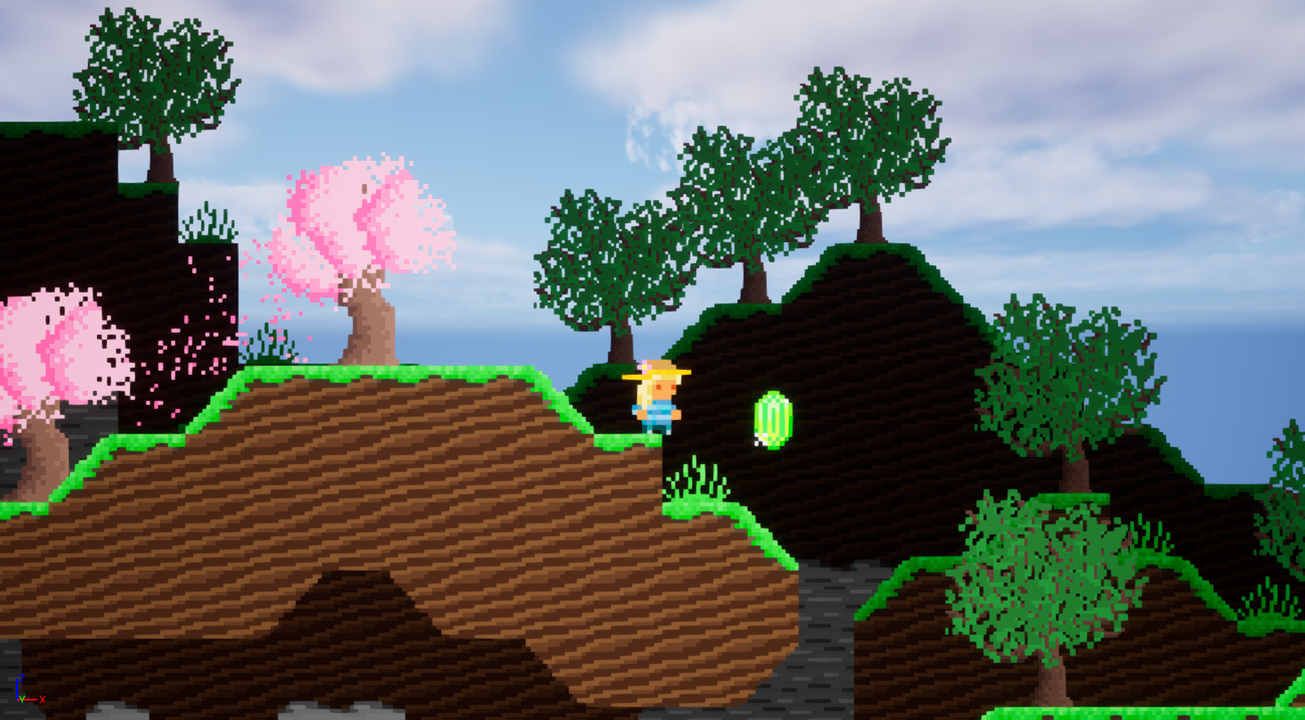
Figure 23 A section of the Asset Pack within Unreal Engine
To accompany this dissertation, an asset pack was created in the style of a 2D platformer using pixel art as the basis for the art style. This asset pack covered a small range of environments, these being forest, cave, jungle, desert, and beach. This asset pack is made up of; a tile set covering all necessary tiles that are required for the basic terrain; placeable decorations for aspects like the trees, flowers, structures, etc; item sprites for basic collectables and finally a set of sprites covering all movement that the playable character is capable of such as jumping, moving and an idle animation. These sprites were created in Aseprite as it is purpose built for the creation of pixel art as apposed to programs like Photoshop. This asset pack was created to follow the style of older platformer games like Super Mario Bros [17] by making use of simple assets that are clear to the player what they are meant to be, however, the asset pack has also taken advantage of modern developments such as no longer being restricted by a limited colour palette or sprite size.
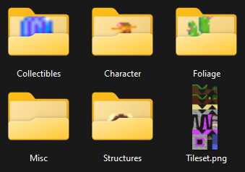
Figure 24 Asset pack within file explorer.
The purpose of this asset pack is to apply the research within this dissertation into a practical application. This means that the asset pack incorporated elements of the research into its creation, this includes aspects such as, art styles, artistic techniques and methods or tricks used by other artists in the creation of their work.
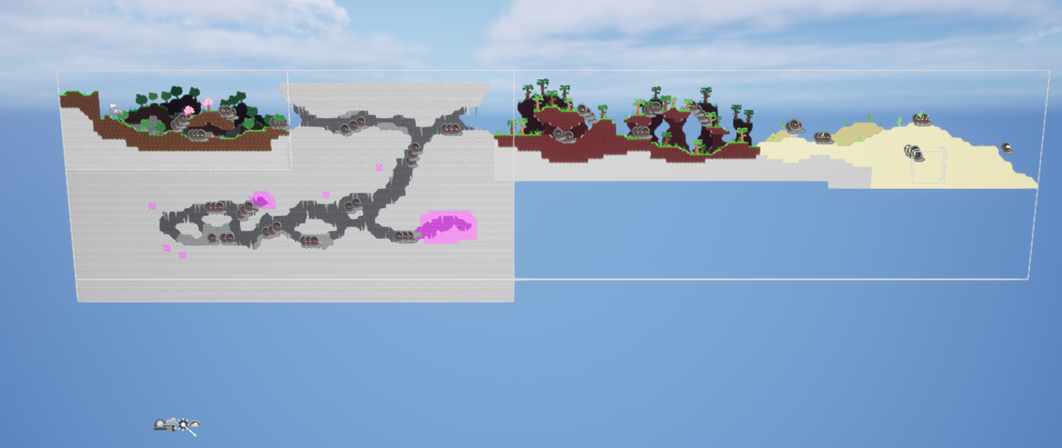
Figure 25 Front view of the level created within Unreal Engine
After creating the asset pack, the assets were then placed within an Unreal Engine project to showcase how they would work within the context of a playable game demo. This also further enhances the assets by placing them within a game engine and allowing for additional techniques to be applied to improve the assets.
The Unreal Engine project provided multiple useful incites into how pixel art can be effectively used to create an interesting and vibrant world by making effective use of techniques and process to enhance the work.
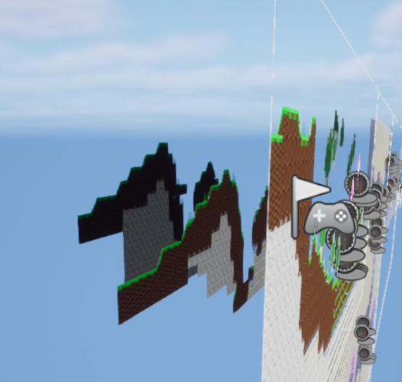
Figure 26 Side view of the level created within Unreal Engine
The main example used with the Unreal Engine project is the use of a 3D space to create a scrolling effect on the background as the player moves around. This was done by creating the project in a 3D space rather than a 2D one and as such the assets move around with the camera. The camera is setup to make the depth between objects noticeable and as such allows for an easy scrolling effect by using the player’s perspective rather than any special effects. This also makes layering objects easier too as layers are determined by an objects depth value rather than being on a dedicated layer that 2D engines would have.

Figure 27 Gemstones created for the asset pack to act as collectibles.
Another technique used is the reuse and recolouring of assets. This was done with the collectible crystals found within the asset pack as using the same sprite helps with recognisability but recolouring that sprite allows for better variety. Some tiles within the tiles set are reused and recoloured as well, for example there are two sets of dirt and grass tiles that are slightly hue shifted to provide a small bit of variety between the two environments. Additionally, the sand and water tiles are the same as they both need to make use of smooth textures that flow together but with different colours and opacity levels.
Finally, the asset pack has taken advantage of Unreal Engine’s blueprint system. This allows for certain actions to be done with blueprints rather than having to animate them by hand. The lighting is one example of this as lighting can be placed within the engine rather than needing it to be animated by hand. Additionally, the water is animated with a simple blueprint to make it move up and down which can then be layered and duplicated really quickly within the engine.
All of this together allowed for a simple but effective asset pack that incorporates many different aspects of this dissertations research to improve upon it.

Conclusion
Early pixel art arose as a necessity and requirement for games to run as the technology was not advanced enough to render complex images that would be found in other media. This meant that between the 1950s to the 1990s, pixel art was the main art style used within video games.
Advancements would occur throughout this time period, such as, an increase in the number of pixels allowed more colours able to be used, as well as more cartridge space allowing. All this allowed for more detailed and intricate worlds to be created within pixel art as the technology continued to advance.
This would reach a breaking point with the introduction of easy to produce 3D technology by the mid-1990s. Marking the beginning of the decline for pixel art as the main art style. While it would survive a bit on handhelds until the late 2000s, pixel art would eventually fall to the side as the main art style used for video games.
Despite this, pixel art still sees widespread usage within indie games as an easier alternative for smaller companies who do not have the time or resources to create a realistic 3D game. This also has led to the creation of new and unique genres and art styles that never would have come about if pixel art was never developed.
This modern-day usage was showcased most clearly in the practical element created for this project. The practical element showcased how modern-day pixel art can take advantage of the advanced 3D technologies found in modern game engines to enhance the artwork showcased. However, the practical element also showcases how older techniques used by games from the 1970s and 1980s can still be applied to modern games. The main example being replication and recolouring of sprites to help speed up the process of asset creation.
So, all of this shows that despite arising as a necessity for games to run on older technologies, pixel art has cemented itself as a definitive aspect of video games, changing its definition and reasons for use as the technology around video games advanced and surpassed the need for pixel art.

Figures
Figure 1 Tennis for Two [1] 4
Figure 2 Pong [4] 5
Figure 3 Galaxian [9] 5
Figure 4 Adventure [10] 6
Figure 5 E.T [12] 6
Figure 6 R.O.B [13] 7
Figure 7 Super Mario Bros [17] 7
Figure 8 Castlevania [20] 8
Figure 9 Sonic the Hedgehog [21] 8
Figure 10 Mortal Kombat [24] 9
Figure 11 Maze War [25] 9
Figure 12 Quake [29] 10
Figure 13 Harvest Moon [32] 10
Figure 14 Doom [33] 10
Figure 15 Advanced Wars [37] 11
Figure 16 Super Mario 64 DS [38] and Super Mario 64 [28] 11
Figure 17 Fallout 4 [44] 12
Figure 18 Terraria [46] 12
Figure 19 Stardew Valley [47] 13
Figure 20 Core Keeper [54] 13
Figure 21 Scott Pilgrim Takes Off [61] 14
Figure 22 Wreck-It Ralph [63] 15
Figure 23 A section of the Asset Pack within Unreal Engine 15
Figure 24 Asset pack within file explorer. 16
Figure 25 Front view of the level created within Unreal Engine 16
Figure 26 Side view of the level created within Unreal Engine 17
Figure 27 Gemstones created for the asset pack to act as collectibles. 17

References
[1] Tennis for Two. [SOFTWARE], Upton: William Higinbotham, 1958.
[2] 'The First Video Game', Brookhaven National Laboratory, [Online], Available: https://www.bnl.gov/about/history/firstvideo.php, [Accessed: Mar. 28, 2024].
[3] Computer Space. [SOFTWARE], Mountain View: Nutting Associates, 1971.
[4] Pong. [SOFTWARE], Sunnyvale: Atari, 1972.
[5] Asteroids. [SOFTWARE], Sunnyvale: Atari, 1979.
[6] Pac-Man. [SOFTWARE], Ōta: Namco, 1980.
[7] Donkey Kong. [SOFTWARE], Kyoto: Nintendo, 1981.
[8] Wimbledon. [SOFTWARE], Mountain View: Nutting Associates, 1974.
[9] Galaxian. [SOFTWARE], Ōta: Namco, 1979.
[10] Adventure. [SOFTWARE], Sunnyvale: Atari, 1980.
[11] Pac-Man. [SOFTWARE], Sunnyvale: Atari, 1982.
[12] E.T. [SOFTWARE], Sunnyvale: Atari, 1982.
[13] 'R.O.B.', Wikipedia, Apr. 7, 2024 (Last Edited), [Online], Available: https://en.wikipedia.org/wiki/R.O.B., [Accessed: Apr. 9, 2024].
[14] 'NES Zapper', Wikipedia, Jan. 7, 2024 (Last Edited), [Online], Available: https://en.wikipedia.org/wiki/NES_Zapper, [Accessed: Apr. 9, 2024].
[15] Duck Hunt. [SOFTWARE], Kyoto: Nintendo, 1984.
[16] Hogan's Alley. [SOFTWARE], Kyoto: Nintendo, 1984.
[17] Super Mario Bros. [SOFTWARE], Kyoto: Nintendo, 1985.
[18] The Legend of Zelda. [SOFTWARE], Kyoto: Nintendo, 1986.
[19] Metroid. [SOFTWARE], Kyoto: Nintendo, 1986.
[20] Castlevania. [SOFTWARE], Ginza: Konami, 1986.
[21] Sonic the Hedgehog. [SOFTWARE], Shinagawa: Sega, 1991.
[22] 'Sega Genesis', Wikipedia, Mar. 18, 2024 (Last Edited), [Online], Available: https://en.wikipedia.org/wiki/Sega_Genesis, [Accessed: Apr. 13, 2024].
[23] Super Mario World. [SOFTWARE], Kyoto: Nintendo, 1990.
[24] Mortal Kombat. [SOFTWARE], Chicago: Midway, 1992.
[25] Maze War. [SOFTWARE], Moffet Field: NASA, 1973.
[26] Spasim. [SOFTWARE], Champaign-Urbana metropolitan area: Jim Bowery, 1974.
[27] Battlezone. [SOFTWARE], Sunnyvale: Atari, 1980.
[28] Super Mario 64. [SOFTWARE], Kyoto: Nintendo, 1996.
[29] Quake. [SOFTWARE], New York City: GT Interactive, 1996.
[30] Earthbound. [SOFTWARE], Kyoto: Nintendo, 1994.
[31] Chrono Trigger. [SOFTWARE], Meguro: Square, 1995.
[32] Harvest Moon. [SOFTWARE], Burlingame: Natsume Inc., 1996.
[33] Doom. [SOFTWARE], Shreveport: id Software, 1993.
[34] Wolfenstein 3D. [SOFTWARE], Aalborg: Apogee Software, 1992.
[35] 'Gameboy', Wikipedia, Apr. 12, 2024, [Online], Available: https://en.wikipedia.org/wiki/Game_Boy, [Accessed: Apr. 13, 2024].
[36] Pokémon Red and Blue. [SOFTWARE], Kyoto: Nintendo, 1996.
[37] Advanced Wars. [SOFTWARE], Kyoto: Nintendo, 2001.
[38] Super Mario 64 DS. [SOFTWARE], Kyoto: Nintendo, 2004.
[39] Grand Theft: Auto Vice City Stories. [SOFTWARE], New York City: Rockstar Games, 2006.
[40] '3DS', Wikipedia, Apr. 9, 2024, [Online], Available: https://en.wikipedia.org/wiki/Nintendo_3DS, [Accessed: Apr. 13, 2024].
[41] 'Steam Deck', Wikipedia, Apr. 11, 2024, [Online], Available: https://en.wikipedia.org/wiki/Steam_Deck, [Accessed: Apr. 13, 2024].
[42] Mario Odyssey. [SOFTWARE], Kyoto: Nintendo, 2017.
[43] Pokémon Sword and Shield. [SOFTWARE], Kyoto: Nintendo, 2019.
[44] Fallout 4. [SOFTWARE], Rockville: Bethesda Softworks, 2015.
[45] Space Invaders. [SOFTWARE], Shinjuku: Taito, 1978.
[46] Terraria. [SOFTWARE], Floyds Knobs: Re-Logic, 2011.
[47] Stardew Valley. [SOFTWARE], Los Angeles: ConcernedApe, 2016.
[48] Harvest Moon. [SOFTWARE], Burlingame: Natsume Inc., 1996.
[49] Undertale. [SOFTWARE], Toby Fox, 2015.
[50] Shovel Knight. [SOFTWARE], Los Angeles: Yacht Club Games, 2014.
[51] Duck Tales. [SOFTWARE], Osaka: Capcom, 1989.
[52] Celeste. [SOFTWARE], Canada: Maddy Makes Games, 2018.
[53] Octopath Traveller. [SOFTWARE], Tokyo: Square Enix, 2018.
[54] Core Keeper. [SOFTWARE], London: Fireshine Games, 2022.
[55] Enter the Gungeon. [SOFTWARE], Austin: Devolver Digital, 2017.
[56] Pokémon Black and White. [SOFTWARE], Kyoto: Nintendo, 2010.
[57] Minecraft. [SOFTWARE], Stockholm: Mojang, 2011.
[58] B. Lee O'Malley, Scott Pilgrim: Scott Pilgrim's Precious Little Life, Portland: Oni Press, 2004.
[59] Street Fighter 2. [SOFTWARE], Osaka: Capcom, 1991.
[60] E. Wright, Director, Scott Pilgrim vs. the World, [DVD], Pikesville: Marc Platt Productions, 2010.
[61] A. Góngora, Director, Scott Pilgrim Takes Off, [Netflix], Tokyo: Science Saru, 2023.
[62] Scott Pilgrim vs. the World: The Game. [SOFTWARE], Saint-Mandé: Ubisoft, 2010.
[63] R. Moore, Director, Wreck-It Ralph, [DVD], Burbank: Walt Disney Pictures, 2012.
[64] R. Moore, Director, Ralph Breaks the Internet, [DVD], Burbank: Walt Disney Pictures, 2018.
[65] C. Columbus, Director, Pixels, [DVD], Culver City: Columbia Pictures, 2015.
[66] S. Spielberg, Director, Ready Player One, [DVD], Burbank: Warner Bro. Pictures, 2018.
[67] Battletoads. [SOFTWARE], Corsicana: Tradewest, 1991.

Bibliography
Tennis for Two. [SOFTWARE], Upton: William Higinbotham, 1958.
Spacewar!. [SOFTWARE], Cambridge: Steve Russel, 1966.
Computer Space. [SOFTWARE], Mountain View: Nutting Associates, 1971.
Pong. [SOFTWARE], Sunnyvale: Atari, 1972.
Maze War. [SOFTWARE], Moffet Field: NASA, 1973.
Spasim. [SOFTWARE], Champaign-Urbana metropolitan area: Jim Bowery, 1974.
Wimbledon. [SOFTWARE], Mountain View: Nutting Associates, 1974.
Space Invaders. [SOFTWARE], Shinjuku: Taito, 1978.
Asteroids. [SOFTWARE], Sunnyvale: Atari, 1979.
Galaxian. [SOFTWARE], Ōta: Namco, 1979.
Pac-Man. [SOFTWARE], Ōta: Namco, 1980.
Space Invaders. [SOFTWARE], Shinjuku: Taito, 1980.
Battlezone. [SOFTWARE], Sunnyvale: Atari, 1980.
Adventure. [SOFTWARE], Sunnyvale: Atari, 1980.
Donkey Kong. [SOFTWARE], Kyoto: Nintendo, 1981.
E.T. [SOFTWARE], Sunnyvale: Atari, 1982.
Pac-Man. [SOFTWARE], Sunnyvale: Atari, 1982.
Duck Hunt. [SOFTWARE], Kyoto: Nintendo, 1984.
Hogan's Alley. [SOFTWARE], Kyoto: Nintendo, 1984.
Super Mario Bros. [SOFTWARE], Kyoto: Nintendo, 1985.
The Legend of Zelda. [SOFTWARE], Kyoto: Nintendo, 1986.
Metroid. [SOFTWARE], Kyoto: Nintendo, 1986.
Castlevania. [SOFTWARE], Ginza: Konami, 1986.
Mega Man. [SOFTWARE], Osaka: Capcom, 1987.
Duck Tales. [SOFTWARE], Osaka: Capcom, 1989.
Super Mario World. [SOFTWARE], Kyoto: Nintendo, 1990.
Final Fantasy IV. [SOFTWARE], Meguro: Square, 1991.
Sonic the Hedgehog. [SOFTWARE], Shinagawa: Sega, 1991.
Street Fighter 2. [SOFTWARE], Osaka: Capcom, 1991.
Battletoads. [SOFTWARE], Corsicana: Tradewest, 1991.
Mortal Kombat. [SOFTWARE], Chicago: Midway, 1992.
Wolfenstein 3D. [SOFTWARE], Aalborg: Apogee Software, 1992.
Doom. [SOFTWARE], Shreveport: id Software, 1993.
Earthbound. [SOFTWARE], Kyoto: Nintendo, 1994.
Chrono Trigger. [SOFTWARE], Meguro: Square, 1995.
Pokémon Red and Blue. [SOFTWARE], Kyoto: Nintendo, 1996.
Super Mario 64. [SOFTWARE], Kyoto: Nintendo, 1996.
Quake. [SOFTWARE], New York City: GT Interactive, 1996.
Harvest Moon. [SOFTWARE], Burlingame: Natsume Inc., 1996.
Advanced Wars. [SOFTWARE], Kyoto: Nintendo, 2001.
Pokémon Firered/Leafgreen. [SOFTWARE], Kyoto: Nintendo, 2004.
Super Mario 64 DS. [SOFTWARE], Kyoto: Nintendo, 2004.
Pokémon Diamond and Pearl. [SOFTWARE], Kyoto: Nintendo, 2006.
Grand Theft: Auto Vice City Stories. [SOFTWARE], New York City: Rockstar Games, 2006.
Plants vs Zombies DS. [SOFTWARE], Seattle: PopCap Games, 2009.
Pokémon Black and White. [SOFTWARE], Kyoto: Nintendo, 2010.
Scott Pilgrim vs. the World: The Game. [SOFTWARE], Saint-Mandé: Ubisoft, 2010.
Terraria. [SOFTWARE], Floyds Knobs: Re-Logic, 2011.
Minecraft. [SOFTWARE], Stockholm: Mojang, 2011.
Pokémon Black 2 and White 2. [SOFTWARE], Kyoto: Nintendo, 2012.
Pokémon X and Y. [SOFTWARE], Kyoto: Nintendo, 2013.
Plants vs Zombies 2. [SOFTWARE], Redwood City: Electronic Arts, 2013.
Shovel Knight. [SOFTWARE], Los Angeles: Yacht Club Games, 2014.
Five Night's At Freddy's 2. [SOFTWARE], Scott Cawthon, 2014.
Five Night's At Freddy's 3. [SOFTWARE], Scott Cawthon, 2015.
Five Night's At Freddy's 4. [SOFTWARE], Scott Cawthon, 2015.
Undertale. [SOFTWARE], Toby Fox, 2015.
Fallout 4. [SOFTWARE], Rockville: Bethesda Softworks, 2015.
Stardew Valley. [SOFTWARE], Los Angeles: ConcernedApe, 2016.
Starbound. [SOFTWARE], London: Chucklefish, 2016.
Enter the Gungeon. [SOFTWARE], Austin: Devolver Digital, 2017.
Mario Odyssey. [SOFTWARE], Kyoto: Nintendo, 2017.
Celeste. [SOFTWARE], Canada: Maddy Makes Games, 2018.
Octopath Traveller. [SOFTWARE], Tokyo: Square Enix, 2018.
Exit the Gungeon. [SOFTWARE], Austin: Devolver Digital, 2019.
Pokémon Sword and Shield. [SOFTWARE], Kyoto: Nintendo, 2019.
Noita. [SOFTWARE], Helsinki: Nolla Games, 2020.
Unpacking. [SOFTWARE], San Francisco: Humble Bundle, 2021.
Let's Build a Zoo. [SOFTWARE], Manchester: No More Robots, 2021.
Pokémon Brilliant Diamond and Shining Pearl. [SOFTWARE], Kyoto: Nintendo, 2021.
Apico. [SOFTWARE], Erie: Whitethorn Games, 2022.
Core Keeper. [SOFTWARE], London: Fireshine Games, 2022.
Viewfinder. [SOFTWARE], Gothenburg: Thunderful Publishing, 2023.
The Cosmic Wheel Sisterhood. [SOFTWARE], Austin: Devolver Digital, 2023.
Sticky Business. [SOFTWARE], Wiesbaden: Assemble Entertainment, 2023.
E. Wright, Director, Scott Pilgrim vs. the World, [DVD], Pikesville: Marc Platt Productions, 2010.
R. Moore, Director, Wreck-It Ralph, [DVD], Burbank: Walt Disney Pictures, 2012.
C. Columbus, Director, Pixels, [DVD], Culver City: Columbia Pictures, 2015.
R. Moore, Director, Ralph Breaks the Internet, [DVD], Burbank: Walt Disney Pictures, 2018.
S. Spielberg, Director, Ready Player One, [DVD], Burbank: Warner Bro. Pictures, 2018.
A. Góngora, Director, Scott Pilgrim Takes Off, [Netflix], Tokyo: Science Saru, 2023.
B. Lee O'Malley, Scott Pilgrim: Scott Pilgrim's Precious Little Life, Portland: Oni Press, 2004.
SJ. Eskilson, Graphic Design: A New History, Second Edition, New Haven: Yale University Press, 2012.
D. Silber, Pixel Art for Game Developers, Oxford: Taylor & Francis, 2015.
J. Dawe, M. Humphries, Make Your Own Pixel Art: Create Graphics for Games, Animations, and More!, San Francisco: No Starch Press, 2019.
Cobra Code, 'How to make a 2D game in Unreal Engine 5 - Beginner Tutorial', Youtube, Jun. 22, 2022, [Online], Available: https://www.youtube.com/watch?v=g31NTpq9p-o, [Accessed: Sept. 2, 2023].
'Cross Stich', Wikipedia, Jan. 8, 2024 (Last Edited), [Online], Available: https://en.wikipedia.org/wiki/Cross-stitch, [Accessed: Jan. 9, 2024].
'Pixel art: What is it?', 2D Will Never Die, [Online], Available: https://2dwillneverdie.com/intro/, [Accessed: Jan. 9, 2024].
'The First Video Game', Brookhaven National Laboratory, [Online], Available: https://www.bnl.gov/about/history/firstvideo.php, [Accessed: Mar. 28, 2024].
'NES Zapper', Wikipedia, Jan. 7, 2024 (Last Edited), [Online], Available: https://en.wikipedia.org/wiki/NES_Zapper, [Accessed: Apr. 9, 2024].
'R.O.B.', Wikipedia, Apr. 7, 2024 (Last Edited), [Online], Available: https://en.wikipedia.org/wiki/R.O.B., [Accessed: Apr. 9, 2024].
'History of Video Games', Wikipedia, Mar. 23, 2024 (Last Edited), [Online], Available: https://en.wikipedia.org/wiki/History_of_video_games, [Accessed: Apr. 9, 2024].
'The evolution of video game graphics: from 8-Bit to HD and VR', Gamestate, Mar. 7, 2023, [Online], Available: https://gamestate.com/blogs/news/the-evolution-of-video-game-graphics-from-8-bit-to-hd-and-vr, [Accessed: Apr. 13, 2024].
'The History of Gaming: The evolution of GPUs', Shadow, [Online], Available: https://shadow.tech/en-GB/blog/history-of-gaming-gpus, [Accessed: Apr. 13, 2024].
'Steam Deck', Wikipedia, Apr. 11, 2024, [Online], Available: https://en.wikipedia.org/wiki/Steam_Deck, [Accessed: Apr. 13, 2024].
'3DS', Wikipedia, Apr. 9, 2024, [Online], Available: https://en.wikipedia.org/wiki/Nintendo_3DS, [Accessed: Apr. 13, 2024].
'Gameboy', Wikipedia, Apr. 12, 2024, [Online], Available: https://en.wikipedia.org/wiki/Game_Boy, [Accessed: Apr. 13, 2024].
'Sega Genesis', Wikipedia, Mar. 18, 2024 (Last Edited), [Online], Available: https://en.wikipedia.org/wiki/Sega_Genesis, [Accessed: Apr. 13, 2024].
fcjim, 'First color video game?', Vintage Arcade Preservation Society, #5, Sept. 30. 2020, [Online], Available: https://forums.arcade-museum.com/threads/first-color-video-game.478606/, [Accessed: Apr. 17, 2024].
C. Nash, 'What was the first color video game?', Quora, [Online], Available: https://www.quora.com/What-was-the-first-color-video-game, [Accessed: Apr. 17, 2024].
'A Television Simulator: CRT Emulation for the Atari VCS', Ian Bogost, [Online], Available: http://bogost.com/games/a_television_simulator/, [Accessed: Apr. 17, 2024].
K. Smith, 'What Was The First "True" Color Arcade Video Game?', The Golden Age Arcade Historian, Sept. 11, 2012, [Online], Available: http://allincolorforaquarter.blogspot.com/2012/09/what-was-first-true-color-arcade-video.html, [Accessed: Apr. 17, 2024].

