ASSESSMENT
of
Sonya Kyuchukova
Student ID 1818665

term1 CLOUD COMPUTING

University of Wales Trinity Saint David

This self research report is about IPv6 addressing. The research is focus on different types of addressing available in IPv6 and is illustrated with proper examples.

Content

- Limitations of IPv4………………………………………………………….……page 3
- Features of IPv6…………………………………………………………….…….page 3
- Comparison of IPv4 and IPv6………………………………………….………..page 6
4. IPv6 Address Format ……………………………………………………………page 7
5. IPv6 Address Types ………………………………………………………….…..page 7
6. Network Prefix ……………………………………………………………….…..page 8

- Limitations of IPv4
The current version of IPv4 has not changed significantly due to the fact that IPv4 is stable, easily applicable and interoperable. But with the exponential growth of the Internet and the impending depletion of IPv4 address space, the number of public IPv4 addresses is drastically diminishing. The use of various devices connected to the Internet is also increasing rapidly, which inevitably leads to the depletion of IPv4 address space , called NAT, which allows the re-use of personal address space, which violates the basic principle of internet design - that each node has a unique address.
The IPv6 address space provides an unlimited number of addresses, but in order to be implemented successfully it must be properly planned using existing IPv4 structures.
IPv6 is designed to have minimal effect on the protocols of the other layers, as well as prevent the accidental addition of new features.
back to content
- Features of IPv6
Davies [1] states that the features of IPv6 are following:
■ New header format
■ Large address space
■ Stateless and stateful address configuration
■ IPsec header support required
■ Better support for prioritized delivery
■ New protocol for neighboring node interaction
■ Extensibility

New Header Format
Header processing is minimized thanks to moving both nonessential and optional fields to extension headers .
Large Address Space
IPv6 has 128-bit (16-byte) source and destination addresses.
Stateless and Stateful Address Configuration
Acording SISCO [2]

Automatic configuration without IPv6 status
All IPv6 node interfaces must have a local connection address, which is usually configured automatically by the interface identifier and the local prefix FE80 :: / 10. The local connection address allows the node to communicate with other node nodes and can be used for further configuration of the node.

Simple network renumbering for IPv6 hosts
Strict aggregation of the global routing table requires networks to be renumbered when a network service provider changes. When IPv6 statusless autoconfiguration is used to renumber a network, the prefix from a new service provider is added to the RA messages that are sent via the link. (RA messages contain each the prefix from the recent service supplier and also the prefix from the new service provider). The connection nodes automatically configure additional addresses using the prefix from the new service provider. The nodes can then use the addresses created by the new prefix and the existing addresses created by the old connection prefix. Configuring lifelong parameters associated with old and new prefixes means that connection nodes can make the transition to using only addresses created by the new prefix. During the transition period the old prefix is ​​removed from the RA messages and only the links containing the new prefix are used in the link (renumbering is complete) (see figure below).
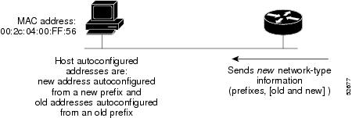
Fig 1.1 IPv6 Network Renumbering for Hosts Using Stateless Autoconfiguration

IPsec Header Support Required
Acording Davies [1]
Support for the IPsec headers is AN IPv6 protocol suite demand. This demand provides a standards-based answer for network protection wants and promotes ability between completely different IPv6 implementations. IPsec consists of 2 forms of extension headers and a protocol to barter security settings. The Authentication header (AH) provides information integrity, information authentication, and replay protection for the whole IPv6 packet (excluding fields within the IPv6 header that has got to modification in transit). The Encapsulating Security Payload (ESP) header and trailer give information integrity, information authentication, information confidentiality, and replay protection for the ESP-encapsulated payload. The protocol generally wont to discuss IPsec security settings for unicast communication is that the web Key Exchange (IKE) protocol.

Better Support for Prioritized Delivery
Acording Davies [1]
New fields in the IPv6 header define how traffic is handled and identified. Traffic is prioritized by using a Traffic Class field, which specifies a DSCP value just like IPv4. A Flow Label field in the IPv6 header allows routers to identify and provide special handling for packets that belong to a flow (a series of packets between a source and destination). Because the traffic is identified in the IPv6 header, support for prioritized delivery can be achieved even when the packet payload is encrypted with IPsec and ESP.

New Protocol for Neighboring
Acording Davies [1]
Node Interaction the Neighbor Discovery protocol for IPv6 is a series of Internet Control Message Protocol for IPv6 (ICMPv6) messages that manages the interaction of neighboring nodes (nodes on the same link). Neighbor Discovery replaces and extends the combination of the Address Resolution Protocol (ARP) (broadcast-based), ICMPv4 Router Discovery, and ICMPv4 Redirect messages with efficient multicast and unicast Neighbor Discovery messages.

Extensibility
Acording Davies [1]

IPv6 can easily be extended for new features by adding extension headers after the IPv6 header. Unlike options in the IPv4 header, which can support only 40 bytes of options, the size of IPv6 extension headers is constrained only by the size of the IPv6 packet.
back to content

- Comparison of IPv4 and IPv6

Davies [1] provide a comparison of IPv4 and IPv6

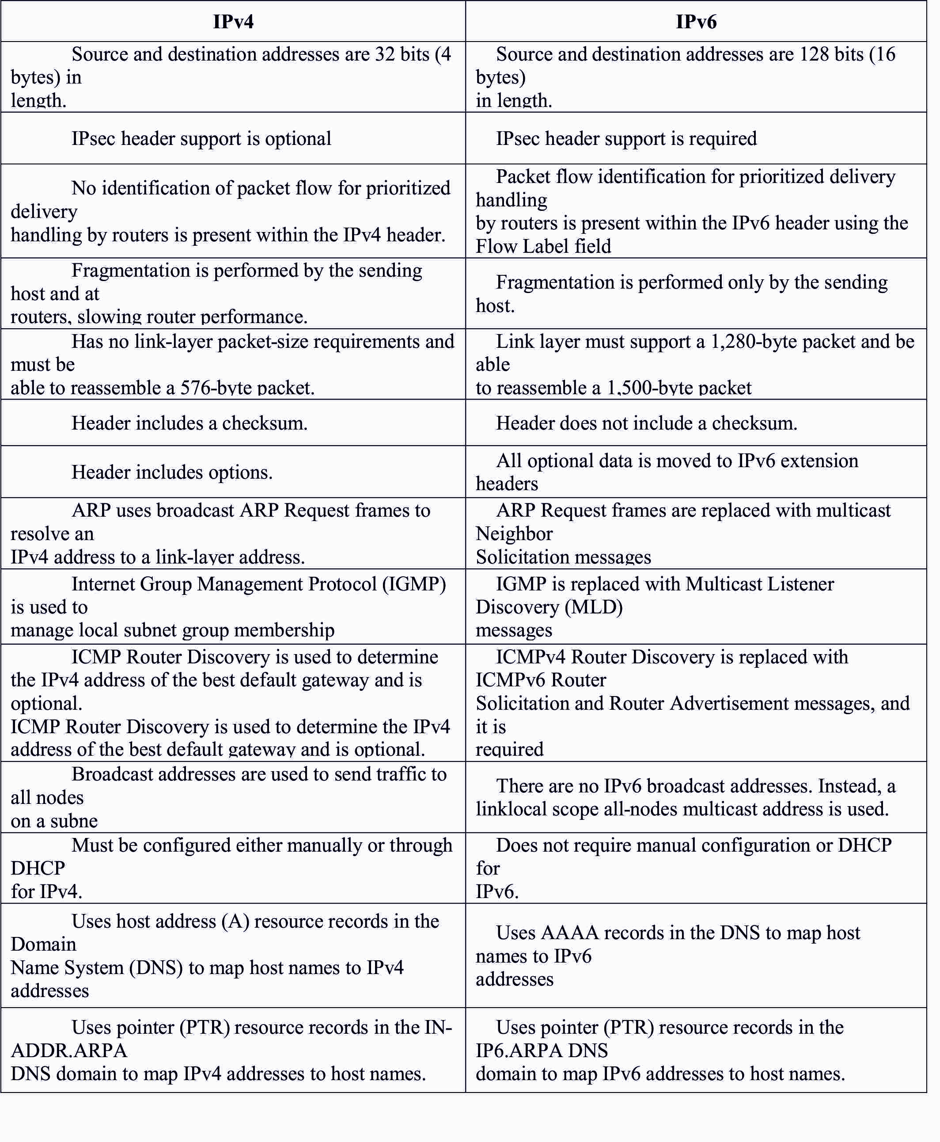
Fig 1.2 Differences between IPv4 and IPv6

back to content

- IPv6 Address Format

Acording SISCO [2]

IPv6 uses 16-byte positional notation system} variety fields separated by colons (:) to represent the 128-bit addressing format that produces the address representation less cumbersome and erring. Here is AN example of a legitimate IPv6 address: 2001:db8:130F:0000:0000:09C0:876A:130B. in addition, to shorten the IPv6 address and create the address easier to represent, IPv6 uses the subsequent conventions: • Leading zeros within the address field are nonobligatory and may be compressed. For example: the subsequent hex numbers will be portrayed as shown in a very compressed format: – Example 1: zero = 0 (compressed form) – Example 2: 2001:db8:130F:0000:0000:09C0:876A:130B =2001:db8:130 F:0:0:9C0:876A:130B (compressed form) • A combine of colons (::) represents ordered fields of 0. However, the combine of colons is allowed one time in a very valid IPv6 address. – Example 1: 2001:db8:130F:0:0:9C0:876A:130B =2001:db8:130F::9C0:876A:130B (compressed form) – Example 2: FF01:0:0:0:0:0:1 = FF01::1 (compressed form) AN address program will simply determine the quantity of missing zeros in an IPv6 address by separating the 2 elements of the address and filling within the 0s till the 128-bit address is complete. However, if 2 ::s are placed within the same address, then there's no thanks to determine the scale of every block of zeros. The utilization of the :: makes several IPv6 addresses terribly tiny.

back to content

- IPv6 Address Types

Acording SISCO [2]

There is a serious distinction within the scientific discipline address needs between AN IPv4 host and an IPv6 host. AN scientific disciplinev4 host generally uses one IP address; however an IPv6 host will have over one IP address. There are 3 major varieties of IPv6 addresses:
• Unicast: AN address for one interface. A packet that's sent to a unicast address is delivered to the interface known by that address.
• ANycast: An address for a collection of interfaces that generally belong to completely different nodes. A packet sent to AN anycast address is delivered to the nighest interface, as outlined by the routing protocols in use, and known by the anycast address.
• Multicast: AN address for a collection of interfaces (in a given scope) that generally belong to completely different nodes. A packet sent to a multicast address is delivered to all or any interfaces known by the multicast address (in a given scope).

back to content

- Network Prefix

Acording SISCO [2]

In IPv6 there are references to prefixes that, in IPv4 terms, loosely equate to subnets. The IPv6 prefix is formed of the left-most bits and acts because the network symbol. The IPv6 prefix is portrayed exploitation the IPv6-prefix or prefix-length format a bit like AN IPv4 address is represented within the egalitarian interdomain routing (CIDR) notation. The /prefix-length variable may be a decimal price that indicates the quantity of high-order contiguous bits of the address that kind the prefix, that is that the network portion of the address. For example: 2001:db8:8086:6502::/64 is a suitable IPv6 prefix. If the address ends in a very double colon, the trailing double colon will be omitted. Therefore the same address will be written as 2001:db8:8086:6502/64. In either case, the prefix length is written as a decimal variety sixty four and represents the left-most bits of the IPv6 address. The same address in IPv4 would be xxx.xxx.xxx.xxx/16.

back to content

References:
[1] Davies,Joseph (2012) Understanding IPv6 , Microsoft Press
[2] https://www.cisco.com

