

Name: Daicylen Antolin
Student #: 1818171
Module: Digital Skills and Research Methods
Module #: BMSW4003
Title: Impact of Virtual Learning Environment on Student’s
Learning in the UWTSD London Campus
Lecturer: Modak Koushik


TABLE OF CONTENTS

INTRODUCTION
RATIONALE
OBJECTIVES
REVIEW of EXISTING LITERATURE
RESEARCH METHODOLOGY
- Quantitative
- Qualitative
- Population
- Data Collection Process
  - Primary
  - Secondary
FINDINGS, ANALYSIS, DISCUSSIONS
CONCLUSION
REFERENCES
APPENDICES

Introduction
The aim of this study is to provide a deeper understanding on the enhancing impact of VLE on the students learning. The literature review provides an understanding on VLE and the methods and tools used in it along with review of past papers. Further to this, the study discusses research methodology utilised for the research. In addition to this, finding and discussion is discussed and finally the research is concluded. A VLE should provide education in all possible way that it benefits all the learners. It has changed the way students learn and along with that, can easily send their assignments through e-learning and instructors can review assignments, give feedbacks and gives marks.

Rationale:
This research will play an important role in providing a deeper understanding of the learning process that should be undertaken by the UK's education department to assess students' learning and understanding. This lesson will also help the teacher and the instructors on how to use and effectively use learning strategies to enhance student performance (Ashcroft, et al 2019). The findings of this study will help academic students to better consider the learning styles that are related to the student's work. This lesson helps different institutions at every stage put their education back into VLE to make it more useful to both teachers and students.

Objectives:
The objective is to ensure the increasing number of people who can engage in the educational process that will be easier for them and eliminate the barrier of distance. The following are the definitions of the problem created by this analysis.
1. What effect does VLE have on student learning?
2. To what extent does it lead to student freedom in learning?
3. What are some of the visual aids that students see through VLE?
4. What are the barriers to learning through VLE?
5. Where is VLE access easier?

Review of Existing Literature:
Communication development in the technological sector is the main reason behind the rise in the demand for Virtual Learning that has connected the learners. Virtual teaching combines the delivery of course work through the internet, email and the messages that are posed in online forums (Demian and Morrice, 2012). Through asynchronous learning, students can learn even when the internet is unavailable or offline. Time and constraints are never an issue for such learning, students can communicate through their computer at all times. Learners are able to complete their course work at their own pace, through the use of the internet as a tool instead of volunteering for online classes exclusively (Dillenbourg, et al 2015). On the contrary, real time virtual learning is synchronous that encompasses chatting and video conferences that permit students to ask questions that are answered by the teacher instantly through instant message. Common tools used mostly, for synchronous learning is Google Hangout and Skype (Liu and Dun, 2016).
The term E-learning widely refers to the range of information technology utilised with the aim of enhancement of the processes of education at the secondary and the higher education levels. For supporting the e-learning institutions need to develop and implemented Learning Management Systems (LMS) at institutional level (Mogus, et al 2012). The main purpose of LMS is to provide reference materials and tests for students via e-learning. A variety of tasks can be performed by LSM for instance providing reference materials for learning. The best feature is that the teacher and the student can both signup and start using it without awaiting the administrator’s approval. It has features such as posting comments and sending notes and attachments. It has features such as assignments and creating events and even direct messaging to the instructor.
As a fact, there are some advantages packed within VLE in the learning and teaching process. The most obvious is that it solves the problems of the instructor inadequate class timing. Through the VLE teachers and instructors can optimise their own timeline and thereby focusing on the curriculum and students can adjust their schedule and learning time (Vuopala, et al 2016).
Consequently, other advantages include the online delivery of material and links that allow the instructor and the learner share their experiences and deliver online accordingly saying time and money on buying text books. Meanwhile, as the learners of the modern day are mostly technology savvy who spend most of their time in communication and searching information over the virtual world? To get the most out of VLE in any aspect of learning or teaching the VLE should be productive, collaborative, informative aggregative and communicative (Ryan, and Poole 2019). Then again, the practise of virtual teaching and learning brings values ​​to both students and teachers. According to (Cite), in the student section, the responsibility for learning is raised as students have to learn how to use and use media. It also affects how your partner is learning. Students who come from a 'traditional' learning environment, should be shifted to a more functional and active learning environment. On the part of teachers, language proficiency is especially useful for teachers as it requires a great translation and a detailed knowledge of the material, how it is done and when to use it (Soh, et al 2018).
In essence, real learning and teaching should use baseless statements based on the construction phase, emphasizing that students, not just teachers, can contribute to learning. In other words, it is supposed to promote the independence of students. Also, learners can ask queries personally, on the other hand, the instructor only must upload any worksheet, book. He can upload the results to each student and maintain the privacy of learners.

Research Methodology
The research methodology includes a combination of the specific methods used in the research process for the collection, gathering and evaluation of the collected data. It defines the methods and tools required for compiling relevant data for the research area. The method of study is categorized into two sections: primary and secondary research. These two studies are further classified into qualitative and quantitative exploration methods. Collection tools for primary exploration methods include questions, interviews and survey results. However, the collection tools for the second study include a review of previous studies, magazine articles and government websites (Thomas, and Thorpe 2019). Because exploration in research encompasses creating a deeper understanding of the impact of VLE on student learning in the method of qualitative research.
- Quantitative:
It is conducted primarily by questionnaires and contains close- ended, open-ended and multiple choices.
- Qualitative:
It is also a quantitative but a qualitative study. The results are observed and drawn through them and contains an open-ended, close-ended and multiple choices.
Source of Data for this study is Primary, which involves collecting data directly from the respondents. The participants were asked to provide their opinions and the data will be collected using a questionnaire based on platform of VLE, named Moodle.
3. Sample size:
The sample size that was selected and was a total of 20 respondents from the UWTSD, whom the data for the research was conducted.
4. Data Collection:
The gathering of data for the study purpose on a research area is acknowledged as the data collection. The gathering of data is further classified into two sorts of data collection methods:
4.1-Primary Data Collection:
Ongoing data collection is documented through interviews, comments, phone calls and information from the direct source of data collection. Therefore, the first method of data collection is to check the validity of the information obtained since the information is accurate and therefore this method of data collection will be used for study.
4.2-Secondary Data Collection:
Data obtained from other media sources than the human researcher is acknowledged as a secondary data method. Examples of this information include information from government websites such as census, data analysis and reviews of previous studies.
5. Sample:
According to the study, the sample group of people, objects and / or items was selected from a large population or group for data collection and measurement. The model at the level of justification is the small sample size of the population that confirms the specificity of a study sample. The sample data that will be collected for the purpose of this study will include interviews and completed questionnaires. The number of people will not exceed 20 individuals.

6. Ethics in the Data Collection:
The ethics of research are acknowledged as the fundamental ethical principles and values ​​of the areas and aspects of the study. This includes how investigators are used or whether the people or animals or results of the investigation may be misused for criminal purposes or for the benefit of society (Yang, 2020). Because this study encompasses human participation, they will be intricate in the research project. Also, the privacy of researchers. Generally, the consent for pre-trial participation will be described in the consent form.

Findings, Analysis and Discussion:
This chapter shows the results of the research study in the University of Wales Trinity Saint David London Campus. Quantitative and qualitative research was conducted and following are the results that were generated from the data collected by questionnaires consisting of 10 items, sample size is 20.
Q1: Is it easy to use VLE with your module?
As per the analysis of the results it was found that 19 participants out of 20 agreed positive to the easiness of the use of VLE with their present study module.

Q2: Does VLE have good impact with student learning?
Results of analysis for the second questions was that 19 out of 20 participants strongly agreed provided their answer as a yes.

Q3: Did you experience any technical problems in accessing VLE?
Result of the analysis of the answer to the third question was found that 12 participants strongly disagreed whereas, 8 participants replied negatively who had faced several issues while accessing VLE.

Q4: Which ways do you find it easy to study your module?
Results of the analysis of the answer to this question was that 05 participants were found to be happy using the old way of learning, as they are not computer literate whereas, 12 participants were found happy using VLE and 03 of the participants replied as to no idea.

Q5: How useful is VLE?
It was found that 12 participants responded positively to the usefulness of VLE and 08 participants responded by saying very useful.

Q6: Where do you usually access VLE?
In response to the above question, 12 of the participants responded that they accessed VLE anywhere, whereas 06 participants responded at school meanwhile 02 participants responded that they accessed VLE at home.

Analysis on the open-ended questions:
How does VLE improve student’s learning?
*Most answers are the aspect of practicing, and said it is helpful for the beginners. Others said students can look at it anytime and access the module easily.
How does VLE help with your module?
*It can not only be used in desktop, but it has also mobile app, that makes it easier to use, it also makes it more interesting and engaging.
What disadvantage about using VLE?
*Moodle is easy to use but, technically difficult for people who has less knowledge with computer. This cannot be accessed without internet.
Why do you need to access VLE?
*It is the easiest way to keep track of the lessons and would mean making changes to the old way of learning.

Conclusion:
The use of VLE in the university is a life changing experience, and the main purpose is to introduce the importance and its positive impact to the learners. Meanwhile, e-learning processes are electronically supported learning and teaching practices. These e-learning systems created an impact on education of the individual experience, practice and awareness of the learner.
Advantages of VLE learning include the online delivery of material and links that allow the instructor and the learner to share their experiences. Furthermore, in delivering online learning saves time and money on buying textbooks. In essence, VLE learning and teaching should be based on the construction phase, emphasizing that students, not just teachers, can contribute to learning.

Finally, it is concluded that a thorough study on the impact of VLE on student learning will play a significant role in providing a deeper understanding of VLE. This would create the bases of further research on the subject, required for adoption by the education sector of UK to assess student learning and understanding.

References:
Ashcroft, T., Bird, L., Bull, S., Harper, P., James, A.M. and Robertson, C., 2019. Engagement with impact: enhancing the student learning experience during year one of a functional library model. New Review of Academic Librarianship, (just-accepted), pp.1-20
Banjarmasin, I.A. and Antasari, P.P.I. ,Investigating the Impacts of Virtual Learning Environment (vle) on efl learners at english department.
Demian, P. and Morrice, J., 2012. The use of virtual learning environments and their impact on academic performance. Engineering Education, 7(1), pp.11-19.
Liu, X., Li, S. and Dun, X., 2016, December. Study on Blended Learning Model for College English Teaching Based on Moodle System. In 2016 6th International Conference on Mechatronics, Computer and Education Informationization (MCEI 2016). Atlantis Press.

Mogus, A.M., Djurdjevic, I. and Suvak, N., 2012. The impact of student activity in a virtual learning environment on their final mark. Active Learning in Higher Education, 13(3), pp.177-189.
Ryan, E. and Poole, C., 2019. Impact of Virtual Learning Environment on Students’ Satisfaction, Engagement, Recall, and Retention. Journal of medical imaging and radiation sciences.
Soh, O.K., Lim, L.A.D., Yee, L.Y., Ying, L.K. and Yin, L.L., 2018. A Review on the Students’ Perceptions of Online Learning Tools in Improving English Writing Skills.
Thomas, G. and Thorpe, S., 2019. Enhancing the facilitation of online groups in higher education: a review of the literature on face-to-face and online group-facilitation. Interactive Learning Environments, 27(1), pp.62-71.
Yang, P.L., 2020. English Journal Writing on Moodle for EFL College Learners: An Investigation of English Self-Efficacy and Writing Performance. In Language Learning and Literacy: Breakthroughs in Research and Practice (pp. 191-210). IGI Global.

Dillenbourg, P., Schneider, D. and Synteta, P., 2015. Virtual learning environments. In 3rd Hellenic Conference" Information & Communication Technologies in Education" (pp. 3-18). Kastaniotis Editions, Greece.

Vuopala, E., Hyvönen, P. and Järvelä, S., 2016. Interaction forms in successful collaborative learning in virtual learning environments. Active Learning in Higher Education, 17(1), pp.25-38.

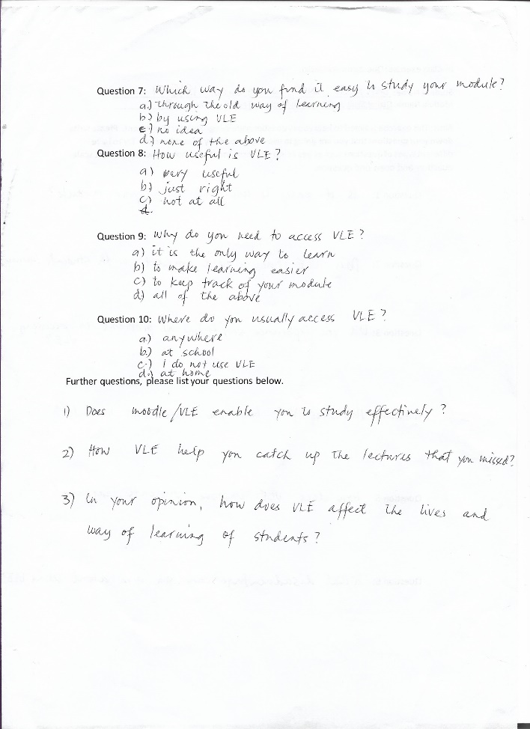
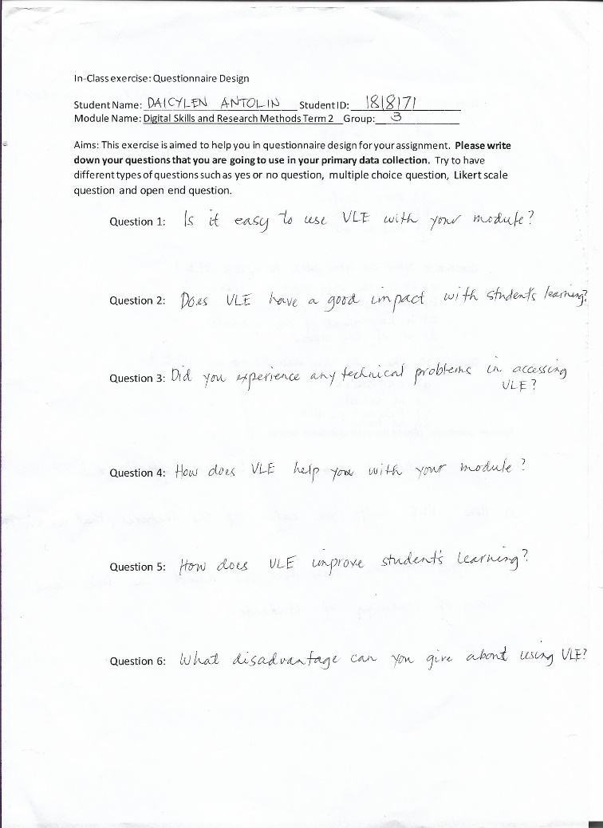
Appendices:

