
APPENDIX GA36d

LEVEL 7 ASSESSMENT SPECIFICATION

Student name: | LEUNG HON TO | Student ID number: | 2133985
Programme: | MBA
Module: | Finance for Business Managers
Module code: | HKBM7008 | Contribution to Overall Module Assessment (%): | 100%
Lecturer: | Dr Katherine Mo | Internal Verifier: | Dr Arion Wong
Assignment Title: | Assignment 1 | Word count (or equivalent): | 5,000 words  ± 10%
Submission deadline: | 5 September 2022 | Return date of provisional marks & written feedback: | Within 10 days after submission
Submission method: | All written assessments, where practical and possible, must be submitted via Turnitin unless otherwise instructed by the Lecturer. (Please DO NOT put this assessment specification into Turnitin or it will match many similarities with other students’ submissions.)  Alternative submission method (if applicable):  Late submission of the assessment will result in a late penalty mark. Penalties for late submission: Up to one week late, maximum mark of 50%. Over one week late, 0%. Only the Extenuating Circumstances Panel may approve a change to submission dates.
Academic honesty / referencing: | Academic honesty is required. In the main body of your submission you must give credit to authors on whose research and ideas your work is based. Append to your submission a reference list that indicates the books, articles, etc. that you have used, cited or quoted in order to complete this assessment.

Executive Summary

The report asses on King Fook’s financial status and compare with the market. It also asses on the corporate governance and address on the key areas. In order to sustain the growth of King Fook, there is a 5-year new project to drive the success.

By analyzing the financial report of King Fook, calculated and interpreted the accounting ratio such as “Bankruptcy Index”, “profitability”, “liquidity and efficiency”, “solvency”, and “stock market prospects” to see King Fook performance. After the comparison of King Fook with Luk Fook and Chow Sang Sang, King Fook needs to improve on the financial performance especially on the cost control and utilize the current assets to make more profits.

By analyzing the corporate governance of King Fook, it should hire the External Auditor on Audit Committee, set up Remuneration Committee and Nomination Committee to improve the internal control.

King Fook’s business is now all in Hong Kong. The future plan of the group is entering Mainland China market and open 6 stores in China with an average of 700 square meters per store. This is a 5-years project.

Table of content
1. Introduction 4
1.1 Company’s background 4
1.2 Operating Business Overview 4
1.3 Shareholdings and Organization structure 6
2 King Fook’s financial analysis 8
2.1 Listed companies of bankruptcy index Z-Score analysis 8
2.2 Financial structure 9
2.3 Paying debt ability 10
2.4 Operational ability 12
2.5 Operating expenses 13
2.6 Growth ability 15
2.7 Stock Market Prospects Analysis 16
3 King Fook’s Corporate Governance 17
3.1 Corporate Governance System 17
3.2 Deviate of the Listing Rules 18
3.3 Transparency and board diversity within a traditional family business 19
3.4 Compliance with Corporate Governance Code 20
3.5 Suggestions for improvement 20
4 Investment project 21
4.1 Project information 21
4.2 The first-year calculation of sales 21
4.3 Computing Tax Cost and Profits 22
4.4 Computing Cashflow 22
4.5 Computing ARR and NPV 22
4.6 PAYBACK PERIOD and IRR 23
4.7 Investment appraisal 23
4.8 New project appraisal methods for analysis 24
4.9 Suggestion for cashflow of new project 24
5 Financing and capital management 25
5.1 Financing methods for analyzing 25
5.2 Financing methods proposed 26
6 Recommendations and Audit Plan 27
7 Conclusion 28
8 References 28
9 Appendix 35

Introduction

1.1 Company’s background
King Fook Holdings Limited is a Hong Kong jewelry retailing and wholesaling company which established in 1949. Its businesses cover gold ornaments, jewelry, watch, fashion and gift retailing, bullion trading, securities brokerage and diamond wholesaling (King Fook Holdings Limited, 2022).

In March 1988, King Fook Holdings Limited was listed in The Stock Exchange of Hong Kong Limited (Stock code: 280). The IPO (initial public offering) is unavailable. The earliest data can find is in 2000. The total number of 435,071,650 ordinary shares in issue during 2000 and the final dividend $2,175,538 (2000: HKD$0.5 cent per share) (King Fook Holdings Limited, 2000).

In 2021, the company issued 913,452,092 (2020: 913,650,465) and The Board committed to payout dividend of HK1.0 cents per ordinary share which equal to total HKD$9,100,000 in each of the Year (King Fook Holdings Limited, 2021).

As at 20 Aug 2022, King Fook’s stock price at HKD$ 0.380 with issued 911,408,465 shares and the market capital at HKD$ 346,330,000. The stock value at year 2017 was 0.495. There is a negative growth 23% of stock value when compared to 5 years ago (Yahoo Hong Kong financial network, 2022).

1.2 Operating Business Overview

King Fook’s business model is a Business to Customer (B2C). B2C company produce services or products, they will sell their products to consumers through their own channels (Wirtz and Lihotzky, 2003).

At First, King Fook only focused on gold refining and bullion trading. Later, the business expanded to retail business, selling jewelry, watches and gold jewelry. Now, King Fook is operating 9 stores and can be divided to two lines. The first one is a Traditional Hong Kong Jewelry shop – 景福珠寶to target more conventional customers and the 2 shops are located in Central. The other line is a New Trendy Western Style Jewelry shop – MASTERPIECE BY KING FOOK to target trendy customers and the 7 shops are mainly located in shopping mall such as TST Harbour City, Admiralty Pacific Place, Shatin New Town Plaza (King Fook Holdings Limited, 2021).

Apart of the physical store, King Fook adapted the pandemic and developed an E-commerce platform in April 2020 to offer a convenient shopping experience to customers (King Fook Holdings Limited, 2021).

In Figure 1.2.1, the sales performance of King Fook is increasing rapidly. The growth rate of 2017 to 2021 is 60% (King Fook Holdings Limited, 2021).

Figure 1.2.1: Sales performance of King Fook from 2017 to 2021.
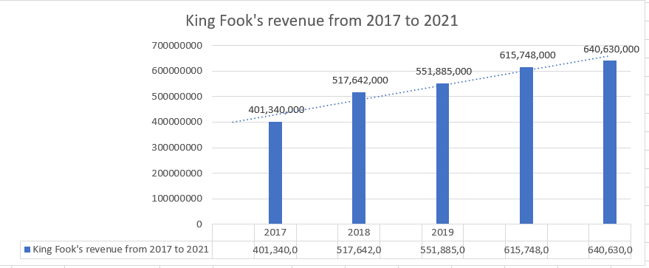
Source: Constructed by author

The main business of the group is bullion trading, gold ornament, jewelry, watch and gift retailing and diamond wholesaling. The main driver is gold ornament, jewelry, watch and gift retailing with the growth 0.8%.

Figure 1.2.2: 2020 & 2021 Revenue Distribution of King Fook
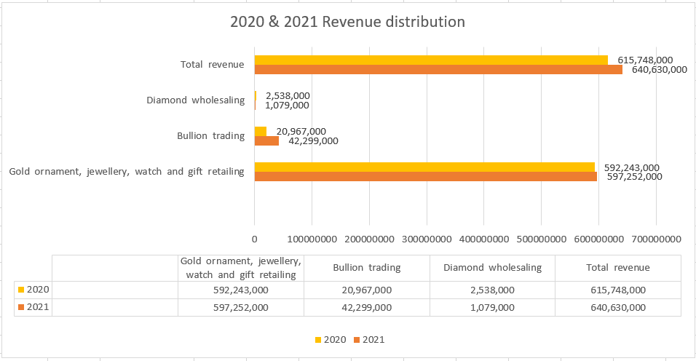
Source: Constructed by author

  - Today’s Business Environment

Due to pandemic of COVID19, Hong Kong Government still tight in the immigration control which lead to the number of visitors from 1 January 2022 to 30 April 2022 dropped by 27.3% as compared to the corresponding period in 2021 (Hong Kong Tourism Board, 2022).

Also, Social Distancing policy led to postponed wedding or even cancellation. It affected the gold and jewelry business.

In the business of Hong Kong Jewelry, the leading company is Chow Tai Fook and the market capitalization is HKD$163.60 billion. The second one is Luk Fook Holdings Limited and the market capitalization is HKD$11.86 billion. The third one is Chow Sang Sang and the market capitalization is HKD$6 billion (Yahoo Hong Kong financial network, 2022).

1.3 Shareholdings and Organization structure

The shareholdings of King Fook are mainly distributed to Yeung Chi Shing Estates Limited (60.84%) (AASTOCKS, 2022).

King Fook only disclosed its Board of Directors and Senior Management. There are 3 Executive directors, 1 non-executive directors and 4 Independent non-executive directors. For Senior management, there are 1 Chief Executive Officer, 1 General Manager, 1 Chief Financial Officer. Other than that, the group did not disclose its organization structure nor business unit (King Fook Holdings Limited, 2021).

1.4 Research comparison company information

The comparison companies are Luk Fook Holdings Limited (00590) and Chow Sang Sang (00116). Including King Fook Holdings Limited (00280), all three companies are in the same business nature – Jewelry retail. Among these three companies, Luk Fook has the largest scale of business and the highest market value at HKD$ 11.86 billion. Therefore, the following financial analysis will base on these three companies.

Table 1.4.1: Comparison company
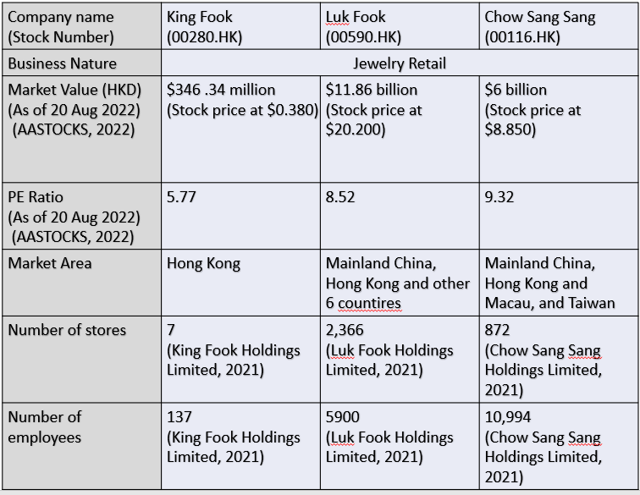
Source: Constructed by author

King Fook’s financial analysis
By looking at the statement of the Consolidated Statement of Profit or Loss and Other Comprehensive Income and The Consolidated Statement of Financial Position in King Fook and compared with Luk Fook and Chow Sang Sang, we will have a assessment of the feasibility, stability and profitability of the business (Kaufmann, Gadmer and Klett, 2001).

2.1 Bankruptcy index Z-Score analysis
Z-Score analysis is a credit risk models to predict the possibility of enterprise bankruptcy by analyzing and simulating the main financial indicators of the enterprise, thereby predicting the credit risk of the enterprise (Altman, 2013).

Table 2.1.1: Financial background analysis on King Fook, Luk Fook and Chow Sang Sang 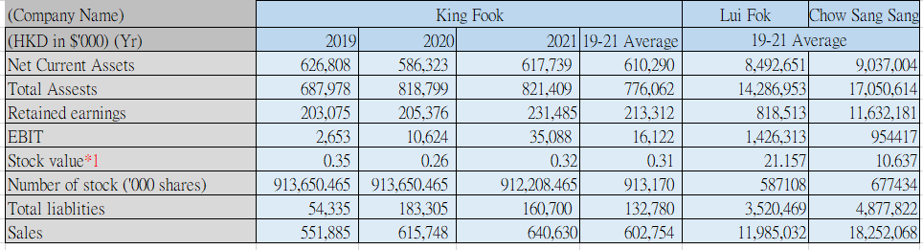
Note 1：Mar 31 closing value by dividend and stock split adjustment
Source: Constructed by the author.

This table shows that in terms of the stock value and sales scale, King Fook is the smallest size company among Luk Fook and Chow Sang Sang. Although the size of King Fook is smaller than the other two companies, the growth rate of Retained earnings is 13% and EBIT is 230%. The Stock value growth 21% and the sales growth 4%. More importantly, the total liabilities drop 12%.

Table 2.1.2: Z-Score analysis on King Fook, Luk Fook and Chow Sang Sang
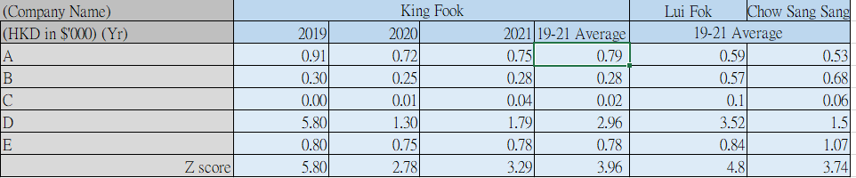
Source: Constructed by the author

Three companies’ bankruptcy index analysis: 3 years Z-Score (average 3.96) of King Fook is in a safe-area and indicate a low probability of bankruptcy. When Z-Score is close to 0, the company is likely facing bankruptcy. When Z-Score is close to 3, the company is having a solid financial status (Altman, 2013). Compared to Luk Fok and Chow Sang Sang, King Fok is in the medium level.

2.2 Financial structure
By looking at the financial structure, it can help us to understand the proportional relationship between debt and equity in the company’s capital after King Fook has financed through stocks (Stiglitz, 1988).

Table 2.2.1: Financial structure analysis on King Fook, Luk Fook and Chow Sang Sang
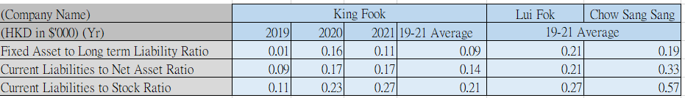
Source: Constructed by the author

Fixed Asset to Long term Liability Ratio refers to how well the company’s ability to paying debt with company’s tangible assets (Holz, 2002). In table 2.2.1, King Fook has the lowest Fixed Asset to Long term Liability Ratio on average 0.09 when compared to other two companies. Therefore, King Fook is lagging behind the market in terms of the ability to cover the long-term liabilities.

Current Liabilities to Net Asset Ratio refers to how much company’s net assets are contributed by the current liabilities (Welch, 2011). In table 2.2.1, King Fook has the lowest Current Liabilities to Net Asset Ratio on average 0.14 when compared to other two companies. It means that King Fook can consider having a bank loan to increase on investment.

Current Liabilities to Stock Ratio refers to how much company’s inventories are contributed by the current liabilities (Husna, Satria, 2019). When compared to other two companies, King Fook has the lowest Current Liabilities to Stock Ratio means King Fook has less proportion on current liabilities by inventories.

After analyzing the financial structure of the above three companies, King Fook is below the market average and need to catch up the market.

2.3 Paying debt ability
Analyzing the paying debt ability can help the company understand its ability to repay its long-term and short-term debts with its assets. The ability of paying cash or repay debts is a key to prolong the survival and healthy development of the company (Lin, Liu and Liang, 2010).

Table 2.3.1: Paying debt ability analysis on King Fook, Luk Fook and Chow Sang Sang
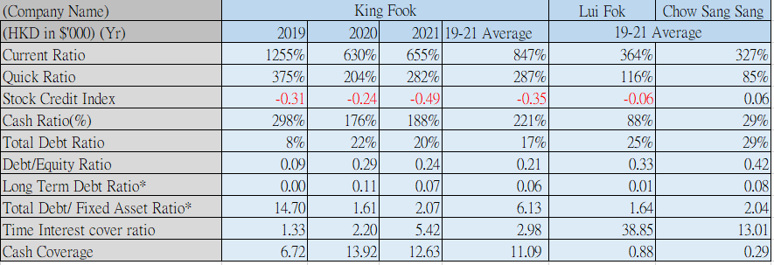
Source: Constructed by the author
Current Ratio can show the liquidity on the company and a high ratio indicate having a stronger liquidity of corporate assets and the stronger short-term solvency; otherwise if the ratio is the weaker. It is generally believed that the current ratio should be above 2:1, and the quick ratio should be above 1:1. If the current ratio is too high which means the company have not leverage the cash effectively to create profits (Nuryani and Sunarsi, 2020).

In table 2.3.1, King Fook’s Current Ratio and Quick Ratio are on average 847% and 287% as it is both 2-fold of the other two companies. In King Fook case, they need to improve the use of existing assets and leverage it to gain business.

King Fook Stock Credit Index is on average -0.35 which indicated King Fook has high inventory level and relatively low total current liabilities.
Cash ratio refers to King Fook's cash assets to current liabilities (Marietta and Sampurno, 2013). This indicator reflects the immediate liquidity of King Fook. Cash Ratio 221% can show the ability of King Fook to repay the debts immediately when compared to Luk Fook (88%) and Chow Sang Sang (29%).

Total Debt Ratio indicate the long-term solvency of a company (Al-Shubiri, 2012). In table 2.3.1, King Fook’s Total Debt Ratio is on average 17% and it is below the market average (Luk Fook 25%, Chow Sang Sang 29%). It means that King Fook relatively has more assets than the liabilities.

Total Debt/ Fixed Asset Ratio of King Fook is on average 6.13 way higher than the market (Luk Fook 1.64, Chow Sang Sang 2.04) which means that King Fook has less fixed asst than its debt. And it is not a good sign for the company.

Time Interest cover ratio refers to the multiple of EBIT to interest expense. The interest coverage ratio is considered to be an indicator for analyzing the long-term solvency of a company (Farah and Amin, 2021). In table 2.3.1, Luk Fook and Chow Sang Sang have 38.85 and 13.01 Time Interest cover ratio. It means that Luk Fook and Chow Sang Sang have a strong ability to pay interest expenses through operating profits. King Fook’s Time Interest cover ratio is on average 2.98 and need to improve the EBIT.

2.4 Operational ability
Operational capability refers to the ability of a company to use various assets to earn profits. The faster the turnover of enterprise assets, the higher the liquidity, the stronger the solvency of the enterprise, and the faster the assets obtain profits (Bawa and Basu, 2020).

In figure 2.4.1, King Fook generated sales 640 million dollars with the growth 4%. Luk Fook’s business is dropping 21% and generated sales 8,861 million dollars. Chow Sang Sang is the performing the best and generated sales 21,987 million dollars with 47%.

Figure 2.4.1: Sales performance of King Fook, Luk Fook and Chow Sang Sang from 2019 to 2021.
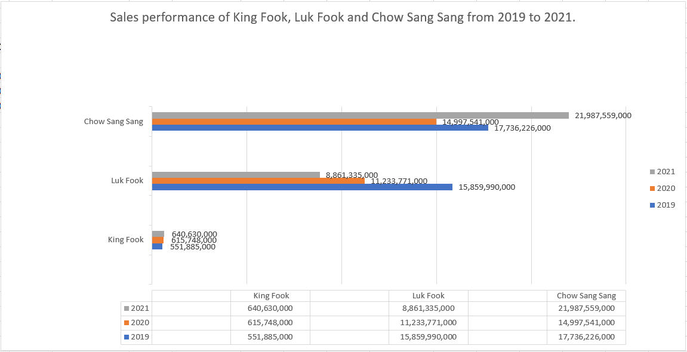
Source: Constructed by the author.

2.5 Operating expenses
Operating expenses refer to the ongoing and expendable expenses of running a business. Operating expenses may include employee salaries, equipment rentals and venue rentals (Enache and Srivastava, 2018).

Table 2.5.1: Operating expenses on King Fook, Luk Fook and Chow Sang Sang
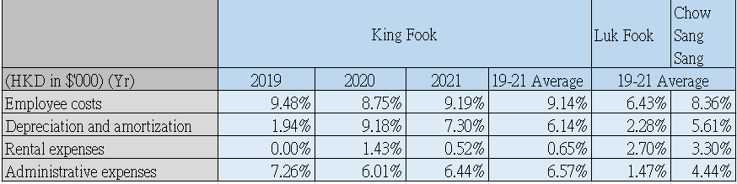
Source: Constructed by the author

In table 2.5.1, King Fook 3 out of 4 expenses are higher than the market average. These three expenses are Employee costs (King Fook 9.41% vs Luk Fook 6.43% and Chow Sang Sang 8.36%), Depreciation and amortization (King Fook 6.14% vs Luk Fook 2.28% and Chow Sang Sang 5.61%), Administrative expenses (King Fook 6.57% vs Luk Fook 1.47% and Chow Sang Sang 4.44%). Only Rental expenses is performing better than the other two companies (King Fook 0.65% vs Luk Fook 2.70% and Chow Sang Sang 3.30%).

Table 2.5.2: Operating expenses on King Fook, Luk Fook and Chow Sang Sang
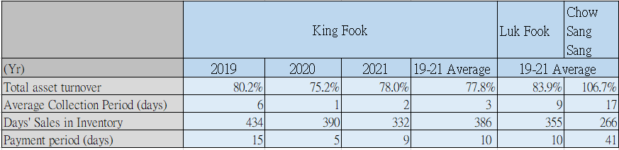
Source: Constructed by the author
Total asset turnover is an indicator to measure the speed of capital turnover (Sunjoko and Arilyn, 2016). In table 2.5.2, King Fook has the lowest Total asset turnover 77.8% when compared to Luk Fook 83.9% and Chow Sang Sang 106.7%. King Fook needs to improve the use as little capital as possible to obtain as much sales revenue as possible, indicating that the capital turnover is fast and the capital utilization effect is good.

King Fook has the lowest Average Collection Period 3 days as better than Luk Fook (9 days) and Chow Sang Sang (17 days) which means the business has higher liquidity.

Days' Sales in Inventory refers to the average number of days it takes for a company to sell its goods (Gołaś, 2020). King Fook need 386 days to sell its goods and it is not performing good as Luk Fook 355 days and Chow Sang Sang 266 days.

Payment period is a measurement of how long to pay off supplier by the company. Longer accounts payable turnover days can benefit company to occupy more supplier's loan. It will reduce the chance to create interest by borrowing from the bank to support the company (Jamal, Sarker and Wang, 2000). In table 2.5.2, King Fook only has 10 days payment period and Chow Sang Sang has 41 days which means a company with a higher ratio is usually a company with a strong market position.

2.6 Profitability

Profitability refers to the ability of a company to make profits (Hofstrand, 2009).

Table 2.5.1: Net profit analysis on King Fook, Luk Fook and Chow Sang Sang
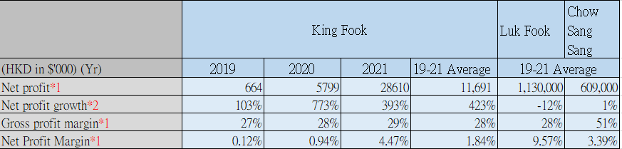
Source: Constructed by the author

Although the business scale of King Fook is smaller than Luk Fook and Chow Sang Sang, the net profit growth rate 423% is better than Luk Fook -12% and Chow Sang Sang 1%. For Net Profit Margin of King Fook is gradually growing up from 2019 to 2021 on average 1.84%. it is still having a room for improvement when compared to Luk Fook 9.57% and Chow Sang Sang 3.39%.

Table 2.6.1: Net profit analysis on King Fook, Luk Fook and Chow Sang Sang
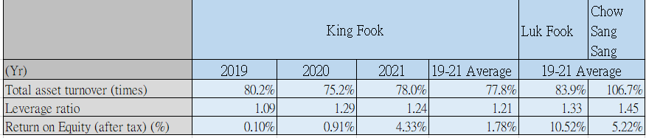
Source: Constructed by the author

Leverage ratio refers to the ratio of total assets to equity capital on the balance sheet (Chen and Zhao, 2006). In table 2.6.1, three company has similar Leverage ratio but Chow Sang Sang is still the best at 1.45, Luk Fook 1.33, King Fook the last at 1.21.

By using The Du Pont Identity to understand ROE. ROE depends on operating efficiency (measured by profit margin), asset management efficiency (measured by asset turnover) and financial leverage (measured by equity multiplier) (

2.7 Growth ability

Growth ability is to improve the internal quality of the enterprise, optimize the external value network, and win the market competitive advantage with an effective business model, and then realizing the growth of company performance (Bei and Wijewardana, 2012).

Table 2.7.1: Growth ability analysis on King Fook, Luk Fook and Chow Sang Sang
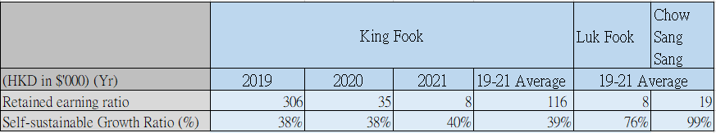
Source: Constructed by the author

Retained earning ratio of King Fook is dropping from 2019 ($306,000) to 2021($8,000). It is similar to Luk Fook $8,000 but lower than Chow Sang Sang 19,000.

In table 2.7.1, Self-sustainable Growth Ratio of King Fook is also below market average 39% when compared with Luk Fook 76% and Chow Sang Sang 99%.

2.8 Stock Market Prospects Analysis
By analyzing the Earning per share, Price-earning Ratio and Dividend yield to have a prediction on stock market.

Table 2.8.1: Stock Market Prospects Analysis on King Fook, Luk Fook and Chow Sang Sang
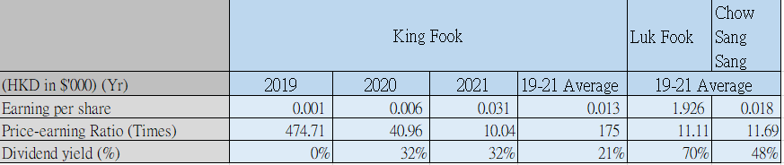
Source: Constructed by the author

Earnings per share refers to the ratio of the company's net profit to the outstanding ordinary shares, reflecting the profitability of ordinary shares (Khan, 2014). Although King Fook is improving from 2019 at 0.001 to 2021 0.031, on average is still lower than Luk Fook 1.926 and Chow Sang Sang 0.018.

Price-earnings ratio is to assess whether the stock price level is reasonable. Calculated the ratio by dividing the stock price by the annual earnings per share (Khan, 2009). King Fook has the highest Price-earnings ratio on average 175 times versus Luk Fook 11.1 times and Chow Sang Sang 11.09.

Dividend yield is the ratio between the dividend and the stock price (Kothari and Shanken, 1997). In table 2.8.1, King Fook is performing the worst on average 21% when compared to Luk Fook 70% and Chow Sang Sang 48%.

King Fook’s Corporate Governance
Corporate governance is the system by which companies are directed and controlled by the board of directors and senior management. The board of directors have a duty to act in the interests of shareholders (Monks and Minow, 2011).

3.1 Corporate Governance System

King Fook has four layers on corporate governance system. The group invites an external consultant to review the risk management framework, risk of governance structure, risk management policy, facilities, coordinate and support the risk management process.

The first layer is The Board is accountable for the group’s business objectives and the risks. Then is the Audit Committee which responsible for oversighting the company risk management and internal control systems. The third layer is Risk Management Committee response for financial and operational executives.

The First line of defense is company’s business unit and departments for identifying, assessing, managing and monitoring risks associated with each business operation.

The Second line of defense is The Risk Management Committee and the external consultant. Assessing relevant risks and carrying out necessary control activities by The Risk Management Committee. Facilitating, coordinate and support the risk management process by the external consultant.

The Third line of defense is the Internal Audit Department for internal audit work to make sure the first and second lines of defense are valid (King Fook Holdings Limited, 2021).

Figure 3.1.1: Director’s list of King Fook
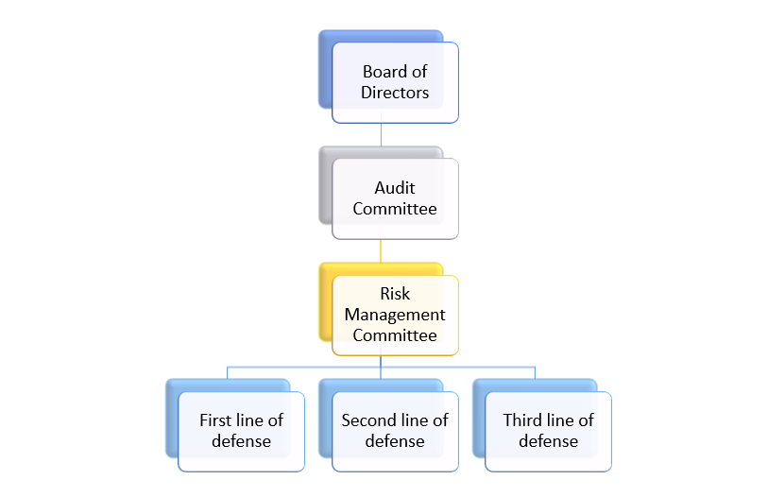
Source: King Fook 2021

3.2 Deviate of the Listing Rules

The group are following all the code provisions in the Corporate Governance under Listing Rules of The Stock Exchange of Hong Kong Limited except 4 code provisions (A.4.1, A.5.1 to A.5.4, D.1.4, E.1.5).

A.4.1, no specific term for the non-executive directors but each of them is subject to retirement by rotation at annual general meeting of the Company at least once every 3 years in accordance. The retiring directors are eligible for re-election.

A.5.1 to A.5.4, the Company has not established a nomination committee.
D.1.4, no formal letters of appointment for directors of its key terms and conditions

E.1.5, no dividend policy or any pre-determined dividend distribution ratio.

3.3 Transparency and board diversity within a traditional family business

King Fook is a family business. The Major shareholder of King Fook is Yeung Chi Shing Estates Limited (60.84%) (AASTOCKS, 2022).

For the board member, all directors are no family relationship to Yeung family. The group has a transparent and varied board member followed board diversity policy (King Fook Holdings Limited, 2021).

Table 3.3.1: Director’s list of King Fook
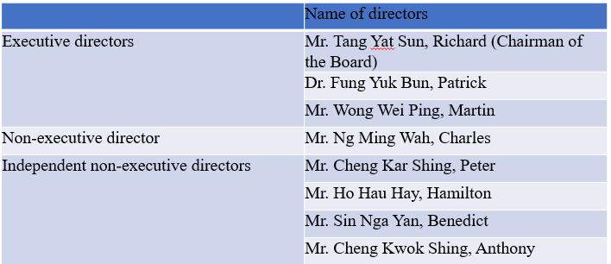
Source: King Fook 2021

There are 3 of the 8 directors have the shares of the company and followed section 352 of the SFO or as otherwise notified to the Company
and the Stock Exchange pursuant to the Model Code for Securities Transactions by Directors of Listed Issuers (the “Model Code”) as set out in Appendix 10 to the Listing Rules were as follows:

Table 3.3.2: Directors’ interests of King Fook
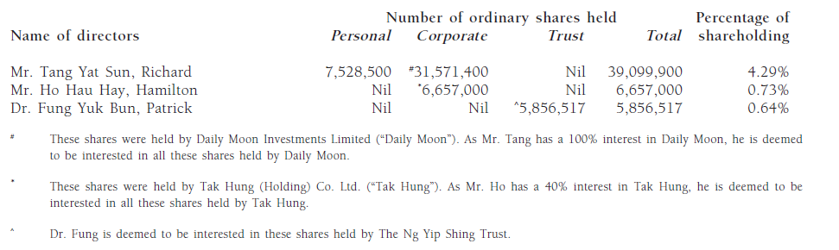
Source: King Fook 2021

Received a letter of confirmation by all independent non-executive directors in accordance with rule 3.13 of the Rules Governing the Listing of Securities on The Stock Exchange of Hong Kong Limited (the “Listing Rules”) and considers that all the independent non-executive directors are independent.

As Non Yeung’s family member, Board of dicrectors led the company to a up raising trend. Base on Return on Assets (ROA), King Fook is in the middle of three companies (3.48%). ROA means how much profits that company leveraged on its assets (Burton, Lauridsen, and Obel, 2002).

Base on Return on Equity (ROE), King Fook is catching up to the other two companies (4.33%). ROE means how much net income generated from shareholders’ equity (Heikal, Khaddafi, and Ummah, 2014).

Table 3.3.3: ROA and ROE on King Fook, Luk Fook and Chow Sang Sang
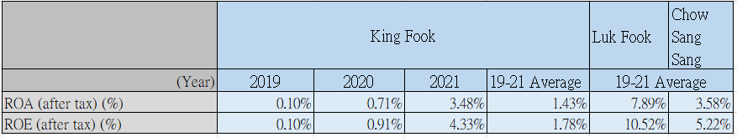
Source: Constructed by the author

3.4 Compliance with Corporate Governance Code
From 1988, there is no news about non-compliance issue on King Fook’s corporate governance (HKEX, 2022).

3.5 Suggestions for improvement
The group can benchmark the peers especially Luk Fook, hire the External Auditor on Audit Committee, set up Remuneration Committee and Nomination Committee (Luk Fook Holdings Limited, 2021). It can improve the internal control.

Create a formal letter of appointment for directors of its key terms and conditions. It can improve the transparency of company.

Investment project
King Fook’s business is now all in Hong Kong. The future plan of the group is entering Mainland China market and open 6 stores in China with an average of 700 square meters per store. This is a 5 years project.

4.1 Project information
Table 4.1.1: Project Information
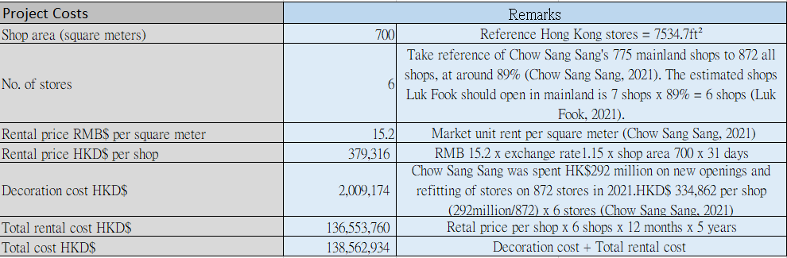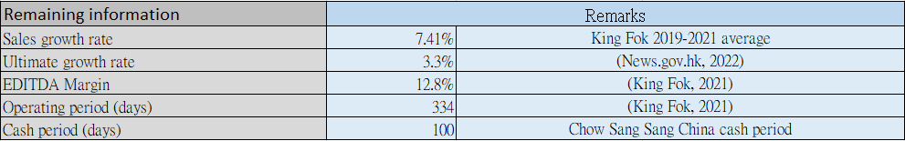
Source: Constructed by the author

4.2 The first-year calculation of sales
Table 4.2.1: Project Sales
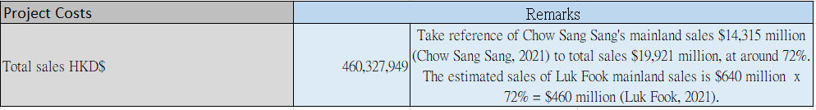
Source: Constructed by the author

4.3 Computing Tax Cost and Profits
Table 4.3.1: Tax cost and profits
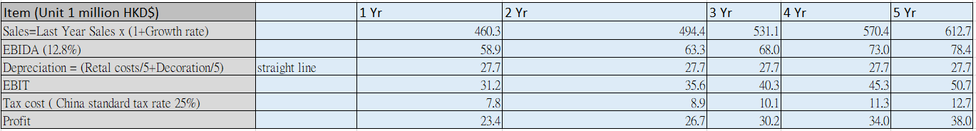
Source: Constructed by the author

4.4 Computing Cashflow
Table 4.4.1: Cashflow
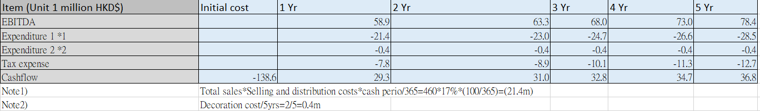
Source: Constructed by the author

4.5 Computing ARR and NPV
Table 4.5.1: ARR
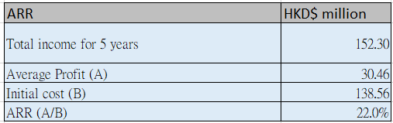
Source: Constructed by the author

Table 4.5.2: NPV
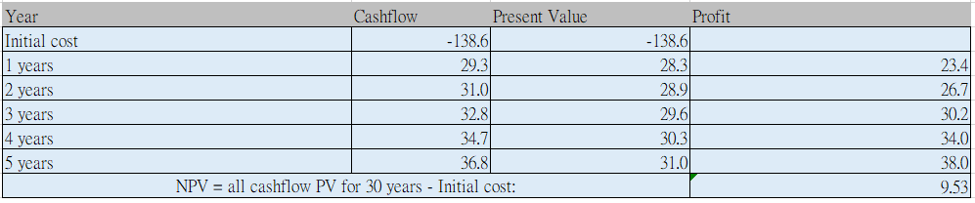
Source: Constructed by the author

4.6 PAYBACK PERIOD and IRR
Table 4.6.1: PAYBACK PERIOD
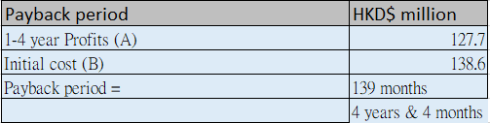
Source: Constructed by the author
Table 4.6.2: IRR
Source: Constructed by the author

4.7 Investment appraisal
By looking at the data analysis, the payback period of opening 6 new stores in China is 4 years and 4 months. Payback period is to calculate how long it take for company to recover the initial cost. The advantage of using payback period is easy to understand, but the disadvantage is ignored time value (Weingartner, 1969).

For the Cash Period 100 days which is referencing from Chow Sang Sang. King Fook needs to improve on Cash Period by Reducing Inventory Days, Improving Account Receivables and Improving Payment Period. Reducing Inventory Days by forecasting the true demand instead of the sales. Improving Account Receivables by offering an Early Payment Discount. Improving Payment Period by keeping the suppliers on good terms. As the business size of King Fook is getting bigger, the cash period will be much longer.

Therefore, the new project can have a positive return for King Fook and explore in China market.

4.8 New project appraisal methods for analysis
Accounting rate of return (ARR) refers to the average annual net rate of return on the original investment of the project (Penman, 1991). The project ARR is 22% which is good. But the limitation of using ARR is the profits can be manipulated by creative accounting.

The Net Present Value (NPV) of the new project is $9,530,000 which is a positive value and it means the project is worth to implement. Net present value is the difference between the discounted value of future cash flows from an investment and the cost of the project's investment (Gallo, 2014). The advantage of using NPV is it discount the cash flow properly.

Internal Rate of Return (IRR) refers to the discount rate that make the net present value to zero (Hartman and Schafrick, 2004). The IRR of the new project is 5.8% is good because it is higher than the Return on Assets (ROA) 3.48%.

4.9 Suggestion for cashflow of new project
By looking at the King Fook’s consolidated statement of cash flows, King Fook always maintains a healthy cash flow. The cash and cash equivalents at the end of 2021 is $209,270,000 with the growth 8% (King Fook Holdings Limited, 2021). The zero-year cashflow of new project required $139,000,000 which is 66% of the 2021 years’ cash flow. Therefore, King Fook can still keep a good liquidity.

Financing and capital management
The initial investment of King Fook’s new project required $138,562,934 which is equal to 17% of total assets $821,409,000 (King Fook Holdings Limited, 2021). Then we will analyze King Fook’s capital and suggest the best financing program.

5.1 Financing methods for analyzing
Table 5.1.1: Financing methods
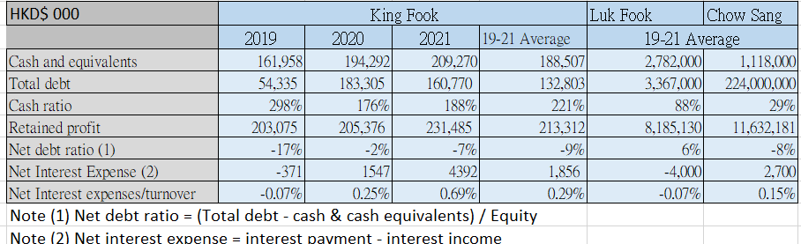
Source: Constructed by the author

- Use of Retained Profit or Cash
The retained profit of King Fook is 231,485,000 at 2021. The initial cost of the new project is $138,562,934 which is 60% of the retained profit.
Cash ratio of King Fook is 188% at 2021 and the market average are Luk Fook 88% and Chow Sang Sang 29%. It means that King Fook needs to leverage the cash to create profits for the company.

- Bank loan
There is no existing bank loan of King Fook in 2021 (King Fook Holdings Limited, 2021). So, we take reference of Chow Sang Snag’s interest rate 1.3%-2.5% in 2021. If King Fook borrow bank loan and the interest rate is 2.5%, the additional interest cost will be $3,464,073. In table 5.1.1, the Net Interest expenses/turnover will become 0.71% ($7,856,000/ ($640,630,000+$460,237,949) which is acceptable.

- Issue shares
King Fook issued 912,208,465 number of stock and the stock value is 0.32 in 2021. If the initial cost is $138,562,934, then King Fook needs to issue 44,340,139 number of stocks to recruit the funding.

- Crowdfunding
Crowdfunding is a public financing which is a "pre-consumption" model to raise project funds from the public. But the disadvantage is we can’t ensure the source of money which is legit or not (Mollick, 2014).

5.2 Financing methods proposed
After analyzing the financing methods, King Fook should use Bank Loan (Bank of China) for the initial cost $138,562,934 with the interest rate 2.5%, 5-year amortization. The projected financial data are as follow.

Table 5.2.1: Projected financial data
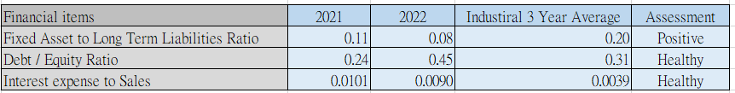
Source: Constructed by the author

King Fook has a positive cash flow and retained earnings to support the bank loan for the 5-year project. In table 5.2.1, Fixed Asset to Long Term Liabilities Ratio has a sightly change from 0.11 to 0.08 and compared to industrial 3-year average 0.20 the assessment is positive.

Forecasting Debt / Equity Ratio is 0.45 in 2022 which is also healthy when compared with industrial 3-year average 0.31.

The assessment of Interest expense to Sales in 2022 is still healthy which is because it drops from 0.0101 to 0.0090.

Recommendations and Audit Plan
After the launch of new 5-year project of opening 6 stores in China, King Fook should have a regular review and audit plan to assess the project.

Table 6.1: First 12 months Gantt Chart for the 5-year project
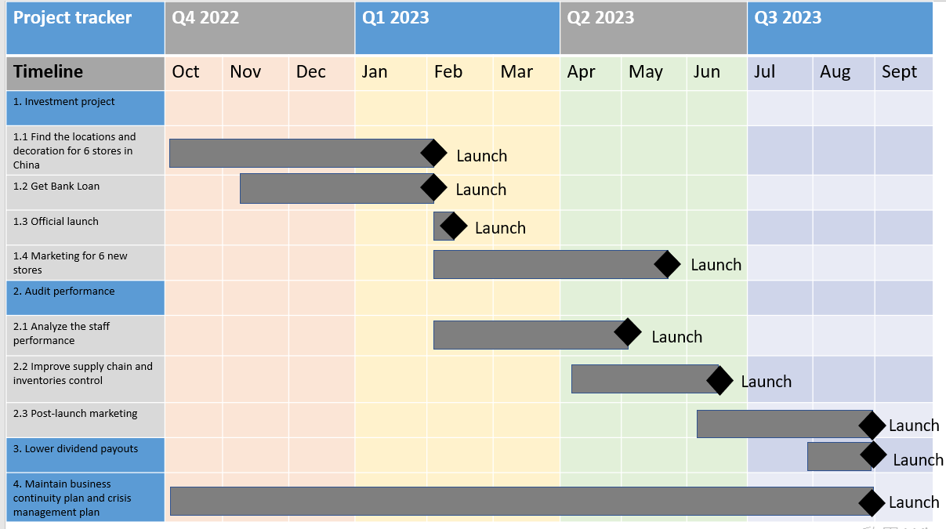
Source: Constructed by the author

There are 4 parts for the 5-year project

- Investment project
For the investment project, King Fook needs to find the suitable location for 6 stores and then put on the decoration during October to January. At the meantime, finance team should communicate with the Bank of China to facilitate a bank loan to make sure the project has enough budget. The official launch should be in February. After the official launch, implanting the marketing program for 6 new stores in China.

- Audit performance
It is important to have a audit on the performance to make sure the new project carry out successfully. There is a analyze for the staff performance during February to April 2023. Improving supply chain and inventories control during April to June. Having a post-launch marketing during June to August.

- Lower dividend payouts
Making sure the shareholders to have a dividend payout during August.

- Continuity plan and crisis management plan
King Fook needs to have a continuity plan and crisis management plan
throughout the whole project. To make sure everything is on the right track and always have a back up plan.

Conclusion
King Fook has a below market average financial report and need to improve the cost control and utilize the current assets to make more profits.

For corporate governance, King Fook should hire the External Auditor on Audit Committee, set up Remuneration Committee and Nomination Committee to improve the internal control.

In order to have a further growth, King Fook’s 5-year new project of opening 6 stores in China can generate average profit $30,460,000 per year. It can help King Fook to catch up the competitors.

References
Academic reference:

- Al-Shubiri, F. N. (2012) Debt ratio analysis and firm investment: Evidence from Jordan. International Journal of Economics and Financial Issues, 2(1), 21-26. Available at: https://dergipark.org.tr/en/download/article-file/362662 (Accessed: 28 June 2022).
- Altman, E. I. (2013) Predicting financial distress of companies: revisiting the Z-score and ZETA® models. In Handbook of research methods and applications in empirical finance. Edward Elgar Publishing. Available at: https://citeseerx.ist.psu.edu/viewdoc/download?doi=10.1.1.25.1884&rep=rep1&type=pdf (Accessed: 18 June 2022).
- Bawa, J. K., and Basu, S. (2020) Restructuring assets reform, 2013: Impact of operational ability, liquidity, bank capital, profitability and capital on bank credit risk. IIMB Management Review, 32(3), 267-279. Available at: https://www.sciencedirect.com/science/article/pii/S0970389617302549 (Accessed: 28 June 2022).
- Bei, Z., and Wijewardana, W. P. (2012) Financial leverage, firm growth and financial strength in the listed companies in Sri Lanka. Procedia-social and behavioral sciences, 40, 709-715. Available at: https://www.sciencedirect.com/science/article/pii/S1877042812007203/pdf?md5=9d4a583bcd875777b9f200aa18f15db8&pid=1-s2.0-S1877042812007203-main.pdf (Accessed: 28 June 2022).

- Burton, R. M., Lauridsen, J., and Obel, B. (2002) Return on assets loss from situational and contingency misfits. Management science, p.1461-1485. Available at: https://d1wqtxts1xzle7.cloudfront.net/47209081/Erratum_Return_on_Assets_Loss_from_Situa20160713-20614-21g21i-with-cover-page-v2.pdf?Expires=1662223780&Signature=TWgViq5muTkSctxHB7F~JmIFcoiEnwgABOYR~Pr0VOe1p8bagw4qMNwKvlC4jXLJffg65YX-ZS6IuASlsX0RIZ0jYrVctvxb7gPPlOQ01hWkw10UW~Kic3N0iC1DN3hGl0Wr-IfP2EFHOedX-YPz7NtrNNSyKdCijFw7iveZGodjiw0agjksqRLqGcHl8yNpmobbb5HeJwvYjZR1SJsfpkFY3JVoAwKYxkyQVZhNyQRCE9aF-4UAseftfjSs-DTbQNog5X41p1DBoc~7Rf0VKuHXso64Mw5ZeMAbFyK2ulOe6y~YTgW6ddOFC2KD1ythXHuHBgr7~JEOl1kaSZGEug__&Key-Pair-Id=APKAJLOHF5GGSLRBV4ZA (Accessed: 18 June 2022).
- Chen, L., and Zhao, X. (2006) On the relation between the market-to-book ratio, growth opportunity, and leverage ratio. Finance Research Letters, 3(4), 253-266. Available at: https://www.sciencedirect.com/science/article/abs/pii/S1544612306000407 (Accessed: 28 June 2022).
- Enache, L., and Srivastava, A. (2018) Should intangible investments be reported separately or commingled with operating expenses? New evidence. Management Science, 64(7), 3446-3468. Available at: https://pubsonline.informs.org/doi/abs/10.1287/mnsc.2017.2769 (Accessed: 28 June 2022).
- Farah, I., and Amin, C. (2021) The Effect of Debt To Asset Ratio, Long Term Debt To Equity Ratio and Time Interest Earned Ratio on Profitability. BINA BANGSA INTERNATIONAL JOURNAL OF BUSINESS AND MANAGEMENT, 1(1), 68-78. Available at: https://dergipark.org.tr/en/download/article-file/362662 (Accessed: 28 June 2022).
- Gallo, A. (2014) A refresher on net present value. Harvard Business Review, 19. Available at: http://www.cogencygroup.ca/uploads/5/4/8/7/54873895/harvard_business_review-a_refresher_on_net_present_value_november_19_2014.pdf (Accessed: 28 June 2022).
- Gołaś, Z. (2020) The effect of inventory management on profitability: Evidence from the Polish food industry: Case study. Agricultural Economics, 66(5), 234-242. Available at: https://www.agriculturejournals.cz/publicFiles/370_2019-AGRICECON.pdf (Accessed: 28 June 2022).
- Hartman, J. C., and Schafrick, I. C. (2004) The relevant internal rate of return. The Engineering Economist, 49(2), 139-158. Available at: https://www.tandfonline.com/doi/abs/10.1080/00137910490453419 (Accessed: 28 June 2022).
- Heikal, M., Khaddafi, M., and Ummah, A. (2014) Influence analysis of return on assets (ROA), return on equity (ROE), net profit margin (NPM), debt to equity ratio (DER), and current ratio (CR), against corporate profit growth in automotive in Indonesia Stock Exchange. International Journal of Academic Research in Business and Social Sciences, 4(12), 101. Available at: https://www.researchgate.net/profile/Muammar-Khaddafi/publication/276311841_Influence_Analysis_of_Return_on_Assets_ROA_Return_on_Equity_ROE_Net_Profit_Margin_NPM_Debt_To_Equity_Ratio_DER_and_current_ratio_CR_Against_Corporate_Profit_Growth_In_Automotive_In_Indonesia_Stock_Exc/links/56a3676908ae232fb2057280/Influence-Analysis-of-Return-on-Assets-ROA-Return-on-Equity-ROE-Net-Profit-Margin-NPM-Debt-To-Equity-Ratio-DER-and-current-ratio-CR-Against-Corporate-Profit-Growth-In-Automotive-In-Indonesia-Stoc.pdf (Accessed: 18 June 2022).
- Hofstrand, D. (2009) Understanding profitability. Ag Decisions Makers, 2, C3-24. Available at: https://www.extension.iastate.edu/winnebago/sites/www.extension.iastate.edu/files/winnebago/c3-24-1%20Understanding%20Profitability.pdf (Accessed: 28 June 2022).
- Holz, C. A. (2002) The impact of the liability–asset ratio on profitability in China's industrial state-owned enterprises. China Economic Review, 13(1), 1-26. Available at: https://repository.hkust.edu.hk/ir/bitstream/1783.1-2198/1/HolzpostrefereedSOELeverageApril01.pdf (Accessed: 28 June 2022).
- Husna, A., and Satria, I. (2019) Effects of return on asset, debt to asset ratio, current ratio, firm size, and dividend payout ratio on firm value. International Journal of Economics and Financial Issues, 9(5), 50. Available at: https://www.proquest.com/openview/ca61658de174e8aae6f268e3d33aef10/1?pq-origsite=gscholar&cbl=816338 (Accessed: 28 June 2022).
- Jamal, A. M. M., Sarker, B. R., and Wang, S. (2000) Optimal payment time for a retailer under permitted delay of payment by the wholesaler. International Journal of Production Economics, 66(1), 59-66. Available at: https://www.sciencedirect.com/science/article/abs/pii/S1544612306000407 (Accessed: 28 June 2022).
- Kaufmann, R., Gadmer, A., and Klett, R. (2001) Introduction to dynamic financial analysis. ASTIN Bulletin: The Journal of the IAA, 31(1), 213-249. Available at: https://www.research-collection.ethz.ch/bitstream/handle/20.500.11850/422515/S0515036100001628.pdf?sequence=1 (Accessed: 28 June 2022).
- Khan, M. I. (2009). Price Earning Ratio and Market to Book Ratio. Available at: https://mpra.ub.uni-muenchen.de/23969/1/MPRA_paper_23969.pdf (Accessed: 28 June 2022).
- Khan, T. R., Islam, M., Choudhury, T. T., and Adnan, A. M. (2014) How earning per share (EPS) affects on share price and firm value. Available at: http://dspace.bracu.ac.bd/xmlui/bitstream/handle/10361/6343/13572-15840-1-PB.pdf?sequence=1&isAllowed=y (Accessed: 28 June 2022).
- Kothari, S. P., and Shanken, J. (1997) Book-to-market, dividend yield, and expected market returns: A time-series analysis. Journal of Financial economics, 44(2), 169-203. Available at: https://www.sciencedirect.com/science/article/pii/S0304405X97000020/pdf?md5=4fb82951b4cc0aa21de733172b8ca8d9&pid=1-s2.0-S0304405X97000020-main.pdf (Accessed: 28 June 2022).
- Liesz, T. J., and Maranville, S. J. (2008). Ratio Analysis featuring the Dupont Method: an overlooked topic in the finance module of small business management and entrepreneurship courses. Small Business Institute Journal, 1(1), 26283. Available at: file:///D:/download/26283-ratio-analysis-featuring-the-dupont-method-an-overlooked-topic-in-the-finance-module-of-small-business-management-and-entrepreneurship-courses.pdf (Accessed: 28 June 2022).
- Lin, W. C., Liu, C. F., and Liang, G. S. (2010) Analysis of debt-paying ability for a shipping industry in Taiwan. African Journal of Business Management, 4(1), 77. Available at: https://academicjournals.org/journal/AJBM/article-full-text-pdf/766751D20882.pdf (Accessed: 28 June 2022).
- Marietta, U., and Sampurno, R. D. (2013) Analisis Pengaruh Cash Ratio, Return On Assets, Growth, Firm Size, Debt to Equity Ratio Terhadap Dividend Payout Ratio:(Studi Pada Perusahaan Manufaktur Yang Terdaftar di Bursa Efek Indonesia Tahun 2008-2011) Doctoral dissertation, Fakultas Ekonomika dan Bisnis Available at: http://eprints.undip.ac.id/40084/1/MARIETTA.pdf (Accessed: 28 June 2022).
- Mollick, E. (2014). The dynamics of crowdfunding: An exploratory study. Journal of business venturing, 29(1), 1-16. Available at: https://www.sciencedirect.com/science/article/pii/S088390261300058X (Accessed: 28 June 2022).
- Monks, R. A., and Minow, N. (2011) Corporate governance. John Wiley & Sons. Available at: https://books.google.com.hk/books?hl=zh-TW&lr=&id=iCYSnFhsCXQC&oi=fnd&pg=PR17&dq=Corporate+Governance&ots=Ex759FORbW&sig=0pZCgU-b8fgvHmDO9WKoNGy5aU0&redir_esc=y#v=onepage&q=Corporate%20Governance&f=false (Accessed: 18 June 2022).
- Nuryani, Y., and Sunarsi, D. (2020) The Effect of Current Ratio and Debt to Equity Ratio on Deviding Growth. JASa (Jurnal Akuntansi, Audit dan Sistem Informasi Akuntansi), 4(2), 304-312. Available at: file:///D:/download/1378-Article%20Text-3480-2-10-20200810.pdf (Accessed: 28 June 2022).
- Penman, S. H. (1991) An evaluation of accounting rate-of-return. Journal of Accounting, Auditing & Finance, 6(2), 233-255. Available at: https://journals.sagepub.com/doi/abs/10.1177/0148558X9100600204?journalCode=jafa (Accessed: 28 June 2022).
- Stiglitz, J. E. (1988) Why financial structure matters. Journal of Economic Perspectives, 2(4), 121-126. Available at: https://pubs.aeaweb.org/doi/pdf/10.1257%2Fjep.2.4.121 (Accessed: 28 June 2022).
- Sunjoko, M. I., and Arilyn, E. J. (2016) Effects of inventory turnover, total asset turnover, fixed asset turnover, current ratio and average collection period on profitability. Jurnal Bisnis dan Akuntansi, 18(1), 79-83. Available at: file:///D:/download/40-Article%20Text-115-1-10-20180416.pdf (Accessed: 28 June 2022).
- Welch, I. (2011) Two common problems in capital structure research: The financial‐debt‐to‐asset ratio and issuing activity versus leverage changes. International review of finance, 11(1), 1-17. Available at: https://www.ivowelch.info/research/journalcopy/irfi-2011.pdf (Accessed: 28 June 2022).
- Weingartner, H. M. (1969) Some new views on the payback period and capital budgeting decisions. Management Science, 15(12), B-594. Available at: https://pubsonline.informs.org/doi/abs/10.1287/mnsc.15.12.B594 (Accessed: 28 June 2022).
- Wirtz, B. W., and Lihotzky, N. (2003) Customer retention management in the B2C electronic business. Long Range Planning, p.517-532. Available at: https://www.sciencedirect.com/science/article/abs/pii/S0024630103001298 (Accessed: 18 June 2022).

Non-academic reference:

- AASTOCKS (2022) King Fook Holdings Limited – Peers. Available at: http://www.aastocks.com/en/stocks/analysis/peer.aspx?symbol=00116&t=1&s=10&o=0&hk=0 (Accessed: 20 Aug 2022).
- AASTOCKS (2022) King Fook Holdings Limited – Fundamentals. Available at: http://www.aastocks.com/en/stocks/analysis/company-fundamental/company-information?symbol=00116 (Accessed: 20 Aug 2022).
- Chow Sang Sang (2021) Annual Report 2020/2021. Available at: https://corp.chowsangsang.com/reports/2022/e_annual%20report%202021_upload.pdf (Accessed: 20 Aug 2022).
- HKEX (2022) HKEX Market Search Result. Available at: https://www.hkex.com.hk/Global/HKEX-Market-Search-Result?sc_lang=zh-HK&q=king%20fook&sym=king%20fook&u=Market%20Data|Products|Services|Listing|News|FAQ|Global&ft=&refine=Corporate%20Governance&isRefine=1&isSearchClick=0 (Accessed: 20 Aug 2022).
- Hong Kong Tourism Board (2022) Monthly Report - Visitor Arrival Statistics Available at: https://www.discoverhongkong.com/content/dam/dhk/intl/corporate/newsroom/tourisum-statistics/2022/tourism_stat_04_2022.pdf (Accessed: 20 Aug 2022).
- King Fook Holdings Limited (2000) Annual Report 2000/2001. Available at: https://www1.hkexnews.hk/listedco/listconews/sehk/2001/0802/ltn20010802047.htm (Accessed: 28 Aug 2022).
- King Fook Holdings Limited (2021) Annual Report 2020/2021. Available at: https://www1.hkexnews.hk/listedco/listconews/sehk/2021/0722/2021072200382.pdf (Accessed: 20 Aug 2022).
- King Fook Holdings Limited (2022) About us. Available at: https://www.kingfook.com/?route=history (Accessed: 20 Aug 2022).
- Luk Fook Holdings Limited (2021) Annual Report 2021. Available at: https://www1.hkexnews.hk/listedco/listconews/sehk/2021/0719/2021071900332.pdf (Accessed: 21 Aug 2022).
- Yahoo Finance (2021) Luk Fook Holdings (International) Limited (0590.HK). Available at: https://finance.yahoo.com/quote/0590.HK/history?period1=1583020800&period2=1617235200&interval=1d&filter=history&frequency=1d&includeAdjustedClose=true (Accessed: 30 July 2022).
- Yahoo Hong Kong financial network (2022) King Fook Holdings Limited. Available at: https://hk.finance.yahoo.com/quote/0280.HK?p=0280.HK (Accessed: 20 Aug 2022).

Appendix
- King Fook’s value on 29 March 2019
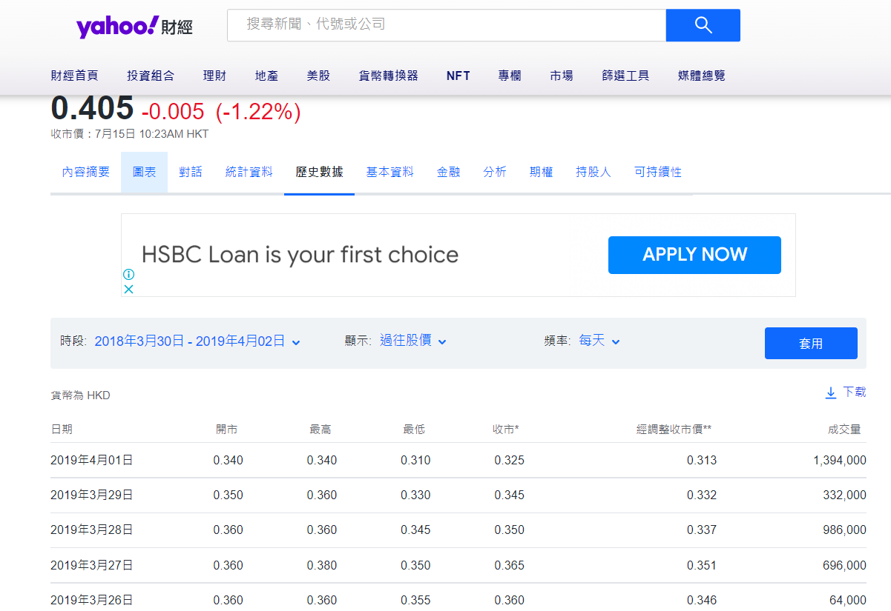

- King Fook’s value on 31 March 2020
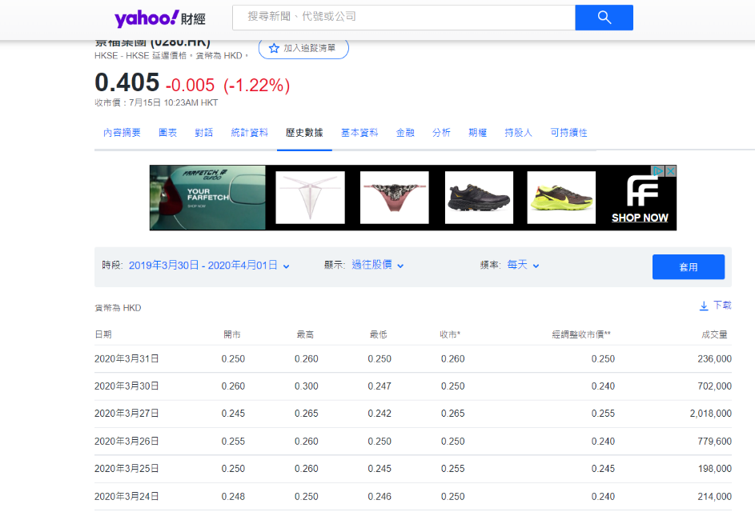

- King Fook’s value on 31 March 2021

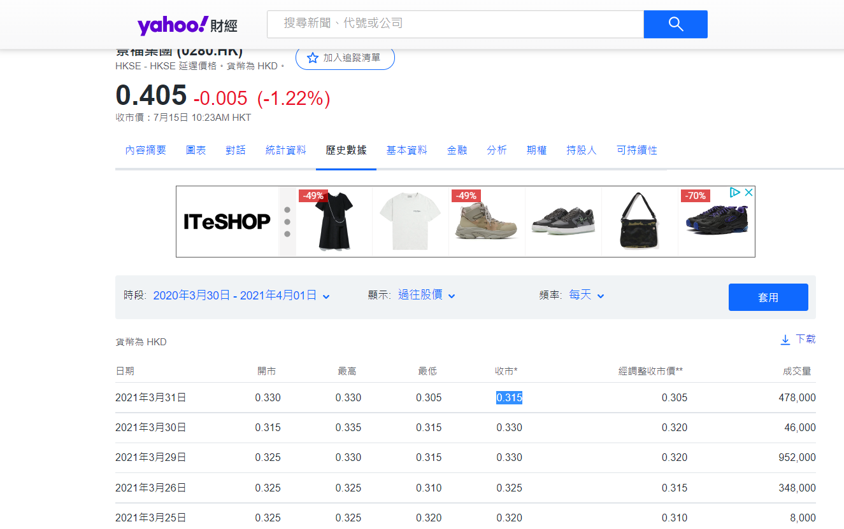

- King Fook’s balance sheet 2019
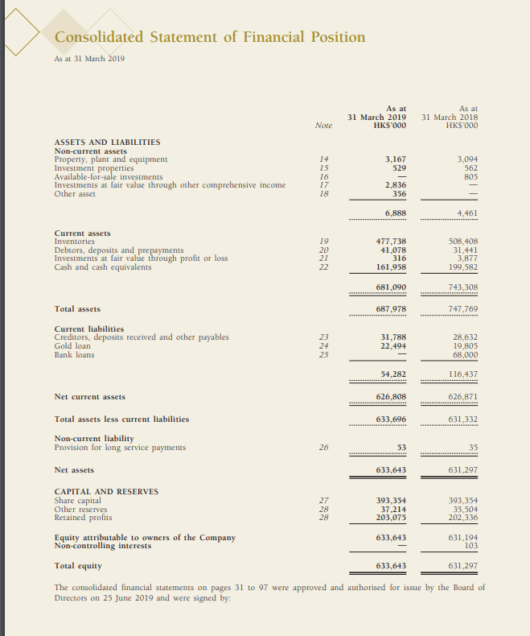

- King Fook’s Income statement 2019
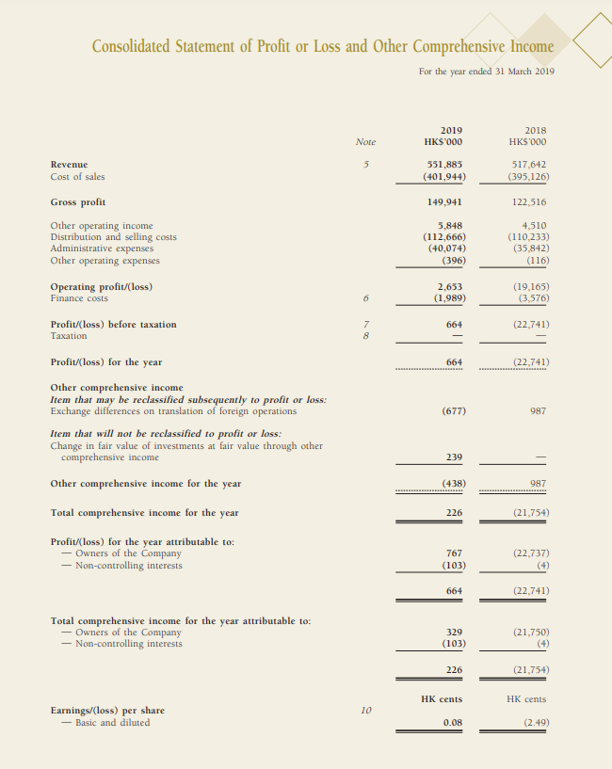

- King Fook’s balance sheet 2020
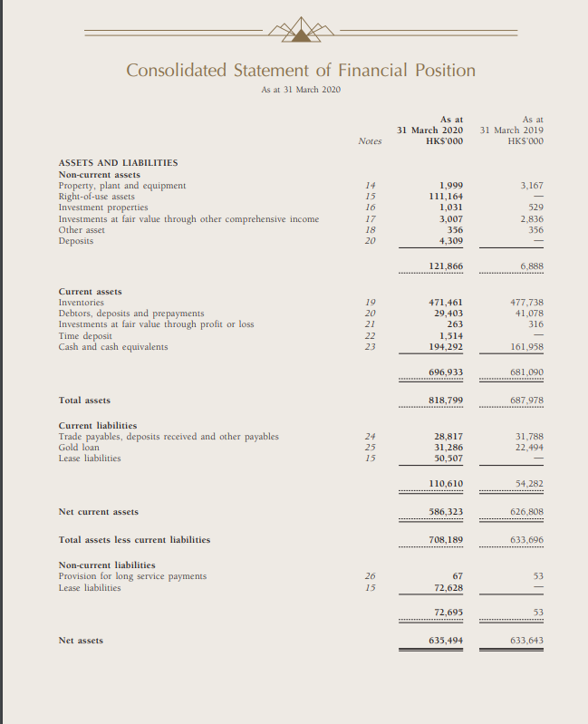

- King Fook’s Income statement 2020
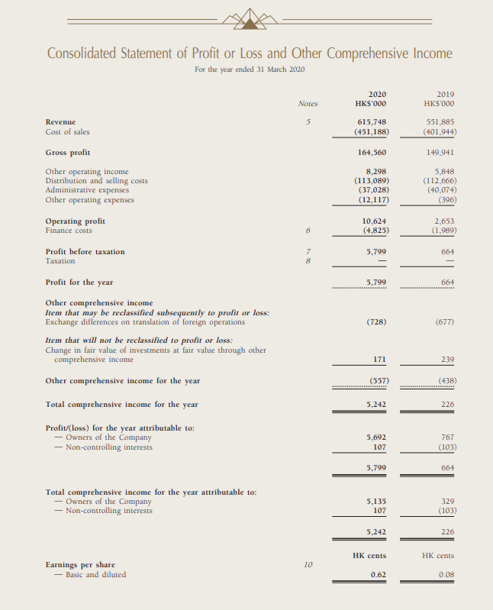

- King Fook’s balance sheet 2021
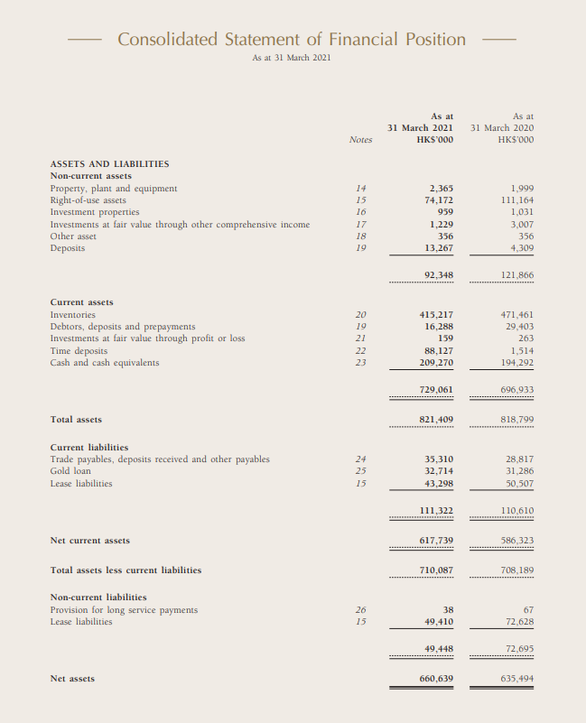

- King Fook’s Income statement 2021


