
Module Name: Academic Skills in the Digital Era
Module Code: BMSW4013
Assessment 1: E-Portfolio
Student Name: Elena Pavelea
Student Number: 2514510
Lecturer: Scott James
Deadline: Friday 21st November 23:59PM

AI Acknowledgement
I acknowledge the use of Library AI assistant to look for key words in the books.
I confirm that I have copies of my drafts, notes, and other resources I used, which I may be asked to provide in evidence.

Contents
Component 1 – Research and Planning 4
Source Exploration 4
Key Challenge for Students 5
Key Opportunity for Students 5
Planning Your Report 6
Timeline for Component 2 6
Component 2 – Answering the Question 7
Introduction 7
Challenges Students Face 7
Opportunities Digital Tools Provide 8
How Students Can Adapt 9
Conclusion 9
Component 3 – Reflective Presentation 10
Slide 1 (Overview) 10
Slide 2 (Research) 11
Slide 3 (Planning & Writing) 12
Slide 4 (Challenges) 13
Slide 5 (Successes) 14
Reference List 15

Component 1 – Research and Planning

Source Exploration
For this research, I have chosen The Study Skills Handbook by Stella Cottrell. This guide offers university students reliable and practical strategies and is widely recognised as a trustworthy educational resource, as mentioned on Bloomsbury Publishing website https://www.bloomsbury.com/uk/study-skills-handbook-9781350421271/ (2025) (Accessed: 19/11/2025). The book presents research-based advice on managing time, developing research and academic writing skills, enhancing critical thinking, and adapting study techniques for digital, hybrid, or distance-learning.
Cottrell (2024) emphasises that students achieve their best results through personalized study routines which match their learning needs. They must learn how to approach technology and online learning purposefully, while maintaining focus, controlling distractions, and using digital tools effectively. In the digital era, students face challenges such as information overload and social isolation. They can overcome these through planned routines, critical thinking and digital literacy. I chose the handbook because it addresses specific difficulties that students encounter in online and blended learning environments and offers strategies to manage independent and self-paced study effectively.
According to Cite Them Right (2022), students should evaluate their sources by considering factors such as currency, relevance, authority, currency, and purpose. These principles are also reflected in the CRAAP test framework for assessing information credibility (Sye and Thompson, 2023). The Study Skills Handbook by Cottrell (2024) meets all these requirements because it provides an updated version for online learning while serving students who study digitally. It also demonstrates expert knowledge to help students achieve academic success.

Key Challenge for Students
Scholars face major obstacles in the modern digital age because they struggle to maintain their attention while dealing with various distractions. They struggle to focus on their studies because they receive notifications through social media platforms and messaging applications.
Cottrell (2019) explains that concentration is a vital study skill, and students must manage their time effectively to prevent procrastination. From my experience, studying online can be challenging because it is easy to switch between academic and non-academic websites.
The book highlights the importance of this problem because students’ academic achievements depend on their ability to concentrate according to McMillan (2021). Without proper focus, students only process information at a surface level, which weakens understanding and critical thinking (Cottrell, 2023).

Key Opportunity for Students
The digital tools provide an essential benefit through their flexible learning approaches. Students can study whenever they can, and from any location, because they have access to materials and support through online platforms. In her book, Cottrell (2019) shows that students learn independently when they can study at their own peace because this method allows them to take control of their learning progress. The digital resources serve mature and distance learners who need to manage their education alongside their professional duties and family responsibilities according to Burroughs (2019).
The tools, according to McMillan (2021) provide all students with equal access to vital educational materials which help them learn better and easier. The experience I gained from using online platforms taught me better time management skills which allow me study effectively while handling my other responsibilities. One of the time management tools that I frequently use is Google Calendar. This app comes in very handy for university assignments and not only. It allows me to set reminders before the assignment is due and track due dates for tasks with deadlines.

Planning Your Report
I will focus equally on both positive and negative elements in Component 2 to create a balanced view. I plan to include examples such as Pomodoro Technique, digital distractions, and online learning resources.
My report will be structured as follows:
→Introduction
→Challenges
→Opportunities
→Adaptation Strategies
→Conclusion.

Timeline for Component 2
Task | Date/ Deadline
Finish research | 7 November 2025
Draft first section | 9 November 2025
Complete first draft | 10 November 2025
Final editing | 20 November 2025

Component 2 – Answering the Question

Introduction
The digital era has reshaped education through innovative methods for students to learn, communicate, and access information. Education in the modern world depends heavily on digital learning environments which include online lectures and virtual libraries and AI tools. However, students encounter various obstacles because technology causes distractions and digital overload and requires them to manage themselves.
Students need to understand both advantages and disadvantages of digital tools to achieve academic success, and according to Cottrell (2019), students who learn to modify their study methods for digital environments develop improved concentration skills and higher academic performance. Digital literacy and critical thinking skills, together with time management are now essential study skills for successful academic learning.
The report will analyse two main challenges faced by students, two opportunities created by digital tools, and three successful strategies for adapting successfully to digital learning requirements.

Challenges Students Face
One of the main challenges in the digital era is distraction, because students are constantly exposed to notifications, social media, and online entertainment, which often interrupt concentration. This is one of my biggest obstacles when trying to study online as I find myself opening notifications without even realising, like a second nature. McMillan (2021) explains that students need to develop focus and organisation skills to study successfully in online learning environments. Students begin their research work, but they often end up getting distracted by other websites or messaging apps which results in decreased productivity and poor quality of their work. The main problem is information overload, as the internet provides endless information, but most of is likely inaccurate.
According to Cite Them Right (2023), evaluating the accuracy and credibility of digital information is an essential part of digital literacy. Students who can’t evaluate their sources properly will most likely use incorrect information in their academic work.
The present difficulties need instant solutions because they prevent students from reaching their highest academic potential and learning achievement.

Opportunities Digital Tools Provide
Digital tools create numerous obstacles for users, but they also bring multiple benefits and advantages. Flexible and accessible learning stands as the primary advantage of this system. Students can learn at their own speed from any place through online platforms. Burroughs (2019) states that this adaptable schedule benefits students who have work duties or family commitments because it creates a more inclusive educational environment.
Learners can use recorded materials with online lectures to watch lessons repeatedly until they fully grasp the concepts. Students gain digital and critical thinking abilities through this method. Cottrell (2023) states that technology use enables students to develop analytical abilities and reflective thinking through their practice of digital content evaluation. These skills are valuable not only in education but also in professional life.
Digital tools create better learning experiences when used with intention because they help students become more independent while building their engagement and self-assurance.

How Students Can Adapt
Students need to create effective strategies for digital technology management because this requirement stands as essential for their success in the digital age. The three main approaches consist of time management, critical AI tool use and digital literacy enhancement.
According to Ogut (2025), The Pomodoro technique is a method to split a study session into smaller chunks with short breaks in between, that enhances productivity and reduces burnout. This study technique combined with digital planners and time management, helps students create structured study schedules which boost their learning efficiency. Cottrell (2021) recommends setting realistic goals and prioritising tasks to reduce stress and improve focus. AI tools like ChatGPT and Grammarly provide educational support when students use them accordingly.
Students must check AI-generated information before using it according to McMillan (2021) who also highlights the importance of academic integrity and cautions students against unnecessary use of digital tools. They develop the ability to find trustworthy sources and assess their credibility through their digital literacy skills development. Cite Them Right (2023) provides a complete set of instructions for proper reference citation and plagiarism prevention. Students can learn online research skills through university workshops and online library training which help them improve their digital information discovery abilities. They learn digital skills through these methods which enables them to handle digital learning environments with confidence.

Conclusion
In the digital era, students encounter multiple challenges but also gain significant learning opportunities. Managing information overload and focus maintenance are key challenges, yet digital tools offer growth and learning opportunities. According to Cottrell (2019) and McMillan (2021), students can achieve success by developing time management, digital literacy, and responsible technology-use skills. Mastering these skills leads to better academic results and personal development. Learners who master digital tools develop self-reliant critical thinking abilities which enable them to solve problems in modern technological environments. The main obstacles involve information distraction and excessive content, but students gain the chance to learn flexibly through digital tools. Students should establish regular study schedules, evaluate digital sources critically and restrict their device usage for academic purposes to strengthen their digital abilities through repetitive practice.

Component 3 – Reflective Presentation

Slide 1 (Overview)
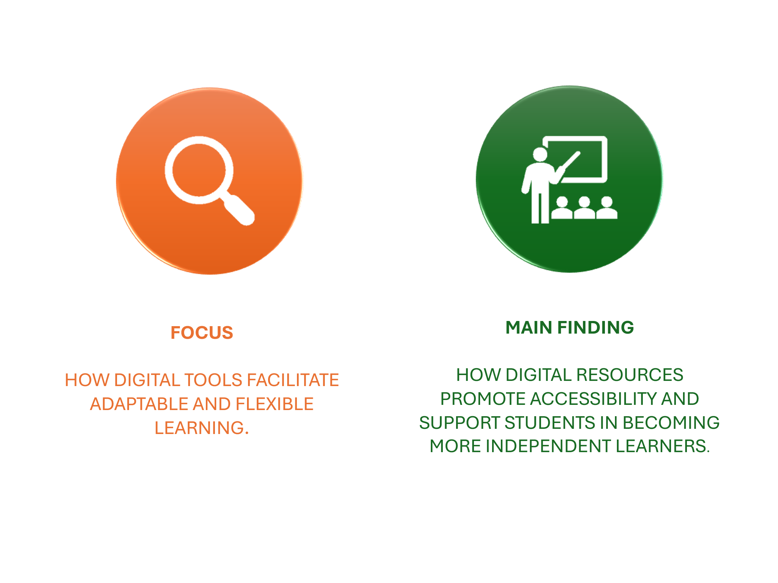

Slide 2 (Research)
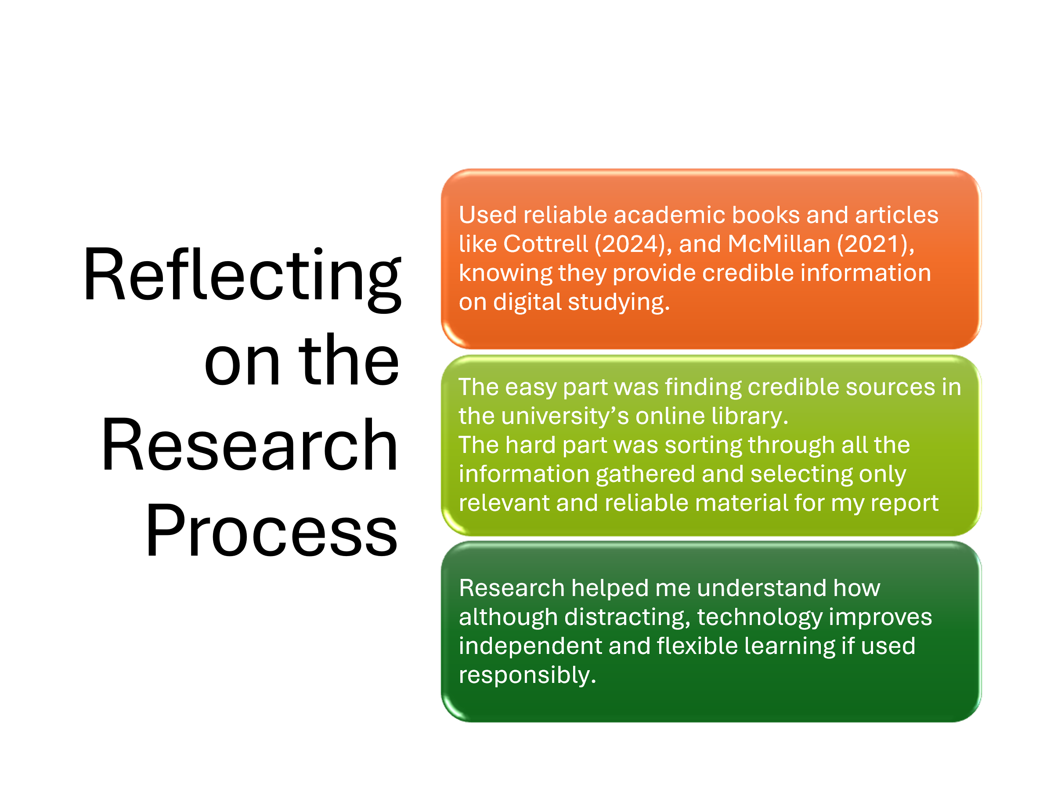

Slide 3 (Planning & Writing)
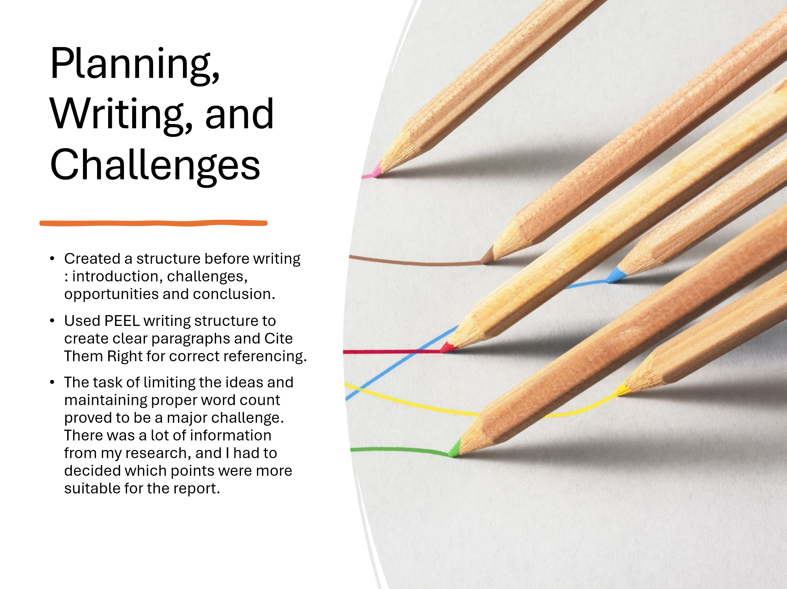

Slide 4 (Challenges)
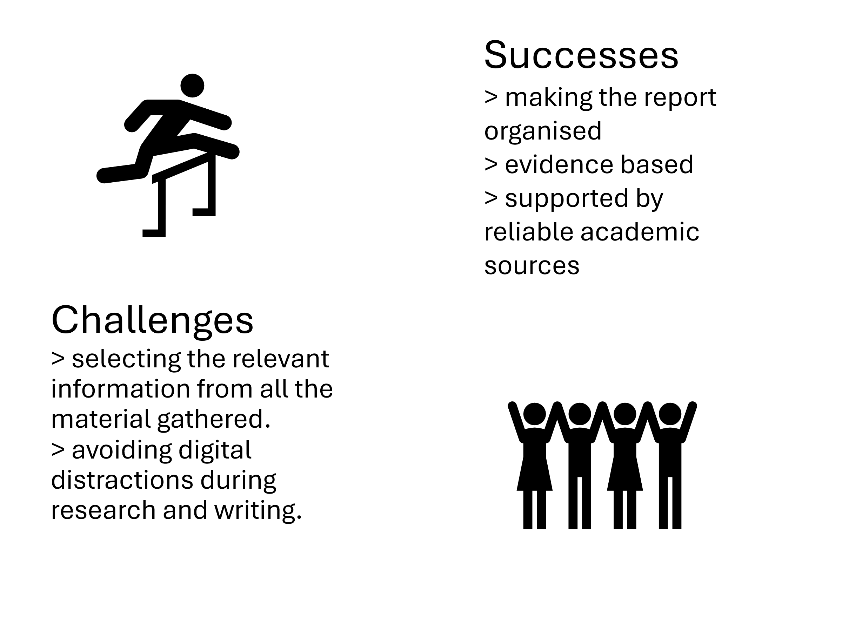

Slide 5 (Successes)
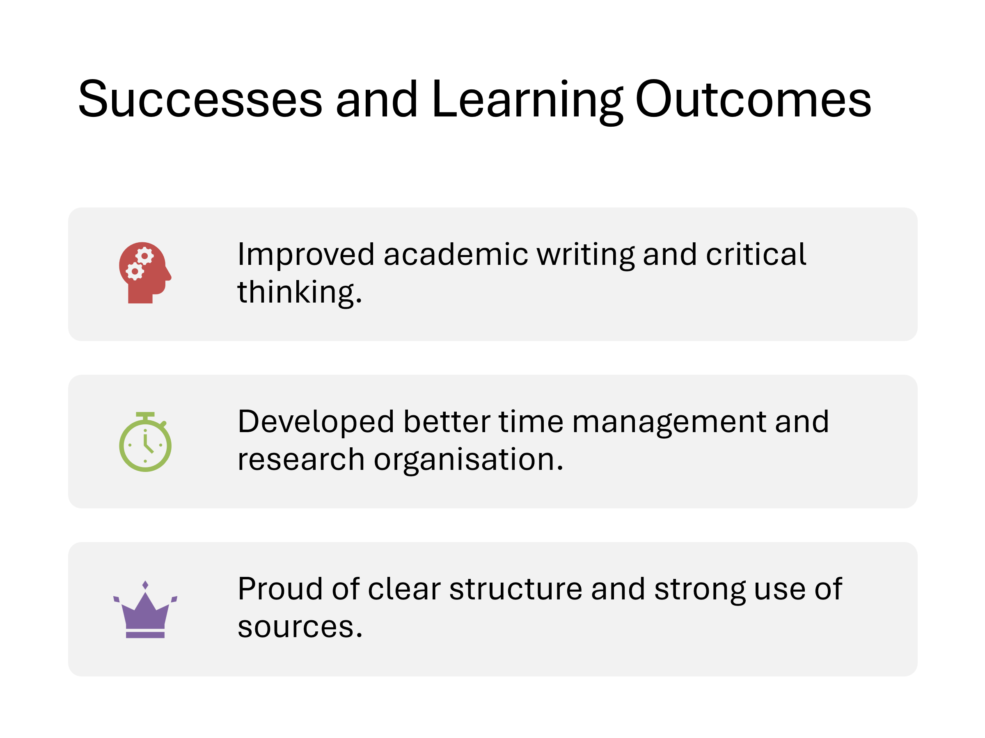

Reference List
Burroughs, C. (2019). The return to study handbook: study skills for mature, distance, and workplace learners. Kogan Page.
Cite Them Right: The Essential Referencing Guide, 12th Edition (2022) ProtoView. Beaverton: Ringgold, Inc.
Cottrell, S. (2019) The study skills handbook. Fifth edition. London: Red Globe Press.
Cottrell, S. (2021) Skills for success: personal development and employability. 4th edition. London: Red Globe Press.
Cottrell, S. (2023) Critical thinking skills: effective analysis, argument and reflection. Fourth edition. London: Bloomsbury.
Cottrell, S. (2024) The study skills handbook. Sixth edition. London, United Kingdom: Bloomsbury Academic, Bloomsbury Publishing Plc.
David Sye and Dana Thompson (2023) Tools, Tests, and Checklists: The Evolution and Future of Source Evaluation Frameworks, Journal of new librarianship., 8(1). Available at: https://doi.org/10.33011/newlibs/13/9.
https://www.bloomsbury.com/uk/study-skills-handbook-9781350421271/ (2025) (Accessed: 19/11/2025).
McMillan, K. (2021) The study skills book: your essential guide to university success. Fourth edition. Harlow, England: Pearson Education Limited.
Ogut, E. (2025) Assessing the efficacy of the Pomodoro technique in enhancing anatomy lesson retention during study sessions: a scoping review, BMC Medical Education, vol. 25, pp. 1-12
Zou Y, Kuek F, Feng W and Cheng X (2025) Digital learning in the 21st century: trends, challenges, and innovations in technology integration. Front. Educ. 10:1562391. doi: 10.3389/feduc.2025.1562391

