
Geographical Information Systems (ACCA5027)

Geodemographic Analysis using GIS Software

Carys Rees 2003859

Contents
Introduction 3
Gathering the Necessary Information for Deprivation in Neath Port Talbot 4
Deprivation Areas within Neath Port Talbot 5
Creating a Table including the Vaccination Centres in Neath Port Talbot 5
Adding the vaccination Centre Points 6
Results 6
Adding the Area Names for a Cleaner Look 7
Results 8
The Total Classification of Households in Neath Port Talbot 9
The Total of Households Deprived in 4 Dimension 9
Obtaining the Cars and Vans Data from the UK Data Service 10
The Total Cars and Vans condensed into a Table to Open into MapInfo 11
Opening and Geo Coding the Total Vans and Cars per Household 12
Range Values of the Total Number of Cars and Vans per Household 12
Map of No Cars and Vans per Household 13
Total Deprivation and Cars Result 13
Number of People who have had their Covid-19 Vaccinations 14
Conclusion 14
Thematic Maps 17
Spatial Queries 18
Importance of Geo Coding 19
Hypothesis on the Deprivation within Neath Port Talbot 19
Conclusion 22
Reference List 23

Introduction
In this assignment, the use of a Geographical Information Systems (GIS) software is to develop how the system could be built to inform healthcare professionals on the uptake of vaccination programmes. The first part of the assignment will show the development of the workspace being created, with the results and a description of each screenshot. And in the second part of the assignment, there will be a report detailing the fundamentals of the GIS software and the resources used to create the workspace.

Part One

Gathering the Necessary Information for Deprivation in Neath Port Talbot
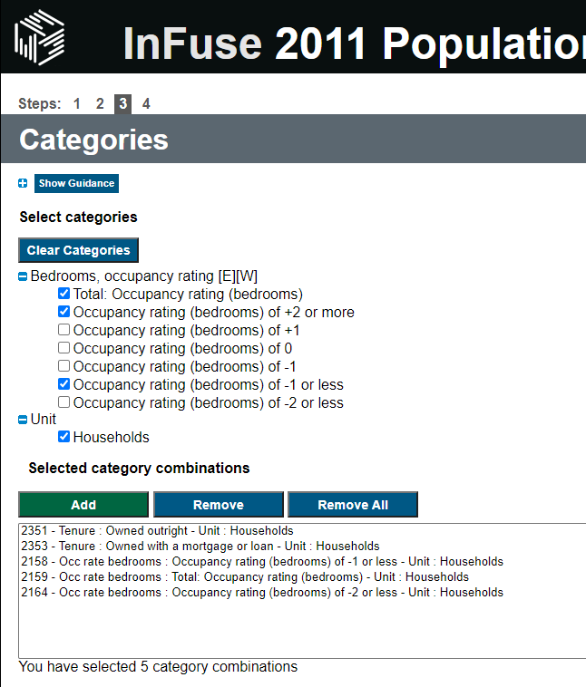
To gather the information on the deprivation statistics in Neath Port Talbot, an online service called the Uk Data Service was used, which allows us to add different categories and download the data into an excel file. Here, the screenshot above shows the occupancy rating, which is the number of bedrooms, and the number of occupancies which is -2 or less.

Deprivation Areas within Neath Port Talbot
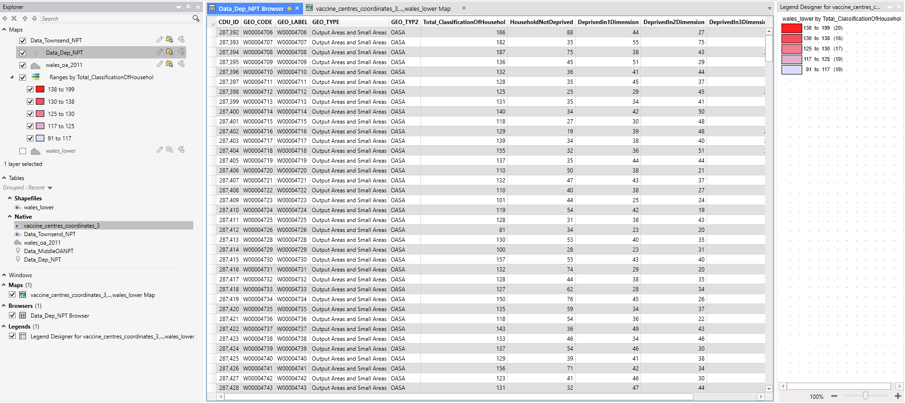
This is then the information broken down into a table, with each column containing the name, the geo code, and the household information broken down into sections, these are households that are not deprived, households that are deprived in one dimension, households that are deprived in two dimensions, etc.

Creating a Table including the Vaccination Centres in Neath Port Talbot
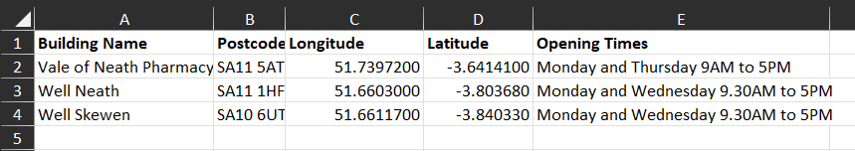
Above, there is a screenshot that shows the names, locations and opening times of the vaccination centres located in Neath Port Talbot. This is an important step in creating this map as it allows us to analyse the locations of these centres, and whether people are able to get to the place in order to get their vaccinations. The longitude and latitude coordinates are important to include as it is the format in which MapInfo is able to identify the location. It is important to geocode this table when it is imported into MapInfo so that it can create a map of the locations.

Adding the vaccination Centre Points
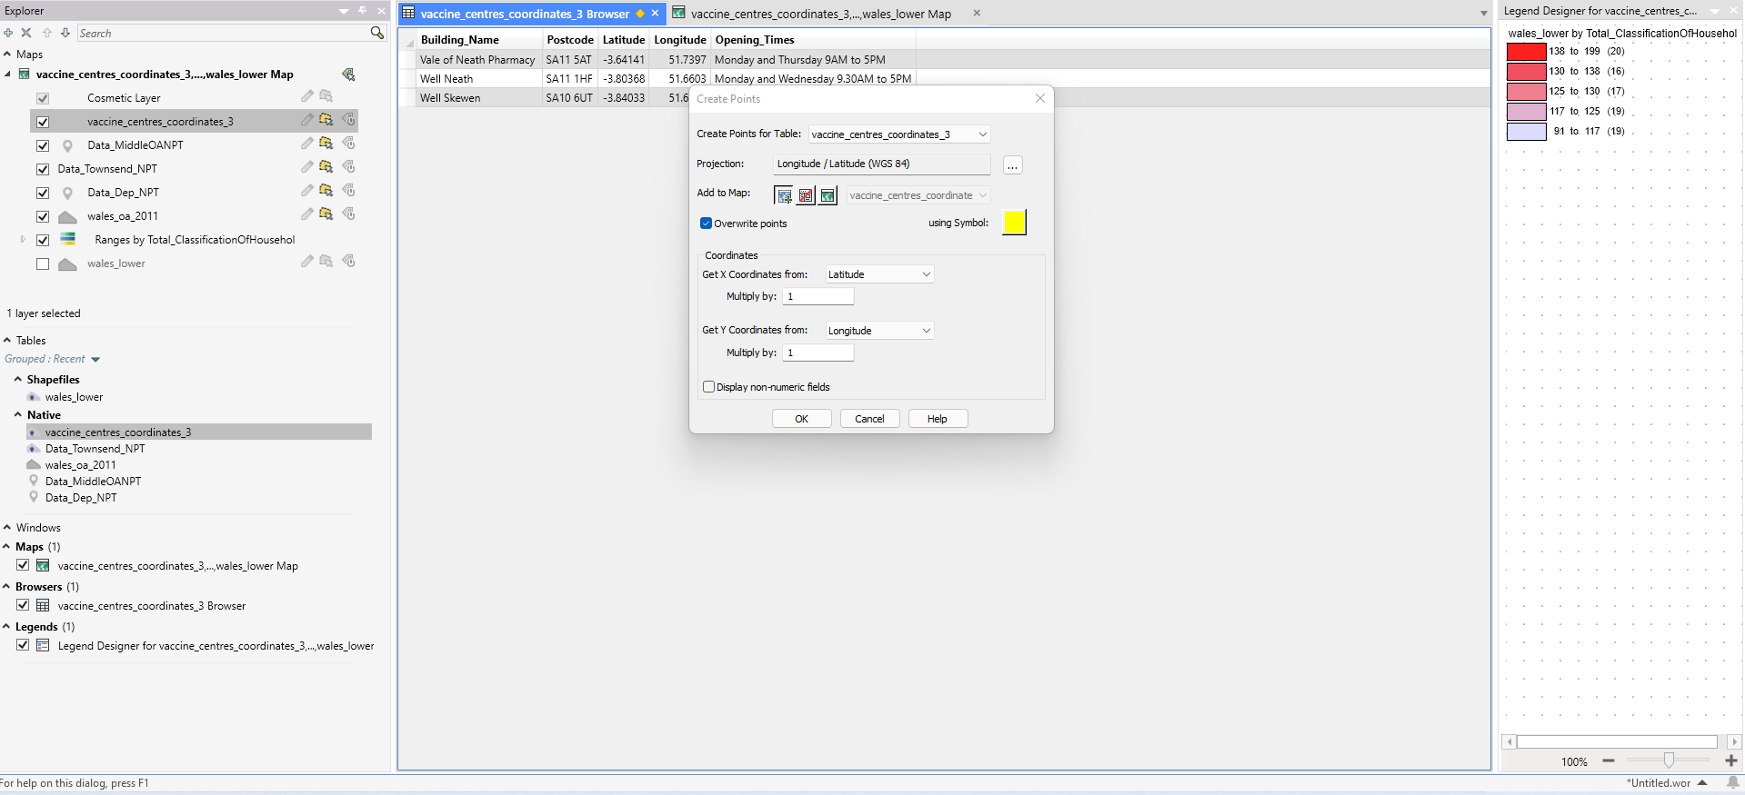
Now that the data has been imported and geocoded, it is important to add the centre points so that it gets added to the Neath Port Talbot map. The symbol has been changed to a circle and is bright yellow so that they are easily identifiable with the deprivation ranges on show.

Results
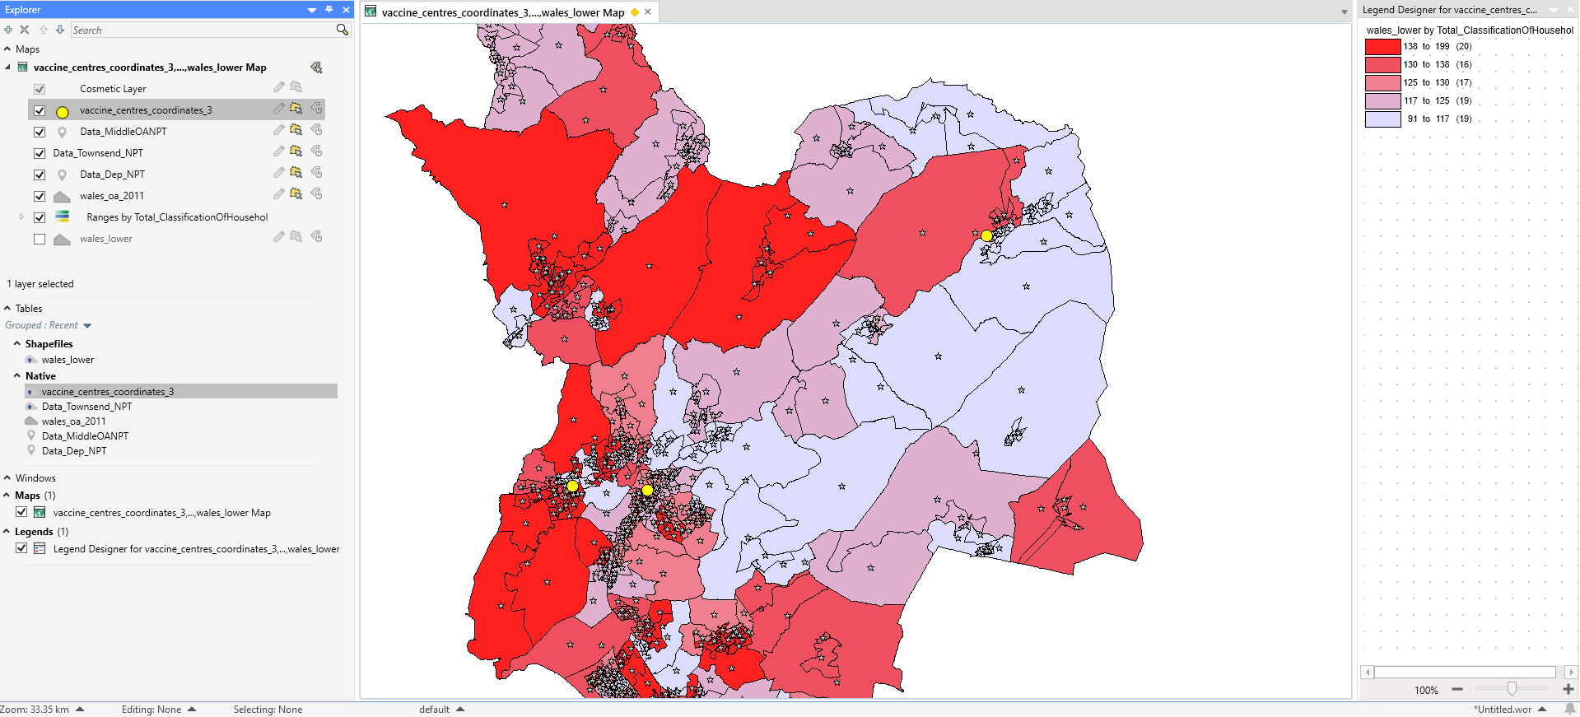
This is the result of the vaccination centres being added. It is clear to see that there is not much choice for centres, as two are relatively close to each other with the other being far away. It is important to establish distance between the centres so that they are easily accessible by more people. The two that are close together are less thought out and therefore does not make it accessible to the regions further away.

Adding the Area Names for a Cleaner Look
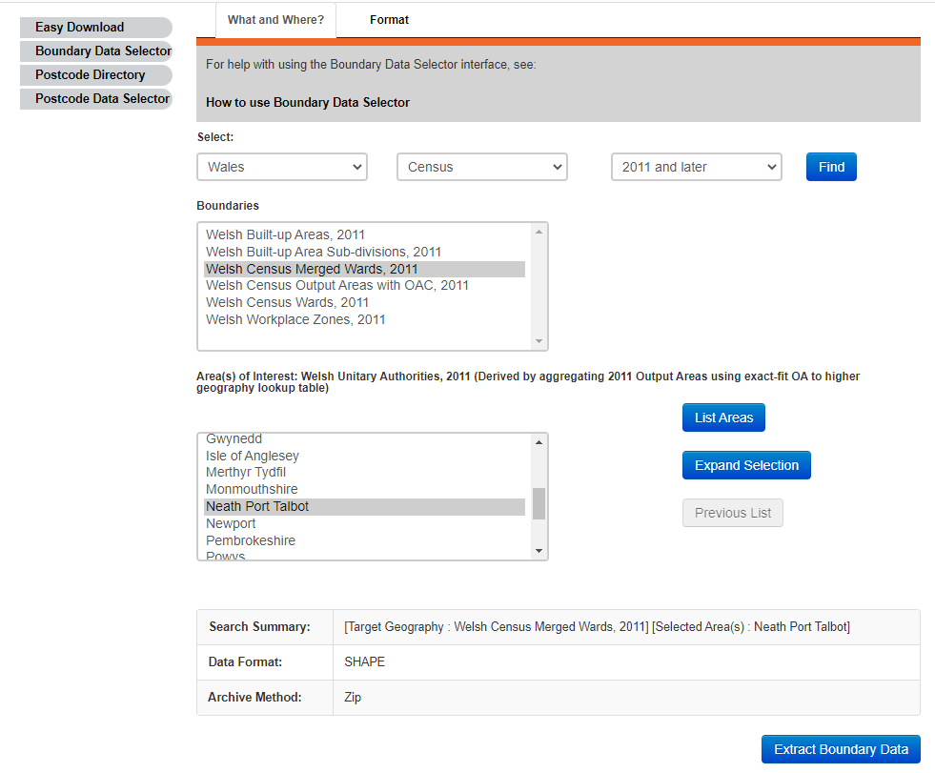
Here the UK Data Service is being used to identify the names of the villages within Neath Port Talbot. This allows the user to clearly read and understand the map.

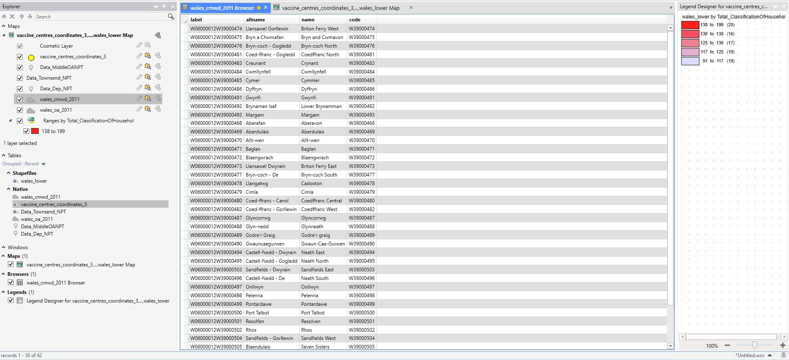
This is the table being imported into MapInfo. It is important to save the excel file as a 97-2003 version as that is the only version MapInfo supports.

Results
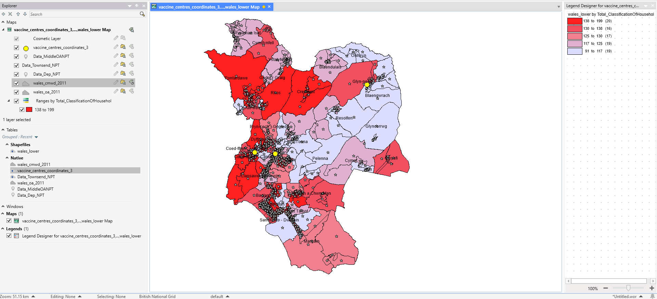
This is a lot more visually appealing to the user’s eye, which not only makes it easier to look at but is also easier to read and understand. Without these names, it is hard to identify the place names within Neath Port Talbot.

The Total Classification of Households in Neath Port Talbot
The total classification of households is easier to visualise and comprehend when they are colour coordinated. This is broken down into each place within Neath Port Talbot, which allows us to see which areas are more deprived than others.

The Total of Households Deprived in 4 Dimension
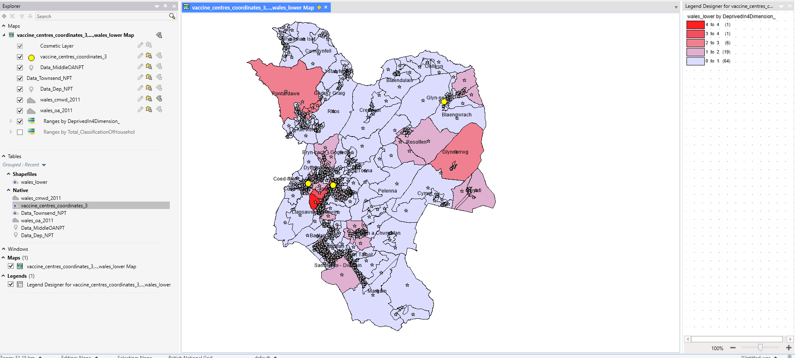
Identifying the total household deprived in 4 dimensions is the governments way of identifying deprived households. The four dimensions are employment, education, health and disability and housing [1]. Employment is determined whether any member of the household is unemployed, excluding full-time students, or on long-term sick. Education in the household is any member who does not acquire a level 2 or higher education, again excluding full time students. Health and disability are established when any member of the household has general health that is ‘very bad’ or long-term health problems. And lastly housing is calculated whether the housing is overcrowded, an occupancy rating of -1 or less, in a shared dwelling or has no central heating.

Obtaining the Cars and Vans Data from the UK Data Service
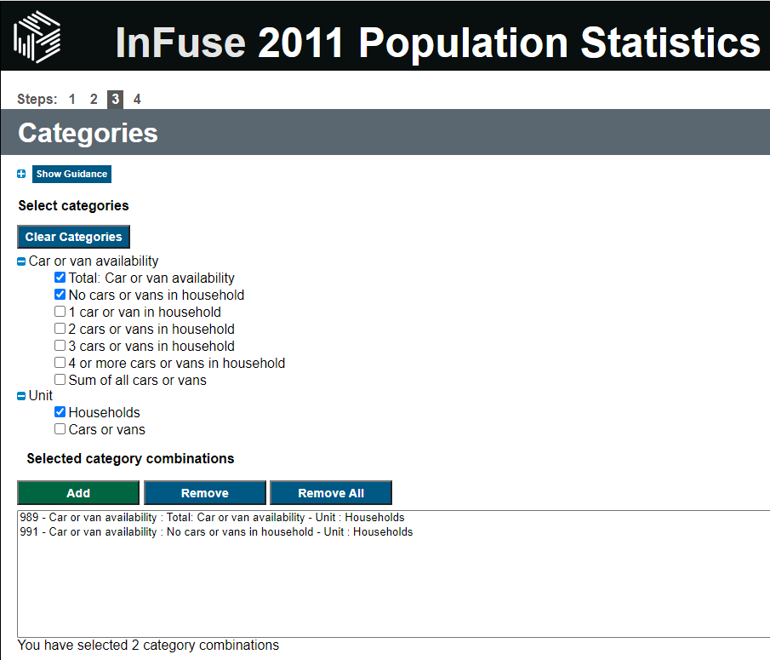
To establish whether people are able to get their own transport to the vaccination centres, it is important to identify whether they have any cars or vans in their households. To do this, we get this information from the UK Data Service, import the table into MapInfo and to Geocode the data so that it is ready for use in the map. The UK Data Service allows us to access information on the total number of cars or vans in each household or whether they have no access to their own transportation.

The Total Cars and Vans condensed into a Table to Open into MapInfo
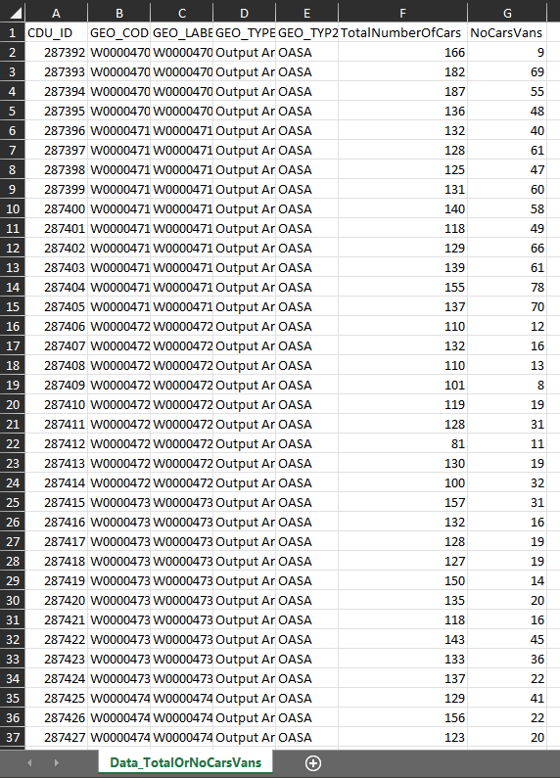
When we first obtain the downloaded file, the labels need to be condensed and change into titles that are more readable and easier to understand. It is also important to save the excel file as a 97-2003 worksheet.

Opening and Geo Coding the Total Vans and Cars per Household
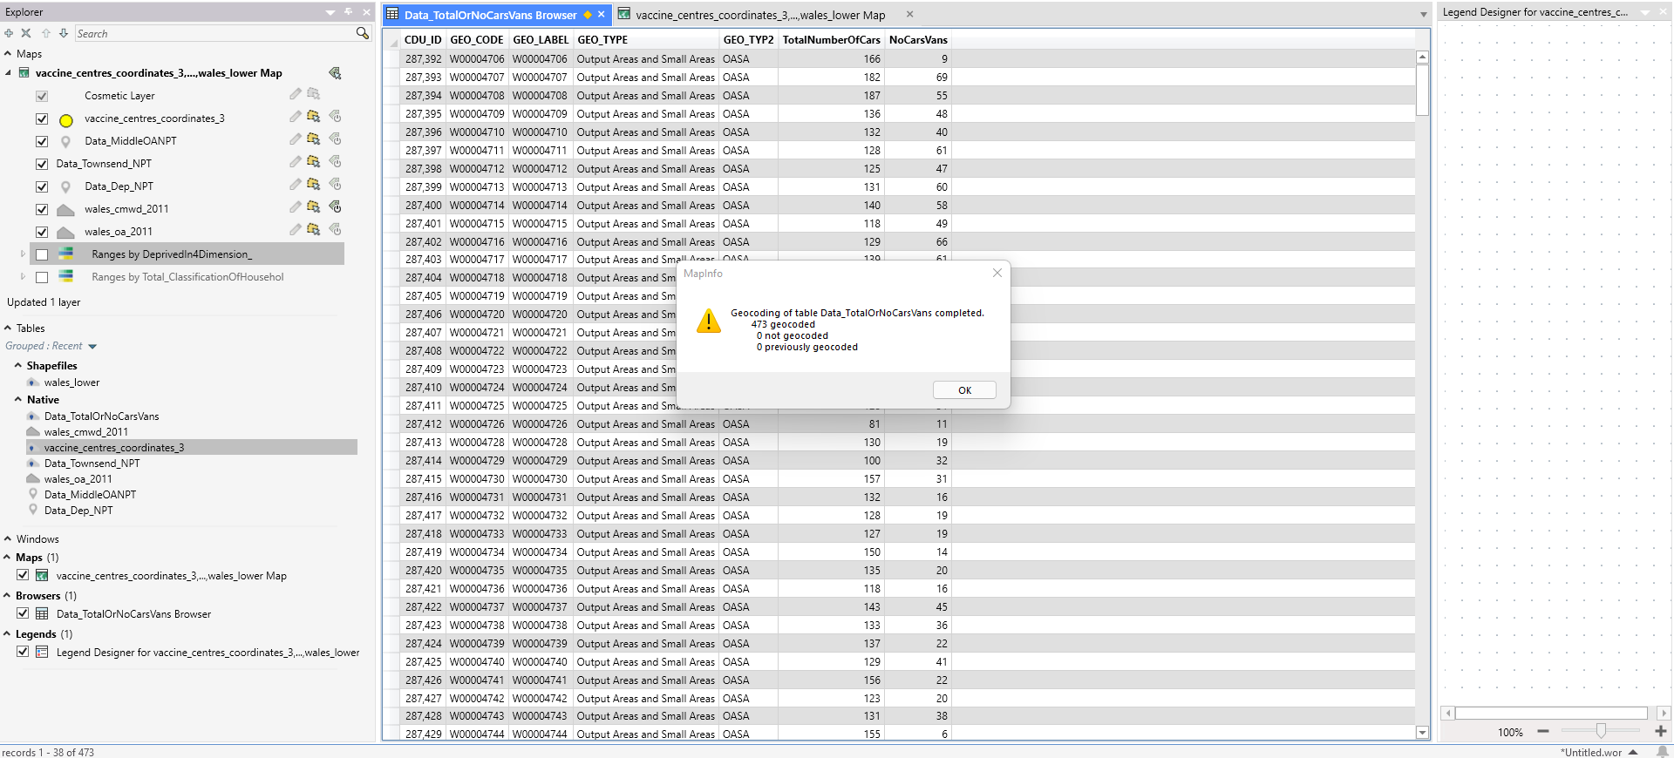
Importing the table into MapInfo is an easy process, in which you click the open table button and file the correct file. Then it is important to geo code the data. Once these steps are established, the data can be brought into the map and used to analyse the total amount of cars or vans per household.

Range Values of the Total Number of Cars and Vans per Household
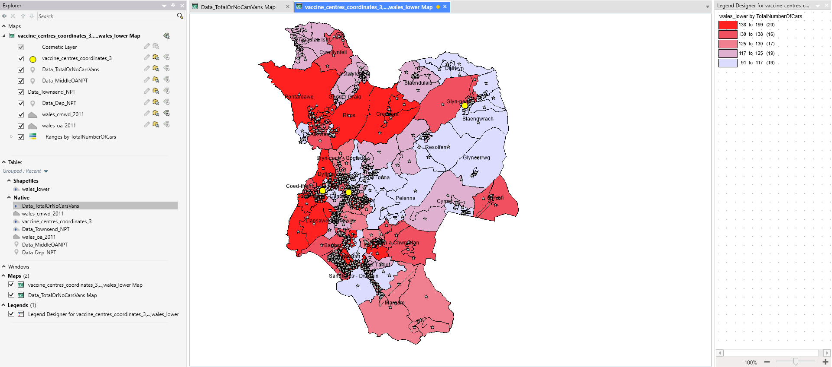
As mentioned above, ranges are created to identify the total number of cars of vans per household and that is condensed into each area within Neath Port Talbot. It is clear to see above that the darker areas have the greatest number of vehicles in their households and the lighter ones have no vehicles, which shows that there is a lot of deprivation within Neath Port Talbot.

Map of No Cars and Vans per Household
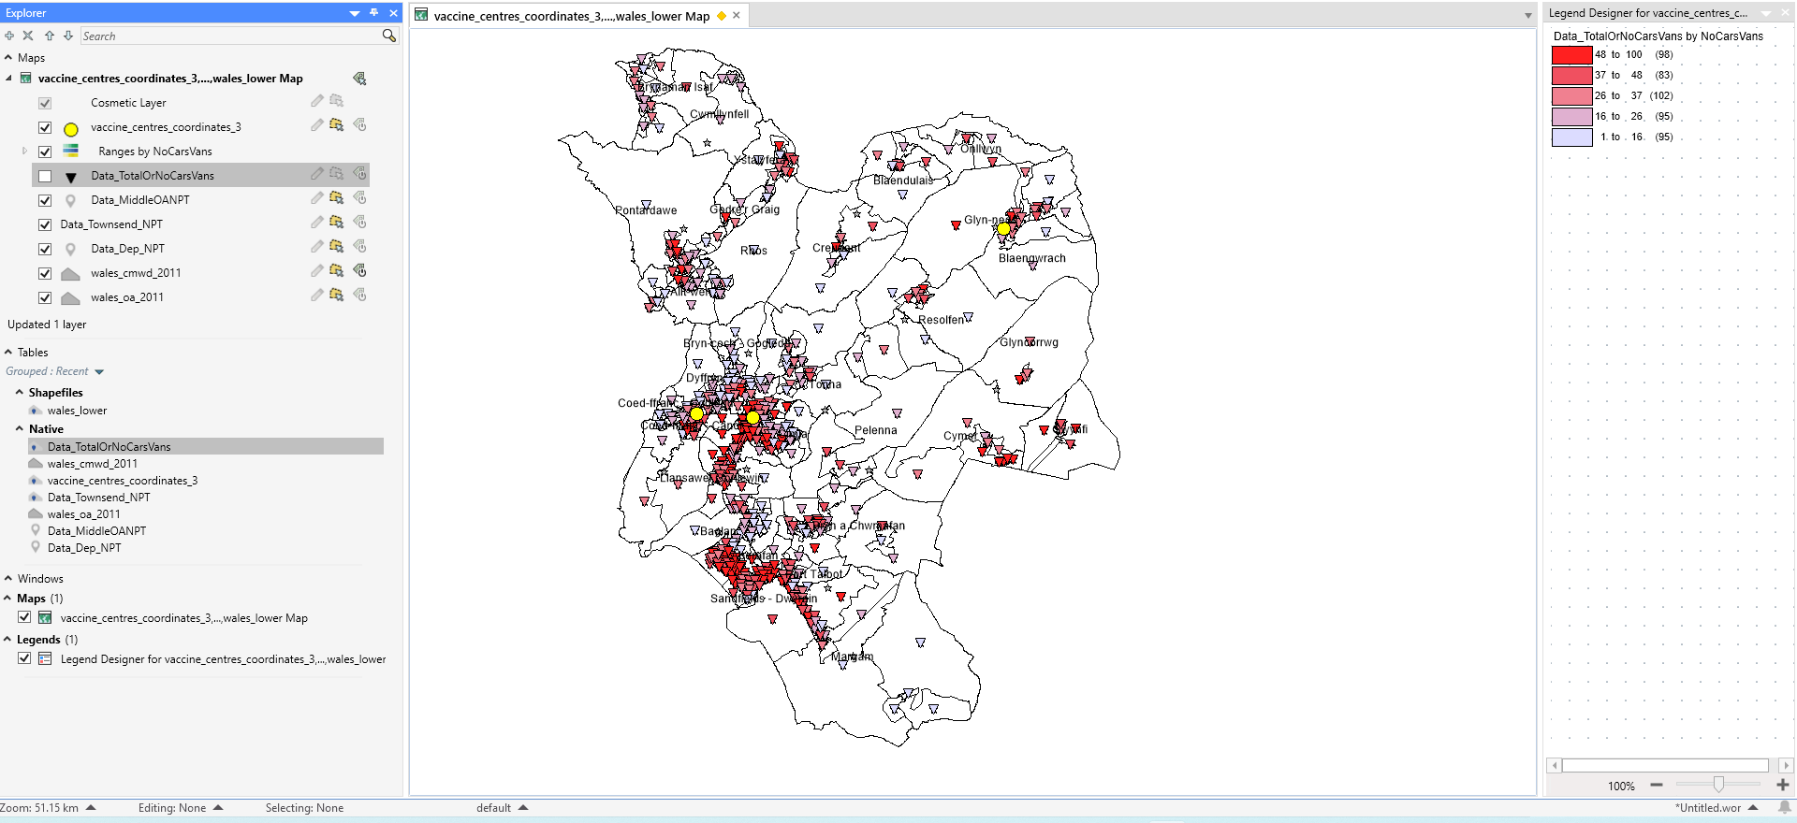
Contrasting the information above, an alternative form of showing the number of areas that have no access to vehicles in households is with symbols rather than highlighting the whole area. Not only is this more accurate, but it is easy to identify the areas in which they have no cars or vans in their households.

Total Deprivation and Cars Result
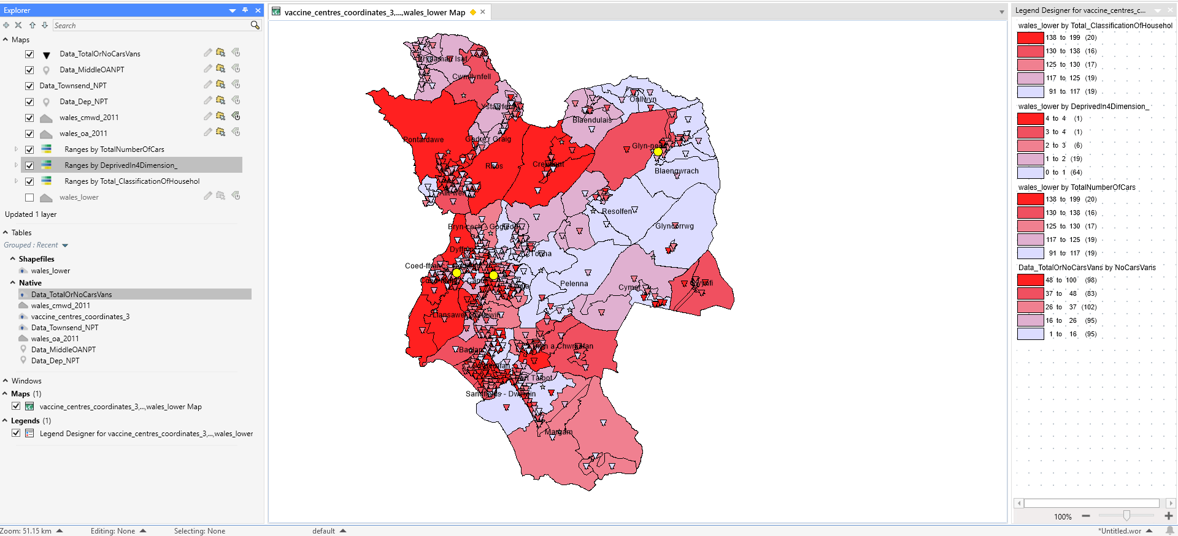
The above screenshot shows both data results. With the areas highlighted is the total number of cars or vans in each household in Neath Port Talbot, and the symbols displaying the number of households who do not have access to their own transportation.

Number of People who have had their Covid-19 Vaccinations
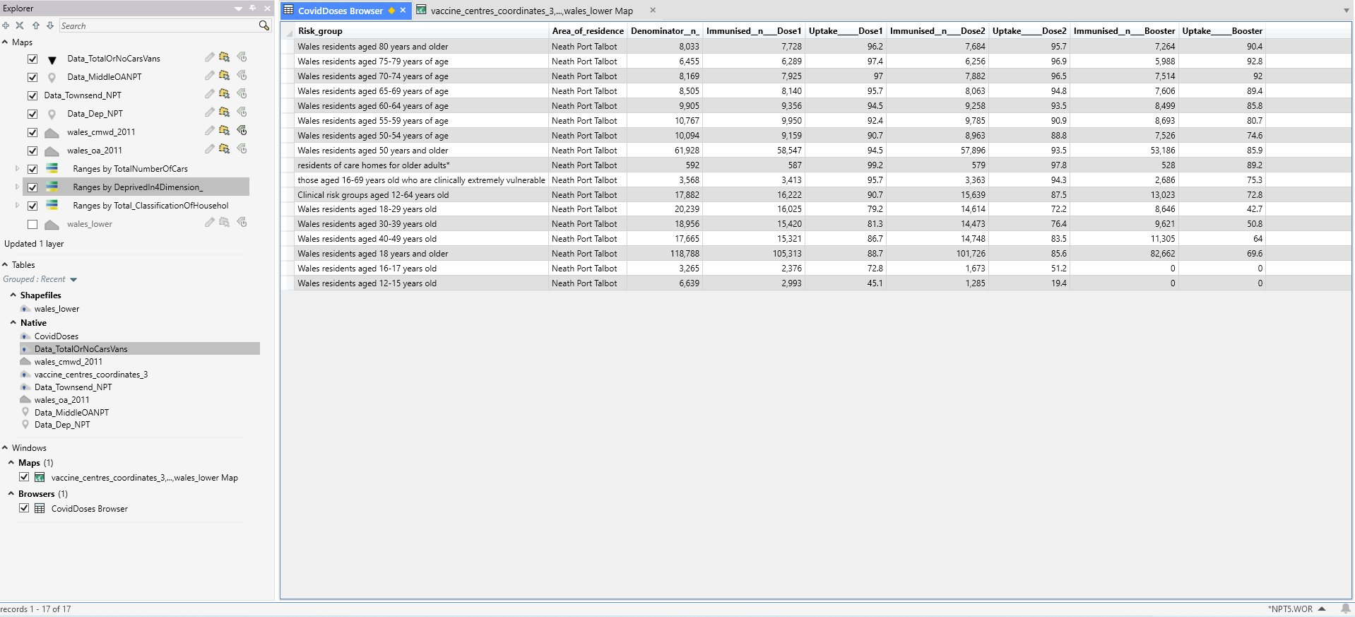
Here is a table imported into MapInfo, which shows the different age groups who have been vaccinated with their first, second, third and booster doses of their covid-19 vaccinations. It is clear to see that the older generation are a lot more cautious and are vaccinated to prevent the severe symptoms of catching covid-19. In this study, there will be research to establish that people in deprived areas are less likely to be vaccinated. Whether this is related to their lack of transport, the vaccination centres being far away and their lack of funds to get public transportation to the vaccination centres.

Conclusion
To conclude, it is clear to see the different maps, tables and queries that were used to create a map of the covid data. It is important to remember that when data is downloaded from the UK Data Service, the file type is the latest version of excel. Then, to make modifications to make the labels readable and understandable so that they are not hard to identify. Then when saving it is important to save the table as an excel 97-2003 workbook as it is the only version that MapInfo will accept and identify. Every map starts off as a table and what makes it a map is to geo code it. When this is done it takes the postcodes, names, and coordinates to shape the area and that is when the whole map comes together. Below there will be an image which shows the final workspace and the different tables included.
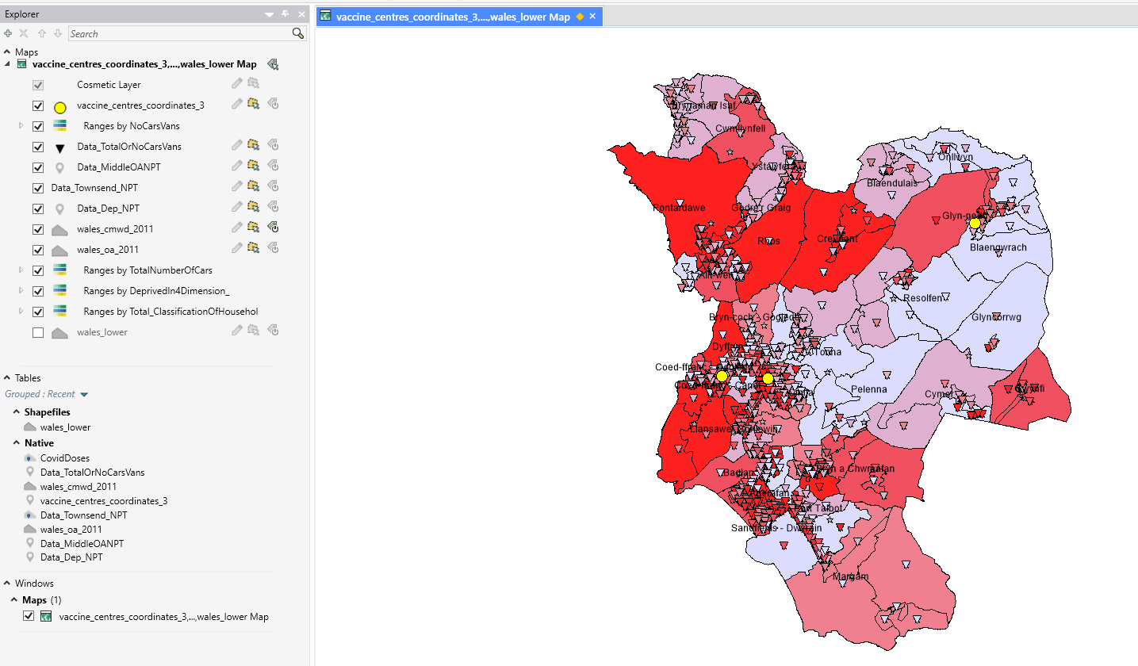

Part Two

Thematic Maps
The Geographical Information Systems is created using a software called MapInfo Pro. This is a useful tool as it allows the user to create, manage and visualise geospatial data. It allows the user to connect data with geography. There are many benefits to MapInfo, such as allowing the user to important and manage tables within the workspace, its ease of navigation between maps and tables, and allows the user to have multiple maps open at once to allow us to compare the different data sets. [2].
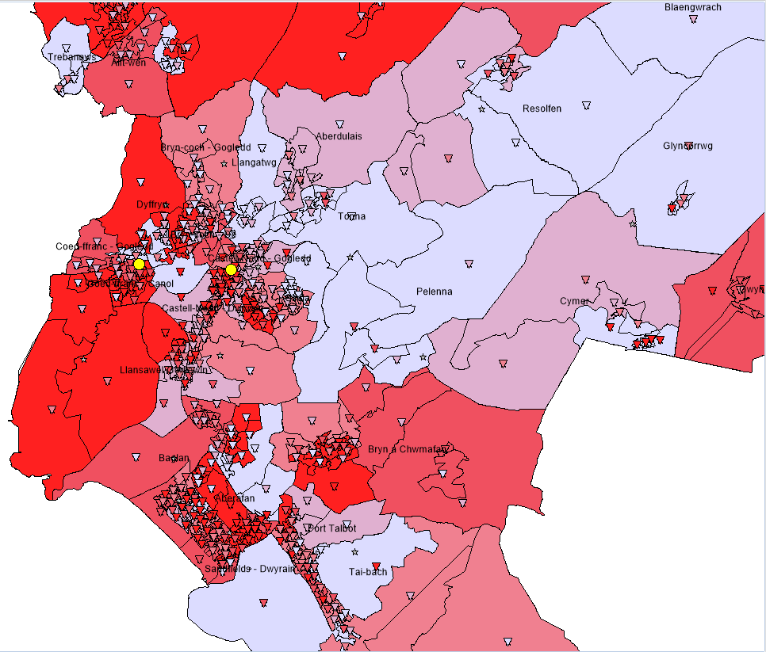
The use of thematic maps is a good way of showing the statistics in a more pleasing, easy on the eye way. It uses colours and symbols to display the data so that it is clear to see what is going on and makes the map a lot less cluttered. On the left-hand side shows how themes are used on the areas of the map to show the deprivation levels within Neath Port Talbot. The darker areas show the deprived areas then the lighter areas display the least deprived areas. Having the names of the places and having them highlighted in colours allows us to see exactly which area is deprived and which area is not. Coed Ffrand and Dyffryn are areas that are massively deprived whereas Tonna and Pelenna are the least deprived areas. It is rather convenient that the vaccination centres are in a more built-up area, as it means that their safety is better established.
The small triangle symbols show the cars and vans total, with the darker ones showing where there are no cars and vans and the lighter ones showing the ones with cars or vans. They are very much cluttered and harder to see, however it is based off per household. The areas in which that do not have any symbols on are the ones where there is no data to establish whether there are any cars or vans.
It is also important to remember that on the UK Data Service, the data we are basing it off is the 2011 survey, which is 11 years ago. Therefore, this information is not completely accurate as a lot of things can change in this amount of time. Although a survey would have been conducted in 2021, we do not have access to this information yet as it is currently being used by the government for research purposes. Additionally, with the pandemic being in full force since 2020, there has been a delay with every task, work, and research, which shows us the real impact that covid 19 has had on the world.

Spatial Queries
The method of getting a data subset from a map layer by working directly with the map features is known as a spatial query. Data is kept in attribute tables and feature/spatial tables in a spatial database. [6].
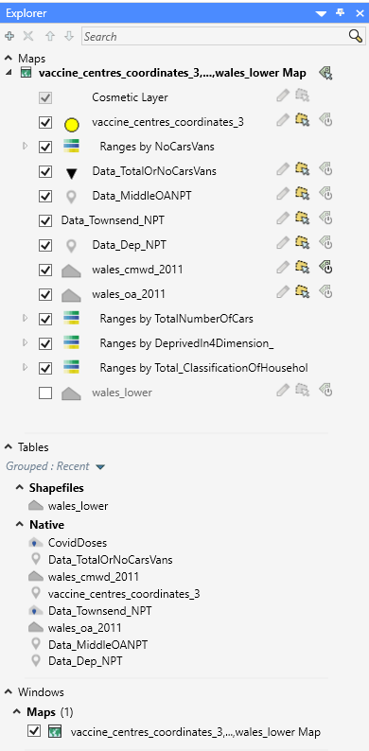
For example, the tables, maps, and queries are all sorted into the left-hand side of the workspace. This is sorted into the maps, tables, and windows. The interesting feature of MapInfo is that when a table is important and its use is to be added to the map, you can drag it up. On the first pass, it goes up into a map on its own. Then when it gets dragged up yet again, then it gets added to the pre-existing map so that it is clear to see the data visually.
Another example of spatial queries is when the Neath Port Talbot map being altered to add the names of the regions within Neath Port Talbot. The data was gathered from the UK Data Service, which allowed us to find the names of the areas within Neath Port Talbot. The boundary data file was downloaded and opened into an excel file. This then got saved as a 97-2003 workbook, which is the only version that is available to open in MapInfo. Then it is important to geocode this table so that it aligns with the map already open, drag up the table twice and the table will then be in the maps native. Then it is important to change the label colour so that the writing is visible, then this is the easiest and best way to show the areas within Neath Port Talbot using spatial queries.

Importance of Geo Coding
Geo coding is used on every table imported into the MapInfo workspace. It is the process of determining geographic coordinates for place names, street addresses and postcodes. [8]. An example of this is that the vaccination centres are listed below. It includes the name of the building, its postcode, the longitude and latitude of the buildings and its opening times. It is important to include the longitude and latitude as is it the most accurate way for MapInfo to identify its location. This table is then saved as an excel 97-2003 workbook, which then gets imported into workspace, and then geo coded into the Neath Port Talbot map. It is also then important to change the symbol shape and size so that it is clear for the user to read and understand. It is rather easy to get the longitude and latitude of the areas when there is a postcode available. There is an online application called free map tools which you simply copy in multiple postcodes at once, click convert and it immediately shows the coordinates. [9]. This is a useful and easy way of identifying the coordinates for the buildings. Another way of doing this is to find the building on google maps and then in the information or in the search bar it will show the longitude and latitude coordinates which allows MapInfo to easily identify the area. 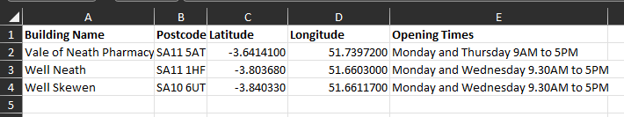

Hypothesis on the Deprivation within Neath Port Talbot
The map created in the MapInfo highlights the deprivation levels within Neath Port Talbot, whether people have good or bad health and the number of cars that are available per household to travel to the vaccination centres highlighted in the bright yellow circles. The base colour of the map has the region ranges which had the sequential red-light purple RGB colours. This allows us to see that the darker coloured areas are the most deprived regions, which then increases in lightness, showing that they are the least deprived areas within Neath Port talbot. This is calculated by seeing if the household is not deprived or whether it is deprived in four dimensions. The four dimensions are based off employment, education, health and disability and housing [1]. Employment is determined whether any member of the household is unemployed, excluding full-time students, or on long-term sick. Education in the household is any member who does not acquire a level 2 or higher education, again excluding full time students. Health and disability are established when any member of the household has general health that is ‘very bad’ or long-term health problems. And lastly housing is calculated whether the housing is overcrowded, an occupancy rating of -1 or less, in a shared dwelling or has no central heating.

The second sequential red-light purple RGB colours, is defined as little triangle symbols that shows the number of vehicles that are available within each household, whether that be no cars or vans or the total number of cars or vans. This is important to highlight as it allows us to examine whether people can use their own transportation to get to the vaccination centres.
The result of this allows us to make assumptions that the people in the most deprived areas tend to have no access to cars or vans which makes it difficult to access the vaccination centres. The only form of transportation they would rely on would be to either walk, which can be difficult for some if they are disabled or of old age and cannot walk far, or rely on public transport, which can also be difficult if they have no funds to pay for it. This is especially true if they live a fair distance away from the centres, as the longer the journey the more it is going to cost them for public transport. We can also assume that people in less deprived areas have their own means of transportation, allowing them to go to the vaccination centres when they get an appointment, or is a walk-in centre.
From the covid-19 vaccination table, it is clear to see that the older and more vulnerable people within Neath Port Talbot have received their three doses and the booster jab, which will protect them from the severe symptoms that people get when they catch the virus. It is known that if older adults catch the virus, they are more likely to get very sick with it, this could lead to hospitalisation, intensive care, a ventilator to help them breathe and potentially death. [3]. It is also the same unfortunate result if any person, of any age, has an underlying medical condition.
It is difficult to get hard facts of the data when they are so varied, therefore we can hypothesise what the map shows us. For example, we cannot for certain say that every household within deprived areas have no car or van, as this is not correct. However, we can hypothesise our ideas with the data we were given. Also, we cannot say that people in deprived areas are not vaccinated as we have no hard facts of the matter. Whether the people have family members or friends who can drive, they could get a lift with them to vaccination centres. There is not enough covid data available to get hard facts on this as it has only been around and researched for two years. In years to come the research will be so extensive and in depth that the facts we are hypothesising can be turned into hard facts.
Not only this, but people in deprived areas should also not be assumed as unvaccinated as they could be as conscious as to the importance of the vaccination, same as people who are in less deprived areas. Just because they live in deprived areas does not mean they will not get vaccinated, as the people in the most least deprived areas could also be unvaccinated, it is unfair to assume. However, it is clear to see that the means of transport to get to the vaccination centres are limited and therefore reduce their ability to get to these areas.
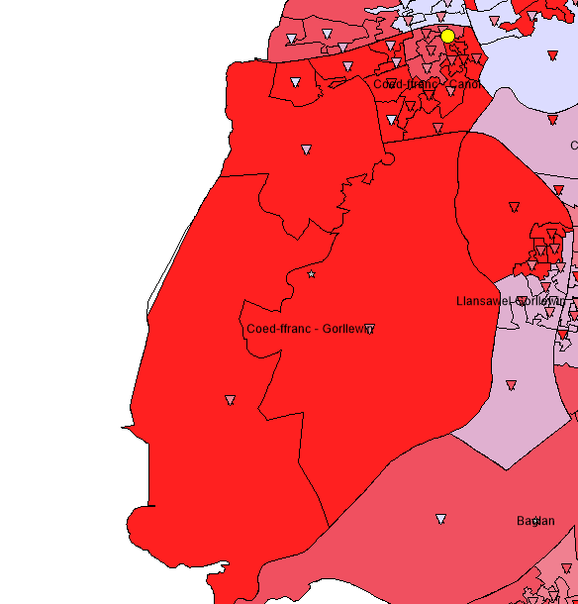
As you can see on the left, this whole area is deprived with a vaccination centre based at the top near some less deprived areas. This means that everyone in deprived areas must travel a long way to the vaccination centre which makes it less accessible for the people in this Coed Ffranc area. This is such a massively sized deprived area, so it would have been more useful to position a vaccination centre in the middle of the area so that it is in walkable distance for everyone without cars and vans.

According to the office for National Statistics, when they conducted survey visit between 21st of February and 20th of March 2022, that third vaccination rates were lower in the people that lived in deprived areas, along with those who identified being from a non-white ethnic minority, and people who worked outside from the home for more than five days a week or who had previously been affected with covid-19. [4]. Contradicting this information, people aged between 18- and 34-year-olds are more likely to be vaccinated with their third dose in deprived areas. The younger generation are taking precautions to protect the vulnerable against the virus. It is clear to see that the older age groups are less likely to be vaccinated, which is the opposite of expectation as they are the most likely to be vaccinated in less deprived areas. There could be multiple factors for this, such as not having transportation, being unable to leave the house, or even being too paranoid of the virus to get onto public transportation or to even leave the house.
Before covid-19 was around, it was known that people in deprived areas, older and frail people, and people with long term illnesses, were at higher risk of catching any infection. [5]. Given the facts of the vaccinations, it is clear to see that Neath Port Talbot will be at a massive risk of not reaching herd immunity, which is the sole purpose of the vaccination programme. Herd immunity is when a large group of people within a community becomes immune to a disease, whether this be covid 19 or any other illness. The benefit of this is that the disease will be unable to spread from person to person as they would all be immune and therefore the whole community becomes protected against viruses. [7].

Conclusion
In conclusion, it is clear to see the massive impact covid 19 has had on the world and individuals. It is interesting to see the number of people who have been vaccinated and the many factors that impact this. It can depend on the economy, their financial status, the occupancy per dimension, transport, health and wellbeing and many other factors. Although these may not be hard facts, it is easy to hypothesise the reasons behind not being vaccinated and the impact it can have on those people and others.
MapInfo is a fantastic software to use as it allows us to bring in multiple data sets and use the information to visualise the health and deprivation that some people are facing in everyday life. It is fascinating to see how the data can be brought in as a table that is hard to understand and created into something that’s easy to read and understand. The use of colours and helps with this. Finally, the use of Geographical Information Systems software demonstrates how a system can be built to inform healthcare professional on the uptake of vaccination programmes. The system highlights areas, within a health authority, where uptake of a vaccination is good or where it may be at risk of not reaching herd immunity.

Reference List
[1] “Classification of household deprivation (Great Britain) 2011 | UK Data Service | Census Data,” Ukdataservice.ac.uk, 2017. https://statistics.ukdataservice.ac.uk/dataset/classification-household-deprivation-great-britain-2011 (accessed May 01, 2022).
‌ [2] https://www.facebook.com/gisgeography, “MapInfo Professional by Precisely,” GIS Geography, Feb. 2018. https://gisgeography.com/mapinfo-professional-precisely/ (accessed May 02, 2022).
‌ [3] “Older Adults Risks and Vaccine Information,” 2022. https://www.cdc.gov/aging/covid19/covid19-older-adults.html (accessed May 02, 2022).
‌ [4] Latest insights team, “Coronavirus (COVID-19) latest insights,” Ons.gov.uk, Apr. 20, 2022. https://www.ons.gov.uk/peoplepopulationandcommunity/healthandsocialcare/conditionsanddiseases/articles/coronaviruscovid19latestinsights/vaccines (accessed May 03, 2022).
[5] “Older people are at risk from COVID even after vaccine - NIHR Evidence,” NIHR Evidence, Apr. 27, 2022. https://evidence.nihr.ac.uk/alert/older-people-at-risk-from-covid-even-after-vaccine/ (accessed May 03, 2022).
‌ [6] “GIS Analysis: Fundamentals of Spatial Query,” GIS and Geocomputation for Water Resource Science and Engineering, pp. 111–128, Mar. 2016, doi: 10.1002/9781118826171.ch9.
‌ [7] “Herd immunity and COVID-19: What you need to know,” Mayo Clinic, 2022. https://www.mayoclinic.org/diseases-conditions/coronavirus/in-depth/herd-immunity-and-coronavirus/art-20486808 (accessed May 04, 2022).
‌ [8] “Introduction to Cloud Geocoding in MapInfo Cloud Geocoding in MapInfo Pro,” 2018. [Online]. Available: https://higherlogicdownload.s3.amazonaws.com/PITNEYBOWES/UploadedImages/f6a38d70-4644-49b2-b95c-c8fe50abef09/Geocoding_with_MiPro-2.pdf
‌ [9] “Convert UK Postcode to Latitude / Longitude,” Freemaptools.com, 2019. https://www.freemaptools.com/convert-uk-postcode-to-lat-lng.htm (accessed May 05, 2022).
‌
‌

