Academic and Employability Skills

Student: Mirela Bors Tutor: Adesewa Ajayi
ID Number: 1920412
Table of Contents
Introduction 3
Topic 1- Referencing 4
Topic 2 - Academic Writing 6
Topic 3 –Public Speaking and Presentations 8
Topic 4 - CV Writing 10
Conclusion 12
References 13
Appendices 14

Introduction
Reflection refers to the action of writing about the feelings or experiences about something, particularly an event that occurred in the past. In this report, I shall reflect on my learning throughout the module. The topics that I shall reflect on are referencing, academic writing, public speaking, and presentations and CV writing. My reflection shall present my learning experiences during Term 1 wherein I learnt key details about employability and employability skills. Overall, the report shall provide valuable insights regarding my current knowledge, my thoughts about the topics taught in class and my class performances in general.
In order to reflect effectively on my learning throughout the module, I shall apply Gibb’s Reflective Cycle that leads one through six stages while exploring and throwing light on an experience: description, thoughts and feelings, evaluation, analysis, conclusion and action plan (Li et al., 2020). In addition to this, I shall also use Driscoll’s Model of Reflection which comprises three questions namely, ‘what’, ‘so what’ and ‘now what’ (nottingham.ac.uk, 2020). The effective use of these models shall help me to throw light on how much I have learnt in class and what I can do with this learning in enhancing my professional worth and employability.

Topic 1- Referencing (Gibb’s Model)
Description
The first stage of Gibb’s Model is the description stage wherein the overall experience of an event is described. In this module, my class experiences helped me significantly in learning about the concept of referencing and the way in which I can properly acknowledge the authors whose words I paraphrase in my assignments.
Feelings
This stage helps in articulating the feelings or thoughts regarding the experience (Markkanen et al., 2020). I feel that learning about referencing was indeed crucial for me to ensure that all the sources from where I conduct my research are given their due acknowledgement and that I do not steal their ideas or plagiarise, which is academic misconduct and liable for severe punishment in my university (Pears and Shields, 2019).
Evaluation
This stage helps in evaluating the learning and experience. The positive side of learning about referencing in Term 1 is that I can now easily adhere by the university’s norms and avoid plagiarism. However, the negative aspect of this is that many a times, the job of referencing becomes time-consuming and incorrect references leads to deduction of marks.
Analysis
This stage focuses on analysing the knowledge and work that I have gained through my assignments and studies. I most definitely believe that learning about the ways to reference my sources properly has been immensely useful, especially in the context of academic writing. Attending class lectures on the same has also helped significantly in clearing many doubts about the need for referencing and the various styles of referencing that are followed typically.
However, at the same time, I also believe that my initial approach to referencing was unnecessarily time-consuming as I paraphrased the content first and cited my sources in the end. This often led to incorrect intexts, which rendered the entire process of referencing almost useless.
Conclusion
This stage is where a conclusion is arrived at regarding the learning and what could have been done differently. When I joined university, I was clueless about the need for referencing and the way in which sources of an academic work can be referenced properly. Through regular class lectures and while working on Task 1 assignment, I have been able to gain a proper understanding about this concept.
Action Plan
The final stage of Gibb’s Reflective Model is where an action plan for further improvement is created (Cherkis and Rosciano, 2018). In my next assignment, I shall make sure that I keep citing my sources whenever I am paraphrasing from a particular work. I shall also make sure that I am consistent about the referencing style throughout the work.

Topic 2 - Academic Writing (Driscoll’s Model)
What?
Academic writing is crucial for any student as it essentially serves as a tool for communication that communicates the knowledge acquired by a student in a particular field of study (Zemach and Rumisek, 2016). My class lectures and Task 1 assignment contributed significantly towards helping me to learn about the critical concept of academic writing and the way in which academic writing can be done properly.
The first task in the module required me to write academically and attending classes and following the instructions of my professors helped me to grasp the basics of academic writing. I was asked to paraphrase from the sources I conducted my research from and cited them clearly at the bottom to avoid plagiarism.
So what?
Learning about the key concept of academic writing at university was indeed a revelation for me that helped me significantly to use my own words to present someone else’s ideas and even my own in some assignments. I feel that this experience was indeed crucial for me to go through as a university student as I now realise that a well written assignment can go a long way in letting my thoughts show through clearly, whereas, a poorly written work instead gives off the impression that the though-process is muddy as well (Aunurrahman et al., 2017). Moreover, I feel that having strong academic skills helped me to be an active learner in addition to being a unique interpreter of any information that comes my way.
However, the approach that I took when I first attended the class on this topic wasted a lot of time as I initially used informal and colloquial terms while writing. Moreover, in my attempt to paraphrase, I made the mistake of looking up the synonyms of every word instead of simply writing the sentence in a different manner that could have saved a lot of time.
Now what?
The overall experience of learning about academic writing was immensely useful for me as I have been able to impress my professors with the same and score good grades in my assignments. Reflecting on my incorrect approach helped me to realise that I could have simply re-written complete sentences in my own words rather than wasting precious time looking up synonyms or antonyms. Therefore, in future, I shall try to read books and spend some hours with my thesaurus as a means to improve my existing vocabulary. I shall also continue to practice the art of paraphrasing in order to speed up on this and improve my overall academic writing.

Topic 3 –Public Speaking and Presentations
Description
During the module, I was required to speak in my front of my batch mates and professors while presenting an assignment. I had to read from my hard copy of my notes and maintain eye contact with my audience while addressing them. I was required to appear confident while doing so and speak clearly and distinctly in order to keep the audience engaged throughout. It was a nerve-wracking experience for me as I am an under confident and introvert person in general. However, with adequate support from my professors and peers during classes, I was able to overcome this fear to an impressive extent.
Feelings
I feel that in order to be a successful corporate professional, it is important to have the ability to speak confidently in public and present own work in the most attractive way. However, as I mentioned, the entire experience of public speaking and presenting was highly challenging for me, as I do not at all feel confident while speaking to a group of people and having all of their attention on me for the entire time. However, the module and adequate support that I received from my professor during class helped me to overcome this fear to a significant extent. They have provided me with the necessary confidence to speak clearly to a small group of people without feeling faint.
Evaluation
Learning about the basic aspects and nuances of public speaking and presentations indeed helped me to feel more confident about my abilities and me. It has also been useful in helping me to improve my communication and interpersonal competencies along with my critical thinking abilities. Overall, the lessons imparted to me about the importance and need to speak efficiently in public have contributed significantly towards boosting my personal satisfaction (Raja, 2017).
However, at the same time, the huge amount of time that I require to prepare myself for speaking in public during a presentation takes away precious time that I could have used elsewhere on other projects or even personal pursuits.

Analysis
I am of the opinion that I have been able to gain a concrete understanding of the need for public speaking exercise, as it is a necessity in the professional field. This is indeed a positive aspect of this experience, while on the negative side, the amount of time that I still require to prepare myself for such an exercise, is rather unnecessary.
Conclusion
This experience has made me more confident about myself and has lent me a healthy amount of personal satisfaction that was missing in me prior to this. However, I still feel that I can improve further on this and enhance my existing knowledge by taking upon opportunities to demonstrate my newly acquired learning.
Action Plan
I can improve on my public speak abilities further by consulting with my professors and being patient while preparing myself for presentations at university. I need to keep reminding myself of the benefits of public speaking so that the preparation time does not feel like a waste altogether.

Topic 4 - CV Writing
Description
CV writing is crucial for job hunting as it is the first document that one can use to impress recruiters and prospective employers (BREAK, 2020). The module included CV writing and helped me to understand the key characteristic features of a well-made CV and the steps that need to be taken to prepare a well-detailed CV.
Feelings
I feel that CV writing is indeed useful for me as a student and most definitely as a professional in future, as it can be used to inform prospective employers about my educational qualifications, work experiences, and existing skills and interests (Dhaliwal et al., 2018). I am also of the belief that learning about the importance of CV writing would go a long way in preparing myself for the corporate world.
Evaluation
Writing a well-tailored CV can help me to make a good first impression on my future employers and let them know of my current abilities and knowledge. However, the negative side to this experience is that due to my lack of work experience, I initially wrote misleading things about myself in my CV to impress recruiters.
Analysis
CV writing exercises in class elevated my existing knowledge about the relevance of a well made CV and guided me how I can prepare the same for myself as the first step towards preparing for the job market. However, the fact that I mentioned misleading information about myself in a bid to compete with the CVs of my peers was a major downside of this experience.
Conclusion
Attending classes on this topic helped me positively in preparing myself for the process of job hunting in today’s competitive business market. I have been able to convince myself of the benefits offered by this practice and identified further scope of improvement in this area in me.

Action Plan
In order to avoid writing misleading information on my CV, it is important for me to realise that instead of falsifying my CV, my focus should be on figuring out how best to accumulate honest experiences that I can mention in my CV. Learning about the formatting and the overall presentation of a good CV is also paramount.

Conclusion
Therefore, it might be concluded that reflection is an important practice that has helped me to have a clearer perspective on the learning and experiences that I acquired while working on the module and attending classes. This report has presented my reflection on the four topics that was taught to me in class. I have evaluated and analysed each of the topic in terms of my learning and feelings about them while also pointing out the ways in which I could have done things differently and the future course of action to improve my knowledge and learning experience further in future.

References
Aunurrahman, A., Hamied, F.A.H. and Emilia, E., (2017). EXPLORING THE TERTIARY EFL STUDENTS'ACADEMIC WRITING COMPETENCIES. Indonesian Journal of Applied Linguistics, 7(1), pp.72-79.
BREAK, P.C., 2020. Writing successful CV, Preparation for Project Interview and Making Perfect LinkedIn Profile.
Cherkis, F. and Rosciano, A., (2018). Reflective practice: Implementation across curriculums. International Journal of Nursing Research Health Care, 7.
Dhaliwal, U., Singh, S. and Singh, N., (2018). Reflective student narratives: honing professionalism and empathy. Indian J Med Ethics, 3, pp.9-15.
Li, Y., Chen, W., Liu, C. and Deng, M., (2020). Nurses’ Psychological Feelings About the Application of Gibbs Reflective Cycle of Adverse Events. American Journal of Nursing, 9(2), pp.74-78.
Markkanen, P., Välimäki, M., Anttila, M. and Kuuskorpi, M., (2020). A reflective cycle: Understanding challenging situations in a school setting. Educational Research, 62(1), pp.46-62.
nottingham.ac.uk. (2020). Driscoll cycle. [online] Available at: https://www.nottingham.ac.uk/nmp/sonet/rlos/placs/critical_reflection/models/driscoll_cycle.html (Accessed: 17 December 2020).
Pears, R. and Shields, G.J., (2019). Cite them right: the essential referencing guide. Macmillan International Higher Education.
Raja, F., (2017). Anxiety Level in Students of Public Speaking: Causes and Remedies. Journal of education and educational development, 4(1), pp.94-110.
Zemach, D.E. and Rumisek, L., (2016). Academic writing. Macmillan.

Appendices
Appendix 1: Gibb’s Reflective Cycle
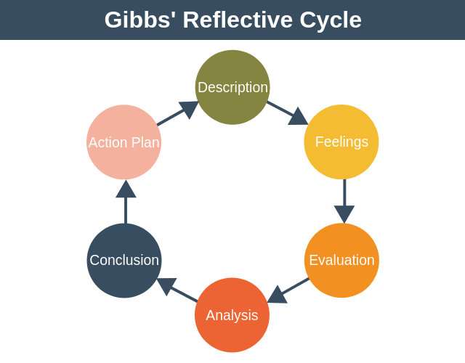

Appendix 2: Driscoll’s Reflection Model
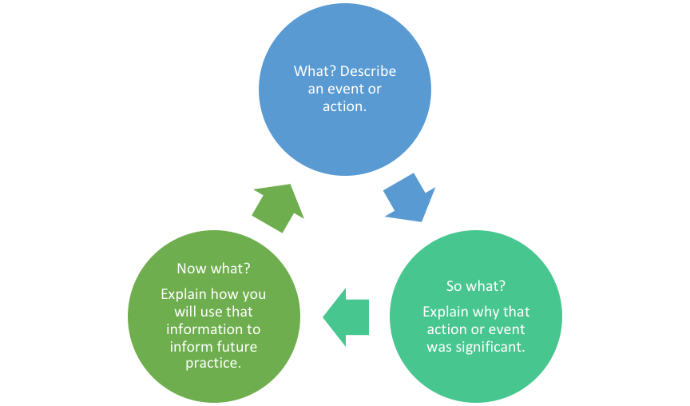

Appendix 3: CV

