A Discussion on Huawei’ s Transformation


MAY 2023

MOUDLE NAME: BMMB7000 Change & Stability Management
NAME: CHEN ZHIZONG
STUDENT NUMBER: 2216862

Contents
1. Background 1
2. Analysis of Internal and External Influencing Factors 1
3. Analysis of Huawei’s Current Transformation Policies 4
4. Recommendations for Huawei’s future change policy 8
5. Reference list 11

Background
Huawei is a global technology company headquartered in Shenzhen, Guangdong Province, China. Founded in 1987 by Ren Zhengfei, the company’s business covers various fields including telecommunications equipment, consumer electronics, smartphones, and cloud computing (TechTarget Contributor,2016) . Its main business is to provide telecommunications operators with network equipment and solutions, including wireless, wired, core networks, data centers, etc., as well as enterprise-level businesses and consumer electronics businesses. Huawei is one of the world’s leading information and communications technology (ICT) solution providers.
Huawei has invested heavily in R&D and has deployed its products and services in more than 170 countries and regions. In 2018, it surpassed Apple to become the world’s second-largest smartphone manufacturer, trailing only Samsung Electronics. In 2020, Huawei’s global smartphone shipments, for the first time, surpassed both Samsung and Apple. In 2022, it ranked ninth among the top ten most valuable global brands(Amy Sarkar,2022).
In May 2019, the U.S. government placed Huawei on the Entity List, prohibiting U.S. companies from selling technology and equipment to Huawei. This ban prevented Huawei from using chips and technology from U.S. companies such as Qualcomm, Intel, and Micron, causing a significant impact on Huawei’s supply chain and product development. As a result, Huawei had to undergo comprehensive business adjustments and transformations to alleviate pressures on production and the supply chain(Emily Feng,2019）.

Analysis of Internal and External Influencing Factors
Huawei’s chip R&D have been affected by both the driving and hindering factors of the internal and external environment in which the company operates. In the following section, we will analyze this using the PESTEL and SWOT models.
2.1 Pestel
2.1.1 Political Factors
Under the influence of the China-US trade war, the US government has prevented U.S. chip companies from supplying chips to Huawei. This includes Huawei’s fixed supplier TSMC, which has a leading position in the chip industry. According to data from Counterpoint Research, Huawei’s primary Kirin chips, which are crucial to its smartphones, dropped to near zero in the third quarter of 2022, indicating that Huawei’s emergency inventory from TSMC has been depleted (Dylan Martin,2022）. Chips are a vital component of smartphones. On the other hand, due to the support of the Chinese government and China’s enormous consumer power, Huawei still maintains its leading position in the Chinese and global mobile phone markets.
2.1.2 Economic Factors
According Strategy Analytics data, global smartphone shipments decreased by 11% year-on-year in the first quarter of 2022(Mobilevillage,2022）. This marks the third consecutive quarter of annual declines in smartphone sales. Due to the impact of COVID-19, the global unemployment rate has increased, and people’s purchasing power has decreased, leading to a reduced willingness to purchase and upgrade to new smartphone models, with a greater focus on meeting basic living needs as a priority in consumption(Isobel Asher Hamilton,2020）.
2.1.3 Social Factors
In recent years, Huawei has had a solid customer base in the Chinese market. The extradition case of Meng Wanzhou that ended in 2021 also ignited patriotic fervor among the Chinese people, drawing attention to the brand and cultivating a group of loyal customers(Zhang Yangfei,2021）. On the other hand, globally, Huawei’s brand image and reputation may have been affected by the chip incident. Consumers and businesses may have doubts about Huawei’s products due to security, trust, and reliability issues. At the same time, Huawei may need to make more efforts in talent recruitment and retention to cope with market changes(Simon Yuen,2021）.
2.1.4 Technological Factors
Chips are the core components of smartphones. Due to the influence of the global political environment, chip imports have been affected, and some Chinese companies have attempted to develop and produce alternative chips. However, China’s actual production and research capabilities are still relatively weak(Jordan Schneider,2021）. Currently, there are no local chip technology companies in China that can keep up with international technological developments. Therefore, in the short term, Huawei may face issues such as technological lag, extended R&D cycles, and increased difficulty in achieving technological breakthroughs. However, in the long run, this may help Huawei reduce its dependence on external suppliers and enhance its independent R&D capabilities and core competitiveness.
2.1.5 Environmental Factors
The impact of the chip incident on Huawei’s environment is relatively small. However, as global concerns about sustainable development and environmental protection intensify, Huawei may need to adopt more environmentally friendly measures in product design, production, and supply chain management to reduce environmental risks(Irishtechnews,2020）.
2.1.6 Legal Factors
In terms of law, Huawei needs to comply with import and export regulations, intellectual property laws, and competition laws in various countries(Nawied Jabarkhyl,2020）. The chip incident may lead to more legal disputes and compliance issues for Huawei globally, increasing legal risks and costs.
2.2 SWOT
2.2.1 Strengths
2.1.1 Huawei has a complete industrial chain in the fields of communication equipment and smartphones, covering independent R&D, design, manufacturing, and sales. It also has a large R&D team and continuously invests substantial resources in technology(Elizabeth Coyne,2023）, actively promoting research and applications in areas such as 5G, artificial intelligence, and cloud computing. Meanwhile, Huawei is constantly pushing for innovation, introducing a series of chips and technologies with independent intellectual property rights, such as Kirin chips and 5G technology. These technologies and products not only drive Huawei’s business development but also promote technological progress in the entire industry to some extent. Therefore, Huawei has a high competitiveness in terms of technological strength and innovation capabilities, thereby the impact of the chip issue on Huawei is only temporary.
2.1.2 Huawei has a broad customer base and partnership relationships worldwide, with strong market influence and brand recognition. Huawei’s clients in the communication equipment field include operators, government agencies, and enterprises such as China Mobile, China Telecom, British Telecom, Deutsche Telekom, and Saudi Telecom. In the smartphone field, Huawei’s customers are spread across the globe(Silvia Elaluf-Calderwood,2022）, with a wide user base. These customer and partner relationships provide Huawei with vast market and business opportunities and drive its rapid development in the global market. For Huawei, this foundation will play a crucial role in promoting its business adjustments and transformations.
2.2.2 Weaknesses
2.2.1 Huawei is subject to sanctions by the U.S. government, preventing it from obtaining chips and technological support from U.S. companies. U.S. companies have a significant technological monopoly advantage in chips and technology, and Huawei’s inability to obtain support for these key technologies may impact its product R&D and production capabilities (Jeremy Mark and Dexter Tiff Roberts,2023）.
2.2.2 Huawei faces intense competitive pressure in the international market, and its market share may be eroded. The U.S. market is also one of the largest markets globally, and Huawei’s products are unable to enter the U.S. market, which will affect its business development and market share (Ashutosh Kumar,2021）.
2.2.3 Due to the sanctions imposed by the U.S. government, Huawei have to face comprehensive business adjustments and transformations. How to make the right adjustments and effective transformations in specific business areas, achieve rapid breakthroughs, and get back on track in the market will be a test for Huawei itself(The Nation,2022）.
2.2.3 Opportunities
2.3.1 Huawei can take this opportunity to strengthen its ability to independently research and develop and manufacture chips, reduce reliance on external suppliers(Cheng Ting-Fang,2022）, improve competitiveness across the industry chain, and enhance customer satisfaction and brand recognition through innovation and product optimization.
2.3.2 Huawei can expand into other industries to improve the company’s market competitiveness and market share(Ma Si,2022) . For example, consumer electronics can not only attract more customers but also increase customer loyalty and word-of-mouth effect, further improving brand recognition.
2.3.3 Huawei can actively explore other markets worldwide, strengthen business cooperation with Europe and Asia, and expand market space(Vladimir Shopov,2022). Due to sanctions by the U.S. government, Huawei’s market and business have been affected to some extent. To cope with this situation, Huawei actively seeks cooperation with other international companies. Huawei has a considerable market share and brand recognition in the European market. Additionally, Huawei has established multiple R&D centers and laboratories in Europe, actively expanding the European market can help Huawei reduce its dependence on the U.S. market, alleviate the impact of sanctions, and improve the company’s market competitiveness and market share.
2.2.4 Threats
2.4.1 New product supply chain disruption(Pablo Valerio,2023) . Chips are the core components of electronic products, a lack of chips will lead to bottlenecks in the product supply chain. Huawei’s production and delivery of smartphones, laptops, communication equipment, and other products will be severely impacted, possibly leading to order delays or an inability to complete orders on time.
2.4.2 Declining product competitiveness: Chips are one of the critical factors affecting product performance and quality, a lack of chips will impact Huawei’s product performance and competitiveness(Jeanne Whalen,2021). If the chip supply shortage cannot be resolved in the short term, Huawei may lose its competitive edge in the market.
2.4.3 Limited technological innovation: Chips are key to technological innovation, a lack of chips will restrict Huawei’s technological innovation and product upgrades(Arjun Kharpal,2020) . This may affect Huawei’s position and reputation in future market competition.
2.4.4 Increased financial losses: Chip supply shortages will lead to production stagnation, increased production costs, and inventory backlog issues, all of which will increase Huawei’s financial losses.

3. Analysis of Huawei’s Current Transformation Policies
Currently, due to various factors including sanctions from the U.S. government, Huawei has undergone a series of business adjustments and transformations to adapt to the situation and market development. The main adjustments and changes include the following aspects:
3.1 Market segmentation and change of development direction
3.1.1 Huawei has separated its sub-brand Honor(Elles Houweling,2021）. This move complements Huawei’s customer base. Besides focusing on online sales and material differentiation, Honor’s key technologies are the same as Huawei’s. According to market statistics, Huawei’s brand has rapidly become prominent among other brands. In November 2020, Huawei announced that it had signed an acquisition agreement with a Shenzhen-based company to complete a full acquisition of the commercial assets. In this way, although Honor loses the middle-income group covered by the Honor brand, it can purchase the latest processors in the supply chain, as it is not subject to U.S. restrictions, allowing Honor terminals to carry the latest processors. Although the separation of the smartphone business poses challenges and risks for Huawei, it also lays a more solid foundation for the company’s long-term development and sustainability.
3.1.2 Product diversification. Huawei has gradually expanded its business from single domains such as smartphones to more areas, shifting from mobile business to focus on the development of ICT infrastructure and enterprise business, such as network equipment, cloud computing, the Internet of Things (IoT), and intelligent vehicles (Oliver Noyan,2021). This business diversification can reduce the risks and dependence on a single domain and create more space for Huawei’s future strategic adjustments and business transformation.
3.2 Transition to becoming an industry service provider, changing the direction of data energy services
3.2.1 Huawei has continuously improved its self-developed HarmonyOS(Amy Sarkar,2023), achieving initial coverage of all scenarios from smartphones to ICT equipment, and providing detailed usage data for its next development with the help of hundreds of millions of devices. By the end of 2021, the global monthly active users of Huawei terminals exceeded 730 million.
3.2.2 Huawei has Leverage its 5G-related patents to increase revenue. If popular smartphone manufacturers want to develop 5G smartphones, they must pay patent fees(Igor Bonifacic,2021). For example, Huawei’s lawsuit against Verizon appeared in February 2020; before that, Huawei had proposed to pay Verizon more than $1 billion for over 230 patent licenses.
3.2.3 Huawei has its own chips in the server domain to meet the growing data center business. With the rapid development of the global data industry, Huawei occupies an increasingly larger share in cloud service revenue. In 2021, Huawei announced its cloud service performance for the first time, with revenue reaching 201 billion yuan, a year-on-year increase of 34%. It ranks second in the Chinese market and has risen to the top five in the global market(Deng Li,2021) .
3.3 However, Huawei has been affected by the following factors during the implementation of the above changes:
3.3.1 Difficulty in developing chip technology
Huawei faces significant technical challenges in independently developing chips, as chip R&D require high technical levels and extensive experience. First, Huawei needs to increase R&D investment, strengthen talent introduction and training, recruit a large number of outstanding chip electronic engineers, and promote internal employee technical training and career development to cultivate more high-quality technical talents. Second, strengthen cooperation with universities and research institutions, jointly research and develop new technologies, promote industry-university-research cooperation, and improve technological innovation capabilities.
3.3.2 Chip R&D and manufacturing depend on a vast supply chain system
Huawei relies heavily on the supply chain, while its channels for independently developing chips are narrow and small-scale. Huawei can leverage its global resource advantages, attract more global talents and partners, carry out international cooperation and exchanges, strengthen technological innovation and product development, and enhance its global market competitiveness.
3.3.3 Increased pressure on R&D funding
Huawei’s operating costs are high, and in the short term, the company’s profit margin is declining due to product issues, leading to internal financial strain. Independent chip R&D requires significant funding. Therefore, Huawei needs to develop scientific investment and financial strategies to maintain the company’s sustainable development. For example, strengthening cost control, Huawei has tightened cost control in response to the pressure brought by U.S. sanctions, minimizing expenses as much as possible. For instance, focusing more on efficiency and cost in procurement and supply chain management, and cutting unnecessary expenditures.
3.3.4 Delays in launching new Huawei products
Due to the restrictions imposed by U.S. sanctions, Huawei faces challenges in chipsets, operating systems, and other technologies, causing delays in launching new products. Especially in the smartphone domain, since Huawei cannot use Google’s Android operating system, it had to introduce its operating system, HarmonyOS, which requires re-adapting applications and ecosystems, resulting in delayed release of new smartphones. In response, Huawei can collaborate with other manufacturing companies to jointly research and produce chips, strengthening its R&D and production capabilities. At the same time, it can cooperate with software and service providers to jointly develop and promote new digital products and solutions to enhance market competitiveness.
3.4 The U.S. government has restricted U.S. companies from selling chips and other technology products to Huawei, leading to Huawei facing a shortage in the chip supply chain. Using Lewin’s model to analyze the causes of Huawei’s changes due to the chip event, we can divide the factors into driving forces and restraining forces, as follows:
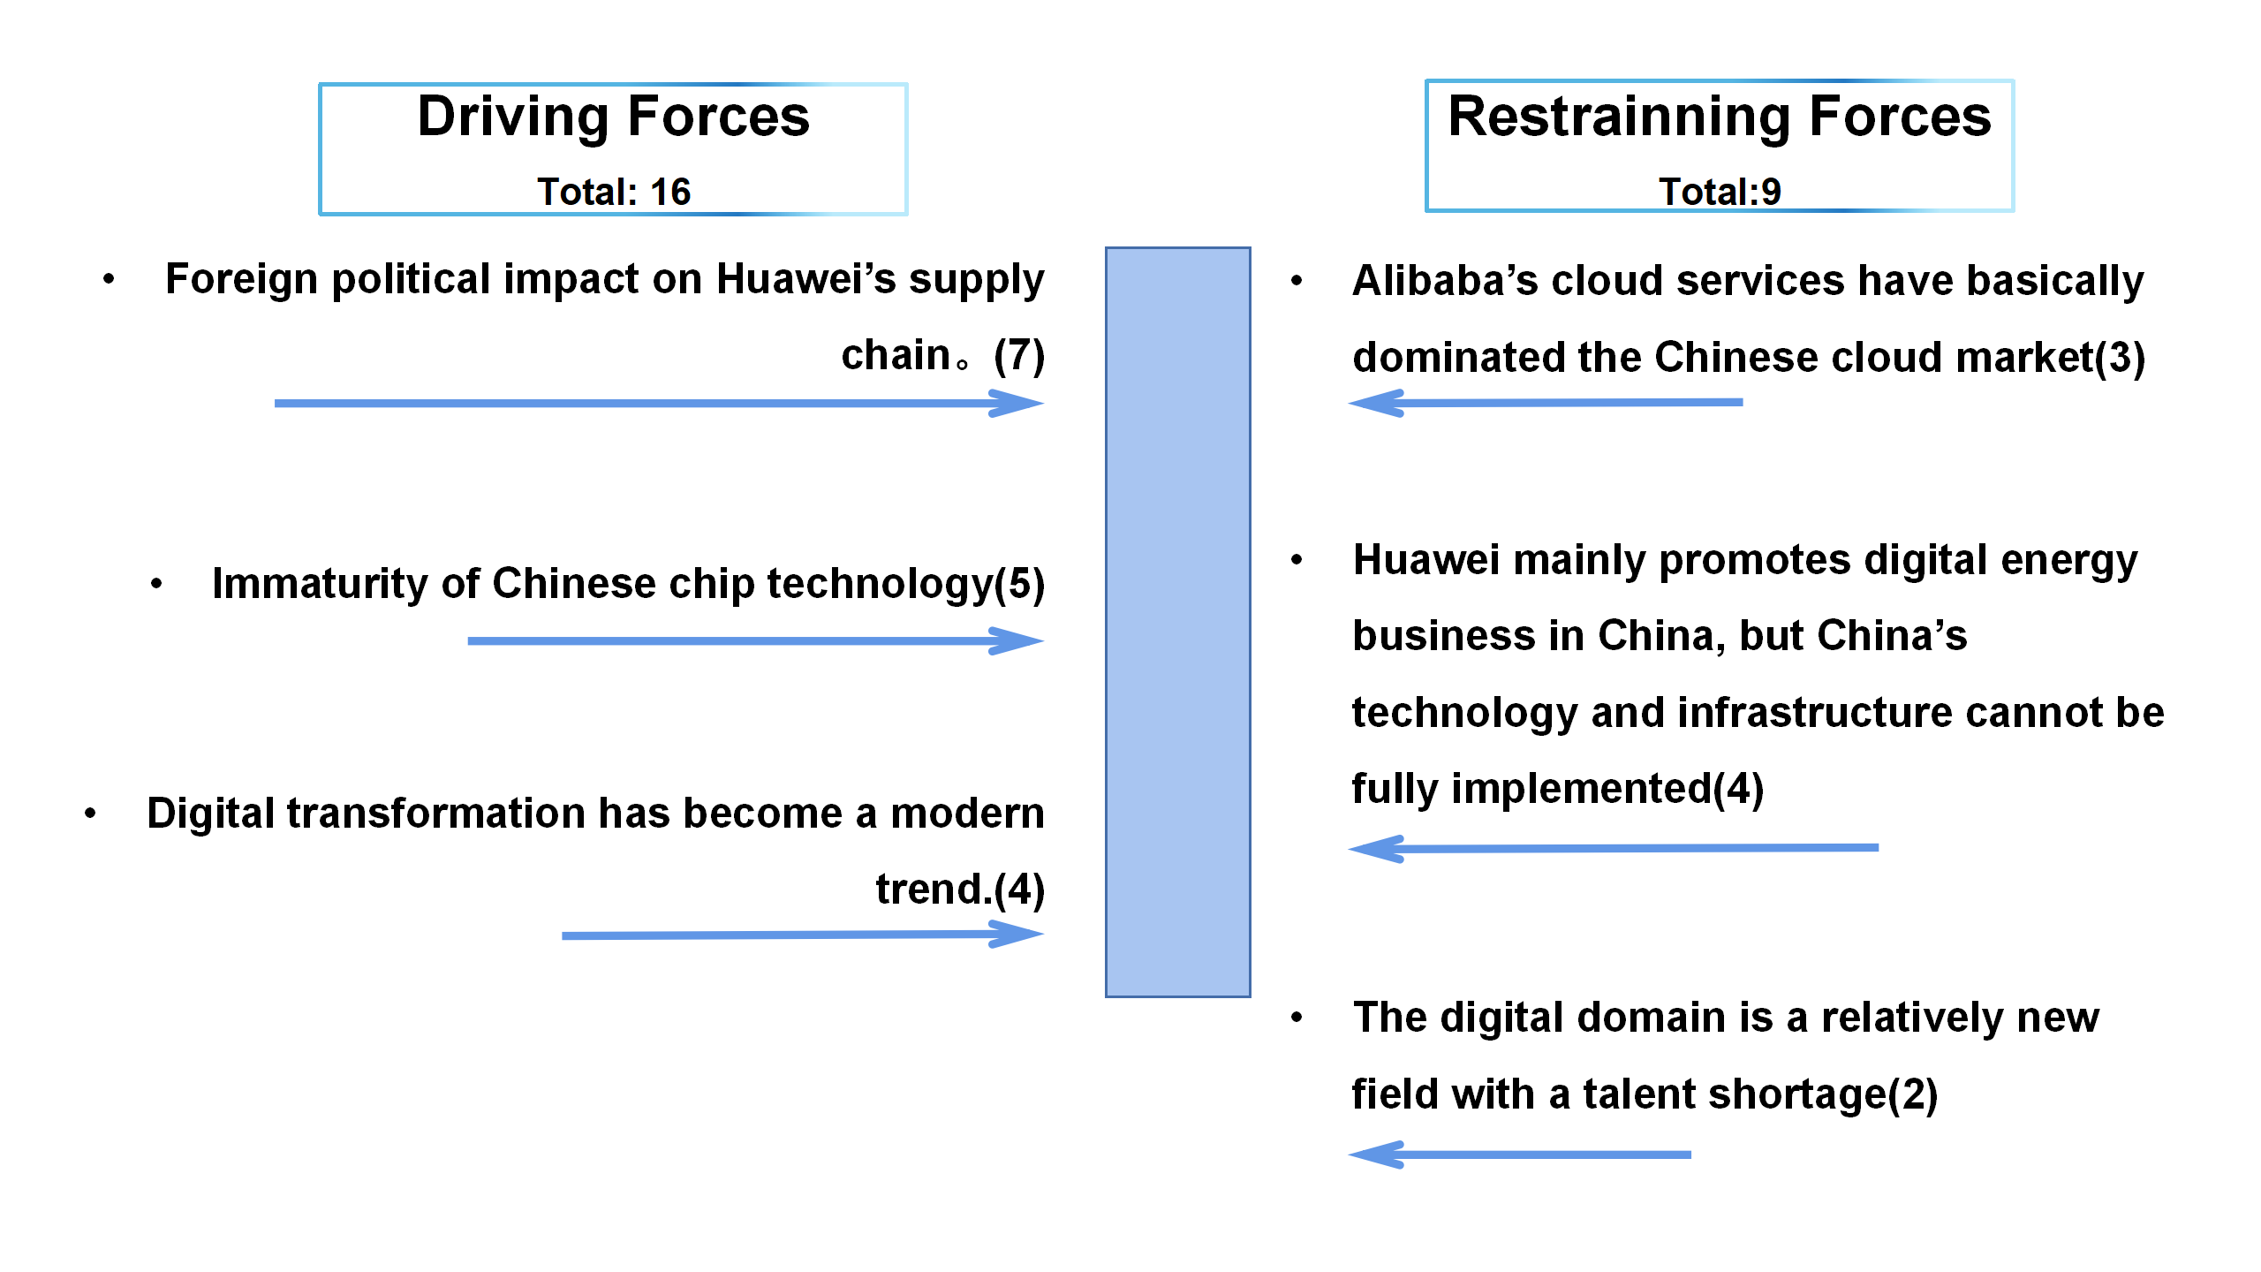
3.4.1 Driving forces:
3.4.1.1 Foreign political impact on Huawei’s supply chain(Dan Robinson,2023). For example, the impact on Huawei’s production and sales, decline in market competitiveness, reduction in R&D investment, and decrease in economic benefits, etc. This forces Huawei to undergo comprehensive business adjustments and transformations, requiring changes to the current strategy.
3.4.1.2 Immaturity of Chinese chip technology. Currently, smartphones mainly use silicon-based chips, with the best technology in the industry being TSMC. Huawei launched the P50 in 2021, claiming that 5G chip phones could not reach the general level of 5G. It has been almost four years since 2019, but Huawei still cannot launch a 5G smartphone. Although Habo Investment invested in China’s largest third-generation chip material (by the end of 2022), it remains doubtful whether it can support large-scale chip production even if it breaks the technological barrier. Therefore, the influence of these fundamental core technology factors directly promotes the weak business proportion of Huawei’s terminal manufacturing(Arjun Kharpal,2021).
3.4.1.3 Digital transformation has become a modern trend(David Sun,2021）. With the rapid development of information technology and increasingly fierce market competition, more and more enterprises have begun to realize the importance of digital transformation and have started to take corresponding measures. In China, enterprises and government agencies have already started using digital platforms for business management. Due to Huawei’s wealth and technical resources, as well as its influence on Chinese society, Huawei’s transformation will progress rapidly. Huawei’s digital transformation involves multiple aspects, including the application of information technology, the reorganization of business processes, and changes in organizational culture.
3.4.2 Restraining forces:
3.4.2.1 Alibaba’s cloud services have basically dominated the Chinese cloud market. Alibaba Cloud is one of the leading companies in the Chinese cloud computing market, with rich experience and technical accumulation in cloud computing, big data, and artificial intelligence(Fan FeiFei,2021) . Although Huawei Cloud has achieved significant results in the past few years, there remains a gap compared to Alibaba Cloud. However, Huawei Cloud has been strengthening its technical capabilities and service capabilities, actively cooperating with partners, and improving brand awareness and market share through market promotion and marketing. Huawei Cloud’s cloud service products perform well in terms of security, performance, and price, and they continuously launch new products and services to meet customer needs. In addition, Huawei Cloud has other advantages, such as strong infrastructure, globally distributed data centers, and rich industry solutions. These advantages provide support and competitive advantages for Huawei Cloud in competing with Alibaba Cloud. With the advancement of digital transformation and the rapid development of the cloud computing market, Huawei Cloud can further expand its market share and influence in the future.
3.4.2.2 Currently, Huawei mainly promotes digital energy business in China, but China’s technology and infrastructure cannot be fully implemented(Kenson Yeoh and Dingding Chen,2022), possibly unable to guarantee the digestion of data volume and stable operational capability. China’s energy industry infrastructure and equipment are relatively backward, requiring increased investment and improvement, as well as further strengthening of technology R&D and promotion applications to meet the application needs of digital technology.
3.4.2.3 The digital domain is a relatively new field with a talent shortage(Chen YuBo,2021) , which requires Huawei to have sufficient financial resources while carrying out business development and talent training. Huawei attract outstanding talents to the digital field by establishing reasonable incentive mechanisms, providing excellent development platforms, and continuously improving employees’ skill levels to adapt to the development needs of the digital domain.
3.4.3 Through the analysis of driving and restraining forces in Huawei’s change management, we have the following conclusions:
3.4.3.1 How to solve the current state (Unfreeze)
Regarding the chip incident, Huawei has made strategic adjustments in all major strategic areas, such as increasing R&D investment, enhancing self-research capabilities; promoting technology cooperation, jointly developing chip technology; strengthening international cooperation, absorbing advanced technology and management experience from external sources; and enhancing talent training to improve Huawei’s chip R&D strength.
3.4.3.2 Moving to the Transition State (Transition)
In this stage, Huawei needs to start adapting to change and look for new solutions. This may include seeking alternative supply chains and strengthening independent R&D capabilities. For example, providing support for 5G patent technology and charging patent fees; utilizing Huawei Cloud to provide data center services; digital transformation, producing smart cars, and so on.
3.4.3.3 Consolidating the New State (Refreeze)
At this stage, the new approach is accepted and recognized as normal, but this requires time and efforts. Huawei should continue to adhere to a customer-centric, innovation-oriented, and stable-based attitude to face challenges and seek new development opportunities.

4.Recommendations for Huawei’s future change policy
In the future, Huawei plans to shift from focusing on foreign markets and trade development to deepening domestic business development, starting from the new infrastructure plan for transportation and building energy centers, using technology and 5G communication advantages as a foundation, and transitioning to domestic infrastructure construction and the use of new energy and traditional energy optimization and digitalization methods to cooperate with each other under the support of national government policies.
4.1 Huawei’s future plans are influenced by the following factors:
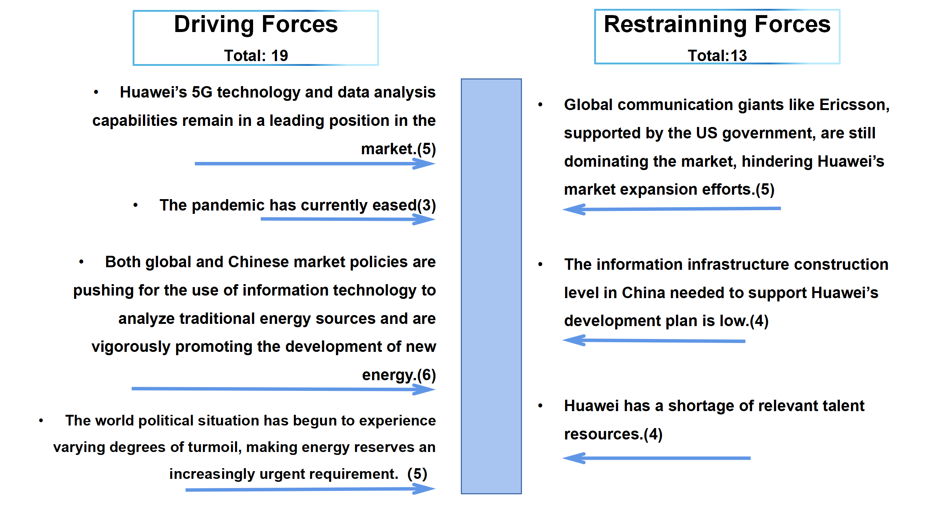
4.1.1 Driving forces:
Huawei’s 5G technology and data analysis capabilities remain in a leading position in the market.
The pandemic has currently eased, and countries are now focusing on resuming market trade, while physical trade still relies on the construction of basic transportation infrastructure such as ports.
Both global and Chinese market policies are pushing for the use of information technology to analyze traditional energy sources and are vigorously promoting the development of new energy.
The world political situation has begun to experience varying degrees of turmoil, making energy reserves an increasingly urgent requirement.
4.1.2 Restraining forces:
Global communication giants like Ericsson, supported by the US government, are still dominating the market, hindering Huawei’s market expansion efforts.
The information infrastructure construction level in China needed to support Huawei’s development plan is low. This requires significant financial and material investment.
Huawei has a shortage of relevant talent resources.
In summary, Huawei’s efforts to promote new infrastructure projects in transportation and assist the Chinese government in promoting a more efficient, reliable, and sustainable energy management system with smart grid and battery energy storage technology are indeed feasible as two reform policies when unable to expand its market overseas.
4.1.3 Finally, Huawei’s future development and reform direction is based on data analysis and R&D, focusing on the following aspects:
4.1.3.1 Maintaining the leading position in 5G technology and prioritizing the R&D of 6G technology: As a global leader in telecommunications equipment manufacturing, Huawei is already at the forefront of the 5G technology field. In the future, Huawei should continue to invest heavily in 5G technology R&D and begin researching 6G technology to prepare for the future communication technology revolution and maintain its competitiveness in the global communication technology field.
4.1.3.2 Engage in the R&D of IoT and edge computing technologies: With the popularization of IoT devices, Huawei can increase investment in IoT and edge computing fields, developing more intelligent hardware and solutions. This includes various fields such as smart homes, industrial automation, and intelligent transportation.
4.1.3.3 Cloud computing and artificial intelligence: Huawei has already made inroads into the cloud computing field and may further expand its cloud computing business in the future, providing more infrastructure, platform, and software services. At the same time, Huawei can increase investment in the field of artificial intelligence, developing more AI technologies and applications, promoting the development of artificial intelligence technology, and applying it to more products and services to enhance user experience and create more commercial value.
4.1.3.4 Establishing ecosystem partnerships: Huawei has already established a wide range of ecosystem partnerships, and in the future can continue to strengthen and expand these collaborations, working with partners from various industries to develop more innovative products and solutions, creating more value for users.
In conclusion, Huawei’s future development direction will continue to be diversified, covering multiple fields such as communication technology, artificial intelligence, IoT, and cloud computing to address the challenges and opportunities of future technology revolutions and pursue sustainable development for the company. This includes focusing on the innovation of specific consumer electronic products and transitioning to providing cutting-edge digital analysis and processing services for various industries. This approach will enable Huawei to eventually seek further development opportunities in overseas markets and expand its market share and brand recognition.

Reference list
- TechTarget Contributor (2016) Huawei Technologies Available at: https://www.techtarget.com/searchdatacenter/definition/Huawei-Technologies (Accessed:27 April 2023)
- Amy Sarkar (2022) Huawei gets 9th position in World’s Top 10 Most Valuable Brands 2022 available at: https://www.huaweicentral.com/huawei-gets-9th-position-in-worlds-top-10-most-valuable-brands-2022/ (Accessed:27 April 2023)
- Emily Feng （2019）U.S. Move To Isolate Huawei Sends Ripples Through Global Supply Chain Available at: https://www.npr.org/2019/05/16/723983055/u-s-move-to-isolate-huawei-sends-ripples-through-global-supply-chain(Accessed: 27 April 2023)
- Dylan Martin（2022）US sanctions drain Huawei of homegrown advanced chips available at https://www.theregister.com/2022/12/21/us_sanctions_huawei_chips/ (Accessed: 27 April 2023)
- Mobilevillage （2022）Samsung Hits Highest Global Smartphone Share in 5 Years available at https://www.mobilevillage.com/strategy-analytics-samsung-hits-highest-global-smartphone-market-share-in-five-years-q1-2022/(Accessed: 27 April 2023)
- Isobel Asher Hamilton （2020）Huawei is downplaying coronavirus impact on its smartphone sales, but experts say it will suffer more than Apple Available at: https://www.businessinsider.com/huawei-coronavirus-impact-analyst-commment-2020-2(Accessed: 27 April 2023)
- Zhang Yangfei（2021）Huawei looks forward to Meng Wanzhou's return from Canada available at www.chinadaily.com.cn/a/202109/25/WS614ef05ba310cdd39bc6b7ba.html (Accessed: 27 April 2023)
- Simon Yuen （2021）Huawei reportedly plans to recruit more talent amid sanctions Available at:https://www.marketing-interactive.com/huawei-reportedly-plans-to-recruit-more-talent-amid-sanctions(Accessed: 27 April 2023)
- Jordan Schneider（2021）China’s Chip Industry: Running Faster But Still Falling Behind available at:https://rhg.com/research/china-chips/(Accessed: 27 April 2023)
- Irishtechnews（2020）TECH FOR A BETTER PLANET: HUAWEI’S COMMITMENT TO ENVIRONMENTAL PROTECTION Available at: https://irishtechnews.ie/tech-for-a-better-planet-huaweis-commitment-to-environmental-protection/(Accessed: 27 April 2023)
- Nawied Jabarkhyl （2020）We abide by laws of 170 countries': Huawei tells UK it can be trusted with 5G network available at https://newseu.cgtn.com/news/2020-06-09/-We-abide-by-laws-of-170-countries-Huawei-makes-its-case-for-UK-s-5G-Ra6mf33RrG/index.html
- Elizabeth Coyne （2023）Huawei doubles down on R&D, investing $23.2B despite profit decline Available at: https://www.silverliningsinfo.com/5g/huawei-doubles-down-rd-investing-232b-despite-profit-decline(Accessed: 27 April 2023)
- Silvia Elaluf-Calderwood （2022）Huawei data centres and clouds already cover Latin America. Chinese tech influence is a gift to countries and politicians that don’t respect human rights Available at:https://strandconsult.dk/blog/huawei-data-centres-and-clouds-already-cover-latin-america-chinese-tech-influence-is-a-gift-to-countries-and-politicians-that-dont-respect-human-rights/(Accessed: 27 April 2023)
- Jeremy Mark and Dexter Tiff Roberts （2023）United States–China semiconductor standoff: A supply chain under stress Available at: https://www.atlanticcouncil.org/in-depth-research-reports/issue-brief/united-states-china-semiconductor-standoff-a-supply-chain-under-stress/(Accessed: 27 April 2023)
- Ashutosh Kumar（2021）Hit by US sanctions on Huawei, Mainland China smartphone shipments decline 4% Yo .. Read more at: https://telecom.economictimes.indiatimes.com/news/hit-by-us-sanctions-on-huawei-mainland-china-smartphone-shipments-decline-4-yoy-in-q4-report/80561803 Available at: https://telecom.economictimes.indiatimes.com/news/hit-by-us-sanctions-on-huawei-mainland-china-smartphone-shipments-decline-4-yoy-in-q4-report/80561803https://telecom.economictimes.indiatimes.com/news/hit-by-us-sanctions-on-huawei-mainland-china-smartphone-shipments-decline-4-yoy-in-q4-report/80561803(Accessed: 27 April 2023)
- The Nation （2022）Huawei looks for new areas of business growth despite U.S. sanctions Available at: https://www.nationthailand.com/business/40015257(Accessed: 27 April 2023)
- Cheng Ting-Fang （2022）Huawei dives into chip production to battle U.S. clampdown Available at: https://asia.nikkei.com/Business/Tech/Semiconductors/Huawei-dives-into-chip-production-to-battle-U.S.-clampdown(Accessed: 27 April 2023)
- Ma Si (2022) Huawei to expand further beyond handsets Available at: https://global.chinadaily.com.cn/a/202204/21/WS6260b1a9a310fd2b29e58410.html(Accessed: 27 April 2023)
- Vladimir Shopov (2022)From 5G hardware to apps and data: How Huawei has adapted to survive Available at: https://ecfr.eu/article/from-5g-hardware-to-apps-and-data-how-huawei-has-adapted-to-survive/(Accessed: 27 April 2023)
- Pablo Valerio (2023) Huawei Seeks Domestic Sources for Chips & Supply Chain Available at: https://epsnews.com/2023/03/22/huawei-seeks-domestic-sources-for-chips-supply-chain/(Accessed: 27 April 2023)
- Jeanne Whalen (2021) U.S. campaign against Huawei appears to be working, as Chinese tech giant loses sales outside its home market Available at: https://www.washingtonpost.com/technology/2021/03/31/impact-us-campaign-against-huawei/(Accessed: 27 April 2023)
- Arjun Kharpal (2020) ‘Bleak but salvageable’: Huawei has limited options as U.S. sanctions cut off supply to smartphone chips Available at: https://www.cnbc.com/2020/08/12/huawei-options-as-us-sanctions-cut-its-supply-of-smartphone-chips.html(Accessed: 27 April 2023)
- Elles Houweling （2021）Phonemaker Honor is no longer part of Huawei. It’s now part of the Chinese government available at https://www.verdict.co.uk/chinese-smartphone-maker-honor-not-worried-about-blacklist/(Accessed: 27 April 2023)
- Oliver Noyan (2021) Huawei’s strategy to diversify business lines after major financial losses Available at: https://www.euractiv.com/section/5g/news/huaweis-strategy-to-diversify-business-lines-after-major-financial-losses/(Accessed: 27 April 2023)
- Amy Sarkar (2023) Huawei HarmonyOS progressed rapidly over the past three years Available at: https://www.huaweicentral.com/huawei-harmonyos-progressed-rapidly-over-the-past-three-years/(Accessed: 27 April 2023)
- Igor Bonifacic (2021) Huawei will use its 5G patents to make money off of other companies available at https://www.engadget.com/huawei-5g-patent-licensing-184450343.html?guccounter=1&guce_referrer=aHR0cHM6Ly93d3cuYmluZy5jb20v&guce_referrer_sig=AQAAAEcgr5C0qN6PZw7Fqp13UzhclGbLA_3JcrWCgtJ8inx65kTSTWXk3fIp0hqSWsr3ObFPWYXYqzDpCcRNE1Vgf5vVqG3jI-FiFgqwwuH9hYayt_rNZzlAy6ARqauORE17YS6CvKHQFswvtKJkIx1OOZ4cDHQXjGPrMSE3WCm-uw_j (Accessed: 27 April 2023)
- Deng Li (2021) Huawei Cloud ranks 2nd in China and 5th in global cloud market: Chairman available at https://www.huaweicentral.com/huawei-cloud-ranks-2nd-in-china-and-5th-in-global-cloud-market-chairman/ (Accessed: 27 April 2023)
- Dan Robinson (2023) White House pushes for total ban on US exports to Huawei Available at: https://www.theregister.com/2023/01/31/huawei_us_exports_ban/(Accessed: 27 April 2023)
- Arjun Kharpal (2021) China is pushing to develop its own chips — but the country can’t do without foreign tech Available at: https://www.cnbc.com/2021/10/25/china-pushes-to-design-its-own-chips-but-still-relies-on-foreign-tech.html(Accessed: 27 April 2023)
- David Sun （2021）The Digital Road to Energy Transition available at https://e.huawei.com/en/blogs/industries/energy/2021/data-energy-revolution (Accessed: 27 April 2023)
- Fan FeiFei(2021) Cloud infrastructure market sees rapid expansion Available at: https://global.chinadaily.com.cn/a/202109/23/WS614be332a310cdd39bc6aebf.html(Accessed: 27 April 2023)
- Kenson Yeoh and Dingding Chen (2022)China-US Competition: Who Will Win the Digital Infrastructure Contest？ Available at: https://thediplomat.com/2022/12/china-us-competition-who-will-win-the-digital-infrastructure-contest？/(Accessed: 27 April 2023)
- Chen YuBo (2021) Future of China's digital economy available at https://www.chinadaily.com.cn/a/202101/28/WS6011fe41a31024ad0baa5911.html (Accessed: 27 April 2023)

