

LOCATION: Swansea | LLEOLIAD: abertawe
LEVEL 4 | LEFEL 4
EXAMINATION PERIOD | CYFNOD ARHOLIADAU
may 2021 | mai 2021

MODULE CODE: ACDB4002 / ACDA4006
Electrical & Electronic Principles

TIME: 2 HOURS
answer all questions

Equipment or materials required – Calculator
Adnoddau neu ddefnyddiau sydd eu hangen - Dim

ANSWER ALL QUESTIONS

- Name the specific circuit element represented by the following symbols:

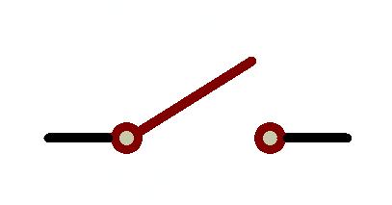switch
[1 Mark]

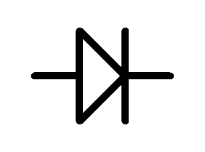Diode
[1 Mark]

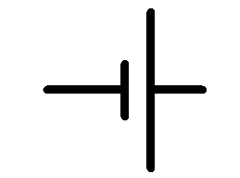Battery
[1 Mark]

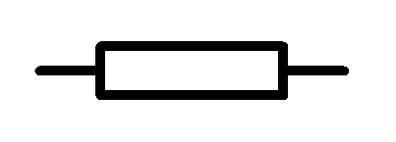Resistor
[1 Mark]

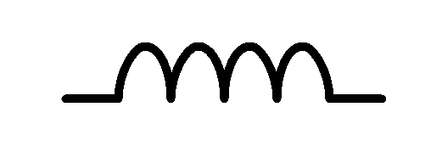Inductor
[1 Mark]

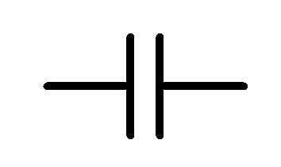Capacitor
[1 Mark]

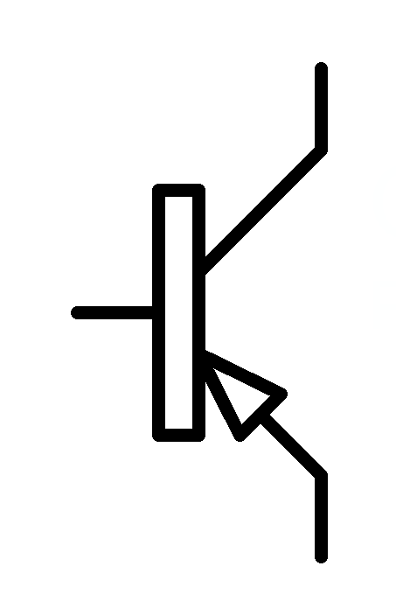PNP Transistor
[1 Mark]

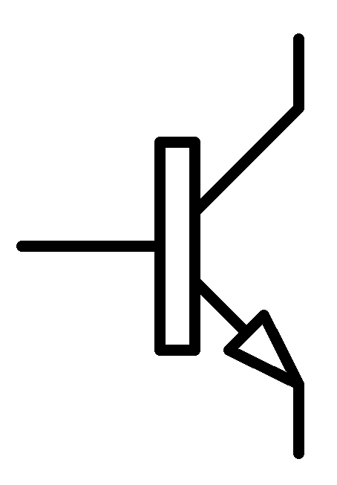NPN Transistor
[1 Mark]

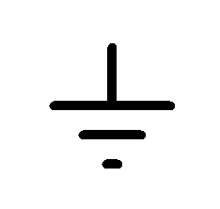Ground
[1 Mark]
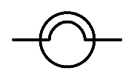
Lamp [1 Mark]
- Sketch the voltage – current relationship of a standard rectifier diode. Label the forward conduction voltage, the reverse breakdown voltage and the reverse leakage current.
[10 Marks]
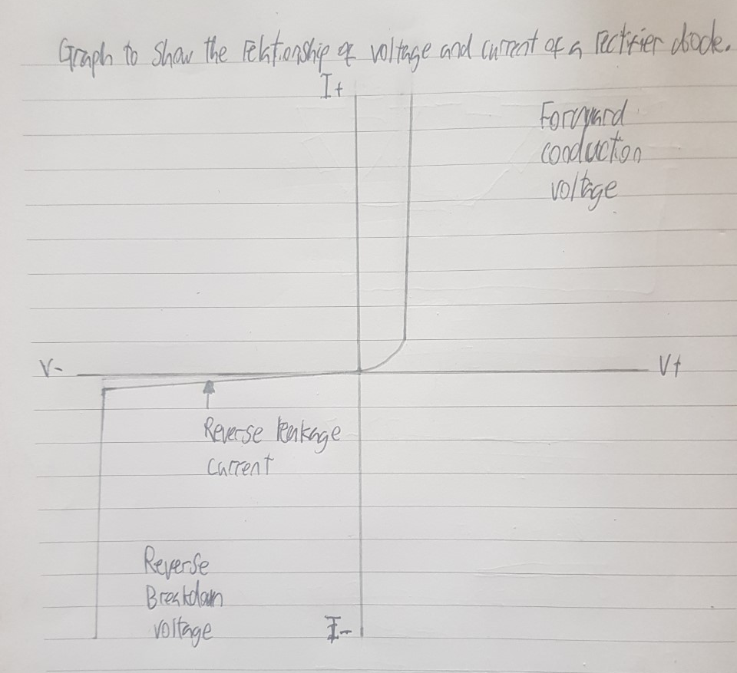

- For the circuit shown in fig Q3. Calculate the following:
  - Total circuit resistance
R1 = 1k
1/R 2+3 = 1/5600 + 1/220
1/R 2+3 = 1/0.0472$\dot{4}0259\dot{7}$
1/R 2+3 = 211.6838488
1/R 4+5 = 1/4700 + 1/3300
1/R 4+5 = 1/0.00515
1/R 4+5 = 1938.75
RT = 1000 + 211.6838488 + 1938.75
RT = 3150.433849 ohms
RT 3150.434 ohms 3d.p.
[4 Marks]
  - Total circuit current

15 ÷ 3150.434849 = 4.761248996 mA
= 0.004761248996 A
[2 Marks]
  - Current flowing through R2

[4 Marks]
  - Total power delivered by the battery
[2 Marks]
  - Power dissipated by R4

15 ÷ 4700 = 0.00319 A
P = 15 x 0.00319
P = 0.0479 W
P = 47.9 mW

[4 Marks]
  - R4 is replaced by a wire link. What is the new circuit current?
[4 Marks]

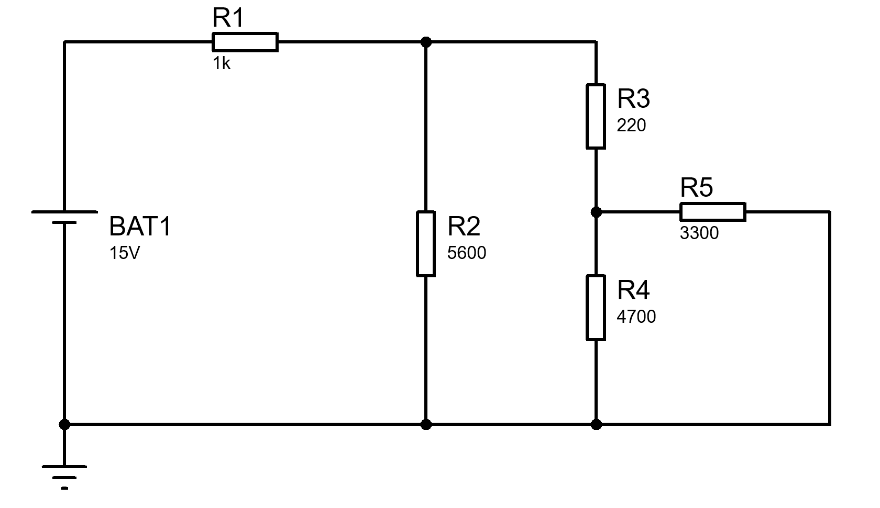
Fig Q3

- An oscilloscope display shows the above voltage waveform. The oscilloscope settings are shown in the box next to the waveform.

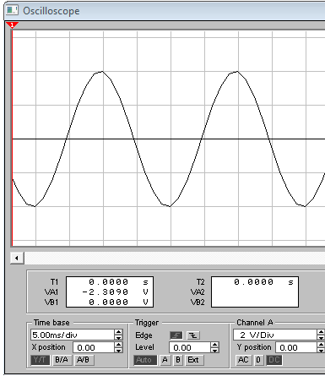
Oscilloscope settings:
50 mV/div
100 µs/div

Fig Q4

- Estimate the period of the waveform

4 div x 100 µs/div = 400 µs
[1 Mark]
- From the estimated period, determine its frequency

f = 1/0.0004
f = 2500Hz
[1 Mark]
- Determine its peak to peak amplitude

4 div x 50mV = 200mV
= 0.2 V
[1 Mark]
- Sketch the diagram shown in fig Q4 and indicate on it any two points between which the PERIOD (T) could be measured
[1 Mark]

- For a series RLC circuit where R=120Ω, L= 470mH, and C=1µF supplied from a 48V 400Hz supply,
  - calculate the voltage across:

    - The resistor
[2 Marks]
    - The capacitor
[2 Marks]
    - The inductor
[2 Marks]
  - Calculate the resonant frequency of the circuit

fres = 1/2π$\sqrt{0.47x0.000001}$
fres = 232.513442
[2 Marks]
  - At the resonant frequency, calculate the circuit current
[2 Marks]

- A 12 V battery has an internal resistance of 3 Ω,
  - Calculate the power dissipated by various load resistances and complete the table below
Load resistance of 1
12V ÷ 4Ω = 3A
P = 12V x 3A
P = 36W

Load resistance of 2
12V ÷ 5Ω = 2.4A
P = 12V x 2.4A
P = 28W

Load resistance of 3
12V ÷ 6Ω = 2A
P = 12V x 2A
P = 24W

Load resistance of 4
12V ÷ 7Ω = 1.71A
P = 12V x 1.71A
P = 20.57W

Load resistance of 5
12V ÷ 8Ω = 1.5A
P = 12V x 1.5A
P = 18W

Load resistance (Ω) | Load power (W)
1 | 36
2 | 28.8
3 | 24
4 | 20.57
5 | 18
[10 Marks]
  - Plot a graph of the load power against load resistance

[6 Marks]

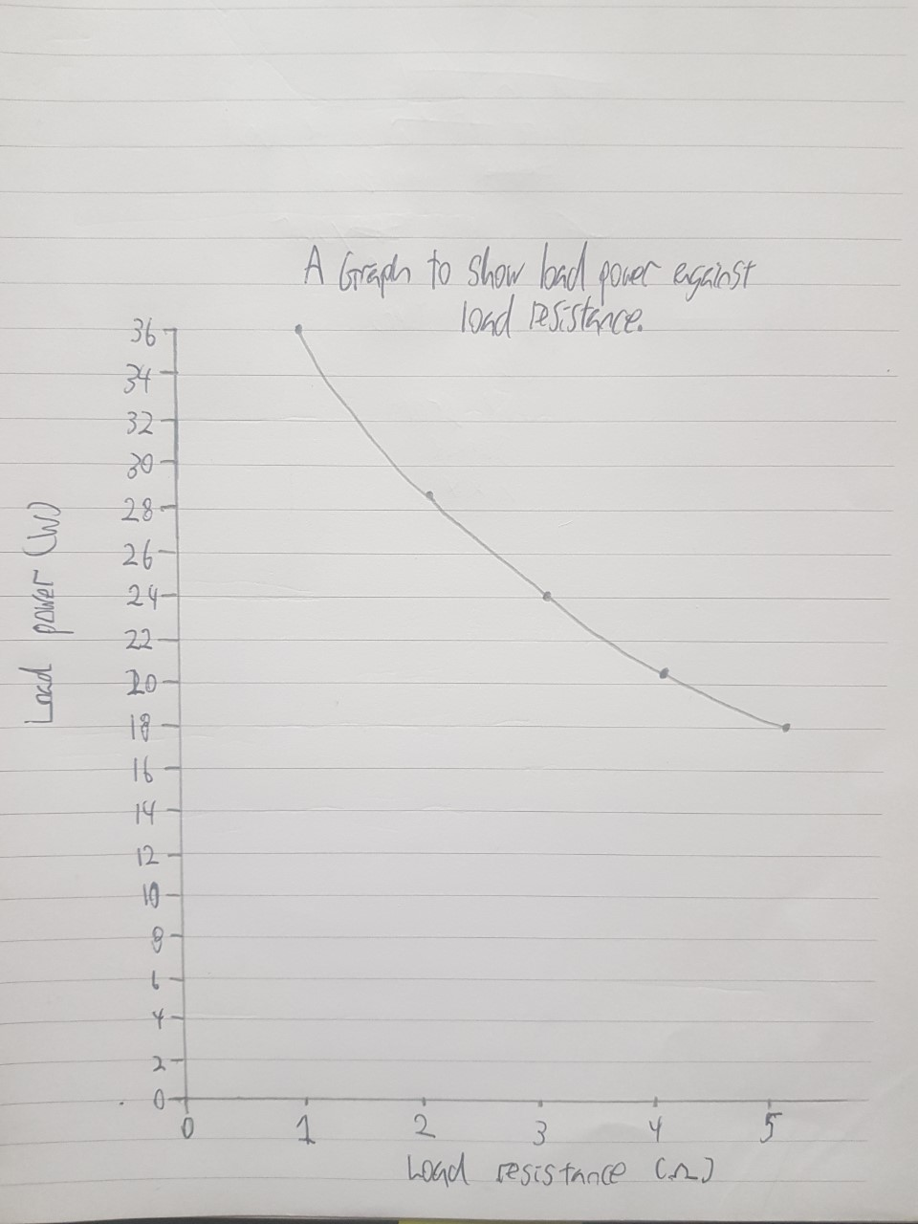

Diwedd/End

Formulae Sheet
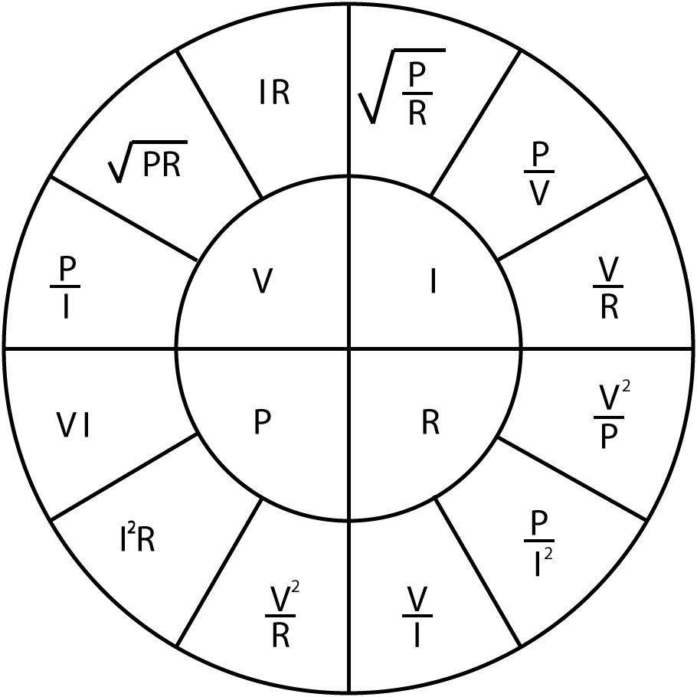 |  | $$R_{T}=R_{1}+R_{2}+…+R_{n}$$  $$\frac{1}{R_{T}}=\frac{1}{R_{1}}+\frac{1}{R_{2}}+…+\frac{1}{R_{n}}$$  $$\frac{1}{C_{T}}=\frac{1}{C_{1}}+\frac{1}{C_{2}}+…+\frac{1}{C_{n}}$$  $$C_{T}=C_{1}+C_{2}+…+C_{n}$$  $$L_{T}=L_{1}+L_{2}+…+L_{n}$$  $$\frac{1}{L_{T}}=\frac{1}{L_{1}}+\frac{1}{L_{2}}+…+\frac{1}{L_{n}}$$ | $$V_{Out}=V_{in}\frac{R_{B}}{R_{A}+R_{B}}$$  $$I=I_{in}\frac{R_{B}}{R_{A}+R_{B}}$$
$$X_{C}=\frac{1}{2πfC}$$
$$X_{C}=-j\frac{1}{ωC}$$

$$X_{L}=2πfL$$
$$X_{L}=jωL$$

$$Z=R+j\left(X_{L}-X_{C}\right)$$  $$\left|Z\right|=\sqrt{R^{2}+{\left(X_{L}-X_{C}\right)}^{2}}$$ | $$ω=2πf$$  $$X_{T}=X_{L}-X_{C}$$ | $$φ=\tan^{-1}{\frac{X_{T}}{R}}$$  $$pf=\cos{φ}$$ | $$f_{res}=\frac{1}{2π\sqrt{LC}}$$
$$V_{C}=V_{s}\left(1-e^{{-t}/τ}\right)$$  $$I_{C}=\frac{V}{R}\left(e^{{-t}/{RC}}\right)$$  $$V_{C}=V_{0}\left(e^{{-t}/τ}\right)$$  $$I_{C}=-\frac{V}{R}\left(e^{{-t}/{RC}}\right)$$  $$τ=RC$$ | $$τ=\frac{L}{R}$$  $$V_{L}=V\left(e^{{-Rt}/L}\right)$$  $$V_{L}=-V\left(e^{{-Rt}/L}\right)$$  $$I_{L}=\frac{V}{R}\left(1-e^{{-Rt}/L}\right)$$  $$I_{L}=\frac{V}{R}\left(e^{{-Rt}/L}\right)$$ | $$f=\frac{1}{2πRC}$$  $$A_{V}=20\log{\frac{V_{out}}{V_{in}}}$$  $$A_{P}=10\log{\frac{P_{out}}{P_{in}}}$$ | $$Q=\frac{X_{L}}{R}$$  $$Q=\frac{X_{C}}{R}$$  $$Q=\frac{f_{R}}{f_{U}-f_{L}}$$  $$Q=\frac{1}{R}\sqrt{\frac{L}{C}}$$
$$E=\frac{1}{2}CV^{2}$$
$$E=\frac{1}{2}LI^{2}$$
$$V_{B} \text{=}\frac{\text{RB2}}{\text{(}\text{RB}\text{1 + }\text{RB}\text{2)}}\text{×} V_{CC}$$  $$V_{E}=V_{B}-0.7$$  $$I_{C}=I_{E}$$  $$V_{C}=V_{CC}-\left(I_{C}×R_{C}\right)$$  $$Av=\frac{v_{c}}{v_{b}}$$  $$V_{E}=10\%V_{CC}$$  $$R_{IN}=\frac{1}{\frac{1}{{RB}_{1}}+\frac{1}{{RB}_{2}}+\frac{1}{\left(h_{FE}×R_{E}\right)}}$$  $$R_{OUT}=R_{C}$$  $$A_{V}≈-\frac{R_{C}}{R_{E}}$$ |  | $$V_{out}=-\frac{R2}{R1}×V_{in}$$  $$V_{out}=\left[1+\frac{R2}{R1}\right]×V_{in}$$  $$V_{out}=\frac{R2}{R1}×\left[V_{2}-V_{1}\right]$$  $$V_{out}=-\frac{R2}{R1}×\left[V_{1}+V_{2}\right]$$  $$V_{out}=-\left[\frac{R}{R1}×V_{1}+\frac{R}{R2}×V_{2}+…+\frac{R}{Rn}×V_{n}\right]$$

Detach this page and place in answer book

Student Number …………………………. Question Number ……………………….

