Colour and Emotion: Visual theories that allow us to see the way we do.
P149886
BA (Hons) Graphic Design
6029 words
Donna Williams

Figures

Fig 1.
SimplyPsychology (2010). Perceptual Set. [image] Available at: https://www.simplypsychology.org/perceptual-set.html [Accessed 4 Dec. 2018].

Fig 2.
SimplyPsychology (2010). Rat Man. [image] Available at: https://www.simplypsychology.org/perceptual-set.html [Accessed 4 Dec. 2018].

Fig 3.
CyberPhysics (2018). Electromagnetic Spectrum. [image] Available at: https://www.cyberphysics.co.uk/topics/light/emspect.htm [Accessed 4 Dec. 2018].

Fig 4.
KU College (2018). Grey Squares. [image] Available at: http://blog.college.ku.edu/visual-illusion-are-you-teamwhitegold-or-teamblueblack/ [Accessed 2 Dec. 2018].

Fig 5.
Art Studio Chalkboard (2012). Colour Mixture. [image] Available at: http://studiochalkboard.evansville.edu/c-opticsA.html [Accessed 2 Dec. 2018].

Fig 6.
MettreEnVeller (2011). Cool and Warm Colours. [image] Available at: http://mettreenvaleur.blogspot.com/2011/03/warm-colours-vs-cold-colours.html [Accessed 4 Dec. 2018].

Fig 7.
Van Gogh, V. (1888). The Bedroom. [oil paint] Amsterdam: Van Gogh Museum.

Fig 8.
Trauma Informed Practice (2016). Trauma-Informed Practice. [image] Available at: https://www.trauma-informedpractice.com/online-live-courses/online-course-catalog/ [Accessed 2 Dec. 2018].

Fig 9.
Belanger, M. (2015). [image] Available at: https://www.michellejbelanger.com/art-therapy.html [Accessed 2 Dec. 2018].

Fig 10.
LEHAR, S. (2016). [image] Available at: http://braungardt.trialectics.com/sciences/psychology/gestalt-psychology-2/ [Accessed 2 Dec. 2018].

Fig 11.
Flagg, J. (1917). I want you for the US army. [image] Available at: https://amhistory.si.edu/militaryhistory/collection/object.asp?ID=548 [Accessed 2 Dec. 2018].
(Flagg, 1917)

Fig 12.
K. Stauber (1936). Germany Lives. [image] Available at: http://h-street1316-dc.blogspot.com/2014/03/brief-2-cop-publication-page-content.html [Accessed 2 Dec. 2018].

Fig 13.
NAZI propaganda poster (1937). Give me 4 years time. [image] Available at: https://www.nytimes.com/2008/08/03/books/review/Benfey-t.html [Accessed 2 Dec. 2018].

Contents

Introduction

Chapter one: How we see?
1.1. Perception
1.2. Colour

Chapter Two: Visually Evoking Emotion
2.1. Art Therapy
2.2. Gestalt

Chapter Three: Application of Colour and Emotional impact
3.1 Propaganda

Chapter Four: Discussion

Chapter Five: Conclusion
Introduction

As a designer understanding how our work can have an emotional effect on the people viewing it is vital, as this can aid the success of the work. How a person perceives and responds to the design in that given moment of time is a subconscious process, but I want to have an understanding as to how this process happens. I am going to focus my research on understanding how the brain perceives visual information and how each individual can interpret things differently, how past experiences, culture and general perception can have an impact on what we see and what we feel when we look at things.
In my writing am going to be focusing on how we see and perceive, how we emotionally respond to what we see and then how understanding these factors can lead to a more successful design; focusing on propaganda and how this can cause an emotional response in people. I want to understand the subconscious process of perception better and have a better insight into how to make art and design outcomes more thoughtful and ultimately more successful, and how propaganda has such a mass impact.
In chapter one I will look at how we see. In this chapter I will research into psychological theories of perception and how our brain process’ information to allow us to see and respond to the stimuli in the way that we do. Focusing my research on proven theories of perception and how these impacts our thought and the way that we see art and design. I will also look at how we see colour and how our brains process the information to allow us to see these colours the way that we do. I will also be researching into how colour can evoke an emotional response from us as we look at it, and how designers can use colour to improve the impact of their work.
In chapter two I will look at how visual imagery evokes emotion and how different ways of thinking impact on the perception of a visual piece. I will research art therapy as I think understanding how this practice works will give me a more informed idea of how visual imagery and creation can give us an emotional response and offer a way for us to connect to imagery. I will also research ways of thinking, and theories of how we see and how we can think when looking at things.
In chapter 3 I will look at how propaganda is designed, I feel that this is relevant as its whole purpose is to evoke an emotion, persuade you do do/believe in something or to change/enhance your perception of a person or idea. Propaganda is using all of the things discussed earlier to its advantage and I will be researching and showing examples of this.
Chapter one: How we see?

1.1. Perception

In the field of perception there are several theories that show us how our brain processes visual data and creates a cognitive and emotional response. This chapter will give an understanding in some of the theories that are proposed that allow us to perceive the way that we do.

Perceptual Set
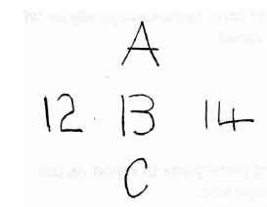
“Perception of the present, memory of the past, and expectation of the future’.
Perceptual set puts forward the idea that perception is an active process involving an interpretation of what is being viewed. Allport (1955-) defined this as “A perceptual bias, or predisposition or readiness to perceive particular features of a stimulus”. Shown in the Bruner and Minturn figure 13 (Fig 1).

The concept of perceptual set is that we have pre-conceived ideas of everything that we are going to perceive. This can affect by the mindset, mood, emotion etc. of the viewer. It states that expectations, motivations and culture have the biggest effects recorded.
Fig 1.

A study by Bagels and Alampy in 1961 used the image shown of “Rat-Man” (Fig 2). This study was set out to prove the effect that expectation has on perception. In the study people were shown images of animals and humans prior to being shown the above image to try and determine whether expectation had an effect on perception. First the subjects were shown images of animals prior to being shown rat-man, in this case they perceived the image as a rat. But, when they were shown images of people prior, they perceived the rat-man image as a man. This shows that expectation has a heavy influence on what we perceive.
Fig 2.
Perceptual set also studies how motivating factors can change our perception. Factors like bodily needs (food, water, psychological), emotional needs, values, reward and punishment. For example, a hungry person would view a distorted red circle to be an apple or tomato etc.
“Perception can also be influenced by an individual’s expectations, motives and interests. The term perceptual set refers to the tendency to perceive objects or situations from a particular frame or reference” (Hockney, 2008.)
This way of perceiving is useful to us, it allows us to make quick judgements on scenarios, objects etc. and also, to help us make decisions based on our past experiences with similar conditions. Also, when we are wrong about what we perceived we build new perceptual sets so that next time we encounter a similar situation we can perceive it better or correctly. But with this theory it identifies that it can lead us to perceive incorrectly when we are unaware of our error or inability to perceive correctly. Our minds can show us what we want to see, and this can lead to wrong or misjudged perception which could go unnoticed.
This way of perceiving is known as ‘top down processing’, it generalizes what we see, corresponding to what we have seen before. It starts with a general view and then gets more specific. The general perception is what we expect to see and if we are if we are happy with this then that’s what it is taken for, we accept our perception as the reality.
Emotions play a huge role in our visual perception at any given time. If a person is angry, they will often see objects, people, expressions etc. as aggressive or negative. If they are happy then research shows that they perceive situations more positively.
Perception of the present, memory of the past, and expectation of the future. (Gombrich, 1983).
This sums up the general idea behind perceptual set. Our brains will show us what we already know without the need to actually physically perceive it. The reality can be very different to what our mind perceives. This is a very powerful concept to understand for designers, it allows the capacity to create motion, fluidity, flow and give the still image some expression. Our past perception experience can alter our current perception of reality.

Behavioral and Geographical Environment

“we can be attracted or repelled from things in our environment, but that these forces of attraction or repulsion only occur in the behavioral environment, not the geographical one” - Koffka. (Sughito,2016).
How we interpret all of the characteristics of the environment will dictate the perception that we have of it. What we see is what is there but how we interpret it is down to experiences, and principles learned through our lives. The presence of one’s ego or massive swings in one’s moods, health etc. can change the behavioral environment dramatically. If the creator of the work is in a negative or positive behavioral environment, then this could have the corresponding effects to the geographical environment or vice versa. All aspects of our makeup have an effect on our creative process, whether it be mental, motivational or social factors. The output of creativity is fueled by the stimulus that effects the internal. Visual creatives can capitalize on this theory, understanding the environment to which the visual will be placed is paramount to the success or the impact of the design.

Affect Theory

Affects over time are what form our personalities, our views, our action and reactions. In design affect is a huge factor in the success or failure of a piece. Design can have an extremely diverse range of effects on people, with each response being slightly different, or individual.
Our ideas and experiences tend to be common but not deep, or deep but not common. We have neglected the gift of comprehending things through our senses. Concept is divorced from percept, and thought moves among abstractions (Armstrong, 1991).
When something like affect is considered in a creative format it becomes difficult to pick a singular answer, as each response is individual. This is where affect theory helps create a better understanding and consideration for a person’s views. With this considered it poses the question is subjectivity or individual perception simply the final answer to a collection of one’s objective views, a sum of all the parts.
All the parts having clear explanations of as to why someone likes or dislikes. The ability to look at someone’s reaction and deconstruct it is a key role for the creative as it can give a deeper understanding of how humans have emotional reactions to visual stimulus.
After deconstructive reading, the art object remains. Life goes on. Art, whether we will or not continues providing effects. Affects are immanent to matter. They are certainly immanent to experience. (O’Sullivan,2001)
Affects make up everything around us, art and design is made up of affects. The creatives response to his medium is a reaction to their affects over time. This is then deconstructed by the viewer. Art historians decode art of the past and find links as to how the world at the time caused a certain style, painting, design etc. but the creator was simply reacting to the stimuli (affects) around them.
To derive such generalities from a work of art is laborious, but not different in principle from trying to describe the nature of the other complex things, such as the physical or mental makeup of living creatures. Art is the product of organisms and therefore probably neither more nor less complex than the organisms themselves. (Arnheim, 2004).
The art is the affects frozen in time. If affects are taken for what they are; a moment, an event, then the art or design is simply a reaction or response. Essentially emotion is what triggers the creating, making, reaction, action etc. emotion is the underpinning factor of affect.
The effects of the world around us have an impact on the work produced and the opinion of the viewer at that present time. Emotion is the feeling at the present, this is relevant for viewer and creator. If emotions are personal experiences, then affects are the forces that perceive, produce and from such experiences.

1.2. Colour

The colours that can be seen by the human eye are all part of a huge range of vibration energies, this is known as the electromagnetic spectrum. The electromagnetic spectrum is much larger than what we can see extending to radio waves and gamma waves. The portion that we can see is visible light. A misconception is that we see colour with our eyes, we actually see colour with our brains. Our eyes simply Chanel the waves of light into our brains visual center; Occipital lobes. Each wave of energy that comes into our eyes has an energy value, this value corresponds to a colour. This is the colour that our brain will then process and therefore the colour that will be seen.

Colour is one of the key elements to any visual piece. Whether that be in art, nature, design etc. colour is responsible for aesthetic and psychological properties to us. It not only pleases or displeases us visually, it also allows people to feel something when they look at it.
Colour evokes moods; expresses feelings and even affects your physical sense of well-being (Cherry and Gams, MD, 2018).
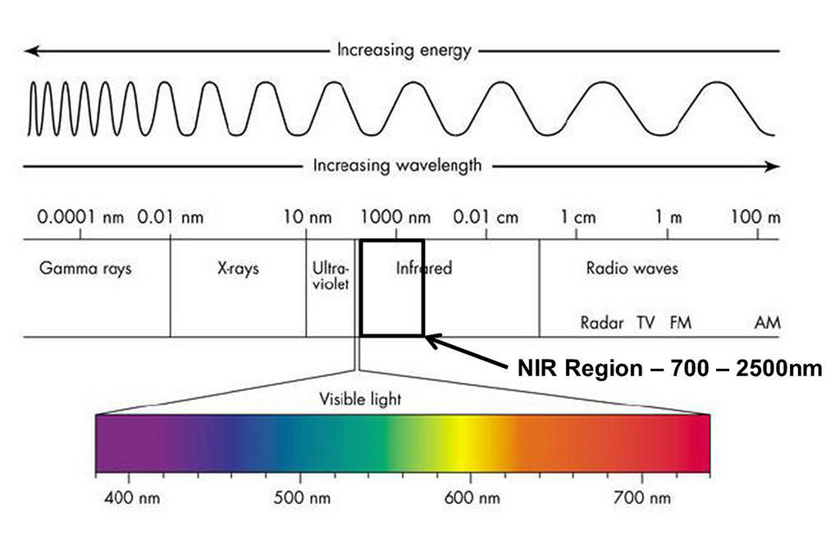
Fig 3.

There is no definitive way of proving that each and every person is seeing the exact same colour at any given time. The brain will take information from what it is seeing and try and extractive relevant data, this will them provide the viewer with an image (perception).
No one will ever be sure that his neighbor sees a particular colour exactly the same way himself does. We can only compare colour relations (Roy and Bomford,2000.)
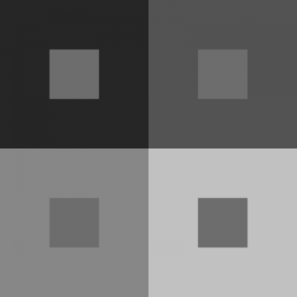
Like in the way that we see colour, colour relations work in a similar way. We compare what we see from a range of pre-determined colours on a chart, spectrum etc. These then will be assigned and therefore will the agreed colour of said object.

There is a slight variation in the way that colour appears to the human eye when we look at it in different contexts, colours that are side by side will appear slightly different due to hues, this is known as simultaneous contrast. Greys will appear slightly pink, blue on red will appear slightly green etc.
Colours appearance always tends toward the complimentary hue of the colour surrounding it. One colour can be made to look like two, or two or more can be made to look like one. (Bloomer,1990.)
Fig 4.

This leads to a phenomenon called optical mixture. This is when the edges of shapes are lost and become difficult to see clearly. This can lead to the visual losing its shape and become a blur/blend of colour rather than defined individual shapes. John Ruskin said
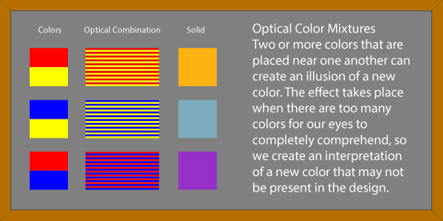
Fig 5.

Every hue throughout your work is altered by every touch that you add in another place; so what warm a minute ago, become cold when you put a hotter colour in another place, and what was in harmony when you left it, becomes discordant as you set other colours beside it. (Arnheim, 2004).
This gives a good idea of the complexities of colour and the fine line that designers have to walk on to find balance and harmony in a piece of work. An over exposure to a colour for too long can also have a great effect. If an artist was to sit in front of a red canvas for hours on end with no breaks, that red would lose its brightness, along with this other colours would take on a red hue and therefore change the colours perceived.
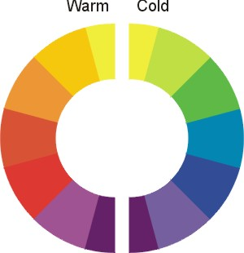
Fig 6.

When colour is described it is said to be either warm or cold. This is not only a description of what we see but a description of our reaction when we view the piece. It is the same as our interactions with humans, you can have a warm interaction with someone; friendly, kind, caring. Or on the other end it can be a cold encounter where you feel at unease and uncomfortable. Designers use this all the time in their work to provoke the desired emotions that they want from their work, whether this is intentional or subconscious.

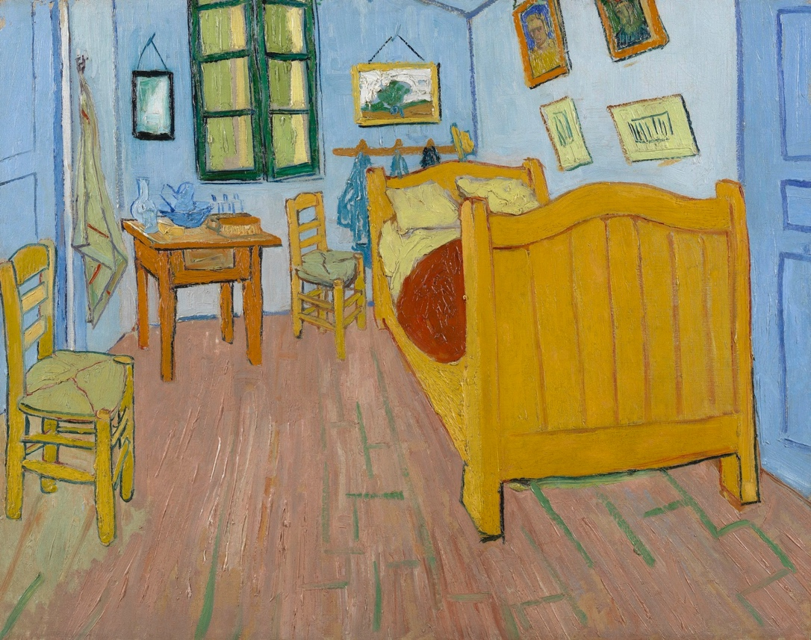
Van Gogh used to apply these principles to his work, most notably the painting of his bedroom in Arles (1888). This piece of art is very special due to us knowing the exact intention of the colour as Van
Fig 7.

Gogh wrote to his brother Theo and friend Gauguin describing the use of the colour and the feeling that he hoped to provoke. The letter was written to Gauguin in October 1888 and reads
“…my bedroom with its furniture of whitewood which you know. Well, it amused me enormously to do that interior with nothing in it, with a simplicity a la Sevrat: with flat paint but coarsely put on, the neat pigment, the walls pale violet… I wanted to express an absolute calm with these very different tones, you see, where there is no white expect in the mirror with its black frame…” a further letter to his brother Theo “…colour alone must carry it off… it should be suggestive of rest and sleep in general. In other words, the sight of the picture should rest the head, or rather the imagination… the walls are pale violet and the floor red… the doors are green, that is all… it is colours with flat tints… . (Gombrich, 1983).
This gives an insight into the thought that get into the paintings and what the artist intends for us to see, and how much of an influence colour has on our perception.

Colour can provoke certain emotions, this is an area that has been observed for many of years. Any combination of shapes, lines and colour has the ability to provoke and influence our emotions. Dr. Ernest Schachtel (1903-1975) implied that the way we perceive colour and experience is significantly similar to that of affect and emotional response. In these cases, we are passive receivers of the reality and the stimuli presented to us. He stated that
“An emotion is not the product of the actively organizing mind. It merely presupposes a kind of openness, which for example a depressed person might not have”. (Arnheim, 2004).
With this in mind it suggests that colours role is essentially to produce an emotional response and experience and shape withholds the form to which colour complies. Schatachel went on to say further
The expressive qualities (primarily of colour, but also shape) that spontaneously affect the passively receiving mind, whereas the Teutonic structure of pattern (characteristic of shape, but also found in colour) engages the actively organizing mind…. Through time and across cultures people have ascribed various meanings to colours. Colour invests ritual and custom with symbolic meaning, represents the identity of cosmological forces and promotes desirable feelings and mind/body states. It is tempting to look for universal colour symbolism because of certain constants in human experience i.e. Blue sky, green grass, orange/red fire. But these experiences do not mean the same in every culture. (Armstrong, 1991).
The way that each individual reacts, experiences or views colour is an individual experience. Like with affect theory, each colour will mean something different to each person. This is where colour becomes a hard area to objectify. Culture plays one of the biggest roles in the subjectivity of colour. For example, in the UK white represents purity and innocence, traditionally the chosen colour for wedding dresses. In china and other again contras white symbolizes death and spirits. This displays the vast diversity of colour meanings around the world; The emotional responses and the visual experience to colour will be vastly different.

Chapter Two: Visually Evoking Emotion

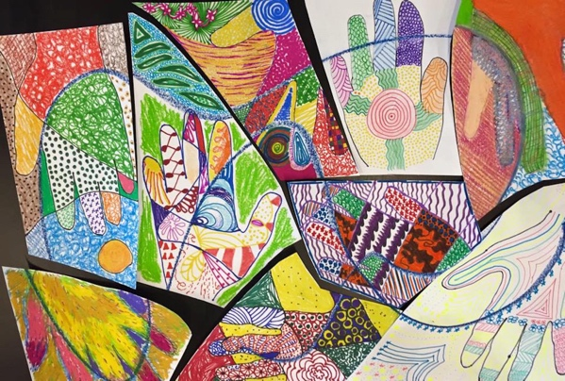
2.1. Art Therapy
Fig 8.

Art therapy is a unique to the person partaking in it, it is an individual experience.
What happens in art therapy? … What happens is always different, always unique to the individual and often quite inspiring (even mysterious), but it is hardly ever without some change for the better in the psychological state of the patient’ (Connell, 1998).
Art therapy has grown in popularity with psychologists and counsellors to help aid with patient’s recovery from a wide scope of mental illness.
Art therapists believe that the artistic process brings to surface feelings and emotions in the same way that free association does, incorporating benefits of both talk therapy and dream analysis, but accomplishing more than either one does alone (Case & Dalley, 1992; Ganim, 1999).
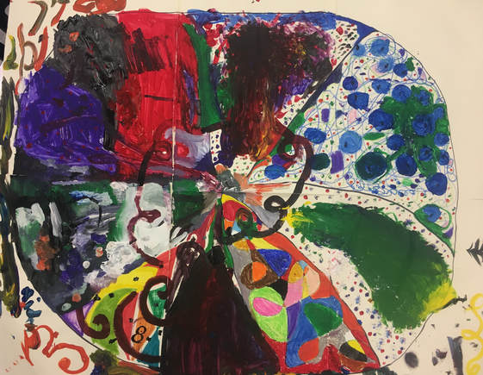
Understanding how visual perception can affect the mental health of a person is vital to the counsellor or psychologist in their role of helping the patient. It can also be important to an artist or deigns creating a visual piece. The theories of seeing have allowed and created a deeper understanding of people’s views, beliefs and perception of their world, and give a in depth knowledge of how-to asses and help them. The better research and understanding of colour has given a better insight into the understanding of emotional responses and how each individual colour can trigger a different response is an area that has helped move the understanding forward.
Fig 9.
most of the focus in art therapy is on the creation of an image or a representation of reality. Ostensibly missing from the discussion are the therapeutic benefits of nonrepresentational visual art. Preimage elements of art, such as line, form, and color, can be used by clients themselves in their own healing (Rhinehart & Engelhorn, 1982).
The research completed looking into the visual theories that allow us to perceive the world in the way that we do have given an insight into the way to which we subconsciously perceive the world. Understanding this has allowed me the insight into art therapy and how it functions practically. Applying these theories to real world experiences to create links and cross references for a further understanding.
Emotional response and how we react to visual imagery are a psychological response. In a world where verbal communication dominates it is very rare that the communication is through visual, no words need to be exchanged.
To be able to communicate through silent empathy is a rare experience. (Connell, 1998).
The creative process can for some have a very therapeutic value, allowing them to release any inner tension or realize that these inner emotions are present. The strive to create something perfect isn’t the goal of this therapy as this method could prove very detrimental to someone’s health, adding to their anxiety further. This strive for perfection has caused a lot of artists to have mental breakdowns. The purpose of art therapy is to realize and get emotions out through different artistic mediums.
Like discussed before art therapy has similarities to the visual perception theories discussed and how it works as a practical healing method. One that has a similarity is Affect theory. Affect theory is the collection of experiences that make us perceive the way that we do, in Art therapy
‘patients find memories arising as they begin to make pictures - sometimes happy, often poignant, always significant. No art work, however seemingly understated, minimal, bland or simple can be dismissed because it may appear naive, but the patient will recognize where the image comes from’. (Connell, 1998).
This recognition of where the image is coming from is the awareness of affect. The understanding of what might be causing the person to feel that way as opposed to with affect theory the thing that is causing the person to perceive in that way.
There is now a greater importance placed on our emotions and how our inner feelings are voiced and protected. The awareness that visual imagery can have such a great impact on the person viewing it or the person creating it is something that needs to be taken into great consideration on both sides. The psychological impacts on the way we perceive and the emotional responses to this.

2.2. Gestalt

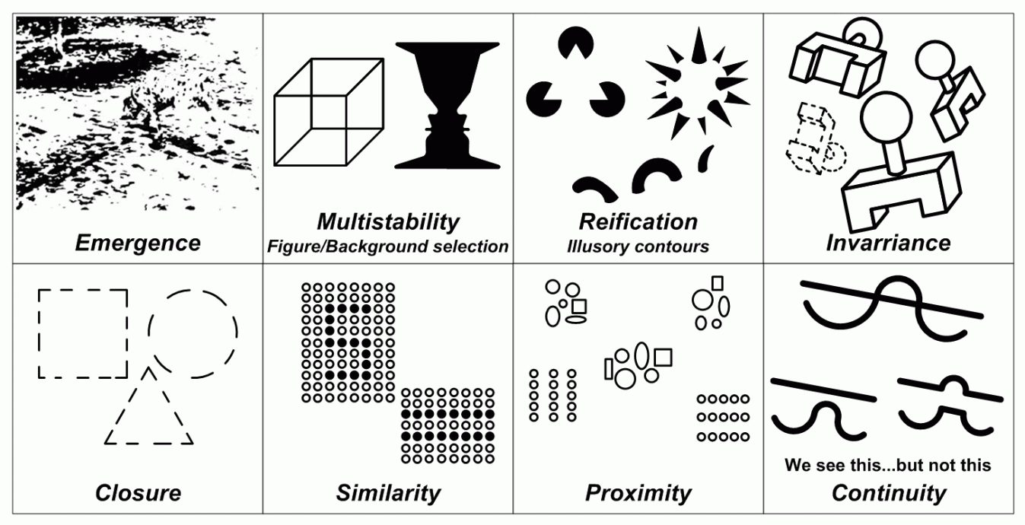
“gestalt psychology originated as a theory of perception that included the inter-relationships between the form of the object and the process of the perceiver… Gestalt thinking emphasized ‘leaps’ of insight, closer, figure ground characteristics, fluidity of perceptual process and the perceiver as an active participant in his perceptions rather than a passive recipient of the qualities of form” (Fagan and Shepard, 1986).
Fig 10.

The whole is more than the sum of its parts. This is the vague outline of Gestalt theory. It is the study and acknowledgement that humans tend to subconsciously piece shapes, ideas and concepts together to form a more unified whole. It implies that our minds give us representations of what the actual reality is. What we think we see might not be what the creator intended us to see as our minds may not correspond completely to what is in actual reality. Essentially, we construct our own reality, views, sight etc. in our own heads. Gestalt therapy acknowledges this concept and takes it further. The Gestaltist way of thinking seeks to help us identify parts that we have hidden away or are blocking ourselves from seeing.
Most of us by the time that we are considered adult and mature, have forgotten how to be ourselves. We remember just enough of what being ourselves feels like and we are afraid of it. Gestaltists offer a way to get through this wall of fear - we seek ways to recognize what we have hidden away. (Rhyne, 2001)
With psychological theories there has always been a grey area with the accuracy and measurability of the theories as it is hard to measure and produce solid analytics due to the nature of the brain. As everyone is individual it means that we cannot expect the same results or reliable data. But, with gestalt theory this isn’t the case. It was vigorously tested and taken to the laboratory and produced incredible results. From these tests and results the main characteristics of the theory were formed.
Gestalt theory sates that we must approach humans in a holistic mind set and view point. We cannot focus on the mind in a singular fashion; as this would be ignoring the amazing complexities and would be reducing the power that the brain has.
The world has a dynamic reality and we must appreciate and acknowledge this fact. In a dynamic reality there are active components. These active components are humans and nature, both are active in reality. Humans are all uniquely active, therefore the perception of one’s reality going to be different to the perception of another. Humans have their own vision, thoughts, ideas and experiences. How one’s brain processes and receives the elements of this dynamic reality is individual. This concept must be taken into account when looking into Gestalt theory.
The Gestalt theory seeks to take the above concepts and find a simplified solution and to answer how we perceive as individuals. Perception as a concept is holistic. It’s the end result of our brain collecting all relevant data and allowing us to understand what we are seeing, hearing, smelling etc.
The application of Gestalt theory in psychological areas is one that had profound effects.
“productive thinking consists of carrying out creative reorganizations of the elements of the problems in order to solve them. Reproductive thinking is limited to applying the previous knowledge in a mechanical way”. (Salazar, 2017)
If someone was to approach perceiving in a reproductive thinking way, then they would fail to see the meaning and miss the concept; as they would start attaching their past ideas and experiences to it. Productive thinking however would allow the person(s) to see it for what it is, in that moment. This could lead to a more positive opinion or perception of the reality, being more open minded to the concepts and ideas presented. Gestalt theorists insist that we must think productively.
The understanding that each of us has our own truth, this then leads into the idea that as humans we have no limit to creative potential. The key is the understanding and the ability to be present in our reality, ready to perceive it for what it is and not what we think it could be. Our creativity or expressions can be good indicators to the psychological state that the given person is in. Art materials can be a way of allowing a people to express themselves; expression is something that they could have been denied. This is known as gestalt art experience.
Bring realizations together into the pattern of my own gestalt, who's every part is related to the total configuration that is me - past, present, future…. Every line you draw is uniquely yours; the ones I draw are individually mine, each of us is involved in our own personal happening. When you engage in an art activity, you are experiencing yourself; what you produce comes not from a depersonalized “it” but from a very personal you. (Rhyne, 2001)
Gestalt theorists think that we should learn by discovery, learning is part of the dynamic reality and is a constant process. Thus, why we should not rely on the old thought and ideas to interfere with the current creative potential, the expression is in the moment. The lines and shapes produced are a graphic representation or record of what we perceive, whether this be a thought, feeling or thing.

Chapter Three: Propaganda
3.1. Propaganda

The idea of propaganda is to psychologically manipulate the masses, to persuade people into thinking a certain way (often seen politically), also for deception or intimidation. It can also be a way of people spreading a message of good, a true message that can help bring togetherness to a somewhat divided group. Gustave Le Bon (1841-1931) had well known and respected characteristics of the masses, he thought of them to be De-individualized, irrational, easily influenced, prone to violent action and all together of regressive nature.
Fig 11.

“If the individuals in the group are combined into unity, there must surely be something to unite them, and this bond might be precisely the thing that is characterized of a group. (Adrono, 1991)

For the designers and artists making the propaganda this all had to be considered, the influence of the work and how they wanted their message to be perceived was vital as it would dictate the success or failure of their work. Propaganda is not just about making the art visually appealing, it has to have certain elements discussed earlier in this paper to make for a successful campaign. The most famous example of this is the poster shown on this page.

Fig 12.

Throughout history people have used art to influence the beliefs and behaviors of others… art has been used to educate us, to mold our opinions. (Timmers,1999).
When we look at propaganda and the impact that it has had in global conflict it is clear to see that from a design point of view the Nazis had the most considered design. When looking at the campaign and the movement as a brand the style is well considered. The consistency of colour and simple geometric forms is most notable. Hitler had a clear vision as to how he wanted his movement to be perceived, he identified that there are many parts that need to be considered to make up a whole visual. Like discussed earlier with the Gestalt approach; The whole is more than the sum of its parts. Hitler would take the time to arrange geometric formations, symbols and other components, piecing together all of these parts to make the whole a better image.
“But the most brilliant propagandist technique will yield no success unless one fundamental principle is borne in mind constantly and with unflagging attention. It must confine itself to a few points and repeat them over and over. Here, as so often in this world, persistence is the first and most important requirement for success.” ― Adolf Hitler (Goodreads.com, 2006).
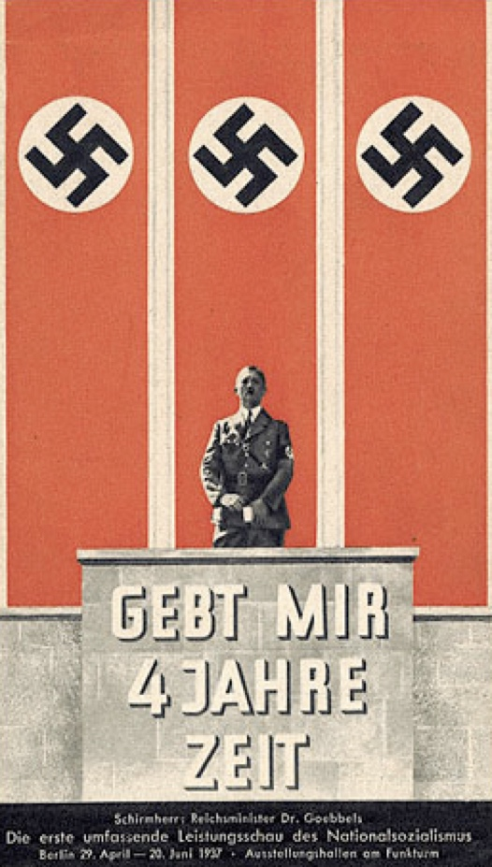
One of the biggest success from the designers was the implementation of colour. When people think Nazi, they think of the strong influences of red and black. The reaction to colour from humans is subconscious and we are not aware of the impact that it can have on us. Colour has powerful psychological effects and can stimulate feelings and emotions. Dr. Joseph Goebbels, the Reichsminister of Propaganda for the Nazi was very aware of the effects of colour and how people can associate colour with movements, memories etc.
It has been observed, for example, that Goebbels could play on the will and emotions of the masses as though he were playing a musical instrument. In Nazi propaganda, hues in the red spectrum, for example, tended to predominate visual media designed to appeal to and stir patriotic feelings whilst darker shades, such as black and grey, tended to prevail in propaganda designed to activate anti-Semitic emotions. His methods are noted for their incredible effectiveness. (Broudy, 2009).
Fig 13.

Chapter 4: Discussion

The visual theories that I have outlined in this dissertation that allow us to see the way that we do, have shown that perception is a process. There are certain key elements that work together to give us a whole visual perception. The Gestalt approach of acknowledging that the whole is more than the sum of its parts implies that humans perceive holistically at first and that it takes time invested and the ability to step back and analyze the object to get a deeper understanding or a different perception. The active process of perception that is put forward in the perceptual set theory supports the argument of the Gestalts.
Humans have a perceptual bias to the stimuli, we have pre-conceived ideas of what we are about to perceive. We quickly make judgement on the whole object, perceiving something that may not actually be present, with expectation of the stimuli dominating our perception.
My research also shows that past experiences have a profound effect on perception. Affect theory tells us that experiences of the past inform our perception of the present. The stimuli can trigger emotional responses in people. Emotion is a limiting factor of our present perception of the stimuli. Along with the visual perception theories, colour plays a huge role in our emotional responses to stimuli. Dr Satchel drew parallels between colour and affect, stating that we have emotional responses to both. With colours response having symbolic meaning, culturally or personally.
In my research it is evident that emotion is a dominating factor of perception. How we perceive can be hugely affected by our emotional and mental state at the time. Mental state can give us an openness to perceive or a very closed off perception. I found this evident when researching propaganda. The role of propaganda is to psychologically manipulate people and to change their way of thinking. Capitalizing on a present mental state. An openness to new ideas or a closed off perception that can be equally manipulated. When propaganda is designed it is thought out in this way. It gives people something to emotionally connect to and join with. Carefully chosen colour and a collection of design elements that really can get people thinking and connecting with is what is required for a successful campaign.
My research has shown me that emotion is at the forefront of everything that we perceive. But with emotion comes a lot of grey areas with the theories that are discussed. As emotion is a personal thing with everyone being different then it is impossible to know for certain that everyone is perceiving in the same manner. The theories discussed all work towards the idea of perception being a process, but with emotion involved does this make perception spontaneous and too personal to simplify down to a scientific theory. With psychological theories there will always be grey areas and especially with something such as perception.

Conclusion

In my paper I have learned that perception is a process, one that humans subconsciously go through. We are unaware in the present moment of what our brains are doing, as it just happens. Perception happens instantly due to many of the theories that I discussed earlier, and this is affected by our present emotions. I have concluded that there are stages of perception and that it can be methodical, but the overriding factor of emotion is what dominated and eventually leads us to our final perception. The ability to be aware of our emotions will allow us to have a more open perception of the world around us and allow us to make better and more informed perceptions.
Being a designer, it has taught me that there are several key elements to making a good design. We have to consider the viewer of the work as well as ourselves. It has shown me that colour and shape can have a profound effect on someone’s emotional response to a piece and that these elements need careful consideration.
I have also learned that we cannot control what someone will think of our work. A mental state of the viewer could close them off to perceive our work in the way that we want, and this is just part of being human.
Overall, I have learned that perception is individual and personal. Each person will go through their own personal process of perception which will be informed by their past experiences, cultural beliefs and personal state of mind. With emotion leading this process.

Bibliography

Angelika (2001). The aesthetic of effect. Theoretical Humanities, 6(3), p.126.

ARNHEIM, R. (1986). new essays on the psychology of art. University of California.

Adrono, T. (1991). The Culture Industry: Selected Essays On Mass Culture. Routledge, p.135.

Armstrong, T. (1991). Colour perception. Diss, Norfolk, Eng.: Tarquin Publications, p.0.

Arnheim, R. (2004). Art and visual perception. Berkeley, CA: University of California Press, pp.2, 362.

Berger, J. (2008). Ways of Seeing. Penguin Classics.

Broudy, D. (2009). The Propaganda of Patriotism and Colour. Communications Journal, 1(1).

Bloomer, C. (1990). Principles of Visual Perception. TAB Books Inc, p.94.

Cherry, K. and Gams, MD, S. (2018). Color Psychology: Does It Affect How You Feel?. [online] Verywell Mind. Available at: https://www.verywellmind.com/color-psychology-2795824 [Accessed 2 Dec. 2018].

Fagan, J. and Shepherd, I. (1986). Gestalt therapy now. New York, N.Y., [etc.]: Harper & Row.

Fonagy, P. (2010). Affect Regulation. Other Press Professional.

Franklin, B. (1994). Packaging politics. London: Arnold.

Goebbels, J. (2018). Top Joseph Goebbels Quotes That Reflect His Thought Process. [online] Quotes.thefamouspeople.com. Available at: https://quotes.thefamouspeople.com/joseph-goebbels-2005.php [Accessed 3 Dec. 2018].

Gombrich, E. (1983). The Image and the Eye: Further Studies in the Psychology of Pictorial Representation. Phaidon Press, p.47.

Gwinner, K., Knox, M. and Hacking, S. (2009). The place for a contemporary artist with a mental illness. Journal of Public Mental Health, 8(4), pp.29-37.

Hoffmann, H. (1996). The triumph of propaganda. Providence: Berghahn Books.

IMPACT OF PSYCHOLOGY IN ART. (2015). International Journal OF Engineering Sciences & Management Research, 2(2).

Jankowski, M. (2018). Who Is Feeling Red, Yellow and Blue? Rothko and Color Perception. Bachelor Art History. University of Amsterdam.

Jones, A. (2012). Seeing differently. Hoboken: Taylor & Francis.
Kaplan, F. (2001). Areas of Inquiry for Art Therapy Research. Art Therapy, 18(3), pp.142-147.
Kin Man, N. (2014). Affect Regulation and Treatment for Depression and Anxiety through Art: Theoretical Ground and Clinical Issues. Austin Publishing Group, 4(1).

Koffka, K. (1935). PRINCIPLES OF GESTALT PSYCHOLOGY. [online] Gestalttheory.net. Available at: http://gestalttheory.net/cms/uploads/pdf/archive/1934_1960/Principles_Gestalt_Psychology_koffka.pdf [Accessed 2 Dec. 2018].

Lima, M. (1995). from aesthetics to psychology. American anthropological association, 26(4).

Masters, H. (2018). Art Therapy and Art History Theories, an Inquiry. Digital Commons at Loyola Marymount.

Munari, B. and Creagh, P. (2008). Design as art. London: Penguin.

Malchiodi, C. (2012). Handbook of art therapy. New York: Guilford Press.

Malchiodi, C. (2010). The art therapy sourcebook. New York: McGraw-Hill.

Michaud, E. and Lloyd, J. (2004). The cult of art in Nazi Germany. Stanford, Calif.: Stanford University Press.

O'Sullivan, S. (2001). THE AESTHETICS OF AFFECT: Thinking art beyond representation. Angelaki, [online] 6(3), p.126. Available at: https://simonosullivan.net/articles/aesthetics-of-affect.pdf.

Rhyne, J. (2001). the gestalt approach to experience art and art therapy. American journal of art therapy, p.109.

Roy, A. and Bomford, D. (2000). A closer look: Colour. Yale University Press, p.330.

Rhyne, J. (2001). The Gestalt approach to experience, art, and art therapy. American Journal of Art Therapy, 40(1), p.109.

Salazar, A. (2017). Gestalt Theory: What is it, characteristics, its laws and main applications. [Blog] Gestalt Theory. Available at: https://blog.cognifit.com/gestalt-theory/ [Accessed 8 Oct. 2018].

Sughito, E. (2016). Objective and subjective environments: gestalt principles of psychology. [online] Medium. Available at: https://medium.com/@social_archi/objective-and-subjective-environments-gestalt-principles-of-psychology-67d20b79e4b0 [Accessed 3 Oct. 2018].

Timmers, M. (1999). The power of the poster. V & A Publications, p.7.

Thomson, M. (1997). On art and therapy. London: Free Association Books.

Thompson, G. (2016). Complex Subjectivity Revealed through Art and Human Science. Human Science Perspectives, 1(1).

Von Ehrenfels, C. (1937). On Gestalt-qualities. Psychological Review, 44(6), pp.521-524.

White, D. (2008). Art and Mental Illness: An Art Historical Perspective. Art and Mental Illness: Myths, Stereotypes and Reality.

Zeki, S. (2003). Inner vision: an exploration of art and the brain. Oxford: Oxford University Press.

