

Task 1 – Reading Task Template
Upload your photo of your A3 in-class notes here:
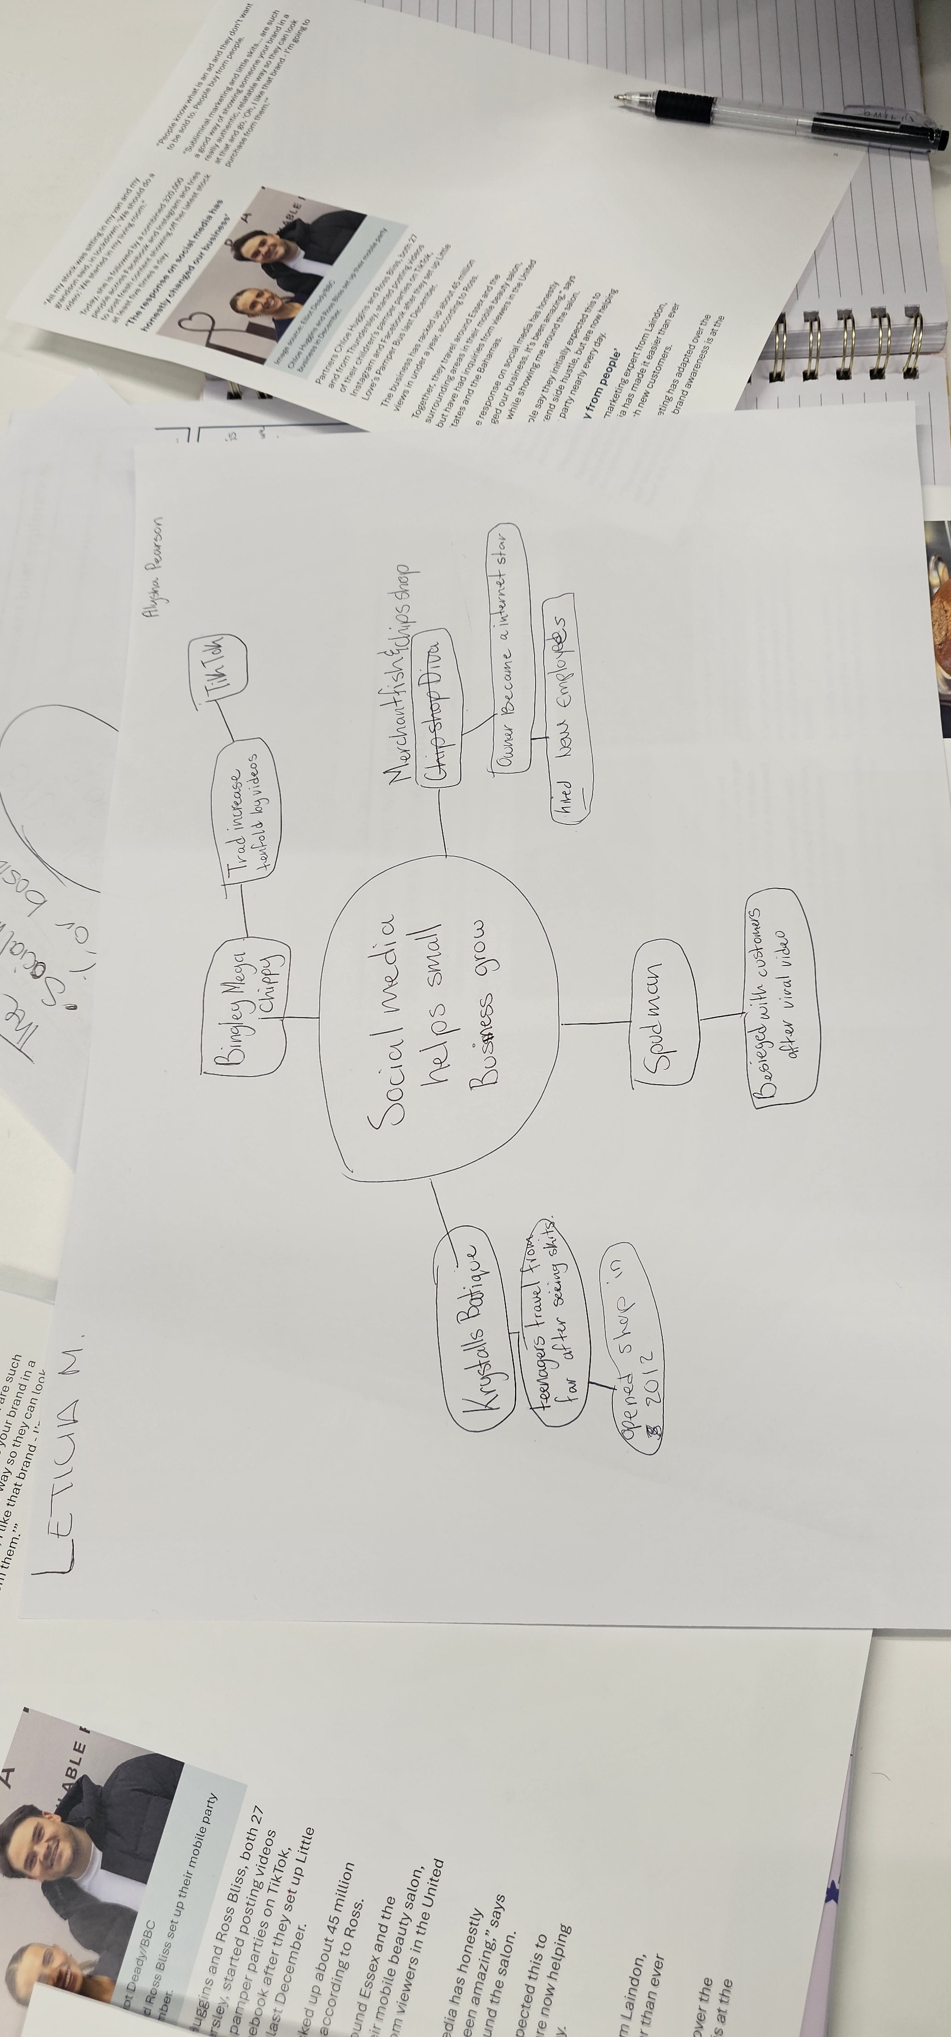

1. Answer these questions using the sentence starters below
a. What is the main idea of the text?
The main idea is that social media can helps smalls business to grow.
b. What are two key points?
One key point is that the business can have Millions of views on social media.
Another key point is can hide new employees.
c. What part of the text did you find most important? Why?
The most important part is how people can make viral a shop easily.
d. Was anything unclear or difficult to understand?
I was not sure about how long can take to be someone viral for fun.
e. How did your group help you understand the text better?
My group helped me by sharing the differents opinions about internet and how a small business can increase in positive aspects.
3. One sentence reflection
Question: What did you find challenging about this task?
The hardest part was understanding the difference way to communicate there are right now , where you can post, chats, and sells things on internet without visiting the places.

