Motorsports Event Management Assignment 1

By

Sebastian Birchmore

Contents

Contents 2
1 Introduction 3
2 About the club 3
3 Location 4
4 list of officials 5
5 Paperwork 6
6 Planning 6
7 Equipment 6
8 Course design 7
9 Contingencies 9
10 References 9

1 Introduction

This proposal is plans for South Wales automobile club (S.W.AC) auto test to be held in July 2022.
This document will present the how the club plan to run the even. The requirements for hosting the event, the safety plans, the required officers, any external people that are needed, the course designs and how the event it gong to be run.

2 About the club
The South Wales automobile club has been involved in promoting motorsport in south Wales since 1903. The club has a long and rich history in running events in Wales from hill climbs and speed trials to the international Welsh rally since 1964.
The club is a member of the Welsh association of motor clubs and an MSA registered motor club.
They normally meet Wednesday evening.

3 Location

There is several things to consider when looking for a suitable location. The geographical location is an important consideration as the club covers all of south Wales, because of this it needs to be easily accessible for people to get to. Good road networks for people that are toeing their cars and it needs to have good public transport links for any spectators that don’t have transport.
The next consideration is the land that the auto test is being planned to be run on. It needs to have enough space for all the competitors to be able to set up so they have somewhere it park when they are not running or if the car came on a trailer somewhere for that to park. As the event is being hosted in the summer the weather should not be an issue in regards to running the courses. The ideal location with be a large piece of smooth land so that any potential issues will be reduced. The location needs to have toilet facilities and the ability to have some catering would be nice a deciding factor in where to have the event.
Taking everything into account the best venue Pembrey race course as it is a large space that is already set up for motor racing events. It has enough space for setting up the three different courses. There are toilet facilities and catering which could be arranged to be used for the event. There is more than enough parking for everyone to be park than not running or if they need to park a trailer.
The location is ideal as it is just the M4, making it easy to competitors and spectators to reach.

4 list of officials

The event will require a small amount of people to host the event. The roles are split into two groups, the stuff that needs to be done before the event happens and everything that happens when the even is running.
The work before the even consists of paperwork such as getting the permission from the venue to use it for the event. The main focus will be to get competitor entries.
The requirements on the day will be different as the focus is to see the smooth running of the event. The clerk of the course will oversee everything that happens on the day making sure that the event runs smoothly. coordination will be needed between everyone that is running the event to make sure that it runs as smoothly as possibly.
The list of officials includes but is not limited to:
- Clerk of the course
- Time keepers
- Administeration
- Line fault judges
- Results official
- Scrutineers
- First aiders

Clerk of the course’s role is too over seen the running of the whole event and to make any decisions that need to be made of the course of the event.

Time keeps are needed for each of the three courses to time hold long people take to provide the times to results officials so that there is a permanent record of the competitors times.

The Administration team will be responsible to getting all the the required permissions and entries in the run up to the event.

Line fault judges are required for every course and their job will be to watch everyones runs to make sure that the follow the course and don’t hit any of the cones as that will give a time penalty to the competitors time.

The results official is needed to record the times that are provided by the time keeps from each fo the courses so that people can see how quickly they did the course and compare with the other entrants.

Scrutineers are needed to check everyones cars when the arrive to make sure that they are safe to run and that they comply with the class that they are running in.

For events of this size the first aiders will not be a member of the club but st johns ambulance as they will be better suited to the role in the unlikely requirement they are needed by anyone at the event.

5 Paperwork

To run a club event like this requires permission of the MSA as the governing body that oversee motorsport in the UK.
They need to provide a organising permit for the event.
Permission from pembrey circuit needs to be acquired to allow the club to use the venue. This will state what the club can and can’t do when the event is running.
Local authorities and emergency services need to be informed about the event. They likely will want plans of the event and how it planed to be run.
Insurance will be needed incase of damage to private property of injury to someone.

6 Planning

The planning is important to make sure that everything is in place and that they event runs smoothly on the day.
The first thing that is required to a permit from the MSA to be allowed to run the event, this needs to be applied for attest six weeks before the intended date of the event.
Advertising needs to be made and published to inform people of the event. A entry from needs to be made so that people can sign up for the event.
The roles of the clubs members needs to be decided os that everyone one knows who is doing what job so that everything is sorted in time.
The course designs need to be made and agreed on so that they can be published on the club website closer to the event to people know that the courses are going to be on the day.
The entry price needs to be decided so people can decide how many runs they want based on the price.

7 Equipment

The amount of equipment that the club needs for the event it small as a lot of equipment will be available at the venue and can be uses for the event. Such as the undercover pits that can be used for the competitors to park cars when not being used.
The club will use the catering services offered at the venue as everything needed is already there.

The club will need to provide the following:
- Cones to mark out the course
- Hay bales to mark out parts of the course
- Barrier tape to keep ant spectators a safe distance from the course
- A flag for each course to be used to signal the of each run.
- Stop watches to time each course
- Fire extinguishers

8 Course design

Before looking at that course designs here is an image of the entire site.

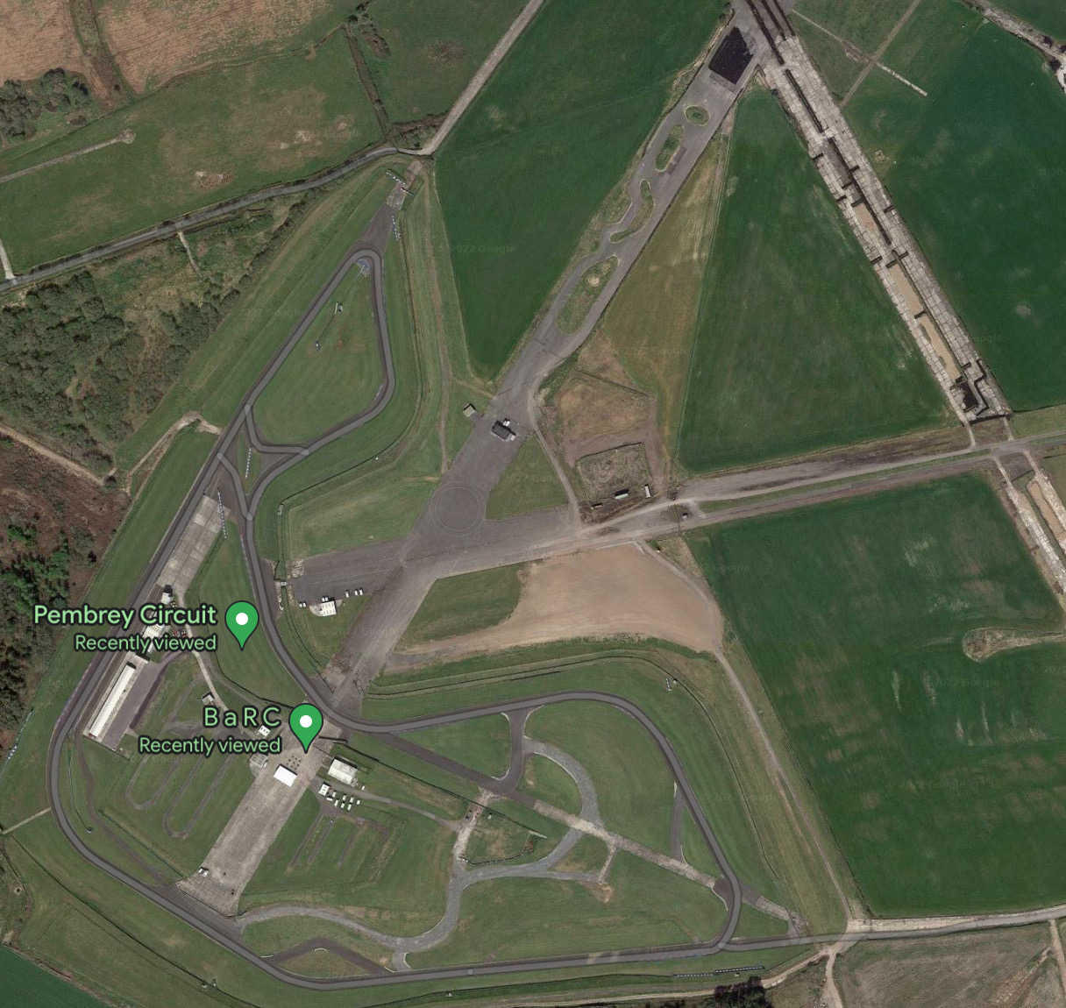
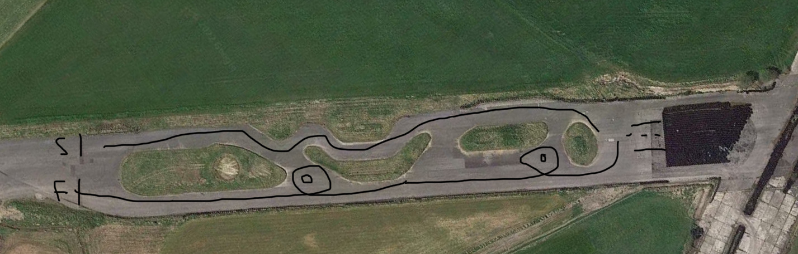
The first course: The driver drives straight then into a series of right and left’s then reverse into a box before slide round a obstacle the a straight line to the finish.

The second course: Go straight into a reverse box that then follows to slide round an obstacle then straight the into a double slalom before heading to the figure of eight then finish.
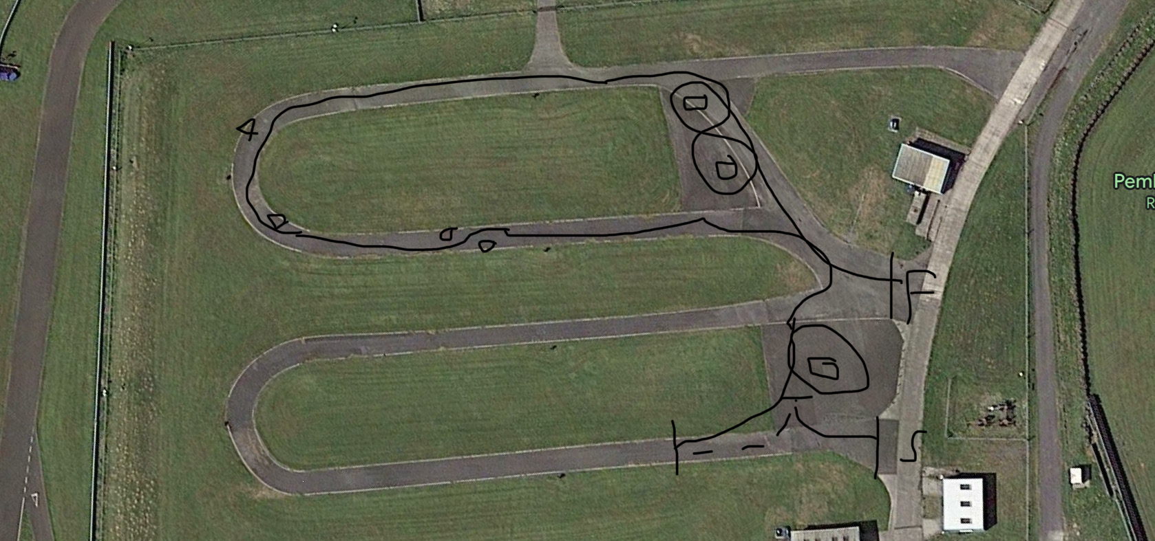

The Third course: Straight into a reverse into a box then all the was don’t the straight to a slide round a obstacle to straight to a hairpin corner then right onto a straight followed by a sweeping left.

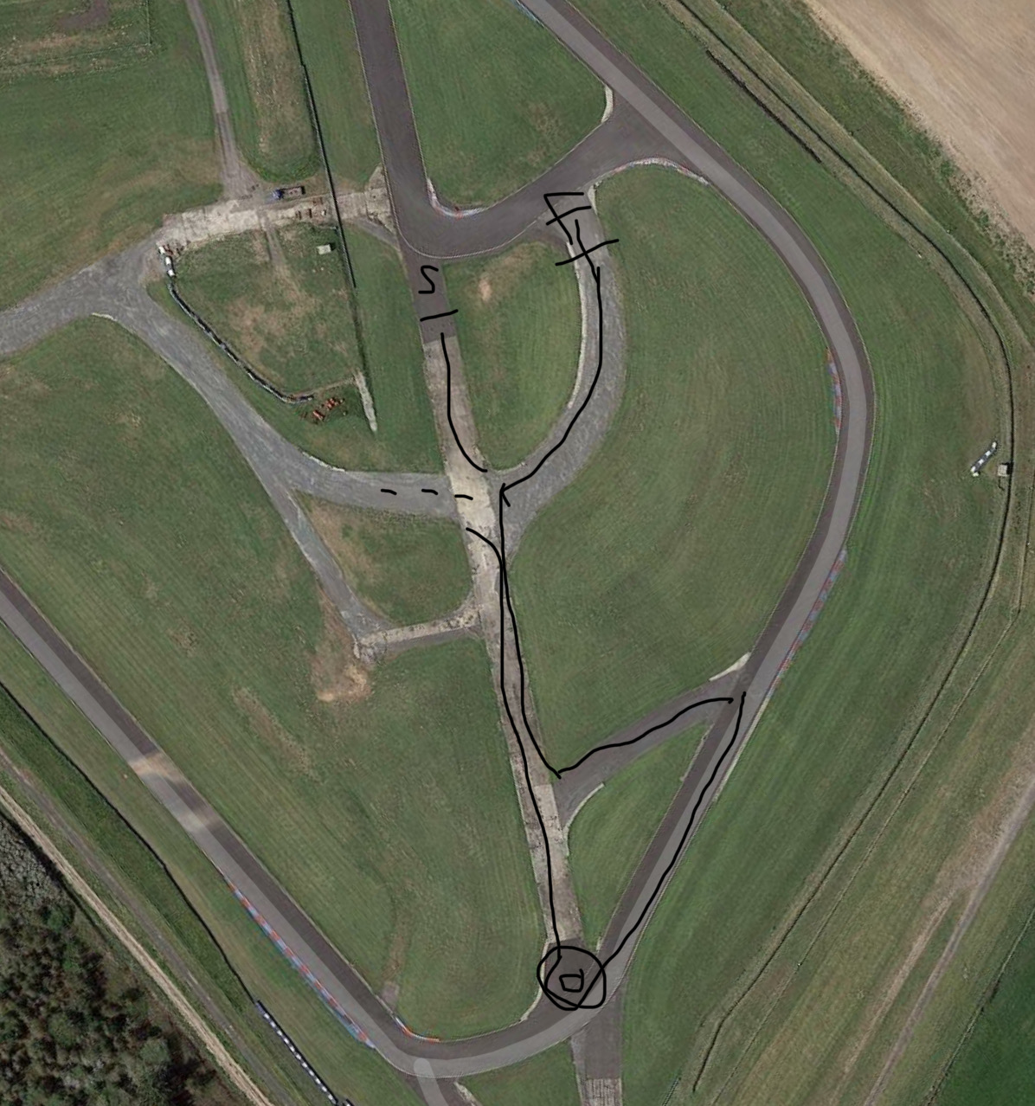

9 Contingencies

In the event of adverse weather conditions, the event will have to postponed or cancels with the competitors given the option to have a refund or move their entry on the new date. This depends on how bad the weather as if it is just light to medium rain then the event can still run since it is all on tarmac and gazebos can be provided.
In the event of an accordant then the marshals and the paramedics will attend. Depending on the severity of the incident then the course will be red flagged to allow the emergency services attend the incident.

10 References
http://www.southwalesac.com/#marshalling

