Student name: Sana Sahir
Student ID: 2113495
Module name: Changemakers; build your Personal Brand for Sustainable Employment
Module code: BMHP5015
Lecturer name: Ogochukwu Agunenye

Table of Contents
Introduction 3
Unit 1: Brand You 3
Topic (1.a): Ambition is critical. 3
Topic (1.b): What Drives You. 4
Topic (1.c): The Boundaryless Career. 4
Topic (1.d): Boundaryless Skills. 4
Unit 2: It’s a small world. 5
Topic (2.a): No One is an island. 5
Topic (2.b): Variety is the Spice of Life. 5
Topic (2.c): Network Society. 5
Unit 3: Opportunity knocks 6
Topic (3.a): Create your own luck. 6
Topic (3.b): Identifying Career opportunities. 6
Topic (3.c): Opening Doors. 7
Topic (3.d): Me.com 7
Unit 4: The pursuit of happiness 7
Topic (4.a): Future Me 7
Topic (4.b): Passion Perseverance 8
Topic (4.c): Plan, Prepare, Perform 8
Topic (4.d): Career and models 8
Personal Development Plan (PDP) 9

Introduction
Employability skills are the traits, habits, and abilities that help people get jobs and succeed. Technical knowledge and soft skills like communication, teamwork, problem-solving, and adaptability are included. Professional success depends on the field or industry (World Economic Forum, 2020). Most jobs require communication, time management, problem-solving, and adaptability. One must assess one's skills and compare them to the job requirements to determine if they match.
Self-reflection, performance, and formal assessments can produce this report. In addition, education, training, work, volunteering, and networking can help me gain employability skills. These skills can improve my career prospects and professional success. Finally, personal employability skills are essential for career success. I must assess my abilities and compare them to job requirements to determine if they match professional practice in an actual or simulated environment. These skills can boost my career.

Unit 1: Brand You

Topic (1.a): Ambition is critical.
Success drives me. Inspire me. Ambition can backfire. Overachieving isolates. I must balance life and desire. Freedom means following one's ideals. Self-awareness, convictions, and possibilities guide my decision. Consider my interests, needs, and values before choosing Self-awareness and honesty Goals focus me. My goals. SMART goals and metrics. Split and Writing goals simplify. Time, resources, challenges, Plan, and act (Gregor, 2015). My mistakes, Plan changes, and Goals matter. Honesty counts. Transparency builds trust; according to (Kant,2017), "Honesty is the first chapter of knowledge".

Topic (1.b): What Drives You.
Being "in the zone" is being so concentrated that time passes quickly. Flow and intrinsic motivation are often linked. (Csikszentmihalyi 1990) found that flow states are more likely when a task has clear goals, timely feedback, and is demanding but within one's competence. Control and mastery are rewarding. Intrinsic motivation satisfies autonomy, competence, and relatedness, according to (Ryan and Deci 2000). Needs met motivate and inspire. Hence, to be "in the zone" and driven by purpose rather than money, I must pick tasks that align with my values, allow me power and mastery, and meet my psychological needs. I can use my drive and enjoy important work.

Topic (1.c): The Boundaryless Career.
The gig economy has popularised boundaryless careers, which enable workers to attempt several occupations. The McKinsey Global Institute found that gig labour offers flexibility and development, but financial instability and unpredictability, especially for low-skilled people who may struggle to find stable, well-paying positions. Gig labour may increase inequality, especially for women and minorities who obtain new skills, experiences, and work-life balance. For others, gig work's instability and insecurity outweigh its rewards. Gig employment should be carefully selected and based on personal preferences, as it creates financial instability and inequality, but also freedom and progress.

Topic (1.d): Boundaryless Skills.
Transferable skills are used in various fields. Employers value these skills because they enable quick tasks and job adaptation. I value limitless talents: Professional success requires good communication. The NAFE (NACE, 2019) says employers value communication skills most. Every industry needs problem-solvers. These include identification, data analysis, solution formulation, and execution. Management requires leadership. Encouraging, goal-setting, and delegating. Creativity matters. Advertising, marketing, and design require this skill.

Unit 2: It’s a small world.

Topic (2.a): No One is an island.
Evaluation must include everyone to build connections. This may boost confidence and transparency and ensure the evaluation addresses everyone's concerns. Evaluation may help people work together. Evaluation should be ongoing. It should monitor and improve item performance. This creates lasting bonds. Professional communities require networks. Networking may lead to employment, collaborations, and clients. Networks help you follow industry trends. Experts may teach each other. Networks help members emotionally and professionally. They may advise. Networking raises professional and personal awareness. Your career may benefit. In conclusion, networking is essential for career progress and success (Castells and Himanen, 2014).

Topic (2.b): Variety is the Spice of Life.
Research shows many creative methods. Creative people think fast. Analysers improve ideas. Artists can express themselves differently (Kaufman and Beghetto, 2023). Creative solutions differ. Some succeed alone, others together. Risk-takers and traditionalists exist. Creative people approach problems differently. Creative minds challenge and inspire in art, science, and other fields (Kaufman and Beghetto, 2023).
Diversity enhances life. Thus, richer experiences and relationships make us happier. Experiences can spice up life. Being repetitive and limited may bore us. New people, cultures, and experiences enrich our lives. It promotes novelty. It promotes exploration. Diverse experiences give life meaning (Donath and Boyd, 2004).

Topic (2.c): Network Society.
Decentralisation improves hierarchies (Kunda, 2023 ). Network civilisation shapes business, culture, and communication. I must compete in a networked world using technology and network society knowledge. I need cutting-edge tech to reach customers and stakeholders. In the networked world, Facebook, Twitter, and LinkedIn are essential communication and marketing tools (Westview Press, 1999).

Unit 3: Opportunity knocks

Topic (3.a): Create your own luck.
Our actions and attitudes may produce luck. How to make my own luck: Be proactive: Put myself in luck-generating circumstances and pursue my objectives. This may include networking, attempting new things, or just working hard. Positive individuals are lucky, according to studies (Goodreads, 2023). Focusing on the positive and seeking opportunities may boost my chances of luck. Be grateful: Grateful individuals are happier and more fulfilled, which may improve their results. Appreciating my blessings may bring me luck. Be flexible: Luck might strike unexpectedly. Being open to new experiences and people may boost my luck. Failures are depressing, but they may teach you. Yet, by learning from my errors and overcoming obstacles, I may succeed.

Topic (3.b): Identifying Career opportunities.
Employment prospects and prioritising my goals might be complicated, but I have many options (LiveAbout, 2023). General steps: My values, interests, and skills: Knowing my abilities and beliefs may help me find employment choices that match them. I may self-assess or consult a career consultant. Career research: I may study careers after identifying my values, interests, and abilities. Reading job descriptions, chatting with professionals, and researching industry trends and employment market estimates may help. Prioritise my targets: After I have a list of prospective career pathways, I may prioritise them based on job happiness, financial potential, employment security, and work-life balance. I can make a spreadsheet to rate career alternatives (LiveAbout, 2023). Create a career plan: After identifying my top professional objectives, I can start constructing a career plan that describes the measures I need to follow to attain them. I may need to get further training, grow my network, and get appropriate job experience. Assess and adapt my plan: As I pursue my professional objectives, I need to periodically analyse and adjust my strategy. This may require reprioritizing my goals, changing my career path, or looking for new possibilities that fit my beliefs and interests.

Topic (3.c): Opening Doors.
Identifying my talents and passions may help me concentrate my job search and target sectors or positions that match my skills and interests. Gain expertise: Explore classes, certificates, volunteering, or internships to develop relevant skills and experience in my target area. Network: Attend networking events, meet with industry professionals, and join professional groups to find career chances. Customize my resume: Highlight my talents and experience in each job application. Opening professional doors requires time and work, but I can reach my career ambitions with the appropriate attitude.

Topic (3.d): Me.com
Establishing a solid online presence can take time and effort, so evaluating the commitment required before starting is essential.
Time: I must decide how much time I can devote to building and maintaining an online presence: online profiles, content, audience engagement, and reputation management. Consistency is needed online. I need a content strategy and regular posting. Examine my writing and publishing skills. Online presence requires technical expertise. I need web design, social media, and SEO basics. Budget: My goals may require online presence tools. Hosting, domains, email marketing, and paid social media advertising are examples. Online presence requires a strong personal brand. All my online platforms need my brand voice and value proposition.

Unit 4: The pursuit of happiness

Topic (4.a): Future Me
Reason to attend university and that it has impacted how I approach My studies. Understanding why I am pursuing higher education can provide motivation and direction throughout my academic journey. University offers specialised knowledge and skills, personal and professional growth, and networking with like-minded people. Understanding why I chose higher education helps me tailor my studies to meet my goals and maximise my time at university.
An apparent reason for attending university can also motivate me during tough times. Reminding myself why I'm studying helps me stay focused and achieve my goals.
Knowing why I'm in college helps me study and stay motivated.

Topic (4.b): Passion Perseverance
I study in a specific field at university. This motivated me to study career-related skills and knowledge with a goal-oriented mindset.
University helps me understand the world and myself. In this case, I may explore new interests and perspectives.
The university is for making friends and socialising. Seeking teamwork.
Whatever my reasons for attending university, I must study purposefully and take advantage of the many learning and growth opportunities.

Topic (4.c): Plan, Prepare, Perform
It is crucial to remember that change in a career can be challenging to predict, as many factors can interact and influence each other. However, staying informed about trends and changes in the job market, networking with professionals in my field, and continuously developing new skills can help me stay competitive and adapt to changes in my chosen career or a new one I may select.

Topic (4.d): Career and models
Mentoring can help special education teaching assistants plan their careers. Career mentoring offers these advantages:
Get useful advice: Mentors help me understand special education. Mentoring can help people understand their field (Akhtar and Baig,2018).
Build a network: Mentors can help people build professional networks, which can help them find jobs, learn about new developments, and make important connections.
According to (Kram and Isabella,1985), mentors can help people build important professional relationships, which can increase growth and development opportunities.
Mentors can help me learn career-related skills. Learning new teaching methods or improving communication skills are examples (Gaddis, 2015) found that mentoring helps.

Personal Development Plan (PDP)

My chosen sector for being a Special education teaching assistant who has specific requirements. Setting goals for myself, keeping attention, and finally achieving those goals may all be facilitated by developing a personal development and advancement plan. While planning for my professional future, here are some considerations to keep in mind: Consider the aspects of my personality and skills that serve me the greatest in the business and the aspects that help me the least in my home life. Consider my strengths and areas I may need some improvement, and then utilise the information I've gleaned to my advantage in the pitch I select. Prepare for both the immediate and far future: Consider the near future (within the next year) and the distant future further down the road (within the next 3-5 years). Setting goals that are SMART, Specific, Measurable, Achievable, Realistic, and Timely (SMART) is essential. Find out what qualifications are needed to become a special education teaching assistant and the position's responsibilities. Find out what I don't know that will help me meet these requirements and go closer to achieving my goals. Finally, create a plan of study that includes Creating a plan to ensure that I learn everything necessary. Attending classes, conferences, and seminars, participating in training programmes, and reading books and articles pertinent to the topic are a few examples of this type of field.
I can improve my performance by seeking input from mentors and co-workers and acting on what I learn from that feedback. Locate someone with more expertise than I do and who is ready to assist me and lead me through the process.
Be aware of what is going on in the field of special education as well as what the most effective methods currently in use are. Join relevant professional associations, stay current on critical academic papers, and participate in relevant conferences.
Maintain a consistent evaluation of my progress: It is essential to keep a close eye on my redevelopment and to adjust my strategy as needed in response to what I discover. Recognise my successes and learn from my mistakes by reading this.
It is essential to remember that improving myself is a constant process. If I want to be successful as a teaching assistant for students with special needs, I should follow these steps to build a plan for myself. To further my career and do a better job, I want to continue my education and get a BSC (bachelor's in health and social care level 6). If I get a job, I can advance thanks to my many other talents and abilities. Among them are A solid desire to encourage and inspire young people. Awareness and concern for student health and safety Encouragement of cultural differences among students and staff A patient and competent approach readiness to comply with educational guidelines and pursue further education.

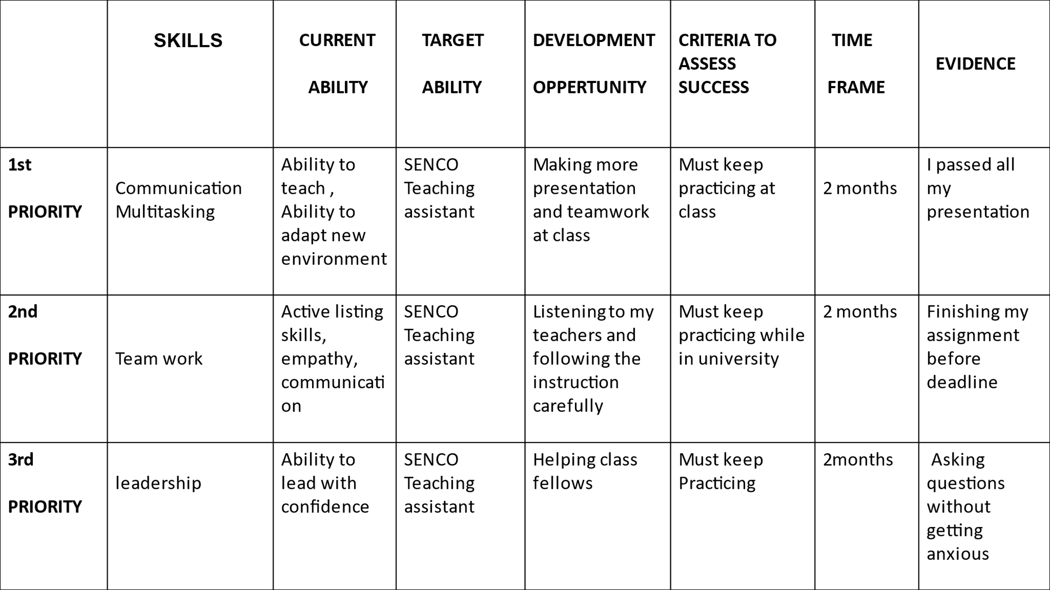

References
World Economic Forum (2020). The future of jobs report 2020. [online] World Economic Forum. Available at: https://www.weforum.org/reports/the-future-of-jobs-report-2020 [Accessed 8 Apr. 2023].
Gregor, M. ed., (2015). Introduction. 2nd ed. [online] Cambridge University Press. Available at: https://www.cambridge.org/core/books/abs/kant-critique-of-practical-reason/introduction/63788671FD2E61B61B06AFFD03303F26 [Accessed 8 Apr. 2023].
Oppland, M. (2019). 8 Ways To Create Flow According to Mihaly Csikszentmihalyi [+TED Talk]. [online] PositivePsychology.com. Available at: https://positivepsychology.com/mihaly-csikszentmihalyi-father-of-flow/ [Accessed 8 Apr. 2023].
Anon, (2014). Self-Determination Theory (Deci and Ryan) - Learning Theories. [online] Available at: https://learning-theories.com/self-determination-theory-deci-and-ryan.html [Accessed 8 Apr. 2023].
Donath, J. and Boyd, D. (2004). Public Displays of Connection. BT Technology Journal, [online] 22(4), pp.71–82. doi:https://doi.org/10.1023/b:bttj.0000047585.06264.cc.
www.naceweb.org. (2023). Employers: Verbal Communication Most Important Candidate Skill. [online] Available at: https://www.naceweb.org/career-readiness/competencies/employers-verbal-communication-most-important-candidate-skill/#:~:text=Employers%20rated%20verbal%20communication%20skills%20%284.63%20on%20a [Accessed 8 Apr. 2023].
Walden University (2019). The Four C Model of Creativity | Walden University. [online] Waldenu.edu. Available at: https://www.waldenu.edu/online-masters-programs/ms-in-education/resource/the-four-c-model-of-creativity [Accessed 8 Apr. 2023].
Augustine, A. (2023). Here’s Why Networking Is Important to Your Success. [online] TopResume. Available at: https://www.topresume.com/career-advice/importance-of-networking-for-career-success#:~:text=Networking%20is%20essential%20since%20it%20will%20help%20you [Accessed 8 Apr. 2023].

