fdlmikail@yahoo.co.uk

Fadul Mikail Omar: 1912914

Program: MBA – Master of Business Administration
Module: International Business
Module Code: LCMB7014
Lecturer: Lan Dang
Assignment Title: Report
Table of contents

1. Introduction 1
2. Overview of the company 4
2.1. Home country Japan and Host country China. 6
Figure 1: Toyota Ownership Analytics 6
Figure 2: Share Price Performance. 6
2.2. Host Country China. 8
Figure 4: China Cars Production 8
2.3. Toyota Competitors. 9
3. The 3 Theoretical Frameworks. 10
3.1. Polycentric Limitations. 11
4. Toyota uses Polycentric Approach and involves staff in decision-making. 12
Figure 6: Toyota Recruitment in the United Kingdom. 13
Figure 7: Evidence of Toyota using a Polycentric. 13
5. PESTEL Analytics Frameworks. 15
Figure 9: PESTEL Analysis. 15
6. Conclusion and recommendation 19
7. References 21

Introduction
The understanding of international business today become a major complex for some multinational enterprises, especially for those who are willing to operate subsidiaries internationally must have a piece of great knowledge about the country that wants to use or invest in to reduce the risk of the greatest impact that affect the firm in the future opportunities are everywhere but depending on the business ideas it makes sense and demands for the product or service that need to be provided to fill the gaps or make differentiation from the existing competitors.
Toyota is a multinational corporation's motor head office in Japan manufacturing cars for more than 80 years now Toyota is the most saleable vehicle around the world and opened many successful subsidiaries in different continents to strategize a variety of successful consumable products or different make of cars. According to Team MBA Skool (2023) Toyota's mixed product strategy and marketing strategy can be explained as Toyota being the world's leading cars making manufacturer providing more than 40 models of cars and categorizing passenger cars, Toyota MPV vans, RAV 4, and many more other builds as commercial purpose plus Toyota sport and set have a number of cars breakdowns list. Toyota uses marketing concepts to provide customer loyalty by giving financial services warranty at certain mileage aim to attract more consumers and priority given to those invested 20 million and plus.
The study discovered that what is the real ethic behind Toyota's success in making cars in foreign currencies that Toyota uses to employ host country staff to minimize the risk of cultural barriers and maximize profit and include them in decision-making purposes to improve the marketing strategy, communicating products to customers by the languages they used to understand this is one the greatest opportunities to grow business. International businesses are using different strategies that suit the nature of the company to grow among competitors. For example, ethnocentric employ only home country staff is contenting with some elements of risk such as cross-cultural communication complex, while the geocentric approach is using the most qualified candidate regardless of the country or continent that belongs to, and that can be expensive to maintain staff traveling expenses, immigration process, and living cost. The polycentric approach strategy differs from both focusing on employing hot country employees and Toyota uses this strategy to mitigate risks of cultural issues, increase staffing value easy communication among them or with the product, and lower the cost of employees’ maintenance.
PESTSL Analysis is used to identify Toyota's strengths and weaknesses to operates a subsidiary in China and discussed the most important elements related to international businesses on how to mitigate risk in terms of laws and regulations, foreign countries' trade restrictions on tariffs agreement changes pending on diplomatic relations. And this is identifying Toyota's current competitors. Whereas Toyota is the most leading automobile manufacturer to achieving the highest sales among its rivals. It is an opportunity for Toyota to entre Chinese Market are the largest population in the world.

Overview of the company
The Japanese automobile Toyota is one of the world’s most well-known brands and has been used by many countries worldwide. Toyota becomes more famous among countries that have less infrastructure, or no roads. According to Cusumano (2011, p. 1-3) Toyota was founded in 1936 and is widely recognized as one of the finest manufacturing industries the world has ever seen and used experiences over 70-plus years, Toyota has a famous reputation for unique capabilities, quality control, and perfection that describe by users despite numbers of defects was reported by customers Toyota lower quality it been fixed in the past decade. Toyota pickups type are more helpful for people able to use it even for trade purposes and are affordable compared to Land Rover. Toyota RAV4 vehicles, “by its second generation, the RAV4 was facing a strong challenge from a few big-name rivals that had followed in its footsteps, like the Honda CR-V, Land Rover Freelander, and Nissan X-Trail. To meet the challenge, it had to grow up a bit, so gone were the gaudy colour schemes and body kits and gone too was the convertible version” (Robbins, 20323).
The Japanese investment in the United States is an opportunity to grow automobile markets and provide jobs for the United States citizen and demand for Toyota. Related to the Japanese company’s success in the United States. according to Turner (2019) for the last several decades, Toyota has managed to create vehicles and parts around 94,000 manufacturing jobs in the United States and invested around 51 billion United States Dollars and more than 1.6 million indirect cooperations from suppliers and dealerships and that success in the United States alone. However, “Toyota Motor is set to pay a $180 million fine for longstanding violations of the Clean Air Act, the U.S. attorney’s Office in Manhattan announced on Thursday, the largest civil penalty ever levied for a breach of federal emissions-reporting requirements” (Tabushi, 2021).
Regarding Toyota’s history and how entered the market in the United States and used to sales of less than 300 cars a year. According to White (2020) in the earlier time, Toyota opened its first dealership in the United States. And no more than 288 vehicles were sold during its first year, but the company has quickly managed to gain loyal customers establishment by 1972, the boost in United States sales helped Toyota to sell around one million vehicles. Today, Toyota has become popular for its many hybrid cars, like the Prius and Camry Hybrid. International business requires county-to-country relationships to a part of the United States’ relation with Japan on the other hand China and Japan managed to build strong relationships bonding politically and minimizing cultural differences for the sake of having fair trade and able reduce tariffs between the two countries. “New Chinese rules on car imports are already benefitting Japanese manufacturers, while American automakers, sanctioned in the U.S.-China trade conflict, are left behind. Since July, China has lowered import tariffs on foreign-made cars from 25% to 15%” (Harwit, 2018, p. 1). In my opinion, the tension between the two countries could affect the international business relationship in tariffs but China and Japan have common borders and cultural elements to sustain a long relationship in fair trade, China changes tariffs with the United States cars increasing the demand for Toyota with lower tariffs and able to sale more than 140,000 cars in a short time to China with affordable price and create numbers of jobs to Chinese workers.
However, Hilpert and Haak (2002, p. 5), state that China is currently Japan’s next most important and topped trading partner despite United States’ close relationship with Japan and China’s most important import source and second largest export market. China’s value is a prime location for Japan’s overseas manufacturing plant. Besides setting up its own subsidiaries by absolute direct investment. Japanese business is committed in relation to the Chinese market in numerous ways, such as capital lending, contract manufacturing, sales commission, licensing agreement and further reaching Japan and China relationship over many decades.

Home country Japan and Host country China.
According to Corporation Toyota Motor (2023) Toyota business was started in 1937 with Head Offices in Japan Tokyo, Honsha, and Nagoya board directors are mainly Japanese the new chairman Akio Toyoda age 69 Japan nationality was appointed in 2023 as representative director of the main headquarters, and three of them British nationalities which are highly respected figures in term of qualifications and previous experience in many different areas and highly skilled. For example, one of the British nationality is member of the board of directors is Simon Humphries, operating officer.
Toyota Corporation Motor presents business activities shareholders’ capital of 635 billion Japanese Yen number of employees of over 30500 and over 800 thousand shareholders including the top 10 shareholders explained the in the diagram below:

Figure 1: Toyota Ownership Analytics
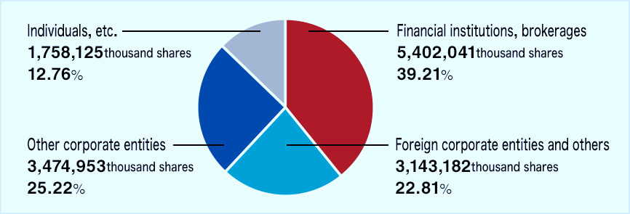
Source: this image was adopted from (Corporation Toyota Motor, 2023)

Figure 2: Share Price Performance.
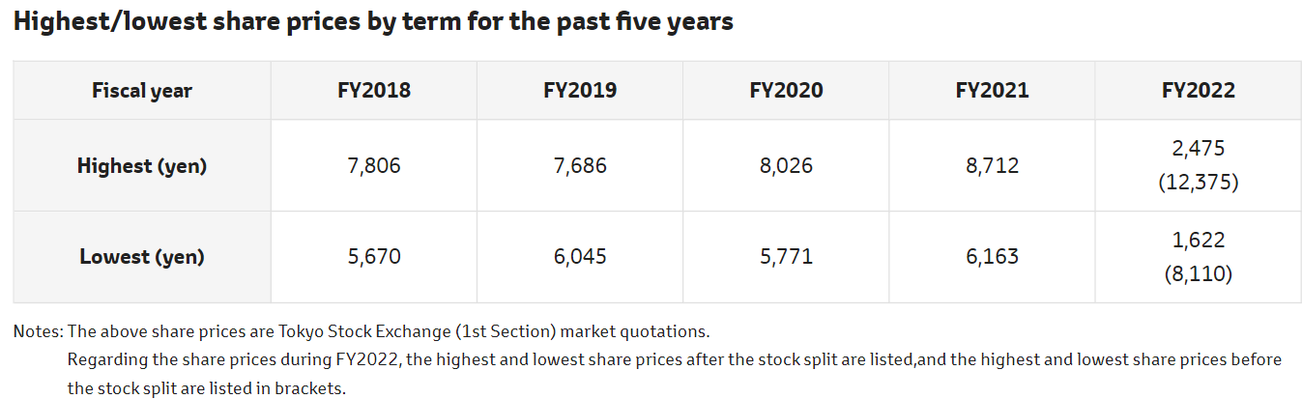
Source: this image was adopted from (Corporation Toyota Motor, 2023)
Figure 3: Toyota's Top 10 Largest Shareholders
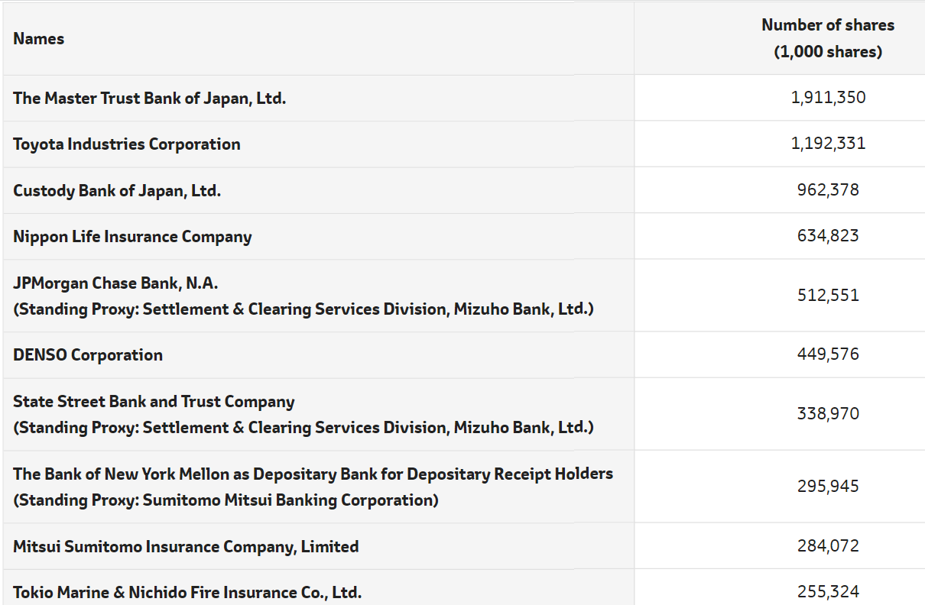
Source: this image was adopted from (Corporation Toyota Motor, 2023)
The above diagrams explain Toyota’s stock overview the last image shows the top 10 largest shareholders the Bank of Japan is representing the highest followed by Toyota Industries Corporation. Whereas the pie chart shows the ownership breakdown percentage of individuals, financial institutes, other corporate entities, and foreign corporate the same as the table indicates that in past five years lowest and highest price share annually all information obtained from Toyota official websites.
And discover that Toyota’s emerging integrated technology to create new versions of Toyota energy-saving electric vehicles to safely claim changes and goals that satisfy customer requirements and market position to take advantage of today’s technological innovation. Realising Toyota’s vision is the customers’ globalization mobility movement with better affordable products and satisfaction. “As often stated by Akio Toyoda, the President of Toyota, our mission is to provide goods and services that make people throughout the world happy through the development and manufacture of vehicles or, in other words, to mass produce to bring happiness” (Corporation Toyota Motor, 2023).

Host Country China.
According to Trading Economics (2023, p. 1-3) China is the world’s largest target market for Toyota whereas China has the world’s largest population, the first biggest automobile manufacturer and more than 26 million sales including all brands in 2023 compared to Toyota’s 2022 sales of over 10 million one brand according to Chinese official website Trading Economics the table below explains the number of China car protection and sales of China at the present time.

Figure 4: China Cars Production
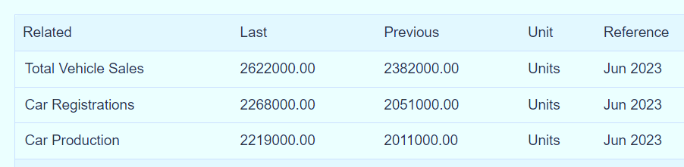
Sources: this image was adopted from (Trading Economics, 2023)
Evidence to witness, China is the fastest growing at present time country’s GDP rising by 3% after Covid-19 was hit China’s economy in the period was not exported from the country due to the various infection but is a pleasant recovery for China’s economy. “Kang Yi, director of the National Bureau of Statistics, cast China’s 3% growth as relatively fast considering unexpected situations and in contrast to Germany, the U.S., and Japan” (Cheng, 2023). China is the second-largest GDP after the United States and Japan is the third in the world economic growth. According to the World Bank (2023), China’s economy is rising rather Japan’s GDP is solidly down. Example of the table below:
Figure 5 China is the World's second Gross Domestic Product.
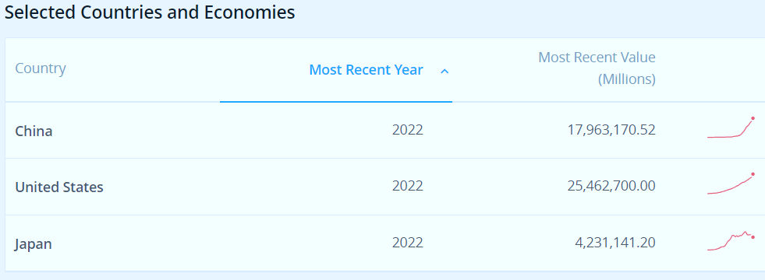
Source: (The World Bank, 2023)
Despite, China’s highest vehicles productions due to the size of the population there is large unemployment creating a gap for international businesses, for example, Toyota is achieving a higher sales competitive cost in recent years, and the famous brand this will add a real value for China it could reduce the rate of unemployment. “The reason that this trade mesh has been growing continuously over the past two decades is that its two cornerstones, China, and Japan, both need it and enjoy it. Two factors make this new relationship symbiotic. The first is sheer size, including the size of China’s consumer markets and the amount of trade that flows between the two countries” (Schaede, 2020).

Toyota Competitors.
Knowing that Toyota has several players first top Honda and Nissan are Japanese multinational car manufacturers achieving the best sales just after Toyota the world’s leading brand in sales because of the promising future development of the Toyota hybrid energy-saving system with affordable prices and durability satisfaction from users. The third Toyota rival is an American motor Ford is one the largest sale around the world well-known and affordable. “Ford Motor Company is a United State based global leader in the automobile manufacturing industry operating both in commercial vehicles and private cars market. Was established in 1903 by Henry Ford. After more than 100 years, the firm is one of the largest automobile players in the world” (Team MBA Skool, 2023, p. 1).
German motor cars are sold worldwide with a great reputation, but Volkswagen is affordable for people who have lower incomes in different countries and achieved better market including poor countries for that reason becoming on the top Toyota competitors. “Key competitors include Honda, Ford, General Motors, Volkswagen, and Nissan. These companies, alongside Toyota, continuously strive to produce innovative and efficient automobiles, as they vie for market share and consumer preference” (Gitnux, 2023).

The 3 Theoretical Frameworks.
In my knowledge companies need to operate internationally require a global strategic recruitment process to identify relevant knowledge and experiences in global human resources management in the workforce environment and fair employees selection, training based on the local cultural climate of host or parent workers need to follow organizational policies and procedures on the global context of the following theories Ethnocentric, Polycentric and Geocentric whereas companies are able to select right people for the right task. Okoro (2012, p. 3), mentions that in today’s global business environment, it has more than enough managers and directors should be needed to understand and appreciate nations those who are coming from a diverse cultural backgrounds and nationalities. The most successful organizations are those who can add international management skills to increase the scope of global exchanges to extend investments and development of nations.
The Ethnocentric approach: Megha (2023), argues that it is ideal and rationale that, the employees of the parent country are more suitable skills than the host country and are well representative of the headquarters’ interest and believe that the best strategy to use their culture even in foreign countries. And parent country staff could get it difficult to accommodate the host country's staffing because of cultural differences. The disadvantages are costly to maintain for host employees to adopt a new culture and difficult to understand the company mission and takes time for customers to be familiar with the products and which decreases sales.
The Geocentric approach: In my knowledge, both local and international cultural belief or cross-culture strategies compared to Ethnocentric and Polycentric one-way used strategies that are three of themes aimed to achieve companies’ environmental response to human culture and beliefs. According to Sarokin (2022) the Geocentric approach focuses on precise regions or countries globally. For example, a sporting goods supplier that influences the market is wares with a focus on football and baseball in the United States, soccer in Europe, Africa, and Latin America, and cricket in India and Pakistan. The most qualified candidates a part of the nationality can persuade the global business strategy based on a Geocentric approach. Disadvantages are highly cost-effective in training and other maintenance, employees isolated from their families could cause stress and difficulty to adapt other cultures.
According to Bika (2023, p. 2-3) a polycentric strategy is a way of recruiting and hiring a local candidate to fill the host country’s required positions and is beneficial to the foreign country to advertise local jobs on boards or create a relationship with local agency recruitment. Polycentric is an international business approach between two countries’ cultural diversity because it is difficult to adjust the expatriate from the parent country or expensive to maintain compared to nationals of the host country. Generally, the polycentric approach increases productivity, with a piece of better knowledge about the host market, and career opportunities for the national of the host country and creates better support for both governments’ relations.

Polycentric Limitations.
Generally, the Polycentric approach is involved in home-country decision-making for a foreign-country subsidiary which is an advantage for local employees’ cultural values in terms of communications and knowledge of international businesses but, rather disadvantages facing difficulties in communication between the host country and home country of the subsidiary and lacking the parent organization culture. According to Megha (2023) less understanding of the market environment of the host country and difficulty in communicating effectively between the employees’ members of both the host and the parent-subsidiary is due to culture and language barriers and it may create a problem, exercising control across the subsidiary. Due to the different thinking processes, this may raise a conflict between the directors of both the host and the home company.

Toyota uses Polycentric Approach and involves staff in decision-making.
According Toyota (2023) similar information from official Toyota websites are proving that, Toyota is a Japanese automobile brand that used a Polycentric approach to achieve international business and provides an excellent relationship with the host country and recruiting employees locally according to local government policies, employment laws, and other benefits that are used by the local authority relating to the working environment. For example, the United Kingdom was used as a host country by Japan to manufacture Toyota has two manufacturing plants in Derbyshire United Kingdom and representing £2.75 billion the company was registered as Toyota Great Britain (TGB) and employs approximately 3000 engineers working for Toyota. For example, “diversity and inclusion at (TGB) and across the Toyota family we are committed to creating a truly inclusive working environment that attracts and engages our diverse talent and enables all of our people to unleash their potential and be their true self at work” (Toyota, 2023). Moreover, the below pictures indicate how Toyota uses polycentric strategies to hire young people or graduates in the United Kingdom careers opportunity example of Holly placement students is a chance for younger to build earlier talent to be part of the Toyota family. Toyota practices job fairness to hire a diversity of different people in particular roles an example of the image below:

Figure 6: Toyota Recruitment in the United Kingdom.
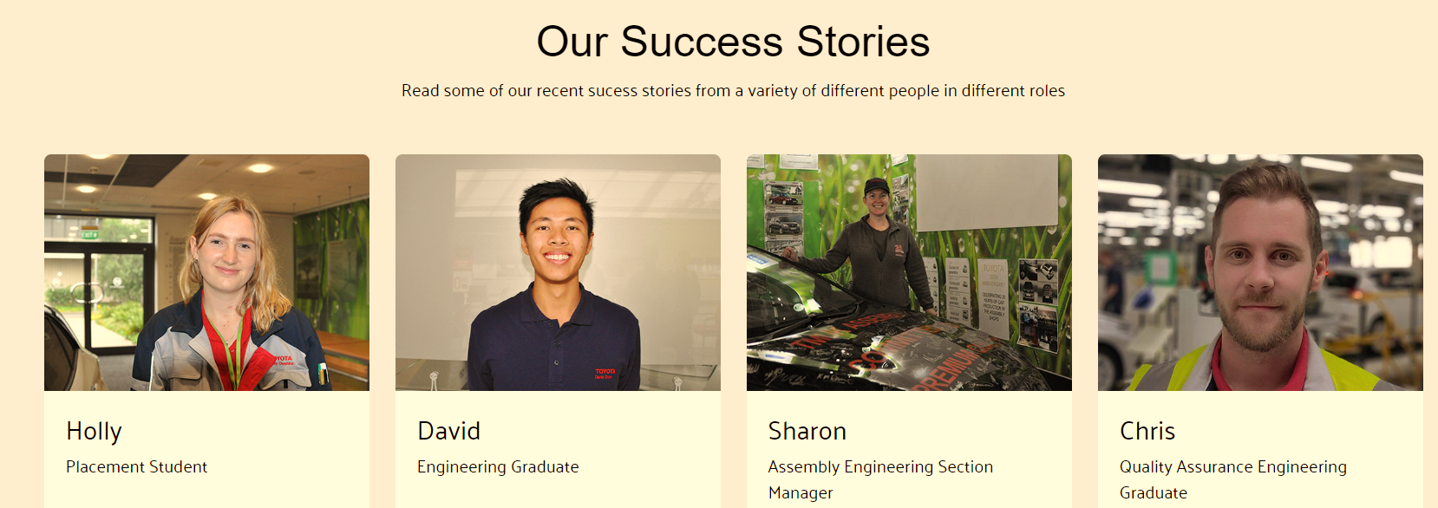
Source: This image was adapted from https://recruitment.toyotauk.com/
Another example of the image below is explaining how the international business operates from country to country and uses a Polycentric strategy it minimizes future staff costs compared to the Geocentric strategy of high expenses to maintain employees whereas the Polycentric approach maximizes local markets and increases sales.

Figure 7: Evidence of Toyota using a Polycentric.
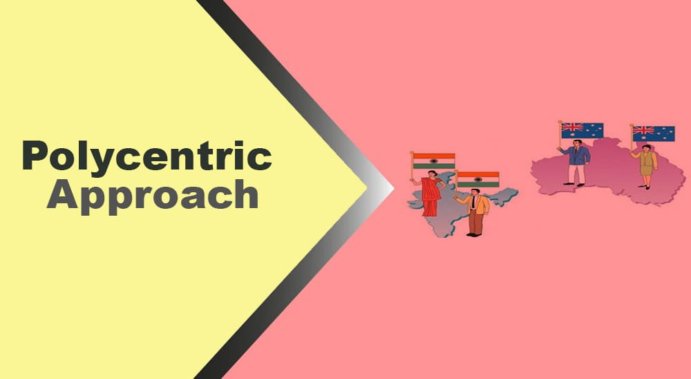
This image was adopted from (Usmani, 2022)
Figure 8: Toyota Applied Polycentric in China Toyota’s official website.
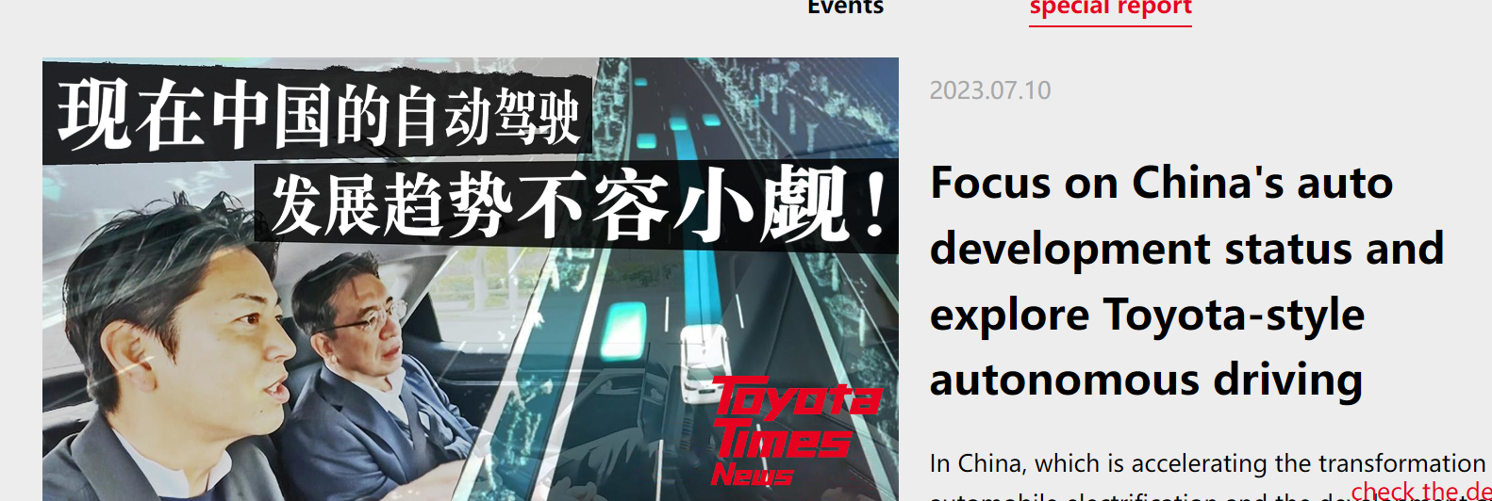
Sources: this image was adopted from (Toyota, 2023)
The image above explains that Toyota uses a Polycentric approach in China and uses the Chinese language to advertise Toyota Time News and the official Toyota website-China google translate only in the English language. Toyota allows engaging in top decision-making military in the United Kingdom Toyota employees to management are local. According to Company House (2023) Matthew Peter Harrison a Toyota chairman who was appointed in 2013, and Darren Paul was appointed in 2016 as a secretary.
In my understanding, Japanese and Chinese international businesses both countries are using higher technological innovation, fair trade practices, and reasonable tariffs and both are using polycentric strategies it is an opportunity for Toyota to operate in China because it managed to adopt the polycentric approach for the host company’s national (HCN) which is benefiting to the Chinese people in reducing the rate of unemployment, less cultural confusion and maximize Toyota productions and minimize costs. For example, “most Chinese MNEs tend to pursue two contrasting expatriate staffing approaches. In advanced economies, Chinese MNEs tend to adopt the polycentric approach by filling key positions using HCNs, but the ethnocentric approach by transferring expatriates non-discriminatively to subsidiaries in developing economies” (Froese et al. 2020, p. 4).
Toyota is one of the world’s largest cars manufacturers and the main headquarter in Japan’s home country according to Toyota (2023) website Europe Toyota’s growing sales in more than 170 countries around the world, with 71 manufacturing companies and 370 thousand employees and most importantly attaining a good relationship with partners and following government regulations, policies in those countries which Toyota manufacturing based with a growing reputation to serve the nationwide or single community. “Japan and China Connection mainly and often overlooked in this scenario are the newly emerging Asian trade dynamics, anchored on realistic and cooperative business relations between China and Japan. Perhaps these are the world’s second and third-largest economies. Pre-COVID, their joint GDP was about $15 trillion, compared to $18 trillion in the United States” (Schaede, 2020).

PESTEL Analytics Frameworks.

Figure 9: PESTEL Analysis.
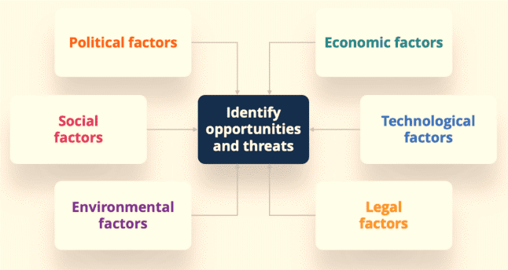
Source: this image was adopted from (Peterdy, 2023).
PESTEL Analysis is a strategic tool to evaluate an organization's future and to grow potential markets, for example, Political, Economic, Social, Technical, Environmental, and Legal these factors will provide elements for each requirement that is relevant to the companies.
According to Wood (2022, p. 1) Political: Includes political instability, government policies, trade policy, restrictions, taxation, employment laws, and environmental laws. Political instability factor: Has an immediate impact on Toyota which is measured by the war or China and Japan's downside relations like conflicts or war could change the current trade agreement but not necessarily this to be between Japan and China for example, China stands by Russia's war against Ukraine and this uncertainty could affect the United States and China.
Trade agreements: I do believe that the current relations between Japan and China are opportunities for Toyota's subsidiary to operate in China. For example. “During that period, China’s economy was still in a primitive stage, so Japan, with its experience of rapid economic growth, supported China through infrastructure projects and loans” (Nagata, 2022). Government policies: in my opinion, these policies are an internal political challenge as election periods may lower taxation or rise it could affect Toyota when the tax goes up may increase the labour of the production and decrease sales per item which goes down on profit or a higher price could change the buyers' attitude.
Economic: Involves inflation, interest rates, consumer- income, exchange rates, and employment rates. Understandably inflation: “The inflation rate for consumer prices in China moved over the past 35 years between 1.4% and 24.3%. For 2022, an inflation rate of 2.0% was calculated” (World Data, 2023, p. 1). This is an entire economical downside apply to the countries at different levels depending on local economic strength which is challenging Toyota's experience in such an economic situation when buyers living costs struggle to minimize Toyota's consumption. According to Study Smarter (No date), when inflation pushes wages to decrease income people's salaries will drop and have less income to spend on products or services. Similarly, Exchange rate: Factors affecting Toyota when lenders increase cost is difficult for businesses and individuals to afford the exchange of buying and production lower consumption reduce Toyota's revenue and demand for labor and increase the raw material costs due to Toyota subsidiary's local exchange rate lower than the host country.
Social Factors: These are related to cultural beliefs, population growth, career attitudes, lifestyle, health, and education level. Population Growth: According to The World Bank (2023, p. 2) China population are more than 1.42 billion and almost 5 million unemployment these indications are positive for Toyota growing market as China's largest rising nation in the world and good economic performance Toyota will help to reduce unemployed in China and share in expanding local economy because Toyota's reputation and affordability allow it to achieve a better market share in China. Cultures and Beliefs: Cultural diversity is creating complexity in workplace communications due to international businesses but Toyota's subsidiary in China identified solutions by using polycentric strategies to minimize the risk of cultural barriers to engage local employees in decision-making and similar beliefs, respecting other people is creating value to the organization brand and have the freedom to express their feelings in comfortable manors and willing to about Toyota background to become a part of Toyota brand.
Technological Factors: I believe that the internet availability, automation, cyber security, cloud software, and technology infrastructure. Internet: According to World Bank (2023) people who are using the internet are above 73% and people access electricity are 100%. The Internet availability is useful for Toyota able to communicate their products among customers through social media, engine search can help for research purposes or development, and money transaction. “The rise of the Internet of Things (IoT) has the potential to change the world as we know it and will fundamentally change many companies’ business models as well as the way consumers interact with these companies and other stakeholders” (Langley et al. 2021, p. 1). Lack of internet could affect Toyota production performance in today’s competition.
Automation: According to SEO Outerbox (2022) a type of automation is a computer system used in industry to control manufacturing processes, and auto machines are used to reduce human costs usually cheaper, more accurate, and increases productivity is useful for Toyota car manufacturers' Intelligence machines or robots to cut costs. Lacking automation will affect Toyota's production, quality vehicles safety today requires higher-tech tests and overall reduce demand. This automation requires good country infrastructure, electricity power high level of education, internet speed, and cyber security organizations like Toyota require information security and data protection.
Overall Toyota subsidiaries in China will benefit from the technology which highly uses artificial intelligence and good cyber security to protect their nation's privacy, sensitive information, and financial information that has a direct impact on local and foreign organizations. “Cyber security automation is a concept used to describe advanced systems powered by artificial intelligence (AI) and machine learning (ML)” (Risk Optics, 2023).
Environmental factors: Global warming, environmental disaster, extreme weather, carbon. Global warming is a climate change that will impact on Toyota subsidiary that operating in China. According to Steinwehr (2021, p. 1) China is the worth to releases carbon emissions than any other country, but China promises or tries to take responsibility for global warming Oxford University scientists in 2019 China release more than 10 billion metric of tons CO2 double the United States these factors will include Toyota participants to solution as a car maker to reduce emissions and sustained a green energy Toyota must be aware of the consequence of environmental issues. Extreme weather: could cause flooding disasters can affect the productions units damage equipment and restrict access due to bad weather roads blocking can cause a lack of transportation, and Toyota must plan ahead for an environmental unexpected crisis such as the Covid-19 situation alternative Toyota may invest more in Robert machine intellectual one person can operate a machine without contacting other to reduce the transporting of viruses.
Legal factors: according to Professional Academy (2023, p. 1) factors include rules and regulations, global trade, advertising limitations product safety, employees’ laws, and customers' right. Legal Factors such as trade registrations can impact directly or indirectly Toyota subsidiaries in China whereas an agreement needs to be signed between the two countries China could decide the number of cars produced by Toyota, whether enforce tariff charges or free tariffs upon relationships. Toyota must have a clear legal position and restrictions that require Chinese laws may wish to protect their domestic enterprises by imposing higher tariffs in foreign countries. “Tariffs indirectly affect the exporting country as domestic consumers are put off by the rising costs. If domestic consumers still have an interest in the good or service, they will have to embrace the higher fees. These inflated prices are sometimes referred to as artificial prices” (Chadbon, 2022).
Advertising: It is important that Toyota produces cars will require to explain product features, prices, and product safety to consumers, and anything it has been said by the company will hold responsible for it when translation may give different meanings to other languages due to cultural beliefs this could impact Toyota's performance in China. According to Hill (2019) accurate translation is a key to communication and delivering effective advertisements when sending messages from one language to another needs a clear understanding of culture, religion, customs, and morals these factors must be acknowledged by foreign companies.
Employees' Rights and Customers' Rights: I agree that international employment laws such as disability, gender discrimination, salary, and retirement pay need to be reviewed at all times according to the local government laws or could affect Toyota's production and sales when directors do not comply with Chinese law and similarly buyers right to review products quality and safety or refund when the product does not meet the agreed and this could be proving by both foreign and local. “About laws and regulations that are changing in the near future, what laws and regulations apply to the business policies and procedures compliant with the law” Chadbon, 2022).

Conclusion and recommendation
Finally, the discovery of this report includes how international businesses strategy are an important direction for organizations to sustain long-term financial growth or achieve goals Toyota is a Japanese car brand and one of the successful internationally known Toyota is involved in many different models and sizes are serving different purposes to satisfy customers need and want for example have a choice to buy Toyota Hybrid is meant to save energy that one the advantage Toyota uses again rivers. Toyota uses a polycentric approach as its international business strategy and it identity that other strategies that are used by some multinational enterprises such as ethnocentric and geocentric strategies are used to achieve different goals and objectives depending on the organization setting.
Toyota is planning future ahead to integrate advanced technologies in their vehicles to improve safe driving on the roads, cut the level of pollution to achieved lower emotions and others features that use to attract more people to brand and reduce the leave of competition. Investigation carried out to review Toyota cars manufacturers in deep or insightful what is Toyota financial strengths, brand loyalty, the worldwide opening branches, strategies that used to apply in the foreign countries that how useful to the Toyota as company growth, productivity in particular China and what are the challenges that Toyota can face in China in term of political relationship with Japan and laws, regulations that could affecting international business. PESTEL Analysis has been used to identify Toyota internal and external capabilities and all elements of threats has been examined to mitigate risks related to the environmental issues and general political relation strength that how impacts on businesses.
It found that Japan and China share borders and, in the past, have serious diplomatic tension but in the present time both countries have managed to build a solid relationship to protect the export and import goods and services between them with lower custom and discover that it is a great opportunity for Toyota subsidiary in China. Apart of Toyota using polycentric strategy to engage host country in decision making similarly Toyota employed more one from third country as directors and is good for Toyota to use geocentric it is helpful employ people who got multiple qualifications or adopted more than one cultural knowledge. A part of the costs they can add more value because of the experience that can bring differential direction to the Toyota future may that person use to work for Toyota rivals and bring similar knowledge.

References
Bika, N. (2023) International Recruitment Policy. Available at: https://resources.workable.com/international-recruitment-policy (Accessed: Jun 24, 2023).
Carmely, M. (2022) 'Toyota Target Market Segmentation & competitors analysis | Start.io', Start.io - A Mobile Marketing and Audience Platform, . Available at: https://www.start.io/blog/toyota-target-market-analysis-toyota-customer-base-market-segmentation-competitors/ (Accessed: Jun 13, 2023).
Chadbon, W. (2022) What are tariffs and restrictions in global trade? Available at: https://www.privalgo.co.uk/what-are-tariffs-and-restrictions-in-global-trade/ (Accessed: Jul 21, 2023).
Cheng, E. (2023) China reports 3% GDP growth for 2022 as December retail sales, industrial production beat estimates. Available at: https://www.cnbc.com/2023/01/17/china-reports-3percent-gdp-growth-for-2022.html (Accessed: Jul 16, 2023).
Company House, (2023) Matthew Peter Harrison personal appointments - Find and update company information - GOV.UK. Available at: https://find-and-update.company-information.service.gov.uk/officers/o-bjBe3LV5OyXxX7flVzigwcnpI/appointments (Accessed: Jul 12, 2023).
Corporation Toyota Motor. (2023) Governance | ESG (Environment, Social, Governance) Activities | Sustainability. Available at: https://global.toyota/en/sustainability/esg/governance/index.html (Accessed: Jul 15, 2023).
Cusumano, M.A. (2011) 'Reflections on the Toyota debacle', Communications of the ACM, 54(1), pp. 33-35.
Froese, F.J. et al. (2020) 'Liability of Asianness? Global talent management challenges of Chinese, Japanese, and Korean multinationals', Human Resource Management Review, 30(4), pp. 100776.
Gitnux (2023) Toyota: Business Model, SWOT Analysis & Competitors 2023. Available at: https://blog.gitnux.com/companies/toyota/ (Accessed: Jul 17, 2023).
Harwit, E. (2018) Warming Japan-China Ties: Implications for American Cars. Available at: https://www.chinausfocus.com/finance-economy/warming-japan-china-ties-implications-for-american-cars (Accessed: Jun 16, 2023).
Hill, B. (2019) What Are Some Challenges That Firms Face for International Marketing? Available at: https://smallbusiness.chron.com/challenges-firms-face-international-marketing-3356.html (Accessed: Jul 21, 2023).
Hilpert, H. and Haak, R. (2002) Japan and China: Cooperation, competition and conflict Springer.
International Trade Administration, (2023) China - Automotive Industry. Available at: https://www.trade.gov/country-commercial-guides/china-automotive-industry (Accessed: Jun 6, 2023).
Ishii, K. (2009) 'Nationalistic sentiments of Chinese consumers: The effects and determinants of animosity and consumer ethnocentrism', Journal of International Consumer Marketing, 21(4), pp. 299-308.
Langley, D.J. et al. (2021) 'The Internet of Everything: Smart things and their impact on business models', Journal of Business Research, 122, pp. 853-863.
Megha, M. (2023) 'What is Ethnocentric Approach? definition and meaning', Business Jargons, . Available at: https://businessjargons.com/ethnocentric-approach.html (Accessed: Jun 24, 2023).
Nagata, K. (2022) Japan and China's 'hot' economic ties increasingly complex. Available at: https://www.japantimes.co.jp/news/2022/09/26/business/japan-china-50-years-economic-ties/ (Accessed: Jul 22, 2023).
Okoro, E. (2012) 'Cross-cultural etiquette and communication in global business: Toward a strategic framework for managing corporate expansion', International journal of business and management, 7(16), pp. 130.
Peterdy, K. (2023) PESTEL Analysis. Available at: https://corporatefinanceinstitute.com/resources/management/pestel-analysis/ (Accessed: Jul 17, 2023).
Professional Academy (2023) Marketing Theories – PESTEL Analysis. Available at: https://www.professionalacademy.com/blogs/marketing-theories-pestel-analysis/ (Accessed: Jul 17, 2023).
Risk Optics (2023) What is Cybersecurity Automation? Available at: https://reciprocity.com/blog/what-is-cybersecurity-automation/ (Accessed: Jul 23, 2023).
Robbins, A. (2023) Toyota RAV4 Models Over the Years - CarGurus.co.uk. Available at: https://www.cargurus.co.uk/Cars/articles/toyota-rav4-models (Accessed: Jun 14, 2023).
Sarokin, D. (2020) What Is Polycentric Marketing? Available at: https://smallbusiness.chron.com/polycentric-marketing-24670.html (Accessed: Jun 25, 2023).
Schaede, U. (2020) Japan-China Business Relations: Symbiotic Pragmatism for the Asian Century? Available at: https://www.thejapanologist.com/blog/japan-china-business-relations (Accessed: Jul 12, 2023).
SEO, Outerbox. (2022) 'Different Types of Automation Systems & Their Benefits | 4 Types of Industrial Automation Systems That Can Support Your Business - South Shore Controls', Industrial Automation and Process Control Systems, . Available at: https://southshorecontrols.com/the-different-types-of-automation-systems-and-how-they-can-benefit-you/ (Accessed: Jul 23, 2023).
Steinwehr, U. (2021) Fact check: What's China's role in climate change? – DW – 06/30/2021. Available at: https://www.dw.com/en/fact-check-is-china-the-main-climate-change-culprit/a-57777113 (Accessed: Jul 23, 2023).
Study Smarter. (No date) Inflation and Business: Explanation & Effects | StudySmarter. Available at: https://www.studysmarter.co.uk/explanations/business-studies/influences-on-business/inflation-and-business/#:~:text=With%20inflation%2C%20employees%20will%20need,prices%2C%20which%20adds%20to%20inflation. (Accessed: Jul 22, 2023).
Tabushi, H. (2021) 'Toyota to Pay a Record Fine for a Decade of Clean Air Act Violations - The New York Times', Available at: https://www.nytimes.com/2021/01/14/climate/toyota-emissions-fine.html.
Team, MBA.Skool. (2023) Top Toyota Competitors & Similar Companies. Available at: https://www.mbaskool.com/competitors/companies/18440-toyota.html (Accessed: Jul 17, 2023).
The World Bank (2023) World Bank Open Data. Available at: https://data.worldbank.org (Accessed: Jul 16, 2023).
Toyota (2023) Toyota Careers & Jobs Search | Discover Toyota | Toyota UK. Available at: https://www.toyota.co.uk/discover-toyota/careers (Accessed: Jul 9, 2023).
Toyota (2023) Toyota China Official Website- Home. Available at: http://www.toyota.com.cn/ (Accessed: Jul 14, 2023).
Toyota, (2023) Toyota in the World | Toyota Europe. Available at: https://www.toyota-europe.com/about-us/toyota-in-the-world (Accessed: Jul 12, 2023).
Toyota, (No Date) Welcome to TOYOTA Careers. available at: https://recruitment.toyotauk.com/ (Accessed: Jul 12, 2023)
Trading Economics, (2023) China Car Production - June 2023 Data - 2005-2022 Historical - July Forecast - Chart. Available at: https://tradingeconomics.com/china/car-production (Accessed: Jul 16, 2023).
Turner, A. (2019) Japanese automakers tout US-based jobs at all-time high as Trump ramps up trade war. Available at: https://www.cnbc.com/2019/05/21/japanese-automakers-tout-all-time-high-us-job-creation-pressure-on-trump.html (Accessed: Jun 14, 2023).
Usmani, F. (2022) 'Polycentric Approach: Definition, Pros & Cons - Parsadi', Pareadi, . Available at: https://parsadi.com/polycentric-approach/ (Accessed: Jul 10, 2023).
White, A. (2020) 'How Many Japanese Automakers Are There?', MotorBiscuit, . Available at: https://www.motorbiscuit.com/how-many-japanese-automakers-are-there/ (Accessed: Jun 14, 2023).
Wood, A. (2022) 'PESTLE Analysis Example I 6 Real-World Companies + Free Guide', On Strategy, . Available at: https://onstrategyhq.com/resources/pestle-analysis-examples/ (Accessed: Jul 17, 2023).
World Data (2023) Inflation rates in China. Available at: https://www.worlddata.info/asia/china/inflation-rates.php (Accessed: Jul 26, 2023).

