The video that will be reviewed is one created on YouTube by Kings and Generals on the Albigensian Crusade, which focuses on the Siege of Carcassonne and the Massacre at Béziers. The video was uploaded on the 22nd of September in the year 2024. The video generally focuses on document type of style in the telling of the events.
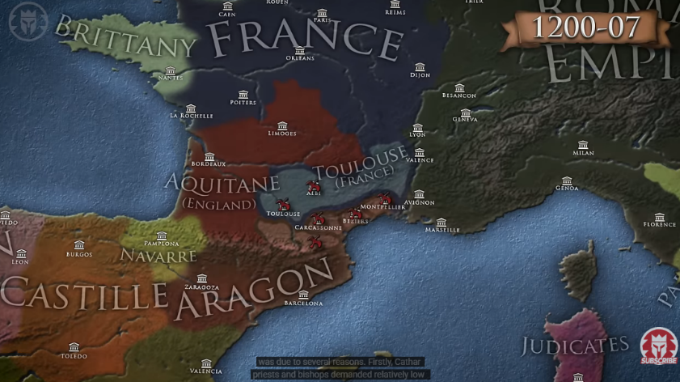
Due to the style of documentary that the video is in, as well as the animations. Which are similar to a strategy video game such as Total War, because of the 2d top down view (see fig 1). It seems to call towards the younger population, mostly because the video has a more action style to it, and is less academic in the sense of how it is directed. The video does not completely require the viewer to have prior knowledge of the Albigensian Crusade and the Massacre at Béziers, as the video briefly explains on the reasons why the crusade began in the first place – the video mentions the death of Peter of Castelnau which is the main event that would cause the crusade the begin in the first place. The video also briefly explains to the viewer on what Catharism is, which helps give context for the rest of the video, which is supportive in understanding how small the differences were between Cathars and Catholic during the conflict. The video also gives context on where Catharism may have originated, and also the reasonings as to why the Albigensian Crusade was named as such – mostly due to the largest and most prominent population of Cathars which was in in the Languedoc region of Modern day France, and was the Castra (Fortified City) of Albi.
Figure 1, Top down view of video (Kings and General, n.d . ‘Why Did the Albigensian Crusades Happen? - Medieval History’).

The video follows a documentary style format in the way it provides information to the viewer; it is still for the most part brief in how it does this, however, it provides a knowledgeable format which is easy to understand for the target audience. The narrator for the video is never seen and only heard due to the video only having animation, and not using images or videos from the real world – this does make it feel unprofessional to a degree, but the narrators fluency in how they convey the histories is effective and efficient – it seems the script the narrator wrote is followed entirely, and there is no derailing, this also does have some negative effects for the viewer, as it feels robotic in some instances, but the imagery of the documentary does aid in this not being a serious issue throughout the video.
The aesthetics of the video as said above treat it as some sort of action/strategy video game. With its stylistic approach on 2d and 3d animation, one showing strategy, another with still images with little animation and one which takes the video games style of the video to a higher degree (see fig 2). 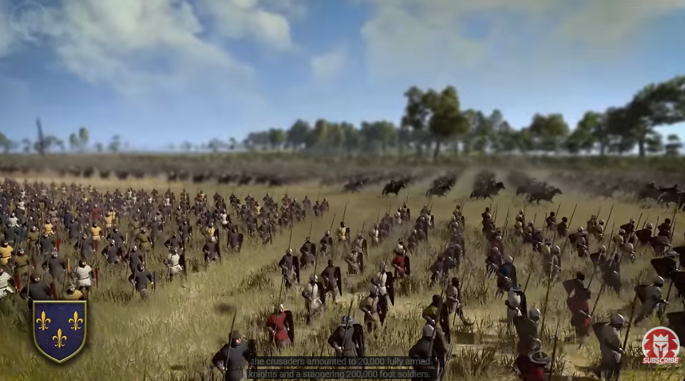
Figure 2, Image from video ((Kings and General, n.d . ‘Why Did the Albigensian Crusades Happen? - Medieval History’).
As seen in figure 2, the video looks strikingly similar to video games, specifically those of the Total War series. The video goes so far as to use a song throughout the video which creates a tense feeling, especially when it goes into explaining the Massacre at Béziers and Siege of Carcassonne. The choice in music does attempt to create tense emotions, however, I found that it made the video to some degree ‘childish’ and unserious, especially that choice of music for the Massacre at Béziers which feels disingenuous. Despite this, the video does effectively tell the audience on what happened at Béziers with context to create more imagination for the viewer when watching the video. The narrator mentions the numbers of the Crusaders and the different types from the Northern parts of France and mentions how the numbers that are written in the primary sources are overexaggerated, which does help the viewer understand the views of the writers back then, who were Caesarius of Heisterbach and Pierre des Vaux-de-Cernay. In addition to using the primary sources the video does put some focus on the main quote of Arnaud Amaury, where the Abbot says “Kill them all, the Lord knows who are his own”. This quote alone creates an environment in the video of shock, even for the standards back then, this outlook itself was alien to most of the population during the period – and for us today we can also feel these emotions of shock. The video does show a fantastic understanding of the events, although, the video feels more like a document than a worthwhile video documentary, it merely provides the events chronologically and does not give its own interpretation of these events despite the figures which are evidently from other academic sources. This can be viewed as a positive as it gives the viewer the source content to create their own interpretation, however, due to the brief nature of the video documentary it is difficult to create these original thoughts, if the video was longer and focused more on the Massacre and Siege, rather than moving onto the next topic and neglecting these events.
In conclusion the video is fantastic to begin researching and to get a small bearing of the Massacre of Béziers and Siege of Carcassonne, but it lacks awfully in its information because of how brief the content is in the video. The animation helps younger audiences to engage in history and potentially do their own research which is a positive and it is efficient in doing so, one must only look to the comments to see the discourse of the topic. However, the video does not provide any source material or references for further reading, which is a negative to the general viewer. Overall, it is a good video documentary but lacks uniqueness in how it interacts with the events. It reads like a monotonous blow by blow account of history which fails to approach the truth of a human tragedy. It also neglects to delve into the political landscape of 13th century Catholicism and Catharism – and this makes the video tedious and uninteresting.

Bibliography
Barber, M. C. (1977) Women and Catharism. Reading Medieval Studies, III. pp. 45-62 ISSN 0950-3129 Available at https://centaur.reading.ac.uk/84350/
‘COAT of ARMS’. 2022. The Coat of Arms, Annual Journal of the Heraldry Society, Volume 5.239
Graham-Leigh, Elaine. 2001. ‘Justifying Deaths: The Chronicler Pierre Des Vaux-De-Cernay and the Massacre of Béziers’, Mediaeval Studies, 63.1 (Brepols Publishers NV): 283–303 <https://doi.org/10.1484/j.ms.2.306486>
Kings and Generals. 2024. ‘Why Did the Albigensian Crusades Happen? - Medieval History’, Youtu.be <https://youtu.be/mKPhahc50v4?si=CNDjtgkJzkGGSUHs> [accessed 16 February 2026].
McGlynn, Sean. 2015. Kill Them All (The History Press).
Robechek, Ruth W. 1929. The Troubadours and the Albigensian Crusade (Berkeley: University of California Press Books Division).

Kings and Generals. 2024. ‘Why Did the Albigensian Crusades Happen? - Medieval History’, Youtu.be <https://youtu.be/mKPhahc50v4?si=CNDjtgkJzkGGSUHs> [accessed 16 February 2026].
Ibid.
Ibid 00:43.
McGlynn, Sean. 2015. Kill Them All (The History Press) p. 8.
Kings and Generals. 2024. ‘Why Did the Albigensian Crusades Happen? - Medieval History’, Youtu.be <https://youtu.be/mKPhahc50v4?si=CNDjtgkJzkGGSUHs> [accessed 16 February 2026] 01:55.
Ibid.
Kings and Generals. 2024. ‘Why Did the Albigensian Crusades Happen? - Medieval History’, Youtu.be <https://youtu.be/mKPhahc50v4?si=CNDjtgkJzkGGSUHs> [accessed 16 February 2026].
Ibid.
Ibid.
Kings and Generals. 2024. ‘Why Did the Albigensian Crusades Happen? - Medieval History’, Youtu.be <https://youtu.be/mKPhahc50v4?si=CNDjtgkJzkGGSUHs> [accessed 16 February 2026].
Ibid.
Graham-Leigh, Elaine. 2001. ‘Justifying Deaths: The Chronicler Pierre Des Vaux-De-Cernay and the Massacre of Béziers’, Mediaeval Studies, 63.1 (Brepols Publishers NV): 283–303 <https://doi.org/10.1484/j.ms.2.306486> p. 283
Kings and Generals. 2024. ‘Why Did the Albigensian Crusades Happen? - Medieval History’, Youtu.be <https://youtu.be/mKPhahc50v4?si=CNDjtgkJzkGGSUHs> [accessed 16 February 2026] 10:39.

