Module Code | BMSW5104
Title | Managing Project in the Organisation
Student Name | Navila Hassan
Student ID | 1711167
Lecturer | Ernest Ovia

Introduction 1
Defining the Project 1
Assessing the Risk Factors of the Project 3
- Recognizing the Relevant Stakeholders 3
- Users Stories 3
- Balancing the Iron Triangle 4
Time and Cost Estimation 6
Monitoring Progress 7
- Stand up Meeting 7
The personal reflection 8
Recommendation 8
Reference 9

Introduction
This report will explain the tool and techniques that have been used during the project development plan in the completion of Vintners Antiques (VA) family project. VA is a family run an antique shop that has run for over thirty years, and now the third generation oversees the business. The role and responsibility of each member are describing below:
Name | Job | Role and Responsibility
Doreen Vintner | Accountant | Has been working as the accountant for ten years
Denis Vintner | Driver and Antique finders | In charge of antique transportation and search of the antique stuff due to his own passion.
Suha Madani | Customer Services | In charge of the customer service for about three years.
Omar King | The Warehouse Operator | Omar is classified as the general allrounder. He knows where everything is, he has been working in the shop since he was a boy. He also repairs the broken items that Denis brings to the shop.

Inspired by the TV show VA want to improve their business as same as the ‘Salvage Hunters’ run by Drew Pritchard. They have decided to shift the company to the warehouse that has only been used for the storage purpose.
The warehouse is a very basic store like an empty shell as it does not have electricity, phone, internet not even office space. The project is enriched to transform the warehouse into fully functioning Antique business showroom mirroring the ‘Salvage Hunters’.

Defining the Project
Project is the vehicles for delivering changes with expected quality to achieve the proposed purpose. The characteristic of a project is intentionally temporary, and therefore, the project needs to define its deliverables that include:
- The defined completion time with the start and target end date
- A defined budget
- Defined resources include human resources, building materials, IT equipment etc. (Roberts, 2012).
The Vintners family Project Management (PM) involved the coordination of resources to complete the Warehous with the required quality standard. (PMI, 2008). According to Baars (2006) the basis for all PM is to recognize the project life cycle phases the beginning, middle and end periods of the project. This led the project into the best possible direction as the total workload can be divided into smaller part therefore it is easy to monitor. The following figure demonstrates the organisation of the phasing model that has been placed into during the VA PM:
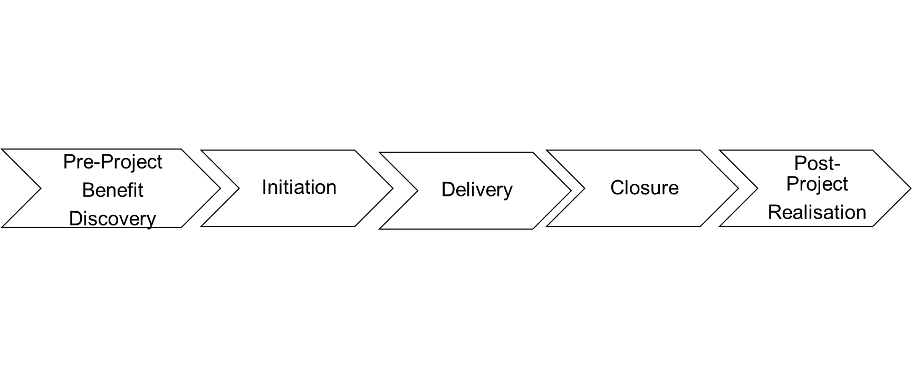
Source: (Robert, 2012)
The pre-project is where the benefits of the proposed ideas are explored and examined. Roberts (2012) explains before any plan initiation; it is significant to understand the change the company is seeking to make through this project and realizing the benefit they can receive once the project is completed. The actual project begins at the initiation phase, where decisions are made concerning the following:
• What is the aim of this project?
• Is it feasible?
• Whom is to carry out the project?
• Who are the possible stakeholders in this project?
• What are the limitations of this project? (PMI, 2008).

Assessing the Risk Factors
Project Management aim is to bring a solution to a problem. A problem is a gap between the expected outcome and the present situation. A solution can only be achieved through understanding the certain and uncertain obstacles. Therefore, a more accurate plan can be initiated (PMI, 2008).
Most importantly, a project is accelerated through changes that may transform the process performance or culture of the settings; thus, expectations outcomes are less easy to determine or managed. The uncertainties of these unknown elements revealed the project’s risky nature. Once the extent of risks identified the right project management effort could be implemented to minimize the risks and successful delivery of the project (Heagney, 2012).

Recognizing the Relevant Stakeholders
The stakeholders in a project refers to the people who are interested in the developed project representing the particular part of the business that are commercial, specialised and User-friendly (Roberts, 2011). Roberts (2012) recognises a suitable project structure needs a balance steering group people who fit into these three camps.
The steering group of stakeholders is created for the project to be commercially funded, to gain expert inputs and to understand the voice of the services users.
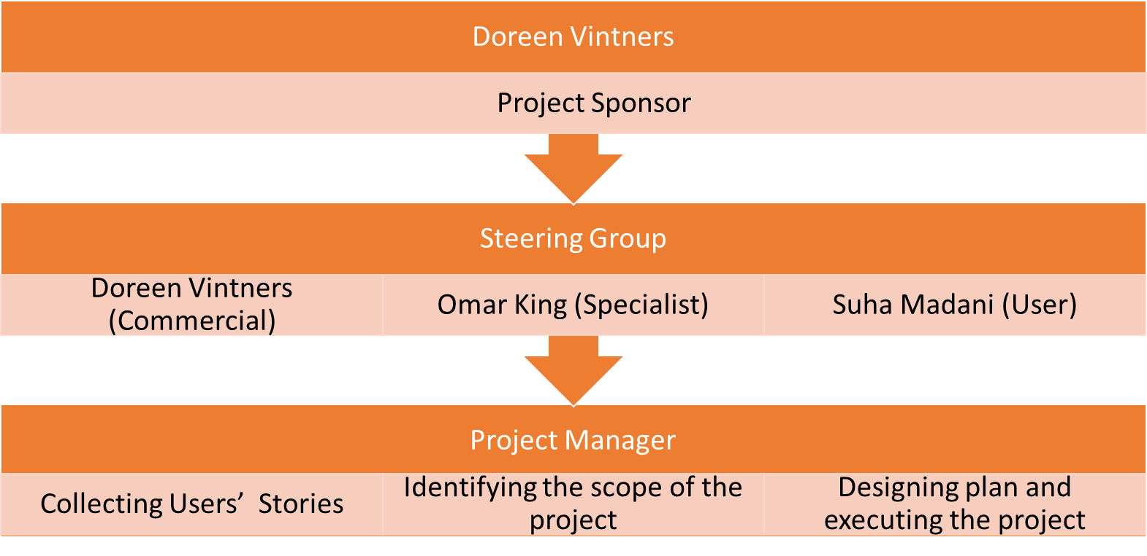

Users Stories
A high level of pre-project effort been made to save cost and schedule facilities in the VA project. For this to happen, the stakeholders’ requirements and concerns need to be integrated (Aibinu and Fageha, 2012). User Stories (US) is a PM technique that allows the project manager to define the expected product and services from various stakeholders. These stories are then recorded in various source such as sticky notes, software, whiteboard etc. The VA project consisted of a good number of users stories the short natural sentence describing the type of functionality the user expected and why they want it. The format of VA project users’ stories designed such: As the services provider, I want the warehouse to be facilitated with parking space because this will benefit distance driver customer. Through this technique, the main need and requirements were reflected; the obstacles of the project that needed to overcome were also recognized. However not all the stakeholder’s expectation can be meet (Aibinu and Fageha 2012). The stories need to be managed through tasks prioritization categorizing into the must, want and niche criteria. Once the definitive lists of the task prioritization been presented with the Microsoft Planner, it had been assumed that most of the agreements between the VA and the project team been established (Berteig, 2019).

Balancing the Iron Triangle
Iron Triangle is a project management technique that consists of three major factors scope, time and budget. A project to proceed successfully, there must be a balance among these factors. Project scope is the vital process using stakeholders’ inputs and this need to be identified at the primary stage of the project lifecycle (Atkinson, 1919). The nature of the VA project is the combination of the construction and renovation to create a comfortable business operation area. Aibinu and Fageha (2012) explain, construction project specifically involves a different degree of changes in the surrounding environments and peoples, which can impact negatively or positively. Therefore, understanding the project scope with sufficient information will identify the amount of work that needs to be also performed to avoid the major changes.
The Vintner family project prosecuted with cautiously defined project scope; with active stakeholders’ involvement. This information helped the project to design a balanced plan that matched the VA’s budget and time while reassuring the customer (VA family). Once the scope, time and cost factors of been agreed, the customer (VA) were expected not to add any more requirements. (Gibson et al., 2006).
The Design Phases
At this point, the project has reached at the actual system design phases the second stage of the waterfall PM approach. Two of the most important factors here is the proper planning and task delegation. Proper planning that mirrors the clear upfront requirements needs to be understood by the people who are involved in the PM team. Effective task delegation involves assigning the right people based on their positive attitudes, qualification, skills and willingness to contributes to the challenge. Therefore, the project management team members were allocated with the specific role and responsibilities for the different aspect of the project areas. This greatly influenced the distribution of the resource allocation such as managing workers, recognizing the clerical, safety risk, law and regulation, contacting worker and third-party craftsman (Pop and Boian, 2014).

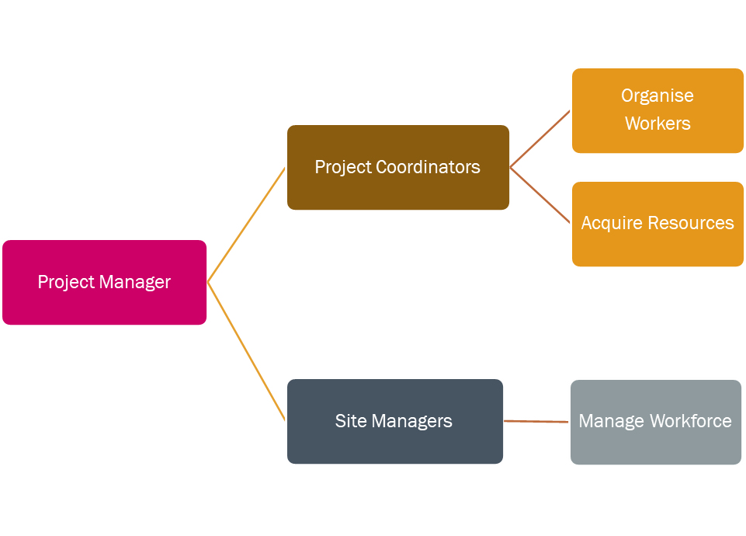Figure 3. VA project task delegation
Project Coordinator’s role was to liaise with the different workers and systematically organised them to make sure the plan is in aligned with the project objectives.
Site manager ensured that the assigned tasks are being performed to the expected standard in the assigned time. Both characters instructed to informed to the project manager (Pop and Boian, 2014).
To determine the progress, team members were referred to the documentation created throughout the process. Documentation is a big priority at the waterfall project management as this clarified what is expected, thus guide in producing the right product and services (Berteig, 2019).

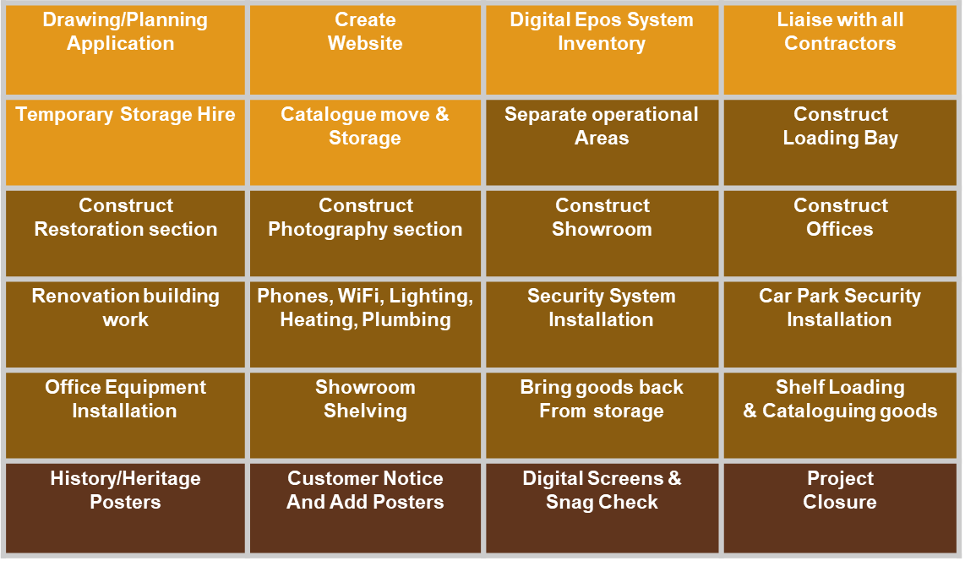
Figure 5. The planning and task allocation of the VA project

Time and Cost Estimation
The time and cost forecasts for every parts of the project have been projected applying the Delphi Technique. This is an ancient and well accepted technique that involves accounting certain people’s perception referring as the wisdom of the crowd to make a very accurate estimations. However, it can be quite anxious for the clients when it’s come to learn about the estimated time of the task (Robert, 2011). Robert (2012) explains it is challenging to make accurate guesses for task time estimation. As the solution he suggests, creating grids for each documented user stories measuring the size and complexity scoring low, medium or high to understand the effort, cost and lengths of each task. Therefore, a more accurate task duration was estimated.

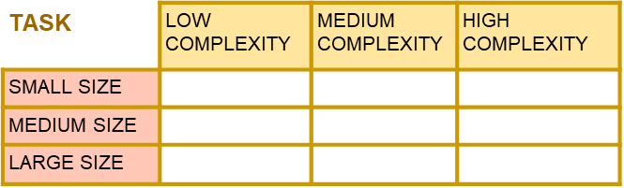
The overall project duration been calculated with the Gantt chart software, reflecting the time duration for each task would have taken place. Gant chart is one of the useful project planning technique that displays task/event activities against time. The horizontal line represents the time scale, and the verticals line represent the activities list. Each bar represents the length and position of each task; the start date, end date and duration of the activity.

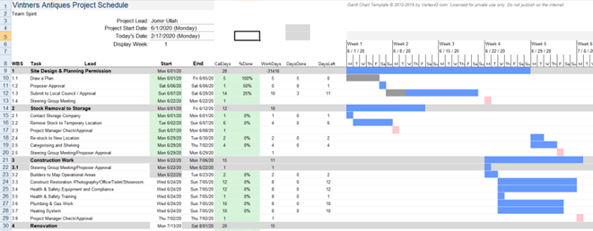

Progress Monitoring
The project progress monitoring involves continuous tracking of the ongoing operation. The VA project involved multiple team members in charge of various areas of the project at the same time. The Gantt chart is used to demonstrates the Vintner family the project management team effort of scheduling activities based on the previous stage’s information specifications. To maintain the tasks qualities that assured the budget, scope and time constraints, everyone in the project needs to follow the approved Gantt chart by the board. The main objective of these documents is to guide the entire team to communicate the task progress to one another. (Maylor, 2001).

Stand up Meeting
Stand up meeting is a technique used in project management to share everyone’s task progress with the entire team, not only the PM. The meeting only last for ten minutes and held in standing up looking for brief answers of three questions:
- What you did yesterday?
- What are you going to do today?
- What are the problems that are stopping you from progress?
- We have just demonstrated a few days in the life of a project (KPMG, 2019).
The stand-up meeting is the part of the dynamic concept the Management by Objective (MBO). MBO considered as one of the rewarding management systems that provide a simple but systematic way to integrate the company’s need and molding worker attitudes that target each objective of the success (Thomson, 1998).
The regular stand up meeting is about engaging in continuous feedback for assessing individual task progression, thus providing performance accountability; problem and obstacle will be recognised; therefore, the quick solution can be planned. In order to ensure the quality, the VA project relayed on the horizontal/vertical communication and feedback among the steering group and the entire workforce while updating the Gantt chart (KPMG, 2019).

The personal reflection
The completion of the VA family project has helped me to identify how a business can continue to maintain its operation by selecting the right project management team. A project is temporary with a definite time, budget and resources. Every project is unique because it has a short life cycle with specifics sets of operation to accomplish a particular goal to bring certain change in the business. The management of the project involves the application of the right skills, knowledge, tool and technique to initiates the project requirements. Such as user stories to identify their problem, Chevron for task prioritisation and order, Delphi methods for accurate estimation and Gantt chart as the communication sources that can be monitored and updated. The project moved forward with the waterfall methodology, which is a traditional fixed planned driven approach. This approach is well situated where the goal of the project and the solution to the problem are both addressed and clearly understood (Roberts, 2011); (Roberts, 2012). Merwe (2017) recognises that deviation in the plan such as changes in cost, timing and scheduling are more likely to be inevitable no matter how sophisticated the initial planning. Thus, the lack of adaptability to change make the waterfall approach risky to many projects. Whereas, the agile approach is more flexible and can directly deal with the unexpected challenges in dynamic changing environments.

Recommendation
Both approaches have do not guarantee the success of the project. Pavel Kukhnavet (2018) describes it is vital to learn about the company’s requirements, objectives and goal before choosing the project methods. If that information clearly clarified the amount of task involved, therefore more accurate estimation is calculated, then the waterfall process is the way to go. In the other hand if the stakeholders’ expectations are not clearly captured and the environments are reluctant to the change, then agile would be the ideal approach (PMI, 2008).

Reference

- Aibine, A. A., Fegeha, M. K. (2012). ‘Managing Project Scope Definition to Improve Stakeholder’s Participation and Enhance Outcome’, Social and Behaviour Sciences, 74(2013). P.P 154-164. [Online] Available at: https://www.researchgate.net/publication/257718824_Managing_Project_Scope_Definition_to_Improve_Stakeholders'_Participation_and_Enhance_Project_Outcome (Accessed: 24/03/2020).

- Atkinson, R. (1999). ‘Project management: cost, time and quality, two best guesses and a phenomenon, it’s time to accept other success criteria’, International Journal of Project Management, 17(6), pp. 337-342. [Online] Available at: https://notendur.hi.is/vio1/Project_management_Cost_time_and_quality.pdf (Accessed: 27/03/2020).

- Baars, W. (2006). Project Management Handbook. [Online] Available at: https://www.projectmanagement-training.net/wordpress/wp-content/uploads/2015/11/book_project_management.pdf (Accessed: 21/03/2020).

- Berteig, M. (2019). User Stories and Story Splitting - Agile Advice. [online] Agile Advice. Available at: http://www.agileadvice.com/2014/03/06/referenceinformation/user-stories-and-story-splitting/ (Accessed: 25/03/2020).

- Gibson Jr, G. E., Wang, Y. R., Cho, C. S., and Pappas, M. P. (2006). What Is Pre-project Planning, Anyway? Journal of management in engineering, 22(1), pp. 35-42. [Online] Available at: https://www.researchgate.net/publication/245298447_What_Is_Preproject_Planning_Anyway (Accessed: 18/03/2020).

- Heagney, J. (2012). Fundamentals of project management. New York: American Management Association.

- Hygger (2018). ‘How to choose the best Approach Among Different Project Management Methodologies?’ Pavel Kukhnavet [Blog].18 Jan. Available at: https://hygger.io/blog/how-to-choose-the-best-project-management-methodology/ (Accessed: 27/03/2020).

- KMPG. (2019). Agile Internal Audit. [Online] Available at: https://home.kpmg/content/dam/kpmg/sg/pdf/2019/09/agile-internal-audit.pdf (Accessed: 28/03.2020).

- Roberts, P. (2012). Effective project management. London, U.K.: Kogan Page.

- Roberts, P. (2011). Effective Project Management. Dawsonera [Online] Available at: https://www-dawsonera-com.ezproxy.uwtsd.ac.uk/abstract/9780749461584 (Accessed: 27/03/2020)

- PMI. (2008). A Guide to the Project Management Body of Knowledge. 4th Edn. [Online] Available at: https://www.works.gov.bh/English/ourstrategy/Project%20Management/Documents/Other%20PM%20Resources/PMBOKGuideFourthEdition_protected.pdf (Accessed: 27/03/2020).

- Maylor, H. (2001). ‘Beyond the Gantt chart: Project management moving on’, European Management Journal, 19(1), pp.92–100. [Online] Available at: https://www-sciencedirect-com.ezproxy.uwtsd.ac.uk/science/article/pii/S0263237300000748 (Accessed: 26/03/2020).

- Merwe, I. (2017). How relevant are waterfall project management methodologies in today’s modern project environment? [Online] Available at: https://www.researchgate.net/publication/321808034_How_relevant_are_waterfall_project_management_methodologies_in_today's_modern_project_environment (Accessed: 27/03/2020).

- Pop, B., Boian, F. (2014). ‘Algorithms for Automating Task Delegation in Project Management’, Computer Science and Information Systems, Vol. 2 pp. 1191–1196. [Online] Available at: https://annals-csis.org/proceedings/2014/pliks/426.pdf (Accessed: 25/03/2020).

- Thomson, T. M. (1998). MANAGEMENT BY OBJECTIVES. [Online] Available at: http://home.snu.edu/~jsmith/library/body/v20.pdf (Accessed: 28/03/2020).

