

Project Management Plan

Module name: Managing projects in the organization
Module Code: BMSW 5104
Student Name: Nedyalko Radev
Student ID: 2128093
Lecturer Name: Aderemi Ojebode

Table of Contents
1. Introduction 3
2. Project Description 4
3. Project Scope 4
4. Work Breakdown Structure 5
5. Quad Chart 6
6. Gantt Chart 7
7. Stakeholders' Involvement 8
8. Allocation of Resources 9
9. Risk Analysis 10
10. Conclusion 13
References 14
Appendix 16

List of Figures
Figure 1: Work Breakdown Structure…………………………………………………………….6
Figure 2: Gantt Chart 8
Figure 3: Stakeholder Mapping 9

1. Introduction
This report will be prepared based on the project management plan of TallyBook which is a personal finance management application. In the pitch of the project, a brief analysis of the business idea was presented. But this report will mention more aspects of the project management plan. The plan will be divided into various sections such as scope, stakeholder management, allocation of resources, quad chart, work breakdown structure, etc. In this report, a proper analysis of the business idea will be given which will also identify the potential risks of the plan. This will also help the investors to identify the potentiality of the business plan.

2. Project Description
TallyBook is a new business idea that will meet the needs of a certain group of people. The product will operate in the personal finance management sector. Due to the importance of proper finance management at the individual level, this app will be developed which will meet the demand for effective personal finance management (French et al., 2021). In the current world, ensuring better finance management is important. The rising cost of necessary commodities and the global economic crisis have increased the need for proper finance management. But in the present world, people have become very busy with different tasks. For this reason, finance management can be a difficult task for people (Tyson, 2023). In addition, listing all costs and income can be challenging and time-consuming for people who use traditional paper-based systems. For this reason, the development of TallyBook can solve these problems.
TallyBook is a mobile app which will allow the management of personal finance through the features of the app. This app will allow the better management of finance for students which are the main customer base of the company. Students are the primary customers of TallyBook. Students who are pursuing bachelor's or master’s degrees tend to work part-time as their main earning (Panos and Wilson, 2020). On the other hand, they have to spend on different factors along with educational expenses. For this reason, TallyBook will help them to keep a record of all expenses and earnings. In addition, TallyBook will allow customers to find financial sources and lending opportunities. Customers can get loan opportunities and also maintain all their finance-related aspects through the mobile app. Along with the management of daily finance, customers can find the savings or lending amount they need to pay within the deadline (Jozani et al., 2020). Not only managing daily finance but also loan opportunities and investment opportunities will be provided through TallyBook for customers.

3. Project Scope
In terms of the scope of TallyBook, the mobile app has a very big potential in the current market. If the development and management of TallyBook go according to the plan, then the mobile app can become the first choice for customers in terms of personal finance management. Firstly, the target customers of the company are facing the need for a finance management app with a lot of facilities (Manser Payne et al., 2021). At present, there are some personal finance management applications available in the Mobile Play Store. However, these finance management applications offer limited facilities to customers which will be overcome through the TallyBook.
In this app, customers will be able to find the daily expenses and income along with monthly data on expenses. Not only this, customers will also find the headings of each cost. As a result, they will be able to control the expense. In addition, the app will suggest to customers about their personal finance management. According to the developed programming, TallyBook will offer personal finance management suggestions based on monthly expenses and income. In addition, if customers can save more than their expenses, the app will also offer investment opportunities to customers. Small investment opportunities will be included in the mobile app through partnering with financial investment companies (Fox et al., 2021). Suggesting the scope of opportunity and controlling finance can allow customers of TallyBook to improve their personal finance management. TallyBook will initially be found in the Play Store for both Android and IOS. The primary aim of increase the number of users. For this reason, customers can easily download from the Play Store. Third-party advertisement will be the main income for the company. In addition, TallyBook will introduce subscription-based services to customers. After increasing the popularity of the company, TallyBook will introduce subscription-based services to increase the income of the company.

4. Work Breakdown Structure
Initiation: It is the first stage of the development of TallyBook. In this stage, brainstorming was done by the group members to find the solution to the given problem of personal finance management. Students are facing problems related to personal finance management which allowed the generation of the idea of TallyBook.
Software Development: In the software development stage, the TallyBook mobile application will be developed based on C++ and JavaScript. For the Android Play Store, Android Studio will be used for the development of the app. On the other hand, for the IOS store, Swift programming language will be used for compilation.
Marketing: The marketing of TallyBook will be done based on social media platforms. As target customers of TallyBook are very active on social media platforms, the app will be promoted through social media platforms. It will attract customers and they will install the app from the Play Store (Hassandoust et al., 2021). For this kind of application, the usage of digital marketing will be more effective rather than traditional marketing.
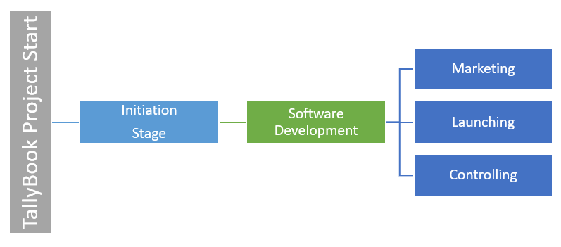
Figure 1: Work Breakdown Structure
Source: (Fox et al., 2021)
Launching: TallyBook will be launched in both the Android Play Store and the IOS App Store. Potential users who want to download the app from the Play Store can easily download it without any payment. In addition, the app won’t cost any money for usage rather they will have to see some advertisements because it will be a source of income for the app developer company (Peter and Dalla Vecchia, 2021). However, TallyBook will introduce subscription-based services after gaining popularity.
Controlling: It will be one of the most important stages of the app development. In this stage, customer feedback will be taken through the separate option of providing feedback. Developers will try to improve the application based on the feedback of customers. This will ensure proper development of the app in the long term.

5. Quad Chart
Purpose | Customers
The purpose of TallyBook is to help users in their personal finance management. In particular, students who are pursuing bachelor's or master's degrees are customers who are facing problems in their personal finance management. Their problem will be solved through TallyBook as the app will help to keep a record of expenses, incomes, funding and investment opportunities (Veleva and Tsvetanova, 2020). Management of personal finance, controlling cost, finding investment opportunities as well as loan-taking opportunities will be provided through TallyBook. | University students are the primary customer segment for TallyBook. As they have to maintain many costs related aspects as well as have to maintain the income from part-time work. So, keeping a record of expenses and investment opportunities can allow these users to improve their finances (Marle, 2020). In addition, anyone can download this application from the app store to maintain their finance. Job holders, business people, etc. can use the app very easily because of the user-friendly appearance of the app.
Desired Result | Measures of Success
In terms of desired results, TallyBook wants to increase the popularity and the number of users of the app. Achieving a certain number of users will allow achieving the breakeven point for the company. In addition, achieving more than 10 million users within 3 years of operation can be used to measure the success of TallyBook. Through the income from the advertisement, break even margin will be achieved. After reaching one million users, TallyBook will introduce a subscription-based service. | In terms of measuring the success for TallyBook, the company will be counted successful if the company can reach 10 million users within 3 years of operation. In addition, achievement of the break-even margin within the 2 years of operation will be counted as the success for the company. Along with this, the company will collaborate with investment companies for lending and investing money to users. This will be the long-term goal for TallyBook.

6. Gantt Chart
Factors | Duration | Start Date | End Date
App Development | 6 Months | 03/01/2024 | 08/01/2024
Promotion | 3 Months | 08/01/2024 | 11/01/2024
Initial Customer Acquisition | 2 Months | 11/01/2024 | 01/01/2025
Growth | 6 Months | 01/01/2025 | 07/01/2025
Break-even Achievement | 6 Months | 07/01/2025 | 01/01/2026
10 million Customers | 10 Months | 01/01/2026 | 11/01/2026

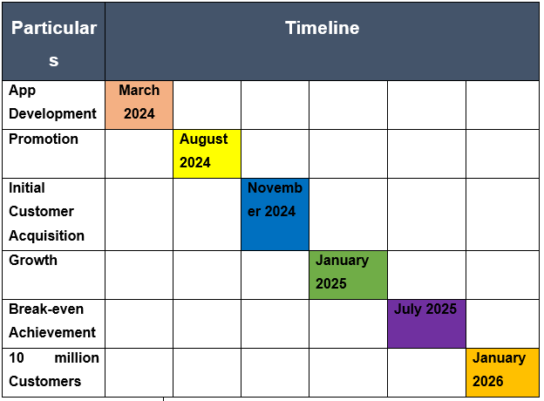
Figure 2: Gantt Chart
Source: Author
It is expected that TallyBook will achieve the key objectives within the 2 years and 8 months of operation. From March 1, 2024, the development of TallyBook will be started and within November 2026, TallyBook will achieve a 10 million user milestone. After gaining the expected number of users, TallyBook will focus on the expansion of the business more.

7. Stakeholders' Involvement
In terms of stakeholders, TallyBook will engage certain parties. All these parties will have the interest and power to affect the company. In the initial stage, TallyBook will not employ anyone. Rather the developer of the app will maintain the daily operation of TallyBook. Key stakeholders of TallyBook are:
Investors: Developers and angel investors of TallyBook are the key investors of the company. They will seek a return from the company. Within two years, TallyBook wants to achieve the break-even margin. Then, the profits of TallyBook will be distributed to these investors of TallyBook.
Customers and Users: Users will be the second most important stakeholder for TallyBook. As they will use the app for their personal finance management, they will want to have convenient service from the app. Meeting customer's demands and developing the app accordingly will ensure the long-term success of TallyBook.
Partners: In the long term, TallyBook wants to collaborate with financial companies such as banks, insurance, etc. To offer loan opportunities and investment opportunities to users of TallyBook, the company will collaborate with these financial companies. They will seek a return on their investment which will be ensured by the developer of TallyBook.
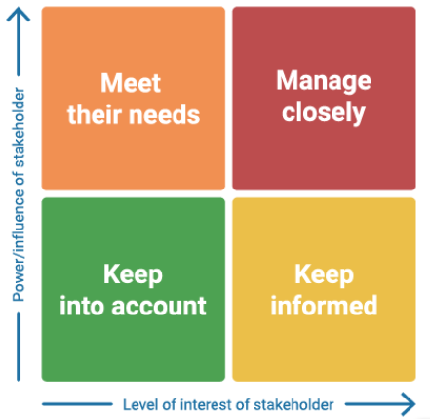
Figure 3: Stakeholder Mapping
Source: (Sarker et al., 2021)
Regulatory Bodies: The government and other regulatory authorities will be one of the key stakeholders because of the involvement of the personal data of customers. For this kind of finance-related company, it is very important to ensure the protection of customers' data. So, these government bodies will monitor the usage of the personal data of TallyBook.
Employees: In the medium term, TallyBook will be developed more which will require the developer to engage employees for better management. Employees will be employed for marketing, customer support and IT. They will maintain and promote the app to customers to improve the experience of users.

8. Allocation of Resources
Sources of Fund
In terms of sources of funds for the development of TallyBook, the developers aim to get funds from angel investors. In addition, the bank loan will be taken for the development of TallyBook. Getting funds from investors will help developers to focus on the development of the app more. The fund ratio for developing TallyBook will be 60:40 where 60% of funds will be collected from angel investors and 40% of funds will be collected from bank loans. It is expected, that the developers of TallyBook will be able to cover all costs within 50,000 pounds.
Allocation of Fund
App Development: For developing the app through a third-party company, around 20,000 pounds will be used by the developers of the business idea. This is the main source of cost and most of the resources will go into this stage (Alzoubi, 2022). Once the development of TallyBook is complete, the developers will focus on operation.
Marketing: For marketing of TallyBook, around 10,000 pounds will be used. The usage of third-party websites, social media platforms, etc. will be used. As digital marketing will be more effective for the popularity of TallyBook, the developers will spend on digital marketing. Promoting through social media apps and using ad boosting will help to reach more customers.
Customer Support: For the customer support facility, around 5,000 pounds will be spent. Three employees will work on three shifts to offer 24-hour services to customers. Feedback from customers will be managed by these three employees who will manage the complaints of customers.
Maintenance: For maintenance of the app on different platforms and daily operations, around 10,000 pounds will be allocated. Proper management of the app is necessary along with continuous development of the facilities. The app will ensure more services to customers with time.
Other Fees: Other fees such as security fees, registration fees and other fees will need around 5,000 pounds. Registration of the app, and applying for patents, trademarks, etc. will cost the company.

9. Risk Analysis
There are several risks associated with the development and management of TallyBook. Those are:
Security Risk: It will be the most affecting risk for TallyBook. As a mobile finance management app that will use the personal data of customers, TallyBook might be attacked by hackers. Unethical users and cyber criminals might try to attack the app for financial fraud, identity theft, etc. (Sarker et al., 2021). To overcome this, TallyBook will ensure encryption and other security measures.
Technology Risk: Technological development is higher within the UK (Wanof, 2023). For this reason, the developers of TallyBook will have to ensure compliance with the latest technological resources. Without complying with the latest technology, TallyBook might not be able to hold customers for a long time.
Financial Risk: Financial risk is the risk of occurring loss. As the developers want to get investment from angel investors and bank loans, generating profits for these parties is a must for TallyBook. As there are some finance management applications available, TallyBook might not get the expected profits from the operation which might raise financial risk (French et al., 2021).
Compliance Risk: Compliance risk is another major risk for TallyBook because of the nature of the app. As it is a finance management application which will involve the personal data of customers, compliance with regulatory bodies is a must. In addition, compliance with GDPR, regulations and financial compliance is necessary for the management of the app. If developers can’t maintain the changing compliance, then TallyBook might face problems.
Schedule-related Risk: There is a chance that the project might not be completed within the assumed deadline. This can affect the investors negatively as well as other stakeholders. Due to the uncertainties related to app development, this kind of risk can arise.
Reputation Risk: In the current world, a negative review of anything can create a negative perception among customers. For this reason, negative reviews about TallyBook can affect the popularity of the app (Panos and Wilson, 2020). Although TallyBook will ensure a 24-hour complaint management facility for customers, there is still a chance that customers might get a bad experience. As a result, negative reviews can arise which might affect the reputation of TallyBook.
Risk Mitigation: To avoid risks, TallyBook will do a patent so that competitors can’t copy the app. To mitigate risks, the project development plan will be followed properly so that any area of the project doesn’t get missed. In terms of risk transfer, if losses arise, the developers will ensure that losses of the project are distributed to stakeholders also (Alzoubi, 2022). Lastly, the development team accepts the risk of having higher competition in the market.

10. Conclusion
The personal finance management app named TallyBook is a solution to finance management for students and individuals who aim for better finance management. Although students who are pursuing a bachelor's or master's degree are the primary target customers, individuals who have income and expenses can use this application for better management of finance. Daily expenses, monthly income, statements after every month, suggestions for better finance management, loan opportunities as well as investment facilities will be provided through TallyBook. The app will be available in the Play Store on both Android and IOS platforms. Users will be able to improve their knowledge and better maintain their financial resources through the app. TallyBook aims to achieve the break-even margin within 2 years of operation where the income will be generated through in-app advertisement. However, once the app reaches 1 million users, it will introduce a subscription-based service which will be the main source of income then. Collaboration with financial companies will be done in the long term to offer loan and investment opportunities to customers for improving their financial resources.

References
Alzoubi, H.M., (2022). BIM as a tool to optimize and manage project risk management. International Journal of Mechanical Engineering, 7(1).
Fox, G., Clohessy, T., van der Werff, L., Rosati, P. and Lynn, T., (2021). Exploring the competing influences of privacy concerns and positive beliefs on citizen acceptance of contact tracing mobile applications. Computers in Human Behavior, 121, p.106806.
French, D., McKillop, D. and Stewart, E., (2021). The effectiveness of smartphone apps in improving financial capability. In Financial Literacy and Responsible Finance in the FinTech Era (pp. 6-22). Routledge.
Hassandoust, F., Akhlaghpour, S. and Johnston, A.C., (2021). Individuals’ privacy concerns and adoption of contact tracing mobile applications in a pandemic: A situational privacy calculus perspective. Journal of the American Medical Informatics Association, 28(3), pp.463-471.
Jozani, M., Ayaburi, E., Ko, M., and Choo, K.K.R., (2020). Privacy concerns and benefits of engagement with social media-enabled apps: A privacy calculus perspective. Computers in Human Behavior, 107, p.106260.
Manser Payne, E.H., Peltier, J. and Barger, V.A., (2021). Enhancing the value co-creation process: artificial intelligence and mobile banking service platforms. Journal of Research in Interactive Marketing, 15(1), pp.68-85.
Marle, F., (2020). An assistance to project risk management based on complex systems theory and agile project management. Complexity, 2020, pp.1-20.
Panos, G.A. and Wilson, J.O., (2020). Financial literacy and responsible finance in the FinTech era: capabilities and challenges. The European Journal of Finance, 26(4-5), pp.297-301.
Peter, M.K. and Dalla Vecchia, M., (2021). The digital marketing toolkit: a literature review for the identification of digital marketing channels and platforms. New trends in business information systems and technology: Digital innovation and digital business transformation, pp.251-265.
Sarker, I.H., Hoque, M.M., Uddin, M.K. and Alsanoosy, T., (2021). Mobile data science and intelligent apps: concepts, ai-based modelling and research directions. Mobile Networks and Applications, 26, pp.285-303.
Tyson, E., (2023). Personal finance for dummies. John Wiley & Sons.
Veleva, S.S. and Tsvetanova, A.I., (2020), September. Characteristics of the digital marketing advantages and disadvantages. In IOP Conference Series: Materials Science and Engineering (Vol. 940, No. 1, p. 012065). IOP Publishing.
Wanof, M.I., (2023). Digital technology innovation in improving financial access for low-income communities. Technology and Society Perspectives (TACIT), 1(1), pp.26-34.

Appendix





