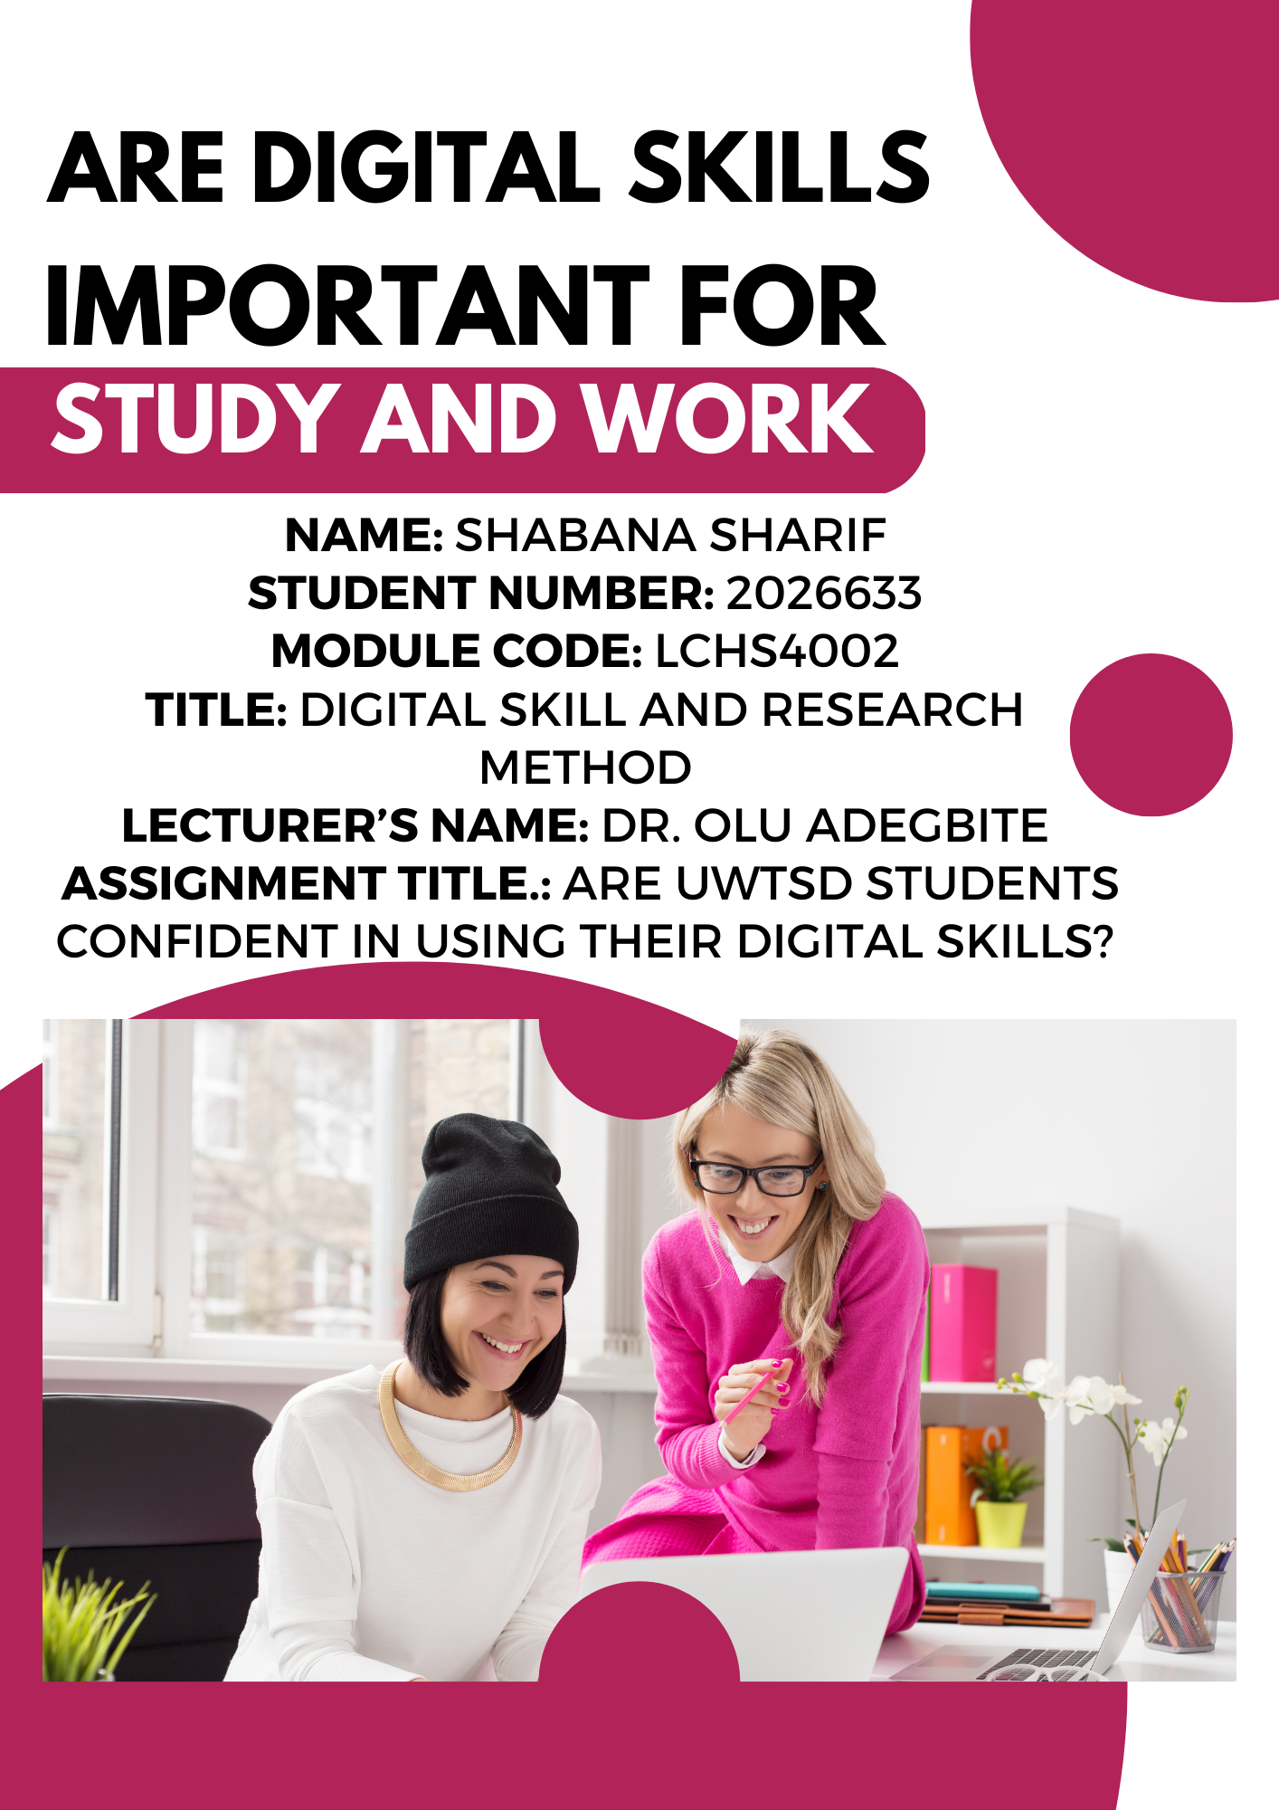

Contents
1. Introduction: 3
2. Research Design: 4
2.1 Research Question: 4
2.1 Methods: 4
2.3 Ethical Considerations: 4
3 Results: 6
Question 1: 8
Question 2: 9
Question 3: 9
Question 4: 9
Question 5: 9
Question 6: 9
4 Discussion: 10
5 Conclusion: 11
6 Reference List 11
7 Appendix A 11

Introduction:
In today's rapidly changing world, the need for digital skills has never been more critical. With technology permeating nearly every aspect of daily life, it has become essential for individuals to possess a strong understanding of digital skills in order to succeed in both academic and professional settings (UNCTAD, 2018). The significance of collaboration cannot be understated either, as it has become an essential element of the modern workplace (Boyer, 2019). In this report, we will delve into the importance of digital skills in both study and work environments, with a particular emphasis on collaboration tools like Microsoft 365 and online learning platforms such as Moodle.
To provide a comprehensive understanding of the topic, the report will begin by examining the significance of digital skills and collaboration in the modern era. We will explore the role that digital tools play in facilitating collaboration across different industries and how they have transformed the way we work and learn. In addition, we will analyze how the emergence of digital libraries and online learning platforms has revolutionized the way students and professionals approach collaboration, highlighting their unique benefits and contributions to collaborative efforts.
Moreover, the report will delve deeper into the specific advantages of using digital tools, including how they can enhance productivity, streamline communication, and improve learning outcomes in different contexts. We hope to give a thorough grasp of the good effects that digital abilities and collaboration tools may have on academic and professional activities through this investigation.
The research question that we seek to answer in this report is whether digital skills are crucial for success in both study and work environments, and how collaboration tools like Microsoft 365 and Moodle can facilitate this process. We will examine the various ways in which these tools can be leveraged to enhance productivity and success, while also considering potential limitations and challenges that may arise.
Based on our research and analysis, we hypothesize that Microsoft 365 will be the most widely used digital tool among UWTSD students due to its versatility and convenience (Microsoft, 2023). However, we will also consider other potential digital tools and their respective advantages and disadvantages.
Overall, the purpose of this report is to highlight the importance of digital skills and collaboration tools in today's society. By examining their impact on academic and professional settings, we hope to provide insights into how individuals can effectively utilize these tools to enhance their success and productivity.

Research Design:

2.1 Research Question:
The research question for this study is:
Are digital skills important for study and work, and which digital tools are most frequently used for collaboration among students at the University of Wales Trinity Saint David (UWTSD)?

Methods:
A mixed-methods strategy was employed for this study's research methodology, which includes both qualitative and quantitative techniques (Kowalczyk, 2019). The study utilized a survey questionnaire to collect data from UWTSD students on their use of digital tools for collaboration.
The survey questionnaire consisted of five questions. The first question asked participants for their voluntary consent to participate in the research. The second and third questions asked participants about their use of Microsoft Teams and WhatsApp, respectively, in comparison to other digital tools. The fourth question asked participants to rank the applications according to how frequently they used them. The fifth question asked participants about their frequency of use of Microsoft Teams for collaboration.
The survey was distributed to UWTSD students through email and online platforms such as Moodle and social media. The study's nature and objectives were explained to participants, who were also guaranteed of the study's confidentiality and anonymity. Also, participants were made aware that their participation in the study was completely voluntary and that they might leave at any moment.

2.3 Ethical Considerations:
The research study was conducted with ethical considerations in mind. The University of Wales Trinity Saint David Research Ethics Committee examined and approved the research proposal. The study's nature and aim were explained to participants, who also received a permission form in exchange. They were also guaranteed of their privacy and anonymity.
The survey questionnaire was designed to collect data in a non-invasive manner and to avoid asking sensitive or personal questions that could cause discomfort or distress to the participants. Participants in the survey had the freedom to leave the research at any moment and without consequence, according to the survey.
The data collected from the survey questionnaire was analyzed in a way that protected the anonymity and confidentiality of the participants. Any personal information that was collected from the participants was stored securely and was only accessible to the research team.
In conclusion, this research study utilized a mixed-methods approach to investigate the importance of digital skills for study and work, and to determine the digital tools most frequently used for collaboration among UWTSD students. The study was conducted with ethical considerations in mind, and the survey questionnaire was designed to collect data in a non-invasive and confidential manner. The findings from this study have implications for the use of digital tools in study and work settings and can inform future research in this area.

Results:

In question 1, all participants answered "Yes" to the question of whether they consented to take part in the research voluntarily. This indicates that they are willing participants, which is important for the ethical conduct of research. In question 2, the majority of participants (4 out of 5) answered "No" to the question of whether they use Microsoft Teams more than other digital tools. This suggests that the participants may not be heavily reliant on Microsoft Teams for their work or communication needs. As per the results of question 3, three out of five participants answered "Yes" to the question of whether they use WhatsApp more than other digital tools. This indicates that WhatsApp is a popular communication tool among the participants. In question 4, the ranking of digital tools based on frequency of use by participants is as follows: OneDrive (4.2), MS Teams (3.6), MS Word (2.8), Moodle (2.6), and WhatsApp (2.0). This suggests that OneDrive is the most frequently used digital tool among the participants, followed by MS Teams. In question 5, half of the participants agreed or strongly agreed that they use MS Teams frequently to collaborate with others, while the other half disagreed or were neutral. This suggests that the participants have varying levels of reliance on MS Teams for collaboration. As per the results of question 6, three of the five participants, or three out of five, were of the view that they prefer using WhatsApp over Microsoft Teams for collaboration. This supports the finding from Question 3 that WhatsApp is a popular communication tool among the participants.
Overall, the data suggests that the participants may not heavily rely on Microsoft Teams for their communication and collaboration needs, and that OneDrive is a frequently used digital tool. The popularity of WhatsApp as a communication tool is also apparent. The fact that this is a tiny sample size and could not be typical of bigger populations or different situations must be kept in mind.

Discussion:
The report aims to explore the importance of digital skills and collaboration tools in both academic and professional settings. The hypothesis posits that Microsoft 365 is the most widely used digital tool by UWTSD students due to its versatility and convenience. However, the results of the questionnaire reveal several interesting findings that require discussion.
Firstly, the majority of participants did not use Microsoft Teams more than other digital tools. This finding contrasts with the hypothesis and may indicate that Microsoft 365 is not the "go-to" tool for all students for anything related to university work. However, half of the participants still reported using MS Teams frequently to collaborate with others, suggesting that it remains a popular tool for some.
Secondly, the data shows that OneDrive is the most frequently used digital tool among the participants, followed by MS Teams. This contradicts the hypothesis that Microsoft 365 is the most used digital tool by UWTSD students. However, it should be noted that this is a small sample size, and the results may not generalize to larger populations.
Another interesting finding is that WhatsApp is a popular communication tool among the participants, with three out of five reporting using it more than other digital tools. This aligns with the result from Question 3, which found that WhatsApp is a frequently used communication tool among the participants. This finding is consistent with the literature that highlights the increasing use of social media and messaging apps for communication and collaboration (Kapoor et al., 2018).
Overall, the data suggests that the participants have varying levels of reliance on different digital tools for communication and collaboration. While OneDrive is the most frequently used tool, WhatsApp is a popular communication tool. The findings highlight the importance of understanding students' digital tool usage and collaboration habits in both academic and professional settings (Matthews and Johnson, 2017).
Regarding the research question, the results appear to show that digital skills are important for study and work, and that collaboration tools such as Microsoft 365 and Moodle facilitate this. However, the specific tool usage patterns vary among participants and may not align with the hypothesis.
The results do not have a clear mode since there is no specific digital tool that is used most frequently by all participants. Instead, the data show that the participants have varying levels of reliance on different digital tools.
The result that surprised me was the finding that Microsoft Teams is not the most used digital tool by UWTSD students, as this contradicts the hypothesis. However, it is crucial to keep in mind that the sample size is modest, and more study may be required to generalize the results (Andrade, 2020).
The research only included five people, which is a small population size. This restricts the findings' applicability to bigger populations. It might be essential to conduct more study with a bigger sample size to corroborate the findings. Additionally, the study only focuses on UWTSD students, and the results may not apply to other universities or professional settings. Future research could consider a more diverse sample to increase the generalizability of the findings.
In conclusion, the report highlights the importance of digital skills and collaboration tools in academic and professional settings. The data suggests that participants have varying levels of reliance on different digital tools for communication and collaboration. The findings provide insights into students' digital tool usage and collaboration habits and emphasize the need for further research in this area.

Conclusion:
In conclusion, this report has highlighted the importance of digital skills and collaboration tools in both academic and professional settings, with a focus on Microsoft 365 and Moodle. The study conducted at the University of Wales Trinity Saint David (UWTSD) utilized a mixed-methods approach to investigate the importance of digital skills for study and work and determine the digital tools most frequently used for collaboration among UWTSD students. The findings from this study suggest that while Microsoft Teams may not be heavily relied on by UWTSD students, WhatsApp is a popular communication tool among the participants.
Overall, the study has shown that digital skills are crucial for success in the modern world, and collaboration tools like Microsoft 365 and Moodle can enhance productivity and success in both academic and professional contexts. However, the study also highlights that some issues cannot be solved, such as the varying preferences of individuals when it comes to digital tools.
Based on the evidence collected, it is recommended that UWTSD continues to promote the use of digital tools and online learning platforms to enhance collaboration and productivity among students. It is also recommended that future research is conducted to explore the use of digital tools in different academic and professional contexts, as well as the effectiveness of different training methods for improving digital skills.

Reference List
Andrade, C. (2020). Sample size and its importance in research. Indian Journal of Psychological Medicine, [online] 42(1), pp.102–103. doi:https://doi.org/10.4103/ijpsym.ijpsym_504_19.
Boyer, S. (2019). The Importance of Collaboration in the Workplace. [online] Nutcache. Available at: https://www.nutcache.com/blog/the-importance-of-collaboration-in-the-workplace/.
Kapoor, K.K., Tamilmani, K., Rana, N.P., Patil, P., Dwivedi, Y.K. and Nerur, S. (2018). Advances in Social Media Research: Past, Present and Future. Information Systems Frontiers, [online] 20(3), pp.531–558. doi:https://doi.org/10.1007/s10796-017-9810-y.
Kowalczyk, D. (2019). Research Methodologies: Quantitative, Qualitative & Mixed Method - Video & Lesson Transcript | Study.com. [online] Study.com. Available at: https://study.com/academy/lesson/research-methodologies-quantitative-qualitative-mixed-method.html.
Matthews, W. and Johnson, D. (2017). Promoting Technology-Based Collaboration Among Pre-Service Music Educators: An Inter-University Project. International Journal of Teaching, [online] 29(3), pp.436–446. Available at: https://files.eric.ed.gov/fulltext/EJ1150762.pdf.
Microsoft (2023). Unlock students’ full potential with Education Insights in Microsoft Teams. [online] Microsoft Education Blog. Available at: https://educationblog.microsoft.com/en-us/2023/02/unlock-students-full-potential-with-education-insights-in-microsoft-teams [Accessed 29 Mar. 2023].
UNCTAD. (2018). Digital skills are not optional in today’s tech-savvy world. [online] Available at: https://unctad.org/news/digital-skills-are-not-optional-todays-tech-savvy-world.

Appendix A


