Kichka Koleva

Student Number 1817698

Module Title: M4X01916 – MARKETING ESSENTIALS

Lecturer: Dale Clarke

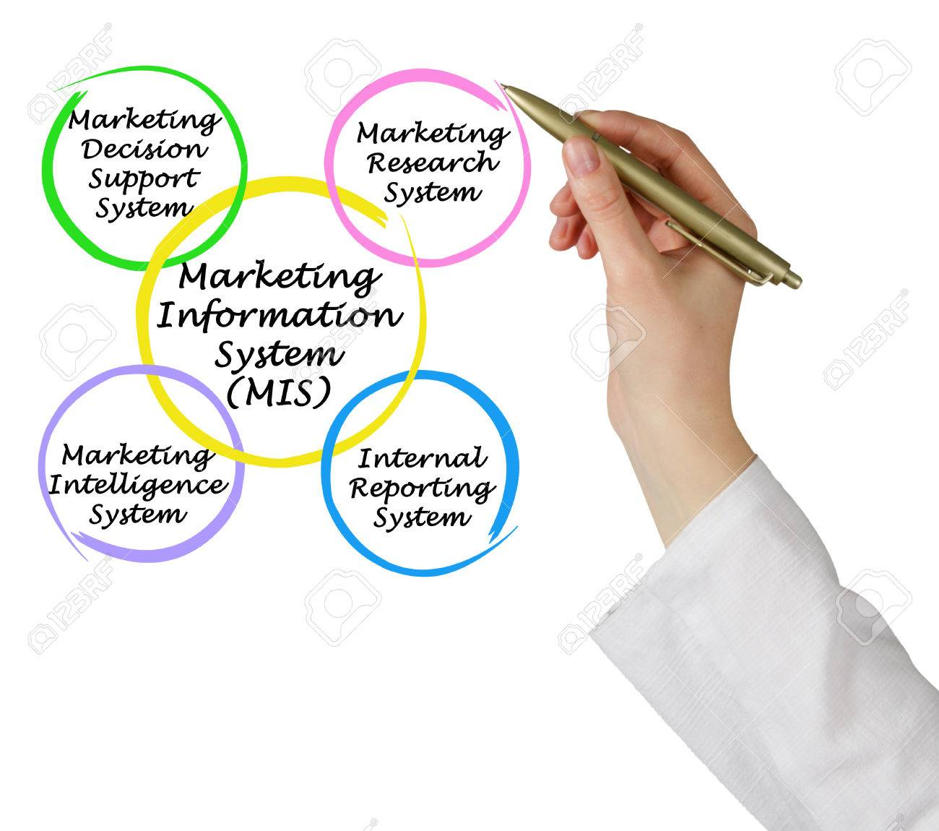

Table of contents
Introduction ..............................................................2
Gathering information................................................2-3
Marketing within MIS.................................................3
Communication...........................................................3-4
Effectiveness within the Hospitality and Airbnb..........4
Conclusion....................................................................4-5
References:...................................................................5

Introduction
If we ask ourselves what marketing means, it will surely be difficult to give a precise definition. We could say that marketing means everything related to advertising and everything related to sales and the right people. It all combines the meaning of the marketing.
Blick, D. (2011), “Marketing is a philosophy of business that places the customer at the centre of the universe.”
We can see marketing in every part of the small business such as sales, funding, IT, business evolution, administration and client care and according to Blithe, J. (2013), “Marketing is inherently interesting.” Maybe because we are all customers or because marketing is related to people or perhaps many of this is country to intuition.
Marketing Information System (MIS) can be called as that type of information that marketing and advertising need. The main function of the MIS includes the capacity for collecting information and its alignment for easier access to products, sales, trends and customer type and as Theodosios, T. (2015) says “Marketing Information System are people, equipment and procedures to gather, sort, analyze, evaluate and distribute needed, timely and accurate information to marketing decision makers.” Based on the data received from customers about which product is most desirable, what day of the week is most wanted and when is the best time to promote this product, all this information will be used to develop a Efficient Marketing Strategy as an example we can mention all advantage cards.
In this report I will analyze the MIS as an efficient IT implement for the hospitality and will use Airbnb as example how they used information analytics to construct new product supply, develop its service and accentuate on new marketing enterprises because Airbnb apparently increased to be the world’s leading hotel group out of nowhere.

Gathering information
Information can be gathered from inside and outside the institute. External gathering information is consumer surveys, while internal gathering information is guest feedback, guest registration information, in-house guest surveys and all the employee meetings.
Reid, R and Bojanic, D (2009) “It would be extremely difficult and quite hazardous for the management of hospitality organization to make decisions without accurate and up-to date marketing information.” Airbnb is very good example for that how by using abundant database contained of guest and host interplays, they construct a pattern that asses the probability of booking a place, given where the person was looking. For example if you are searching for a place near to Victoria Station, the reservation skew toward neighbourhoods where people also search for Victoria Station, very often make a booking in the Chelsea area.

Marketing within MIS
A Marketing Information System is carefully selected strategy for getting the right information within the firm. Marketers can see the connection between the MIS and marketing research on a different way, that will be determined by the size of the firm and the products or services that are marketed.
Wild, J and Diginess, C. (2010) “For a marketing information system to be of any use, the information must be of high quality and add value to the decision making process.”
Airbnb has developed the concept of good accommodation for less money, prompt communication between the host and the guest and absolutely trust worth between them, flexible check-in and check-out time. Their selling point is that that don’t view marketing with a capital M like most companies do; everything they do starts with the community first.

Communication
Kotler and Armstrong, (2012). “An effective marketing program blends each elements of the marketing mix into an integrated scheme designed to achieve the company’s objectives by delivering value to customers.”
Marketing mix is consisted by 4 P’s (Product, Price, Place, Promotion ), which determines the seller point of view and the 4 C’s (Customer, Value, Cost, Convenience, Communications) that linked to the customers experience.
The Airbnb marketing mix analyzes the company to cover these 4 P’s and explain the marketing strategy to Airbnb.
Product:
Airbnb is a website where helps customers and users to find hotel, hostel and other species of accommodation. Airbnb offers a diversity of services in its marketing mix, for tourists they suggest easy finding of the perfect accommodation e.g. family accommodation, beds in hotels, hotel rooms and more. Airbnb host can determine the price or service offered. Airbnb also can give an estimate for this type of accommodation based on a similar type of registration, location and guest capacity. By doing that Airbnb appears as a broker that makes communication and transaction between the guest and the host easy trough the portal.
Price:
Airbnb maintains its annual income by charging service charges from the host. Airbnb helps hosts insetting optimal prices and how to maximize their revenue.
Place:
Airbnb gives an access to accommodation more than 191 countries by their web portal. Access to this web portal is via all digital platforms and thereby has a strong global reach. So everyone in the internet ecosystem can use Airbnb very easy.
Promotion:
Airbnb permanently communicates the value proposition for “Life as a local” it’s via its ads and uses delocalized strategy implantation for these promotion by creating content that matches a given place.

Effectiveness within the Hospitality and Airbnb
One of the fundamental parts in development and growth of any company is marketing. All the components of marketing such as advertisement, market research, market strategy, pricing, budget, marketing goals should be present and guarantee a successful business.
Such an example for instance is Airnbn. Much can be learned from their marketing strategy. Analysing AirBnb’s strategies, some advantages of the Marketing Information System are:
-Brand partnership ( Airbnb shows that working together can generate a lot of buzz. . The following example comes to support this statement. KLM Royal Dutch Airlines, UK bookstore chain Waterstones and even the French government are all a part of successful business allegiance. The following example comes to support this statement.)
-Influencers ( By inviting journalists, bloggers, You Tubers, podcasters and Instagram stars to events – that gives surprising results.)
-Quality imagery ( The more options there are to be offered in terms of security for both the host and the guest can certainly lead to more bookings. These will include for instance free photograph offered on site.)
Build a community (Users an encouraged to communicate more often and are allowed to gather as much information as possible in order to build a stronger relation.)
-Iconic (They pay attention to the smallest details which helps them achieve their goals in the business. And the most rewarding moments comes when their guest says: “Wow, this is so much better than a hotel.”)

Conclusion
Marketing information System is methodical process for the regular collection of crude data both internally and externally and the transformation of these data into information doing marketing solutions. Information does not make marketing solutions, but it supports managers to take decisions.
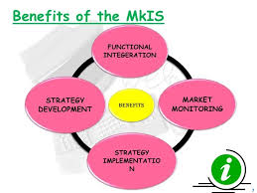
Airbnb changes the accommodation market by maintaining hotel prices and providing additional rooms in the most up-to-date travel destinations in the country during peak periods when hotel rooms are sold and the prices go up. In this way hotels that had the greatest profits at the time when the rooms are limited and the customers have to pay more, remain losers.
Kotler, F. (2009)“One of the shortest definitions of marketing is the process of ‘meeting needs profitably’.” Marketing is the way to understand what the customers and consumers need and to make marketing selection to link these needs. Many business people can’t pick the sign of marketing think for it as “the art of selling product” or just match it with ads. Both are marketing tactics seeable to the consumer. Airbnb marketing task is not to find the right customers for their places or services, but to design the right places and services for their customers. They did the first step to promote their new idea for “Trips service” in London and it shows the experience when booking through the service, not just accommodation.

References:
Blick, D. (2011), “The Ultimate Small business Marketing Book”, United Kingdom: Flament Publishing
Blythe, J. (2013), “Principles and Practise of Marketing”, United Kingdom: SAGE
Kotler, P. and Armstrong, G. (2012), “ Principles of marketing” 14 th ed. Upper Saddle
Kotler, P. (2009), “Marketing Management”, United kingdom: Pearson Education
Reid, R and Bojanic, D (2009), “Hospitality Marketing Management”, United Kingdom: John Wiley and Sons
Theodosios, T. (2015), “Trends and Innovations in Marketing Information Systems”, United Kingdom: IGI Global
Wild, J and Diginess, C. (2010), “Marketing research”, United Kingdom: Juta and Company Ltd

